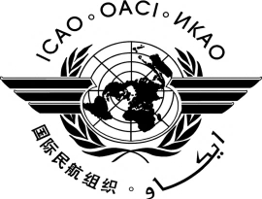
TWENTIETH MEETING OF THE AFRICA-INDIAN OCEAN PLANNING AND IMPLEMENTATION REGIONAL GROUP (APIRG/20)

YAMOUSSOUKRO, COTE D’IVOIRE, 30 NOVEMBER - 2 DECEMBER 2015

ATTENDANCE NOTIFICATION AND REGISTRATION FORM

- Please fill and forward the form in the same (MS Word) format. Do not fax, scan or change format to PDF.
- Insert information in the grey empty boxes
- Where appropriate, click to make the appropriate selection

- Surname

- Given Name (s)

- Job Title

- State/Organization

- Mailing Address

- Telephone

- Fax

- E-mail address

- Hotel

Note: As indicated in the information bulletin, participants are expected to make their own hotel reservations and arrangements to obtain their visas. Hotel information is provided in the Information Bulletin.

Please complete and return to the following address: The Regional Director
ICAO ESAF Regional Office, Nairobi
Email : icaoesaf@icao.int
Fax: +254 20 762 1092

The Regional Director
ICAO WACAF Regional Office
Email: icaowacaf@icao.int
Fax: +221 33 820 3259

