SADISOPSG/7-WP/7

16/5/02 17/05/00

SADIS OPERATIONS GROUP (SADISOPSG)

SEVENTH MEETING

Cairo, 9 - 13 June 2002

Agenda Item 2: Annual statement of SADIS operational efficacy and update of SADIS inventory

MANAGEMENT REPORT

(Presented by the United Kingdom)

Summary

The United Kingdom as the SADIS provider State has produced a Management Report for the seventh meeting of the SADIS Operations Group which reviews the SADIS service that has been provided during the past 12 months.

1. Introduction

Following last year’s complimentary remarks from the SADISOPSG, the Management Report for the year 2001/2002 that is provided in the appendix is based on the style of report presented last year to the SADISOPSG. However Conclusion 6/7 from the SADISOPSG is noted and where practical, information from the last 2 years is also included in this Management Report.

2. Action

The SADISOPSG is requested to advise the provider State if the content of this report provides the required information, that the information is easily accessible and understood, and if any changes to the report are required in the future.

SADIS

MANAGEMENT REPORT

2001-2002

WAFC LONDON

May 2002

FOREWORD

F.1 In the final report of the SADISOPSG/2, Paragraph 2.10 and Conclusion 2/3 placed the following action on the United Kingdom as the Provider State of SADIS.

F.2 ‘In order to extend the future annual reviews of the operational efficacy of the SADIS in step with the increase in SADIS VSAT installations, it was agreed that:

a) ICAO should solicit the opinion of user States/users prior to each SADISOPSG meeting and report on the results to the group; and

b) The service provider should be requested to provide annual
management reports prior to each SADIS meeting.

F.3 This management report by the United Kingdom attempts to meet this requirement. Diagrams and other relevant documents are included in a series of Annexes to the report.

F.4 A summary of the year’s main events is provided at the beginning of the Report. Further detail is given in the individual sections or in Working Papers and Information Papers to be presented at SADISOPSG/7.

Richard Orrell
WAFC London
EXECUTIVE SUMMARY: YEAR 2001 TO 2002

E.1. The growth of SADIS over the past 12 months has been slow with 5 new systems installed across the footprint. The greatest growth was in regions MID and AFI. The slow rate of growth is partially a result of the temporary cessation in the supply of new receivers following the sale of the receiver patent from one U.S. Company to a new supplier – ISC.

E.2 The fourth two-way VSAT has been installed in Dakar. The two-way VSAT trial commenced at 0000UTC 1 May 2002. No progress has been made with the installation of the fifth two-way VSAT in Nairobi.

E.3 The Internet based FTP Standard Service has been introduced operationally as a backup source of data for approved SADIS or ISCS recipients. The HTTP Premium Service will be introduced later in 2002.

E.4 The volume of OPMET data disseminated by SADIS has risen very appreciably during the past 12 months. In particular OPMET from the regions AFI, ASIA and CAR has increased quite markedly, but data from all of the other regions has risen as well.

E.5 The dissemination of WAFC London high level BUFR encoded SIGWX data on PVC3 has continued throughout the year. One further technical issue needs resolution before it can be declared operational.

E.6 The first GRIB and BUFR training seminar has been held in Niamey. Comprehensive participation from the ASECNA states was greatly appreciated. A further training seminar is scheduled for the ASIA/PAC region later in the year.

E.7 The SADIS Provider has contracted an independent satellite communications expert to advise on potential complementary technologies such as QPSK with Turbo coding that could be used alongside the existing broadcast protocol. This would ensure that SADIS stays at the forefront of modern satellite technology.

E.8 Administration messages have been issued on a regular basis during the year. These messages have been made available for viewing on the SADIS web site.

E.9 All of the commercially available SADIS software has been tested against the list of required functionality’s agreed at SADISOPSG/6. The results from this testing are presented to SADISOPSG by way of a separate working paper. These results will also be made available on the SADIS web site.

E.10 To encourage market forces to bear on the quality and price of SADIS hardware, a number of additional hardware manufacturers are being sought.

CONTENTS

Page
1. THE SYSTEM COMPONENTS

1.1 Two-Way enhancement: SADIS system specification
1.1.1 Broadcast Service 8
1.1.2 Collection Service 8
1.1.3 Back-up Service 9
1.1.4 User Support Service 9

1.2 SADIS Inventory:
1.2.1 Equipment 9
1.2.2 Procured Services 13
1.2.3 Annual Staff Requirement 14

1.3 SADIS technical components and costs: Updated Two-Way and
One-Way costs
1.3.1 Revised costs of One-Way SADIS VSAT 15 1.3.2 TCP/IP Protocol 15 1.3.3 Costs for Two-Way systems 16

Annex: 1. Glossary of abbreviations protocol conversion units 17

2. SADIS USAGE & DATA VOLUMES

2.1 Status of Operational Hardware Units 18

2.2 Hub Infrastructure 19

2.3 Data Rates and Broadcast Content
2.3.1 Data Rates 19
2.3.2 Content of Broadcast 19

Annex: 1. Example of Data Volume by percentage on SADIS Port 1 24

3. PERFORMANCE OF THE VSAT & HUB

3.1 VSATS
3.1.1 Installation procedures 25
3.1.2 Summary of Returned Equipment - Astrium report on MTBF 26
3.2 Hub- outages 28
3.3 Signal loss
3.3.1 Sun/Satellite Conflicts 29
3.3.2 Data Losses and re-sends 29
Annex: 1. Authorised SADIS Users 30

- DATA AVAILABILITY, TIMELINESS & SOURCE

4.1 Data Availability
4.1.1 Summary of Administrative Messages issued May 2001
to April 2002 35
4.1.2 SIGWX Chart Areas 35
4.1.3 GRIB-1 Data 36
4.1.4 Sources of OPMET 37

4.2 BUFR Encoded SIGWX Products
4.2.1 High level BUFR encoded charts 39
4.2.2 Medium level BUFR encoded charts 39

Annexes: Examples of SIGWX charts available on SADIS: 40-53
SWH (above FL250): SIO, ASIA, INDOC, MID, NAT, AFI,
EURSAM produced by WAFC London
SWM (FL100 – FL450): EUR, MEA, ASIA SOUTH produced
by WAFC London
The Americas, North Pacific and South Pacific – SWH WAFC Washington products

5. USER SERVICES

5.1 Help Desk
5.1.1 The Met Office Help Desk 54
5.1.2 CACC Help Desk 'OPMET' 54

5.2 Hardware Returns Procedure
5.2.1 Returns Information 54
5.2.2 MTTR 54
5.3 SADIS FTP Backup Service – The Standard Service 55

5.4 SADIS User Guide 56
5.5 SADIS Web Page 56

Annexes:
1. Standard Service Technical Information Document 58
2. Met Office Help Desk Facility - SPA 68 3. Astrium returns procedures and forms 70

1. THE SYSTEM COMPONENTS

1.1 SADIS System specification (in compliance with the SADIS User Guide)

The SADIS broadcast infrastructure has been consistently stable throughout the last 12 months. Only a number of very minor modifications to the megapacs have been carried out since SADISOPSG/6. The broadcast infrastructure has thus remained largely unchanged since SADISOPSG/6.

1.1.1 Broadcast Service

a) Distribution of WAFS upper wind and temperature forecasts in GRIB1 code derived from 0000, 0600, 1200, and 1800 UTC model runs, and relative humidity (RH) fields for FL050, 100, 140, and 180;

- Distribution of WAFS upper wind and temperature forecasts (from 0000 and 1200 UTC model runs only) in T.4 facsimile chart format;

c) Distribution of WAFS SIGWX forecasts in T.4 facsimile chart form;

d) Distribution of WAFC London originated high level SIGWX forecasts in BUFR format;

e) Distribution of OPMET information in alpha numeric format (METARS, TAFs, SIGMET, special AIREPs, volcanic ash and tropical cyclone advisories) from those states whose OPMET information is needed to satisfy approved requirements in the regions served by SADIS;

f) Volcanic ash trajectory and dispersion charts in T.4 facsimile format from VAACs London, Toulouse, Washington and Montreal (charts from the other VAACs are either unavailable, or in a format (e.g. partitioned) not suitable for SADIS transmission;

g) Distribution of amendments to the foregoing as necessary.

1.1.2 Data Collection Service

a) Collection of relevant OPMET information from States by the SADIS Gateway, including the Two-Way facility, in accordance with approved requirements stated by the PIRGs and actioned by SADISOPSGs. This function will become operative as soon as the SADIS Gateway becomes operational.

b) Monitoring and validation of data received at the SADIS Gateway, including the Two-Way, to the required standards, for the provision of real-time scheduled reports and for off-line quality control analysis. This function will become operative as soon as the SADIS Gateway becomes operational.

c) Collection of other required SADIS products, such as WAFC Washington SIGWX charts and volcanic ash trajectory charts.

1.1.3 Back-up Service

a) Reception of U.S. ISCS broadcasts for back-up purposes is available.

b) FTP backup service is available to all approved SADIS or ISCS recipients with permission from their Meteorological Authority.

1.1.4 User Support Service

a) 24-hour help line/faults desk;
b) Dissemination of amendments to the SADIS User Guide via the SADIS
broadcast.
c) Support user trials as determined by the relevant ICAO bodies.
d) Dissemination of all SADIS administrative messages via the live broadcast and the SADIS web site.
e) Maintenance of a SADIS News Page on the SADIS web site

1.2 SADIS Inventory

The inventory items identified below cover the equipment and staffing required to provide, operate and maintain the SADIS. The inventory includes: hub infrastructure (including all additions following the completion of the hub enhancement project) and communications circuits, ISCS data back-up system, procured services and staff. It should be noted that some equipment items are under lease and form part of a wider infrastructure. Costs of individual items cannot be separated from the required infrastructure which includes a significant part of the development of the software and technical configuration. The inventory is in accordance with the SADIS User Guide.

1.2.1 EQUIPMENT

A. Hub Infrastructure & Communications Circuits

The hub infrastructure connection to Tthe Met Office message-switch (TROPICS) consists of a number of units developed in conjunction with Astrium and other suppliers. These are installed either at Bracknell or at the up-link site at Whitehill, Oxford. The components of the original inventory changed when the Two-Way enhancement project was fully implemented. It should be noted that the Met Office is in the process of upgrading its message switch. The new switch will be known as FROST and is scheduled to become operational some time during June 2002.

i) Solely procured for SADIS

a) 2 Two-Way VSATs with enhanced Two-Way capability (note that there are 3 original two-way VSATS sited in Switzerland, South Africa and the United Kingdom. These have been re-configured to enable them to communicate with the enhanced hub infrastructure). Following decisions taken by SADISOPSG/5 and SADISOPSG/6 these 2 Two-Way VSATs will be installed in Dakar and Nairobi.

b) Gateway function equipment SADIS Gateway Function software (developed specifically for the SADIS gateway as part of the NATS CoreMet system, see iii)

ii) Principally procured for SADIS

At the Met Office

Product display console, including software.

Communications between Whitehill and Met Office

2 Fibre Optic 64 Kbps circuits.

At the Up-link Site (Whitehill)

a) Units forming part of a totally integrated rack structure, with back-up, referred to as Chain A and Chain B: (see following list at sections 4 & 5)

1 CX 1000 frame relay switch This was an error in the Inventory of last year.
2 modulators
1 Modem Switch These items already mentioned in list at sections 4 & 5.

b) Units and Services leased from Astrium (under contract to CABLE & WIRELESS Communications Ltd):

1 (70 to 140 MHz) Convertors
Use of 1 (140 to C band) Convertors
Use of Satellite Hub - Lease represents only on a very small part of this large aperture

iii) Not procured principally for SADIS

a) Message-switch (TROPICS): Total Investment £2.3M of which 1.25 percent is attributable to SADIS usage. Migration of SADIS data feeds from TROPICS to FROST anticipated during June 2002.
Message switch (FROST): Total Investment £2.3M of which 2.03 percent is attributable to SADIS usage.

b) OPMET gateway function . Message Switch (CoreMet system). Note that some elements of this are exclusively for the support of the SADIS Gateway function.

B. ISCS Data Back-Up System

ISCS VSAT system including, receiver, cables, break unit and X 25 frame relay switch.

Note: The equipment, including leases, listed above under A and B are being capitalised over the SADIS contract period.

SADIS TWO WAY DEVELOPMENT
INVENTORY OF DELIVERABLE EQUIPMENT
(*) Denotes equipment reused from original broadcast system.

Item Description Quantity

1. Bracknell Equipment

1.1 Network Management System (NMS Computer) 1 off
1.2 MemoTech PAD (for NMS) 1 off *
1.3 Telecoms interface units Megabox 2 off
1.4 CX1000 Frame Relay Switch (for NMS) 1 off *
1.5 Product display console including software (COROBOR) 1 off *

2. Bracknell Equipment (Spares)

2.1 Telecoms interface units Megabox 2 off
2.2 NMS Spare CPU 1 off
2.3 MemoTech PAD (for NMS) 1 off *
2.4 CX 1000 Frame Relay Switch (for NMS) 1 off*

3. Communication link Whitehill / Bracknell

3.1 Fibre optic 64 Kbps circuits 2 off *

4. Whitehill earth station (uplink equipment)

4.1 Telecoms controller Megapac V rack assembly 2 off
4.2 Station interface unit (SIU) 2 off
4.3 8360 Modulator 2 off *
4.4 8471 Receive Demodulators 12 off
4.5 8550 Modem Switch 1 off *
4.6 140 - L band upconverter 2 off
4.7 X Term NMS simulator 1 off
4.8 Equipment Rack Assembly (Chain 1) 1 off *
4.9 Equipment Rack Assembly (Chain 2) 1 off

5. Whitehill earth station (spares)

5.1 8471 Receive Demodulators 1 off
5.2 Station interface unit (SIU) 1 off
5.3 Megapac V rack assembly 2 off
5.4 MegaPAC V Frad units 2 off
5.5 140 - L band upconverter 1 off
5.6 8360 Modulator 1 off*
5.7 8550 Modem Switch 1 off*

6. Whitehill services (leased from Matra Marconi Space) Astrium under contract to Cable & Wireless)

6.1 70 MHz to 140 MHz converters 2 off *
6.2 140 MHz to C band converter 2 off *
6.3 Satellite Hub leased bandwidth 1 off slot *

7. TWO-WAY VSAT Systems (2 in number)

7.1 Channel master 2.4 metre type approved antenna 2 off
7.2 5 watt C Band Outdoor unit assembly 2 off
7.3 Low noise block downconverter 2 off
7.4 RF Integration kit 2 off
7.5 Indoor unit rack assembly 2 off
7.6 Station interface unit (SIU 2 off
7.7 8471 Receive Demodulators 2 off
7.8 Telecoms interface units Megabox 2 off
7.9 8371 Modulator 2 off
7.10 Tool kit 2 off
7.11 Cross-site cables set 2 off

8. Test Rig at Poynton

8.1 Enhanced Simulator 1 off

1.2.2 PROCURED SERVICES

a) Space segment annual lease: 900 MHz radio frequency dedicated to SADIS with data rates at 38.4 Kbps for the One-Way channel and 19.2 Kbps for the Two-Way channel.

b) Annual maintenance of Met Office and Whitehill site equipment that is not leased.

c) Gateway function

i) communication link Met Office and NATS infrastructure site.
ii) system maintenance.

1.2.3 ANNUAL STAFF REQUIREMENT

A. Met Office of the UK

Help Desk
Note.— The Help Desk acts as a first point of contact for all enquiries, including those concerning the OPMET gateway function. Complex enquiries will be passed to a relevant expert. Experts are available either on a 24-hour rota basis, or as a daytime support with a call-out capability.

24-hour support Grade & Skill

1. Help desk (first point of contact) Scientific supervisor
2. Operational Supervisor Technical meteorologist
3. Systems Supervisor Computer engineer
4. HQ maintenance Support Telecommunication technical officer

The total support for SADIS is considered as 10% of the total support offered by the four posts. These four posts are directly involved with SADIS operations and form part of a total roster of eight different skills and functions.

Additional support

Systems Integration Team

Grade & Skill
2% of engineer
20% of network computer engineer
Administrator 55% executive officer
70% of support specialist - meteorologist (providing support to ICAO Regions, SADIS users & SADIS User Guide)

Development & enhanced 2-Way Field Trial Support and other projects

Manpower 10% of engineer
10% of data traffic manager
Budgets Travel/Expenses (Consultants fees etc)

B. NATS Infrastructure Site (OPMET gateway function) See also note under 3 A 'Help desk' above

24-hour support Grade & Skill

1. Operational staff support 40% 50% of air traffic services assistant
2. Engineering staff support 20% of systems engineer
3. SADIS administration support 100% 50% of air traffic services assistant

1.3 SADIS Technical Components and Costs: Updated One and Two-Way VSAT Costs

1.3.1 REVISED COSTS OF ONE-WAY SADIS VSATS

During the period covered by this Management Report the previous U.S. supplier of the MSK SADIS receiver (called PTS) has sold the receiver patent to another U.S. company called ISC. This company will now supply the MSK receiver to Astrium at an additional cost. Inevitably this additional cost has had to be passed on to the customer and the revised price is given below.

One-Way System = £13,636 excluding packing and shipping

This is a 20% increase on the cost of the system when receivers were sourced from PTS.

One-Way Costs as presented at SADISOPSG/6

One Way + Installation kit = £11,110 + £170
12 months Gold Service cover = £830

Gold Service provides same day, global dispatch of an exchange / repair 8467FS unit (receiver containing Satelcom FRAD card). Local government regulations and shipping restrictions permitting, a courier will exchange the replacement for the defective unit within 96 hrs of the service call. This period will typically be 36 hours within the EC.

1.3.2 TCP/IP PROTOCOL

Equipment | Price Per Unit
TCP/IP Interface Box | £1,750.00*
Fully Integrated Unit Receiver/Terminal + antenna | £13,636.00

*This figure is budgetary. Please contact Astrium for a firm quotation.

The cost of a receiver with integral TCP/IP card and Satelcom FRAD and antenna is priced the same as the usual X.25 presentation receiver with antenna.

1.3.3 COSTS FOR TWO-WAY SYSTEMS

All new 2-way systems will conform to the new EU regulations - Type Approval ETSI EN 301 443:2000 and EMC Conformance ETSI EN 300 673:1996.

Should any user be interested in purchasing a 2-way VSAT then it is advised that they contact Astrium directly for a quotation. It is the considered view that the market for 2-way VSATs is likely to be very small and requests for quotations from Astrium will be dealt with on a case by case basis. This ensures that each quotation is binding rather than Astrium releasing a universal budgetary price that may change as new regulations are introduced and the price of a unit changes accordingly.

Annex 1 – Glossary of Abbreviations

AIREP Air report

BUFR Binary Universal Format for the representation of meteorological data.

CAA Civil Aviation Authority - UK Met. Authority

GRIB Gridded binary (code)

ISCS International Satellite Communication System (US satellite broadcasts similar to SADIS covering North and South America, the Caribbean and Central America, the Pacific and Eastern Asia).

METAR Routine aviation weather report in code form.

NATS National Air Traffic Services

OPMET Operational meteorological (information or data).

PIRG ICAO planning and implementation regional group.

SADIS GATEWAY
The United Kingdom message-handling system which receives data, from the Aeronautical Fixed Service, for transmission on SADIS.

SIGMET Information of specified en route weather phenomena that may affect the safety of aircraft operations.

SIGWX Significant weather.

T.4 Coded digital facsimile transmission format.

TAF Terminal Aerodrome Forecast. Aerodrome forecast in code form.

TROPICS Transmission and reception of observational and product information by computer-based switching (message switching equipment).

WAFS World Area Forecast System.

2. SADIS USAGE & DATA VOLUMES

2.1 Status of Operational Hardware Units

The growth in the number of operational units has been slow but steady over the past 12 months. The regions of greatest SADIS growth have been MID and AFI.

The following tables compare the number of access approved units for March 2000, April 2001, and March 2002.

Table 1 Number of access approved units by ICAO Region
March 2000

ICAO Area | Access Approved
EUR | 57
MID | 22
AFI | 42
ASIA | 22
TOTAL | 143

Table 2 Number of access approved units by ICAO Region
April 2001

ICAO Area | Access Approved
EUR | 61
MID | 22
AFI | 43
ASIA | 25
TOTAL | 151

Table 3 Number of access approved units by ICAO Region
March 2002

ICAO Area | Access Approved
EUR | 61
MID | 24
AFI | 45
ASIA | 26
TOTAL | 156

The tables indicate that 5 new units have been approved in the last 12 months.

2.2 Hub infrastructure:

During the past 12 months, the hub infrastructure has proved reliably stable, and no significant remedial action has been necessary. This is reassuring following the completion of the major engineering work that formed the two-way enhancement program. This was reported in the 2000-2001 SADIS Management Report.

2.3 Data Rates and Broadcast Content

2.3.1 Data rates.

The aggregate data throughput of 38.4Kbps has been maintained in accordance with
the technical specification. The system is in theory capable of running at 64Kbps with
an aggregate data throughput minus system overheads of around speed 50 to 52Kbps. However following the problems encountered by a number of users in 1999 with data rates of this speed, bandwidth control has been maintained on all PVC's.
Bandwidth control has been maintained throughout the past 12 months to limit the throughput of data to the following continuous rates:

GRIB 19.2Kbps
T4 19.2Kbps
OPMET 9.6Kbps.

This has satisfactorily resolved the problems encountered during 1998 - 1999, which related to the software contained within the EPROMS being unable to handle the input data fast enough.

2.3.2 Content of Broadcast

GRIB

GRIB bulletins are broadcast four times per day. Repeat broadcasts are not routinely carried out.

TABLE 2.1 Average daily data volume of forecast fields in GRIB code since 4 April 2001

Bulletins GRIB1 (Mbytes)
T+6 1248 5.6
T+12 1248 5.6
T+18 1248 5.6
T+24 1248 5.6
T+30 1248 5.6
T+36 1248 5.6
TOTAL 7488 33.6
The WMO headers of a complete set of WAFS GRIB data are listed below:

H(T,U,V)(I-P)(B-G)(85,70,60,50,40,30,25,20,15,10) EGRR

HR(I-P)(B-G)(85,70,60,50) EGRR
HH(I-P)(B-G)(96,97) EGRR
HT(I-P)(B-G)97 EGRR
H(U,V)(I-P)(B-G)96 EGRR

Total = 1872 bulletins per model run. 4 model runs per day (0000, 0600, 1200 and 1800 UTC). This equates to approximately 8.4MB of data per model run, or 33.6MB of GRIB data per day.

T.4 CHARTS

The chart information promulgated via SADIS (in T.4 facsimile format) consists of SIGWX and wind/temperature charts. The only SIGWX charts which are transmitted via SADIS are WAFS charts produced by WAFC London and WAFC Washington, one medium level chart produced by the Australian Bureau of Meteorology and one high level SIGWX chart produced by the Kenyan Met. Service.

Additional T.4 products include Volcanic Ash Trajectory and Dispersion charts from VAACs London, Montreal, Washington and Toulouse. Unfortunately the equivalent charts produced by the other VAACs are not available for SADIS transmission because the products are either not received by the Met Office or are in a partitioned format which TROPICS cannot accommodate.

It is important to note that T.4 wind and temperature charts are NOT produced from the 0600 and 1800 UTC model data. This data is only produced in GRIB format - see section 2.3.2 GRIB data, above.

Some 364 T.4 wind and temperature charts are broadcast every day, which amounts to
approximately 27MB of data (approx. 74KB per chart).

60 T4 SIGWX charts are broadcast every day (approx. 80KB per chart), with 40 charts originating from WAFC London, 12 from WAFC Washington (covering areas: Americas, N. Pacific, and S. Pacific) 4 from the Kenyan Met. Service and 4 from the Bureau of Meteorology in Melbourne. It is proposed in a working paper due for presentation at SADISOPSG/7 that the charts from Kenya and Australia be removed from the SADIS broadcast.

It should be noted that the Met Office receives the charts originating from WAFC Washington with KKCI as the ‘CCCC’ group, and re-heads them for SADIS transmission to KWBC. This action was implemented from early 2002 when WAFC Washington changed the ‘CCCC’ group applied to their SIGWX charts from KKCI to KWBC. It is proposed that some work be carried out to ascertain what the impact will be, if any, if the re-heading of these bulletins is stopped.
The T.4 chart content can be summarised as follows:

TABLE 2.2 Average daily volumes of chart data.

T.4 Charts Data Volumes (Mbytes)

Number generated at WAFC London
SIGWX 40 3.2
Wind & Temperature 364 27

Generated by other Centres
SIGWX 20 1.6

Total broadcast 31.8 MB

The only addition during the past 12 months has been the new area “M” WAFC Washington chart.
Please note that occasional T.4 volcanic ash dispersion and trajectory charts from VAACs London, Montreal, Washington and Toulouse are sent in addition to the products listed above.

OPMET
An average daily OPMET broadcast is about 10.5 Mbytes of data and approximately 33500 messages. This is a further significant increase compared with the same period last year, when approximately 29000 bulletins were broadcast. By ICAO region, the breakdowns taken in 2000 and 2001, and 2002 are shown in the following three tables.

TABLE 2.3 Example of daily OPMET bulletins by source – March 2002

Data Type | ICAO area
TT | AFI | ASIA | CAR | EUR | MID | NAM | NAT | PAC | SAM | Unknown | Grand Total
FB |  |  |  | 6 |  |  |  |  |  |  | 6
FC | 89 | 298 |  | 2032 | 17 | 783 | 10 | 17 |  |  | 3246
FK |  |  |  |  |  |  |  | 4 |  |  | 4
FT | 227 | 372 | 275 | 635 | 127 | 1521 | 34 | 105 | 303 |  | 3599
FV |  | 10 |  |  |  |  |  |  |  | 3 | 13
SA | 1021 | 1643 | 1069 | 9417 | 854 | 8758 | 205 | 183 | 1089 |  | 24239
SP | 13 |  |  | 132 |  | 2158 | 10 |  | 5 |  | 2318
WC |  | 2 |  |  |  |  |  | 7 |  |  | 9
WS | 8 | 1 |  | 56 | 9 | 15 | 4 | 16 | 6 |  | 115
WT | 8 | 13 |  |  |  |  |  | 27 |  |  | 48
WV |  | 1 | 1 |  |  |  |  | 1 | 4 |  | 7
Grand Total | 1366 | 2340 | 1345 | 12278 | 1007 | 13235 | 263 | 360 | 1407 | 3 | 33604

TABLE 2.4 Example of daily OPMET bulletins by source – March 2001

Data Type | ICAO Area
TT | AFI | ASIA | CAR | EUR | MID | NAM | NAT | PAC | SAM | Unknown | Grand Total
FC | 43 | 52 |  | 1911 | 10 | 752 | 19 | 24 |  |  | 2811
FT | 216 | 252 | 232 | 718 | 116 | 1706 | 37 | 119 | 247 | 10 | 3653
SA | 357 | 1257 | 973 | 8559 | 701 | 7261 | 144 | 121 | 1255 | 18 | 20646
WS | 15 | 60 |  | 59 | 21 | 20 | 19 | 34 | 10 |  | 238
WV |  |  |  | 6 |  |  |  |  |  |  | 6
SP |  | 1 |  | 71 |  | 1908 | 7 |  |  |  | 1987
WW |  |  |  |  |  |  |  |  | 3 |  | 3
WT | 3 | 6 |  |  |  |  |  |  |  |  | 9
Grand Total | 634 | 1628 | 1205 | 11338 | 848 | 11647 | 226 | 298 | 1515 | 28 | 29367

TABLE 2.5 - Example of daily OPMET bulletins by source – March 2000

Data Type | ICAO Area
TT | AFI | ASIA | CAR | EUR | MID | NAM | NAT | PAC | SAM | Unknown | Grand Total
FC | 56 | 33 |  | 1799 | 3 | 1148 | 11 | 17 |  |  | 3067
FT | 285 | 205 | 241 | 555 | 105 | 671 | 12 | 26 | 186 | 3 | 2289
SA | 399 | 726 | 704 | 7604 | 621 | 2126 | 151 | 44 | 193 | 13 | 12581
WS | 16 | 24 | 1 | 59 | 2 |  | 4 | 3 |  |  | 109
WV |  |  | 2 | 10 |  |  |  |  | 3 |  | 15
SP |  |  |  | 138 |  | 312 |  |  |  |  | 450
WT | 19 | 7 |  |  |  |  |  | 2 |  |  | 28
FV |  |  |  |  |  |  |  |  |  | 8 | 8
FB |  |  |  | 7 |  |  |  |  |  |  | 7
UA |  |  |  |  |  |  | 1 |  |  |  | 1
WA |  |  |  | 1 |  |  |  |  |  |  | 1
Grand Total | 775 | 995 | 948 | 10173 | 731 | 4257 | 179 | 92 | 382 | 24 | 18556

BUFR

The dissemination of BUFR encoded WAFC London high-level SIGWX charts have continued throughout the last 12 months. This data is disseminated on PVC3.
At the time of writing the BUFR data has yet to be declared operational pending the production of BUFR code that encapsulates the movement of fronts. Work has been undertaken and completed, to resolve a problem with the “wrap-around” of jets that cross the international date line, and high level BUFR data is now produced for the whole globe, including the Pacific region . It is envisaged that the high level BUFR will be declared operational before the end of 2002.

It should be noted that all of the workstation manufacturers have developed BUFR visualisation software. Some refinement of a number of the packages is still necessary before they meet the requirements of Annex 3, but these refinements are largely of a cosmetic nature.

NEW PRODUCTS

The new WAFC Washington area “M” chart was introduced to the SADIS broadcast during July 2001.

Additional OPMET data has been added to the broadcast as it has become available to the Met Office. The further increase in OPMET data reaching the uplink is noted with interest.

Annex 1 - Example of Data Type by Percentage Volume on Port 1 - March 2002
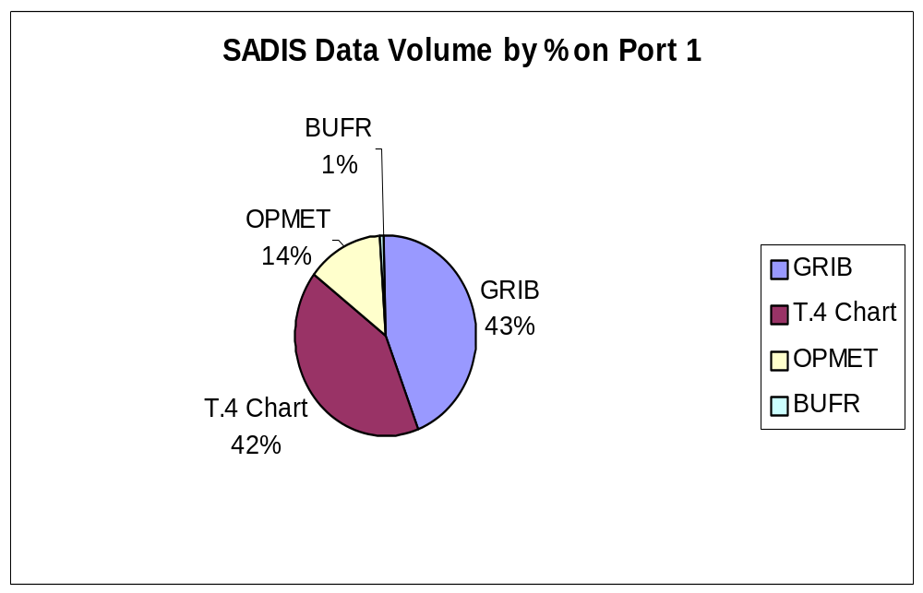

3. PERFORMANCE OF THE VSAT & HUB

3.1 VSATS

The list of authorised accesses to the SADIS service is given in the Annex 1 to Chapter 3

3.1.1 Installation Procedures

Full installation instructions are provided with the Astrium equipment. However, the following matters should be addressed prior to any other preparatory work, as listed in the SADIS User Guide:

- Is there a clear line of sight to the satellite from the proposed location?
- Is there access for the transport of equipment - e.g. check lifts, doorways etc?
- Are there structural implications if roof-mounted e.g. load-bearing capability, non-penetrable mounts and ballast? Total weight of antenna (2.4 m diameter) plus brackets and base assembly is approx. 450 kg; ballast to secure structure is 1500kg; total weight including ballast is 1950 kg; footprint required for non-penetrating mount is approx. 25 m². A civil engineer consultancy may be required to ascertain this.
- Is planning or installation permission required in any particular State or location?
- Do any changes to be made comply with local building regulations?
- Consider runs of cable to end-user. In this respect 75 m is the normal maximum; beyond this, ascertain line amplifier requirements?
- The main power requirement is 90 to 265 volts AC, 50/60 Hz, 300 watts.
- How reliable is the power supply? An uninterruptible power supply backup may need to be considered.
- Third party insurance, e.g. in the event of a dislodged antenna causing injury.
- Storage of sub-systems and equipment prior to installation.
- Radiation hazard (RADHAZ) for two-way VSATS in which case frequency clearance of the site may be required from the Post, Telephone and Telegraph (PTT) Authorities.
- Interference - spurious emissions may cause problems with air navigation equipment or explosive devices.
- Survivability of the antenna: although the manufacturer will specify this, due regard must be paid to the support structure that holds it in place.
- Access for the maintenance of the equipment.
- Two-way VSATS may need licensing through State PTT and Astrium should do installation.

Due regard should be considered on the environment extremes that the VSAT is expected to operate.

Note:- The required ballast must be supplied by the user. This can be sandbags, concrete blocks or any other suitable medium providing the required weight.

3.1.2 Summary of returned equipment - ASTRIUM Report on MTBF

There are expected to be at least 146 VSAT stations commissioned by the end of March 2002. To date, some 290 plus SADIS units have been despatched of which 154 were the 8465 model, 118 were the 8467F model and approx. 25 are of the latest 8467FS / FT models [these are the new receivers containing the Satelcom FRAD card].

Summary of returned equipment

Of the 154 model 8465 units despatched, a total of 64 units have been returned of which 16 were found to have no fault on their first return. A total of 27 units have been returned on more than one occasion.

Of the 118 model 8467 units despatched, 45 units have been returned of which 7 were found to have no fault on their first return. A total of 19 units have subsequently been returned on more than one occasion.

Of the 25 model 8467FS units despatched, 7 units have been returned of which 4 were found to have no fault on their first return. Only one unit has been returned more than once.
The table below summaries the failures found in all returned units: -

FAULT | TOTAL | 8465 | 8467 | 8467FS
FRAD | 76 | 38 | 38 | 0
PSU | 16 | 12 | 3 | 1
MODEM | 20 | 17 | 3* | 0
IF CARD /DOWNCONVERTER | 17 | 14 | 3 | 0
NFF | 38 | 22 | 11 | 5
LOOSE I.Cs | 9 | 1 | 8 | 0
CONFIGURATION | 14 | 10 | 3 | 1

✶ Note. Modem cards on the 8467 Models are not the same as the modem card on the 8465 models. Above figures include failures on repeat returns.

The table above shows that the majority of failures on the 8467 model remains the FRAD card failures – constituting approx. 55% of the total failures, in comparison to the 8465 model which suffered failures in a range of areas. The latest model 8467FS in comparison has shown no FRAD failures to date, the majority of returns being “No Fault Found”. The problems associated with loose I.Cs have also been addressed and are unlikely to recur in future. It should be noted that all new systems are of the type 8467FS.
However, due to equipment obsolescence and various changes in the supply of certain parts of the equipment, users must realise that in some cases, failures of 8465 receivers may not be repairable and the equipment will need to be replaced with the latest version 8467FS model. [This issue was raised in the 2000-2001 SADIS Management Report presented at SADISOPSG/6.] Also, certain failures within the 8467 receiver may not be repairable in the near future due to a change of supplier of the receiver– in such cases there will probably be no alternative but to purchase an 8467FS receiver.

MTBF Calculation

The MTBF has been calculated using field data and quantity of confirmed faulty hardware returned. Assuming the equipment is in full operation by the customer and allowing for transit times, the MTBF for each model is as follows:

Model 8465: 106981 hrs at end March 01, 105006 hrs at end March 02

Model 8467: 89866 hrs at end March 01, 92688 hrs at end March 02

Model 8467FS: 104448 hours at end March 02

Mean Time between reception and return of faulty Equipment: -

MTTR = 7.8 weeks

The MTTR figure has remained fairly static at approximately 8 weeks over the last year, but this figure also includes repairs to 4 units that have been at ASTRIUM for several months awaiting the acceptance of quotations and preparation of export documentation. With these units removed, the MTTR decreases to 6.0 weeks.

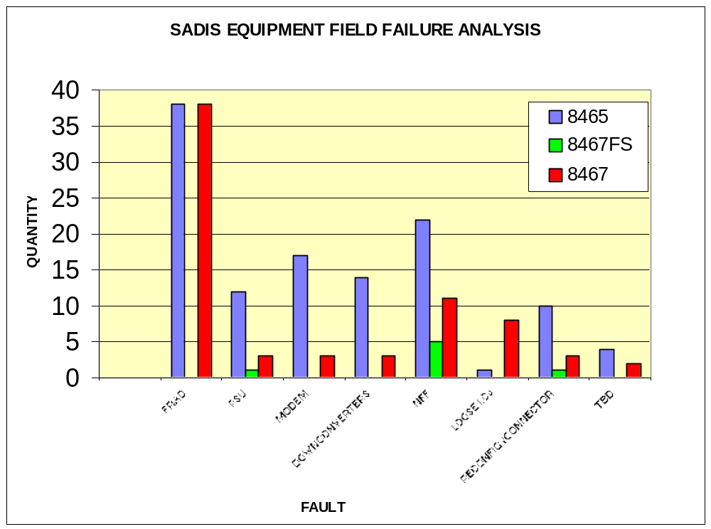

3.2 HUB - Outages

a) Planned - During the past twelve months there have been 8 planned outages of short duration lasting for between five minutes and 30 minutes due to engineering work on the Met Office message switch. All of these outages were flagged beforehand to users via a SADIS administrative message.
b) Unplanned – 7 unplanned interruptions occurred during the past twelve months. These were mostly of short duration (under 10 minutes) and avoided the main GRIB run periods.

3.3 SIGNAL LOSS

3.3.1 Sun/Satellite Conflicts

All stations will experience a temporary signal degradation or outage for a few minutes
a day in two defined periods a year due to the sun and the satellite being in line. With
the aid of a software program the ‘Help Desk’ facility is able to confirm the date and
time of occurrence of signal degradation if the exact Latitude and Longitude are
provided.

Administrative messages alerting users of the probable window of conflict can be issued, but the Help Desk can confirm the period more accurately if they are given the exact latitude and Longitude. This service was provided to a small number of SADIS users during the year.

3.3.2 Data losses and re-sends

Very occasionally SADIS users requesting the re-send of various SADIS products contact the Met Office Helpdesk. SADIS is a point to multi-point distribution service which means that if a product is re-transmitted because a single customer failed to receive it, the product is re-transmitted to all SADIS users. This can cause confusion. It is the policy of the Helpdesk to only agree to data re-sends if it can be demonstrated that the primary broadcast failed, and thus a product failed to be received by all SADIS users. This is straightforward to ascertain because the Helpdesk staffs have access to a SADIS workstation that is fed with live SADIS data.

The introduction of the FTP backup service should eliminate the need for data re-sends, unless of course the primary broadcast fails, when they will be initiated as usual.

Data packet losses via the broadcast continue to be extremely low. Data losses are normally associated with problems with end user hardware or software. Misalignment of the antenna (probably caused by exceptionally strong winds) has caused problems to a small number of users during the last 12 months.

 | AUTHORISED ACCESS TO SADIS – March 2002
Country / State | User | Authorising Authority | Notification Received
A
Afghanistan | NMS | Ministry of CAA & Tourism | 13th October 1999
Algeria | NMS | Self Authorising | 13th July 1997
Armenia | Hydromet/Aviamet | Self Authorising | 15th November 1996
Australia | NMS | Bureau of Meteorology
Austria | Austro Control | Austro Control
Azerbaijan | Air Navigation Service | Self Authorising | 23rd March 1998
B
Bahrain | NMS | CAA | 29th August 1995
Bangladesh | NMS | Self Authorising | 2nd April 1997
Belgium | NMS | Min of Communications | 28th April 1995
Belgium | Eurocontrol | Min of Communications | 5th November 1999
Benin | NMS | Self Authorising | 7th February 1997
Botswana | NMS | CAA | 8th July 1996
Brunei | NMS | Min of Communications | 7th December 1995
Bulgaria | ATSA | Ministry of Transport | 13th April 1997
Burkino Faso | NMS | Ministry of Transport | 17th June 1997
Burundi | NMS | IGEBU | 4th July 1996
C
Cameroon | NMS | Ministry of Transport | 1st April 1998
Central African Republic | NMS | Ministry of Transport & Aviation | 26th June 1997
Chad | NMS | Ministry of Transport & Public Services | 23rd August 1995
China | NMS | CAAC | 18th August 1995
China | Royal Observatory | UKCAA | 2nd November 1995
China | Macau NMS | CAAC | 11th October 1995
China Taiwan | Taiwan NMS | CAAC | 15th September 1998
Congo | CAA/NMS | Ministry of Transport | 11th December 1997
Croatia | ATSA | Ministry of Maritime affairs | 23rd September 1995
Cyprus | NMS | NMS | 11th October 1995
Czech Republic | Hydro Met | Ministry of Transport - CAA | 15th May 1995
D
Denmark | SAS Airline | NMS
Denmark | Met Institute | Danish Met Institute
E
Egypt | NMS | Egyptian Met Authority | 4th November 1995
Equatorial Guinea | NMS | Ministry of Transport & Communications | 27th March 1995
Eritrea | Meteorological Department of CAA | Ministry of Transport | 12th June 1996
Estonia | ANS | ECAA | 29th June 1999
Ethiopia | NMS | NMS | 14th March 1997
Ethiopia | Ethiopian Airlines | NMS | 24th June 1996
F
Finland | NMS/CAA | FCAA | 21st March 1995
France | MeteoFrance | Ministry of Transport & Equipment | 23rd March 1998
France | Sofreavia | Min of Transport, & Equipment | 19th February 1998
G
Gabon | NMS | Ministry of Transport | 18th July 1995
Gambia The | NMS | Department of Water Resources | 20th February 1998
Georgia | NMS | Ministry of Environment | 2nd February 1998
Germany | EuroWings | Deutscher Wetterdienst | 5th September 1996
Germany | Lufthansa | Federal Ministry of Transport | 23rd February 1995
Ghana | NMS | NMS | 13th January 1998
Greece | NMS | MoD | 3rd April 1995
Guinea | NMS | Ministry of Transport | 6th January 1998
H
Hungary | NMS | Ministry of Transport
I
India | NMS | Self Authorising | 16th February 99
Indonesia | NMS | Self Authorising | 18th February 2000
Iran | NMS | Self Authorising | 21st January 1996
Italy | ATS | Self Authorising | 17th February 1997
Italy | Alitalia | DGDCA | 21st April 1995
Ivory Coast | NMS | Ministry of Equipment & Transport | 28th April 1995
J
Jordan | NMS | Self Authorising | 5th November 1995
Jordan | Jordanian Airlines | CAA Jordan | 5th January 1997
K
Kenya | NMS | Ministry of Transport | 3rd June 1996
Korea North | CAA | Self Authorising | 1st May 1997
Korea Republic | Korean Met Administration | Korean Met Administration | 24th May 2001
Kuwait | NMS | DGCA | 18th January 1995
L
Lao P D R | NMS | Ministry of Agriculture and Forest | 17th March 1999
Lebanon | NMS | Beirut Int A/P | 11th October 1995
Libya | NMS | Self Authorising | 9th October 2000
M
Madagascar | NMS | Self Authorising | 13th May 1996
Malawi | NMS | Self Authorising | 17th June 1996
Malaysia Kuala Lumpur | NMS | CAA | 28th December 1996
Maldives | NMS | Self Authorising | 11th September 1996
Mali | NMS | Ministry of Transport | 28th March 1995
Malta | NMS | Self Authorising | 26th February 1996
Mauritania | NMS | Ministry of Transport & Equipment | 29th January 1997
Mauritius | NMS | Self Authorising | 11th March 1997
Moldova | ATS | CAA | 21st July 2000
Mongolia | CAA | Ministry of Nature and Environment. | 14th November 1996
Morocco | NMS | Self Authorising | 16th January 1996
Mozambique | NMS | Self Authorising | 1st October 1998
N
Namibia | NMS | Ministry of Transport & Communications | 6th January 1997
Nepal | NMS | Ministry of Transport | 6th January 1998
Netherlands | KNMI | DG CAA | 17th June 1996
Netherlands | KLM | Public Works & Water | 3rd February 1997
Netherlands | Sigmex | Ministry of Transport & Public Works | 4th November 1996
Niger | NMS | Ministry of Transport & Equipment | 14th March 1995
Nigeria | NMS | Federal Ministry of Transport | 27th November 1995
O
Oman | CAA | Ministry of Communications | 11th October 1995
P
Pakistan | NMS | Government of Pakistan | 8th July 2000
Palestine | NMS | Ministry of Transport | 8th February 1998
Poland | NMS | Institute of Met and Water Management | 10th January 1999
Portugal | NMS | Min of Equipment | 30th January 1996
Q
Qatar | NMS | Ministry of Communications | 1st January 2001
R
Romania | Romatsa | CAA | 28th March 1995
Russian Federation | Roshydromet | Rosaeribavigacia | 27th June 1995
Rwanda | NMS | National Met Service
S
Saudi Arabia | MEPA | CAA | 1st September 1999
Senegal | ASECNA | ASECNA
Seychelles | NMS | Ministry of Tourism and Transport | 3rd June 1996
Sierra Leone | NMS | Meteorological Department | 25th August 1995
Singapore | NMS | Self Authorising | 21st July 1995
Slovak Republic | NMS | Ministry of Transport | 30th July 1996
Somalia | NMS | CAA | 17th June 1996
South Africa | NMS | Weather Bureau | 9th November 1995
South Africa | Netsys | Weather Bureau | 9th November 1995
Sri Lanka | NMS | CAA | 9th February 1998
Swaziland | NMS | Ministry of Transport and Communications | 6th June 1996
Sweden | CAA | Swedish CAA | 6th December 1995
Switzerland | NMS | Insistute de Met | 9th January 1996
Syria | NMS | Damascus Int A/P | 11th October 1995
T
Tanzania U R | NMS | NMS | 17th July 1995
Thailand | NMS | NMS | 3rd October 1995
Togo | NMS | ASECNA | 18th March 1999
Tunisia | NMS | Min of Transport | 2nd June 1995
Turkey | NMS | Self Authorising | 1st March 1999
Turkmenistan | NMS | Ministry of Natural Resource | 24th February 1997
U
Uganda | NMS | CAA Kampala | 17th June 1996
Ukraine | NMS | UACMC | 8th June 1995
Ukraine | ATS | Self Authorising
United Arab Emirates | NMS Abu Dhabi | Ministry of Communications | 11th October 1995
United Arab Emirates | NMS Abu Dhabi | DCA | 9th November 1996
United Arab Emirates | NMS Dubai | Ministry of Communications | 16th March 1999
United Kingdom | Bytron | UKCAA | 19th November 1997
United Kingdom | British Midland Airlines | UKCAA | 30th July 1996
United Kingdom | Meteorological Office | UKCAA
United Kingdom | Brittania Airways | UKCAA | April 1999
United Kingdom | Aviation Briefing | UKCAA | 13th August 1999
V
Vietnam | CAA | Air Navigation Department | 21st January 1998
Y
Yemen | NMS | CAA | 18th October 1999
Yugoslavia F R | FATCO | Air Traffic Control Service | 21st July 1997
Yugoslavia F R | F Hydromet Institute | Ministry of Transport | 1st July 1998
Z
Zaire | NMS | Ministry of Transport | 1st January 1998
Zambia | NMS | Department of CAA

4. DATA AVAILABILITY, TIMELINESS &
SOURCE

4.1 Data Availability

4.1.1 Summary of Admin Messages issued between May 2001 and April 2002.

The number of ADMIN messages issued between May 2001 and April 2002 totalled 15. This is a decrease from the 29 that were issued during the previous year. This decrease is attributed to the reliability of the broadcast infrastructure during the past 12 months.

Under headings NOUK10, 11, 13, 31 and NOBX99 were:

SADIS USER GUIDE
New charts and products | 6
Planned Outages | 4
Unplanned Outages | 5
EUR OPMET Catalogue | 0

The approved ADMIN message headers automatically routed to SADIS included:

NOUK10 EGRR – generally used to advise on model or product difficulties. This is the preferred bulletin header for general messages.
NOUK 11 EGRR – generally advice messages (engineering outages etc).
NOUK13 EGRR - SADIS user Guide Updates (ICAO can only authorise
these messages).
NOUK31 EGGY - CAA Advisory messages (none have been seen at the
SADIS up-link).
NOBX99 EBBR - European OPMET DATA bank Catalogue UPDATES.
PLUK30 EGRR
PLUK31 EGRR
PLUK32 EGRR
PLUK33 EGRR

PLUK34 EGRR

The above PL series have been reserved for any graphical ADMIN messages but users would be alerted and directed from a NOUK10 EGRR message.

4.1.2 SIGWX chart areas

i. High-level WAFS Chart Areas: B,C, D, E, G,H and K are produced by WAFC London. Examples of WAFS SIGWX charts generated by WAFC London are shown in the Annex to Chapter 4.

ii. SWM/SWH (FL100 to FL450) SIGWX charts produced by WAFC London: EUR, MEA, ASIA SOUTH.

iii. High-level WAFS chart areas A (Americas), I (North Pacific) and F (South Pacific) are produced by WAFC Washington. Examples of these are shown in the annex.

4.1.3 GRIB-1 data

The figures included in the table below for TROPICS-E shows that the 90% and 95% availability for the T+24 maximum wind field (used as a control) is almost always available before 0410/1610 UTC or before. The figures for 2002 are particularly encouraging. Figures for the dissemination of 0600 and 1800 UTC model GRIB are not currently available.

 | TROPICS E
 | 0000 UTC |  |  |  |  | 1200 UTC |  |  |  |  | 0000+1200
 | <  04:05 | <  04:10 | >  04:09 | <  16:05 | <  16:10 | >  16:09 | <  HH+  04:05 | <  HH+  04:10 | >  HH+  04:09
 | 90% | 95% |  | 90% | 95% |  | 90% | 95%
Mar 2001 | 94 | 94 | 6 | 97 | 97 | 3 | 95 | 95 | 5
Apr 2001 | 100 | 100 | 0 | 100 | 100 | 0 | 100 | 100 | 0
May 2001 | 100 | 100 | 0 | 99 | 99 | 1 | 99 | 99 | 1
Jun 2001 | 100 | 100 | 0 | 98 | 100 | 0 | 99 | 100 | 0
Jul 2001 | 100 | 100 | 0 | 100 | 100 | 0 | 100 | 100 | 0
Aug 2001 | 98 | 99 | 1 | 100 | 100 | 0 | 99 | 99 | 1
Sep 2001 | 100 | 100 | 0 | 99 | 100 | 0 | 99 | 100 | 0
Oct 2001 | 93 | 94 | 6 | 100 | 100 | 0 | 97 | 97 | 3
Nov 2001 | 99 | 100 | 0 | 100 | 100 | 0 | 99 | 100 | 0
Dec 2001 | 97 | 97 | 3 | 100 | 100 | 0 | 98 | 99 | 1
Jan 2002 | 100 | 100 | 0 | 96 | 98 | 2 | 98 | 99 | 1
Feb 2002 | 100 | 100 | 0 | 100 | 100 | 0 | 100 | 100 | 0
Mar 2002 | 100 | 100 | 0 | 98 | 99 | 1 | 99 | 99 | 0
 | AVERAGE EARLIEST LATEST MONTH
 | T+06 | 03:30 |  |  |  | T+06 | 15:32
 | T+12 | 03:33 |  |  |  | T+12 | 15:35
 | T+18 | 03:39 |  |  |  | T+18 | 15:42
 | T+24 | 03:38 |  |  |  | T+24 | 15:42
 | T+30 | 03:45 |  |  |  | T+30 | 15:47
 | T+36 | 03:44 |  |  |  | T+36 | 15:57

4.1.4 Sources of OPMET

OPMET for the SADIS broadcast is sourced from a wide variety of communication networks. OPMET bulletins are switched to SADIS as soon as they are received in Bracknell, regardless of the route from which they were received. Duplicate bulletins are surpressed. The table below highlights the proportion of bulletins that are switched to the SADIS broadcast from each communication network.

Source Breakdown by Centre – March 2002

AFTN | CAA Switch | 18838 | 56%
AFTN Total |  |  | 18838 | 56%
GTS | Lisbon | 100 | 0%
 | Melbourne (bi-lateral) | 25 | 0%
 | Montreal (bi-lateral) | 94 | 0%
 | Moscow | 300 | 1%
 | Offenbach | 1190 | 4%
 | Oslo | 481 | 1%
 | Rome | 453 | 1%
 | Toulouse | 1320 | 4%
 | Washington | 7590 | 23%
GTS Total |  | 11553 | 34%
Internal to Msg Switch | EGRR Bulletin Preparation | 350 | 1%
 | Rejected Bulletins | 36 | 0%
Internal to Msg Switch Total |  |  | 386 | 1%
ISCS | ISCS | 88 | 0%
ISCS Total |  | 88 | 0%
Military | Defence Stations | 20 | 0%
 | Woensdrecht (NATO) | 2719 | 8%
Military Total |  |  | 2739 | 8%
Grand Total |  |  | 33604 | 100%

These figures were derived from an analysis of the OPMET data feeding into TROPICS-A. This makes the analysis considerably easier. SADIS is actually fed by data from TROPICS-E, but the figures that could theoretically be derived for TROPICS E would be very similar to those produced from TROPICS-A. The only exception is for data arriving from ISCS. This data is not routed from TROPICS-E (fed to SADIS) to TROPICS-A so the figures in the table above contain a zero contribution from ISCS. This would not be the case for TROPICS-E where a few per cent (<5%) would be expected to be allocated to ISCS.

Comparing with the same information produced 2 years ago (data not available for 2001), we can see that the AFTN is an increasingly important primary source of OPMET data for SADIS.

Source Breakdown by Centre – March 2000

Type Description Total Percentage

AFTN | CAA Switch | 5059 | 27%
AFTN Total |  |  | 5059 | 27%
GTS | Lisbon | 93 | 1%
 | Melbourne (bi-lateral) | 19 | 0%
 | Montreal (bi-lateral) | 1007 | 5%
 | Offenbach | 2480 | 13%
 | Oslo | 288 | 2%
 | Rome | 315 | 2%
 | Toulouse | 1160 | 6%
 | Washington | 3718 | 20%
 | Copenhagen | 4 | 0%
GTS Total |  | 9084 | 49%
Internal to Msg Switch | EGRR Bulletin Preparation | 100 | 1%
 | Rejected Bulletins | 35 | 0%
Internal to Msg Switch Total |  |  | 135 | 1%
ISCS | ISCS | 485 | 3%
ISCS Total |  | 485 | 3%
Military | Defence Stations | 21 | 0%
 | Woensdrecht (NATO) | 3772 | 20%
Military Total |  |  | 3793 | 20%
Grand Total |  |  | 18556 | 100%

4.2 BUFR Encoded SIGWX Products

4.2.1 High level BUFR encoded charts

The dissemination of BUFR encoded high level SIGWX charts from WAFC London on PVC3 has continued throughout the last 12 months. The Met Office has not been informed of any difficulties experienced by users in receiving this product. Disseminating BUFR on PVC3 does not appear to conflict with the T.4 products that are also distributed on this PVC.

Following the resolution of a problem when jet streams cross the international date line, and a minor change in the work practice of the WAFC London forecasters, at the time of writing it is envisaged that the BUFR will be issued on an operational basis by the end of 2002.

It is anticipated that high level BUFR encoded WAFC Washington SIGWX will be available for the SADIS broadcast later in 2002.

4.2.2 Medium level BUFR encoded charts

It is anticipated that medium level BUFR encoded elements (turbulence and icing) will be available on SADIS in early 2003.

Annex to Chapter 4

Examples of SWH WAFS Chart 4-1 to 4-7

WAFS Charts: SIO, ASIA, INDOC, MID, NAT, AFI, EURSAM
(Produced by WAFC London)

Examples of SWM/SWH Charts (FL100 to FL450) 4-8 to 4-10

Charts: EUR, MEA, ASIA SOUTH
(Produced by WAFC London)

Examples of SWH WAFS Chart 4-11, 4-12 and 4-13

Charts covering ICAO regions A (The Americas), I (North Pacific) and F (South Pacific).
(Produced by WAFC Washington)

4 - 1 ICAO Region K - SIO

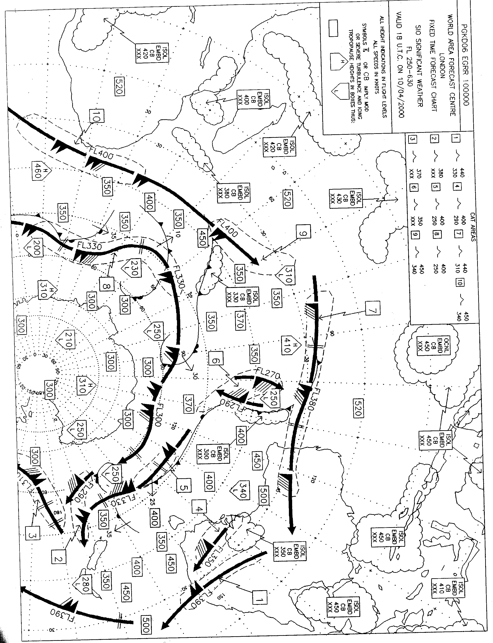

4 - 2 ICAO Region Z - Asia

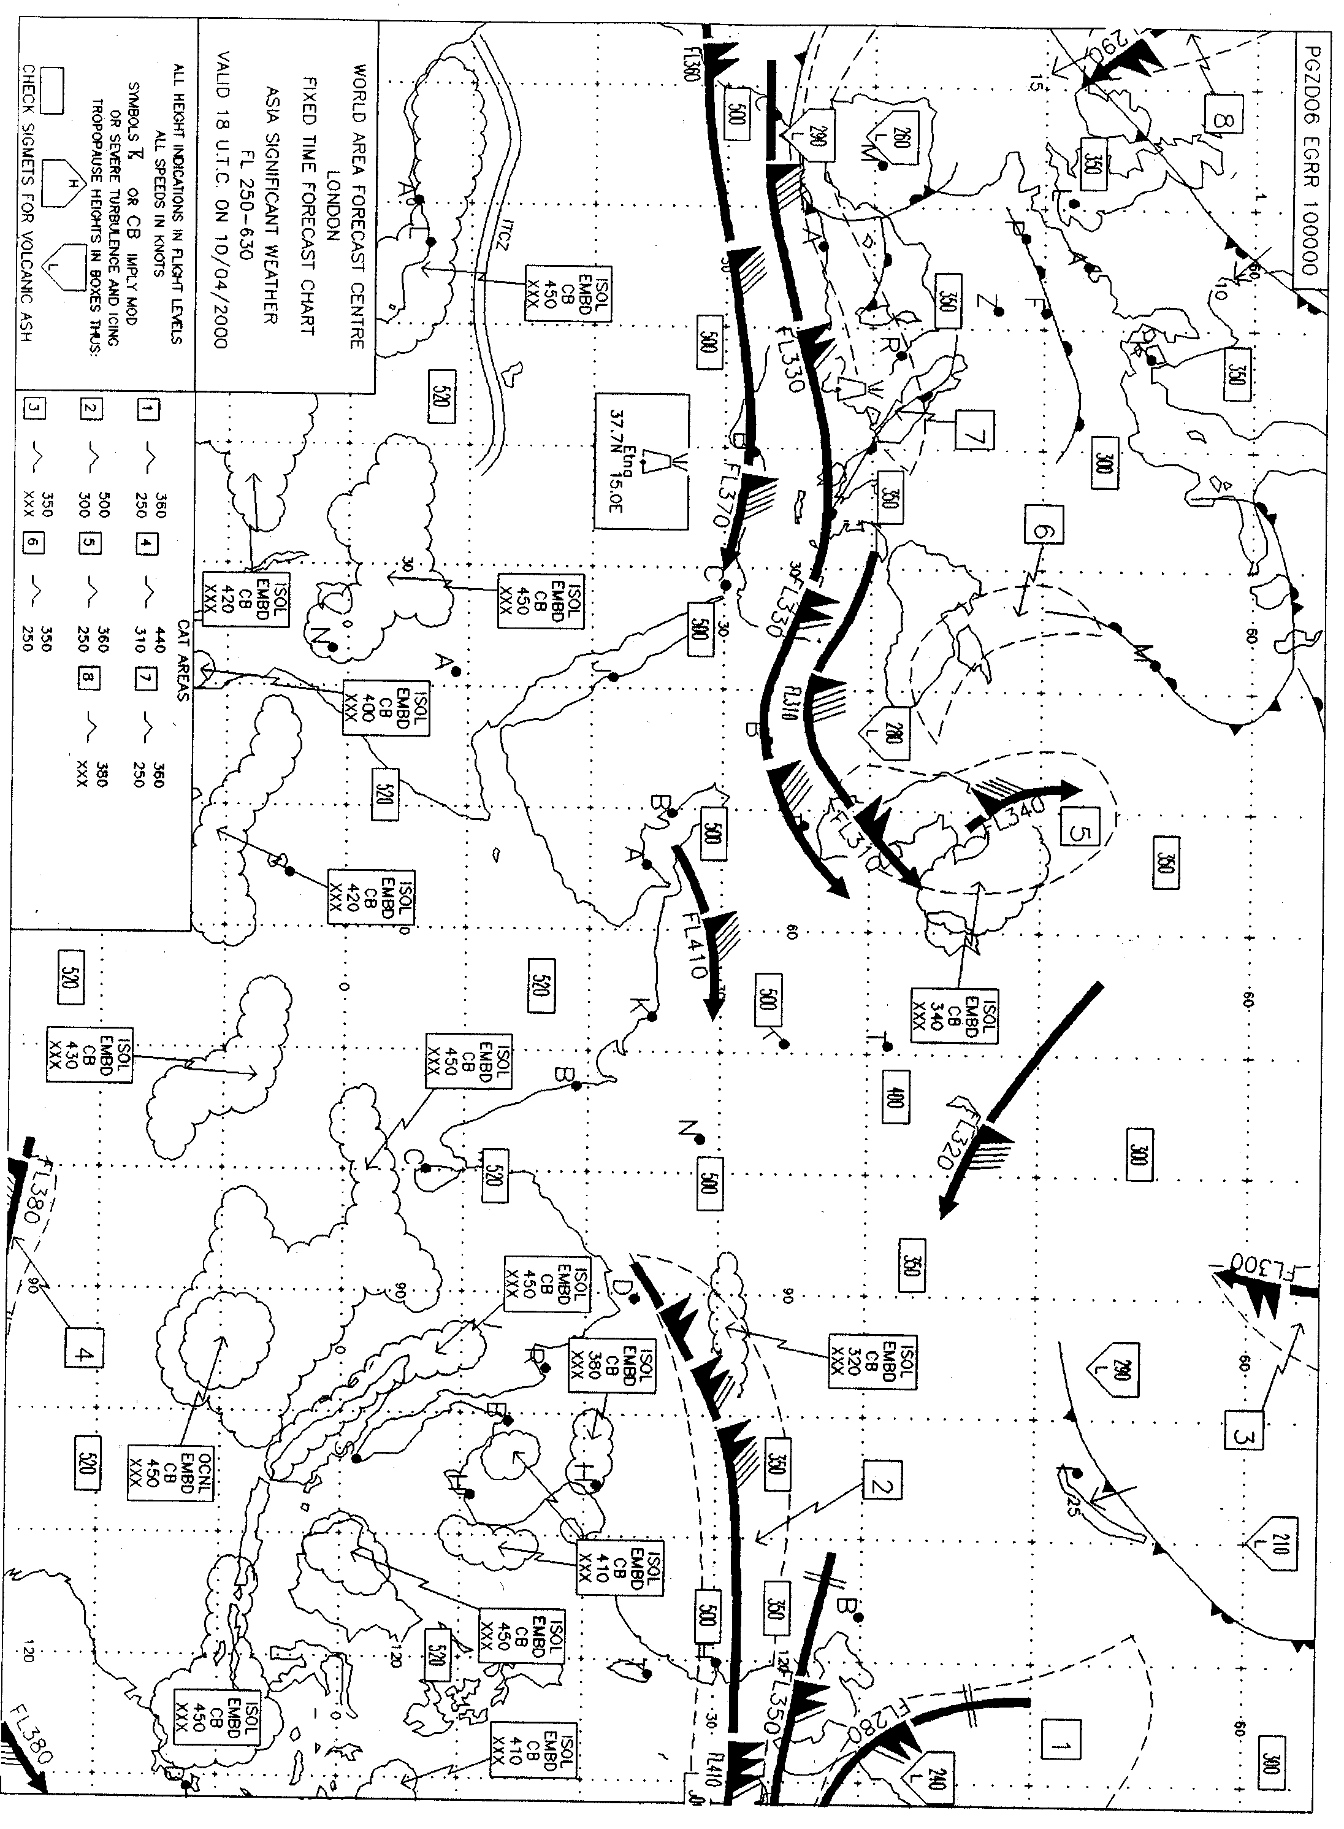

4 - 3 ICAO Region E - INDOC

4 - 4 ICAO Region G - MID

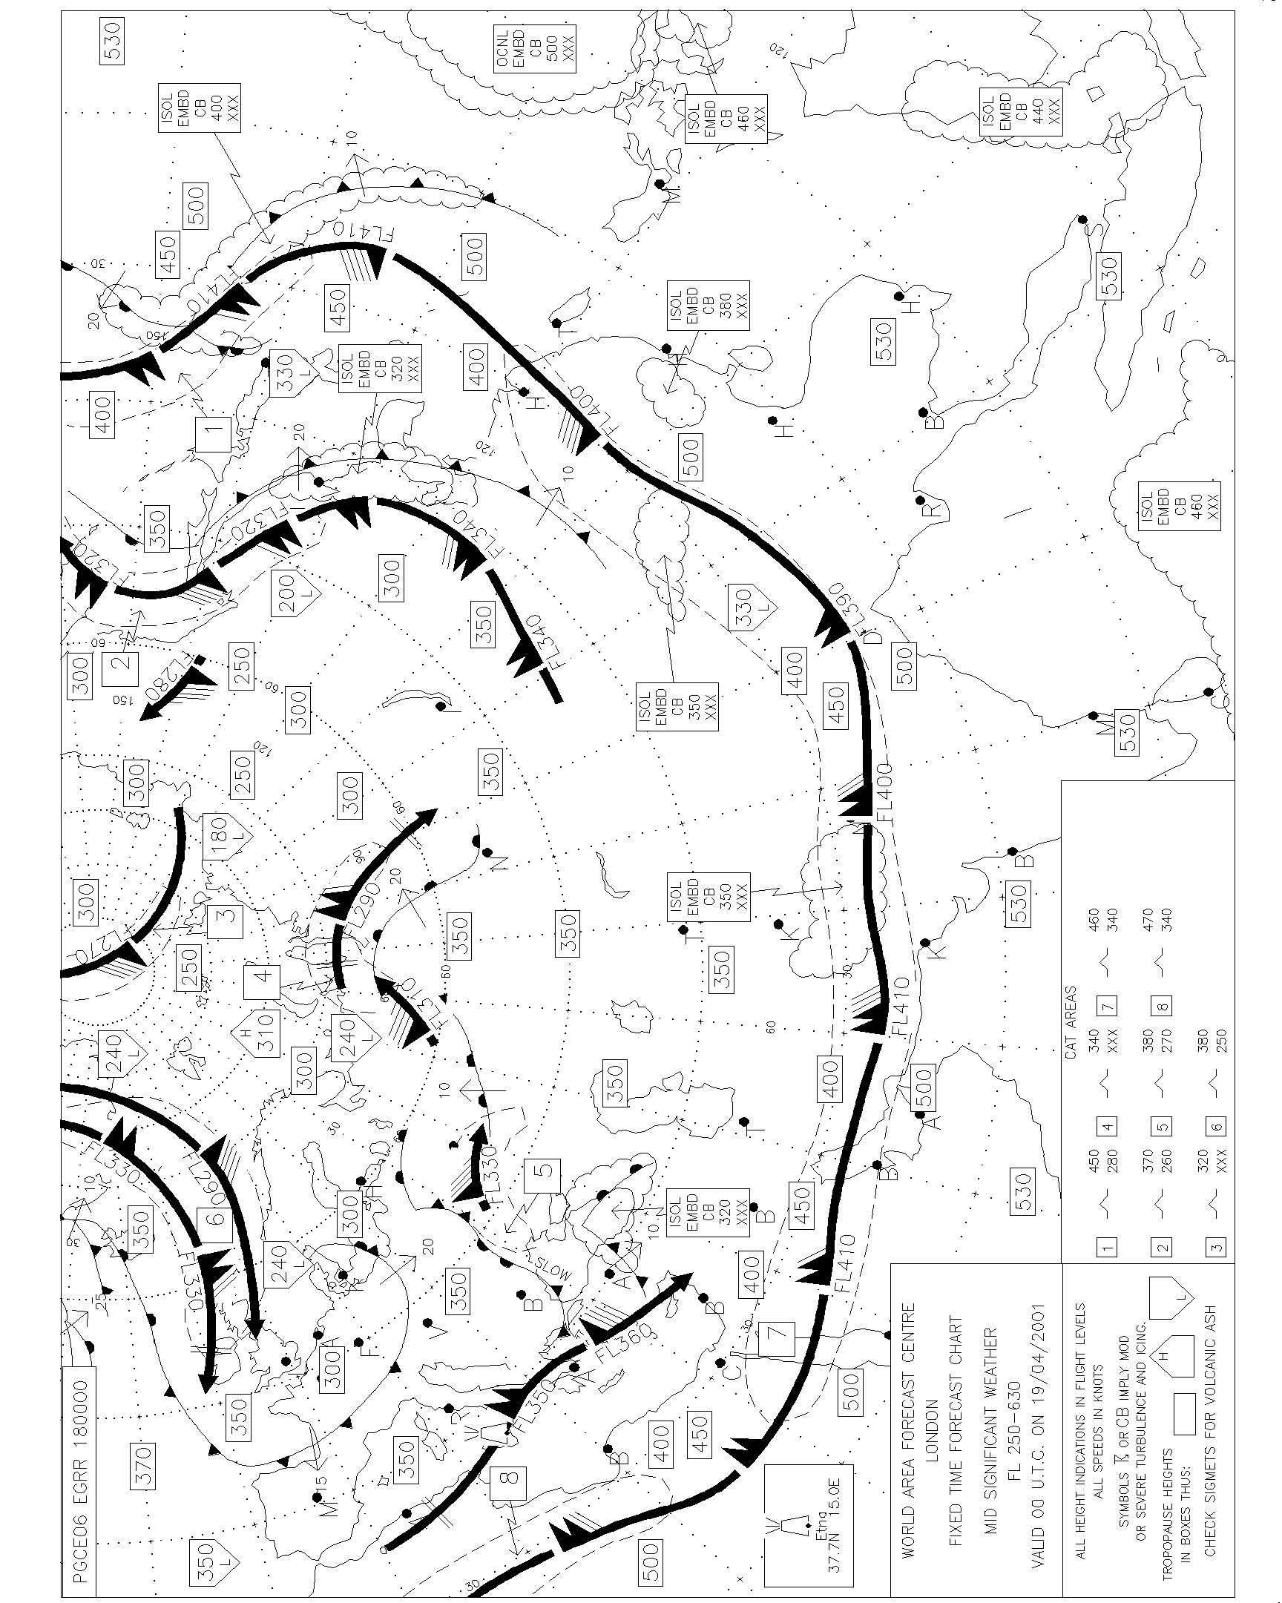

4 - 5 ICAO Region H - NAT

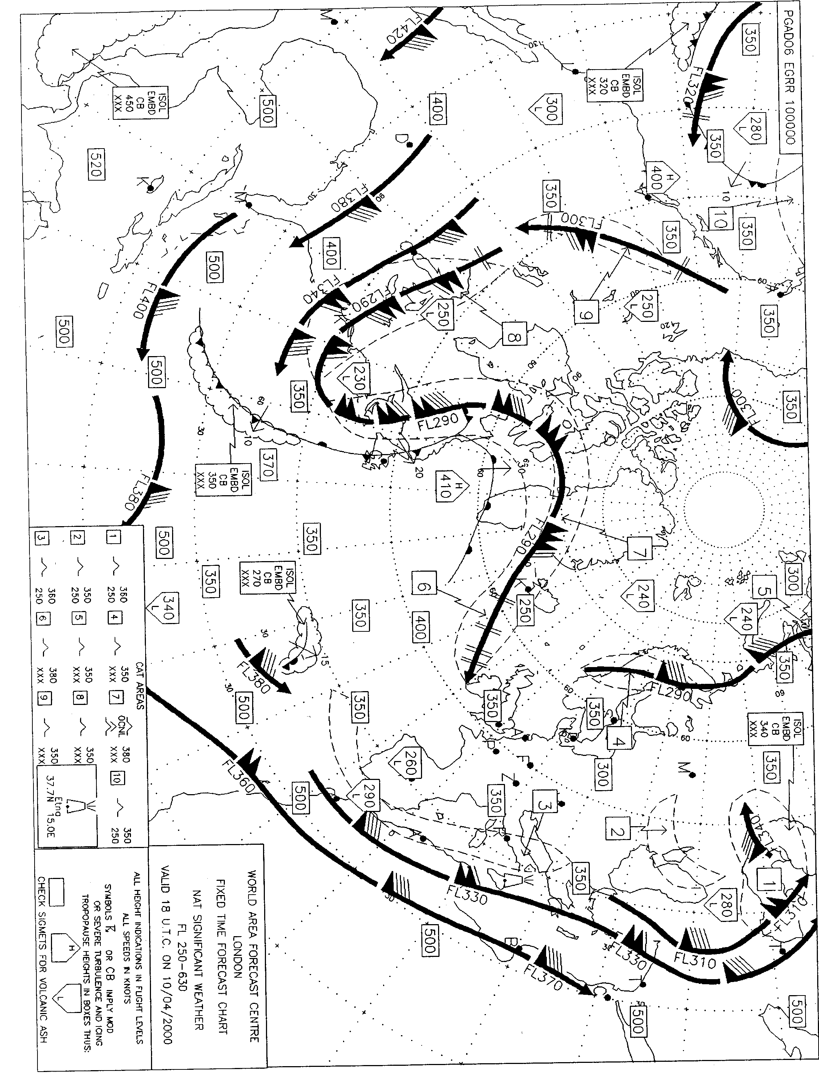

4 - 6 ICAO Region R - AFI

4 - 7 ICAO Region D - EUR/SAM

4 - 8 ICAO Region B - EURO

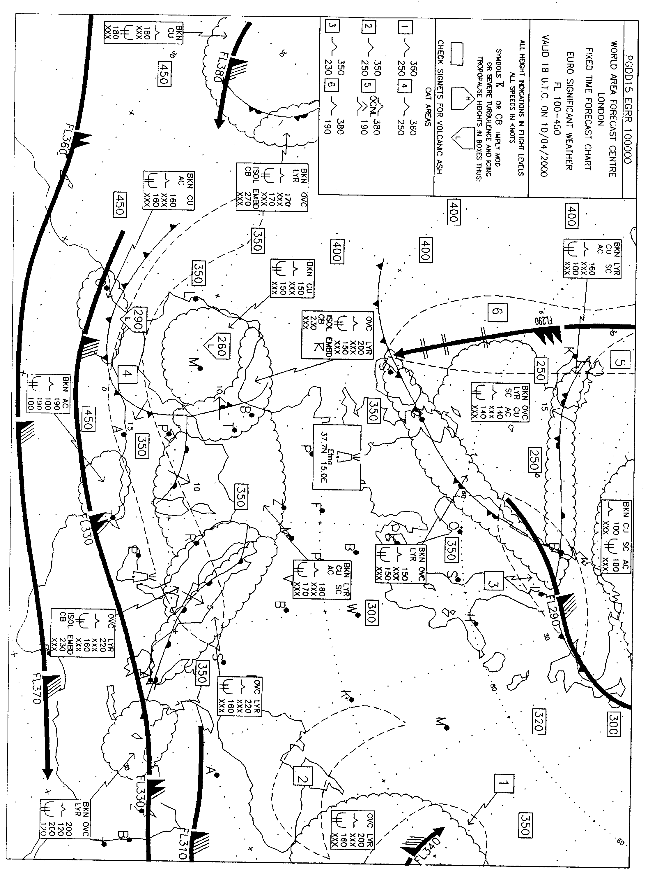

4 - 9 ICAO Region G - MID

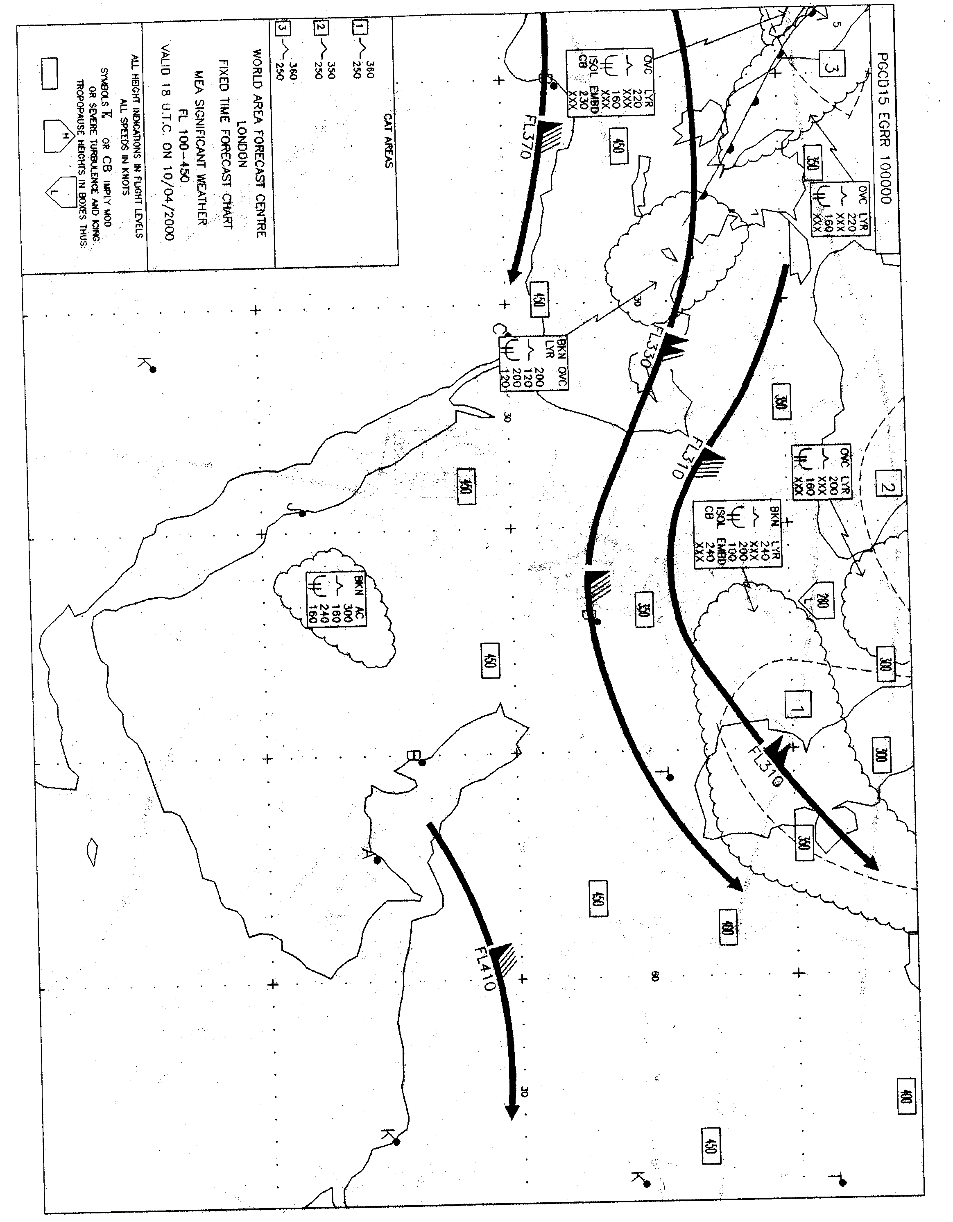

4 - 10 ICAO Region D - Asia South

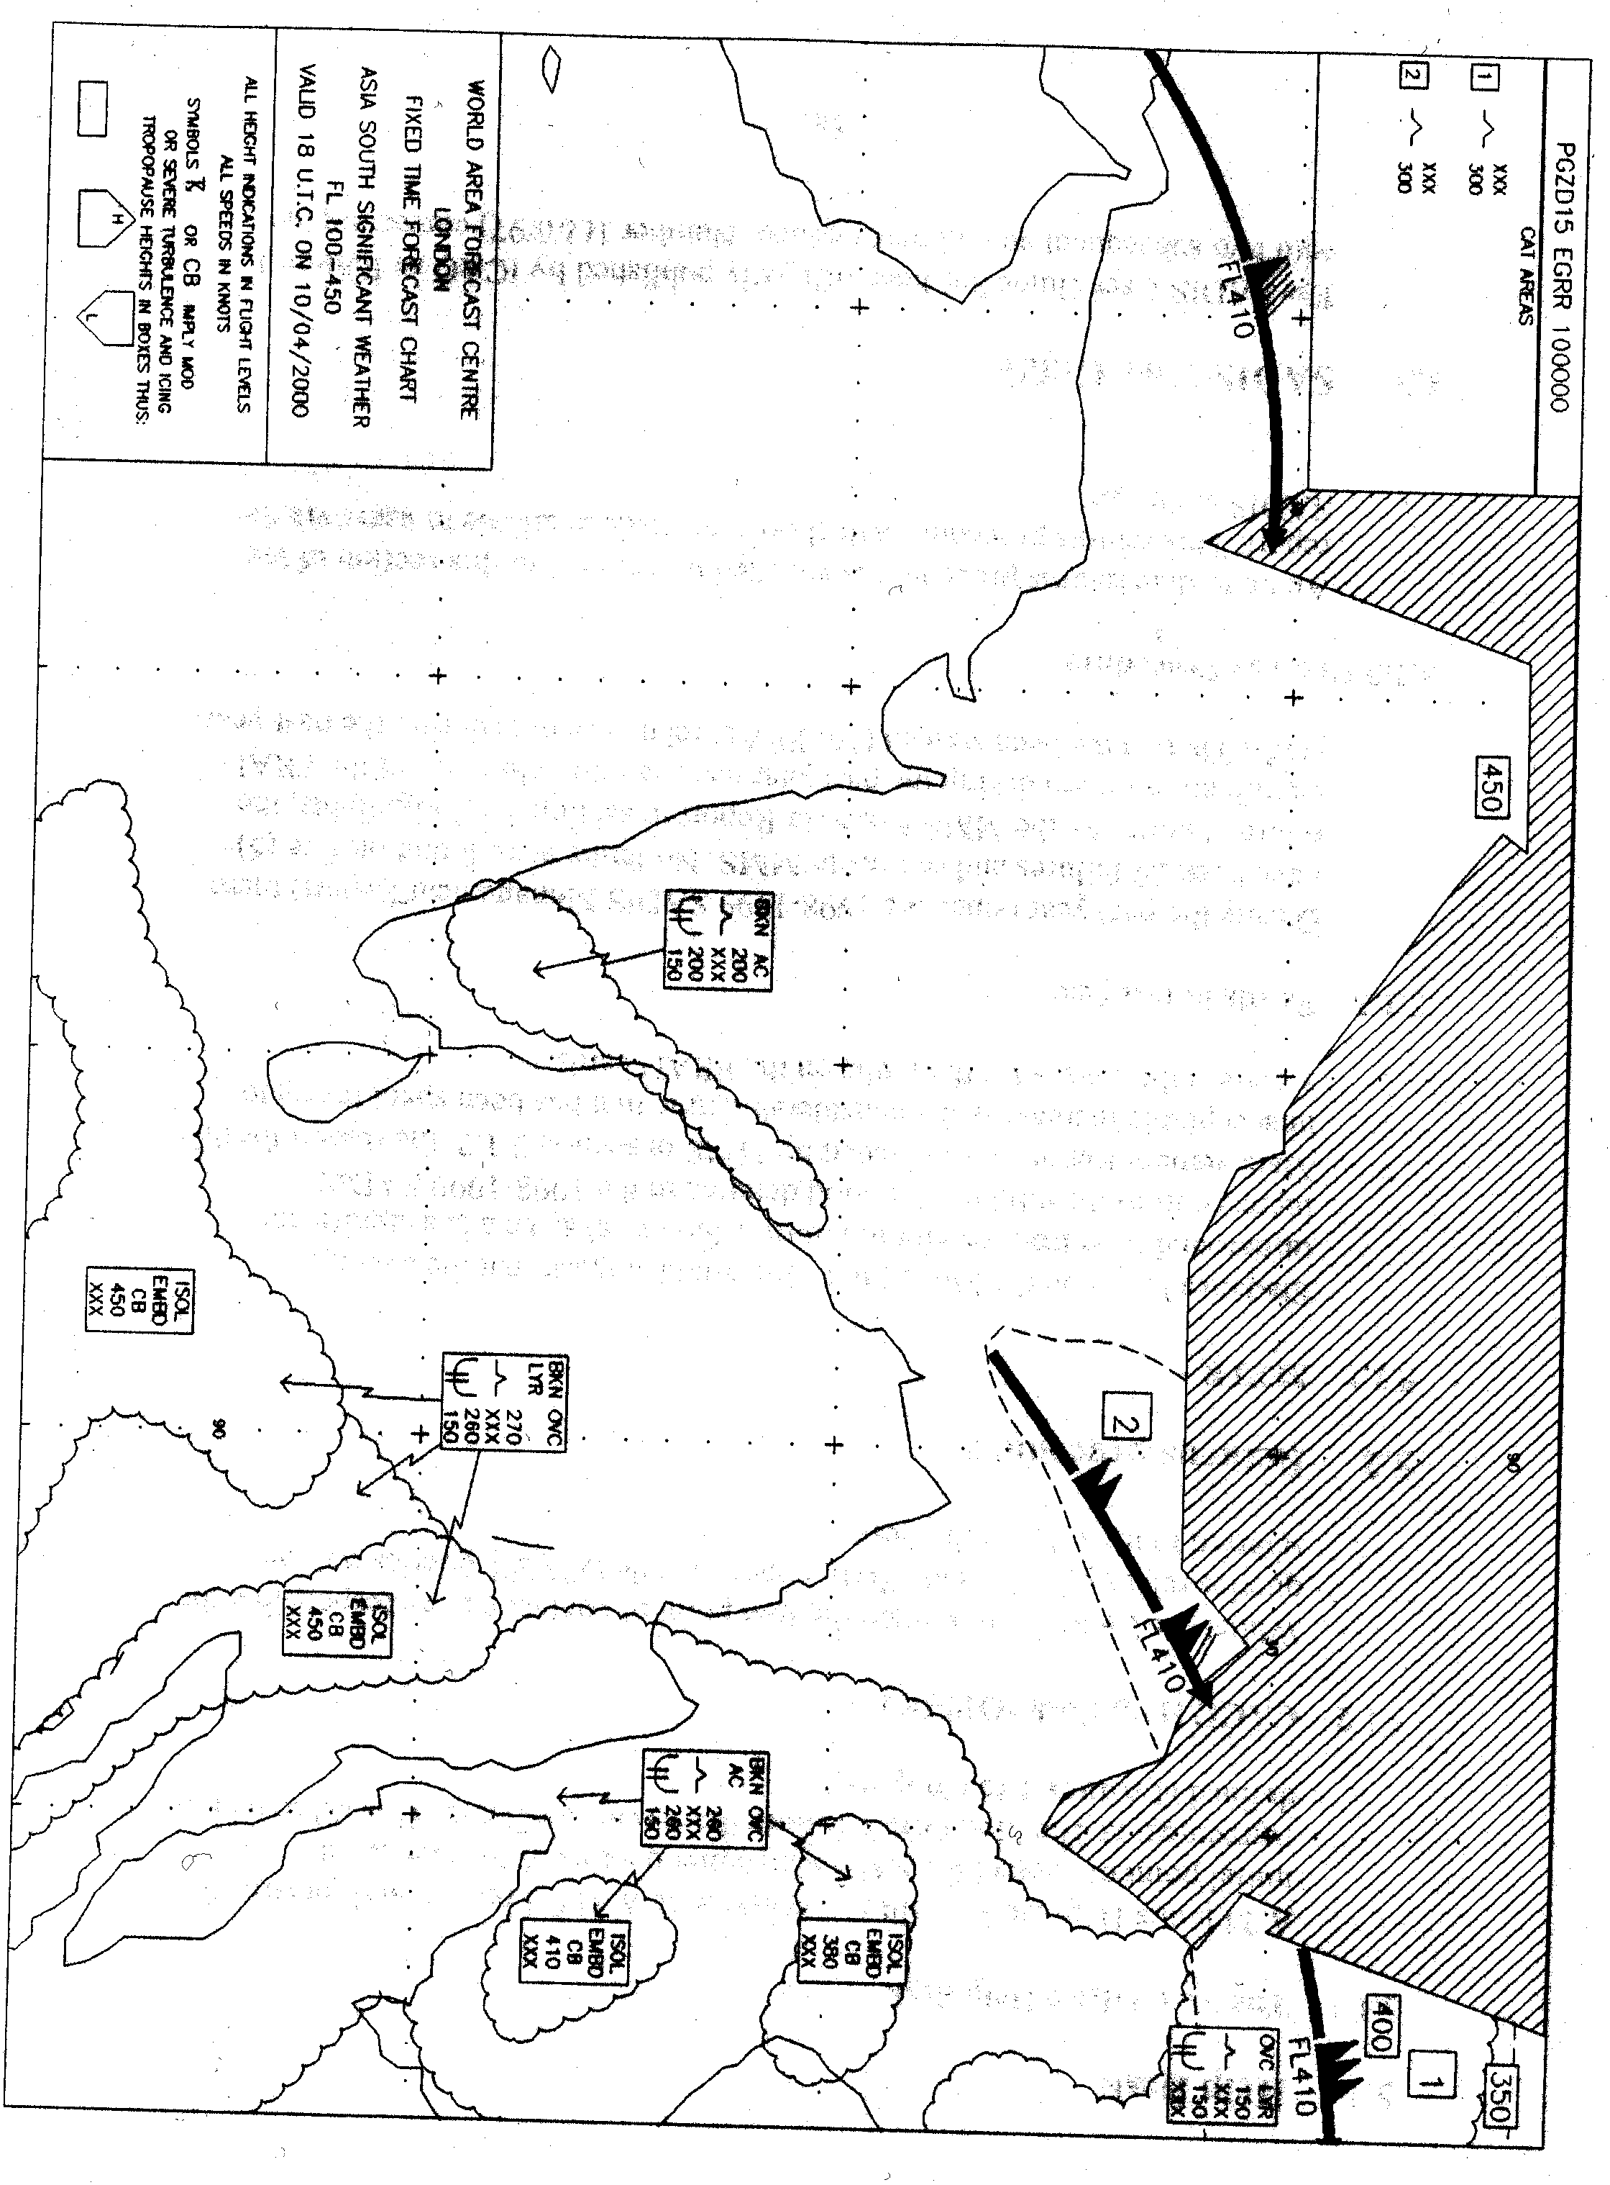

4 -11 ICAO Region A - The Americas

4-12 ICAO Region I - North Pacific

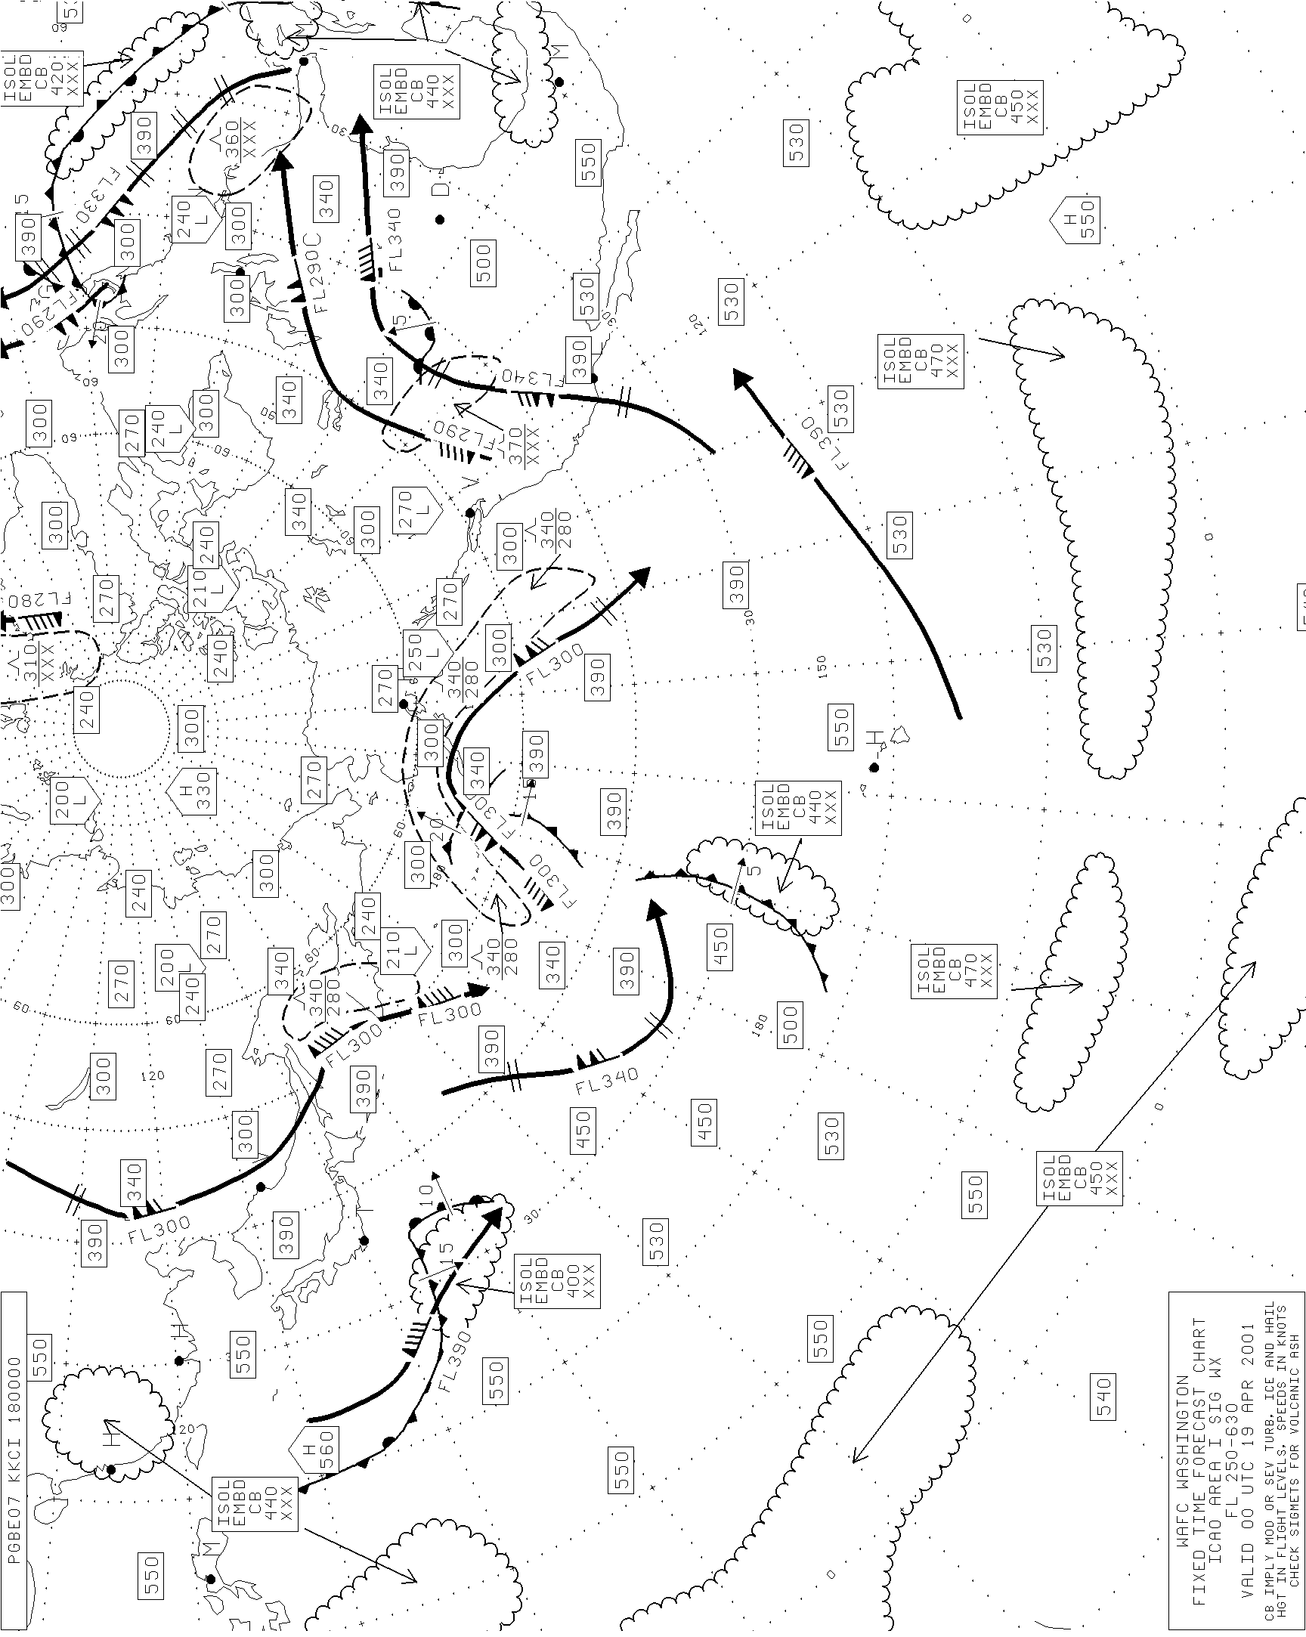

4-13 ICAO Area F – South Pacific

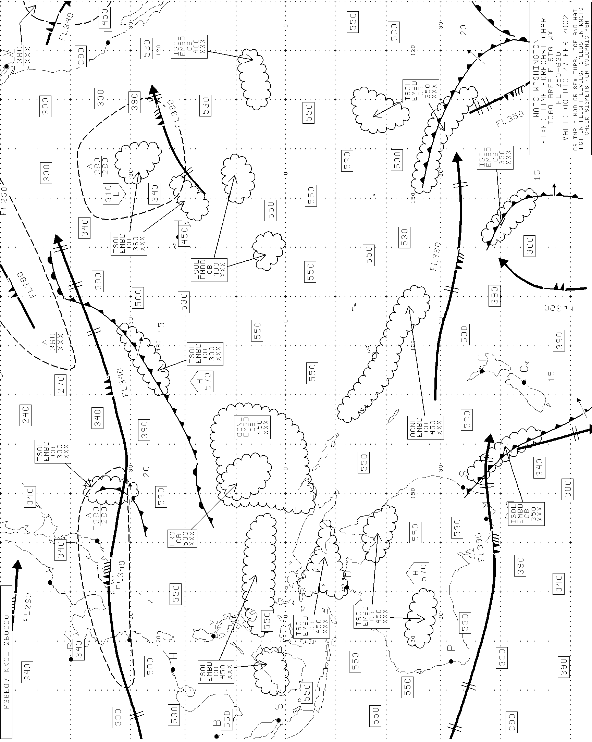

5. USER SERVICES

5.1 Help Desk

5.1.1 The Met Office Help desk

A 24 hours Help Desk facility is available at WAFC London, and remains the initial point of contact for SADIS customer queries. A Service Provision Agreement at the Met Office defines the service available. Users should note that this facility can be accessed via telephone - +00 44 (0)1344 856666 – via fax +00 44 (0)1344 854412 – and via e-mail – helpdesk@metoffice.com This agreement is defined at Annex 1 to Chapter 5.

5.1.2 CACC Help Desk ‘OPMET’

Whilst the Met Office will remain the first point of contact and be responsible for queries relating to T.4 and GRIB, unanswerable OPMET queries may be referred to the CAA Help Desk.

5.2 Hardware Returns procedure

5.2.1 Returns Information

Astrium provide a returns procedure for faulty SADIS hardware. An up to date returns procedure is attached in Annex 2 to this section of the report. Once a unit has been returned to the UK for repair, its progress can be monitored by way of the SADIS returns tracking database that it available via the WWW at URL:

http://www.metoffice.com/sadis/services/astriumdatabase.html

5.2.2 MTTR

Astrium have provided a full report on the mean time to repair (MTTR) and the mean time before failure (MTBF) in section 3.1.2 of this report. It should be noted that a small number of units that have remained with Astrium for an appreciable length of time because of a delay in the acceptance of quotations and in the provision of finance. The MTTR figures that are assigned to these units are artificially raising the MTTR. It should be noted that with the figures for these units removed, the MTTR decreases to 6.0 weeks which is comparable to the MTTR that was applicable at SADISOPSG/6.

5.3 SADIS FTP Backup Service – The Standard Service

5.3.1 In May 2002 the Met Office introduced a free of charge complementary FTP backup service to all approved SADIS or ISCS recipients. This service provides users with an alternative mechanism for receiving WAFS data in the event of problems with the primary receiving equipment. The service is Internet based.

5.3.2 To obtain access to the service the Met Office requires written confirmation from the Met Authority of the State in which the backup service will be used stating that they are content for the user to access the service. On receiving this information the Met Office will provide the user with unique login details. Usage of the service will be monitored and logged. Please contact Pam Sexton (pam.sexton@metoffice.com) or Richard Orrell (richard.orrell@metoffice.com) for further information regarding accessing this service.

5.3.3 The FTP backup service is a real time data library of operational SADIS data. Appropriate visualisation software is required to display (and in the case of GRIB and BUFR) and manipulate the data accordingly. All of the current SADIS workstation manufacturers will be offering a software upgrade to enable their customers to retrieve data from the FTP service via a user-friendly interface, and then visualise the data using the company’s standard visualisation software.

5.3.4 The 24-hour, 365-day a year Met Office Helpdesk will be available to users accessing the SADIS backup service. Non operational issues that do not require immediate action should be directed to Pam Sexton (pam.sexton@metoffice.com) or Richard Orrell (richard.orrell@metoffice.com)

5.3.5 Some recipients of the SADIS or ISCS broadcast may wish to access the Internet based backup service but are currently prevented from doing so by slow and unreliable, or non-existent, Internet connectivity. To address this issue the Met Office has been liasing with a number of companies who can provide Internet connectivity via satellite anywhere in the world. If any users would be interested in learning more about this technology then please contact Pam Sexton (pam.sexton@metoffice.com) or Richard Orrell (richard.orrell@metoffice.com) for further information. This technology will ensure that WAFS data is potentially accessible anywhere in the world.

5.4 SADIS User Guide

Edition 2 of the SADIS User Guide (officially published by ICAO in early 2001) is available for viewing direct from the ICAO web site at URL:

http://www.icao.int/icaonet/dcs/SUG_2ed.pdf

The SADIS User Guide is available in English, French, Russian, Arabic and Spanish.
Annex 1 of the SADIS User Guide will be available shortly in *.PDF format from the ICAO web site. Annexes 2 and 3 of the SADIS User Guide are available for viewing direct from the SADIS web site at URL:

http://www.metoffice.com/sadis/annexes/first.html

Annex 2 of the SADIS User Guide identifies for each aerodrome, the relevant SA, FC, and FT bulletins in which the stations report are listed. The current Annex 3 of the SADIS User Guide identifies the bulletins and the aerodromes contained within each bulletin for each ICAO Region.
.
Annexes 2 and 3 of the SADIS User Guide list those bulletins that are automatically routed and have been seen at the Met Office message switch - TROPICS-E/FROST. If designated bulletins are received at the Met Office message switch, then they will be automatically routed and broadcast on SADIS. Bulletins (that may contain reports for aerodromes listed in SADIS User Guide Annex 1) which are never received by TROPICS-E will obviously be unable to be broadcast on SADIS.

5.5 SADIS WEB PAGE

In compliance with SADISOPSG/3 Conclusion 3/16, WAFC London developed and implemented a SADIS web page, available at:

http://www.metoffice.com/sadis

SADIS authorisation procedures and general system information is currently available, and further enhancements have been made over the past twelve months.

Up to date versions of SADIS User Guide Annexes 2 and 3 are available for viewing from this web site. These annexes are updated on a quarterly basis. The Met Office acknowledges the support and assistance of the EUR MOTNEG, and in particular Belgocontrol for the provision of this data.

The SADIS News Page is available and provides users with additional SADIS information of a non-operational nature.

SADIS administrative messages are posted on to the SADIS web site, and are a direct copy of the bulletins disseminated on the live broadcast.

To help keep SADIS users better informed about the progress of equipment that has been returned to Astrium for repair, the Astrium Returns Tracking Database has been kept up to date throughout the year. The information on the database is updated whenever Astrium supplies new information – normally on a 2-4 week cycle. The database can be accessed via URL:

http://www.metoffice.com/sadis/services/astriumdatabase.html

Annex 1: Standard Service Technical Information Document

**Please note that the terms “Standard Service” and “WAFSBAK” are used interchangably in this document. “WAFSBAK” is the generic name assigned to the server hardware.**

World Area Forecast System (WAFS) Backup Service – The Standard Service

Version 1.0

- Introduction

The WAFS FTP backup system has been provided by the Met. Office as a backup service for the dissemination of operational WAFS data. This facility will enable users to receive WAFS data via the Internet in the event of problems with their primary receiving hardware. This facility will be offered free of charge to all approved SADIS or ISCS recipients.

The WAFS data is placed on a HP UNIX server, which is part of a high performance cluster, directly from The Met. Office message switch - TROPICS. TROPICS will shortly be superceded by a new message switch - FROST. The data is available in real time and is placed on the server at the same time as it is transmitted on the live satellite broadcast, thus making WAFSBAK a truly real time system.

- User Access

Any approved SADIS or ISCS recipient can obtain access to WAFSBAK so long as they have obtained specific approval from their Met Authority. The Met Office will require a copy of the approval authorisation (letter, fax, or e-mail) from the Met Authority before granting access to a user. Once the Met Office has seen evidence of the approval, a unique username and password will be assigned to the user so that access can take place. This simple process is summarised below.

User requests access to WAFSBAK
|
User seeks approval from their Met Aurthority
|
Copy of authorisation is passed to Met Office
|
Met Office issues user with WAFSBAK access information
|
Access commences

- General WAFSBAK Service Information

WAFSBAK is a simple data library, and does not provide any sort of visualisation. Visualisation of products extracted from WAFSBAK will require additional software which is being developed by the SADIS workstation manufacturers (Almos SIGMEX BV, Corobor, I.E.S., Netsys, and Sofreavia), or by in-house software developed or obtained by the end user. Data formats on WAFSBAK will be of the same type as the same products obtained via SADIS, namely:

OPMET – Text
SIGWX Charts and Wind & Temperature Charts – T.4 facsimile format
BUFR encoded high level SIGWX information – BUFR
GRIB encoded wind, temperature and humidity information – GRIB1
Volcanic ash trajectory/dispersion charts – T.4 facsimile format
Volcanic ash and tropical cyclone advisory statements - Text

Customer usage of WAFSBAK will be monitored. Files will be created logging which products each user downloads. If a customer appears to be abusing the service then their access may be barred.

Significant resources are being used to provide the WAFSBAK service. This include an L-class HP server, and a guaranteed bandwidth of 2MB/s from the server to the Internet (from October 2002). This bandwidth will be proportioned to allow up to 100 simultaneous accesses at 20KB/s. These specifications can be upgraded if demand necessitates.

- Customer login process

Individual customer accounts will be established on the server. These will be accessed via a unique set of login information: a username, and a password. This information will be provided by the Met Office to each and every user.

Workstation software needs to be constructed in such a way as to automate the login process. The software needs to be able to store the customers login details and send these directly to the WAFSBAK server when required. FTP sessions need to be established as seamlessly for the customer as possible.

General login information for the service:

IP Address: 151.170.243.6
Server name: sadis.meto.gov.uk
Domain name: meto.gov.uk
FTP address: ftp sadis

- File formats on WAFSBAK

All files on WAFSBAK follow the WMO FTP standard.

All concatenated files follow this format:

^CMessage Length
Bulletin Number
Bulletin Header
Actual Data

Explicitly this means that the first line of each concatination begins with a ^C character except the very first line in a concatenated file which does not have the ^C character but follows the rest of the format detailed above. The example below contains the very first three concatinated files from an OPMET file. Additional highlighting text is given by the side in bold red type.

0000053600^A^M^M There is no ^C character, but the digits give the message length
387^M^M This is the bulletin number
SAFR41 LFPW 181300^M^M This is the standard WMO bulletin header (AHL)
LFBG 181300Z 17004KT CAVOK 08/02 Q1024=^M^M
LFBI 181300Z 20005KT 9999 SCT040 BKN050 07/04 Q1023 NOSIG=^M^M
LFBL 181300Z 13003KT 9999 SCT016 BKN043 05/02 Q1023 NOSIG=^M^M
LFKC 181300Z 33006KT 9999 FEW036 12/03 Q1020 NOSIG=^M^M
LFKF 181300Z 25013KT 230V300 9999 SCT037 13/04 Q1020 NOSIG=^M^M
LFLB 181300Z 35002KT 8000 FEW026 04/M02 Q1024 NOSIG=^M^M
LFLD 181300Z 23005KT 3500 BR BKN004 05/05 Q1023=^M^M
LFLV 181300Z 17005KT 130V210 9999 OVC026 05/00 Q1023=^M^M
LFTH 181300Z 12004KT 080V170 9999 FEW030 13/05 Q1020 NOSIG=^M^M
^C0000029700^A^M^M ^C character, followed by the message length
388^M^M This is the bulletin number
SABN31 OBBI 181300^M^M This is the standard WMO bulletin header (AHL)
OBBI 181300Z 33022KT 9999 FEW025 17/10 Q1020 NOSIG= ^M^M
OEDF 181300Z 32016KT CAVOK 17/M04 Q1020 NOSIG= ^M^M
OEDR 181300Z 30012KT CAVOK 16/05 Q1019 NOSIG=^M^M
OTBD 181300Z 32014KT 260V360 9999 FEW025 18/09 Q1019 NOSIG=^M^M
OKBK 181300Z 32014KT CAVOK 17/00 Q1022 NOSIG=^M^M
^C0000013500^A^M^M ^C character, followed by the message length
389^M^M This is the bulletin number
SACN31 CWAO 181300^M^M This is the standard WMO bulletin header (AHL)
METAR CYJT 181300Z 07005KT 15SM -SHSN SCT025 BKN038 M06/M08 A2976 RMK^M^M
SC4SC3 VSBY LWR N-NE SLP078=^M^M
etc..etc..

All non-concatinated files, BUFR, T4 products etc., follow the same format but do not contain the ^C character at the start of the file.

- WAFSBAK Directory Structure

Following considerable amount of helpful feedback from a number of manufacturers and some SADIS users who were engaged in beta testing the original software, a number of important changes have been made to the format and structure of the file library on WAFSBAK.

It is not envisaged that any further changes will be made in the foreseeable future. However we would always value any feedback from users as to how this file library could be modified to improve the service to its customers. If any further changes are required then these will have to go through a formal change request process.

Top Level Directory Structure on WAFSBAK

BUFR
GRIB
OPMET
OPMET_daily_hourly_files
OPMET_last_5mins
OPMET_last_hour
OPMET_set_of_5min_files
SADIS_Administrative_Messages
Special_AIREP
T4_Charts
T4_chart_amends
Tropical_Cyclone_Advisories
Volcanic_Ash_Advisory_Statements
Volcanic_Ash_Dispersion_Graphics
last_18hours_data

We will now go through these different directories one by one highlighting how each directory and file is populated.

  - BUFR

Please Note: All files contained within directory BUFR are in binary.

The sub-directories of BUFR are a breakdown to all 9 types of BUFR bulletin. These directories are populated by files which contain the raw BUFR bulletins. 36 hours worth of BUFR data files is stored in each directory.
File names are of the format JU*E/D**_EGRR_ddTTtt.

The 9-sub directories are:

CAT
Embedded_CB
Fronts
ICING
JETS
Other_Parameters
Other_SIGWX
TROP
TURB

Please note that directories ICING, Other_Parameters, and TURB contain files which relate to medium level BUFR information. These are not currently produced operationally (February 2002). Operational implementation of these files is planned for later in 2002/early 2003.

BUFR charts based on 0000 UTC model run -
T+18 (“D”) issued between 06:30 and 08:00 Nominal issue time is 08:00)
T+24 (“E”) issued between 12:30 and 14:00 (Nominal issue time is 14:00)
BUFR charts based on 1200 UTC model run -
T+18 (“D”) issued between 18:30 and 20:00 (Nominal issue time is 20:00)
T+24 (“E”) issued between 00:30 and 02:00 (Nominal issue time is 02:00)

  - GRIB

Please Note: All files contained within directory GRIB are in binary.

The sub-directories of GRIB are a breakdown to the following directories:

T+12
T+18
T+24
T+30
T+36
T+6

Within each of these 6 directories are a number of downloadable files of name format T+XX_TTtt. 24 hours worth of data is stored in each of these directories, so 4 files should be present because there are 4 GRIB runs per day.

Each file is a concatination of all individual GRIB bulletins which are valid for each GRIB validity period. For example file T+12_0000 will contain ALL WAFS GRIB files (including all parameters) which were produced from the midnight model run and are valid for T+12.

End user software will need to extract individual bulletins from each concatinated file. Each concatinated file is approximately 1.3MB in size.

  - OPMET

OPMET data is stored on WAFSBAK in a variety of different ways. Directory OPMET is one such way and contains a list of 24 files of name format TTZ, which contain 60 minutes worth of OPMET data. For example file named 00Z will contain a concatination of all OPMET bulletins between 00:00Z and 00:59Z. All 24 files are held on the server, and simply updated each time a new file is created.

  - OPMET_last_5mins

This file is populated and updated every 5 minutes. It contains a concatination of the last 5 minutes of OPMET bulletins. This is the file which needs to be regularly downloaded if a user wishes to have permanent access to the very latest OPMET data.

  - OPMET_set_of_5min_files

This directory contains 11 files of name format OPMET_TTtt. These 11 files are created every hour (TT).

In the array below the numbers in quotes correspond to the file extensions (tt) for the set of 5 min files that are updated at the times stated. New data (from file OPMET_last_5mins) gets appended to the relevant files every five minutes.

@ 5 mins past each hour: ("05","10","15","20","25","30","35","40","45","50","55");
@ 10 mins past each hour: ("10","15","20","25","30","35","40","45","50","55");
@ 15 mins past each hour: ("15","20","25","30","35","40","45","50","55");
@ 20 mins past each hour: ("20","25","30","35","40","45","50","55");
@ 25 mins past each hour: ("25","30","35","40","45","50","55");
@ 30 mins past each hour: ("30","35","40","45","50","55");
@ 35 mins past each hour: ("35","40","45","50","55");
@ 40 mins past each hour: ("40","45","50","55");
@ 45 mins past each hour: ("45","50","55");
@ 50 mins past each hour: ("50","55");
@ 55 mins past each hour: ("55");

Thus if a user logs on at 37 minutes past the hour (TT) if they download file OPMET_TT35 they will obtain a file which contains all of the OPMET which has been received by the server from 00 minutes past the hour to 35 minutes past the hour.

  - OPMET_last_hour

The file OPMET_last_hour is produced once per hour and updated every hour – on the hour. It is produced when file OPMET_TT55 is updated with the OPMET bulletins received between the production of OPMET_TT55 and the creation of OPMET_(TT+1)05, ie. it contains the last hour of complete OPMET bulletins.

  - OPMET_daily_hourly_files

The 24 files which are contained within this directory have the name format:
“OPMET_hourly_data_TT00”. Each file is updated once every 24 hours and is a copy of the file “OPMET_last_hour” which is created every hour of the day. Therefore all 24 files contained within the directory should contain data, and are updated when the constituting “OPMET_last_hour” file is created.

  - SADIS_Administrative_Messages

SADIS administrative messages have AHLs of NOUK10 EGRR and NOUK11 EGRR. Any recent messages are stored as individual files in the SADIS_Administrative_Messages directory. These messages are automatically deleted at 23:55 each day if they have resided on the server for greater than 24 hours.

  - Special_AIREP

Special AIREP bulletins of AHL format UA**** CCCC are placed as single files within this directory. These messages are automatically deleted at 23:55 each day if they have resided on the server for greater than 24 hours.

  - T4_Charts

This important directory contains two sub directories – SIGWX and Wind_n_Temperature. These important sub-directories contain all of the WAFS SIGWX chart and the WAFS wind and temperature charts.

SIGWX sub-directory

This sub-directory is further broken down into the following directories:

AMERICAS (containing PGEE07_KWBC_TTttii 4*daily) [Americas area]
ASIA (containing PGGE07_KWBC_TTttii 4*daily) [S. Pacific area]
Asia_South (containing PGZD06_EGRR_Ttttii 2*daily,
PGZE06_EGRR_TTttii 2*daily,
PGZD15_EGRR_TTttii 2*daily, and
PGZE15_EGRR_TTttii 2*daily)
EUR (containing PGDD15_EGRR_TTttii 2*daily, and
PGDE15_EGRR_TTttii 2*daily)
EURAFI (containing PGRD06_EGRR_TTttii 2*daily, and
PGRE06_EGRR_TTttii 2*daily)
EURASIA (containing PGHE32_HKNC_TT1200 1*daily,
PGHE36_HKNC_TTttii 1*daily,
PGHE38_HKNC_TTttii 1*daily, and
PGHE98_HKNC_TTttii 1*daily)
EURSAM (containing PGSD06_EGRR_TTttii 2*daily, and
PGSE06_EGRR_TTttii 2*daily)
INDOC (containing PGGD06_EGRR_TTttii 2*daily, and
PGGE06_EGRR_TTttii 2*daily)
MEA (containing PGCD15_EGRR_TTttii 2* daily, and
PGCE15_EGRR_TTttii 2* daily)
MID (containing PGCD06_EGRR_TTttii 2*daily,
PGCE06_EGRR_TTttii 2*daily)
NAT (containing PGAD06_EGRR_TTttii 2*daily, and
PGAE06_EGRR_TTttii 2*daily)
North_Pacific Currently empty.
PACIF (containing PGBE07_KWBC_TTttii 4*daily) [N.Pacific area]
SIO (containing PGKD06_EGRR 2*daily, and
PGKE06_EGRR_TTttii 2*daily)
South_Pacific Currently empty.

Please note that bulletins which have been created by centres other than EGRR and KWBC will be deleted from the service when the RAFC status of the originating office is terminated. Also, it is envisaged that bulletins (seemingly) created by KWBC will soon be stored on the FTP server with a CCCC group of KKCI. This is the official ICAO designator of the originating office.
Files are stored for at least 24 hours. These files are automatically deleted at 23:55 each day if they have resided on the server for greater than 24 hours.

Wind_n_Temperature sub-directory

This directory is broken down into the following sub-directories:

ASIA
EUR
EURAFI
EURSAM_B
EURSAM_B1
INDOC
MID
NAT
PACIF
SAM

The names of these sub-directories correspond to the different ICAO regions. The charts contained in each sub-directory, and stored as individual files, are valid for the ICAO region whose name is assigned to the sub-directory. File names are identical to the AHLs of the same bulletins broadcast via SADIS.

As before, files are stored for at least 24 hours, and the files are automatically deleted at 23:55 each day if they have resided on the server for greater than 24 hours.

  - T4_chart_amends

These products are simple, generally short, text files and are available from the T4_chart_amends directory. Files are stored for at least 24 hours, and are automatically deleted at 23:55 each day if they have resided on the server for greater than 24 hours.

File names:

FXUK65_EGRR_TTttii
FXUK66_EGRR_TTttii

  - Tropical_Cyclone_Advisories

Files placed in this directory are text files and are stored for at least 24 hours, automatically deleted at 23:55 each day if they have resided on the server for greater than 24 hours.

  - Volcanic_Ash_Advisory_Statements

Files placed in this directory are text files and are stored for at least 24 hours, then automatically deleted at 23:55 each day if they have resided on the server for greater than 24 hours.

  - Volcanic_Ash_Dispersion_Graphics

Files placed in this directory are in T.4 facsimile format and are stored for at least 24 hours, automatically deleted at 23:55 each day if they have resided on the server for greater than 24 hours.

At the current time (February 2002) these products are not produced by all the Volcanic Ash Advisory Centres (VAAC) in a format which is acceptable for SADIS broadcast. Only charts products by VAACs London, Toulouse, Washington and Montreal are available via this directory (or indeed via the live SADIS broadcast).

  - last_18hours_data

This extremely large file is a concatination of the last 18 hours worth of SADIS data in one file. As a result a complete mixture of different formats is contained in the file.

6. Contact Information

The initial point of contact within the Met Office for operational issues should be the Helpdesk which is available 24 hours a day, 365 days a year.

E-mail: helpdesk@metoffice.com
Telephone: +44 (0)1344 856666

Other issues, including requests from users wishing to access the service, and general feedback should be directed to Richard Orrell at WAFC London.

E-mail: richard.orrell@metoffice.com
Telephone: +44(0)1344 854892
Fax: +44(0)1344 854156

7. Users wishing to access the service but with no/poor Internet connectivity

The Met Office has been investigating various solutions to enable users who currently do not have Internet access, or whose access is unreliable or slow, access to a reliable high speed connection. The Met Office anticipates holding a trial during the latter part of 2002 to take a look at this technology in detail. Even though it is not envisaged that the Met Office will specifically recommend a technology to any one user, we are happy to point an interested customer in the direction of a few companies who may be able to provide a cost effective Internet service via satellite anywhere in the world. Please contact Richard Orrell for further information about this option.

Annex 2: Met Office Help Desk Facility: Service Provision Agreement

UK HELP DESK FACILITY

Support Cover Time

The Met Office IT Operations Centre shall provide support on a 24 hour per day, 365 days per year basis for all the agreed services.

The Services

1. Call logging

Information to be logged:

Caller details – name, location and telephone contact number
Incident details – two field categorisation plus free text information
Date and time of logging
Logging Operator i/d

Method of call logging:
Telephone (ex 6666)
E-mail (helpdesk@metoffice.com)
Fax (ex 4412)

Call logging Targets

Telephone -80% of all calls to be answered within 20 seconds

-100% of all calls to be answered within 5 minutes
e-mail requests
-80% logged within 15 minutes of receipt
-100% logged within 1 hour of receipt
Fax
-80% logged within 15 minutes of receipt
-100% logged within 1 hour of receipt

All incidents logged will have a unique reference assigned to them (an IDC number) – this reference number should be quoted if any follow up action is required

2. Level One Support

The first phase of level one support is immediate telephone support and shall be undertaken following the call logging process using information that is readily available and quickly deliverable; requests for repeat data shall normally be handled in this stage. It should be noted though that data re-sends are not normally initiated unless a product has failed to be broadcast to all recipients. The Helpdesk operators have access to a bulletin monitoring program which clearly indicates whether a product has been successfully transmitted and received (in Bracknell) via SADIS. This approach is taken to prevent confusion to users when multiple broadcasts of a product occur.

Targets
-provide the first phase of support in less than 5 minutes
-to log all actions taken

The second phase of level one support shall be undertaken to cover any issues that are contained in the user guide or deal with data supply problems.

Targets
-to be completed within 30 minutes
-to log all actions taken

System Monitoring
Provide system monitoring and action specific events as agreed with the SADIS support team.

3. Level Two Support

Provide support within the scope of training delivered and documentation provided, this shall include:

communication links to Whitehill - fault identification and rectification, management of rectification by carrier suppliers as required;

communication equipment (Megapac), fault identification and rectification using third parties as required;

equipment at Whitehill, switching from chain A to B;

assistance with technical problems at Whitehill;

investigation of data content with referral to the product production or product routing teams as required.

Targets
-to be completed within 30 minutes to 4 hours dependent on other operational priorities or to escalate at agreed times to third parties.
-to log all actions taken

Annex 3: Astrium Returns Procedure & Forms


SADIS VSAT RETURNS PROCEDURE

The following procedure will apply to any equipment that has become defective and needs to be repaired - including items that are still under warranty.

Any item returned without seeking prior authorisation from ASTRIUM may only be repaired at the discretion of ASTRIUM.

1. Before returning any equipment, please FAX or EMAIL a request for a RMA
(Return Materials Authorisation) number using the forms on the next two pages to:-

Mr L. Fowler (Product Support Manager), Astrium Ltd

Fax No. 011 - 44 - (0)1625 884899 or
Email to: les.fowler@astrium-space.com

Please state clearly the following (itemised on the attached two forms):-

1. Sender's name
2. Sender's fax number
3. Company name & address
4. Return address if different from above
5. Equipment type
6. Serial number
7. Date of purchase (approx.)
8. Purchase Order number (if known)
9. Nature of defect (describe in brief and then fill in fault report)

A RMA number will be issued together with details of where to send the goods and paperwork for customs purposes. A specimen VSAT return label is attached for information.

2. The following conditions will apply to all items returned for repair, unless subject to separate agreement:-

a) Repairs will be returned in "as received" condition and NOT refurbished to
"as new" standard.

b) All returns received outside of the warranty period will be subject to an investigation/administration charge. Repair charges will be subject to a separate quotation.

c) All returns received within the warranty period with the exception of items deemed "NO FAULT FOUND" shall be repaired free of charge. Items deemed "No fault found" will be sub,ject to an Investigation/Administration charge PLUS carriage.

d) The warranty period for repaired items will be 90 days, or the remaining balance of any existing warranty period, whichever is the greater.
To:  (page 1 of 2)

For Attention: Mr L. Fowler (Product Support Manager), Astrium Ltd, Poynton

Fax No. 011 - 44 - (0)1625 884899
Email: les.fowler@astrium-space.com

SADIS VSAT RETURNS PROCEDURE

REQUEST FOR A RETURN MATERIALS AUTHORISATION (RMA) NUMBER

Section 1: Senders Details

Name
Tel. Number |  | Fax. Number
Company Name
Company Address
Return Address (for equipment) if different from above

Section 2: Equipment Details

Equipment Type
Serial Number
Date of Purchase (approx.)
Purchase Order Number (if known)
Nature of defect (Please describe briefly below and then fill in fault report on page 2)

To: (page 2 of 2)

For Attention: Mr L. Fowler (Product Support Manager), Astrium Ltd, Poynton

Fax No. 011 - 44 - (0)1625 884899
Email: les.fowler@astrium-space.com

SADIS RECEIVER FAULT REPORT

Prior to the return of a SADIS receiver for repair please fill in the following information by a tick in the box provided to aid fault diagnosis.

Senders Name |  |  | Fax. Number
Company Name & Address

Step 1 – Front Panel Indications
 |  |  | OK |  | Fault
a) | Is O.D.U. Lamp | ON? | [ ] |  | OFF? | [ ] | then go to STEP 2.
b) | Is I.D.U. Lamp | ON? | [ ] |  | OFF? | [ ] | then return for repair.
c) | Is Fade Lamp | OFF? | [ ] |  | ON? | [ ] | then go to STEP 3.
If all indications are OK then go directly to STEP 4.

Step 2 – Check that 18 V d.c. is present at the RF input connector at the rear of the receiver.
+ V.E. = centre pin |  |  |  | - V.E. = connector outer
If 18 volts present | YES | [ ] | Then L.N.B. or cross cable faulty.
 | NO | [ ] | Then return for repair.

Step 3 – Fade Lamp is ON (see Step 1c)
a) | Check L.N.B. (fit spare).
b) | Check antenna still appears to be as installed.
(If the fade lamp remains ON then return for repair.)

Step 4 – If all indications are correct.
a) | Is the receiver passing data to the terminal?
 |  | YES | [ ] | unit is OK.
 |  | NO | [ ] | Then go to 5.

Step 5 – Turn off the receiver. Wait for 15 seconds and the re-power up the receiver. Is the receiver now passing data?
 | YES | [ ] | Contact Astrium Engineer.
 | NO | [ ] | Return for repair.

VSAT RETURN LABEL

RMA No:

FAO: MR L FOWLER
ASTRIUM LTD
FIRST AVENUE
POYNTON INDUSTRIAL ESTATE
POYNTON
STOCKPORT
CHESHIRE
SK12 1NE
UNITED KINGDOM

NATS infrastructure site: Operational core MET system, including installation, oversight, tests and training: 1 700 000 of which 20 per cent is attributable to SADIS.

