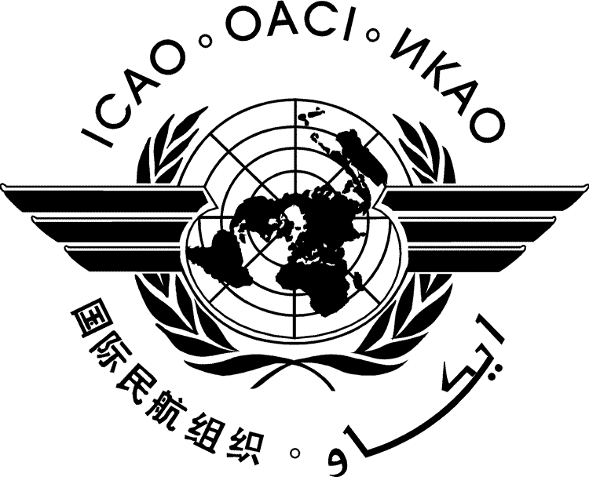 |  | SADISOPSG/18-DP/1  30/5/13

SATELLITE DISTRIBUTION SYSTEM OPERATIONS GROUP (SADISOPSG)

EIGHTEENTH MEETING

Dakar, Senegal, 29 to 31 May 2013

Agenda Item | 1: | Opening of the meeting

DRAFT REPORT

Agenda Item | 1: | Opening of the meeting

- Place and duration
  - The eighteenth meeting of the Satellite Distribution System Operations Group (SADISOPSG/18) was held at the International Civil Aviation Organization (ICAO) Western and Central African (WACAF) Regional Office, Dakar, Senegal, 29 to 31 May 2013.
  - The meeting was opened on 29 May 2013 at 0900 hours by Mr. Mamina Kamara, Deputy Director General of the Agence Nationale de l'Aviation Civile et de la Météorologie du Sénégal (ANACIM). Mr. Kamara extended a warm welcome to participants and highlighted the importance of meteorological services to international air navigation safety and efficiency in the region. These remarks were followed by an opening address by Mr. Mam Sait Jallow, Regional Director, ICAO WACAF Regional Office. Mr. Jallow similarly extended a warm welcome to the group to Dakar. During his address, Mr. Jallow summarized the developments that had taken place since the meeting was last held in Dakar in 2008 (SADISOPSG/13) and the main items that would be discussed during the meeting, including the operation and the development of the SADIS over the coming 5 years or more. Mr. Jallow alluded to an ICAO Meteorology Divisional Meeting proposed to be held in 2014, for which the group’s input would be considered essential to ensure SADIS fulfils users’ requirements into the future and for which the ICAO Council had very recently agreed to convene in July 2014 in Montreal, in part conjointly with the Fifteenth Session of the World Meteorological Organization (WMO) Commission for Aeronautical Meteorology (CAeM-XV).
- Attendance
  - The list of participants is given in Appendix A.
- Chair and officers of the Secretariat
  - The Chair of the group, Ms. Gaborekwe Khambule, presided over the meeting throughout its duration, assisted by the Vice-Chair of the group, Ms. Juan Zou.
  - Mr. Greg Brock, from the ICAO Headquarters, Montreal, was the Secretary of the meeting, assisted by Mr. Akoa Benoit Okossi from the ICAO WACAF Regional Office, Dakar and Mr. Vitalis Ahago from the ICAO Eastern and Southern African (ESAF) Regional Office, Nairobi.

— — — — — — — —

