 | International Civil Aviation Organization  WORKING PAPER
  ACP/1-WP/19
  7/5/07
  English only

AERONAUTICAL COMMUNICATIONS PANEL (ACP)

FIRST MEETING

Montréal, 10 to 18 May 2007

Agenda Item | 1: | Review of the progress on the future communication study

FCS TECHNOLOGY INVESTIGATION OVERVIEW

(Presented by B. Phillips)

SUMMARY
This working paper provides an overview of the Future Communication Study (FCS) technology investigation progress. It includes a description of the methodology applied to technology evaluation; evaluation criteria; and technology screening (down select) results. A comparison of screening results with other similar technology screening activities is provided.

Additional information included in this working paper is a description of in-depth studies (including characterization of the L-band aeronautical channel; L-band deployment cost assessment; and performance assessments of candidate technologies in the applicable aeronautical channel) that have been conducted to support technology evaluations. The paper concludes with a description on-going activities leading to conclusion of the technology investigation and the development of technology recommendations.

Action by the ACP is in paragraph 10.

- INTRODUCTION
  - One goal of the Future Communication Study (FCS) cooperative research program is the investigation of candidate communications technologies to identify those that can support the long-term aeronautical mobile air-ground communication operating concept. The long term operating concepts and associated requirements for the Future Radio System (FRS) are being defined in the Communications Operating Concept and Requirements (COCR) for the Future Radio System, one product of the FCS. The FRS technology investigation effort has been planned as a sequence of studies, including Phase I: Technology Pre-Screening (completed in December 2004), Phase II: Technology Screening (completed July 2006), and Phase III: Detailed Technology Investigation (scheduled for completion in 2007).
  - A primary result of the Technology Pre-Screening (Phase I) was that there was no one solution that best met all of the needs of aviation stakeholders. Rather, a set of recommended areas of investigation was identified that would support future communications options including more efficient utilization of the Very High Frequency (VHF) spectrum; development of a data link solution in the Distance Measuring Equipment (DME) Band (referred to as L-Band); use of commercial satellite systems with Aeronautical Mobile Satellite (Route) Service (AMS(R)S) allocations; and development of a data link solution in the Microwave Landing System (MLS) Extension band (referred to as C-Band), primarily for airport surface applications. The results of the Technology Pre-Screening phase are documented in the report, “Technology Assessment for the Future Aeronautical Communications System,” NASA/CR—2005-213587 available at http://gltrs.grc.nasa.gov/reports/2005/CR-2005-213587.pdf (ACP/1-IP/2 refers).
  - Feedback on the Technology Pre-Screening results from the ICAO Aeronautical Communication Panel (ACP) included indication that the original terms of the FCS were too broad. Rather than specifying a technology that would meet all Air Traffic Management (ATM) communication requirements (including voice and data), it was recommended that the technology investigation should focus on a data-only solution. Further, the panel asked that a set of evaluation criteria be directly traceable to the COCR document developed for the Future Radio System.
  - It is the intent of this paper to summarize progress of the FCS technology investigation, with a focus on Technology Screening results and on-going detailed technology evaluation/analysis activities (Phase II and Phase III activities). A response to ICAO ACP recommendations to show traceability of the FRS technology evaluation criteria to the COCR is specifically addressed. The results of the Technology Screening (FCS Phase II) are documented in the report, “Identification of Technologies for Provision of Future Aeronautical Communications,” NASA/CR—2006-214451, available http://gltrs.grc.nasa.gov/reports/ 2006/CR-2006-214451.pdf. (ACP/1-IP/1 refers).
- technology evaluation methodology
  - For many reasons, decision making in the aeronautical environment can be considered complex. There are a large number of stakeholders with differing needs and desires. There are many and sometimes conflicting factors that influence stakeholder technology decisions with regard to the aeronautical environment. And, specific to the FRS, there are many alternative technologies to consider.
  - Many study elements have been synthesized to formulate a technology assessment approach that can accommodate a complex decision making environment. Specifically, a process-oriented six step methodology was implemented for FCS technology evaluations. This methodology is shown in Figure 1. The activities defined in the methodology have been performed in the context of three study phases, Technology Pre-Screening (Phase I), Technology Screening and In-Depth Studies (Phase II), and additional In-Depth Studies & Technology Evaluation (Phase III).

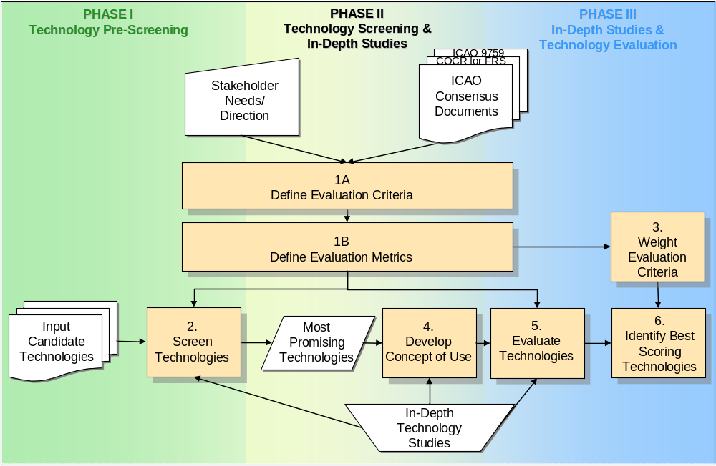
Figure 1: FCS Technology Evaluation Methodology
  - The first set of activities in the defined evaluation process (steps 1A and 1B) included definition of evaluation criteria and metrics. Addressing stakeholder direction, a structured analysis of the COCR was undertaken to ensure traceability of criteria to requirements. This structured analysis, along with consideration of ICAO recommendations for future communication systems captured in consensus documentation, was used to derive technical and institutional technology evaluation criteria. The derived evaluation criteria account for functional and performance needs of aviation, safety in the aeronautical domain and cost/risk elements associated with implementation of a technology in the future communication infrastructure.
  - Using the defined evaluation criteria, the next step in the evaluation process (step 2) is to identify most promising technology candidates. An inventory of over 50 technologies was considered in the technology screening process. This included technologies collected through Requests for Information from NASA to industry; EUROCONTROL inputs from European manufacturers; and ICAO ACP WG-C member state inputs and represented technologies defined for current and planned commercial applications as well as standards and prototypes developed specifically for aviation.
  - The remaining steps in the evaluation process (steps 3 through 6) contribute to detailed assessment of the most promising candidate technologies. A concept of how the technology would be applied to the aeronautical environment described in the COCR is defined followed by evaluation of a technology to determine applicability of the candidate in meeting future aeronautical communication needs.
- evaluation criteria
  - Employing structured analysis of the COCR and considering ICAO recommendations for future communication systems (ANC/11 Recommendations; Global Air Navigation Plan for CNS/ATM Systems – ICAO Doc 9750), technical and institutional evaluation criteria have been derived. Here, technical criteria address the required performance and functions of the Future Radio System while institutional criteria address the elements of a technology that make it a viable solution (e.g., cost, risk).
  - A total of eleven evaluation criteria were defined including two technical evaluation criteria (with associated sub-criteria addressing specific functional and performance requirements of the Future Radio System) and nine institutional evaluation criteria. A summary of the criteria and traceability to source documents is provided in Table 1.

Table 1: Summary of Technology Evaluation Criteria

 |  | Evaluation Criterion | Description | Traceability
Technical Criteria | 1 | Meets ATS Data Link Needs | Measure of the ability of a technology to provide sufficient functional and performance capability to meet operational and environmental requirements of the COCR for ATS services | COCR Functional Communication Needs (Section 2 Operational Services; Section 3 Operational Environment for Communications);  COCR Security Requirements (Section 4.3.5, Table 4-14);  COCR Performance Requirements (Section 5 Operational Performance Requirements; Section 6 Communication Loading Analysis)
Technical Criteria | 2 | Meets AOC Data Link Needs (in addition to ATS Data Link Needs) | Measure of the ability of a technology to provide sufficient functional and performance capability to meet operational and environmental requirements of the COCR for AOC services (in addition to ATS services) | COCR Functional Communication Needs (Section 2 Operational Services; Section 3 Operational Environment for Communications);  COCR Security Requirements (Section 4.3.5, Table 4-14);  COCR Performance Requirements (Section 5 Operational Performance Requirements; Section 6 Communication Loading Analysis)
Institutional Criteria | 3 | Technical Readiness Level | Provides an indication of the technical maturity of the proposed technology in the context of the FCS communication roadmap | 11th ICAO Air Navigation Conference (Sept/Oct 2003) Recommendation 7/5 – Number 2
Institutional Criteria | 4 | Standardization Status | Indicates the relevance and maturity of a proposed technology’s standardization status. | Global Air Navigation Plan for CNS/ATM Systems – ICAO Doc 9750 (5.14)  11th ICAO Air Navigation Conference (Sept/Oct 2003) Recommendation 7/5 – Number 3
Institutional Criteria | 5 | Certification | Provides a relative measure of the candidate’s complexity. | Global Air Navigation Plan for CNS/ATM Systems – ICAO Doc 9750 (5.14)  11th ICAO Air Navigation Conference (Sept/Oct 2003) Recommendation 7/5 – Number 3
Institutional Criteria | 6 | Ground Infrastructure Cost | Estimates relative cost to service provider to provision services to a geographically large area | Global Air Navigation Plan for CNS/ATM Systems – ICAO Doc 9750 (5.14)  11th ICAO Air Navigation Conference (Sept/Oct 2003) Recommendation 7/5 – Number 4
Institutional Criteria | 7 | Cost to Aircraft | Estimates relative cost to upgrade avionics with new technology | Global Air Navigation Plan for CNS/ATM Systems – ICAO Doc 9750 (5.14)  11th ICAO Air Navigation Conference (Sept/Oct 2003) Recommendation 7/5 – Number 4
Institutional Criteria | 8 | Spectrum | Gauges the likelihood of obtaining the proper allocation of the target spectrum and the compatibility of proposed technology with existing aeronautical systems in target band (second component not included in pre-screening) | Global Air Navigation Plan for CNS/ATM Systems – ICAO Doc 9750 (Statement of ICAO Policy on CNS/ATM Systems Implementation and Operation, Appendix A to Chapter 2, pg I-2-8)
Institutional Criteria | 9 | Security – A&I | Provides an assessment of technology authentication and data integrity capabilities | COCR Security Requirements (Table 4-11)  Global Air Navigation Plan for CNS/ATM Systems – ICAO Doc 9750 (Statement of ICAO Policy on CNS/ATM Systems Implementation and Operation, Appendix A to Chapter 2, pg I-2-8)
Institutional Criteria | 10 | Security – Robustness to Interference | Provides a relative assessment of technology robustness to interference | COCR Security Requirements (Table 4-11)
Institutional Criteria | 11 | Transition | Assesses acceptable transition characteristics, including:  - Return on partial investment  - Ease of technical migration (spectral, physical)  - Ease of operational migration (air and ground users) | Global Air Navigation Plan for CNS/ATM Systems – ICAO Doc 9750 (Statement of ICAO Policy on CNS/ATM Systems Implementation and Operation, Appendix A to Chapter 2, pg I-2-7)
- Technology screening
  - As noted above, an inventory of over 50 technologies was considered for technology screening. These technologies represent a wide range of technology families including cellular derivatives, public safety radio, satellite and custom aeronautical technology solutions. A full listing of the technology inventory is shown in Table 2 below.
Table 2: Summary of Technology Evaluation Criteria

Technology Family | Candidates
Cellular Telephony Derivatives | TDMA (IS-136); CDMA (IS-95A); CDMAone (IS-95B); CDMA2000 1xRTT; W-CDMA (US)/UMTS FDD (Europe); TD-CDMA (US)/UMTS (Europe); CDMA2000 3x; CDMA2000 1xEV; GSM/GPRS/EDGE; TD-SCDMA; DECT
IEEE 802 Wireless Derivatives | IEEE 802.11; IEEE 802.15; IEEE 802.16; IEEE 802.20; ETST HIPERPAN; ETSI HIPERLAN; ESTI HIPERMAN
Public Safety and Specialized Mobile Radio | APCO P25 Phase 1; APCO P25 Phase 2; TETRA Release 1; TETRAPOL; IDRA; IDEN; EDACS; APCO P34; TETRA Release 2 (TAPS); TETRA Release 2 (TEDS); Project MESA
Satellite and Other Over the Horizon Communication | SDLS; Connexion by Boeing; Aero B-GAN; Iridium; GlobalStar; Thuraya; Integrated Global Surveillance and Guidance System (IGSAGS); HF Datalink; Custom Satellite System; Digital Audio Broadcast
Custom Narrowband VHF Solutions | VDL Mode 2; VDL Mode 3; VDL Mode 3 w/SAIC; VDL Mode E; VDL Mode 4 ; E-TDMA
Custom Broadband Solutions | ADL; Flash-OFDM; UAT; Mode-S; B-VHF (MC-CDMA); LDL; (E-TDMA in L-Band)
Military | Link 16; SINCGARS; EPLRS; HAVEQUICK; JTRS;
Other | APC Phone (Airphone, Aircell, SkyWay)
  - In the table above, technologies are organized into technology families, characterized by similarities in user requirements, services offered, and reference and physical architectures. The technology screening process employed key performance metrics associated with the application of criteria 1, 2, and 8 in order to identify the most promising candidates from each family for meeting the needs of aviation. Specifically, the key metrics selected for terrestrial technology screening were data loading capability and technology communication range. For satellite and over-the-horizon technologies, the key metrics for screening were ability to use protected spectrum and the data loading capability. For the data loading capability and technology communication range metrics, specific threshold values traceable to the requirements of the COCR were defined. Maximum data loading thresholds were defined for air traffic services (ATS) alone and for ATS and airline operational control (AOC) in both the near term (Phase 1) and the far term (Phase 2). Communication range thresholds were defined for airport surface (APT), enroute high density (ER HD), terminal maneuvering area (TMA), enroute low density (ER LD), and a reference threshold that represents the radio horizon for FL180 (REF).
  - The data loading and range components of the screening filter were applied to identify those technologies that meet, exceed, or come close to meeting COCR-derived data capacity and range requirements. To support the application of this filter, a technology concept/application customized to the aeronautical environment was used. The evaluated technology data rate corresponds to the technology physical layer capability and does not explicitly account for protocol overhead, where applicable, which is addressed in the detailed technology assessments. The spectrum screening filter removed from further consideration those technologies that inherently rely on unprotected spectrum (in other words, not in Aeronautical Mobile (Route) Spectrum (AM(R)S) or Aeronautical Mobile Satellite (Route) Spectrum (AMS(R)S)), as those technologies are not viable candidates for the Future Radio System.
  - Each technology family was assessed and plotted on a “tri-color” chart with unacceptable, marginal and good screening performance regions inferred from COCR requirements. The most promising technologies from each technology family were selected to bring forward from the screening process for detailed evaluation. Depending on family performance, none, one or multiple technology candidates were selected.
  - Figure 2 below provides a summary of the screening process applied to all terrestrial technologies. Note that technologies within families that provide good communication range and meet or come close to meeting COCR defined data loading requirements for the COCR Phase 2 concept of operations were selected to bring forward from the screening process.

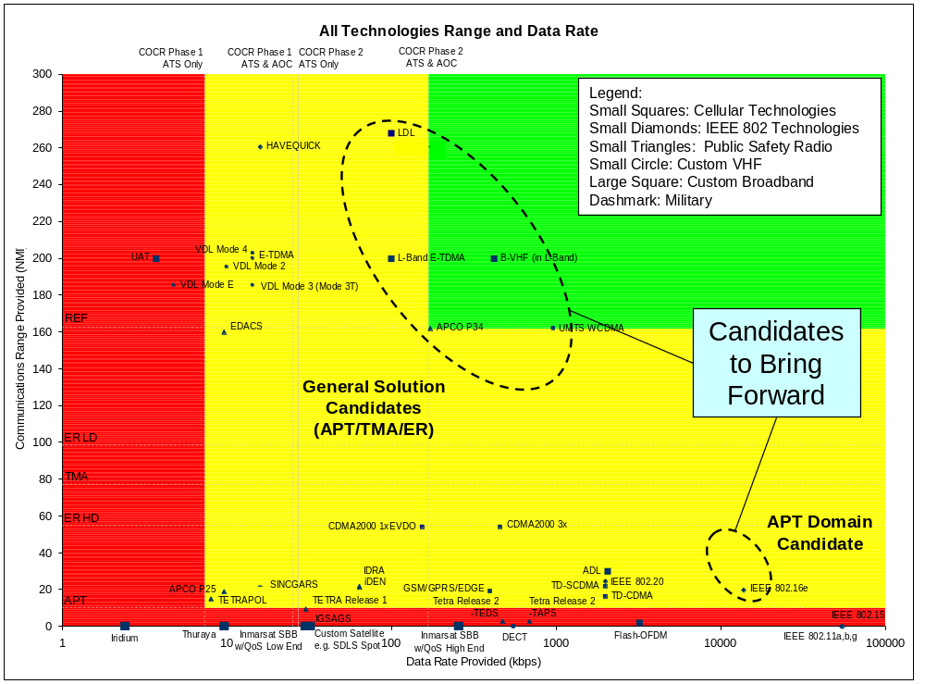
Figure 2: Technology Screening Summary — Terrestrial Technologies
  - After application of the “ability to use protected spectrum” screening metric, satellite and over-the-horizon technologies were considered with regard to data loading capability. Figure 3 below provides a summary of the screening process applied to these technologies. Technologies that meet or come close to meeting COCR defined data loading requirements for the COCR Phase 2 concept of operations were selected to bring forward from the screening process. By the very nature of the service provided, the communications range thresholds do not apply to the satellite and over-the-horizon technologies.

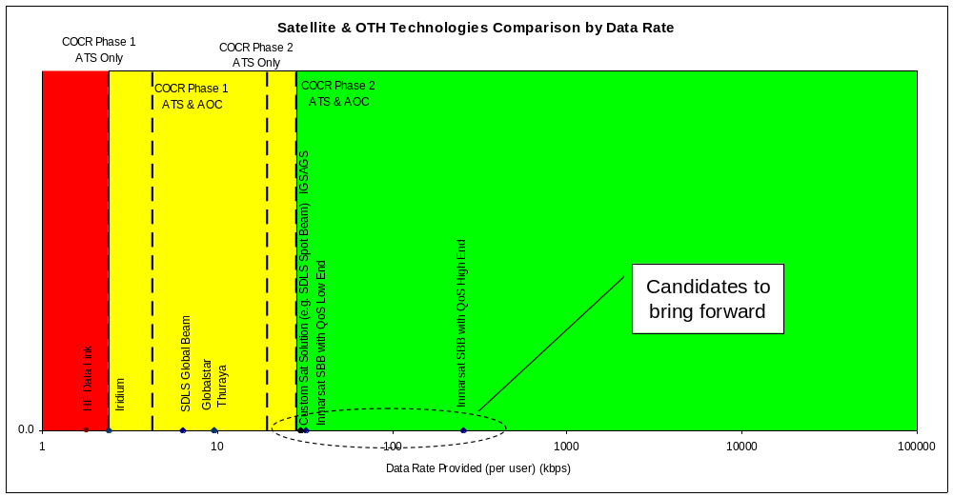
Figure 3: Technology Screening Summary — Satellite Technologies
  - As a result of the technology screening process, eight technologies were identified as candidates to bring forward for further consideration. Of these candidates, two of the general solution candidates (i.e. candidates for provision of services in the airport (APT), terminal maneuvering area (TMA) and en route (ER) domains) are currently being defined by EUROCONTROL. These technologies, “E-TDMA (in L-band)” and “B-VHF (in L-band)”, as they are named in the screening assessment, began as ideas to evolve technology concepts and definitions originally defined for VHF implementation to technologies specifically tailored for implementation in aeronautical L-band spectrum. These technologies have been recently renamed by EUROCONTROL as Aeronautical Mobile All-purpose Communication System (AMACS), an evolution of the E-TDMA concept combined with VDL4 technology concepts, and Broadband – Aeronautical Mobile Communications (B-AMC) an evolution of the B-VHF concept. Since the technical details for these technology concepts are still under development at this time, they have not been considered for detailed evaluation in this study Phase.
  - The remaining six technologies emerging from the screening process fall into two categories. They include candidates for a general aeronautical communication solution for the Future Radio System (also called a continental solution because the solution applies to all continental flight domains including APT, TMA, and ER) and technologies identified as best performers in the context of specific flight domains that have a unique environment and may warrant separate technology consideration (i.e. oceanic and airport domains). A summary of the recommended technologies results from the technology screening is provided in Table 3 below.

Table 3: Screened Technologies for Detailed Evaluation

 | NASA/ITT Screened Technologies
Continental Solution | APCO P34 (TIA 902)  LDL  W-CDMA
Oceanic Domain | Inmarsat Swift Broadband  Custom Satellite System
Airport Domain | IEEE 802.16e
  - As noted in Table 3, for a general continental solution, technologies coming forward from the screening process for detailed evaluation include APCO P34 (TIA 902), LDL and W-CDMA. APCO Project 34 (P34) is an EIA/TIA standardized system (TIA 902) for provision of packet data services in an interoperable dispatch-oriented topology for public safety service providers. The defined standards correspond to the layered P34 protocol stack. As designed for public safety applications, P34 for deployment uses frequency division duplexing. The Scalable Adaptive Modulation (SAM) physical layer is a multi-carrier coherent Time Division Multiple Access (TDMA) modulation (specifically, Orthogonal Frequency Division Mulitplexing (OFDM). The base channel size is 50 kHz, with extensions defined to 100 kHz and 150 kHz, where each 50 kHz provides 96 to 288 kbps (modulation/coding can adapt with Eb/No). The technology specifies three frame formats, Inbound Random Access (used for short signaling and requesting inbound channel bandwidth); Inbound Reserved Access (used for payload data transfer and data acknowledgements); and Outbound Reserved Access (used for payload data transfer and confirmed data acknowledgements).
  - A second technology brought forward from the screening process is an evolutionary technology proposed by the by the U.S., namely L-band Data Link (LDL). Sufficient details were documented and available to enable evaluation this evolutionary technology. Specifically, LDL is derived from the Universal Access Transceiver (UAT) physical layer standards and VDL-3 upper layer standards. The technology uses binary Continuous Phase Frequency Shift Keying (CPFSK) with a channel size of 83.33 kHz. The technology builds upon the TDMA structure defined for VDL-3, using management bursts for exchange of configuration/administrative data and bandwidth reservation, and data bursts for exchange of payload data.
  - The third technology emerging from technology screening is W-CDMA. This candidate is a third generation cellular standard, emerging from the Universal Mobile Telecommunications System (UMTS) (and Global System for Mobile communication (GSM) evolutionary thread. W-CDMA technology partitions radio frequency (RF) resources through a combination of frequency division multiple access (FDMA), code division multiple access (CDMA) and TDMA. A frequency band assignment for W-CDMA is divided into multiple pairs of 5 MHz channels that include dedicated uplink and downlink channels separated by a large guard band. CDMA is the primary means of portioning the channel. W-CDMA specification offers multiple physical layer modulations and associated coding rate configurations for both uplink (mobile to ground station) and downlink (ground station to mobile) connections.
  - For the oceanic domain, candidates identified in the screening process for further consideration included Inmarsat Swift Broadband (SBB) and the Custom Satellite Solution. The Inmarsat SBB concept builds upon the aeronautical services currently provided by this technology. For the custom satellite solution, satellite payloads or architectures specifically designed for aviation have been identified as having promise for meeting oceanic domain communication requirements. The custom satellite solutions considered included Satellite Data Link System (SDLS), a European Space Agency initiative that defines a bent-pipe geostationary satellite architecture implementing CDMA at L-band for aeronautical application, and Multi-function Transport Satellite (MTSAT), a Japanese operational primary/backup geostationary satellite architecture providing aeronautical services.
  - For the Airport domain, candidate applicable technologies include those from the cellular and 802 technology families. Of the candidates in those families that meet the requirements for the Airport, 802.16e has the largest data capacity; a simple ground infrastructure; a developed standard; and appears to be the most applicable. Reference the cellular and 802 family concepts of use for additional information.
  - In March 2006, EUROCONTROL presented its current technology shortlist at the ICAO ACP WG-C10 meeting. It is instructive and informative to compare the current screening results to the technology short-list considered by EUROCONTROL. This is provided in Figure 4. It shows a significant overlap in recommendations for the “short-list” of technologies to consider for the Future Radio System. This overlap is significant as member participants of the Future Communication Study and the ICAO ACP work toward harmonized technology solutions for the future communication infrastructure.

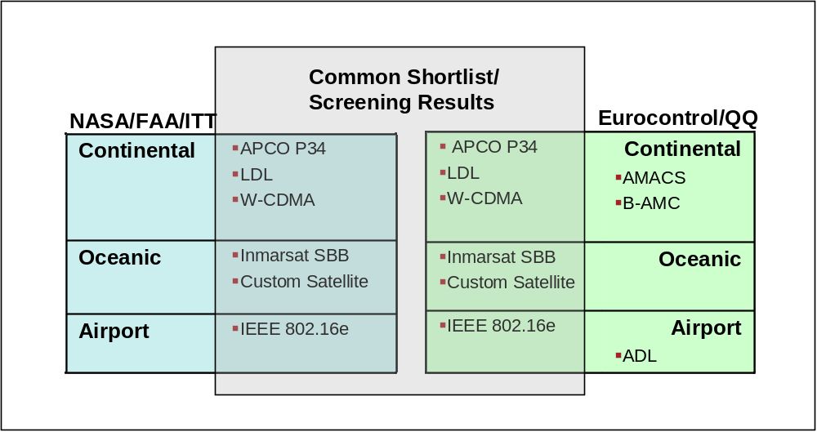

Figure 4: Comparison of NASA/ITT Technology Screening Results to EUROCONTROL Technology Short-List
- detailed technology evaluations
  - To support further consideration of candidate technologies emerging from the screening process and the overall technology evaluation process, several focused and in-depth analyses have been conducted. The topics of these studies have been organized into four major areas including:
- L-Band Technology Performance (see 5.3);
  - L-Band Air/Ground (A/G) Channel Characterization (5.3.1);
  - P34 Performance Assessment (5.3.2);
  - LDL Performance Assessment (5.3.3);
- L-Band Technology Cost for Ground Infrastructure (see 5.4);
- Satellite Technology Availability Performance (see 5.5); and
- C-Band Technology Performance (see 5.6).
  - A summary of results specific to each study area is provided in the following paragraphs.
  - L-Band Technology Performance.
L-Band Air/Ground (A/G) Channel Characterization
    - To support the assessment of technology performance in the L-Band Air-Ground (A/G) channel, a literature search revealed that while many channel models exist for the terrestrial channel in close proximity to L-Band, there had been no previous activity to develop a channel model that characterizes the L-Band Air/Ground (A/G) channel for radiocommunications. As most standardization bodies consider it a best practice to test candidate waveform designs against carefully crafted channel models that are representative of the intended user environment, a channel model was developed that could be used for common characterization of communications waveform performance in this A/G channel.
    - Characterization of the Delay Spread and the Doppler Power Spectrum is essential for generating a useful model for waveform simulation and evaluation of candidate FRS technologies in L-Band. In order to form estimates of the delay spread and associated statistics, a ray-tracing simulation was developed. This simulation models both diffuse and specular reflections from the Earth’s surface. The developed simulation used a method of concentric oblate spheroids to model multipath contributions. The desired product was the set of points on the terrain that were intersected by the oblate spheroids. When plotted, each set of intersection points appears as a distorted annulus approximating the cross section of the spheroid when sliced by the Earth’s surface. Each set of intersection points is mutually exclusive from any other set because any intersection point can only be accounted for once. Each set of intersection points contributes to multipath for a particular delay. Figure 5 illustrates the method of concentric oblate spheroids used to model multipath contributions.
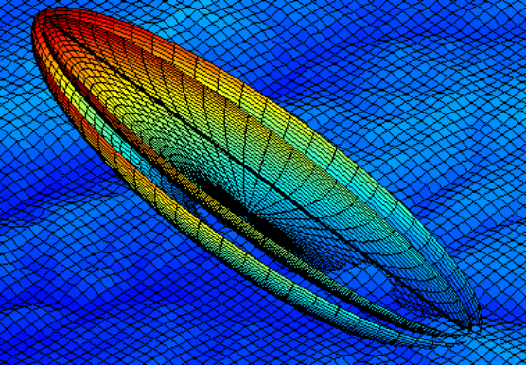
Figure 5: Two Concentric Oblate Spheroids Intersecting the Underlying Terrain
    - Implementing the methodology to apply ray tracing to determine specific specular and diffuse multipath components and employing data reduction and analysis techniques, the mean RMS delay spread was calculated to be 1.4 µs. It is instructive to consider representative technologies at this point since the technology data rate will drive channel model parameter estimation. A rule of thumb frequently applied is that if the mean RMS delay spread is at least one tenth of the symbol duration, then the channel is frequency-selective. In order to illustrate this, two technologies emerging from the FCS Pre-Screening task were considered: LDL and P34. Table 4 shows the corresponding data rates and symbol durations for LDL and P34.
Table 4: Data Rates of LDL and P34

Waveform | Data Rate | Symbol Duration | 1/10th of the Symbol Duration
Waveform |  | 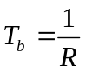 | 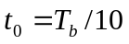
LDL | 62.5 kbps | 16 µs | 1.6 µs
P34 | 4.8 kbps* | 208.3 µs | 20.83 µs
* P34 is an OFDM system. The tabulated data rate is per carrier and is the symbol rate. Overall P34 data rates range from 76.8 – 691.2 kbps

    - Using our rule of thumb, P34 should undergo flat fading and LDL presents a borderline case because the mean RMS delay spread is very close to one tenth of the symbol duration. These results can be used to develop tapped-delay line channel models. An example of a conservative frequency-selective fading model that could be developed for LDL is shown in Table 5 below (Note that the Doppler category is a very conservative estimate applying models commonly used in the land mobile fading environment).
Table 5: LDL Channel Model Parameters

Tap # | Delay (µs) | Power (lin) | Power (dB) | Fading Process | Doppler Category
1 | 0 | 1 | 0 | Rician | Jakes
2 | 1.6 | 0.0359 | -14.5 | Rayleigh | Jakes
3 | 3.2 | 0.0451 | -13.5 | Rayleigh | Jakes
4 | 4.8 | 0.0689 | -11.6 | Rayleigh | Jakes
5 | 6.4 | 0.0815 | -10.9 | Rayleigh | Jakes
6 | 8.0 | 0.0594 | -12.2 | Rayleigh | Jakes
7 | 9.6 | 0.0766 | -11.2 | Rayleigh | Jakes
P34 Performance Assessment
    - In addition to L-band channel characterization, L-band technology performance studies specific to individual technologies were also conducted. An in-depth analysis of P34 net entry, data transfer and BER performance in the L-band channel was performed. The simulation of P34 included evaluation of a ground station and 95 mobile nodes (COCR-defined NAS super sector) employing P34 SAM physical layer properties associated with 50 kHz channelization and QPSK modulation. Simulation model results are shown in Figure 6. These figures show the response time of the P34 simulation to the offered load for each of transmitted message. Note that the sub-network latencies over P34 protocols (SNDCP, LLC CP, LLC UP, MAC) meet COCR latency requirements. Specifically, although there are some startup outliers, 95% of delay measurements are under 0.7 seconds.

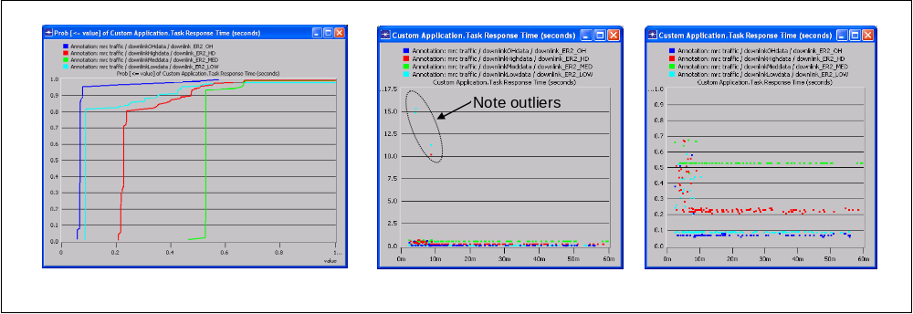
Figure 6: P34 OPNET Modeling Results
    - In addition to simulation of P34 net entry and data transfer performance, P34 performance in the defined L-Band A/G channel was also evaluated. As part of this effort, P34 transmitter and receiver models were generated. Specifically, the P34 SAM physical layer interface was modeled by developing a custom application using C code. The transmitter was implemented as detailed in the specification for the 50 kHz channel using QPSK modulation. The receiver implementation was tested against published results for standardized channel models. Additionally, P34 coding gain (for specified concatenated Hamming codes) was investigated. It was found that, a 3*10⁻³ raw BER is approximately equal to 10⁻⁵ coded BER for P34.
    - The developed P34 transmitter and receiver models were combined with a model of the expected L-Band channel based on analysis work previously described. Specifically, a two tap channel model was simulated where Tap 1 was modeled as Rician, with a K-factor of 18 dB, unity gain, and Jakes Doppler Spectrum; and Tap 2 was modeled as Rayleigh, with a 4.8 μs delay, -18 dB average energy, and Jakes Doppler Spectrum (conservative estimate). In this model, the mobile velocity was taken to be .88 mach. This is the maximum domestic airspeed given in the COCR based on Boeing 777 maximum speed. Additionally, in the model the P34 tuned frequency was taken to be 1024 MHz, with maximum Doppler shift of 1022 Hz.
    - Initial simulations indicate good performance can be achieved in the aeronautical channel, primarily a consequence of the strong line-of-sight component of the received signal (with K factors greater than four). Figure 7 shows initial results (note that initial results are still being validated).

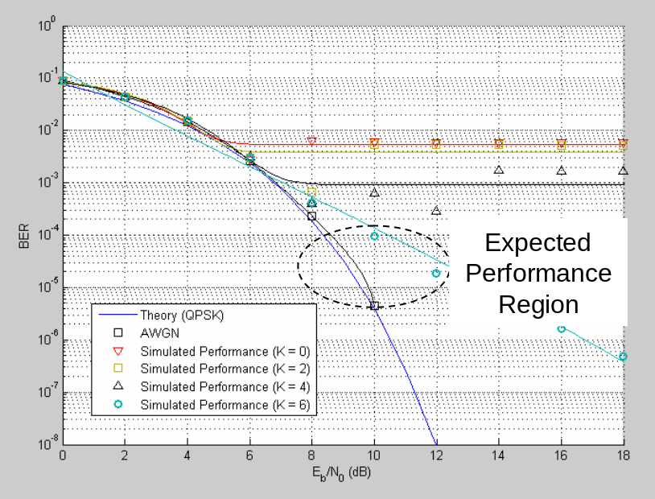
Figure 7: P34 Predicted Performance in the L-Band Aeronautical Channel
LDL Performance Assessment
    - A second technology investigated for performance in the L-band aeronautical channel was LDL. As with P34, LDL transmitter and receiver models were generated and the receiver model validated against known results. After validation, investigation of LDL coding, Reed-Solomon (72, 62), provides a coding gain of 3 to 4 dB in the expected region of operation. LDL performance was simulated in the L-Band aeronautical channel environment. The LDL channel model is a conservative model that introduces an irreducible error floor to system performance. The plot shown in Figure 8 shows the system performance of LDL in the presence of both AWGN and the L-Band aeronautical channel model. Based on the results of this simulation, LDL may require channel equalization to mitigate the effects of the A/G aeronautical channel model in L-band.

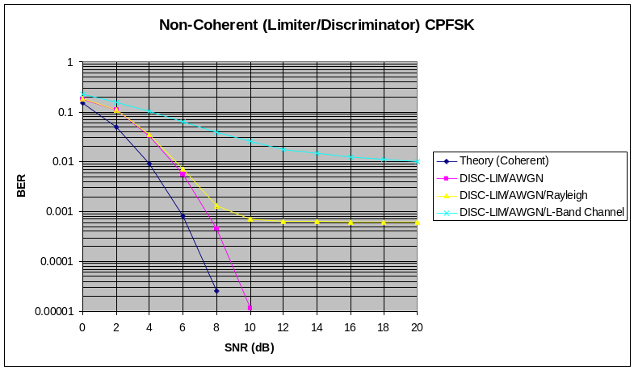
Figure 8: LDL Predicted Performance in AWGN and the L-Band Aeronautical Channel
- L-Band technology cost for ground infrastructure
    - L-Band technology cost was another focus area of in-depth analysis. In this work, the economic feasibility from the perspective of the ground infrastructure provider was evaluated. This analysis was responsive to feedback received on the technology pre-screening results (FCS Phase I) that indicated that due to cost constraints, an L-Band solution is only considered should VHF spectrum prove insufficient to provide total required data link capability. The L-Band business case analysis provided a first order of magnitude estimate of required investment for an L-Band aeronautical ground infrastructure. The technical approach for accomplishing this objective included:
- Through detailed analysis, develop a notional ground L-Band architecture that can meet Future Communication Infrastructure (FCI) requirements as defined in the COCR document for ATC communications;
  - Derive number of radio sites required for total US coverage;
    - Perform L-Band link budget analysis.
    - Develop L-Band Link budget spreadsheet and derive the parameters to close the link.
    - Excess Path Loss derivation.
    - Perform L-Band coverage analysis.
    - Derive radio site redundancy to meet system availability requirements.
    - Develop an architecture to meet availability required..
- Determine if the business case can close;
  - Develop cost elements and estimates for initial development and O&M; and
  - Determine required revenue flow to close the business case.
    - An overview of the technical approach work flow is shown on Figure 9.

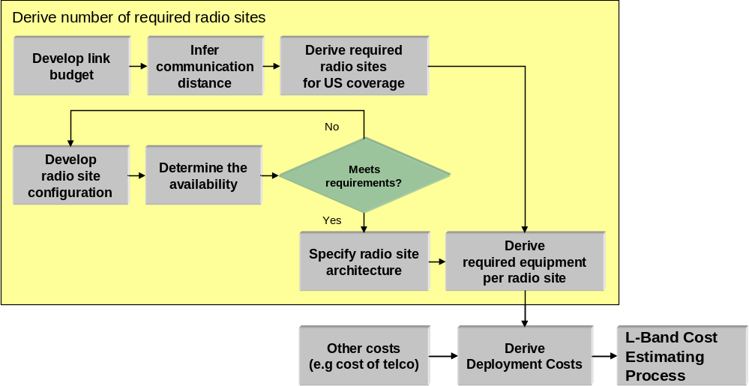
Figure 9: Process for Determining Service Provider Cost
    - While the first order of magnitude cost estimate yielded positive business case results, the important aspect of the study to bring forward to ACP was the framework of the analysis which can be considered a generic framework specifying infrastructure costs associated with an L-Band system. Along with the methodology shown above, the L-band cost modeling work employed several assumptions for consideration including:
- L-Band provides coverage to a large continental region (e.g. United States or Core Europe);
- Coverage is above FL180;
- System Availability of Provision (Ap) meets COCR requirements for COCR Phase II en route services (sans Auto-Execute service); and
- Cost elements considered include: Research and Development (including system design and engineering); Investment (including facilities and equipment); and Operations and Maintenance (including telecommunications, personnel and utility costs.
- Satellite technology availability performance
    - For the Satellite and Over Horizon technology family, two technology inventory candidates have emerged from the technology screening: Inmarsat Swift Broadband (SBB) and Custom Satellite Solution. For satellite aeronautical communication solutions, availability typically arises as an important issue to address. In order to provide required availability, a highly redundant custom satellite system architecture is needed. As this issue is similar for both Inmarsat and Custom Satellite Solutions, it was considered instructive to estimate the availability of two existing, operational satellite systems, Inmarsat SBB and Iridium, that provide services in protected aeronautical spectrum (AMS(R)S).
    - The approach used for SATCOM availability modelling was the analysis model described in RTCA DO-270. This document defines an availability fault-tree to permit characterization and evaluation of multiple availability elements. The fault tree is organized into two major categories, system component failures and fault-free rare events. This model, shown in Figure 10, was useful for comparing architectures and was applied in this study.

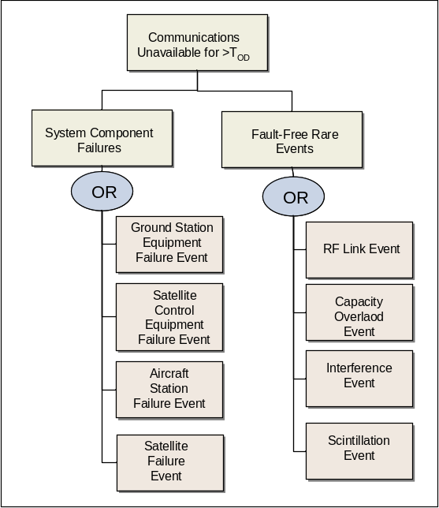
Figure 10: SATCOM Availability Modeling Approach — Fault Tree
    - A summary of availability modeling results is shown in Figure 11. For SATCOM systems, limiting factors for availability include satellite equipment failures and RF link effects (Inmarsat and Iridium), capacity overload (Iridium), and interference (Iridium). For the VHF terrestrial reference architecture, the limiting factors for availability include RF link events and capacity overload. Overall, the detailed evaluation of satellite communication systems (with a focus on provision of required availability) indicated that both Inmarsat SBB and Iridium would not meet availability requirements. Also, custom satellite solution designed to meet COCR availability requirements would, in fact, require a highly redundant and costly architecture. Although availability concerns may limit the use of satellites as cost effective solutions for continental airspace domains, this does not preclude their effective role in providing communication capability in remote and oceanic airspace.

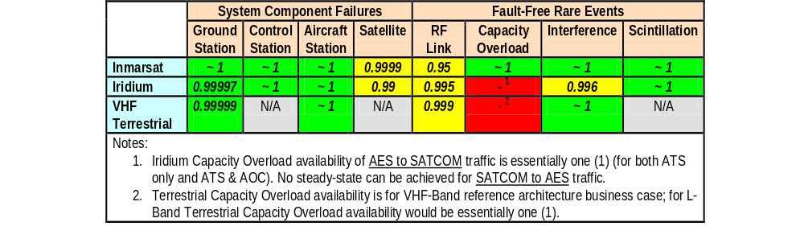
Figure 11: Summary of Availability Modeling Results
- C-Band technology performance
    - C-Band modeling activities were conducted to investigate the utility of an industry standard system in the airport surface environment. The system that was chosen for analysis was the IEEE 802.16e Metropolitan -Area Network (MAN) interface standard. The IEEE 802.16e standard (referred to as simply the 802.16e standard, or 802.16e henceforth) was chosen as it scored well during the initial phase (technology pre-screening) of the FCS technology investigations.
    - As the 802.16e standard supports a range of physical layers, prior to the modeling process, a specific physical layer needed to be selected. Of the possible candidates, better mobility performance is expected from OFDMA than OFDM, and the leading commercial 802.16 forum (the WiMAX Forum) has defined “Mobile” WiMAX profiles which are all expected to adopt the OFDMA physical layer. In this study, however, the OFDM physical layer was selected for analysis, as it seems that if good performance can be predicted for OFDM then by inference the OFDMA physical layer would also work well. Further, there are commercially available chipsets for the 802.16 OFDM physical layer currently available. Since a logical next step to this research would be prototype implementations and trials in the band, and noting that OFDM (due to the aforementioned chipset) is more amenable to prototype equipment development, this seemed to be a reasonable decision.
    - Implementing the methodology defined above, 802.16e transmitter and receiver functions were modeled in the MATLAB Simulink® environment. The next step in the C-Band Modeling work was to validate the developed model. Specifically, the simulation was executed in an AWGN environment and corresponding results compared to published results. Good correlation was achieved. Using a channel model adapted from a detailed model developed by Ohio University, the performance of 802.16e in the aeronautical airport environment was simulated as shown in Figure 12. Here performance was found to be quite good for most of the movement area (incorporating equalization techniques). While this technology has good potential applicability for this domain, additional analysis to look at features to enhance performance (e.g. Hybrid Automatic Repeat Request (HARQ), fast feedback channel and diversity sub-carrier permutations) is warranted.

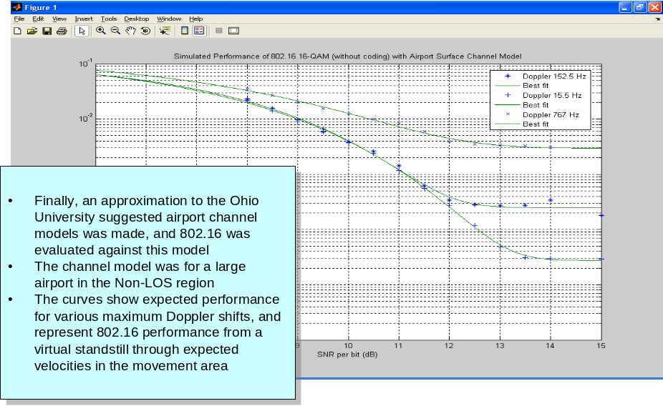
Figure 12: 802.16e Simulation Results for the Aeronautical C-Band Surface Channel Model
- ongoing evaluation efforts
  - To build upon the work conducted in Phase I and Phase II of the FCS and to work towards the conclusion of the technology evaluation, three major task efforts are in progress. These include:
- L-Band Interference Testing (See 6.3);
- Additional In-Depth Technology Studies (See 6.4); and
- Technology Evaluation & Recommendation Development (See 6.7).
  - A brief overview of the objective and methodology associated with each of these work items is provided in the paragraphs that follow.
  - L-Band interference testing
    - L-Band Interference Testing was undertaken to progress the initial analytical interference assessment that took part in Phase II of the FCS technology assessment. In the L-band aeronautical channel, 960-1215 MHz has a primary allocation for Aeronautical Radio Navigation Services (ARNS). There are currently several system implementations that occupy the band and ICAO systems that use spectrum in this band include the Universal Access Transceiver (UAT); secondary surveillance radars (including ATCRBS, Mode A and C, and Mode S); and Distance Measuring Equipment (DME). A need to understand the interference potential of candidate FCS technologies on existing radio-navigation technologies currently operating in the L-band was identified.
    - To perform initial interference assessments (in FCS Phase II), two candidate waveforms (based upon P34 and LDL technologies) were considered in terms of interference potential on UAT, Mode S and DME. Analytical evaluation results for UAT and Mode S indicated that a Carrier-to-Interference (C/I) ratio of 12-15 dB is required for minimum degradation of the UAT receiver and 15 dB or better is required to not substantially degrade the Mode-S preamble detection behaviour (however further consideration of Mode-S performance including Mode-S interference measurements was recommended to fully understand the interference potential). The results of the analytical investigation was that the evaluated technologies were still both viable candidates; however, further exploration of the channel model and receiver implementation was warranted for validating LDL performance in this environment, and interference measurement for these technologies (and other candidates) was recommended. Additionally, due to complexity in analytical modelling of DME performance, bench testing of interference potential of candidate technologies to DME systems was recommended.
    - Following the Phase II recommendation, a work plan was developed to perform laboratory bench tests to characterize interference potential of candidate FCS waveforms to ICAO systems in the L-band spectrum band. Specifically, testing the interference potential of Code Division Multiple Access (CDMA) (used for WCDMA); Multi-Carrier Modulation (MCM) (used for P34); and narrowband digital signals (used for LDL) waveforms to DME was initiated. The approach for this activity is shown in Figure 13. Here, six interrelated activities capture the range of steps required to execute interference measurement and analysis.

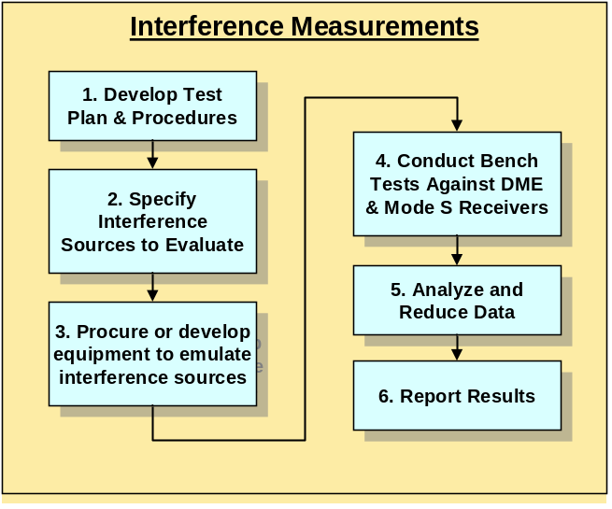
Figure 13: DME Interference Measurement Approach
    - Interference bench testing is currently in progress. Data captured can be used to provide an indication of co-site and inter-site performance of candidate FCS waveforms with regard to DMEs. These results will help to determine the viability of specific technology solutions for deployment in L-Band aeronautical spectrum as well as support the specific assessment of technologies to defined evaluation criteria.
    - Additional in-depth technology studies
    - A second major task activity undertaken in the final phase of FCS technology investigations is additional in-depth technology assessments. Specific work items have included a functional analysis of WCDMA and review of intellectual property referenced in APCO P34 specifications. The WCDMA investigation includes the logical mapping of WCDMA functional elements to the ATM context. Additionally, a series of sequence diagrams that illustrate COCR ATS services in the context of WCDMA protocol transactions is being captured. The investigation of P34 intellectual property, although likely not applicable in the timeframe of FRS deployment, is being investigated to determine if the specific technical capabilities described in the Telecommunications Industry Association standards that support P34 are desirable or applicable to an FCS implementation. The final results of both study topic areas will be reported at the conclusion of the FCS Phase III.
    - Technology evaluation and recommendation development
    - The third major task activity currently in progress is the final technology evaluation and development of FCS specific technology recommendations, one for each airspace environment and the applicable frequency spectrum recommended for that airspace. Using the methodology and evaluation criteria detailed in Sections 2.2 and 3.2 respectively, technologies evaluations will be concluded and applicability of candidate solutions to future aeronautical communications described. The work output will also include the identification of issues to be overcome for implementation of the recommended technologies from the FCS and development of a technology roadmap that identifies steps that need to be taken to move a technology recommendation through to implementation.
- ACTION BY THE ACP
  - The ACP is invited to consider the technology investigation progress described in this paper, including the methodology employed, the screened technology results and detailed evaluation results, and to provide comments if desired.

— END —

Future Communication Infrastructure: Development of Technology Shortlist for Further Investigations”, ICAO ACP WG-C20, Working Paper 13, Luch Deneufchatel, Klauspeter Hauf, Larry Johnsson, John MacBride, Eleuterio Esteban, Jacky Pouzet, March 2006

