 | International Civil Aviation Organization  INFORMATION PAPER
  ACP-WGW03/IP-02
  21/01/10

AERONAUTICAL COMMUNICATIONS PANEL (ACP)

THIRD MEETING OF THE WORKING GROUP OF THE WHOLE

Montreal, Canada 18 – 22 January 2010

Agenda Item 2: | Future Communication Infrastructure, progress update and recommendations

Status of Air-Ground Datalink Study in ENRI/Japan

(Presented by Naoki Kanada)
(Prepared by Yasuto Sumiya, Jun Kitaori and Naoki Kanada)
Electronic Navigation Research Institute (ENRI)

SUMMARY
This paper describes some ENRI's datalink research programs in Japan. ENRI has been evaluating various aeronautical communication systems such as a VDL Mode 3 system, an ATN system, the ICAO Aeronautical Mobile Satellite Services (AMSS) compliant system and so on by experiments using the test beds or by simulations. We start to study the LDACS (L-band Datalink Aeronautical Communication System) and MIMO (Multi-Input Multi-Output) system for aeronautical use.

The research program on LDACS started in April 2009, and will be completed in March 2013. We will develop an LDACS transceiver using a software-defined-radio technique to evaluate the interference problems between LDACS and conventional navaids or communications in ARNS band.

The research program on MIMO system started in April 2008, and will be completed in March 2011. We will develop a basic MIMO system for use in aeronautical system.

We hope that these programs will facilitate the standardization and validation works in the ICAO groups and in other relevant forums. The tools to be developed will facilitate various evaluations for the future aeronautical communication system in these programs.
ACTION
The ACP WGW is invited to note the information

- INTRODUCTION
  - ENRI has been evaluating various aeronautical communication systems such as a VDL Mode 3 system, the ICAO Aeronautical Mobile Satellite Services (AMSS) compliant system and so on by experiments using the test beds or by simulations[1][2][3]. We are planning to study LDACS (L-band Datalink Aeronautical Communication System) and the MIMO (Multi-Input Multi-Output) antenna system for aeronautical use.
  - The research program on LDACS started in April 2009 and will be completed in March 2013. We will develop an LDACS transceiver using a software-defined-radio technique to evaluate the interference problems between LDACS and conventional navaids or communications in ARNS band.
  - The research program on Aeronautical MIMO system started in April 2008, and will be completed in March 2011. We will develop a basic MIMO system for use in aeronautical system.
- CONCEPT and SCHEDULE
  - Figure 1 represents the concept of the LDACS Test Beds using software-defined-radio (SDR). It is the groups of candidates for the future communication system possibly to replace or complement VHF radio communication system in the future. The several aeronautical systems, such as DME, UAT, Mode-S, JTIDS and so on shown as Figure 2, have been used in L-band, the same frequency as for the LDACS. Therefore, conventional system and L-DACS may interfere with each other. We will develop SDR transceiver for LDACS and try to evaluate its performance of physical layer of LDACS, and the effect of interference between LDACS and other systems in L-band.
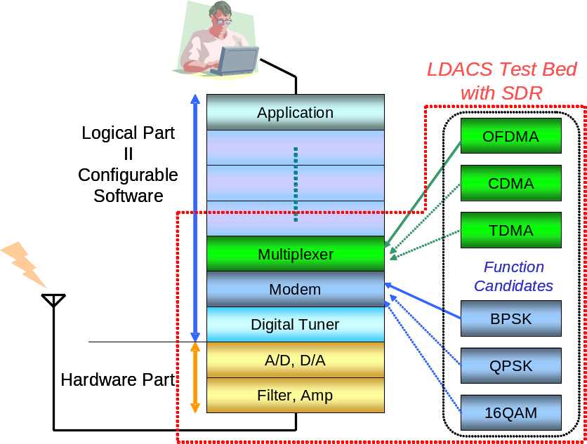

Figure 1 Concept of the LDACS Test Bed with SDR
  - Figure 3 shows the schedule of our development program. This program is a 4 year-plan. We are investigating the specifications of LDACS and selecting suitable SDR boards in the first year. Figure 4 is an example of SDR boards. We will develop the logical model part for the LDACS transceiver using SDR. And, also, we will conduct a series of experiments with them in the 2nd year. We will develop the interface with a user-friendly design for the SDR transceiver in the 3rd year. We will evaluate and modify the LDACS transceiver with SDR in the final year.
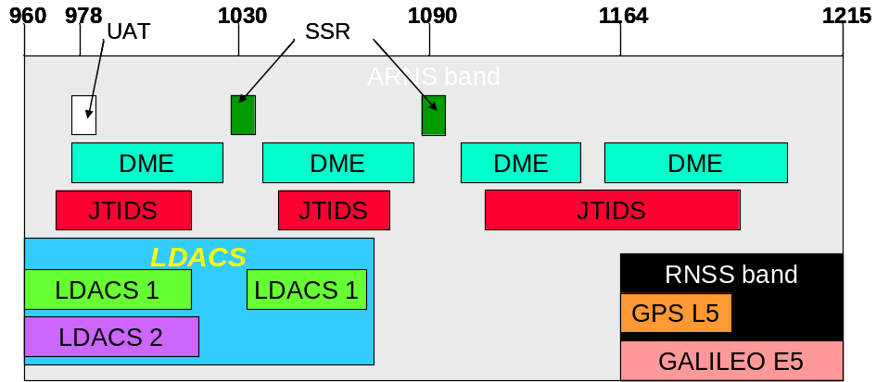

Figure 2 Several Aeronautical Systems in L-band
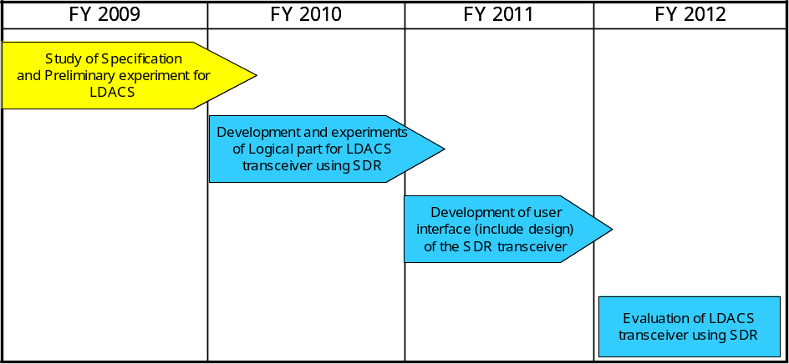
Figure 3 Development Schedule of LDACS Interference Evaluation in Japan

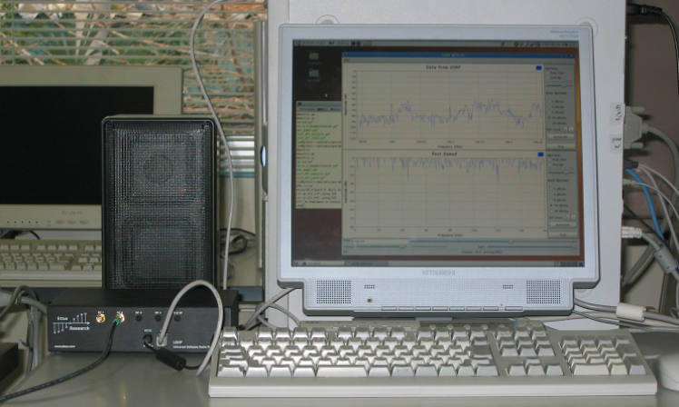
Figure ４ An Example of SDR
  - Figure 5 represents the concept of MIMO system for use in aeronautical system. The MIMO system has the multiple antennas. The performance of the aeronautical system will be greatly improved if the MIMO system is applied to the system of the air-ground communication in the future. The system is similar to that used in cell phone, Wi-fi, Wimax and so on.
  - Figure 6 shows the schedule of the program. We studied a specification and conduct a preliminary experiment on the antenna system in the first year. We developed a basic MIMO system in the second year. We made a basic experiment system in radio anechoic chamber of ENRI shown in Figure 7. The system use the 1/10 scale model of the ENRI’s experimental aircraft made by brass and omni-directional antennas. We expect to obtain the result on the followings by experiment using the frequency of about 10GHz.^{[4]}
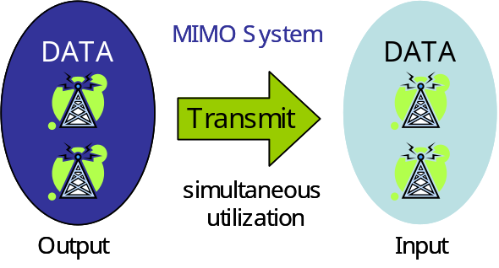
Figure 5 Concept of MIMO System for Aeronautical System

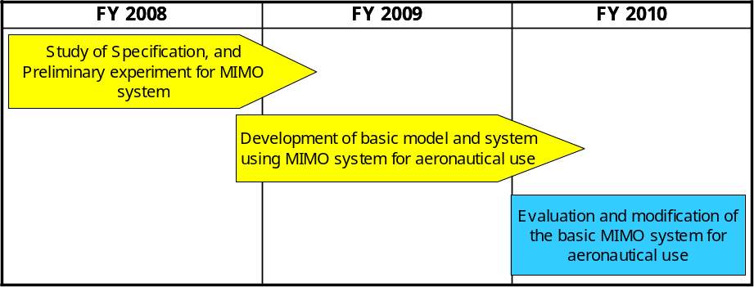

Figure 6 Development Schedule of MIMO System for Aeronautical Application

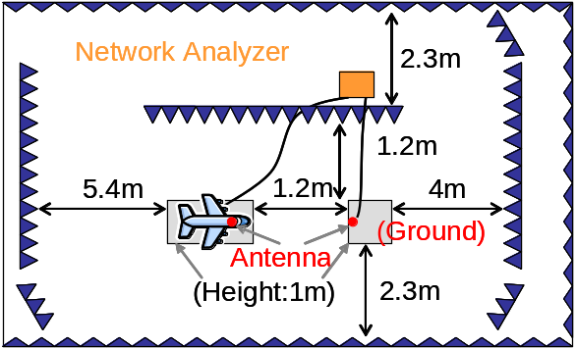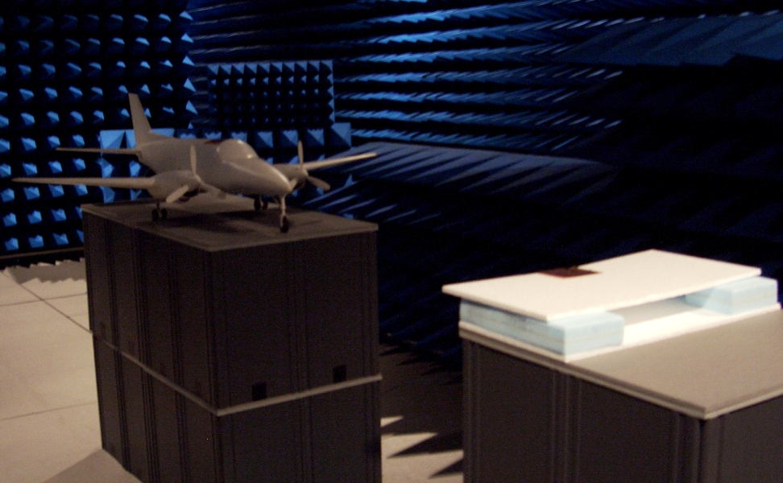

Figure 7 Basic Experimental System in Radio Anechoic Chamber of ENRI

*existence of the wave later than direct wave
*possibility of the reflected or diffracted wave from the surface of main wing and tail, propeller and so on
  - The result means the possibility that MIMO system can be used in aeronautical system. We will evaluate and modify the basic system in the final year of the program. We are studying various specifications of the system from the user’s viewpoint.
  - These programs are included in the research and development of long-term vision at ENRI [5]. The long-term vision of R&D includes the other programs such as the 4D-trajectory study and other studies.

- ConclusionS
  - This paper reports the current and future programs in ENRI for the studies on Aeronautical Datalink system. The program on the development of the LDACS transceiver using soft-ware-defined-radio (SDR) is a 4 year-plan and completes in March 2013. The program with the MIMO system is a 3 year-plan and completes in March 2010.
  - We hope that these programs will facilitate the standardization and validation works in the ICAO groups and in other relevant forums. The tools to be developed will facilitate various evaluations for the future aeronautical communication system in these programs.
- ACTION BY THE MEETING
  - The ACP WGW is invited to note the information provided:

References:
[1] http://www.enri.go.jp/eng/research/kenkyu/safety_02.htm
[2] http://www.icao.int/anb/panels/acp/index.cfm
[3] http://www.eurocontrol.int/nexsat/public/subsite_homepage/homepage.html
[4] Y.Sumiya, Y.Ogawa: “Preliminary Study of Radio Propagation Analysis on an Aircraft Surface using an Aircraft Model”, The 2009 IEICE Society Conference, Sep. 2009 (Japanese only)
[5] http://www.enri.go.jp/eng/long_term_vision.pdf

