AERONAUTICAL COMMUNICATIONS PANEL
Working Group M
7th Meeting
7-11 April 2003, Reykjavík, Iceland

Agenda Item 7): Review of VDL Mode 4 Flight Testing

Results of Flight Tests on VDL Mode 4 as a Point-to-Point Datalink

Presented by F. Lindblom, LFV Sweden

Prepared by F. Lindblom, (LFV), N. Stewart (LFV) and M. Gustafsson (Saab TransponderTech)

SUMMARY

The ICAO AMCP/8 meeting requested that flight-testing on the use of VDL Mode 4 as an ATN compatible air/ground data link should be conducted in order to conclude that the new DLS is fully validated. This paper presents results from such a flight test programme, performed as a joint venture between the Swedish CAA (LFV) and Saab TransponderTech.

Introduction
At the 8th meeting of the ICAO Aeronautical Mobile Communications Panel (AMCP) amendments to the ICAO VDL Mode 4 provisions were discussed and recommended for adoption according to Recommendation 5/6) in the meeting report on Agenda Item 5. However, the meeting raised concerns about the validation of the new DLS and it was decided that flight-testing on the use of VDL Mode 4 as an ATN compatible air/ground data link should be completed. Results from the flight test should be presented to the ACP WG-M/7 meeting and subsequently communicated to the members of the panel in order to be considered by the Air Navigation Commission when processing the AMCP/8 report.

Flight-testing should, according to the initial plans, be conducted within the framework of the European Commission projects of MA-AFAS and MEDUP at the end of March 2003. As these programmes are not primarily focusing on point-to-point communications, delays in the test activity resulted in that no testing of point-to-point communications was done. Therefore, the Swedish Civil Aviation Administration (LFV) and Saab TransponderTech performed flight tests of a VDL Mode 4 air-ground data link with the new modified DLS. The objective of these tests was to complement the previously presented validation work by Eurocontrol on the technical and operational characteristics of ICAO-defined ATN Communications applications over VDL Mode 4 as an ATN subnetwork, concentrating on the DLS.

The flight tests demonstrate
- that the DLS protocols are sufficiently well defined to allow implementation by a manufacturer,
- the correct operation of the protocols.

This paper presents the results from these flight tests.

Illustrations of the installations are found in Appendix A and the verification matrix relating to the as-flown configuration is presented in Appendix B.

VDL Mode 4 as an ATN Subnetwork
The diagram in Figure 1 represents the main software components that constitute the airborne communication stack for VDL Mode 4. The VDL Mode 4 stack is characterised by

- Frame Mode Mobile SNDCF
- Lightweight Data Link Service (DLS) replacing the previously included AVLC (also used in VDL Mode 2)
- VDL Mode 4-specific MAC and physical layer
- Standard ATN Upper Layer Stack (ULS)

In the flight tests reported here, only the DLS, the MAC and the physical layer were exercised. No router and no ATN End System were included in the configuration, so that the SNDCF and the ULS were not present.

Entry Points
GACS Server
ASEs Server

GACS
ASEs

ULS

Airborne ATN Router
IS-SME

Frame Mode SNDCF
CMU/FMU
Comms Stack
JOIN / LEAVE

Test Subnetwork (UDP)
XCVR I/F
RELAY (BCAST Server)
DLS
Serial Subnetwork
T5 Transponder
TRF Tx/Rx

Indicates subnetwork I/O interface

Figure 1 - Airborne CMU Software Architecture

The Flight Test Configuration

Overview
Since the principal aim of the tests performed is to validate the proposed DLS, the as-flown configuration includes just the required elements, viz
- VDL Mode 4 Transponder (Saab TransponderTech T5)
- DLS Processor

The DLS services provide the basis of VDL Mode 4 as an ATN subnetwork. The DLS processor/transponder pair is repeated air and ground. The configuration is largely symmetrical, with the ground unit offering some additional functions.

Figure 2 shows the architecture of the as-flown configuration.

Airborne
Transponder
Ground station
Transponder
RF
DLS
Processor
DLS
Processor

Figure 2 As-flown Configuration

In the as-flown configuration, the DLS functions are distributed across the VDL Mode 4 transponder and the DLS Processor, a separate PC-based device. This architecture is necessitated by the design of the T5 transponder, an existing device that has not been upgraded to include the modified DLS. The functions incorporated in the transponder include the CTS part of flow control, acknowledgement handling and error detection.

The functions implemented in the DLS Processor include fragmentation/re-assembly. The message sequence chart in Figure 3 shows the interaction between the transponder and the DLS Processor and illustrates the functional split between the units.

DLS WIN-prog
Xpdr 1
Xpdr 2
DLS WIN-prog
Transmission
Info
RTS
CTS
Packet 1
INFO
INFO
ACK
Packet 1
INFO ACK
Ok?
Yes
No
Packet 2
INFO
INFO
ACK
Packet 2
Transmission
Info
Continued process until all packets are transmitted

Figure 3 Message Sequence Chart showing Interaction between Units

Saab T5 Transponder
The T5 transponder, developed by Saab TransponderTech, has been used for test, evaluation and validation of VDL Mode 4 in various programs, e.g. MA-AFAS, MEDUP. The T5 transponder consists of the following main sub systems; Power supply, 12 channel Differential Global Positioning System (DGPS) receiver and a Self-organised Time Division Multiple Access (STDMA) VHF transceiver. The unit is packaged as an avionics device for both airborne and ground applications.

Test Results

Introduction
The flights tests were conducted from Linköping civic airport (ICAO designation ESSL) in southern Sweden. The aircraft employed (see attached illustrations) was a Piper Navajo twin-prop (Reg. No. SE-IAS) which has been prepared for test and evaluation purposes. A VHF antenna mounted on the under-side of the aircraft (see illustration) was employed. The aircraft is fitted with two further VHF antennas for ATC use (one on the upper-side and one other ventral). VHF frequencies used during the flights were:
- ATC Tower 118.800 MHz
- ATC Area Control 135.950 MHz
- VDLM4 Transponder 136.950 MHz

During most of the flights, an altitude of 6000 ft. above the aerodrome was maintained. However, message transfers continued during ascent, descent, takeoff and landing and also during taxiing. During the flights, the aircraft was at a range of between 0 and 50 nautical miles from the ground station, which was located at the Saab TransponderTech premises in the town of Linköping, approx. 4 km from the airport. The ground station is located in a laboratory at the Saab facility, which has been equipped for test and evaluation but is not an operational installation.

During the test flights, the VDL Mode 4 link itself was used as communications medium for coordination of test execution between air and ground. This was supplemented by the use of GSM mobile phone.

Results

Test Operation
Test operation is carried out largely manually, with the test operator executing the transmission of messages by hand. Selection of short or long transmission protocol is performed explicitly by the operator, so that he can control the selection of transmission mechanism.
The screen allows the operator to monitor execution of the test and to count and log the number or re-transmissions during a transfer.

Figure 4 shows the operator’s MMI screen as it appears during a long transmission (i.e. using the DLS’s long transmission protocol).
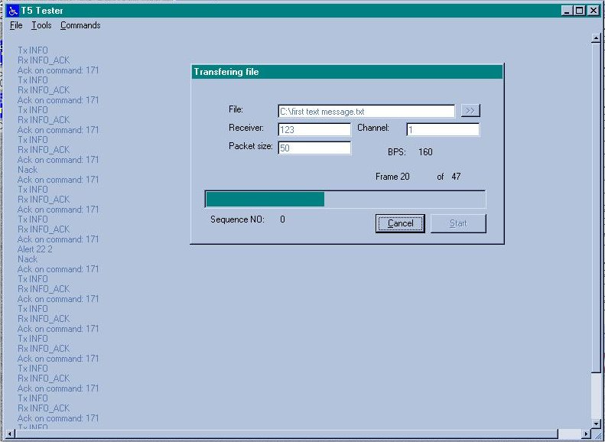
Figure 4 Long Transmission in Progress

Figure 5 shows the operator’s MMI screen as it appears at the end of a long transmission where several re-transmissions have taken place. This also illustrates the use of messages sent by means of the DLS’s short transmission protocol for test coordination between air and ground.
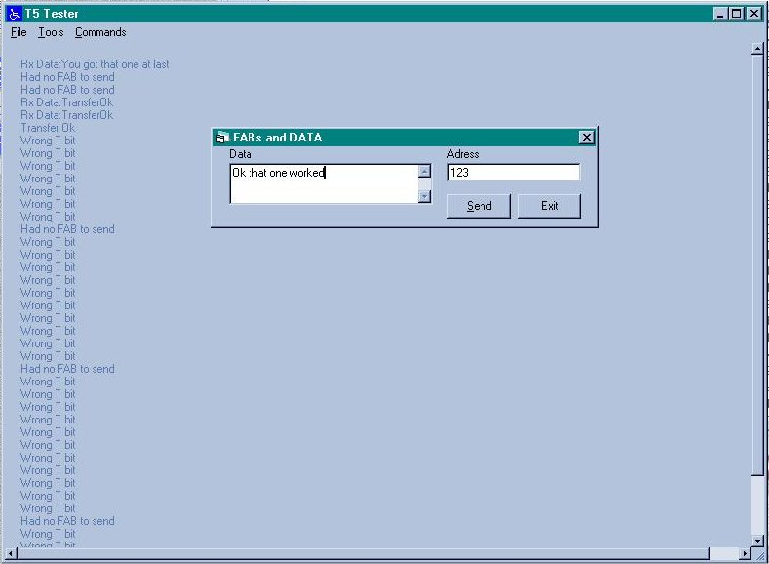
Figure 5 MMI – End of Long Transmission on Link with Several Re-transmissions

Overall Counts
Table 1 presents an analysis of the number of messages transmitted by message size and by direction of transmission. It can be seen that a range of message sizes was employed, so that both the short and long transmission protocols were exercised. In all cases logged, positive acknowledgement of message receipt was received.

Message Size (Bytes) | 0-200 | 200-500 | 500-1000 | 1000-2000 | 2000-3000 | Totals
Protocol | Short | Long | Long | Long | Long
Uplink | 40 | 2 | 0 | 0 | 10 | 52
Downlink | 53 | 6 | 0 | 0 | 5 | 64
Table 1 Analysis of Number of Messages Transmitted

A range of fragment sizes was employed, varying from 10 to 100 Bytes. Accordingly, the number of fragments transmitted for each message varied from 1 up to approximately 50.

Duration of Transmissions
For short transmissions, it was observed that they normally were delivered without re-transmission. The time between starting transmission and receipt of positive acknowledgement was typically 1-2 seconds.

A range of fragment sizes between 10 and 100 Bytes was employed. No significant effects of fragment size were noted. During long transmissions, it was observed that re-transmissions occurred regularly under certain link conditions.

Effect of Re-Transmissions on Transmission Duration
To analyse the operation of the DLS error detection and correction (by re-transmission) functions, a sequence of long transmissions was sent from air to ground. The characteristics of the messages were as follows

- Supplied to the link as an ASCII file (repeatedly by hand)
- File size approx. 2400 Bytes
- Packet (fragment) size 100 Bytes
- Files sent in the direction ground to air

The duration of the transmission (from start until acknowledgement of completion of successful transmission of the entire file) was measured, as was the number of re-transmissions taking place at packet (fragment) level.

The results are shown in the following table.

Tx No. | No. of Frames | Duration (sec) | No. of Re-Transmissions
1 | 24 | 65 | 20
2 | 24 | 75 | 23
3 | 24 | 40 | 9
4 | 24 | 50 | 11
5 | 24 | 35 | 6
Table 2 Effect of Re-transmissions

Based on these measurements, Figure 6 shows the measured relationship between the number of re-transmissions and the overall file-transfer duration.

The intercept on the X-axis of Figure 6 indicates that a zero-retransmission transfer would take 25 secs. Of course, this represents just one user of the link and not the aggregate link capacity. With multiple users, each can expect to achieve the same throughput.

Further, the slope of the graph indicates that each retransmission (of a 100-Byte frame) adds approx. 2.3 seconds to the overall transmission duration.

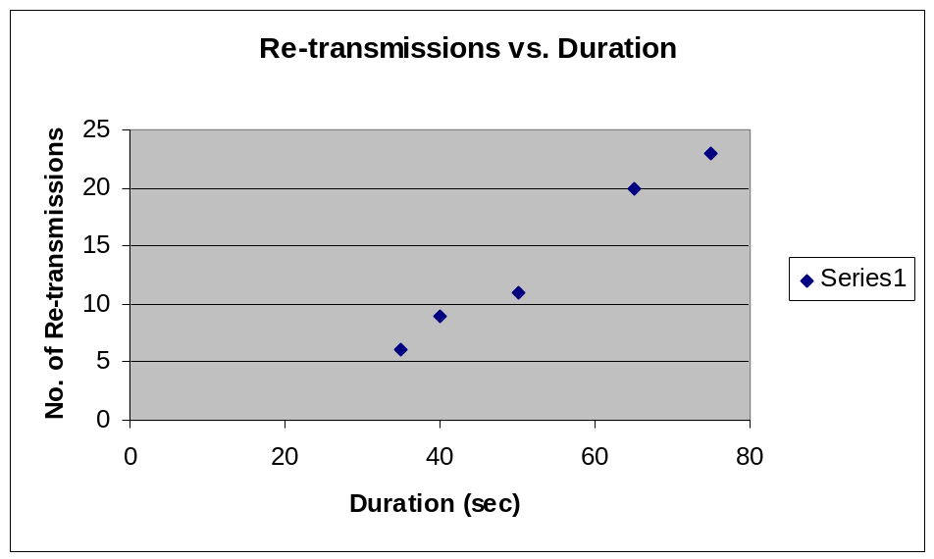
Figure 6 Relationship between Transmission Time and Number of Re-transmissions

Summary of Findings
The findings from the flight tests can be summarised as follows:

- All messages transmitted over the link were delivered successfully, provided a physical link was available. The re-transmit function of the DLS ensured that errors were detected and corrected.
- The fragmentation and re-assembly functions of the DLS ensured that message fragments were re-assembled in the correct order, even in the presence of bit errors and lost frames.
- Short and long transmissions of arbitrary length can be handled by the VDL Mode 4 system with the DLS.

Conclusions
The flight tests demonstrate, in a realistic flight environment, the utility of the new DLS for VDL Mode 4, as specified in the material presented to AMCP/8 by AMCP WG-M for inclusion in the ICAO VDL Mode 4 provisions.

Recommendations
The WGM is invited to:
- note the information in this paper;
- agree that the flight-testing on the use of VDL Mode 4 as an ATN compatible air/ground data link as requested in the ICAO AMCP/8 report paragraph 5.7.2.1 a) is completed;
- conclude that the validation of the new DLS in VDL Mode 4 (presented to AMCP/8 by WG-M) is fully validated and that it subsequently should be incorporated in the ICAO VDL Mode 4 provisions; and
- ask the ICAO Secretariat to communicate the results from the flight test with the ACP members and the ANC according to the actions identified in the AMCP/8 report.

Appendix A Aircraft and Ground Installations
The following illustrations show respectively

- The aircraft used for the tests.
- The VHF antenna employed on the aircraft (the narrow downward-pointing whip antenna to the rear of the A/C).
- Transponder installation on the aircraft.
- Roof-mounted ground antennas (VHF to the left and GPS to the right).


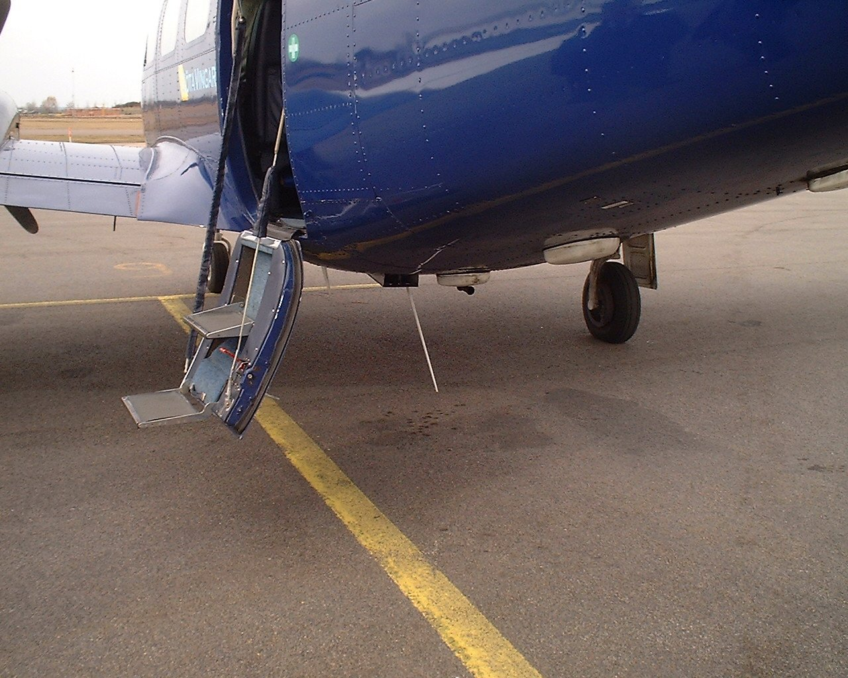
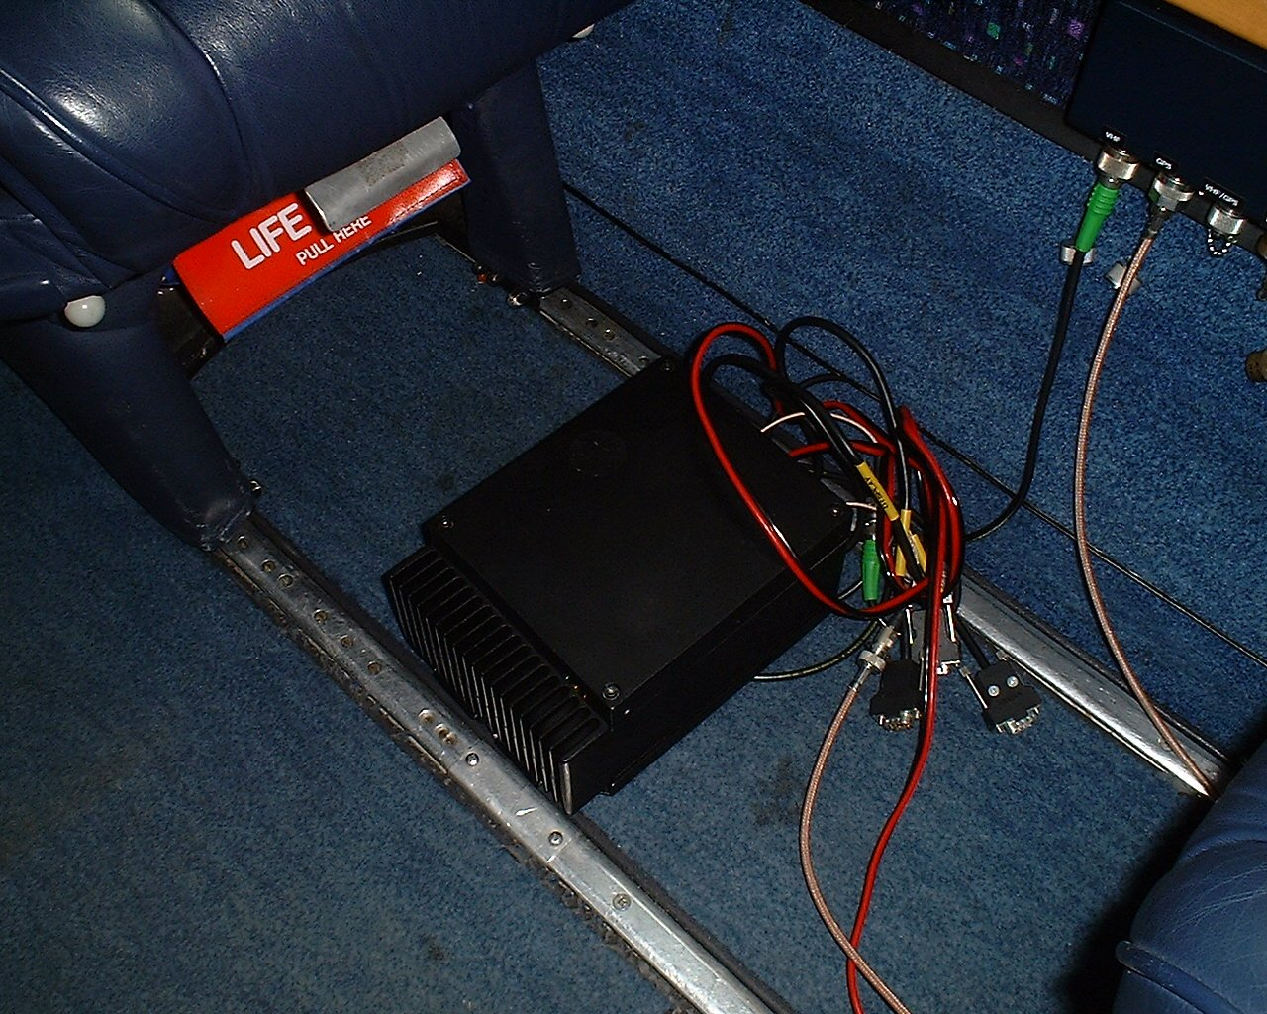

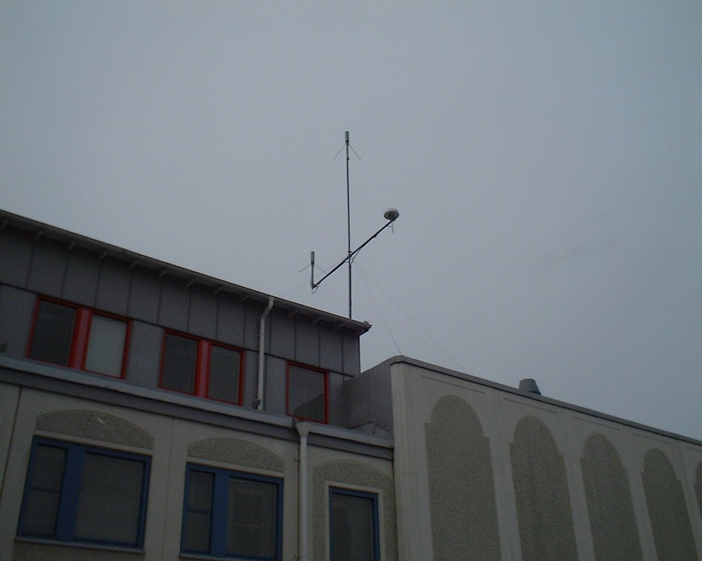

Appendix B Verification Matrix
The following matrix indicates the degree of conformance of the flight configuration with the proposed SARPs for the modified DLS.
Req. Source | Req. Text | Implemented (Y/N)  Commentary | Flight Tested (Y/N)
1.4.1 | The DLS shall support bit-oriented simplex communications using a negotiated setup connection-orientated protocol (NSCOP) and a zero-overhead connection-orientated protocol (ZOCOP).  The DLS shall support broadcast and multicast connectionless communications.  The DLS shall provide the following services  - transmission of user data  - indication that user data has been sent  - reception of user data  - indication that the DLS link has been established  - indication that the DLS link has been broken  Stations supporting the communications functionality provided by the DLS shall simultaneously support at least 8 peer-to-peer links with other stations.  Stations not supporting the communications functionality provided by the DLS shall implement Section 1.4.2.2 and Section 1.4.4.7 only. | Y  The NSCOP protocol has been implemented but without the setup phase.  N/A  a)-e) – Y  Y  N/A | Y  Y  N
1.4.1.1 | User data packets and LME data shall be transferred in the information fields of INFO, UDATA, and CTRL data link protocol data units (DLPDUs) which are collectively known as DATA DLPDUs. LME data shall be contained in CTRL and UCTRL frames only. The link layer shall process the largest packet size, specified in Section 1.4.3.5 of this document, without fragmenting. Larger packets shall be fragmented according to the procedures of Section 1.4.4.3.2. Only one data link user packet shall be contained in a DATA DLPDU. | Y | Y  But LME not tested
1.4.1.2 | On a point-to-point connection, the receiving DLS sub-layer shall ensure that duplicated DATA DLPDUs are discarded and all DATA DLPDUs which are part of a fragmented packet are delivered in the same order in which they appear in the packet. | Y | Y
1.4.1.3 | The DLS sub-layer shall ensure that DLPDUs corrupted during transmission are detected and discarded. | Y | Y
1.4.1.4 | A receiving station shall accept unicast DLPDUs addressed to its current station address. | Y | Y
1.4.1.5 | A VDL Mode 4 station shall accept broadcast DLPDUs and multicast DLPDUs to multicast addresses to which it is listening. | N/A  No multicast
1.4.1.6 | The DLS shall accept an indication of priority of the DATA DLPDU as defined in Table 1-10. | Partial.  No pre-emption. | N
1.4.1.7 | For the purposes of link control, the DLS shall provide the following DLS DLPDU types:  - ACK DLPDUs, consisting of INFO_ACK and CTRL_ACK, for the purposes of acknolwedgement of DATA DLPDUs and DLS link control DLPDUs respectively  - RTS DLPDUs, consisting of CTRL_RTS, INFO_RTS and UDATA_RTS, for the purposes of making reservations for the transfer of DATA DLPDUs  - CTS DLPDUs, consisting of CTRL_CTS, INFO_CTS and UDATA_CTS, for the purposes of acknowledging RTS DLPDUs and providing slots for subsequent transmission of DATA DLPDUs  - Other DLS link control DLPDUs, consisting of FRMR, FRMR_ACK, DM/DISC and SZOM, for purposes of link initialisation, reset and maintenance. | Y | Item 4 not tested
1.4.2.1 | The DLS shall maintain the following state variables for each data link between two peer stations.  State Variable  Usage  T_{t}  Current value of T bit (0 or 1) for transmitted DLPDUs  T_{r}  Value of T bit (0 or 1) for last received DLPDU.  Send array  an array storing user data packets and M-bit linked fragments queued for transmission (one per priority level)  receive array  an array storing received M-bit linked fragments queued for concatenation (one per priority level) | Y | Y
1.4.2.2.1 | The address type field is defined in Table 1-55.  Bit encoding  Description type  Bits 1 to 24  27  26  25  0  0  0  Mobile  Non-unique identity  0  0  1  Aircraft  24-bit ICAO address  0  1  0  Ground vehicles  Nationally administered address space  0  1  1  Reserved  Future use  1  0  0  Ground station  ICAO-administered address space  1  0  1  Ground station  ICAO-delegated address space  1  1  0  Reserved  Future use  1  1  1  All stations broadcast  All stations | Y | Y
1.4.2.2.2 | A mobile station using the non-unique identity address shall randomly choose a 24-bit address. The non-unique identity address of all zeros shall not be used. The non-unique identity address of all ones shall be used for broadcast applications only. All radio units located at a station shall use the same non-unique identity address.  If the station detects that another station is using the same random address, it shall stop transmitting on the current address; it shall then randomly select a new address that is not already present in its PECT. It shall use this new address in subsequent transmissions. | N/A - No broadcast/multicast.
1.4.2.2.3 | The aircraft specific address field shall be the 24-bit ICAO aircraft address. | Y | Y
1.4.2.2.4 | The ICAO-administered ground station specific address shall consist of a variable-length country code prefix (using the same country code assignment defined in Annex 10, Volume III, Chapter 9, Appendix 1, Table 1) and a suffix. The appropriate authority shall assign the bits in the suffix. | Y | Y
1.4.2.2.5 | The ICAO-delegated ground station specific address shall be determined by the organization to which the address space is delegated. | Y | Y
1.4.2.2.6 | The broadcast and multicast addresses shall be used only as a destination address for UDATA DLPDUs. | N/A
1.4.2.2.6.1 | The broadcast and multicast addresses shall be encoded as in Table 1-55a:  Broadcast destination  Type field  Specific address field  All mobiles that use non-unique addresses  000  All ones  All mobiles  001  All ones  All ground stations of a  particular provider  100 or 101, as necessary  Most significant bits: Variable length provider code  Remaining bits: All ones  All ground stations with ICAO-administered addresses  100  All ones  All ground stations  101  All ones  All stations  111  All ones | N/A
1.4.2.3.1 | A DLS station shall transmit the DLS burst defined in Table 1-57 with the VSS user supplied QoS and reservation parameters.  The DLS burst shall consist of one or two DLS DLPDUs combined according to the procedures of Section 1.4.4.12. A DATA DLPDU shall be the final field in the burst (and thus the burst can contain only one of these fields). | Y | Y
1.4.2.3.2 | The DLS DLPDU field shall indicate the DLPDU type and contain, as appropriate, the priority subfield, the more bit, the toggle bit, the initialise bit and length subfield.  DATA DLPDUs shall consist of a single octet containing link control information and a variable length information field and shall be encoded as defined in Table 1-57a  Table 1-57a. DATA DLPDU encoding  Octet  n  n+1  ...................  n+m  Bit  8  7  6  5  4  3  2  1  CTRL  M  T  re  c/r  IB  0  0  0  information field of length m octets  INFO  M  T  pr₄  pr₃  pr₂  pr₁  1  0  information field of length m octets  UCTRL  ucid₄  ucid₃  ucid₂  ucid₁  0  1  0  0  information field of length m octets  UINFO  0  0  0  0  1  1  0  0  information field of length m octets  Reserved  X  X  X  1  1  1  0  0  information field of length m octets  Reserved  X  X  1  0  1  1  0  0  information field of length m octets  Reserved  X  1  0  0  1  1  0  0  information field of length m octets  Reserved  1  0  0  0  1  1  0  0  information field of length m octets  Note.- “X” means 0 or 1  The command/response (c/r), response expected (re) and UCTRL ID (ucid) subfields, are defined in Sections 1.5.3.3.2 and 1.5.2.6.  RTS DLPDUs consist of two octets containing link control information and shall be encoded as defined in Table 1-57b  Table 1-57b. RTS DLPDU encoding  Octet  n  n + 1  Bit  8  7  6  5  4  3  2  1  8  7  6  5  4  3  2  1  CTRL_RTS  lg₅  T  IB  0  1  0  0  1  pr₄  pr₃  pr₂  pr₁  lg₄  lg₃  lg₂  lg₁  INFO_RTS  lg₅  T  0  1  1  0  0  1  pr₄  pr₃  pr₂  pr₁  lg₄  lg₃  lg₂  lg₁  UDATA_RTS  lg₅  0  1  1  1  0  0  1  pr₄  pr₃  pr₂  pr₁  lg₄  lg₃  lg₂  lg₁  Reserved  lg₅  1  1  1  1  0  0  1  pr₄  pr₃  pr₂  pr₁  lg₄  lg₃  lg₂  lg₁  Note.- “X” means 0 or 1  ACK, CTS and other DLS link control DLPDUs shall consist of one octet containing link control information and shall be encoded as defined in Table 1-57c.  Table 1-57c. ACK, CTS and other DLS link control DLPDUs encoding  Octet  N  Bit  8  7  6  5  4  3  2  1  UDATA_CTS  0  0  1  1  1  0  1  1  INFO_ACK  0  T  0  1  0  0  0  1  INFO_CTS  0  T  0  1  1  0  1  1  CTRL_ACK  0  T  IB  0  0  0  0  1  CTRL_CTS  0  T  IB  0  1  0  1  1  Reserved  0  X  X  1  0  1  0  1  FRMR_ACK  1  0  0  1  0  0  0  1  FRMR  1  0  0  1  0  1  0  1  DM/DISC  1  0  1  1  0  1  0  1  Reserved  1  0  1  1  1  0  1  1  Reserved  1  1  0  1  0  0  0  1  Reserved  1  X  0  1  1  0  1  1  Reserved  1  X  X  0  0  0  0  1  Reserved  X  X  X  0  0  1  0  1  Reserved  1  X  X  0  1  0  1  1  Reserved  X  X  1  1  0  0  0  1  Reserved  X  X  X  X  0  0  1  1  Reserved  1  1  X  1  0  1  0  1  Reserved  X  X  X  X  0  1  1  1  Reserved  X  1  1  1  1  0  1  1  SZOM  neg₄  neg₃  neg₂  neg₁  1  1  0  1  Reserved  X  X  X  X  1  1  1  1  Note.- “X” means 0 or 1  All header bits labelled res are reserved and shall be set to zero. | Y | Y
1.4.2.3.3 | The T (Toggle) bit shall be alternately set to zero and one on each successful transmission..  At the start of a communication between two stations, or when the link is reset, the toggle bit shall be initiated according to the procedures of Section 1.4.4.3.3.1for NSCOP communication and Section 1.4.4.3.3.2 for ZOCOP communication. | Y  Toggle bit is initialised to 0. | Y
1.4.2.3.4 | The M (More) bit shall be set to zero to indicate the end of a user data packet and to one to indicate that this fragment is not the last fragment in a multi-fragment user data packet and that further fragments will be transmitted. | Y | Y
1.4.2.3.5 | The priority subfield (p) shall indicate the priority level of the transmission as defined in Section 1.4.1.6. | Y | Not fully tested.
1.4.2.3.6 | The length subfield (lg) shall indicate the length of the DLS burst containing a DATA DLPDU in slots. | Y | Y
1.4.2.3.7 | When the IB (initialise) bit is set the receiver shall initialise the T_{t} and T_{r} state variables and clear the send and receive arrays whilst processing the DLPDU. | Y | Y
1.4.2.3.8 | The negotiation (neg) subfield shall indicate the link management parameters to be used for ZOCOP link control as defined in Table 1-57d:  Negotiation subfield  Parameters to use for ZOCOP link  0  VDL Mode 4 default parameters for version 0  1 – 15  reserved for future use | N/A
1.4.3 | The parameters needed by the DLS sublayer shall be as listed in Table 1-58.  DLS parameters for NSCOP communications shall be determined during the exchange of CTRL DLPDUs, if the default values are not to be used.  DLS parameters for ZOCOP communications shall be determined by the exchange of the negotiation subfield within the SZOM DLPDU.  Symbol  Parameter name  Minimum  Maximum  Default  Increment  TD1  ZOCOP link transmit reset timer  5 s  600 s  60 s  1 s  TD2  ZOCOP link receive reset timer  10 s  1200 s  90 s  1 s  ND1  Maximum number of octets in any user data packet  143 octets  2063 octets  1511 octets  1 octet  ND2  Maximum length of DLS transmission  2 octets  2063 octets  86 octets  1 octet  ND3  Maximum length of fragment  1 slot  32 slots  5 slots  1 slot | TD1 - N/A  TD2 – N/A  ND1 – Y  ND2 – Y  ND3 – Y | Y  Y  Y
1.4.3.1 | For a mobile station maintaining a ZOCOP link with another mobile station, Timer TD1 shall be reset when a DLPDU is sent to the peer. Timer TD1 shall not be cancelled. If Timer TD1 expires, then T_{t} shall be set to 0 and the send channel array shall be cleared. | N/A
1.4.3.2 | For a mobile station maintaining a ZOCOP link with another mobile station, Timer TD2 shall be reset when a DLPDU is received from the peer. Timer TD2 shall not be cancelled. If Timer TD2 expires, the link shall be considered to be terminated. | N/A
1.4.3.3 | The parameter ND1 shall define the maximum number of octets in any user data packet that a DLS shall accept from the data link user or from a peer station. A station receiving a user data packet from a peer station greater in length than ND1 shall discard the packet and shall reset the link in accordance with the procedures of Section 1.4.4.11. A station receiving a user data packet from a data link user greater in length than ND1 shall discard the packet. | 1st sentence –Y  2nd & 3rd – TBD | Not tested.
1.4.3.4 | The parameter ND2 shall define the maximum size in octets of a transmission including flags and reservation data that shall be sent using the short transmission procedures defined in Section 1.4.4.5.  A burst occupying x slots shall contain up to 23 + (x-1)*31 octets of data if x is odd or 24 + (x-1)*31 octets of data if x is even including flags and reservation data. | Y | Y
1.4.3.5 | The parameter ND3 shall define the maximum size in slots of a DLS burst. | Y | Y
1.4.4.1 | Only UDATA DLPDUs shall be broadcast. | N/A
1.4.4.2 | For all DLS bursts containing CTRL, INFO, CTRL_RTS and INFO_RTS DLPDUs, quality of service parameters Q5min, Q5max, Q5mult, Q5exp and Q5num shall be set as defined in Table 1-58a.  Symbol  Parameter name  Default  Q5min  VSS retransmission parameters  Minimum  1.0s  Q5max  Maximum  15s  Q5mult  Multiplier  1.45  Q5exp  Exponent  1.7  Q5num  number of attempts  4  Q5wait  maximum time to wait for a reply  20s | N, no special Q5 parameters for the DLS is used. | Not tested.
1.4.4.3.1 | A sending station shall maintain a prioritised queue of user data packets for transmission.  When determining which user data packet to transmit, the highest priority user data packet shall be sent first.  The DLS DLPDUs CTRL,and CTRL_RTS shall be classified as network management messages and given the highest priority.  The DLS DLPDUs INFO_RTS, and UDATA_RTS shall be assigned the same priority as the DATA DLPDU with which they are associated. | N  Y | Y
1.4.4.3.2.1 | If the length of the DLS burst containing a CTRL or INFO DLPDU is greater than ND3 slots, the sending station shall fragment the user data packet and format it according to the procedures of Section 1.4.4.3.2.3. Otherwise the user data packet shall be sent as a single fragment formatted according to the procedures of Section 1.4.4.3.2.2.  The fragmentation of a user data packet shall take account of whether the station is combining a CTRL or INFO DLPDU with another DLS DLPDU in accordance with the procedures of Section 1.4.4.12.3. | Y | Y
1.4.4.3.2.2 | A single fragment user data packet shall be transferred as a CTRL or INFO DLPDU.  a) The M bit shall be set to zero.  b) For an INFO DLPDU, the pr bits shall indicate the priority of the DLPDU. | Y | Y
1.4.4.3.2.3 | A multiple fragment user data packet shall be transferred as a series of CTRL or INFO DLPDUs.  a) The M bit shall be set to 1 for all fragments except the last fragment.  b) The M bit shall be set to 0 for the last fragment.  c) For INFO DLPDUs, the pr bits shall indicate the priority of the DLPDU. | Y  - - Y  - - Y  - - Y | Y
1.4.4.3.3.1 | When there is no current connection between a mobile station and a ground station and the LME of either station requests the transmission of a CTRL user data packet, the sending station shall fragment the user data packet in accordance with the procedures of 1.4.4.3.2 and send the fragments using either the short transmission procedures see Section 1.4.4.5) or the long transmission procedures (see Section 1.4.4.6). In the first fragment, it shall send either a CTRL DLPDU (short transmission procedures) or a CTRL_RTS (long transmission procedures) and set the IB bit to 1, the T bit to 0 and the state variable T_{t} to 0.  On receipt of a CTRL_RTS DLPDU (long transmission procedures), the receiving station shall send a CTRL_CTS with IB = 1 in accordance with the procedures of Section 1.4.4.6.3.  On receipt of a CTRL_CTS DLPDU with IB = 1 (long transmission procedures), the sending station shall send an INFO DLPDU with IB = 1 in accordance with the procedures of Section 1.4.4.6.4.  On receipt of a CTRL DLPDU with IB = 1, the receiving station shall set its own state variable T_{r} to 0, clear its receive arrays, and consider the link established for receipt of further DATA DLPDUs. The receiving station shall set IB = 1 in the CTRL_ACK response to the CTRL DLPDU.  On receipt of the CTRL_ACK with T = 0 and IB = 1, produced in response to a CTRL DLPDU with IB = 1, the sending station shall set its state variable T_{t} to 1 and consider the link established for transmission of further DATA DLPDUs.  Note.- At this stage the state variables T_{t} for the sending station and T_{r} for the receiving station are initialised. The receiving station must separately initialise the state variables for data transfer in the opposite direction.  On receipt of a CTRL_RTS, CTRL_CTS, CTRL or CTRL_ACK DLPDU in a DLS burst addressed to it for which IB = 1 and for which the T bit is equal to 1 a station shall reset the link in accordance with the procedures of Section 1.4.4.11. | Y | Y
1.4.4.3.3.2 | A mobile sending station (the “sending station”) wishing to send data to a mobile station (the “receiving station”) for which it does not currently have a link, shall send a DLS burst containing a Start Zero Overhead Mode (SZOM) DLPDU and the first INFO (short transmission procedures) or INFO_RTS (long transmission procedures) DLPDU to the receiving station using respectively the short transmission procedures (see Section 1.4.4.5) or the long transmission procedures (see Section 1.4.4.6). It shall set the negotiation field to the highest value that is supported by the DLS in the SZOM DLPDU, the T bit to 0 in the INFO DLPDU and the state variable T_{t} to 0.  On receipt of an SZOM DLPDU combined with an INFO DLPDU (short transmission procedures) or INFO_RTS DLPDU (long transmission procedures), the receiving station shall set its own state variable T_{r} to 0, clear its receive arrays and consider the link established for receipt of further DLPDUs from the sending station. The receiving station shall send a SZOM DLPDU combined with an INFO_ACK (short transmission procedures) or an INFO_CTS (long transmission procedures) in the slot reserved for the transmission setting T=0. In the SZOM DLPDU, the receiving station shall set the negotiation field to the highest value that is supported by the DLS.  On receipt of the INFO_ACK (short transmission procedures) or INFO_CTS (long transmission procedures) combined with an SZOM DLPDU, the sending station shall set its state variable T_{t} to 1 and consider the link established for transmission of further DATA DLPDUs.  For both sending and receiving stations, link parameters shall be selected which correspond to the lower value of the negotiation subfields contained in the SZOM DLPDU sent by the sending station and in the SZOM DLPDU sent by the receiving station. | N/A
1.4.4.3.3.3 | When the T bit has been initialised, the sending station shall set the T bit for transmitted DLPDUs to the value of T_{t}. | Y | Y
1.4.4.4 | After a packet has been selected for transmission according to the procedures of Section 1.4.4.3 the sending station shall calculate the total length in octets of the DLS burst required to contain the DLPDU queued for transmission using the short transmission procedures defined in Section 1.4.4.6. The total length shall include the length of any reservation fields contained within the DLS burst, together with any flags. The calculation of the length of the DLS burst shall take account of whether the station will combine a DATA DLPDU with another DLS DLPDU in accordance with the procedures of Section 1.4.4.12.3. If the total length is less than or equal to ND2, then the station shall use short transmission procedures (Section 1.4.4.6) to transmit the queued data. Otherwise, the station shall use the long transmission procedures (Section 1.4.4.7). The M bit shall be set to 0 for a short transmission. | Y | Y
1.4.4.5.1 | After the selection of a short transmission procedure, the sending station shall transmit a DLS burst containing the DATA DLPDU queued for transmission with QoS parameters as defined in Table 1-60 using the random access procedures. For CTRL and INFO DLPDUs, the T bit shall be set to T_{t}.  A burst containing a CTRL or INFO DLPDU shall contain a unicast request reservation field for the acknowledgement with the parameters in Table 1-60. | Y | Y
1.4.4.5.2.1 | If a station receiving a CTRL or INFO DLPDU has a valid link to the sender it shall transmit a DLS burst containing an ACK DLPDU in the slot reserved by the unicast request reservation field contained in the data DLPDU transmission:  a) A CTRL_ACK DLPDU shall be sent in response to a CTRL DLPDU and an INFO_ACK DLPDU shall be sent in response to an INFO DLPDU  b) The T bit shall be set to the value of the T bit in the received DATA DLPDU. | N  - Y  - Y | N  Y  Y
1.4.4.5.3 | If an acknowledgement to a CTRL or INFO DLPDU is not received from the receiving station, the sending station shall retransmit the DLS burst containing the CTRL or INFO DLPDU and a unicast request reservation field according to the procedures of Section 1.3.21. | Y | Y
1.4.4.5.4 | A station receiving a UDATA DLPDU shall forward the contents of the information field to the DLS user and take no further action.  Table 1-60. Short transmission INFO DLPDU parameters  Symbol  Parameter name  Default  V32  Minimum response delay  (54 msec) * M1 / 60 slots  V33  Maximum response delay  (5 sec) * M1 / 60 slots  V34  Source/destination control  0  V35  Broadcast control  0  V36  Length of reserved block  1 slot  Q1  Priority  Priority of INFO DLPDU  Q2a  Slot selection range constraint for level 1  150 NMI  Q2b  Slot selection range constraint for level 2  150 NMI  Q2c  Slot selection range constraint for level 3  0 NMI  Q2d  Slot selection range constraint for level 4  300 NMI  Q3  Replace queued data  FALSE  Q4  Number of available slots  3 | N/A
1.4.4.6.1 | After the selection of a long transmission procedure, the sending station shall transmit a DLS burst containg an RTS DLPDU to the receiving station in the transmit queue with QoS parameters as defined in Table 1-61. When using the long transmission procedure:  - A station shall send a CTRL_RTS, INFO_RTS or UDATA_RTS DLPDU if a CTRL, INFO or UDATA DLPDU respectively is to be transmitted.  b) The pr subfield shall indicate the priority of the DATA DLPDU to be transmitted (see Section 1.4.1.6)  - The length subfield shall indicate the length of the DLS burst required to contain the DATA DLPDU (see Section 1.4.2.3.6).  d) For CTRL_RTS and INFO_RTS DLPDUs, the T bit shall be set to T_{t}.  Each burst shall contain a unicast request reservation field with the parameters set as defined in Table 1-61. | Y | Y
1.4.4.6.2 | Note.- If a response is not received to the RTS DLPDU, the station retransmits the DLS burst containing the RTS DLPDU and the unicast request according to the procedures of Section 1.3.14.4.4  Table 1-61. Long transmission RTS DLPDU parameters  Symbol  Parameter name  Default  V32  Minimum response delay  (54 msec) * M1 / 60 slots  V33  Maximum response delay  (5 sec)* M1 / 60 slots  V34  Source/destination control  0  V35  Broadcast control  0  V36  Length of reserved block  1 slot  Q1  Priority  Priority of RTS  Q2a  Slot selection range constraint for level 1  150 nmi  Q2b  Slot selection range constraint for level 2  150 nmi  Q2c  Slot selection range constraint for level 3  0 nmi  Q2d  Slot selection range constraint for level 4  300 nmi  Q3  Replace queued data  FALSE  Q4  Number of available slots  3 | Y | Y
1.4.4.6.3.1 | If the responder has a valid link to the sender and the received DLPDU is an RTS_UDATA or if the T bit within the CTRL_RTS or INFO_RTS DLPDU is not equal to T_{r}, then the receiving station shall transmit a CTS DLPDU in a DLS burst in the slot reserved by the RTS DLPDU.  a) A CTRL_CTS, INFO_CTS or UDATA_CTS DLPDU shall be sent in response to a CTRL_RTS, INFO_RTS or UDATA_RTS DLPDU respectively  b) The T bit shall be set to T bit of the RTS DLPDU to which the CTS is a response  For CTRL_CTS and INFO_CTS DLPDUs, the burst shall contain an information transfer request reservation field and be transmitted with the parameters in Table 1-63, indicating the number of slots reserved for transfer of the DATA DLPDU.  For a UDATA_CTS DLPDU, the burst shall contain a unicast request reservation field and be transmitted with the parameters in Table 1-61, indicating the number of slots reserved for transfer of the DATA DLPDU. | Y  - Y  - Y  N  N | Y
1.4.4.6.3.2 | If the responder has a valid link to the sender and if the T bit within the CTRL_RTS or INFO_RTS DLPDU is equal to T_{r}, then the receiving station shall transmit an ACK DLPDU in the slot reserved by the RTS.  a) A CTRL_ACK or INFO_ACK DLPDU shall be sent in response to a CTRL_RTS or INFO_RTS DLPDU respectively  b) The T bit shall be set to the value of the T bit in the received DATA DLPDU.  The DLS burst containing the ACK DLPDU shall contain a response reservation type except as determined by the procedures of Section 1.4.4.12. | Y  - Y  - Y  N | Y  Y  Y
1.4.4.6.3.3 | If the channel is too busy (either the receiving station cannot find a sufficiently large series of contiguous slots or the priority is too low for the channel utilization), then the receiving station shall transmit either a general confirm including a unicast reservation with V34 = 1 indicating when the responder will transmit an information transfer request in response to the RTS or a general failure (see Section 1.3.20) with error type = 01 hex.  Table 1-62. General response to RTS parameters  Symbol  Parameter name  Default  Q1  Priority  Priority of RTS  Q2a  Slot selection range constraint for level 1  150 nmi  Q2b  Slot selection range constraint for level 2  150 nmi  Q2c  Slot selection range constraint for level 3  0 nmi  Q2d  Slot selection range constraint for level 4  300 nmi  Q3  Replace queued data  FALSE  Q4  Number of available slots  3  Table 1-63. CTS DLPDU parameters  Symbol  Parameter name  Default  V42  Length of information transfer  Sufficient to included requested INFO DLPDUs  V43  Minimum information transfer delay  (54 msec) * M1 / 60 slots  V44  Maximum information transfer delay  (5 sec) * M1 / 60 slots  V45  Minimum response delay  (54 msec) * M1 / 60 slots  V46  Maximum response delay  (5sec) * M1 / 60 slots  Q1  Priority  Priority of RTS  Q2a  Slot selection range constraint for level 1  150 nmi  Q2b  Slot selection range constraint for level 2  150 nmi  Q2c  Slot selection range constraint for level 3  0 nmi  Q2d  Slot selection range constraint for level 4  300 nmi  Q3  Replace queued data  FALSE  Q4  Number of available slots  3 | N
1.4.4.6.4.1 | On receipt of a CTRL_CTS or INFO_CTS DLPDU in a DLS burst addressed to it for which the T bit is equal to T_{t} and with an information transfer request reservation field shall transmit the requested DATA DLPDU in the allocated reservation with the T bit set to T_{t}.  On receipt of a CTRL_CTS or INFO_CTS DLPDU in a DLS burst addressed to it for which the T bit is not equal to T_{t} shall reset the link in accordance with the procedures of Section 1.4.4.11.  On receipt of a UDATA_CTS DLPDU in a DLS burst addressed to it with a unicast request reservation field shall transmit the requested UDATA DLPDU in the allocated reservation. | Y  Y  N/A | Y  Y
1.4.4.6.4.2 | If the station has nothing to transmit (e.g., after a reset), it shall not transmit. | Y | Y
1.4.4.6.5.1 | A receiving station which transmitted a CTRL_CTS or INFO_CTS DLPDU in a DLS burst containing an information transfer request reservation field (and consequently has a reservation for an acknowledgement) and which has received the DATA DLPDU with the same setting of T bit as is contained in the CTS, shall transmit in the slot reserved for an acknowledgement an ACK DLPDU in a DLS burst.  a) A CTRL_ACK or INFO_ACK DLPDU shall be sent in response to a CTRL or INFO DLPDU respectively;  b) The T bit shall be set to the value of the T bit in the received DATA DLPDU.  The DLS burst containing the ACK DLPDU shall contain a response reservation type except as determined by the procedures of Sections 1.4.4.12. | Y  - Y  - Y  N | Y  Y  Y  N
1.4.4.6.5.2 | A receiving station which transmitted a CTRL_CTS, INFO_CTS or UDATA_CTS DLPDU in a DLS burst containing an information transfer request reservation field (and consequently has a reservation for an acknowledgement) and which has not received the CTRL, INFO or UDATA DLPDU with the same setting of T bit as is contained in the CTS, shall transmit in the slot reserved for an acknowledgement an ACK DLPDU in a DLS burst.  a) A CTRL_ACK or INFO_ACK DLPDU shall be sent in response to a CTRL or INFO DLPDU respectively  b) The T bit shall be set to the inverse of the value of the T bit in the last transmitted CTS DLPDU.  Note.- The use of the T bit not equal to the last transmitted CTS indicates a “negative acknowledgement (NACK)”  The DLS burst containing the ACK DLPDU shall contain a response reservation type. | N  - Y  - Y  N | N  Y  Y
1.4.4.7 | If the responder to a CTRL, CTRL_RTS, INFO, INFO_RTS or SZOM DLPDU does not support the DLS, then it shall transmit a general failure (see Section 1.3.20) with an error type of 80 hex in the slot reserved by the unicast request reservation field contained in the data DLPDU transmission. | N/A
1.4.4.8 | If the responder to a CTRL or CTRL_RTS DLPDU with IB not equal to 1 or an INFO or INFO_RTS DLPDU which is not combined with a SZOM DLPDU does not have a link with the sender, the responder shall send a DLS burst containing a DM/DISC DLPDU in the slot reserved by the unicast request reservation field contained in the data DLPDU transmission. | Y | Y
1.4.4.9.1 | When a CTRL or INFO DLPDU is received without errors from another station, the value of the T bit shall be inspected and recorded.  If this is:  a) a CTRL DLPDU with IB = 1 or an INFO DLPDU combined with a SZOM DLPDU, or  b) the value of the T bit is not equal to T_{r},  then the user data packet or user data packet fragment shall be accepted and T_{r} shall be set to the value of the T bit in the received INFO or CTRL DLPDU. Otherwise, the received user data packet or user data packet fragment shall be discarded as a duplicate.  When a UDATA DLPDU is received without errors from another station, it shall be passed to the service user as a single incoming user data packet. Otherwise it shall be discarded. | Y  Y | Y  Y
1.4.4.9.2 | If any preceding user data packet fragments have been received with, in the case of an INFO DLPDU, the same value of pr subfield and with the M bit set to one, then the user data part of the received DATA DLPDU shall be concatenated to the end of the user data packet fragments.  If the M bit is set to zero on the received DATA DLPDU, then the user data part of the received DATA DLPDU, including any user data packet fragments received earlier and with which it has been concatenated, shall be passed to the service user as a single incoming user data packet. Otherwise, the received user data shall be retained awaiting the arrival of the remaining parts of the multiple fragment user data packet. | Y  Y | Y  Y
1.4.4.9.3 | UDATA, DM/DISC and all ACK DLPDUs shall be unacknowledged. | Y | Y
1.4.4.10 | When an ACK DLPDU is received without errors from another station, the value of the T bit shall be inspected.  If T = T_{t}, then the DATA DLPDU shall be assumed successfully received and the value of T_{t} shall be set to the inverse of the current value of T_{t}.  If T is not equal to T_{t} or if the ACK DLPDU is not received, then the sending station shall re-send the DATA DLPDU using the short or long transmission procedures as determined by the procedures of Section 1.4.4.4.  When a DATA DLPDU has been successfully received, the highest priority fragment (either the next fragment of the current user data packet or the first fragment/complete DLPDU of the next user data packet) in the send queue, if any, shall be selected for transmission using the procedures of Section 1.4.4.3. | Y | Y
1.4.4.11 | The sending station shall reset the link by sending a FRMR DLPDU in a DLS burst placing a unicast reservation for the response, and shall discard all outstanding user data packets in the send and receive array. If a FRMR_ACK is not received in the reserved slot, the FRMR shall be sent again using the re-transmission procedures. Only when a FRMR_ACK has been received shall the station attempt to re-send data to the receiving station using the procedures of Section 1.4.4.3.3. If the sending station receives an INFO or RTS DLPDU from the peer whilst waiting for a FRMR_ACK, it shall send an FRMR in response.  On receipt of a FRMR DLPDU, the receiving station shall discard any outstanding fragments in the receive array and shall transmit a FRMR_ACK DLPDU in a DLS burst in the reserved slot. | N
1.4.4.12.1 | A station with a queue of transmissions to send to a receiving station should link transmissions using the procedures set out in this section.  An implementation of the DLS shall be capable of providing a combined frame response even if the station does not initiate the use of combined frames. | N
1.4.4.12.2 | It shall be possible to combine the following DLPDUs:  - RTS/DATA  - ACK/CTS  - ACK/DATA  - ACK/RTS  - SZOM/other DLPDUs as described in Section 1.4.4.3.3.2 | N
1.4.4.12.3 | When a receiving station has selected a user data packet for transmission using the procedures of Section 1.4.4.3 it should also select the next user data packet with the highest priority and place an RTS DLPDU in the DLS burst containing the DATA DLPDU for the first user data packet. For CTRL_RTS and INFO_RTS DLPDUs, the T bit shall be set to the inverse of T_{t}. | N
1.4.4.12.4 | On receipt of a RTS/DATA DLS burst, a station shall process the DATA DLPDU first according to the procedures of Section 1.4.4.6.5.1. If the station can find sufficient resources for a subsequent DATA DLPDU transfer, then the DLS burst containing the ACK DLPDU shall also contain a CTS DLPDU for the next DATA DLPDU transfer:  a) A CTRL_CTS, INFO_CTS or UDATA_CTS DLPDU shall be sent in response to a CTRL_RTS, INFO_RTS or UDATA_RTS DLPDU respectively  b) The T bit shall be set to the T bit of the RTS DLPDU to which the CTS is a response  In the case of CTRL_CTS and INFO_CTS DLPDUs, instead of the response reservation type required by the procedures of Section 1.4.4.6.5.1,the burst shall contain an information transfer request reservation field transmitted using the parameters defined in Table 1-63, indicating the number of slots reserved for transfer of the DATA DLPDU.  A receiving station which has data that would fit into a single slot DLS burst containing an ACK DLPDU to send back to the sending, shall include its own DATA DLPDU in this DLS. The burst shall contain a unicast request reservation field with the parameters in Table 1-61 for the acknowledgement of the DATA DLPDU. | Y  - Y  - Y  N | Y  Y  Y
1.4.4.12.5 | If a receiving station has data to send back to the sending station which cannot fit into a single slot DLS burst containing an ACK DLPDU, then the station shall combine an RTS DLPDU for its own DATA DLPDU in the DLS burst containing the ACK DLPDU and use the long transmission procedures for the data transfer. | N
1.4.4.12.6 | If a station is sending an ACK DLPDU to one destination and has data to send to a different destination, then the station should include a unicast reservation field with sdf = 1 with the DLS burst containing the ACK and then transmit an RTS DLPDU to the new destination in the reserved slot. | N
1.4.4.13 | The CTRL DLPDU shall be used for the LME to establish and maintain links as defined in Section 1.5. | N
1.4.4.14 | Air-air communication services shall be supported by a zero-overhead connection oriented protocol (ZOCOP). | N/A
1.4.4.14.1 | When a ZOCOP link has been established, data shall be exchanged as determined by either the short or long transmission procedures as described in Sections 1.4.4.5 and 1.4.4.6. | N/A
1.4.4.14.2 | A station that has established a ZOCOP link with a peer, and which has not sent a packet to that peer for TD1 seconds, and that wishes to send a DATA packet to the peer, shall re-establish the link according to the procedures of Section 1.4.4.3.3.2.  A station shall regard the link as terminated if it has not transmitted to the same peer for TD1 seconds and if it has not received a transmission from the same peer for TD2 seconds.  A station shall regard the link as terminated if it receives a DM/DISC DLPDU from the peer station or an attempt to send a packet to the peer station fails because of a failure notified by the retransmission procedures of Section 1.3.21. | N/A

At certain times during the flights, physical layer link was lost so that messages were undeliverable. This was noted via NACK and reported to the operator.
Note the number of re-transmissions refers to the number of times any 100-byte frame or packet must be re-transmitted during the entire file transfer.
N/A in this matrix implies that the requirement is not applicable for ATN application.

