AMCP/WG-M5/WP-21
19 August 2002

Aeronautical Mobile Communication Panel (AMCP)

Working Group-M Meeting
Fifth Meeting

Saint Petersburg, Russia, 19 to 23 August 2002

Agenda Item 4b: Review of SARPs log-on procedures in the event of satellite failure

Simulation on log-on procedures in the event of satellite failure

Presented by S.Takahashi

(Prepared by A. Ishide, M. Fujita, J. Kitaori)

SUMMARY
When a satellite becomes disabled for some reason, all AESs lose connection to the logged-on GES through the satellite. This situation could greatly harm flight safety. In order to mitigate the impact of satellite failure, it is desirable that the link connection is recovered within 10 seconds after connection loss or that an alternative connection is always available. Therefore, the following measures are most effective.
a. Satellite switchover within 10 seconds in the event of satellite failure
b. Double log-on capability on AES
This paper describes another possible measure to reduce the impact of log-on rush in the event of satellite failure. The measure is,
a. to use 10500 bit/s P_{smc} and R _{smc} channels for log-on separate from P_{d} and R_{d} channels,
b. to prepare a required number of them to accommodate all AES in the event of satellite failure
and
c. to implement a mechanism to choose each of P_{smc} and R _{smc} channels randomly on AES.
Simulations show that the congestion reduces to some extent with this measure. Its effectiveness depends on the number of available P_{smc} and R _{smc} channels and allowable time limit in which all AES should complete log-on.
- Introduction
When a satellite becomes disabled for some reason, all AESs lose connection to the logged-on GES through the satellite. This situation could greatly harm flight safety. In order to mitigate the impact of satellite failure, it is desirable that the link connection is recovered within 10 seconds after connection loss or that an alternative connection is always available. Therefore, the following measures are most effective.
a. Satellite switchover within 10 seconds in the event of satellite failure
b. Double log-on capability on AES
This paper describes another possible measure to reduce the impact of log-on rush in the event of satellite failure. Simulations show that the congestion reduces to some extent with this measure. Its effectiveness depends on the number of available P_{smc} and R _{smc} channels and allowable time limit in which all AES should complete log-on.

- Summary of simulation

2.1 Simulation software
The ASET model developed by Mayflower Co. is used for the computer simulation. This ASET model works on the OPNET, network simulation software. They are installed in a workstation. The simulation software was once used to validate the AMSS Draft SARPs.

2.2 Simulation conditions and procedures
The parameters to be set for simulation are as follows.
- Transmission Data length (octet) : 95 bytes (T channel)
- Channel rate (bit/s) : 600 bit/s, 10500 bit/s
- Transmission mode : periodic (T channel)
- Number of P channel : 1
- Number of R channel : 1, 2, 4, 6
- Number of AES : 20, 40, 60, 80 , 100
In simulation, a certain number of AES start sending log-on requests to a GES on an R channel at a random interval within 60 seconds. After logging on, each AES begins transmissions of 95 octet data at a constant interval of 16 minutes on a T channel. The percentage of logged-on AES among a total AES was calculated as time elapses. The simulation trials were reiterated for different number of AES and for different number of R channels. (Refer to Fig. 1 and 2)

- Simulation Result

3.1 Percentage of Logged-on AES using 600 bits/s P_{smc} and R_{smc} channels
Figures 3 through 5 show the percentage of logged-on AES for different number of R channels as time. The channel rate of P and R channels is 600bit/s.
Figure 3 shows the case of one R channel. For 20 AESs, all AES completes log-on in about 730 seconds. But, for more AES, the percentage of logged-on AES decreases greatly. For 40 AESs, about half of AES cannot log on in 1200 seconds. The percentage drops further for the case of more AES.
Figure 4 shows the case of two R channels. The situation improves a little. But, more than 40 percent of AES still cannot log on in 1200 seconds for the case of more than 60 AES.
Figure 5 shows the case of four R channels. The situation improves further. But, more than 30 percent of AES still cannot log on in 1200 seconds for the case of more than 80 AESs.

3.2 Percentage of Logged-on AES using 10500 bit/s P_{smc} and R_{smc} channels
Figures 6 through 8 show the percentage of logged-on AES for different number of R channels as time. The channel rate of P and R channels is 10500bit/s.
Figure 6 shows the case of one R channel. The percentage of logged-on AES increases faster than that of 600 bits/s as time. But, it still takes about 1000 seconds for 100 AESs to complete log-on.
Figure 7 shows the case of two R channels. All of 100 AESs complete log-on in 500 seconds. It is much shorter time than that in the previous case.
Figure 8 shows the case of four R channels. All of 100 AESs completes log-on in about 200 seconds.

- Discussion
Table 1 shows how long it takes for 100 AES to complete log-on when the channel rate of P and R channels is 10500 bit/s.
Number of R channel | 1 | 2 | 4
Time for log-on completion | 1000 | 500 | 200
This table gives the number of AES that can complete log-on in 10 minutes (600 seconds). If two R channels are available, all of 100 AESs can complete log-on in 10 minutes. It implies that, if four R channels are available, all of 200 AES can log on in 10 minutes. But, it is not obvious that, if eight R channels are available, all of 400 AESs can log on in 10 minutes. The reason why it is not obvious is caused by the effect of the congestion on P channel. It is almost certain that, if eight R channels and two P channels are available, all of 400 AESs can log on in 10 minutes.
Considering the environment in the simulation, the followings should be required to justify the above-mentioned estimation.
a. Priority use of 10500 bit/s P_{smc} and R _{smc} channels is required.
b. The required number of P_{smc} and R _{smc} channels depends on possible number of AES to be dealt with in the event of satellite failure.
c. P_{smc} and R _{smc} channels should be independent to P_{d} and R_{d} channels.
d. A mechanism to avoid concentrated use of particular P_{smc} or R_{smc} channels for log-on by different AES is required.
The following aspects need to be considered before determining whether the above-mentioned approach is satisfactory or not.
a. How many AES should be dealt with for log-on simultaneously in the event of a satellite failure? 100 AESs or 500 AESs?
b. What is the time limitation allowed for log-on completion after link loss? 10 minutes or 1 minute or 30 seconds?

5. Conclusion
It is desirable that the link is maintained with no or very short connection loss period in the event of satellite failure. In order to realize it, the following measures are most effective.
a. Satellite switchover within 10 seconds in the event of satellite failure
b. Double log-on capability for AES
In this report, another measure to reduce the impact of satellite failure is considered. The measure is:
a. to use 10500 bit/s P_{smc} and R _{smc} channels for log-on separate from P_{d} and R_{d} channels,
b. to prepare a required number of them to accommodate all AES in the event of satellite failure
and
c. to implement a mechanism to choose each of P_{smc} and R _{smc} channels on AES.
The following table lists the estimated number of required P_{smc} and R _{smc} channels so that all AESs can complete log-on in 10 minutes.
Number of additional AESs | 100 | 200 | 400
Number of P_{smc} channel | 1 | 1 | 2
Number of R_{smc} channel | 2 | 4 | 8
The number of AES to be dealt with and the limit of allowable time period for all AESs to re-logon are important questions before concluding whether the above-mentioned approach is satisfactory or not.
Since this measure depends on these factors, it is not a perfect approach and it should be only tentative until appropriate measures are to be implemented.
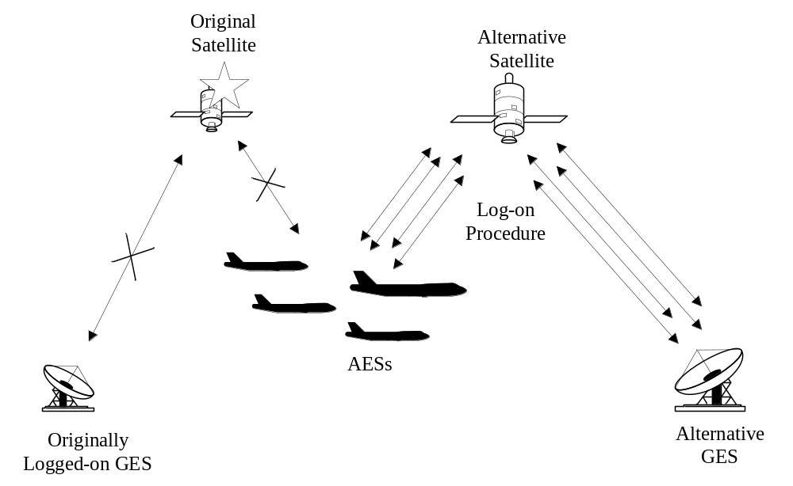

Fig.1 Simulation Concept

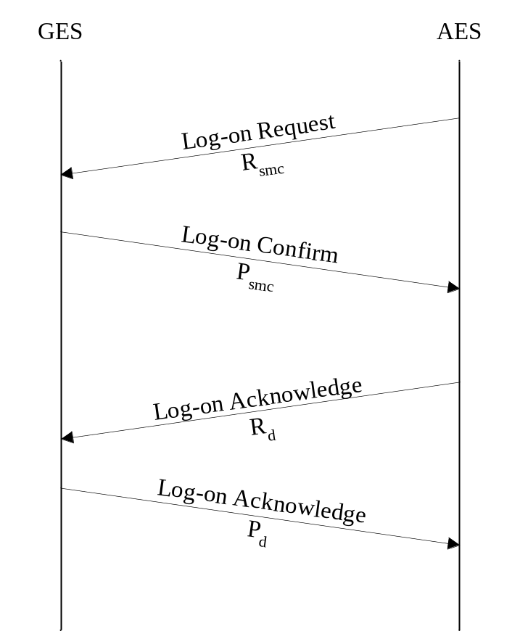

Fig.2 Log-on Sequence
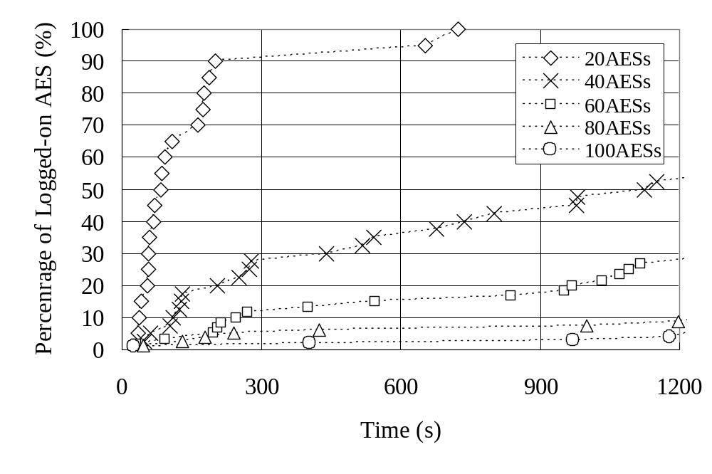
Fig.3 Percentage of Logged-on AES for 600 bits/s P_{smc} and R_{smc} cahnnels
(one P_{smc} channel and one R_{smc} cahnnel)
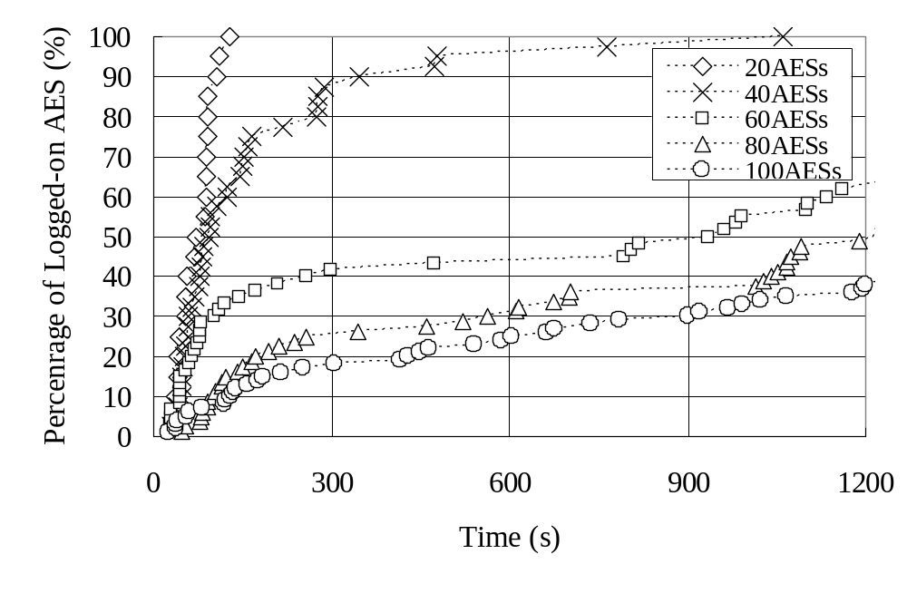
Fig.4 Percentage of Logged-on AES for 600 bps P_{smc} and R_{smc} cahnnels
(one P_{smc} channel and two R_{smc} cahnnels)
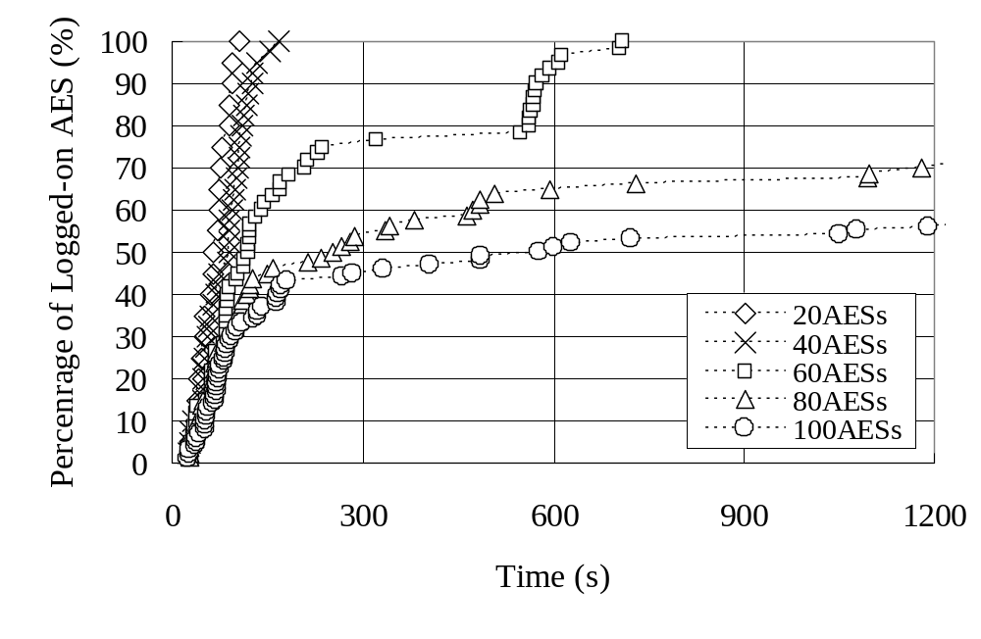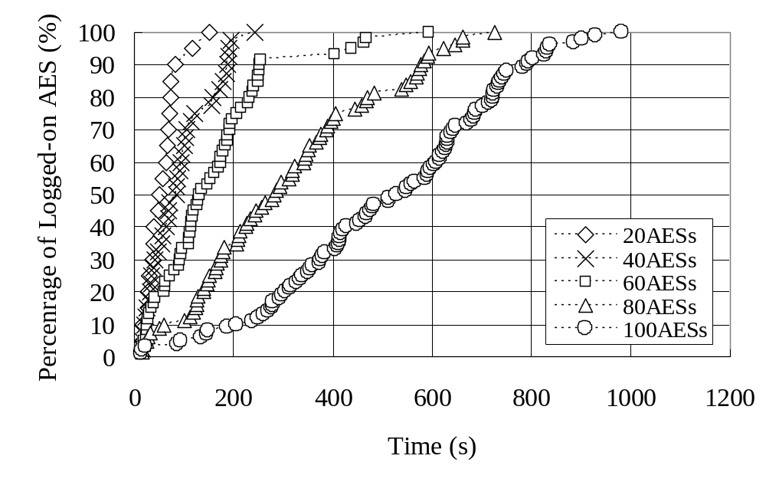

Fig.5 Percentage of Logged-on AES for 600 bits/s P_{smc} and R_{smc} cahnnels
(one P_{smc} channel and four R_{smc} cahnnels)

Fig.6 Percentage of Logged-on AES for 10500 bps P_{smc} and R_{smc} cahnnels
(one P_{smc} channel and one R_{smc} cahnnel)

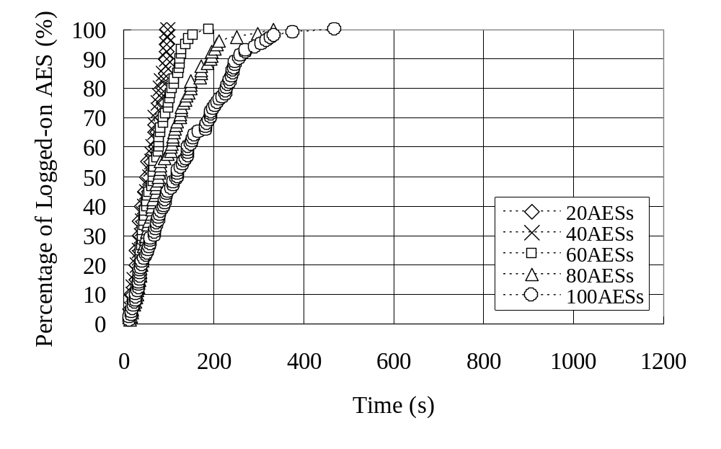Fig.7 Percentage of Logged-on AES for 10500 bits/s P_{smc} and R_{smc} cahnnels
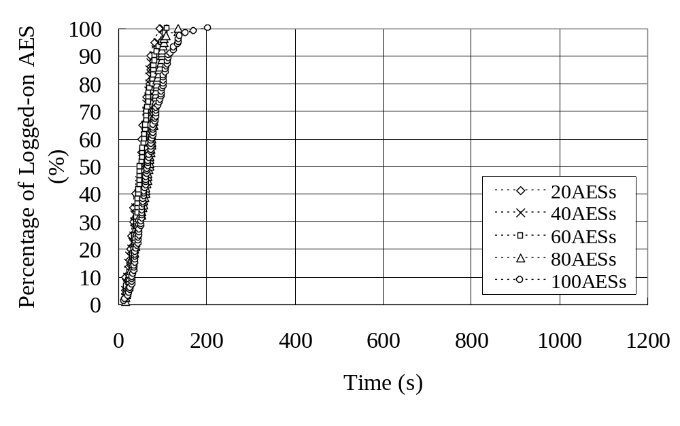(one P_{smc} channel and two R_{smc} cahnnels)

Fig.8 Percentage of Logged-on AES for 10500 bps P_{smc} and R_{smc} cahnnels
(one P_{smc} channel and four R_{smc} cahnnels)

