 | International Civil Aviation Organization  WORKING PAPER
  ACP-WGM 10 IP-01
  23/05/05

AERONAUTICAL COMMUNICATIONS PANEL (ACP)

WORKING GROUP M-10

Montreal, Canada 23 – 26 May 2005

Agenda Item 4: | Resolution of VDL Mode 3 Amendment Proposals

Report of Air Traffic Controller Evaluations for VDL Mode 3

(Presented by Yasuyoshi Nakatani, ENRI)

SUMMARY
The Electronic Navigation Research Institute (ENRI) carried out controller evaluations for VDL Mode 3 (VDLM3) voice and data communications as well as VDLM3 functions such as Controller Override and Anti-Blocking and so on. The evaluations were conducted at the ENRI laboratory with the participation of forty actual air traffic controllers by the use of VDLM3 test system and evaluation tools developed by ENRI. The evaluation results indicated that voice quality and latency transmitted by VDLM3 were suitable for air traffic control (ATC) communications and VDLM3 features such as controller override would be very effective for ATC. This information paper outlines the evaluations results.

- Introduction

The ENRI in Japan has conducted VDLM3 research work since 2000 and has carried out a series of tests to evaluate VDLM3 voice and data communication performances with VDLM3 test system developed by ENRI.

As the final test over the last five-year research work, ENRI carried out controller evaluations for VDLM3 voice and data communications as well as VDLM3 functions such as controller override and anti-blocking and so on. Forty actual air traffic controllers participated in this VDLM3 evaluation test conducted for four days in late January, 2005 at ENRI laboratory.

This paper gives a summary of the evaluation results.

- Participants

Participants, who are actual air traffic controllers of Tokyo Area Control Center (Tokyo ACC) and Tokyo International Airport (TIA), took part in the evaluation. The number of participants was 10 per day and 40 in total in the period. 28 of those work for the Tokyo ACC and rest of 12 work for the TIA. Figure 1 shows the participants profiles.
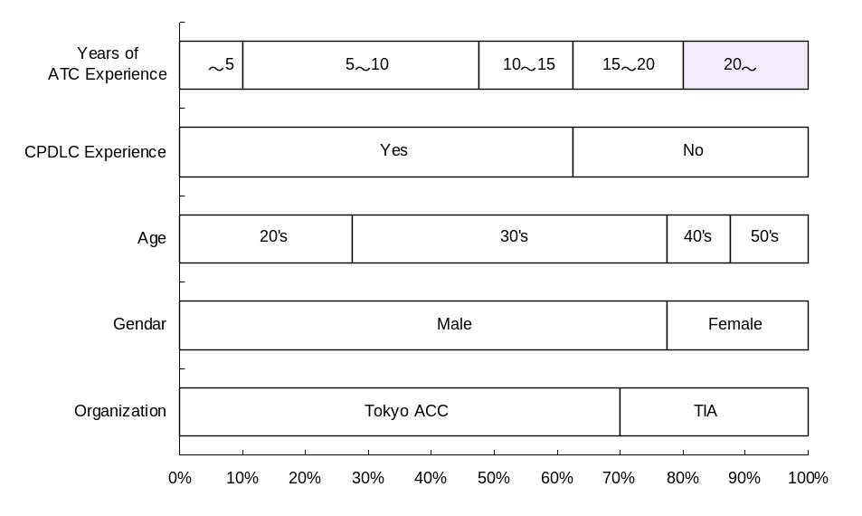
Figure 1 Participants Profiles

- Test Setup

VDLM3 test equipment and tools (simple display system) developed by ENRI were used for this evaluation. Figure 2 left-hand side shows display screen image of the tool. It displays target position like a radar screen, status of voice and data channels and a received message of urgent downlink request (UDR). It can also send/receive CPDLC messages to/from a pilot.
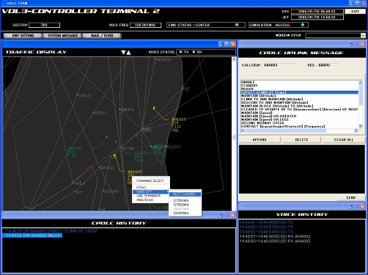
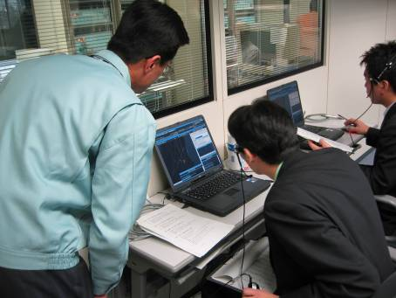

Figure 2 Evaluation Tool
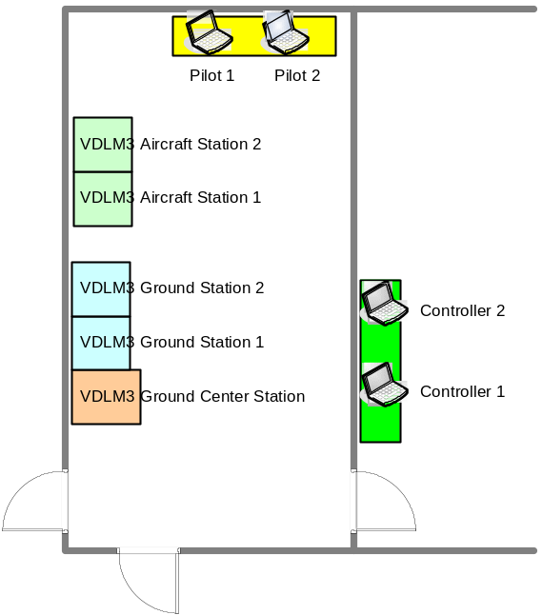Figure 3 Equipment Layout

Figure 3 shows the equipment layout. Mock pilots’ and controllers’ positions were allocated in separate rooms of ENRI laboratory.

Figure 4 describes the system configuration. Two VDLM3 aircraft stations and two VDLM3 ground stations were connected via attenuated circuit.

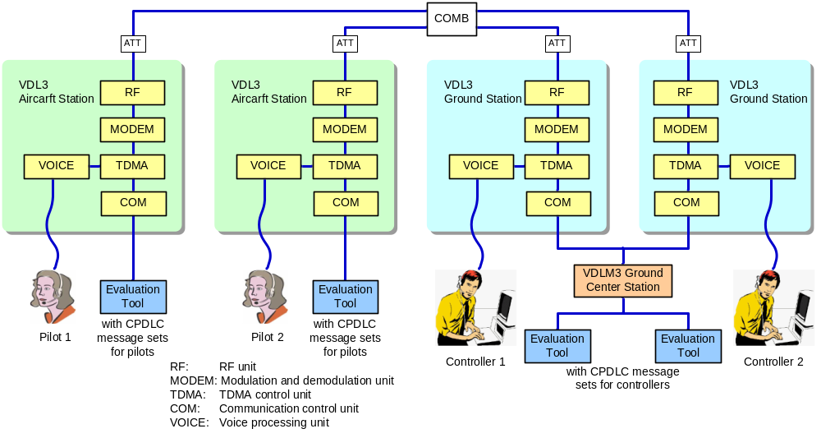
Figure 4 System Configuration

- Evaluation Procedures

During the evaluation test, air traffic controllers participated in air-to-ground procedural tests to evaluate the following items.

  - VDLM3 voice communication
  - Receiving voice quality (subjective listening quality)
  - Receiving voice latency (subjective listening quality)
  - VDLM3 data transmission
  - CPDLC latency
  - VDLM3 features
  - Transmitter Identification Notification function
  - Packet voice transmitted from a pilot to a controller contains transmitter identification (local ID).
  - Controllers can become aware of transmitter identification without hearing call sign by voice.
  - Controller Override function
  - Controllers can preempt ongoing aircraft transmission in order to send an urgent control message to prevent loss of separation of two airplanes or runway incursion.
  - Next Channel Uplink (Handoff) function
  - Uplink of next frequency for pilot concurrence/action
  - Reduce cockpit workload and voice communications for handoff
  - Anti-blocking function
  - First user gets channel; other users cannot access; will hear initial user.
  - Resolution for stepped-on transmissions
  - Urgent Downlink Request function
  - Cockpit-generated data message to a controller that a pilot has an urgent transmission to make.
  - The controller then uses Controller Override to clear the voice channel or break ongoing his transmission to allow the pilot to transmit.
  - Evaluation Tool
  - Operability performance

Each participant played acting as a pilot and a controller in rotation in the test to evaluate VDLM3 features through actual use in both pilot’s and controller’s position. They communicated and operated the evaluation tool while reading scripts that were representative of actual air traffic control communications through VDLM3 system. Then participants answered their evaluation result of each item by choosing one of five choices on the evaluation sheet. (refer to the attachment)

- Evaluation Results

  - Evaluation Results of VDLM3 Voice/Data Communications

Figure 5 shows the evaluation results of VDLM3 voice and data communications. Regarding receiving voice quality, more than 90 percent of the participants answered “Fair” or better, and nearly 90 percent of the participants answered “Slightly bothering but acceptable” or better on VDLM3 voice latency. This result indicated that VDLM3 voice communications were suitable for ATC communications.
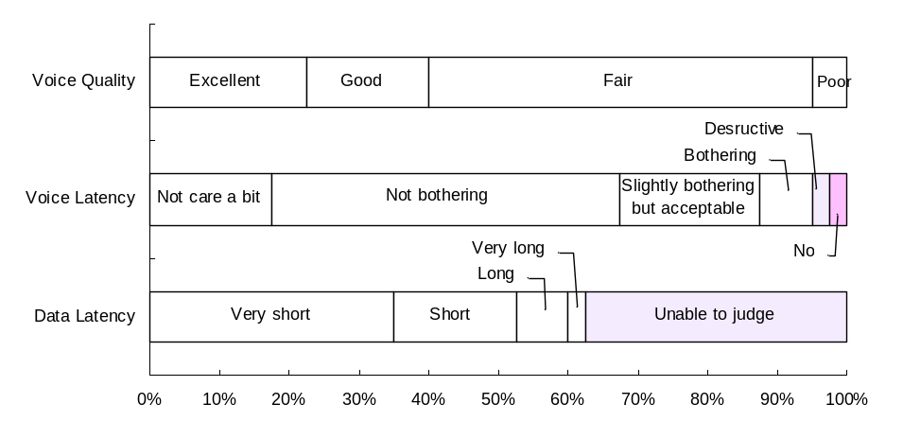
Figure 5 Evaluation Results of VDLM3 Voice/Data Communications

  - Evaluation Results of VDLM3 Features

Figure 6 presents the evaluation results of the VDLM3 features.
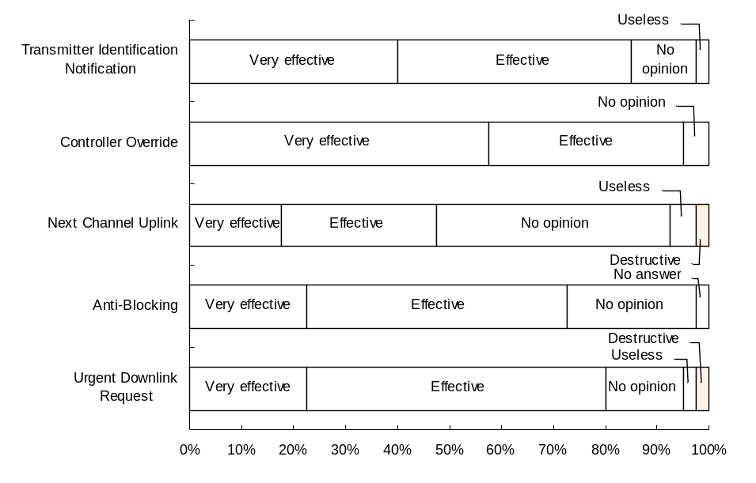
Figure 6 Evaluation Results of VDLM3 Features

With the exception of Next Channel Uplink function, more than 70 percent of the participants answered that the features were effective for ATC communications. In particular, most participants expressed favourable opinions about Controller Override function. Regarding Next Channel Uplink, some participants made a comment that there was a possibility to send a wrong command to pilots and a certain action was required to prevent such careless mistakes.

In the meanwhile, many participants made a comment on Urgent Downlink Request function. They thought that the feature was a good function for pilots but its operational criteria should be defined not to make improper use because receiving UDR was bothersome for controllers.

- Questionnaire

After the evaluations as described above, participants answered a questionnaire about the following questions.

- Do you think that VDLM3 should be implemented for ATC communications?
- Do you think that CPDLC will reduce controllers’ workload for domestic ATC?

Results of the questionnaire are shown in figure 7 below.
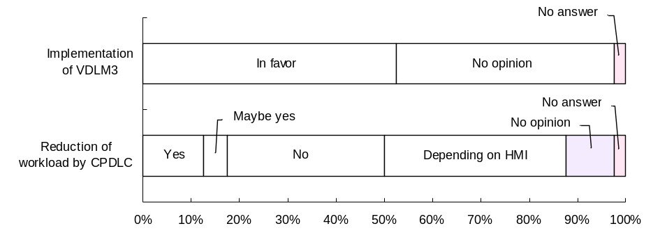
Figure 7 Results of Questionnaire

Half respondents answered to the first question that VDLM3 should be implemented for ATC communications, and no respondent answered definitely that Japan Civil Aviation Bureau has to wait and see VDLM3 implementation.

Regarding the second question, half respondents answered that their workload would be reduced or depending on human-machine interface (HMI). However 13 out of 40 respondents answered that their workload would be increased. Therefore it appears that thorough evaluations in particular for HMI will be required to determine the validity of CPDLC implementation for domestic ATC. For your reference 70 percent of participants have an experience with CPDLC communications in oceanic air space (Tokyo FIR).

- Conclusion

ENRI carried out controller evaluations for VDLM3 and got good results in most evaluation items. Based on the findings of this evaluation and tests conducted so far, ENRI has moved on to the next four-year-term research work for VDLM3 since April 2005. In the final stage, ENRI will conduct end-to-end CPDLC/CM/D-FIS evaluations by the use of VDLM3, ATN circuit and prototype display system with the participation of air traffic controllers possibly including pilots.

- - - - - - - -

