 | International Civil Aviation Organization  WORKING PAPER
  ACP-WGW01/WP-7
  07/06/05

AERONAUTICAL COMMUNICATIONS PANEL (ACP)

FIRST MEETING OF THE WORKING GROUP OF THE WHOLE

Montreal, Canada 20 – 23 October 2008

Agenda Item xx: | Xxx

OPTIONS FOR TRANSPORT LAYER USAGE

(Presented by Christian Kissling, Thomas Gräupl)

SUMMARY
Options for using Transport Layer Protocols. Recommendations for usage and for further activities
ACTION

- INTRODUCTION
It is acknowledged that the mode of transport layer connection has great impact on the quality of service experienced by the application. The intention of this working paper is to summarize and discuss the known transport layer connection options for operational aeronautical applications (i.e. ATS/AOC) in the ATN/IPS. On the basis of this document a set of viable options is identified and a recommendation on how to apply transport layer protocols is given.
- discussion
The properties of aeronautical data traffic in the ATN/IPS have been analyzed several times. [1] is a recent publication summarizing the expected characteristics: ATM data traffic consists predominantly of very short messages (message body between ~20 and a few hundred bytes), spaced by intervals of several seconds to several minutes. A few longer messages (up to a few kilobytes) are also present. Messages are triggered by events related to the progress of the flight or, for a few message classes, by the passing of time. In other words, the traffic is inelastic, consisting of mainly short, infrequent messages occurring at unpredictable, irregular intervals.
The defining characteristic of the aeronautical data traffic is therefore its inelastic nature. It requires a certain minimum level of bandwidth and a certain maximum latency. That is, it cannot adjust to varying network conditions and requires support from the underlying network to achieve the required quality of service (QoS). The migration to ATN/IPS and the possible introduction of new data link services raises the question how these future applications shall use the transport layer of the underlying network.
  - Transport Semantics
Different transport protocols offer different services. The following list gives an overview of possible transport service semantics for ATS/AOC services. This terminology is later used to identify desirable transport semantics in the ATN/IPS.
- Byte stream: Deliver application layer data as an unstructured byte stream.
- Message based service: Deliver complete application messages.
Given the message oriented structure of the ATS/AOC applications, message based service seems more suitable.

- Reliable: Deliver data in such a way that the sender can be sure that it has been delivered.
- Unreliable: There is no guarantee for successful delivery. Even if the data has been delivered successfully, the sender is not informed by the transport layer.
It seems obvious that reliability is desired for critical ATS/AOC messages. However, the COCR defines a set of applications (e.g. surveillance applications) not requiring completely reliable delivery, because they are sent periodically or time out very quickly. [1] states that for some applications, late delivery is worse than no delivery. E.g. a surveillance application might prefer losing an old surveillance report than delaying a fresh report for the retransmission of outdated information.

- At-most-once: Deliver data at most once.
- Zero-or-more: There may be duplicate deliveries.
For command and control applications at-most-once semantics seem to be necessary (e.g. there should be no duplication for a “TURN RIGHT” command!). The impact of zero-or-more semantics on other applications (e.g. surveillance) is unclear.
  - Support of Quality of Service
It is possible to multiplex data from several sources into a single transport connection (e.g using the ATN/OSI dialog service). However, if network layer QoS mechanisms are deployed (e.g. DiffServ) it should be noted that the required Class of Service (CoS) as specified by the application has to be forwarded by the transport protocol to the network layer.
There is currently no well-known transport protocol supporting the assignment of different CoS to different streams/messages within a single transport connection. That is: When current transport protocols are used for multiplexing different services to one connection, network layer QoS is effectively performed per transport connection. This is illustrated in Figure 1.

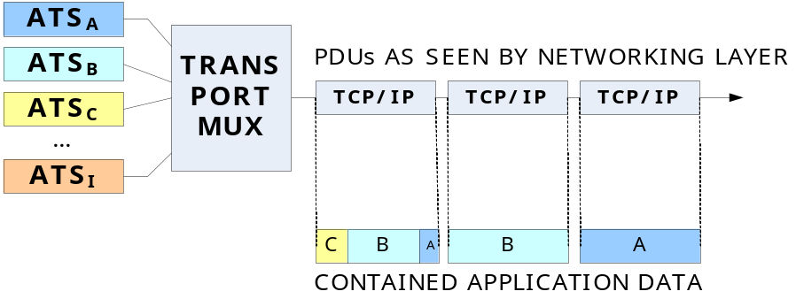
Figure 1: Example for multiplexing different CoS into a single transport connection

As can be seen, there exist several application layer services (CoS A – CoS I, see [2]). If these services are multiplexed into one transport layer connection, this means that each TCP segment can contain data with different CoS. From the network layer point of view, these TCP/IP datagrams are undistinguishable since the transport layer assigns the same CoS to all datagrams of the connection. This poses a big problem with respect to QoS management, security and routing since it is no longer possible to transparently process each message according to it’s CoS in the network layer.
  - Application Distribution and Transport Multiplexing
The proposed topology of the on-board network suggests that message generating applications will be distributed over several hosts (see also Figure 2). In addition the ATS and AOC domain will be separated into distinct sub-nets. However, considering the current (ATN/OSI) number of message generating applications (three) it can be assumed that the number of future applications may be in the same scale.

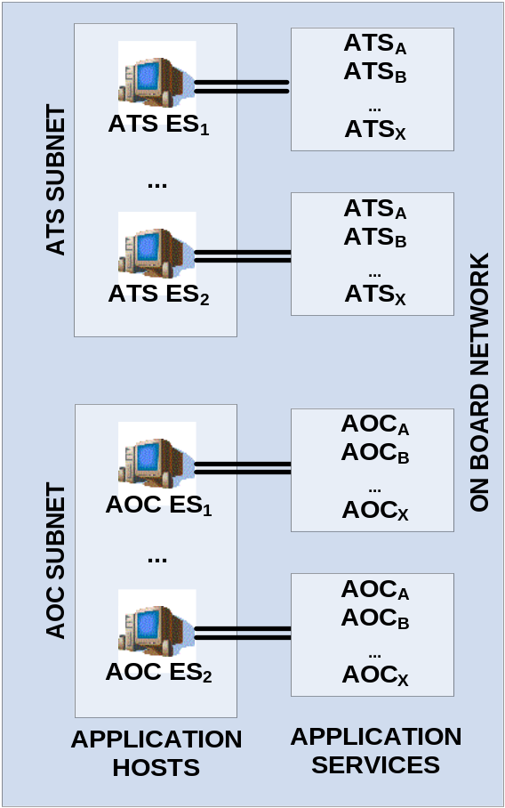
Figure 2: Possible topology of on-board networks
The difference in magnitude between applications (few) and the number of services performed by these applications (many; COCRv2: 32+21 services) suggests that the multiplexing of different services of one application to a single connection is desirable.
Under these assumptions, the following possibilities exist for the multiplexing of services at the transport layer: Transport layer connections can either be established per service instance or can be established only once (e.g. at logon time) and kept open until they are no longer needed (e.g. handover or logoff). As second degree of freedom, the transport layer connections can be established per service class or for a set of multiplexed services. In total this offers the following four options:
- Re-/establishing of connections for each transmission and for each service.
- Establishing a connection once for each service and keeping it open.
- Re-/establishing of a connection for each transmission of a multiplexed set of services.
- Establishing a connection once for a multiplexed set of services and keeping it open.

    - Re-/establishing of connections for each transmission and for each service
As illustrated in Figure 3, each service uses a dedicated transport layer connection. At the time when application service data is generated, the transport layer connection is established, and the data is transmitted. After successful transmission the connection is closed again.

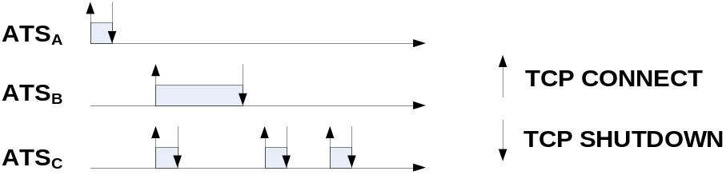
Figure 3: Dedicated transport layer connection per service and per transmission

The major advantage of this solution is that a direct mapping of layer 3 PDUs to application layer CoS is possible, since each TCP/IP datagram carries the necessary information to identify the encapsulated payload. This implies that QoS management can be performed transparently (scheduling, queuing and prioritization in the network layer is fully supported) and that problems with security and routing are avoided.
The disadvantage of this solution is that for each transmission a connection has to be established. This causes a considerable overhead in terms of signalling and connection establishment delay. While the connection establishment time may be less critical for terrestrial radio technologies, it is highly inefficient when used over GEO satellite systems. This is due to the long satellite round trip time of 500 ms. TCP connections are established using a three-way handshake. Under ideal circumstances (no lost packets) this procedure requires three packet exchanges before the first data packet can be sent. In our example this means that it takes 3 * 500/2 ms before the first data packet is sent, and 4 * 500/2 ms before the first data packet is received.
    - Establishing a connection once for each service and keeping it open
Figure 4 illustrates the behaviour of this option. As can be seen, each service uses an own transport layer connection but the connection is not started at the time of data generation and terminated afterwards but initiated at time of logon and kept open until time of logoff.

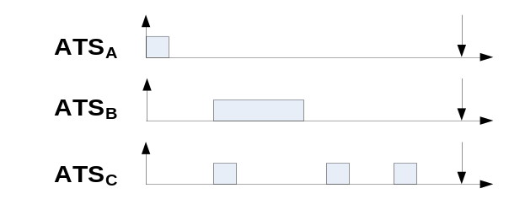
Figure 4: Dedicated transport layer connection per service from logon to handover/logoff

The advantage of this solution is that each TCP/IP PDU carries all information to identify the CoS of the encapsulated data. In comparison to the first option the amount of signalling is greatly reduced. The connection establishment delay is experienced only once per session.
One possible issue of this solution is that the number of open TCP connections in the host can reach very high values (assuming that 32 services may reside in each airborne host). The behaviour of large numbers of concurrent TCP connections is known to cause problems in some cases. However, this problems space is still not very well understood and subject to further research.
A possible refinement of this approach is to open transport connections at the time they are first needed (and not at login). This would distribute the signalling over a longer interval. This is illustrated in Figure 5.
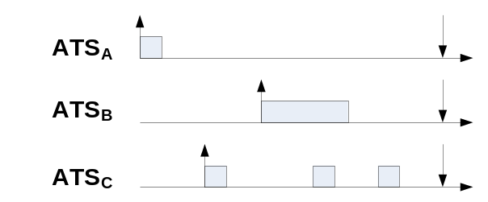
Figure 5: Dedicated transport layer connection per service from first use to handover/logoff
    - Re-/establishing of a connection for each transmission of a multiplexed set of services
The third possibility is to multiplex data of a selected set of services of one application into a single common transport connection as shown in Figure 6. In this case the transport connection is opened whenever data from the application layer is arriving and closed after successful transmission.

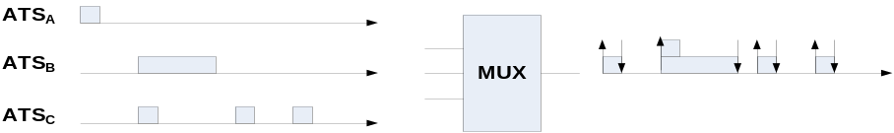
Figure 6: Multiplexing of service connections into one transport stream

One possible advantage of this approach is that in some cases an additional connection establishment can be avoided (see second transmission). This might happen in cases where data of different classes of service are generated at the same time and can use the already opened TCP connection. The likeliness of such an event is, however, questionable and subject for further investigations.
The major disadvantage of this solution is the fact that the network layer can now no longer determine the CoS of the encapsulated data since this information cannot be forwarded by the transport layer protocol. A possible solution to circumvent this problem is to multiplex only services of the same CoS. However, the problem of long connection establishment delays and high signalling overhead cannot be avoided here.
    - Establishing a connection once for a multiplexed set of services and keeping it open.
As last option Figure 7 illustrates the possibility to multiplex selected services of one application into one transport layer connection. The connection is initiated during logon (or first use) and kept open until handover/logoff.

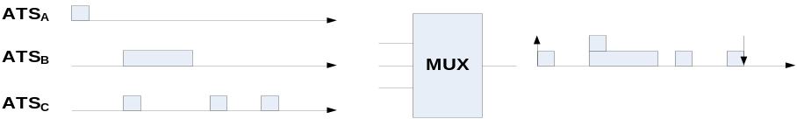
Figure 7: Multiplexing of service connections into on transport stream without reestablishment of the connection,
The main advantage of this solution is that the number of parallel opened TCP connections is smaller than in the second option. Also the connection establishment delays and the related signalling overhead are reduced. However, distinguishing the CoS of the encapsulated application layer is only possible if only services with the same CoS are multiplexed onto a single connection. In this case the number of concurrent TCP connections can be reduced to the number of CoS.
  - ATN/OSI
The existing ATN applications do not use the OSI transport layer directly but only by arbitration of a “dialogue service” (DS). The DS uses the connection oriented TP4 transport protocol of the ISO/OSI stack. There are provisions in the ISO/OSI based ATN for a connectionless transport service CLTP, however, they are currently not used by the DS.
  - Availability of COTS Solutions
If COTS solutions are desired for the ATN/IPS, the following implementation aspects have to be considered.
Already deployed protocols: The only IPS protocols that are widely deployed are TCP [RFC 793] and UDP [RFC768]. SCTP [RFC2960] has found some acceptance, but is not very widely deployed.
Network Appliances (aka “middle boxes”): Most current COTS network appliances (routers, firewalls, etc.) only interwork well with UDP and TCP. It is common that other (unknown or new) protocols cause problems.
UDP based transport protocols: Because of common issues with network appliances it has become widespread practice to deploy new protocols not on top of IP, but on UDP (e.g. RTP, SUN-RPC, DCE, etc.; DCCP and SCTP consider a migration to UDP as well). Although disputed because of an implicit layer violation (“UDP as the new IP.”), this approach is known to work well even in the presence of network appliances. In addition, it does not require the modification of operating system kernels as UDP can be used from the user-space. (Transport protocols operating directly over IP are usually implemented in the OS kernel.)
- Conclusions
For transmission of ATC/AOC data a reliable, message-based, at-most-once semantic transport connection is desirable. Whether for some services a zero-or-more semantic could be used is unclear at the moment.
Multiplexing a large number of services onto a smaller number of transport layer connections is desirable in order to avoid the complex behaviour caused by large numbers of concurrent connections. However, no currently deployed TL protocol provides mechanisms for the forwarding of CoS information to the network layer at the required granularity, therefore CoS identification of the encapsulated data is only possible per connection. That is, transport layer multiplexing can only be performed, if services of the same CoS are multiplexed.
Opening connections at the time of first use and keeping them open until handover/logoff is beneficial in terms of signalling overhead and connection establishment delay.
For these reasons the basic approach should be option I (Re-/establishing connections per service class) with the possible option of refining it to option II (Establishing a connection once for each service and keeping it open). Option IV (Establishing a connection once for a multiplexed set of services and keeping it open) should be considered as a possible alternative if appropriate application classes can be identified.
- ACTION BY THE MEETING
The working group is invited to review the presented information and to decide the way transport layer services shall be used. To assure a uniform usage, the selected way of using TL services should be included in the ATN/IPS standard.
The following recommendations are given:
For the considered time-frame only a well established protocol seems appealing to be used in the standard for the future ATN/IPS. This leaves only TCP or UDP as a choice. For TCP usage the aforementioned 4 options exist. To allow efficient and reliable CoS management, security and proper routing it is recommended to use a dedicated transport layer connection for each application layer CoS and to re-/establish the connection for each transmission (option I). This methodology is also inline with the actual usage of TP4 services. It should however be noted that this method is clearly not the most efficient approach and that optimization by the development of dedicated protocol options could enhance the system performance considerably. Thus, the migration to a more efficient approach (option II and IV) should be considered in the long term.
Secondly it is recommended to initiate the investigation and development of a tailored transport layer protocol with enhanced QoS support within the IETF. This new protocol should provide reliability and message-based, at-most-once semantics. Moreover the protocol should be using UDP datagrams to ensure transparent compatibility with existing COTS network equipment. The functionality of the transport service should be restricted to the minimum necessary functionalities to provide the above mentioned transport semantics and avoid the mechanisms and procedures of TCP/SCTP which may be problematic and can cause unwanted network behaviour (e.g. congestion control, head of line blocking, etc.).
- References
[1] E. Kristiansen, S. Patella, M. Mazzoccanti, “An application layer gateway for air traffic management communication by satellite,” ICSSC’08, San Diego, 2008.
[2] Eurocontrol/FAA, Communications Operating Concept and Requirements for the Future Radio System (COCR), v2.0

There is currently an effort to charter a IETF workgroup (TANA) to investigates this problem (among others).

