

ICAO

Aeronautical Telecommunication Network (ATN)

Manual for the ATN using IPS Standards and Protocols (Doc 9896)

May 28, 2012

Draft Version 21

FOREWORD
This document defines the data communications protocols and services to be used for implementing the International Civil Aviation Organization (ICAO) Aeronautical Telecommunications Network (ATN) using the Internet Protocol Suite (IPS). The material in this document is to be considered in conjunction with the relevant Standards and Recommended Practices (SARPs) as contained in Annex 10, Volume III, and Part I Chapter 3.

Editorial practices in this document.

The detailed technical specifications in this document that include the operative verb “shall” are essential to be implemented to secure proper operation of the ATN.

The detailed technical specifications in this document that include the operative verb “should” are recommended for implementation in the ATN. However, particular implementations may not require this specification to be implemented.

The detailed technical specifications in this document that include the operative verb “may” are optional. The use or non use of optional items shall not prevent interoperability between ATN/IPS nodes.

The Manual for the ATN using IPS Standards and Protocols is divided into the following parts:

Part I – Detailed Technical Specifications
This part contains a general description of ATN/IPS. It covers the network, transport and security requirements for the ATN/IPS.

Part II – Application Support
This part contains a description of applications supported by the ATN/IPS. It includes convergence mechanisms and application services that allow the operation of legacy ATN/OSI applications over the ATN/IPS transport layer.

Part III – Guidance
This part contains guidance material on ATN/IPS communications including information on architectures, and general information to support ATN/IPS implementation.

ICAO

Aeronautical Telecommunication Network (ATN)

Manual for the ATN using IPS Standards and Protocols (Doc 9896)

Part I

Detailed Technical Specifications

PART 1 TABLE of contents

1.0 INTRODUCTION 2
1.1 GENERAL OVERVIEW 2
2.0 REQUIREMENTS 4
2.1 ATN/IPS ADMINISTRATION 4
2.1.1 The ATN/IPS 4
2.1.2 ATN/IPS Mobility 4
2.2 LINK LAYER REQUIREMENTS 5
2.3 INTERNET LAYER REQUIREMENTS 5
2.3.1 General IPv6 Internetworking 5
2.3.2 Mobile IPv6 5
2.3.3 Network Addressing 5
2.3.4 Inter-Domain Routing 6
2.3.5 Error Detection and Reporting 7
2.3.6 Quality of Service (QoS) 7
2.3.7 IP Version Transition 7
2.4 TRANSPORT LAYER REQUIREMENTS 8
2.4.1 Transmission Control Protocol (TCP) 8
2.4.2 User Datagram Protocol (UDP) 8
2.5 SECURITY REQUIREMENTS 8
2.5.2 Ground-Ground Security 8
2.5.2.1 Ground-Ground IPsec/IKEv2 8
2.5.3 Air-Ground Security 9
2.5.3.1 Air-Ground Access Network Security 9
2.5.3.2 Air-Ground IPsec/IKEv2 9
2.5.3.3 Air-Ground Transport Layer Security 11
2.5.3.4 Air-Ground Application Layer Security 11
2.6 Performance 11
3.0 ATN Applications 12
3.1 Ground applications 12
3.1.1 Telephony (VoIP) 12
3.2 Air-Ground Applications 12
3.2.1 Radio 12
3.3 Performance 12
3.3.1 Telephony (VoIP) 12
3.3.2 Radio (VoIP) 12
APPENDIX A – AS Numbering Plan 13

1.0 INTRODUCTION

1.1 GENERAL OVERVIEW
This manual contains the minimum communication protocols and services that will enable implementation of an ICAO Aeronautical Telecommunication Network (ATN) based on the Internet Protocol Suite (IPS), referred to as the ATN/IPS. The scope of this manual is on interoperability across Administrative Domains in the ATN/IPS internetwork, although the material in this manual may also be used within an Administrative Domain. Implementation of the ATN/IPS, including the protocols and services included in this manual, will take place on the basis of regional air navigation agreements between ICAO contracting States in accordance with Annex 10, Volume III, Part I, Chapter 3, and Paragraph 3.3.2. Regional planning and implementation groups (PIRG’s) coordinate such agreements.

The ATN/IPS protocol architecture is illustrated in Figure 1. The ATN/IPS has adopted the same four layer model as defined in Internet Society (ISOC) internet standard STD003.

Note. — STD003 is a combination of Internet Engineering Task Force (IETF) RFC 1122 and RFC 1123.
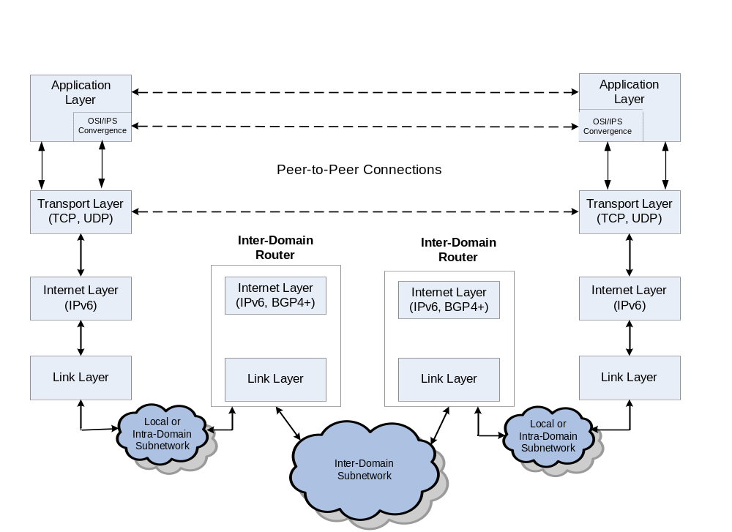
Figure 1 – ATN/IPS Protocol Architecture

This model has four abstraction layers called the link layer, the internet or IP layer, the transport layer and the application layer.

As depicted in Figure 1, this manual does not adopt any specific link layer protocol as this is a local or bi-lateral issue which does not affect overall interoperability.

This manual adopts the Internet Protocol version 6 (IPv6) for internet layer interoperability. Implementation of IPv4 in ground networks, for transition to IPv6 (or as a permanent network) is not addressed in this manual. IPv6 is to be implemented in air-ground networks. The Border Gateway Protocol 4 with extensions is adopted for inter-domain routing.

The Transmission Control Protocol (TCP) and User Datagram Protocol (UDP) are adopted for connection-oriented and connectionless services at the transport layer.

Part II of this document includes convergence mechanisms and application services that allow the operation of legacy ATN/OSI applications over the ATN/IPS transport layer.

Part III of this document includes guidance material to support ATN/IPS implementation.

2.0 REQUIREMENTS

2.1 ATN/IPS ADMINISTRATION

2.1.1 The ATN/IPS
2.1.1.1 The ATN/IPS internetwork consists of IPS nodes and networks operating in a multinational environment in support of Air Traffic Service Communication (ATSC) as well as Aeronautical Industry Service Communication (AINSC), such as Aeronautical Administrative Communications (AAC) and Aeronautical Operational Communications (AOC).

2.1.1.2 In this manual an IPS node is a device that implements IPv6. There are two types of IPS nodes.

- An IPS router is an IPS node that forwards Internet Protocol (IP) packets not explicitly addressed to itself.
- An IPS host is an IPS node that is not a router.

2.1.1.3 From an administrative perspective, the ATN/IPS internetwork consists of a number of interconnected Administrative Domains. An Administrative Domain can be an individual State, a group of States (e.g., an ICAO Region), an Air Communications Service Provider (ACSP), an Air Navigation Service Provider (ANSP), or any other organizational entity that manages ATN/IPS network resources and services.

2.1.1.4 Each Administrative Domain participating in the ATN/IPS internetwork shall operate one or more IPS routers which execute the inter-domain routing protocol specified in this manual.

2.1.1.5 From a routing perspective, inter-domain routing protocols are used to exchange routing information between Autonomous Systems (AS), where an AS is a connected group of one or more IP address prefixes. The routing information exchanged includes IP address prefixes of differing lengths. For example, an IP address prefix exchanged between ICAO regions may have a shorter length than an IP address prefix exchanged between individual States within a particular region.

2.1.1.6 Administrative Domains should coordinate their policy for carrying transit traffic with their counter parts.

2.1.2 ATN/IPS Mobility
2.1.2.1 ATN/IPS mobility is based on IPv6 mobility standards, operated by Mobility Service Providers (MSP).

Note. — A MSP in the ATN/IPS is an instance of an Administrative Domain which may be an ACSP, ANSP, Airline, Airport Authority, government or other aviation organization.

2.1.2.2 ATN/IPS Mobility Service Providers (MSP) shall operate one or more home agents (HA).

2.2 LINK LAYER REQUIREMENTS

2.2.1 The specification of the link layer characteristics for an IPS node is a local issue.

2.3 INTERNET LAYER REQUIREMENTS

2.3.1 General IPv6 Internetworking
2.3.1.1 IPS nodes shall implement IPv6 as specified in RFC 2460.

2.3.1.2 IPS nodes shall implement IPv6 Maximum Transmission Unit (MTU) path discovery as specified in RFC 1981.

2.3.1.3 IPS nodes shall set the flow label field of the IPv6 header to zero, as it is not used in the ATN/IPS.

2.3.2 Mobile IPv6
2.3.2.1 IPS mobile nodes shall implement Mobile IPv6 as specified in RFC 3775.

2.3.2.2 IPS home agents shall implement Mobile IPv6 as specified in RFC 3775.

2.3.2.3 IPS mobile nodes and home agents may implement extensions to Mobile IPv6 to enable support for network mobility as specified in RFC 3963 and enhancements to MIPv6 as listed in Part III section 5.2

2.3.2.4 IPS nodes that implement Mobile IPv6 route optimization should allow route optimization to be administratively enabled or disabled with the default being disabled.

Note. — The use of Mobile IPv6 route optimization is not mandated by this specification until further standard RFCs have been developed by the IETF.

2.3.3 Network Addressing
2.3.3.1 IPS nodes shall implement IP Version 6 Addressing Architecture as specified in RFC 4291.

2.3.3.2 IPS nodes shall use globally scoped IPv6 addresses when communicating over the ATN/IPS.

2.3.3.3 Administrative Domains shall obtain IPv6 address prefix assignments from their Local Internet Registry (LIR) or Regional Internet Registry (RIR).

2.3.3.4 MSPs shall obtain a /32 IPv6 address prefix assignment for the exclusive use of IPS Mobile Nodes or mobile networks.

2.3.3.5 MSPs should use the following IPv6 address structure for aircraft assignments.

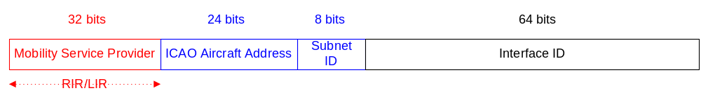

Note 1. — Under this structure each aircraft constitutes a /56 IPv6 end site, which is based on the ICAO 24-bit aircraft address as defined in Annex 10, Volume III, Appendix to Chapter 9.

Note 2. — For onboard services (ATS, AOC, AAC, etc.), an aircraft may have either multiple subnets interconnected to a mobile router, multiple MSPs or a combination of both.

2.3.3.6 Mobility Service Providers (MSPs), shall advertise their /32 aggregate prefix to the ATN/IPS.

2.3.4 Inter-Domain Routing
Note 1. — Inter-domain routing protocols are used to exchange routing information among ASs.

Note 2. — For routing purposes, an AS has a unique identifier called an AS number.

Note 3. — A single Administrative Domain may be responsible for the management of several ASs.

Note 4. — The routing protocol within an AS is a local matter determined by the managing organization.

2.3.4.1 IPS routers which support inter-domain dynamic routing shall implement the Border Gateway Protocol (BGP-4) as specified in RFC 4271.

2.3.4.2 IPS routers which support inter-domain dynamic routing shall implement the BGP-4 multiprotocol extensions as specified in RFC 2858.

2.3.4.3 Administrative Domains shall use AS numbers for ATN/IPS routers that implement BGP-4.

2.3.4.4 Administrative Domains that use private AS numbers shall follow the AS numbering plan described in Part I of this document.

Note. — Administrative Domains that require additional private AS numbers should coordinate through ICAO.

2.3.4.5 IPS routers which support inter-domain dynamic routing should authenticate routing information exchanges as specified in RFC 2385.

2.3.5 Error Detection and Reporting
2.3.5.1 IPS nodes shall implement Internet Control Message Protocol (ICMPv6) as specified in RFC 4443.

2.3.6 Quality of Service (QoS)
2.3.6.1 Administrative Domains shall make use of Differentiated Services (DiffServ) as specified in RFC 2475 as a means to provide Quality of Service (QoS) to ATN/IPS applications and services.

2.3.6.2 Administrative Domains shall enable ATN/IPS DiffServ class of service to meet the operational and application requirements.

2.3.6.3 Administrative Domains supporting Voice over IP services shall assign those services to the Expedited Forwarding (EF) Per-Hop Behavior (PHB) as specified by RFC 3246.

2.3.6.4 Administrative Domains shall assign ATN application traffic to the Assured Forwarding (AF) PHB as specified by RFC 2597.
Note. — Assured forwarding allows the ATN/IPS operator to provide assurance of delivery as long as the traffic does not exceed the subscribed rate. Excess traffic has a higher probability of being dropped if congestion occurs.

2.3.6.5 Administrative Domains that apply measures of priority to the AF PHBs shall assign relative measures based on the ATN mapping of priorities defined in Annex 10, Volume III, Part I, Chapter 3, Table.3-1.

2.3.7 IP Version Transition
2.3.7.1 Administrative Domains should use the dual IP layer mechanism for IPv6 to IPv4 compatibility as described in RFC 4213.
Note. — This provision ensures that ATN/IPS hosts also support IPv4 for backward compatibility with local IPv4 applications.

2.4 TRANSPORT LAYER REQUIREMENTS

2.4.1 Transmission Control Protocol (TCP)
2.4.1.1 IPS nodes shall implement the Transmission Control Protocol (TCP) as specified in RFC 793.

2.4.1.2 IPS nodes may implement TCP Extensions for High Performance as specified in RFC 1323.

2.4.2 User Datagram Protocol (UDP)
2.4.2.1 IPS hosts shall implement User Datagram Protocol as specified in RFC 768.

2.4.3 Transport Protocol Port Numbers

2.4.3.1 IPS nodes shall support and make use of the TCP and/or UDP port numbers defined in Part II of this document.

2.5 SECURITY REQUIREMENTS
Note. — The use of the following security requirements for communications in the ATN/IPS should be based on a system threat and vulnerability analysis.

2.5.1 This section defines IPS node security requirements and capabilities but does not impose their use for communications in the ATN/IPS.

2.5.2 Ground-Ground Security
Note. — IP layer security in the ground-ground ATN/IPS internetwork is implemented using Internet Protocol security (IPsec) and the Internet Key Exchange (IKEv2) protocol.

2.5.2.1 Ground-Ground IPsec/IKEv2
2.5.2.1.1 IPS nodes in the ground-ground environment shall comply with the Security Architecture for the Internet Protocol as specified in RFC 4301.

2.5.2.1.2. IPS nodes in the ground-ground environment shall implement the IP Encapsulating Security Payload (ESP) protocol as specified in RFC 4303.

2.5.2.1.3 IPS nodes in the ground-ground environment may implement the IP Authentication Header (AH) protocol as specified in RFC 4302.

2.5.2.1.4 IPS nodes in the ground-ground environment shall implement the Internet Key Exchange (IKEv2) Protocol as specified in RFC 4306.

2.5.2.1.5 IPS nodes in the ground-ground environment shall implement the Cryptographic Algorithm Implementation Requirements for the Encapsulating Security Payload (ESP) and Authentication Header (AH) if AH is implemented as specified in RFC 4835.

2.5.2.1.6 IPS nodes in the ground-ground environment shall implement the Null Encryption Algorithm as specified in RFC 4835, but not the Null Authentication Algorithm, when establishing IPsec security associations.

2.5.2.1.7 IPS nodes in the ground-ground environment shall implement the Cryptographic Algorithms for Use in the Internet Key Exchange Version 2 (IKEv2) as specified in RFC 4307, when negotiating algorithms for key exchange.

2.5.2.1.8 IPS nodes in the ground-ground environment should use the Internet X.509 Public Key Infrastructure Certificate and Certificate Revocation List (CRL) Profile as specified in RFC 5280, when digital signatures are used as the IKEv2 authentication method.

2.5.2.1.9 IPS nodes in the ground-ground environment should use the Internet X.509 Public Key Infrastructure Certificate Policy and Certificate Practices Framework as specified in RFC 3647, when digital signatures are used as the IKEv2 authentication method.

Note. – The Air Transport Association (ATA) Digital Security Working Group (DSWG) has developed a Certificate Policy (ATA Specification 42) for use in the aviation community. ATA Specification 42 includes certificate and CRL profiles that are suitable for aeronautical applications and interoperability with an aerospace industry PKI bridge. These profiles provide greater specificity than, but do not conflict with, RFC 5280.

2.5.3 Air-Ground Security

2.5.3.1 Air-Ground Access Network Security
2.5.3.1.1 IPS mobile nodes shall implement the security provisions of the access network, to enable access network security.

Note. – For example, the WiMAX, 3GPP, and 3GPP2 access networks have authentication and authorization provisions.

2.5.3.2 Air-Ground IPsec/IKEv2
2.5.3.2.1 IPS nodes in the air-ground environment shall comply with the Security Architecture for the Internet Protocol as specified in RFC 4301.

2.5.3.2.2 IPS nodes in the air-ground environment shall implement the IP Encapsulating Security Payload (ESP) protocol as specified in RFC 4303.

2.5.3.2.3 IPS nodes in the air-ground environment shall implement AUTH_HMAC_SHA2_256-128 as the integrity algorithm for ESP authentication as specified in RFC 4868, when establishing IPsec security associations.

2.5.3.2.4 IPS nodes in the air-ground environment which implement encryption shall implement AES-GCM with an 8 octet ICV and with a key length attribute of 128 bits for ESP encryption and authentication as specified in RFC 4106.

2.5.3.2.5 IPS nodes in the air-ground environment shall implement the Internet Key Exchange (IKEv2) Protocol as specified in RFC 4306.

2.5.3.2.6 IPS nodes in the air-ground environment shall implement IKEv2 with the following transforms:

- PRF_HMAC_SHA_256 as the pseudo-random function as specified in RFC 4868.

- 256-bit random ECP group for Diffie-Hellman Key Exchange values as specified in RFC 4753.

- ECDSA with SHA-256 on the P-256 curve as the authentication method as specified in RFC 4754.

- AES-CBC with 128-bit keys as the IKEv2 encryption transforms as specified in RFC 3602.

- HMAC_SHA_256-128 as the IKEv2 integrity transform as specified in RFC 4868.

2.5.3.2.7 IPS nodes in the air-ground environment should use the Internet X.509 Public Key Infrastructure Certificate and Certificate Revocation List (CRL) Profile as specified in RFC 5280, when digital signatures are used as the IKEv2 authentication method.

2.5.3.2.8 IPS nodes in the air-ground environment should use the Internet X.509 Public Key Infrastructure Certificate Policy and Certificate Practices Framework as specified in RFC 3647, when digital signatures are used as the IKEv2 authentication method.

Note. – The Air Transport Association (ATA) Digital Security Working Group (DSWG) has developed a Certificate Policy (ATA Specification 42) for use in the aviation community. ATA Specification 42 includes certificate and CRL profiles that are suitable for aeronautical applications and interoperability with an aerospace industry PKI bridge. These profiles provide greater specificity than, but do not conflict with, RFC 5280.

2.5.3.2.9 IPS nodes in the air-ground environment, shall implement Mobile IPv6 Operation with IKEv2 and the Revised IPsec Architecture as specified in RFC 4877.

2.5.3.3 Air-Ground Transport Layer Security
2.5.3.3.1 IPS mobile nodes and correspondent nodes may implement the Transport Layer Security (TLS) protocol as specified in RFC 5246.

2.5.3.3.2 IPS mobile nodes and correspondent nodes shall implement the Cipher Suite TLS_ECDH_ECDSA_WITH_AES_128_CBC_SHA as specified in RFC 4492 when making use of TLS.

2.5.3.4 Air-Ground Application Layer Security
2.5.3.4.1 IPS mobile nodes and correspondent nodes may implement application layer security at the IPS Dialogue Service Boundary, which is specified in Part II of this document.

2.5.3.4.2 IPS mobile nodes and correspondent nodes shall append a keyed-hashed message authentication code (HMAC) as specified in RFC 2104 using SHA-256 as the cryptographic hash function, when application layer security is used.

2.5.3.4.3 An HMAC tag truncated to 32 bits shall be computed over the User Data concatenated with a 32-bit send sequence number for replay protection, when application layer security is used.

2.5.3.4.4 IKEv2 shall be used for key establishment as specified in section 2.5.2.2, when application layer security is used.

2.6 Performance

2.6.1 IPS nodes may implement RFC 2488 in order to improve performance over satellite links.

2.6.2 IPS nodes may implement the RObust Header Compression Framework (ROHC) as specified in RFC 4995 in order to optimize bandwidth utilization.

2.6.3 If ROHC is supported, then the following ROHC profiles shall be supported as applicable:

a. the ROHC profile for TCP/IP specified in RFC 4996

b. the ROHC profile for RTP/UDP/ESP specified in RFC 3095

c. the IP-Only ROHC profile specified in RFC 4843

d. the ROHC over Point-to-Point Protocol (PPP) profile specified in RFC 3241

3.0 ATN Applications
Detailed information for the development and deployment of ATN applications for use in ICAO Regions. Refer to the following sections for the applicable standard.

3.1 Ground applications
Refer to the following sections for detailed specifications for ground applications.

3.1.1 Telephony (VoIP)
Telephony ground applications shall be governed by EUROCAE document ED-137B, Interoperability Standards for VoIP ATM Components, VOL 2 – Telephone, edition February 2012.

Note: ED-137B - Interoperability Standards for VoIP ATM Components, edition February 2012 is available on the EUROCAE website at:
http://www.eurocae.net/

3.2 Air-Ground Applications
Refer to the following sections for detailed specifications for air-ground applications

3.2.1 Radio
Radio air-ground applications on the ground component shall be governed by EUROCAE document ED-137B, Interoperability Standards for VoIP ATM Components, VOL 1 – Radio, edition February 2012.

APPENDIX A – AS Numbering Plan

Note: This numbering plan covers ICAO Contracting and Non-Contracting States, and Territories.

ICAO Region | Country/Organisation/Location | AS Number |  | ICAO Region | Country/Org./Loc. | AS Number
MID | Afghanistan | 64512 |  | EUR/NAT | Ireland | 64688
APAC | American Samoa | 64513 |  | EUR/NAT | Italy | 64692
ESAF | Angola | 64514 |  | EUR/NAT | Kazakhstan | 64696
NACC | Anguilla I. (U.K.) | 64515 |  | EUR/NAT | Kyrgyzstan | 64700
NACC | Antigua and Barbuda | 64516 |  | EUR/NAT | Latvia | 64704
SAM | Argentina | 64517 |  | EUR/NAT | Liechtenstein | 64706
NACC | Aruba (Netherlands) | 64518 |  | EUR/NAT | Lithuania | 64708
WACAF | Ascension and St Helena Is. (U.K.) | 64519 |  | EUR/NAT | Luxembourg | 64712
APAC | Australia | 64520 |  | EUR/NAT | The former Yugoslav Republic of Macedonia | 64716
NACC | Bahamas | 64521 |  | EUR/NAT | Malta | 64720
APAC | Bangladesh | 64522 |  | EUR/NAT | Monaco | 64728
NACC | Barbados | 64523 |  | EUR/NAT | Montenegro | 64820
NACC | Belize | 64524 |  | EUR/NAT | Morocco | 64824
WACAF | Benin | 64525 |  | EUR/NAT | Netherlands | 64732
NACC | Bermuda (U.K.) | 64526 |  | EUR/NAT | Norway | 64736
APAC | Bhutan | 64527 |  | EUR/NAT | Poland | 64740
SAM | Bolivarian Republic of Venezuela | 64528 |  | EUR/NAT | Portugal | 64744
SAM | Bolivia | 64529 |  | EUR/NAT | Republic of Moldova | 64724
ESAF | Botswana | 64530 |  | EUR/NAT | Romania | 64748
SAM | Brazil | 64531 |  | EUR/NAT | Serbia | 64756
ESAF | British Indian Ocean Territory | 64532 |  | EUR/NAT | Russian Federation | 64752
APAC | Brunei Darussalam | 64533 |  | EUR/NAT | San Marino | 64828
WACAF | Burkina Faso | 64534 |  | EUR/NAT | Slovak Republic | 64760
ESAF | Burundi | 64535 |  | EUR/NAT | Slovenia | 64764
APAC | Cambodia | 64536 |  | EUR/NAT | Spain | 64768
WACAF | Cameroon | 64537 |  | EUR/NAT | Sweden | 64772
NACC | Canada | 64538 |  | EUR/NAT | Tajikistan | 64776
WACAF | Cape Verde | 64539 |  | EUR/NAT | Switzerland | 64780
NACC | Cayman Is. (U.K.) | 64540 |  | EUR/NAT | The Holy See | 64782
WACAF | Central African Republic | 64541 |  | EUR/NAT | Tunisia | 64832
WACAF | Chad | 64542 |  | EUR/NAT | Turkey | 64784
SAM | Chile | 64543 |  | EUR/NAT | Turkmenistan | 64788
APAC | China | 64544 |  | EUR/NAT | Ukraine | 64792
SAM | Colombia | 64545 |  | EUR/NAT | United Kingdom | 64796
WACAF | Congo | 64546 |  | EUR/NAT | Uzbekistan | 64800
APAC | Cook Islands | 64547 |  | EUR/NAT | Regional - Europe | 65108
NACC | Costa Rica | 64548 |  | EUR/NAT | Regional - Europe | 65112
WACAF | Côte d'Ivoire | 64549 |  | EUR/NAT | EUROCONTROL | 65208
NACC | Cuba | 64550 |  | EUR/NAT | EUROCONTROL | 65212
APAC | Democratic People's Republic of Korea | 64551 |  | EUR/NAT | EUROCONTROL | 65216
WACAF | Democratic Republic of the Congo | 64552 |  | EUR/NAT | EUROCONTROL | 65220
APAC | Democratic Republic of Timor-Leste | 64553 |  | EUR/NAT | EUROCONTROL | 65224
ESAF | Djibouti | 64554 |  | EUR/NAT | EUROCONTROL | 65228
NACC | Dominica | 64555 |  | EUR/NAT | EUROCONTROL | 65232
NACC | Dominican Republic | 64556 |  | EUR/NAT | EUROCONTROL | 65236
APAC | Easter Island (Chile) | 64557 |  | WACAF | Mauritania | 65237
SAM | Ecuador | 64558 |  | ESAF | Mauritius | 65238
MID | Egypt | 64559 |  | NACC | Mexico | 65239
NACC | El Salvador | 64560 |  | APAC | Micronesia, Federated States of | 65240
WACAF | Equatorial Guinea | 64561 |  | APAC | Midway Is. (U.S.) | 65241
ESAF | Eritrea | 64562 |  | APAC | Mongolia | 65242
ESAF | Ethiopia | 64563 |  | NACC | Montserrat I. (U.K.) | 65243
SAM | Falklands Is. (U.K.) | 64564 |  | ESAF | Mozambique | 65244
NACC | French Antilles | 64565 |  | APAC | Myanmar | 65245
WACAF | Gabon | 64566 |  | ESAF | Namibia | 65246
WACAF | Gambia | 64567 |  | APAC | Nauru | 65247
WACAF | Ghana | 64568 |  | APAC | Nepal | 65248
NACC | Grenada | 64569 |  | NACC | Netherlands Antilles | 65249
APAC | Guam (U.S.) | 64570 |  | APAC | New Caledonia | 65250
NACC | Guatemala | 64571 |  | APAC | New Zealand | 65251
WACAF | Guinea | 64572 |  | NACC | Nicaragua | 65252
WACAF | Guinea-Bissau | 64573 |  | WACAF | Niger | 65253
SAM | Guyana | 64574 |  | WACAF | Nigeria | 65254
SAM | Guyane Francaise | 64575 |  | APAC | Niue Island (New Zealand) | 65255
NACC | Haiti | 64576 |  | MID | Oman | 65256
SAM | Honduras | 64577 |  | MID | Pakistan | 65257
APAC | Hong Kong Special Administrative Region of China | 64578 |  | APAC | Palau | 65258
APAC | Iles Wallis Et Futuna (France) | 64579 |  |  | Palestinian Territory, occupied | 65259
APAC | India | 64580 |  | APAC | Palmyra Is. (U.S.) | 65260
APAC | Indonesia | 64581 |  | SAM | Panama | 65261
MID | Iran, Islamic Republic of | 64582 |  | APAC | Papua New Guinea | 65262
MID | Iraq | 64583 |  | SAM | Paraguay | 65263
MID | Israel | 64584 |  | SAM | Peru | 65264
NACC | Jamaica | 64585 |  | APAC | Philippines | 65265
APAC | Japan | 64586 |  | APAC | Pitcairn Island (U.K.) | 65266
APAC | Johnston I. (U.S.) | 64587 |  | APAC | Polynesie Francaise | 65267
MID | Jordan | 64588 |  | NACC | Puerto Rico | 65268
ESAF | Kenya | 64589 |  | MID | Qatar | 65269
MID | Kingdom of Bahrain | 64590 |  | APAC | Republic of Korea | 65270
APAC | Kingman Reef (U.S.) | 64591 |  | APAC | Republic of the Fiji Islands | 65271
APAC | Kiribati | 64592 |  | ESAF | Rwanda | 65272
MID | Kuwait | 64593 |  | NACC | Saint Kitts and Nevis | 65273
ESAF | La Reunion (France) | 64594 |  | NACC | Saint Lucia | 65274
APAC | Lao People's Democratic Republic | 64595 |  | NACC | Saint Vincent and the Grenadines | 65275
MID | Lebanon | 64596 |  | APAC | Samoa | 65276
ESAF | Lesotho | 64597 |  | WACAF | Sao Tome and Principe | 65277
WACAF | Liberia | 64598 |  | MID | Saudi Arabia | 65278
MID | Libyan Arab Jamahiriya | 64599 |  | WACAF | Senegal | 65279
APAC | Macao Special Administrative Region of China | 64600 |  | ESAF | Seychelles | 65280
ESAF | Madagascar | 64601 |  | WACAF | Sierra Leone | 65281
ESAF | Malawi | 64602 |  | APAC | Singapore | 65282
APAC | Malaysia | 64603 |  | APAC | Solomon Islands | 65283
APAC | Maldives | 64604 |  | ESAF | Somali Republic | 65284
WACAF | Mali | 64605 |  | ESAF | South Africa | 65285
APAC | Mariana Is. (U.S.) | 64606 |  | APAC | Sri Lanka | 65286
APAC | Marshall Islands | 64607 |  | MID | Sudan | 65287
EUR/NAT | Albania | 64608 |  | SAM | Suriname | 65288
EUR/NAT | Algeria | 64804 |  | ESAF | Swaziland | 65289
EUR/NAT | Andorra | 64808 |  | MID | Syrian Arab Republic | 65290
EUR/NAT | Armenia | 64612 |  | APAC | Thailand | 65291
EUR/NAT | Austria | 64616 |  | WACAF | Togo | 65292
EUR/NAT | Republic of Azerbaijan | 64620 |  | APAC | Tonga | 65293
EUR/NAT | Belarus | 64624 |  | NACC | Trinidad And Tobago | 65294
EUR/NAT | Belgium | 64628 |  | NACC | Turks And Caicos Islands (U.K.) | 65295
EUR/NAT | Bosnia and Herzegovina | 64632 |  | APAC | Tuvalu | 65296
EUR/NAT | Bulgaria | 64636 |  | ESAF | Uganda | 65297
EUR/NAT | Croatia | 64640 |  | ESAF | Union of the Comoros | 65298
MID | Cyprus | 64644 |  | MID | United Arab Emirates | 65299
EUR/NAT | Czech Republic | 64648 |  | ESAF | United Republic of Tanzania | 65300
EUR/NAT | Denmark | 64652 |  | NACC | United States of America | 65301
EUR/NAT | Estonia | 64656 |  | SAM | Uruguay | 65302
EUR/NAT | Finland | 64660 |  | APAC | Vanuatu | 65303
EUR/NAT | France | 64664 |  | APAC | Viet Nam | 65304
EUR/NAT | Georgia | 64668 |  | NACC | Virgin Islands (U.K.) | 65305
EUR/NAT | Germany | 64672 |  | NACC | Virgin Islands (U.S.) | 65306
EUR/NAT | Gibraltar | 64812 |  | APAC | Wake I. (U.S.) | 65307
EUR/NAT | Greece | 64676 |  |  | Western Sahara | 65308
EUR/NAT | Greenland | 64816 |  | MID | Yemen | 65309
EUR/NAT | Hungary | 64680 |  | ESAF | Zambia | 65310
EUR/NAT | Iceland | 64684 |  | ESAF | Zimbabwe | 65311

ICAO

Aeronautical Telecommunication Network (ATN)

Manual for the ATN using IPS Standards and Protocols (Doc 9896)

Part II

IPS Applications

Part II Table of Contents

1.0 INTRODUCTION 6
1.1 Objective 6
2.0 LEGACY ATN APPLICATIONS 6
2.1 Ground Applications 6
2.1.1 ATSMHS 6
2.1.2 AIDC 6
2.2 air-ground applications 7
2.2.1 Dialogue Service 7
2.2.2 CPDLC, ADS and FIS 8
2.2.3 CM 8
2.2.4 ATN IPS Dialogue Service Primitives 8
2.2.5 Dialogue Service Definition 10
2.3 Transport Layer 26
2.3.1Overview 26
2.3.2 Port Numbers 27
2.3.3 Providing Dialogue Service over UDP 27
2.3.4 Connection-ids 28
2.3.5 Detecting Lost Datagrams 29
2.3.6 Connection Timeout 30
2.3.7 “More” Indicator 30
2.3.8 DS-Provider Parameters 31
2.4 IPS Dialogue Service State Tables 32
2.4.1 IPS Dialogue Service TCP State Tables 32
2.4.2 IPS Dialogue Service UDP State Tables 34

1.0 INTRODUCTION

1.1 Objective

Note. – This part indicates how legacy ATN applications can make use of the ATN/IPS.

2.0 LEGACY ATN APPLICATIONS

Note. – Legacy ATN applications are defined in Doc 9705 and/or Doc 9880. The ATN applications described in Doc 9705/9880 specify the use of the ATN/OSI layers for communication services. This section indicates how those applications make use of the ATN/IPS with minimal impact on the applications themselves.

2.1 Ground Applications

2.1.1 ATSMHS
Note 1. – The ATS Message Handling Services (ATSMHS) application aims at providing generic message services over the Aeronautical Telecommunication Network (ATN).

Note 2. – IPS hosts that support the ATSMHS application shall comply with Doc 9880 Part IIB.

2.1.1.1 To operate ATSMHS over ATN/IPS, IPS hosts shall:
a) make use of RFC 2126 to directly provide TCP/IPv6 interface; or,
b) make use of RFC 1006 to provide a TCP/IPv4 interface combined with IPv4/IPv6 protocol translation device(s).

2.1.1.2 IPS hosts that support the ATSMHS application shall make use of TCP port number 102 as specified in RFC 1006 and RFC 2126.

2.1.2 AIDC
Note 1. – The AIDC application, as defined in Doc 9694, exchanges information between ATS Units (ATSUs) for support of critical Air Traffic Control (ATC) functions, such as notification of flights approaching a Flight Information Region (FIR) boundary, coordination of boundary conditions and transfer of control and communications authority.

Note 2. – AIDC as defined in Doc 9880, Part IIA is currently not planned for implementation in the ATN/IPS environment.

2.1.2.1 IPS hosts in the ATN that support the AIDC application exchanges may make use of the equivalent operational application described in the EUROCONTROL Specifications for On-Line Data Interchange (OLDI).

2.1.2.2 IPS hosts in the ATN that support the OLDI application shall make use of EUROCONTROL Specifications for the Flight Message Transfer Protocol to operate the application over IPv6.

2.1.2.3 IPS hosts in the ATN that support the EUROCONTROL Flight Message Transfer Protocol shall make use of TCP port number 8500.

2.2 air-ground applications

2.2.1 Dialogue Service
2.2.1.1 The Dialogue Service (DS), as documented in Doc 9880 Part III, serves as an interface between the ATN applications and the ATN/OSI upper layer protocols via the control function. In order to minimize the impact on the ATN applications a new dialogue service was developed to support application implementation over the ATN/IPS. This section specifies a replacement for the ATN/OSI DS interface to the upper layers, and is named the IPS DS.

2.2.1.2 The IPS DS maps TCP/UDP primitives to the ATN application DS interface as depicted in Figure 2.

Application User
ATN-App ASE
IPS DS
TCP/UDPDP
Figure 2. ATN IPS Upper Layers Diagram

2.2.1.3 Primitives from the ATN/OSI DS will be mapped as detailed in the following sections. This mapping is used as a substitute for the Upper Layer Communications Service (ULCS) specification of ICAO Doc 9880 Part III.

2.2.1.4 The ATNPKT header format defined below describes a dedicated format designed to accommodate the passing of ATN application data over the ATN/IPS. Either TCP or UDP may be used with the ATNPKT header format.

2.2.2 CPDLC, ADS and FIS
2.2.2.1 IPS hosts that support ATN/OSI Controller-Pilot Data Link (CPDLC), Automatic Dependent Surveillance (ADS) and Flight Information Services (FIS) applications shall use the IPS DS instead of the DS defined in Doc 9880.

2.2.3 CM
2.2.3.1 IPS hosts that support the ATN Context Management (CM) application shall support extensions of its abstract syntax notation (ASN) as described in Part III of this document.

Note 1. – This is in order to allow passing the new IPS addressing information contained in the updated CM application ASN.1.
Note 2. – The CM application is also known as the Data Link Initiation Capability (DLIC) service.
Note 3. – It is expected that a later edition of Doc 9880 will include these extensions taking precedence over those specified in this document.

2.2.4 ATN IPS Dialogue Service Primitives
Note. – In order to retain commonality with the ULCS dialogue service primitives described in Doc 9880, the IPS DS uses the same primitive names.

2.2.4.1 IPS nodes that support the DS functionality shall exhibit the behaviour defined by the service primitives in Table 1.

Table 1. Dialogue Service Primitives
Service | Description
D-START | This is a confirmed service used to establish the binding between the communicating DS-Users.
D-DATA | This unconfirmed service is used by a DS-User to send a message from that DS-User to the peer DS-User.
D-END | This is a confirmed service used to provide the orderly unbinding between the communicating DS-Users, such that any data in transit between the partners is delivered before the unbinding takes effect.
D-ABORT | This unconfirmed service can be invoked to abort the relationship between the communicating DS-Users. Any data in transit between them may be lost.
D-P-ABORT | This unconfirmed service is used to indicate to the DS-User that the dialogue service provider has aborted the relationship with the peer DS-User. Any data in transit between the communicating DS-Users may be lost.
D-UNIT-DATA | This unconfirmed service is used to send a single data item from one peer DS-User to another. Any problem in delivering the data item to the recipient will not be signalled to the originator. This service is specified in 2.7.

Table 2. Parameters of the Dialogue Service Primitives
Service | Parameters
D-START | Called Peer ID  Called Sys-ID  Called Presentation Address  Calling Peer ID  Calling Sys-ID  Calling Presentation Address  DS-User Version Number  Security Requirements  Quality-of-Service  Result  Reject Source  User Data
D-DATA | User Data
D-END | Result  User Data
D-ABORT | Originator  User Data
D-P-ABORT | (no parameters)

Note. – The parameters of the DS primitives are mapped to either the IP header, a field of the transport protocol header, or as transport data in the ATNPKT format defined in 2.2.5.2.

2.2.5 Dialogue Service Definition

2.2.5.1 Sequence of Primitives

2.2.5.1.1 IPS nodes that support the DS functionality shall allow peer communicating DS-Users to:

a) establish a dialogue;
b) exchange user data;
c) terminate a dialogue in an orderly or abnormal fashion;
d) be informed of DS abnormal dialogue termination due to the underlying communication failure; and
e) be consistent with the appropriate use of the corresponding service primitives.

2.2.5.1.2 Either DS-User may send data at any time after the initial D-START exchange, by using the D-DATA service. Under normal circumstances, a dialogue is released by a DS-User invoking the D-END service. A dialogue is abnormally released with the D-ABORT service. If the underlying service provider abnormally releases the dialogue, the DS-Users are notified with the D-P-ABORT service indication.

2.2.5.1.3 It is only valid for the DS-User to issue and receive primitives for a “dialogue” in the sequence specified in Table 3. The table cells containing “Y” indicate valid primitives which may follow the DS primitive columns headings. For example, only “D-START ind” can follow the “D-END cnf” primitive.

Table 3. Sequence of DS primitives for one Dialogue at one DS-User
The DS primitive -> | D-START |  |  |  | D-DATA |  | D-END |  |  |  | D-ABORT |  | D-P-ABORT
May be followed by the DS primitive Y | Req | cnf | ind | Rsp | req | ind | req | cnf | ind | rsp | req | ind | ind
1 D-START req
2 D-START cnf (accepted) | Y
3 D-START ind |  |  |  |  |  |  |  | Y |  | Y | Y | Y | Y
4 D-START rsp (accepted) |  |  | Y
5 D-DATA req |  | Y |  | Y | Y | Y |  |  | Y
6 D-DATA ind |  | Y |  | Y | Y | Y | Y
7 D-END req |  | Y |  | Y | Y | Y
8 D-END cnf (accepted) |  |  |  |  |  |  | Y
9 D-END ind |  | Y |  | Y | Y | Y
10 D-END rsp (accepted) |  |  |  |  |  |  |  |  | Y
11 D-ABORT req | Y | Y | Y | Y | Y | Y | Y |  | Y
12 D-ABORT ind | Y | Y | Y | Y | Y | Y | Y |  | Y
13 D-P-ABORT ind | Y | Y | Y | Y | Y | Y | Y |  | Y

2.2.5.2 ATNPKT Format

2.2.5.2.1 The purpose of the ATNPKT is to convey information between peer DS-Users during the processing of a DS primitive. It is carried in the data part of the transport protocol (either TCP or UDP). It is used to convey parameters of the service primitives that cannot be mapped to existing IP or transport header fields. The ATNPKT will also convey information to indicate the Dialogue Service protocol function (e.g. the type of DS primitive).

2.2.5.2.2 In order to provide the most efficient use of bandwidth, a variable length format is used. The variable length format will allow optimized processing of the DS primitive. This is an important issue when operating over narrow band or costly air ground communication links.

2.2.5.2.3 The ATNPKT format contains two parts:

- a fixed part that is present regardless of the DS primitive, and
- a variable part for optional fields.

2.2.5.2.4 The presence of optional parameters is indicated by setting bits with in the fixed part of the ATNPKT. These bits are referred to as 'Presence Flags' and form the Presence Field. The position of an optional parameter in the variable part is determined by its position in the Presence Field. The ATNPKT format is shown in Figure 3.

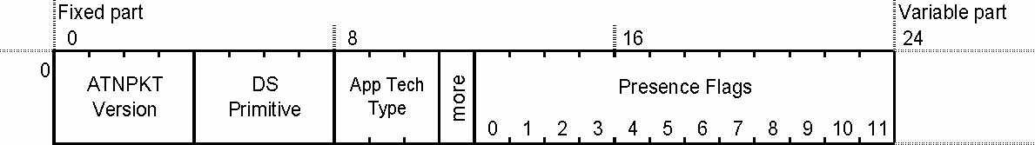
Figure 3. ATNPKT Format
2.2.5.2.5 The optional parameter representation, in the variable part of the ATNPKT, will be determined by the parameter definition. Parameters of variable length will be represented in the LV format (i.e. Length + Value). Fixed length parameters will be represented by their value.

2.2.5.3 ATNPKT Fields

2.2.5.3.1 ATNPKT field formats are described using the convention ( <bits> /<provider> / <usage> ) where:

- <bits> indicates the size in bits of the field value (excluding Length for LV parameters),
- <provider> indicates whether the value is provided by the DS-User as primitive parameter (external) or assigned by the DS-Provider (internal),
- <usage> indicates whether or not the DS-User is to submit a value when invoking the corresponding primitive parameter (optional vs. mandatory).

2.2.5.4 Fixed Part of ATNPKT

2.2.5.4.1 ATNPKT Version

Note. – The ATNPKT version indicates the version of the ATNPKT header.

2.2.5.4.1.1 The ATNPKT version shall be set to 1 and have a format of (4 bits / internal / mandatory).

Note 1. – The ATNPKT version is a number that will increment for any subsequent modifications to the ATNPKT.

Note 2. – Reserving 4 bits will allow for up to 15 versions.

Note 3. – This field is not exposed at the DS-User's level; it will be set by the DS-Provider.

2.2.5.4.2 DS Primitive

Note. – The DS Primitive field is set by the DS-Provider to indicate the type of DS primitive of the packet.

2.2.5.4.2.1 The DS Primitive field shall take one of the values specified below and have a format of (4 bits / internal / mandatory):

Value | Assigned DS Primitive
1 | D-START
2 | D-STARTCNF
3 | D-END
4 | D-ENDCNF
5 | D-DATA
6 | D-ABORT
7 | D-UNIT-DATA
8 | D-ACK
9 | D-KEEPALIVE

Note 1. – Reserving 4 bits will give provision for up to 16 protocol elements, allowing up to 7 additional primitives to be defined.

Note 2. – The D-P-ABORT is not listed, as it is not sent end-to-end. Upon receipt of an abnormal event or expiration of an inactivity timer, a D-P-ABORT will be indicated to the DS-User.

2.2.5.4.3 Application Technology Type

Note. – The Application Technology Type identifies the type of application information that is being carried. Other applications may also take advantage of the IPS infrastructure, e.g. FANS-1/A, ACARS, etc.

2.2.5.4.3.1 The Application Technology Type shall be set to a value of b000 to indicate “ATN/IPS DS” and have a format of (3 bits / internal / mandatory).

2.2.5.4.3.2 The Application Technology Type shall be set to a value of b011 to indicate “FANS/IPS DS” and have a format of (3 bits / internal / mandatory).

Note. – The use or definition of other values is outside the scope of this manual.

2.2.5.4.4 More

Note. – The More bit will be used for segmentation and reassembly of UDP datagrams; and is part of the reliability mechanisms further described in 2.3.

2.2.5.4.4.1 The more bit shall be set to 0 to indicate a single or last segment; it shall be set to 1 to indicate the first or intermediate segment and have a format of (1 bit / internal / mandatory).

2.2.5.4.5 Presence Field

Note. – The Presence Field is a series of Presence Flags (or bits) that indicate whether or not optional fields are present in the variable part of the ATNPKT.

2.2.5.4.5.1 The Presence Field has a format of (12 bits / internal / mandatory).

2.2.5.4.5.2 A Presence Flag shall be set to 0 to indicate the absence of an optional field; it shall be set to 1 to indicate the presence of an optional field.

2.2.5.4.5.3 The optional field details shall comply with Table 4.
Table 4. Presence Field Details
Bit | Optional field | Size (in bits) | Format¹ | Description
0 | Source ID | 16 | V | DS connection identifier of the sender
1 | Destination ID | 16 | V | DS connection identifier of the recipient
2 | Sequence numbers | 8 | V | Sequence numbers (Ns, Nr)
3 | Inactivity time | 8 | V | Inactivity timer value of the sender (in minutes)
4 | Called Peer ID | 24 to 64 (+8) | LV² | Called Peer ID (provided by the local DS-User)
5 | Calling Peer ID | 24 to 64 (+8) | LV² | Calling Peer ID (provided by the local DS-User)
6 | Content Version | 8 | V | Version of the application data carried
7 | Security Indicator | 8 | V | Security requirements: 0 – No security (default value) 1 – Secured dialogue supporting key management 2 – Secured dialogue 3…255 – Reserved
8 | Quality of Service | 8 | V | ATSC Routing Class: 0 – No traffic type policy preference 1 – "A" 5 – "E" 2 – "B" 6 – "F" 3 – "C" 7 – "G" 4 – "D" 8 – "H" 9…255 – Reserved
9 | Result | 8 | V | Result of a request to initiate or terminate a dialogue: 0 – accepted (default value) 1 – Rejected transient 2 – Rejected permanent 3…255 – Reserved
10 | Originator | 8 | V | Originator of the abort: 0 – user (default value) 1 – provider 2…255 – Reserved
11 | User Data | UDP : 0 to 8184³ (+16) TCP: Variable size (+16) | LV² | User Data (provided by the local DS User)

Note 1. – An optional field is present in the variable part when the corresponding bit is set in the Presence Field and has one of the following formats:
- V = value; or
- LV = length (1 or 2 byte(s)) + value

Note 2. – The additional bits required for the length part of LV parameters is indicated between brackets in the above table.

Note 3. – Refer to 2.2.5.5.13 for details regarding the size of the User Data parameter.

2.2.5.5 Variable Parts of ATNPKT

Note. – The variable parts of the ATNPKT will be provided depending on the DS primitive being invoked and the current state of the application using the IPS DS.

2.2.5.5.1 The position of an optional field in the variable part of the ATNPKT shall match the relative position of its corresponding bit in the Presence Field (i.e. options are in the same order as the presence flags).

2.2.5.5.2 Source ID

Note. – The Source ID identifies the DS connection at the sender side. This field is used as part of the reliability mechanisms described in 2.3.

2.2.5.5.2.1 The Source ID shall be present in the D-START and D-STARTCNF primitives, and also when D-ABORT is transmitted after D-START and before D-STARTCNF is received and have a format of (16 bits / internal / optional).

2.2.5.5.3 Destination ID

Note. – The Destination ID identifies the connection at recipient side. This field is used as part of the reliability mechanisms described in 2.3.

2.2.5.5.3.1 The Destination ID shall be present in the D-STARTCNF, D-DATA, D-END, D-ENDCNF, D-ABORT, D-ACK and D-KEEPALIVE primitives and have a format of (16 bits / internal / optional).

2.2.5.5.4 Sequence Numbers

Note. – The Sequence Numbers field contains the sequence numbers to be included in the ATNPKT. This mechanism is used to detect the loss and the duplication of UDP datagrams; it allows implicit (i.e. the service confirmation) or explicit acknowledgement (D-ACK). This field is part of the reliability mechanisms described in 2.3.

2.2.5.5.4.1 The Sequence Numbers field shall be present in all DS primitives over UDP and have the format (8 bits / internal / mandatory) as detailed in Figure 4 below:

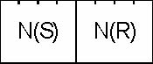
Figure 4. Sequence Number Format
N(S) - [0…15] - sequence number of the ATNPKT sent.
N(R) - [0…15] - expected sequence number of the next ATNPKT to be received.

Note. – For D-ACK and D-KEEPALIVE, only the N(R) is meaningful on transmission.

2.2.5.5.4.2 When using Sequence Numbers with D-ACK and D-KEEPALIVE over UDP, the current value of the send sequence number for N(S) may be used without subsequently incrementing it after transmission.

2.2.5.5.5 Inactivity Time

Note. – The Inactivity Time indicates the time value (in minutes) of the inactivity timer at the sender side. This field is used as part of the reliability mechanisms described in 2.3.

2.2.5.5.5.1The Inactivity Time shall be optionally present in the D-START and D-STARTCNF Primitives and have the format (8 bits / internal / optional).

2.2.5.5.5.2 When this parameter is not provided by the DS-User, the default value of 4 minutes shall be used as inactivity timer by the source DS-Provider.

2.2.5.5.6 Called Peer ID

Note. – The Called Peer ID identifies the intended peer DS-User.

2.2.5.5.6.1 The Called Peer ID shall be either a 24-bit ICAO Aircraft Identifier or a 3 – 8 character ICAO Facility Designation and have the format (24 to 64 bits / external / optional).

2.2.5.5.7 Calling Peer ID

Note. – The Calling Peer ID identifies the initiating peer DS-User.

2.2.5.5.7.1 The Calling Peer ID shall be either a 24 bit ICAO Aircraft Identifier or a 3 – 8 character ICAO Facility Designation and have the format (24 to 64 bits / external / optional).

2.2.5.5.8 Content Version

Note. – The Content Version field is used to indicate the application’s version number.

2.2.5.5.8.1 The Content Version shall be the version of the ASN.1 syntax used for the User Data field and have the format (8 bits / external / optional).

2.2.5.5.9 Security Indicator

Note 1. – The Security Indicator parameter is used to convey the level of security to be applied to the dialogue. In Doc 9880, this field is referred as 'Security Requirements'; it is renamed here since 'requirement' is not really appropriate in this case. It is really an indication from the local DS-user on which kind of security procedure is to be used to setup a secure dialogue exchange.

2.2.5.5.9.1 The Security Indicator parameter shall be one of the following values and have a format of (8 bits / external / optional):

Value | Security Level
0 | No security (default value)
1 | Secured dialogue supporting key management
2 | Secured dialogue
3 – 255 | Reserved

Note. – The absence of this parameter by the DS-User results in the security level being set to the default value, i.e. no security.

2.2.5.5.10 Quality of Service

Note. – The Quality of Service (QoS) parameter is used to convey the DS-User quality of service requirement which is a value corresponding to ATSC Routing Class and/or Residual Error Rate (RER).

2.2.5.5.10.1 The QoS parameter shall have a format of (8 bits / external / optional) and takes the following values:

- The DS-User-provided ATSC Routing class as below:
Value | ATSC Routing Class Description
0 | No traffic type policy preference
1 | “A”
2 | “B”
3 | “C”
4 | “D”
5 | “E”
6 | “F”
7 | “G”
8 | “H”
9 – 255 | Reserved

- The RER as defined below:
Value | RER Level
0 | Low
1 | Medium
2 | High

- ATN application priority may be indicated by inserting Differentiated Service Codepoint (DSCP) values in the IPv6 header as described in Part III of this document.

Note. – The priority is normally set by the network layer, so it is not necessary for the application to provide it. The network layer can discern the priority by the port number being used or IP address and set the differentiated service field accordingly. It should also be noted that the network management procedures may lead to packet re-marking, regardless of the initial application indications, to be consistent with local network differentiated service definitions.

2.2.5.5.10.2 The UDP checksum may be activated for low or medium RER values and not activated for a high RER value.

Note. – TCP checksums are always activated. The UDP checksums are activated by default.

2.2.5.5.11 Result

Note. – The Result is set by the destination DS-User in order to indicate whether or not the requested dialogue initiation or termination completed successfully.

2.2.5.5.11.1 The Result shall have the format of (8 bits / external / mandatory) and take one of the values below:

Value | Definition
0 | Accepted
1 | Rejected (transient)
2 | Rejected (permanent)
3 – 255 | Reserved

2.2.5.5.12 Originator

Note. – The Originator indicates the source of a D-ABORT.

2.2.5.5.12.1 The Originator shall have the format of (8 bit / external / optional) and take one of the values below:

Value | Definition
0 | User (default)
1 | Provider
2 – 255 | Reserved

Note. – When this parameter is not provided by the DS-User the default value is assumed.

2.2.5.5.13User Data

Note. – The User Data contains the Packed Encoding Rules (PER) encoded application data.

2.2.5.5.13.1 The User Data shall have the format of (UDP: 0 to 8184, TCP: variable size / external / optional).

Note 1. – The maximum User Data size for a D-DATA service is the maximum UDP datagram size (8192 bytes) reduced by the size of the ATNPKT header (8 bytes). For other service primitives, the maximum User Data size needs to be adjusted based on the size of the fixed header part plus the size of the variable length parts for that particular service primitive.
Note 2. – The IPS DS will segment UDP datagrams with user data that exceeds 1024 bytes as described in 2.3.7 which will need to be reassembled by the receiver.

2.2.5.6 IPS DS Parameter Mapping

Note. – The IPS DS presents an identical interface of the ULCS to the ATN applications. As such, the parameters of the IPS DS are identical to those of the ULCS. However, there is a different mapping of the contents of those parameters. These modified mappings are summarized in Table 5 and detailed for each primitive in Table 6.

Table 5. IPS DS - ULCS DS Parameter Mapping
DS Parameter Visible to the DS-User | IP Header | Transport Protocol Header | ATNPKT (See ) | Comment
Called Peer ID |  |  | Called Peer ID | This can be an ICAO 24 bit aircraft address or an ICAO Facility Designator (4 to 8 characters)
Called Sys-ID |  | Destination Port Number |  | This is a registered port number assigned to each ATN application (see 2.3.2)
Called Presentation Address | Destination IP Address |  |  | IP address of the recipient ATN application
Calling Peer ID |  |  | Calling Peer ID | This can be an ICAO 24 bit aircraft address or an ICAO Facility Designator (4 to 8 characters)
Calling Sys-ID |  | Source Port Number |  | Using TCP, this port number is dynamically assigned by the transport protocol stack on the client side. With UDP, this port number typically has a static value which is the same as the destination port number.
Calling Presentation Address | Source IP Address |  |  | IP address of the originator of the ATN application
DS-User Version Number |  |  | Content Version | This is the application’s version number
Security Requirements |  |  | Security Requirements | 00 – No security  01 – Secured dialogue Supporting Key Management  02 – Secured Dialogue  03 – Reserved
Quality of Service |  |  | Quality of Service | This parameter is to be transported only when provided as ‘ATSC Routing Class’; the RER and Priority are not indicated end-to-end but are optionally indicated to the IPS DS and used locally
Result |  |  | Result | 00 – Accepted  01 – Rejected (permanent)  02 – Rejected (transient)
Reject Source |  |  |  | 00 – the remote DS-User  01 – the local DS-Provider  Provided locally in the Confirmation primitive only; not transferred end-end
Originator |  |  | Originator | 0 – User  1 – Provider (default)  2-255 – Reserved
User Data |  |  | User Data | This is the PER encoded data provided by the application

2.2.5.6.1 The inclusion of optional ATNPKT parameters for each DS protocol message shall comply with Table 6:
Table 6. ATNPKT Parameters for DS Protocol Messages
ATNPKT Parameter ➢  | Protocol message   | D-START | D-STARTCNF | D-DATA |  | D-UNIT-DATA | D-END | D-ENDCNF | D-ABORT | D-ACK | D-KEEPALIVE
Fixed part
ATNPKT Version |  | M | M | M | M |  | M | M | M | M | M
DS Primitive |  | M | M | M | M |  | M | M | M | M | M
Application Technology Type |  | M | M | M | M |  | M | M | M | M | M
More |  | M | M | M | M(5) |  | M | M | M(5) | M(5) | M(5)
Presence Flag |  | M | M | M | M |  | M | M | M | M | M
Variable part
Source ID |  | M (4) | M (4) |  |  |  |  |  | (1)
Destination ID |  |  | M (4) | M (4) |  |  | M (4) | M (4) | M (2) | M | M
Sequence Numbers |  | UDP: M (4)  TCP:O (4) | UDP: M (4)  TCP:O (4) | UDP: M (4)  TCP:O (4) | UDP: M  TCP: O |  | UDP:M (4)  TCP:O (4) | UDP: M (4)  TCP:O (4) | UDP: M  TCP:O | UDP: M  TCP: O | UDP: M  TCP: O
Inactivity Time |  | O (3) | O (3)
Called Peer ID |  | O (3) |  |  | O
Calling Peer ID |  | O (3) |  |  | O
Content Version |  | O (3) | O (3) |  | O
Security Indicator |  | O (3) | O (3) |  | O
Quality Of Service |  | O (3)
Result |  |  | M (3) |  |  |  |  | M (3)
Originator |  |  |  |  |  |  |  |  | O
User Data |  | O (4) | O (4) | M (4) | M |  | O (4) | O (4) | O
(O = optional, M = mandatory, empty = precluded to use)
(1) Source ID is present if D-ABORT is sent after D-START and before D-STARTCNF is received
(2) Destination ID is absent if D-ABORT is sent after D-START and before D-STARTCNF is received.
(3) For segmented messages this parameter is present only in the first segment.
(4) For segmented messages this parameter is present in all the segments
(5) These primitives will always set the More bit to “0”

2.2.5.7 Dialogue Service Primitives

Note. – In order to provide the services identified in 2.2.4, the primitives listed in Table 7 are used. Each primitive may be either directly exposed to the DS-User (request/response primitives) or reported to the DS-User by the DS-Provider (indication/confirmation primitives).
Table 7. Dialogue Service Primitive Details
Interface Primitive | Dialogue Service Description | DS-User | DS-Provider
D-START req | Request to initiate a Dialogue with a peer DS-User |  
D-START ind | Inform a local DS-User that a peer DS-User requested for a Dialogue initiation |  |  
D-START rsp | Complete a pending Dialogue initiation with either a positive or a negative response |  
D-START cnf | Inform a local DS-User that the peer DS-User completed the pending Dialogue initiation with either a positive or a negative response |  |  
D-UNIT-DATA req | Send a datagram from the local DS-User to a peer DS-User (the end-to-end delivery of the datagram is not guaranteed) |  
D-UNIT-DATA ind | Inform a local DS-User that a datagram is received from a peer DS-User |  |  
D-DATA req | Send a datagram from the local DS-User to a peer DS-User over an established Dialogue |  
D-DATA ind | Inform a local DS-User that a datagram is received from a peer DS-User over an established Dialogue |  |  
D-END req | Request to terminate a Dialogue with a peer DS-User |  
D-END ind | Inform a local DS-User that a peer DS-User requested for a Dialogue termination |  |  
D-END rsp | Complete a pending Dialogue termination with either a positive or a negative response |  
D-END cnf | Inform a local DS-User that the peer DS-User completed the pending Dialogue termination with either a positive or a negative response |  |  
D-ABORT req | Request to abort a Dialogue with a peer DS-User |  
D-ABORT ind | Inform a local DS-User that the peer DS-User requested to abort the Dialogue |  |  
D-P-ABORT ind | Dialogue aborted by the DS-Provider |  |  

2.2.5.8 Dialogue Service Time-Sequence Diagrams

Note. – The sections below illustrate the Dialogue Service protocol exchanges between source and destination DS-Providers, including the ATNPKT user data part.

2.2.5.8.1 D-START service

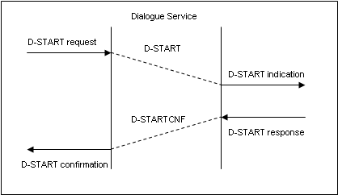
Figure 5. D-START Service
2.2.5.8.2 D-DATA service

Note. – Figure 6 shows the D-DATA service over a TCP connection. Due to the nature of the connection, an ACK is not required. Figure 7 shows the D-DATA service over UDP. In order to provide explicit acknowledgment of the receipt of the UDP packet, a D-ACK is returned by the receiver of the D-DATA ATNPKT.

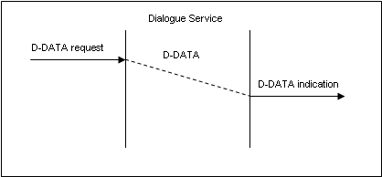
Figure 6. D-DATA Service (TCP)

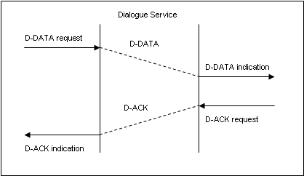
Figure 7. D-DATA Service (UDP)
2.2.5.8.3D-END service

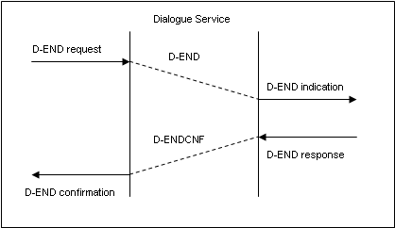
Figure 8. D-END Service
2.2.5.8.4 D-ABORT service

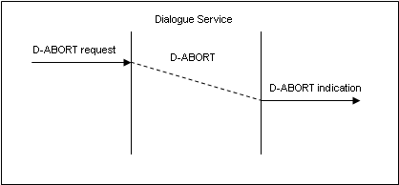
Figure 9. D-ABORT Service
2.2.5.8.5 D-P-ABORT service

Note. – There is no ATNPKT format defined for the D-P-ABORT service, as it is a local indication to the DS-User.

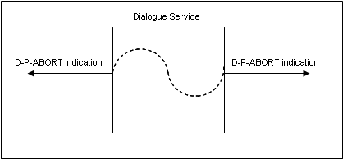
Figure 10. D-P-ABORT Service
2.2.5.8.6 D-UNIT-DATA service

Note. – Figure 11 shows the D-UNIT-DATA service over a TCP connection. Due to the nature of the connection, an ACK is not required. Figure 12 shows the D-UNIT-DATA service over UDP. In order to provide explicit acknowledgment of the receipt of the UDP packet, a D-ACK is returned by the receiver of the D-UNIT-DATA ATNPKT.

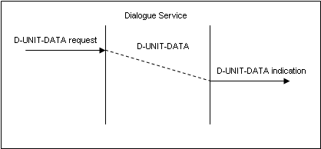
Figure 11. D-UNIT-DATA Service (TCP)
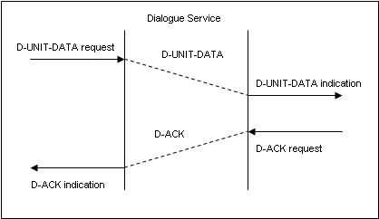
Figure 12. D-UNIT-DATA Service (UDP)
2.2.5.8.7 D-ACK service

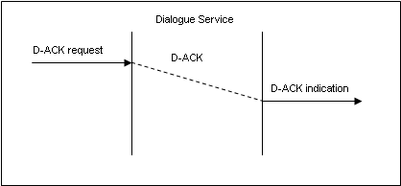
Figure 13. D-ACK Service

2.2.5.8.8 D-KEEPALIVE service

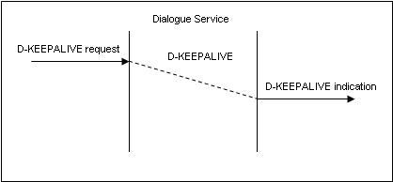
Figure 14. D-KEEPALIVE Service

2.3 Transport Layer

2.3.1Overview
2.3.1.1 The IPS DS has been designed to allow a user selection of either TCP or UDP for the transport protocol. For simplicity, port-related operations are not considered as primitives.

2.3.1.2 The transport layer primitives are given in Table 8.

Table 8. Transport Layer Primitives Used in the IPS DS
 | Transport Layer
Interface Primitive | Description | TCP | UDP
OPEN | Connection establishment (referred as 'active' on initiator side, 'passive' on the other side) |  
CLOSE | Connection termination (referred as 'active' on initiator side, 'passive' on the other side) |  
RECEIVE | Receive transport level datagram |   |  
SEND | Send transport level datagram |   |  

2.3.1.3 Table 9 gives the mapping to be applied between the Dialogue Service and the Transport Layer primitives.
Table 9. Transport Layer - IPS DS Service Mapping
Dialogue Service |  | Transport Layer
Service | Interface Primitive | Interface Primitive | User Data | Protocol
Initialisation
 |  | OPEN (passive) |  | TCP
Dialogue Establishment
D-START | D-START req | OPEN (active) |  | TCP
D-START | D-START req | SEND | D-START | TCP, UDP
D-START | D-START ind | RECEIVE | D-START | TCP, UDP
D-START | D-START rsp | SEND | D-STARTCNF | TCP, UDP
D-START | D-START cnf | RECEIVE | D-STARTCNF | TCP, UDP
Connectionless Data Exchange
D-UNIT-DATA | D-UNIT-DATA req | SEND | D-UNITDATA | UDP
D-UNIT-DATA | D-UNIT-DATA ind | RECEIVE | D-UNITDATA | UDP
Connected-mode Data Exchange
D-DATA | D-DATA req | SEND | D-DATA | TCP, UDP
D-DATA | D-DATA ind | RECEIVE | D-DATA | TCP, UDP
Orderly Dialogue Termination (user initiated)
D-END | D-END req | SEND | D-END | TCP, UDP
D-END | D-END ind | RECEIVE | D-END | TCP, UDP
D-END | D-END rsp | SEND | D-ENDCNF | TCP, UDP
D-END | D-END rsp | CLOSE (passive) |  | TCP
D-END | D-END cnf | RECEIVE | D-ENDCNF | TCP, UDP
D-END | D-END cnf | CLOSE (active) |  | TCP
Forced Dialogue Termination (user initiated)
D-ABORT | D-ABORT req | SEND | D-ABORT | TCP, UDP
D-ABORT | D-ABORT req | CLOSE (active) |  | TCP
D-ABORT | D-ABORT ind | RECEIVE | D-ABORT | TCP, UDP
D-ABORT | D-ABORT ind | CLOSE (passive) |  | TCP
Error-related Dialogue Termination (provider initiated)
D-P-ABORT | D-P-ABORT ind | RECEIVE / SEND (failure) |  | TCP, UDP
D-P-ABORT | D-P-ABORT ind | Unexpected CLOSE (passive) |  | TCP

2.3.2 Port Numbers
2.3.2.1 The following TCP and UDP port numbers shall be used when supporting legacy ATN applications over the ATN/IPS:

5910 Context Management
5911 Controller Pilot Data Link Communication
5912 Flight Information Services
5913 Automatic Dependent Surveillance

Note. – These port numbers are registered by IANA at http://www.iana.org/assignments/port-numbers.

2.3.3 Providing Dialogue Service over UDP
Note. – UDP is mostly employed for applications requiring broadcast or multicast, but it might also be used for simple "request-reply" applications provided that some reliability is added at the highest levels. UDP does not guarantee the end-to-end service delivery of the datagrams. For this reason, additional mechanisms are implemented in the IPS DS to address UDP limitations; basically the truncation, loss, or duplication of UDP datagrams. These mechanisms are specified in the following sections.

2.3.3.1 In order to add some reliability when acting over UDP, the DS-Provider shall implement the mechanisms as described in Table 10:

Table 10. IPS DS UDP Reliability Mechanisms
Provide ‘dialog connection’ over UDP  -identification of connections  - connection timeout  - termination timeout | M O O
Detect the loss of UDP datagrams using one-to-one acknowledgments (on a per connection basis)  - retransmission timer + max retry count  - explicit ack nowledgment  -piggy-back ed ack nowledgment (max delay before ack ) | M M O
Detect long-lived unpaired connections  -inactivity timer + k eep alive | M
Handle UDP datagrams truncation  - datagram segmentation / reassembly | M
(O = optional, M = mandatory)

2.3.4 Connection-ids
2.3.4.1 A pair of connection-ids, the Source ID and Destination ID, shall be assigned during the connection phase (D-START / D-STARTCNF) by every participating DS peer and used over any subsequent exchanges.

Note 1. – DS connection identification above UDP will be handled by the assignment of this pair of connection-ids.

Note 2. – The 2 byte size for these identifiers was chosen because this will allow the DS-Provider to associate a particular semantic to the dialogue-id assigned on its side (without interference with the involved peer DS-User). In such a case, the identifier might be an index in a context table, making it implicitly unique, but also allowing the receiving DS-Provider to find out the context without having to use multiple search criteria and parsing the whole table of contexts.

2.3.4.2 The Source ID and Destination ID shall be conveyed in the variable part of the ATNPKT based on DS primitives as described in Table 11:
Table 11. Source ID and Destination ID Usage
DS Primitive field | Source ID |  | Destination ID
D-START | M | Identifier given by the DS-Provider who initiates the dialogue; it will allow him to find out the dialogue context during the whole dialogue duration. | - | Unassigned at this time
D-STARTCNF | M | Identifier given by the DS-Provider who accepts the dialogue; it will allow him to find out the dialogue context during the whole dialogue duration. | M | Identifier of the DS-Provider who initiated the dialogue.
D-DATA | - | No need to transport it since it would be meaningless for the destination DS-Provider. | M | Identifier of the peer DS-Provider.
D-END | - | No need to transport it since it would be meaningless for the destination DS-Provider. | M | Identifier of the peer DS-Provider.
D-ENDCNF | - | No need to transport it since it would be meaningless for the destination DS-Provider. | M | Identifier of the peer DS-Provider.
D-ABORT before D-STARTCNF | M | Identifier given by the DS-Provider who initiated the dialogue. | - | Unknown for now.
D-ABORT other cases | - | No need to transport it since it would be meaningless for the destination DS-Provider | M | Identifier of the peer DS-Provider.
(O = optional, M = mandatory)

2.3.5 Detecting Lost Datagrams
Note 1. – The loss of UDP datagrams is detected through a one-to-one acknowledgment mechanism, on a per DS connection basis i.e. one data packet sent, one acknowledgement to be received before more data can be sent again.

Note 2. – The acknowledgment may be piggy-backed with a dialogue message in the reverse direction for the same dialogue; this will be possible for instance with confirmed primitives.

2.3.5.1 For unconfirmed DS services, the receiving user shall use an explicit acknowledgment by sending an ATNPKT with no data and with a specific value (D-ACK) as 'DS Primitive'.

Note 1. – For acknowledgment purposes, the 'Sequence Numbers' field of the ATNPKT variable part will be used.

Note 2. – This sequence number is required to avoid delivering duplicated data to the peer DS-user following retransmission (i.e. if a D-ACK has been lost), and in more exceptional circumstances, when UDP datagrams are delivered out of sequence by the network.

2.3.5.2 The DS-Provider shall associate an incremented sequence number to outgoing ATNPKTs and store the sequence number of the last ATNPKT received from the peer DS-Provider in order to acknowledge it in a subsequent transmission.

2.3.5.3 Both outgoing and incoming sequence numbers shall be respectively carried by the N(S) and N(R) subfields of the 'Sequence Numbers'.

Note 1. – N(S) corresponds to the current sequence number of the ATNPKT that has been sent; N(R) is the next sequence number expected as N(S) from the remote DS-Provider (i.e. in its next transmission).

Note 2. – Using sequence numbers will allow the DS-Provider to detect missing or duplicated ATNPKTs. There is at most one unacknowledged ATNPKT; for this reason there will be no grouped acknowledgments and there is no need to implement a selective reject mechanism.

Note 3. – The lack of a timely acknowledgment will entail a retransmission. An excessive number of retransmissions will break the DS connection. The timeout values and the maximum number of retransmissions are detailed in Table 12.

2.3.6 Connection Timeout
Note. – In order to avoid long lived unpaired DS connections, a simple mechanism for detecting inactivity is implemented. Both ends of the DS connection will transmit a keepalive packet when the 'keepalive transmission timer' expires. The keepalive transmission timer is restarted by the sender each time it sends data on the connection, avoiding unnecessary keepalive transmissions.

2.3.6.1 A keepalive (an ATNPKT with no data and with a value of D-KEEPALIVE as 'DS Primitive') shall be sent at each expiry of the local keepalive transmission timer.

2.3.6.2 The keepalive transmission timer may be set to 1/3 of the inactivity timer of the peer DS-Provider, or 1/3 of the default inactivity timer.

Note. – The lack of reception of either data or keepalive packets for an interval of time corresponding to the inactivity time will break the DS connection. The parameter value for this time is detailed in Table 12.

2.3.6.3 The optional ATNPKT field ‘Inactivity Time’ may be used at dialogue initialization time (i.e. in D-START and D-STARTCNF) so that each DS-Provider can adjust its local keepalive transmission timer.

Note. – Absence of the Inactivity Time indicates use of the default Inactivity Time value as in Table 12.

2.3.7 “More” Indicator
Note. – Most of the ATN application messages do not exceed 1000 bytes. Additionally the suggested value of 1024 bytes does not exceed the IP payload (1500 bytes) in the Ethernet frame (1518 bytes).

2.3.7.1 A D-DATA with a user data part exceeding 1024 bytes shall be segmented using the 'MORE' bit reserved in the ATNPKT fixed part.

Note. – Upon receipt of a D-DATA with the more bit set, the receiving side is responsible for ordering and reassembling the segmented data.

2.3.8 DS-Provider Parameters
2.3.8.1 The values specified in Table 12 shall be applied to the identified DS-Provider parameters:
Table 12. DS-Provider Parameters
Parameter | Min | Max | Default
Delay before retransmission | 1 sec | 60 sec | 15 sec
Max number of transmissions | 1 | 10 | 3
Inactivity time | 3 min | 15 min | 4 min

2.4 IPS Dialogue Service State Tables

2.4.1 IPS Dialogue Service TCP State Tables
Table 13. IPS DS State Table for TCP
Events      State ⇒  ⇓  |  | D-IDLE | D-CONNECTED | D-START-SENT | D-START-RECEIVED | D-TRANSFER | D-END-SENT | D-END-RECEIVED | D-WAIT-CLOSE
During initialisation phase |  | - OPEN (passive)
DS-User events | D-START req | - OPEN (active) - Map D-START req to D-START - SEND (D-START) - Enter D-START-SENT state
DS-User events | D-START rsp |  |  |  | - Map D-START cnf to D-STARTCNF - SEND (D-STARTCNF) - In case of positive response : - Start tinact - Enter D-TRANSFER state - Otherw ise : -Enter D-WAIT-CLOSE state
DS-User events | D-DATA req |  |  |  |  | - Map D-DATA req to D-DATA - SEND (D-DATA)
DS-User events | D-END req |  |  |  |  | - Cancel tinact - Map D-END req to D-END - SEND (D-END) - Enter D-END-SENT state
DS-User events | D-END rsp |  |  |  |  |  |  | - Map D-END rsp to D-ENDCNF - SEND (D-ENDCNF) -In case of positive response : -Enter D-WAIT-CLOSE state - Otherw ise : - Start tinact - Enter D-TRANSFER state
DS-User events | D-ABORT req |  |  | - Map D-ABORT req to D-ABORT - SEND (D-ABORT) - Enter D-WAIT-CLOSE state | - Map D-ABORT req to D-ABORT - SEND (D-ABORT) - Enter D-WAIT-CLOSE state | - Cancel tinact - Map D-ABORT req to D-ABORT - SEND (D-ABORT) - Enter D-WAIT-CLOSE state | - Map D-ABORT req to D-ABORT - SEND (D-ABORT) - Enter D-WAIT-CLOSE state | - Map D-ABORT req to D-ABORT - SEND (D-ABORT) - Enter D-WAIT-CLOSE state
TCP events | OPEN (passive) completed | - Enter D-CONNECTED state
TCP events | RECEIVE (D-START) |  | - Map D-START to D-START ind - Report D-START ind to DS-User - Enter D-START-RECEIVED state
TCP events | RECEIVE (D-STARTCNF) |  |  | - Map D-STARTCNF to D-START cnf - Report D-START cnf to DS-User - In case of positive response : - Start tinact - Enter D-TRANSFER state - Otherw ise : - CLOSE (active) -Enter D-IDLE state
TCP events | RECEIVE (D-DATA) |  |  |  |  | - Reset tinact - Map D-DATA to D-DATA ind - Report D-DATA ind to DS-User
TCP events | RECEIVE (D-END) |  |  |  |  | - Cancel tinact - Map D-END to D-END ind - Report D-END ind to DS-User - Enter D-END-RECEIVED state
TCP events | RECEIVE (D-ENDCNF) |  |  |  |  |  | - Map D-ENDCNF to D-END cnf - Report D-END cnf to DS-User - In case of positive response : - CLOSE (active) - Enter D-IDLE state - Otherw ise : - Start tinact - Enter D-TRANSFER state
TCP events | RECEIVE (D-ABORT) |  |  |  | - Map D-ABORT to D-ABORT ind -Report D-ABORT ind to DS-User - CLOSE (active) -Enter D-IDLE state | - Cancel tinact - Map D-ABORT to D-ABORT ind - Report D-ABORT ind to DS-User - CLOSE (active) - Enter D-IDLE state | - Map D-ABORT to D-ABORT ind - Report D-ABORT ind to DS-User - CLOSE (active) - Enter D-IDLE state | - Map D-ABORT to D-ABORT ind - Report D-ABORT ind to DS-User - CLOSE (active) - Enter D-IDLE state
 | CLOSE (passive) |  | - CLOSE (active) - Enter D-IDLE state | - Report D-P-ABORT ind to DS-User - CLOSE (active) -Enter D-IDLE state | - Report D-P-ABORT ind to DS-User - CLOSE (active) -Enter D-IDLE state | - Cancel tinact - Report D-P-ABORT ind to DS-User - CLOSE (active) - Enter D-IDLE state | - Report D-P-ABORT ind to DS-User - CLOSE (active) - Enter D-IDLE state | - Report D-P-ABORT ind to DS-User - CLOSE (active) - Enter D-IDLE state | - CLOSE (active) - Enter D-IDLE state
DS-Provider events | tinact expires |  |  |  |  | - Report D-P-ABORT ind to DS-User - Enter D-IDLE state

2.4.2 IPS Dialogue Service UDP State Tables
Table 14. IPS DS State Table for UDP
Events      State ⇒  ⇓  |  | D-IDLE | D-START-SENT | D-START-RECEIVED | D-TRANSFER | D-END-SENT | D-END-RECEIVED
DS-User events | D-START req | -Map D-START req to D-START - SEND (D-START) - Start tconnect - Enter D-START-SENT state
DS-User events | D-START rsp |  |  | - Map D-START cnf to D-STARTCNF - SEND (D-STARTCNF) -In case of positive response : - Start tinact -Enter D-TRANSFER state - Otherw ise : -Enter D-IDLE state
DS-User events | D-DATA req |  |  |  | - Map D-DATA req to D-DATA - SEND (D-DATA)
DS-User events | D-END req |  |  |  | - Cancel tinact -Map D-END req to D-END - SEND (D-END) - start tterm - Enter D-END-SENT state
DS-User events | D-END rsp |  |  |  |  |  | -Map D-END rsp to D-ENDCNF - SEND (D-ENDCNF) - In case of positive response : - Enter D-IDLE state - Otherw ise : - Start tinact - Enter D-TRANSFER state
DS-User events | D-ABORT req |  | - Cancel tconnect -Map D-ABORT req to D-ABORT - SEND (D-ABORT) - Enter D-IDLE state | - Map D-ABORT req to D-ABORT - SEND (D-ABORT) - Enter D-IDLE state | - Cancel tinact - Map D-ABORT req to D-ABORT - SEND (D-ABORT) - Enter D-IDLE state | - Cancel tterm - Map D-ABORT req to D-ABORT - SEND (D-ABORT) - Enter D-IDLE state | - Map D-ABORT req to D-ABORT - SEND (D-ABORT) - Enter D-IDLE state
UDP events | RECEIVE (D-START) | -Map D-START to D-START ind - Report D-START ind to DS-User - Enter D-START-RECEIVED state
UDP events | RECEIVE (D-STARTCNF) |  | - Cancel tconnect -Map D-STARTCNF to D-START cnf - Report D-START cnf to DS-User -In case of positive response : -Start tinact - Enter D-TRANSFER state - Otherw ise : - Enter D-IDLE state
UDP events | RECEIVE (D-DATA) |  |  |  | - Reset tinact - Map D-DATA to D-DATA ind - Report D-DATA ind to DS-User
UDP events | RECEIVE (D-END) |  |  |  | - Cancel tinact -Map D-END to D-END ind - Report D-END ind to DS-User - Enter D-END-RECEIVED state
UDP events | RECEIVE (D-ENDCNF) |  |  |  |  | - Cancel tterm -Map D-ENDCNF to D-END cnf - Report D-END cnf to DS-User - In case of positive response : - Enter D-IDLE state - Otherw ise : - Start tinact - Enter D-TRANSFER state
UDP events | RECEIVE (D-ABORT) |  |  | - Map D-ABORT to D-ABORT ind - Report D-ABORT ind to DS-User - Enter D-IDLE state | - Cancel tinact - Map D-ABORT to D-ABORT ind - Report D-ABORT ind to DS-User - Enter D-IDLE state | - Cancel tterm - Map D-ABORT to D-ABORT ind - Report D-ABORT ind to DS-User - Enter D-IDLE state | - Map D-ABORT to D-ABORT ind - Report D-ABORT ind to DS-User - Enter D-IDLE state
D S events | tconnect expires |  | - Report D-P-ABORT ind to DS-User - Enter D-IDLE state
D S events | tinact expires |  |  |  | - Report D-P-ABORT ind to DS-User - Enter D-IDLE state
D S events | tterm expires |  |  |  |  | -Report D-P-ABORT ind to DS-User - Enter D-IDLE state

ICAO

Aeronautical Telecommunication Network (ATN)

Manual for the ATN using IPS Standards and Protocols (Doc 9896)

Part III

Guidance Material Section

TABLE OF CONTENTS
1.0 INTRODUCTION 2
1.1 Background 6
2.0 General Guidance 7
2.1 The ATN/IPS 7
2.1.1 The ATN/IPS Internetwork 7
2.1.2 Coordination of Policies among Administrative Domains 9
2.1.3 ATN/IPS Internetworking with Mobility 9
2.2 Network Transition Mechanisms 10
2.2.1 Tunnelling 11
2.2.2 Dual Stack 12
2.2.3 Translation 12
2.2.4 Combining of the Mechanisms 13
3.0 PROTOCOL Stack 13
3.1 Physical and Link Layer Guidance 13
3.2 Network Layer 13
3.2.1 Address Plan 13
3.2.2 Application interface to the network layer 13
3.2.3 Inter-domain routing 13
3.2.4 Multicast 15
3.3 Transport Layer 16
3.3.1 Transmission Control Protocol 16
3.3.2 User Datagram Protocol (UDP) 17
3.3.3 Transport Layer Addressing 17
3.3.4 Application Interface to the Transport Layer 17
3.3.5 Congestion Avoidance 18
3.3.6 Error Detection and Recovery 18
3.3.7 Performance Enhancing Proxies (PEPs) 18
3.3.8 Transport Layer usage 18
3.4 Application Layer 20
3.4.1 ASN.1 extensions to CM 20
4.0 Quality of Service 22
4.1 Introduction 22
4.2 Class Definitions 22
4.2.1 Context 22
4.2.2 ATN/IPS PHBs/CoS 23
4.2.3 DiffServ Code Point (DSCP) Values 25
4.2.4 Traffic Characterisation 26
5.0 MOBILITY GUIDANCE 26
5.1 MOBILE IPv6 26
5.1.1 MIPv6 Bidirectional Tunneling 27
5.1.2 MIPv6 Route Optimization 27
5.2 Enhancements to MIPv6 28
5.2.1 Heirarchical Mobile IPv6 (HMIPv6) 28
5.2.2 Fast Handovers for Mobile IPv6 (FMIPv6) 28
5.2.3 Proxy Mobile IPv6 (PMIPv6) 29
5.2.4 Network Mobility (NEMO) 29
6.0 SECURITY GUIDANCE 30
6.1 Requirments for Implementation 30
6.2 Ground-Ground Security 30
6.2.1 Ground-Ground IPsec 30
6.2.2 Ground-Ground IKEv2 31
6.2.3 Alternatives to IPsec/IKEv2 for Ground-Ground Security 31
6.3 Air-Ground Security 31
6.3.1 Air-Ground IPsec 31
6.3.2 Air-Ground IKEv2 32
6.3.3 Securing Air-Ground End-to-End Communications 33
6.3.4 Securing Access Network and Mobile IP Signaling 35
6.3.5 Public Key Infrastructure Profile and Certificate Policy 36
6.3.6 General Guidance for Implementation of Security 36
7.0 Voice over Internet Protocol (VoIP) 37
7.1 EUROCAE SPECIFICATION 37
7.2 ADDITIONAL INFORMATION 38
7.2.1 Standards and Protocols 38
7.2.1.1 H323 38
7.2.1.2 MGCP/MEGACO 2
8.0 IPS Implementations 1
8.1 OLDI 1
8.2 Flight Management Trasfer Protocol (FMTP) 1
8.2.1 Testing OLDI/FMTP 2
8.3 AMHS 2
APPENDIX A – REFERENCE DOCUMENTS 3
APPENDIX B – ABBREVIATIONS/DEFINITIONS 1

FOREWORD

The material contained in this document supplements the Standards and Recommended Practices (SARPs) and the Manual for Detailed Technical Specifications. This document is to be used to assist in the deployment of IPS systems of the Aeronautical Telecommunication Network (ATN) as defined in Annex 10 — Aeronautical Telecommunications, Volume III — Communication Systems and Part I — Digital Data Communication Systems.

1.0 Introduction
This part of the manual contains information to assist ICAO contracting States in the deployment of an ATN/IPS network to support Air Traffic Management (ATM) services. The following minimum core services should be provided by ATN/IPS network.

These core services enable ATN applications to provide voice and data services with the appropriate priority and security over the ATN/IPS network.

The protocols discussed in this document are based on the open system interconnect reference model (OSI). As the ATN/IPS uses the 4 layer model of the IETF, Figure 1.1 depicts the relationship between OSI, ATN/OSI and the ATN/IPS protocols.

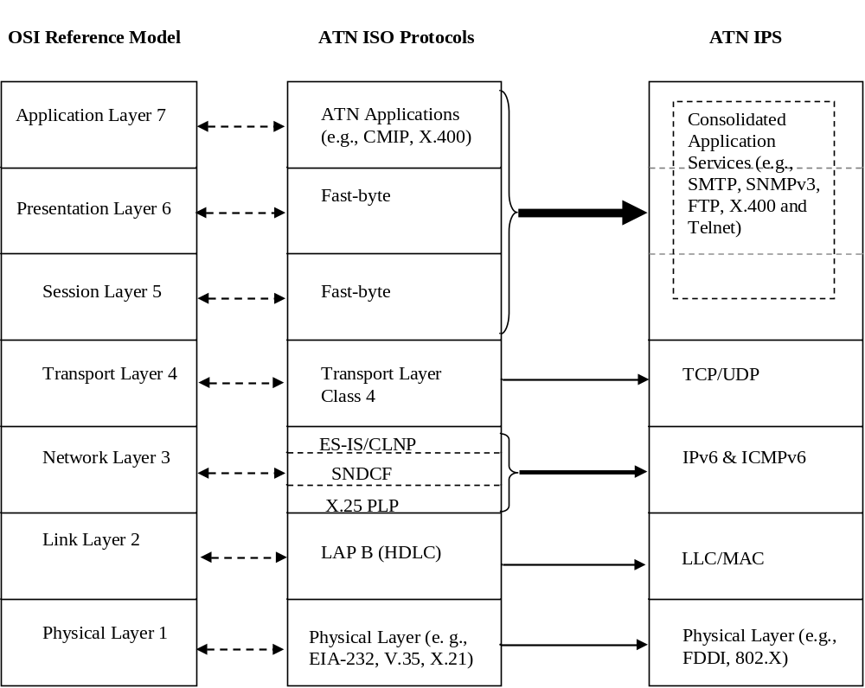

Figure 1.1 Protocol Reference Model

1.1 Background
The ICAO ATN/IPS has been established with the specific goal of providing global ATM services based on commercial off-the-shelf technologies. According to the ICAO SARPS, ATN services can be provided using the ISO based ICAO protocols as specified in Doc 9705/9880 or the ATN/IPS as specified in this manual, Doc 9896. This manual describes the technical approach for networking based on IPS, and will enable ICAO contracting States to provide ATM services on its basis.

2.0 General Guidance
This section contains general guidance information about the implementation of ATN/IPS for ATN applications, multicast and VoIP.

2.1 The ATN/IPS

2.1.1 The ATN/IPS Internetwork
The ATN/IPS Internetwork is specifically and exclusively intended to provide data communications services to air traffic service (ATS) provider organizations and aircraft operating agencies supporting the following types of communications traffic:

- ATS Communication (ATSC). Communication related to air traffic services including air traffic control, aeronautical and meteorological information, position reporting and services related to safety and regularity of flight. This communication involves one or more air traffic service administrations.

- Aeronautical Operational Control (AOC). Communication required for the exercise of authority over the initiation, continuation, diversion or termination of flight for safety, regularity and efficiency reasons.

- Aeronautical Administrative Communication (AAC). Communication used by aeronautical operating agencies related to the business aspects of operating their flights and transport services. This communication is used for a variety of purposes, such as flight and ground transportation, bookings, deployment of crew and aircraft or any other logistical purposes that maintain or enhance the efficiency of over-all flight operation.

In order to support these communications types, this manual specifies a set of technical and administrative requirements on the entities which constitute the ATN/IPS. See Figure 2.1-1.

Technical requirements in this manual are levied against an IPS router, an IPS host, or an IPS node when the requirement applies to both. This manual adopts the RFC 2460 definition of an IPS node as a device that implements IPv6 and distinguishes between an IPS router as a node that forwards IP packets to others, and an IPS host as a node that is not a router.

Administrative requirements in this manual are levied against Administrative Domains. An Administrative Domain is an organizational entity and can be an individual State, a group of States (e.g., an ICAO Region or a regional organization), an Air Communications Service Provider (ACSP), an Air Navigation Service Provider (ANSP), or other organizational entity that manages ATN/IPS network resources and services.

The primary requirement is that each Administrative Domain participating in the ATN/IPS internetwork must operate one or more IPS routers which execute an inter-domain routing protocol called the Border Gateway Protocol (BGP). This is essentially so that the ATN/IPS can be formed across the various Administrative Domains whereby any IPS host can reach any other IPS host in the ATN/IPS internetwork.

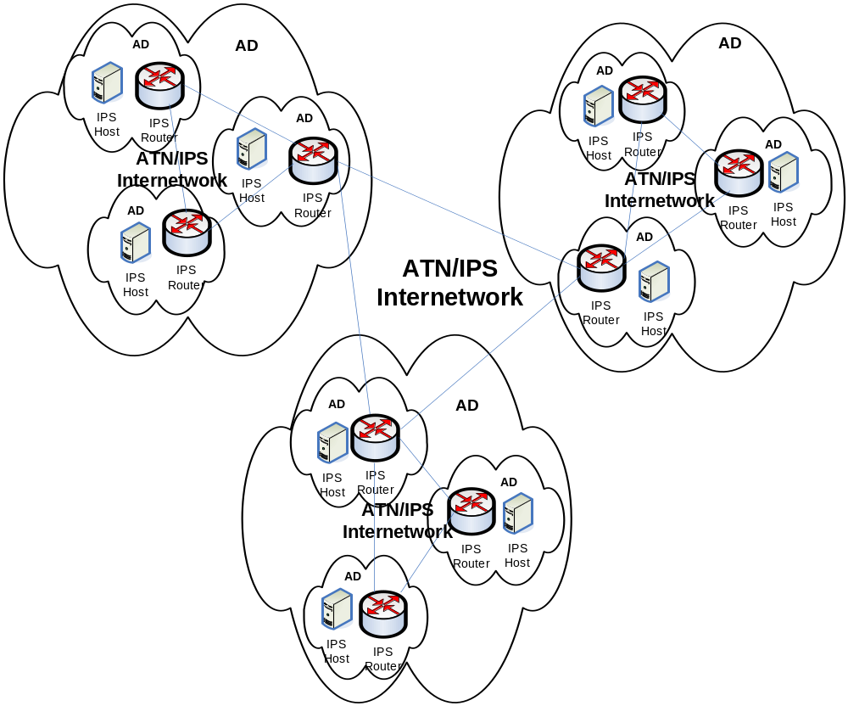

Figure 2.1-1 – The ATN/IPS Internetwork

An inter-domain routing protocol is used to exchange routing information among Autonomous Systems. An Autonomous System, as defined in RFC 1930, is a connected group of one or more IP prefixes run by one or more network operators which has a single and clearly defined routing policy. From this definition we see two distinct entities: one is the AS as a group of IP prefixes and the other is the network operators, i.e., the Administrative Domains. This distinction is meaningful in the Internet since it permits multiple organizations (i.e., Administrative Domains) to run BGP to an Internet Service Provider (ISP) which in turn connects each of these organizations to the Internet. This manual does not preclude using ISPs in this fashion; however, as noted above, requirements are levied directly on the Administrative Domains.

2.1.2 Coordination of Policies among Administrative Domains
IPS routers will exchange information about their internal network prefixes with their immediate neighbor routers but may also forward routing information about other network prefixes learned from other BGP neighbors. As a result, traffic between two Administrative Domains may be relayed by a number of intermediate Administrative Domains. Such traffic being carried on behalf of two others is termed transit traffic.

This manual does not specify which routes are to be advertised between IPS routers nor basic traffic management policies for a dynamically routed environment. Administrative Domains however are required to coordinate their policy for carrying transit traffic with peer Administrative Domains. Administrative Domains that participate in the ATN/IPS should ensure the proper handling of transit traffic on the following basis:

- An Administrative Domain should not advertise a network prefix if it is not prepared to accept incoming traffic to that network prefix destination;

- When establishing the interconnections between two Administrative domains a charging mechanism may be agreed to support implicit corresponding transit policy;

- Administrative Domains that relay transit traffic should ensure that the associated security and QoS policies of the traffic is maintained

2.1.3 ATN/IPS Internetworking with Mobility
The fixed or ground-ground ATN/IPS described in section 2.1.1 may be extended to support mobility, that is, it may be extended to support air-ground communications. This is accomplished through the use of Mobile IPv6, the IETFs general mobility solution. Mobile IPv6 permits mobile nodes (MN) (i.e., aircraft in the ATN/IPS) to communicate transparently with correspondent nodes (CN) (i.e., ground automation systems in the ATN/IPS) while moving within or across air-ground networks. An Administrative Domain in the ATN/IPS which offers Mobile IPv6 service is called a Mobility Service Provider (MSP). Thus the ATN/IPS is extended to support mobility through the addition of MSPs providing mobility service to mobile nodes. Figure 2.1-2 depicts the ATN/IPS with a Mobility Service Provider. As is shown in this figure in order to provide mobility service, the MSP must operate one or more home agents. The home agent provides a key role in that on one side it provides location management to keep track of the movement of a mobile node and to locate the mobile node for data delivery, while on the other side it operates as an inter-domain router providing connectivity to the rest of the ATN/IPS (Note that this is a logical view. Different physical configurations are possible in actual implementations.). It should be noted that Mobile IPv6 RFC 3775 is being updated by the IETF (RFC 3775bis). Implementation of RFC 3775 should take those updates into account.

Figure 2.1-2 shows the minimal configuration, e.g., for ATSC, where the MSP might be an ACSP. However, this is not the only possible configuration. An ANSP may choose to become its own MSP and obtain access service from an ACSP. To support AOC and AAC an Airline may likewise become an MSP. Similarly, an Airport Authority may decide to become a MSP and offer service to the ATN/IPS. In this case IP layer mobility service may be offered along with or in addition to link layer mobility. As noted in section 2.1.1, the ATN/IPS is intended to support ATSC, AAC, and AOC. However, the mobility approach may be used by other aviation organizations. These organizations may become MSPs and support other types of communications such as Airline Passenger Communications (APC). The enhanced forms of Mobile IP listed in section 5.2 may be offered to support all types of communications traffic.

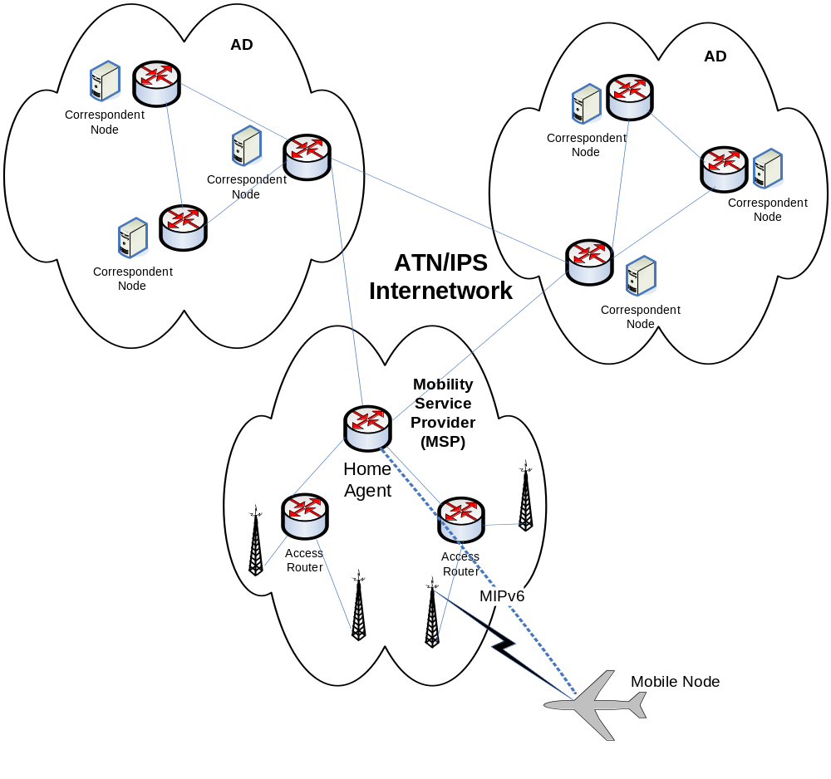

2.2 Network Transition Mechanisms

IPv6 has been adopted by the IETF and the internet authorities to cope with the ever increasing growth rate of the global internet. IPv6 solves many of the technical problems associated with IPv4, in particular the limited IPv4 address space.

The global implementation of IPv6 has already begun, and even within ICAO regions to support Air Traffic Management applications. It is the building block of the next generation internet which will enable a flexible means to roll-out new technologies and services. For this reason, the ATN/IPS is based on IPv6 to take immediate advantage of new commercial off-the-shelf products and technologies.

The implementation of the ATN/IPS will be gradual over a significant period of time. Many organizations will be required to go through multiple steps to ensure that ATN/IPS end-systems and routers are integrated into their existing environment in particular for those that have deployed legacy AFTN, AFTN/CIDIN, X.25, ATN/OSI CLNP (primarily CLNP over Ethernet or “X.25”) and IPv4 systems.

Three transitions mechanisms can assist organisations deploying the ATN IPS in a heterogeneous environment:
- Tunnelling: one protocol being encapsulated in another
- Dual stack: an environment in which multiple protocols operate simultaneously
- Translation: the conversion from one protocol to another

An in-depth description of the first two mechanisms can be found in RFC 4213 (Basic Transition Mechanisms for IPv6 Hosts and Routers). The applicability of above three mechanisms to the ATN/IPS are further described.

2.2.1 Tunnelling

IPv6 has been specified to operate over a variety of lower layer interfaces such as Frame Relay, ATM, HDLC, PPP and LAN technologies. Tunneling implies that a given protocol is encapsulated into another, meaning that IPv6 would be encapsulated into another functionally equivalent network protocol. With regard to the ATN/IPS, the key benefit of this mechanism would be for aeronautical organizations that already operate IPv4 networks to allow the ATN/IPS hosts and routers communicate between each other over such an underlying IPv4 network. Furthermore, if the interconnecting infrastructure between two ATN/IPS administrative domains is limited to IPv4, this mechanism can be applied.

It is recalled that IPv6 cannot operate over X.25; an IPv6 tunnel over IPv4 can be in turn tunneled over an X.25 network. A specific tunneling mechanism termed IP SNDCF is defined for ATN/OSI applications, it is to be noted that this enables interoperability between ATN/OSI applications over an IP network but does not enable interoperability with ATN/IPS applications.

Tunneling mechanisms lead to an increase of protocol overhead and the segregation of the two routed domains creates additional network management e.g. an IPv6 routed domain over an underlying IPv4 routed domain that needs to be managed in terms of QoS, security, and route optimization. In addition, this mechanism only foresees interoperability between ATN/IPS systems as it does not enable interoperability between ATN/OSI systems nor other IPv4 systems within the organization. Nevertheless, it may provide an effective way to enable the ATN/IPS within and between two administrative domains.

The tunneling mechanism is best suited to resolve lower layer communication issues between ATN/IPS IPv6 hosts and routers but does not provide interoperability with non-compliant ATN/IPS systems.

2.2.2 Dual Stack

The dual stack mechanism implies that an implementation handles more than one communications protocol for a given application or function. Within the internet domain a significant number of communication applications have been dual stacked e.g. HTTP, FTP, SSH, DNS, SMTP etc. by supporting both IPv4 and IPv6 protocols. However, in the context of the ATN/IPS the purpose of dual stacking is to resolve similar yet different issues.

The concept of dual stacking is ideally suited for systems that need to support ATN applications for both OSI and IPS. In such environments, the applications are designed in an abstract fashion to be independent of the lower layers, in other words they are unaware which lower layer communications protocol (OSI or IP) is being used to communicate with their peer. X.400 vendors have taken this approach to support both OSI and IP environments avoiding the need to develop complex ad-hoc lower layer communication gateways. Usually such implementations rely on some form of directory or lookup table associating a high-level address with a specific communications protocol address.

The concept of dual stack can be extended to multiple stack, e.g. IPv4, IPv6, X.25. ATN AMHS manufacturers usually support operation over multiple protocols such as OSI, TCP/IP and X.25.

The dual stack mechanism is best suited to provide the maximum level of interoperability with peers while reducing the complexity of lower layer communication protocol gateways and additional single points of failure. It is ideally suited for applications such as AMHS whereby some systems have already been implemented on the basis of OSI and others on TCP/IP. A dual stack approach can be a valid for air-ground data link ground systems to support CPDLC over multiple data link services such as ATN/OSI and ATN/IPS.

2.2.3 Translation

Translation mechanisms imply the conversion from one protocol to another. This mechanism can be interpreted as a lower layer communications gateway between two protocols that share a high degree of commonality. Several translators such as RFC 2766 - Network Address Translation - Protocol Translation (NAT-PT), have been developed in the context of the transition from IPv4 to IPv6 as both versions share a number of common features.
Within the overall transition from IPv4 to IPv6, it was envisaged that some systems may be only capable of communicating with IPv4 and others with IPv6. Considering global internet scalability issues and the fact that most internet applications and systems have become dual stacked, the need for translators has declined.
However, translators may play an important short-term role in the case of the ATN/IPS. For example, although existing AMHS systems operate on dual stack operating systems, none of them have upgraded their application code to make use of IPv6. In other words, RFC 1006 is supported but not RFC 2126. In such particular cases and in view of the limited number of systems, the deployment of translators provides a short-term measure for such systems to comply with the ATN/IPS and inter-work with RFC 2126 enabled systems.
IPv4/IPv6 translators increase the complexity of the IP infrastructure and its management. A dual stack approach is to be preferred but in specific cases translators may be the only short-term measure to provide compliance with the ATN/IPS.

2.2.4 Combining of the Mechanisms

As the ATN/IPS implementation will be gradual it is understandable that a combination of the above three mechanisms will be applied.
Specific combinations of the above mechanisms can be deployed to better fit within the environment of the administrative domain environment.

3.0 PROTOCOL Stack

3.1 Physical and Link Layer Guidance

Physical and link layer issues will be determined by the required service and member state connections. The physical and link layer issues will be on service need basis and should be contained in a memorandum of agreement (MOA).

3.2 Network Layer

The ATN/IPS makes use of IPv6, which uses 128 bit addresses versus 32 in IPv4. IPv6 prefixes are exchanged between Administrative Domains using static routes or BGP to ensure global ATN/IPS routing.

3.2.1 Address Plan
Unlike IPv4, there is no notion of private addresses within IPv6. Similar to existing practices for X.25, each Administrative Domain will require to develop an IPv6 addressing plan, refer to Part I, 2.3.3 Network Addressing. This will involve the receipt of a unique IPv6 prefix and assignment procedures to networks and hosts.

3.2.2 Application interface to the network layer

Although applications generally interface to the communication service at the transport layer, it is sometime necessary to transmit and receive datagrams at the network level. This is granted by some socket API extensions specified in: RFC 3542 - Advanced Sockets Application Program Interface (API) for IPv6.

3.2.3 Inter-domain routing

Inter-domain routing allows the exchange of IPv6 prefixes between Administrative Domains. These exchanges are supported by the configuration of static routing or the border gateway protocol (BGP) between ATN/IPS routers to ensure global ATN/IPS routing.

Depending on the scale of the Administrative Domain, further internal levels of inter- and intra-domain routing or BGP federations may exist.

3.2.3.1 AS numbering plan

AS numbers need to be assigned and configured in ATN/IPS routers to announce their autonomous systems within the routed domain. The AS numbering plan is presented in Part I, Appendix A.

3.2.3.2 ATN/IPS Router Ids

In order to establish BGP between two neighbours, each BGP peer must define a router id. If two routers make use of the same router-id value, BGP sessions cannot be established. As the router id is a 32 bit field, it is usually on the IPv4 address of the router.

As ATN/IPS routers may not have IPv4 interfaces or unique IPv4 addresses, a scheme needs to be recommended. Although global uniqueness of these values is not a pre-requisite, to ease implementation of the ATN/IPS the following scheme is recommended (based on draft-dupont-durand-idr-ipv6-bgp-routerid-01.txt):
- 4 bits set to one, 16 bits set to the AS number (the global AS number plan is in Part I, Appendix A)
- 12 bits manually allocated within the domain. (allows for 4096 different router IDs in each routing domain)

3.2.3.2.1 Routing Advertisement

ATN/IPS routers should advertise network prefixes based on consistent prefix lengths or aggregate route prefixes;

3.2.3.2.2 Traffic type segregation

BGP-4 does not natively allow setting up different set of routes for different traffic to the same destination. ATN/IPS requirement on traffic type segregation may be fulfilled by appropriate provisions in the ATN addressing plan: if the ATN address incorporates an indication of the traffic type, BGP-4 will transparently flood segregated route information for the various traffics.

3.2.3.2.3 Traffic Priority and Differentiated Service

Historically, network layer priority was selected explicitly by the sending application through the TOS field. Although Differentiated Service (RFC 2474) preserves the IP precedence semantic of the TOS field, this approach is now deprecated. This is partly because the IP precedence has been superseded by the Per-Hop-Behaviour (PHB) strategy of Differentiated service, but also because network administrators usually don’t trust application settings.

Differentiated Service (RFC 2474) provides a mean for specifying and implementing QOS handling consistently in the ATN/IPS network. This specification is made on a per node basis, specifying behaviour of individual nodes concerning QOS (Per Hop behaviour). The general framework / current practices is depicted in details in: RFC 2475 - Architecture for Differentiated Services.
Refer to the QoS section 4.

3.2.4 Multicast

The need to send the same information to multiple receivers is one of the main requirements of surveillance data distribution. This requirement can be supported by the Internet Protocol versions 4 and 6 (IPv4 and IPv6 respectively) multicast services. Other networking techniques that achieve the same multicast objective are not further considered within the scope of this document.

A limited number of ICAO Contracting States have deployed national IPv4 multicast services for surveillance data distribution. However, the limited range of the IPv4 multicast address space and the absence of gateways between IPv4 and IPv6 multicast inhibits a scalable deployment for the ATN/IPS.

In recent years, significant technical progress has been made in the field of IP multicast, namely source specific multicast (SSM). Contrary to existing deployments on the basis of PIM-SM (Protocol Independent Multicast—Sparse Mode), SSM provides added simplicity and resiliency to the routing of IP multicast traffic and is ideally suited for surveillance needs.

It’s use over IPv6 is recommended in a Eurocontrol guideline entitled “EUROCONTROL Guidelines for Implementation Support (EGIS) Part 5: Communication & Navigation Specifications, Chapter 12, Surveillance Distribution over IP Multicast Profile Requirement List (PRL)” available at http://www.eurocontrol.int/communications/public/standard_page/com_network.html.

A source specific multicast (SSM) data channel is defined by the combination of destination multicast address and source unicast address. This corresponds to a single surveillance data flow made available from a specific source in the ATN/IPS.
Figure 4.1 SSM Multicast IPv6 address with global scopeIPv6
| 8 | 4 | 4 | 8 | 8 | 64 | 32 |
+--------+----+----+--------+--------+----------------+----------+
|11111111|0011|1110|00000000|00000000| 000……………………000 | group ID |
+--------+----+----+--------+--------+----------------+----------+
- The IPv6 multicast group ID shall be in the range 0x8000000 to 0xFFFFFFFF allowed for dynamic assignment by a host, as specified in RFC 3307 section 4.3 and RFC 4607 section 1.
- The resulting available IPv6 SSM address range is FF3E::8000:0/97 (FF3E:0:0:0:0:0:8000:0 / 97).
- Assuming the appropriate access to the service, to receive a SSM (source specific multicast) stream one requires the following three parameters:
1. Source-address (unicast address)
2. Multicast address (as indicated by the source application)
3. Port (default is 8600 for ASTERIX surveillance data in Europe)

3.3 Transport Layer

The transport layer protocols are used to provide reliable or unreliable communication services over the ATN/IPS. There are two mandatory transport protocols, TCP and UDP. TCP is used to provide reliable transport services and UDP is used to provide best effort service. Other transport protocols may be used but can not affect ATN/IPS communications or services.

3.3.1 Transmission Control Protocol

The Internet Protocol (IP) works by exchanging groups of information called packets. Packets are short sequences of bytes consisting of a header and a body. The header describes the packet's routing information, which routers on the Internet use to pass the packet along in the right direction until it arrives at its final destination. The body contains the application information. TCP is optimized for accurate delivery rather than timely delivery, TCP sometimes incurs long delays while waiting for out-of-order messages or retransmissions of lost messages, and it is not particularly suitable for real-time applications like Voice over IP (VoIP). Real time applications will require protocols like the Real-time Transport Protocol (RTP) running over the User Datagram Protocol (UDP).
TCP is a reliable stream delivery service that guarantees to deliver a stream of data sent from one host to another without duplication or losing data. Since packet transfer is not reliable, a technique known as positive acknowledgment with retransmission is used to guarantee reliability of packet transfers. This fundamental technique requires the receiver to respond with an acknowledgment message as it receives the data. The sender keeps a record of each packet it sends, and waits for acknowledgment before sending the next packet. The sender also keeps a timer from when the packet was sent, and retransmits a packet if the timer expires. The timer is needed in case a packet becomes lost or corrupt.
In the event of congestion, the IP can discard packets, and, for efficiency reasons, two consecutive packets on the internet can take different routes to the destination. Then, the packets can arrive at the destination in the wrong order.
The TCP software library use the IP and provides a simpler interface to applications by hiding most of the underlying packet structures, rearranging out-of-order packets, minimizing network congestion, and re-transmitting discarded packets. Thus, TCP very significantly simplifies the task of writing network applications.
TCP provides a connection-oriented service with a reliable semantic. It operates above the network layer which does not necessarily detect and report all errors (e.g. corruption, misrouting). For this purpose, it provides:
- Error detection based on a checksum covering the transport header and payload as well as some vital network layer information.
- Recovery from error based on retransmission of erroneous or lost packets.
TCP is also designed to detect and manage end-to-end network congestion and maximum user data segment sizes. This is essential for operation over heterogeneous sub networks with some low bandwidth and high latency trunks, such as the actual ATN/IPS Air/Ground sub networks.

3.3.2 User Datagram Protocol (UDP)

UDP provides a connectionless service with limited error detection and no recovery, nor congestion management mechanisms. It is naturally dedicated for light data exchanges, where undetected occasional loss or corruption of packets is acceptable, and when simplicity of use is a goal.

3.3.3 Transport Layer Addressing

Transport layer addressing relies on port numbers (16 bits integer values) that are associated with source and destinations endpoints to identify separate data streams.
Ports are classified in three categories with associated range of values:
- Well-known ports are those from 0 through 1023 and are assigned by IANA. On most systems these ports can only be used by system (or root) processes or by programs executed by privileged users. Such pre-defined well-known port numbers associated to distinct TCP and/or UDP applications makes them visible (“well-known”) to client applications without specific knowledge or configuration.
- Registered ports are those from 1024 through 49151 and are registered by IANA following user request. Essentially such ports play the same role as well-known ports but for less critical or widespread applications. The use of such ports does not require specific privileges.
- Dynamic and/or private ports are those from 49152 through 65535. They may be used freely by applications.

Port assignment is obtained on request to IANA. An up-to-date image of the port registry is available at:
http://www.iana.org/assignments/port-numbers
This assignment plan is compulsory over the public Internet. It should be made applicable to ATN/IPS (at least concerning well-known ports) in order to avoid any conflict.

Furthermore, ATN/IPS hosts are required to supporting the following registered port numbers:
- tcp 102 for ATSMHS
- tcp 8500 for FMTP
- tcp/udp 5910 for CM
- tcp/udp 5911 for CPDLC
- tcp/udp 5912 for FIS
- tcp/udp 5913 for ADS

3.3.4 Application Interface to the Transport Layer

The application interface to the TCP and UDP transport layers is provided consistently on a wide range of platform/operating systems according to the specification made in: RFC 3493 - Basic Socket Interface Extensions for IPv6. This RFC extends the socket interface (originally developed by the Berkeley University for supporting IPv4 in their BSD Unix distribution) to IPv6.

3.3.5 Congestion Avoidance
In order to adapt to variables conditions for draining traffic in sub networks, TCP implements basically 4 mechanisms: slow-start, congestion-avoidance, fast-retransmit and fast-recovery. These are specified in: RFC 2581 - TCP Congestion Control. The two first mechanisms aim at preventing important loss of packets when congestion occurs, while the two others attempt to shorten the delay for retransmitting the lost packets. These mechanisms are implemented independently in every end system; they don’t completely avoid loss of packets.

In the case of low bandwidth sub networks (e.g. ATN Air/Ground sub networks), TCP applications may make use of the Explicit Congestion Notification mechanism will more likely provide a significant benefit. It is specified by: RFC 3168 - The Addition of Explicit Congestion Notification (ECN) to IP. This feature anticipates congestion, significantly reducing packet loss. However, it impacts the transport and network layers, and requires participation of a significant number of routers in the networks (preferentially, the routers at the edge of low speeds / high latency sub networks).

3.3.6 Error Detection and Recovery
TCP error detection relies on lack of timely received acknowledgement. Recovery is performed through retransmission of (supposed) lost packets. Loss of a large numbers of packets in a short period of time may heavily incur the TCP connection throughput (hence performance). This may become critical for high latency sub networks (e.g. ATN Air/Ground sub networks). Support of TCP selective acknowledge option may mitigate this problem by allowing selective retransmission of lost packets only (instead of the whole sequence from the first to the last packet lost). This option is specified in: RFC 2018 - TCP Selective Acknowledgment Options.

3.3.7 Performance Enhancing Proxies (PEPs)
Performance Enhancing Proxies (PEPs) are often employed to improve severely degraded TCP performance caused by different link characteristics in heterogeneous environments, e.g. in wireless or satellite environments that are common in aeronautical communications. Transport layer or application layer PEPs are applied to adapt the TCP parameters to the different link characteristics. RFC 3135 “Performance Enhancing Proxies Intended to Mitigate Link-Related Degradations” is a survey of PEP performance enhancement techniques, and describes some of the implications of using Performance Enhancing Proxies. Most implications of using PEPs result from the fact that the end-to-end semantics of connections are usually broken. In particular, PEPs disable the use of end-to-end IPsec encryption and have implications on mobility and handoff procedures.

3.3.8 Transport Layer usage
The way how transport layer connections are used has great impact on the quality of service experienced by the application. Application messages may have different Classes of Service (CoS) and may require to be delivered reliably and/or in correct order. Four options exist to use the TCP transport layer service:

- I. Re-/establishing of a TCP connections for each transmission and for each service
Each service instance uses a dedicated TCP connection. At the time where the application service data is generated, the transport layer connection is opened and the data transmitted. After successful transmission the connection is closed.

- II. Establishing a TCP connection once for each service and keeping it open
Each service uses a dedicated TCP connection. The connection is opened at the time of logon or first use and closed at time of log off or handover.

- III. Re-/establishing of a TCP connection for each transmission of a multiplexed set of services
A shared TCP connection is established for all services in the set (one application may host several services). Datagrams produced by these applications are transmitted over this shared connection. The connection is opened at time of service datagram generation and closed after successful transmission.

Note: All services of the multiplexed set should require the same CoS and be produced by the same application.

- IV. Establishing a TCP connection once for a multiplexed set of services and keeping it open.
A shared TCP connection is opened for all services in the set (one application may host several services). Datagrams produced by these applications are transmitted over this shared connection. The connection is opened at time of logon or first use and is closed at time of log off or handover.

Note: All applications of the multiplexed set should require the same CoS and be generated by the same application.

Multiplexing services generated by the same application but with different CoS requirements in option III and IV is not advised, as network layer QoS is performed per TCP connection. TCP has no means to provide differentiated QoS within one connection, so any CoS information would at least be partially lost. Multiplexing services generated by the same application and with the same CoS requirements does not create this problem.

It is recommended to use at least one dedicated transport connection for each service (options I, II). The connection may be established either per service or per application.

If different services of one application are multiplexed to a shared TCP connection, all services must require the same CoS (options III, IV).

For air-ground applications, it is recommended to open the connection at the time of first use and to keep it open until logoff or handover (II, IV).

3.4 Application Layer

3.4.1 ASN.1 extensions to CM
3.4.1.1 The ATN Context Management application requires ASN.1 adaptations to operate over the ATN/IPS.

Note .- It is expected that a future edition of Doc 9880 will contain these extensions.

3.4.2 CM ASN.1 Definition

In order to support the conveyance of address information specific to IPS, the CM application ASN.1 needs to be updated. While there are other possible methods of obtaining application addressing information, CM also provides additional information intended to facilitate correlation of aircraft information with flight plan information.

New definitions of ASN.1 were added with a goal to retain backwards compatibility with previous CM implementations. When exchanging application information, the OSI ATN CM used an AEQualifierVersionAddress element. This would be supplemented with an AEEnhancedQualifierVersionAddress element, with a specific new element of APEnhancedAddress. This is shown below:

AEEnhancedQualifierVersionAddress ::= SEQUENCE
{
aeQualifier AEQualifier,
apVersion VersionNumber,
apAddress APEnhancedAddress
}

The APEnhancedAddress element would allow the carriage of either a TSAP for OSI network usage or an IP address for IPS usage. The APEnhancedAddress is shown below:

APEnhancedAddress ::= CHOICE
{
longTsap [0] LongTsap,
shortTsap [1] ShortTsap,
ipAddress [2] IPAddress,
...
}

The IPAddress element is new, and is used to convey the actual IPv6 address. A specific IPv4 definition was not included in this definition. This was done to simplify definitions and to encourage IPv6 migration. If IPv4 addresses are required by some implementations, they can still be represented in IPv6 format using the common IPv4 mapping procedure, i.e. the first 80 bits set to zero, the next 16 set to 1, and the last 32 as the representation of the IPv4 address.

Also, an optional Port element is included. The intention was to allow the specification of a port for the IP address that pertains to a particular application. The port would not be needed if the implementation will use the standard IANA port numbers assigned to the IPS applications. The IPAddress element is shown below:

IPAddress ::= SEQUENCE
{
ipHostOrAddr IPHostOrAddress,
port Port OPTIONAL,
...
}

The IPHostOrAddress element provides further flexibility in that a hostname or an IPv6 address can be used. The hostname is further defined as an IA5 String of size between 2 and 255 characters, the port as an integer from 0 to 65536, and the IPv6 address as an octet string of size 16. These are shown below:

IPHostOrAddress ::= CHOICE
{
hostname [0] Hostname,
ipv6Address [1] IPv6Address,
…
}

IPv6Address ::= OCTET STRING(16)
Port ::= INTEGER(0..65536)
Hostname ::= IA5String(SIZE(2..255))

3.4.3 CM ASN.1 Usage

The usage of the IPv6 ASN.1 will be similar as for the OSI version. This means that when CM wants to provide address information for supported applications, it needs to identify the application, version number of the application, and address of the application for each of the applications that can be supported. This needs to be done regardless of the network technology being used.

For an ATN application running over the IPS, the IPv6 address will be used for the addressing of each supported application. Currently, no usage of hostname is defined, so only the IPv6Address element will be used in the IPHostOrAddress. The IPv6Address element will take the value of the IPv6 address of the application.

The port number will not need to be provided, since port numbers are already defined for the applications and therefore do not need to be conveyed end-to-end. Therefore the IPAddress element will only contain the IPHostOrAddress.

The APEnhancedAddress element will use the IPAddress choice, as the TSAP definitions have no relevance to the IPS. And finally, the AEQualifier and VersionNumber elements would need to be provided as part of the AEEnhancedQualifierVersionAddress. The AEQualifier and VersionNumber elements will be filled out in the same manner as for OSI applications, i.e. the AEQualifier would reference an integer, defined in Doc 9705 Sub-volume IX, from 0 to 255 that identifies the application (e.g. ADS is value “0”) and the VersionNumber would be an integer from 0 to 255 that identifies the version of the application.

Once exchanged, the application information would be made available to other systems or processes on the air and ground systems as necessary in order to allow operation of the applications. This is unchanged from OSI CM.

4.0 Quality of Service

4.1 Introduction
The IETF defined DiffServ Per Hop Behaviours (PHB) as a means to describe, classify and manage network traffic to support the provision of QoS on IP networks. The RFCs do not dictate how PHBs are implemented within a network and this is typically vendor dependent.

In practice, private and public IP network operators provide services based on a limited number PHBs:
- EF (Expedited Forwarding) – defined in RFC 3246, intended as a low loss, low delay, low jitter service. This would typically be used for voice applications.
- AF (Assured Forwarding) – defined in RFC 2597 and updated in RFC 3260. Assured forwarding allows the operator to provide assurance of delivery as long as the traffic does not exceed some subscribed rate. These classes would be used for delay sensitive data applications usually labelled AFx with a drop precedence. Typically each specific customer applications would be matched to a specific AF class and usually one AF class is associated to multimedia applications e.g. video. AF classes are independent of each other and benefit of individual guaranteed bandwidth. This prevents one critical application to take all the available bandwidth and block other critical applications.
- Default – A best effort class which would be used for non mission-critical, non-delay sensitive applications.

4.2 Class Definitions

4.2.1 Context

ATN/IPS communication service providers are likely to make use of the same IPS infrastructure for ATN and other non-ATN defined applications; for example, ATSMHS and surveillance data. Sharing of resources can be at different levels, ATN/IPS applications can use the same type of class of service as other non-ATN applications over the same IP routed infrastructure. Alternatively, ATN/IPS communication service providers may only wish to share the same physical infrastructure and operate a VPN per service; in this case a separate CoS model can be applied to each VPN service, one being the ATN/IPS. Fundamentally, ATN/IPS communication service providers have flexibility in how they enable CoS for the ATN/IPS over their infrastructure.

For CoS definitions, it is essential that ATN/IPS traffic is sufficiently qualified in order to properly mark ingress traffic. As the IP packet enters the network core, PHBs are enforced, depending on the packet marking. ATN/IPS communication service providers will need to handle un-marked or pre-marked ingress traffic and be prepared to mark or re-mark the traffic before it is routed over their infrastructure. The internal techniques, mechanisms and policies to enforce the PHB within the communications service provider networks are considered out of scope of the ATN/IPS.

4.2.2 ATN/IPS PHBs/CoS
The ATN/IPS is to support legacy ATN applications over the IPS. Currently, this intended support covers CM(DLIC), FIS(ATIS), CPDLC, ADS-C, ATSMHS. Indeed, DIR is only specified for ATN/OSI and it is foreseen that AIDC will be implemented through regional solutions.

As each ATN application is mapped to a given CoS, the dynamic support of different priorities per user message category is not considered.

Table 1 provides an example of an Administrative Domain that supports several applications and Classes of Service labelled Very High, High, Normal and Best Effort.

Priority/Application Mapping |  |  | Traffic Identification (Ingress)
Class  (CoS Type) | Drop Precedence | ATN  Priority | ATN  Application | TCP/UDP  Port | IP Address
Very High (EF) |  |  | Voice (VoIP) | RTP numbers 16384-32767 | -
High  (AF) | 1 | 0 | - | - | -
High  (AF) | 1 | 1 | - | - | -
High  (AF) | 1 | 2 | - | - | -
High  (AF) | 1 | 3 | ADS-C | TCP 5913  UDP 5913 | The source or destination address will be part of a reserved address space assigned to mobile service providers
High  (AF) | 1 | 3 | CPDLC | TCP 5911  UDP 5911
Normal  (AF) | 1 | 4 | AIDC | TCP 8500
Normal  (AF) | 1 | 4 | FIS(ATIS) | TCP 5912  UDP 5912 | The source or destination address will be part of a reserved address space assigned to mobile service providers
Normal  (AF) | 2 | 5 | METAR | - | -
Normal  (AF) | 3 | 6 | CM(DLIC) | TCP 5910  UDP 5910 | The source or destination address will be part of a reserved address space assigned to mobile service providers
Normal  (AF) | 3 | 6 | ATSMHS | TCP 102
Normal  (AF) | 3 | 7
Best Effort  (Default) |  | 8 - 14 | - | -
Table 15 - ATN/IPS Priority mapping to Classes

In order to mark ingress traffic, the ATN/IPS provider has several means to identify the traffic: destination transport port number, IP source address, IP destination address.

Note- Making use of the DSCP/ToS value set by the application or prior communication service provider may not be the optimum approach as the value may be incorrectly configured or unknown.

4.2.3 DiffServ Code Point (DSCP) Values
The Per-Hop Behavior (PHB) is indicated by encoding a 6-bit value—called the Differentiated Services Code Point (DSCP)—into the 8-bit Differentiated Services (DS) field of the IP packet header. The DSCP value of the field is treated as a table index to select a particular packet handling mechanism. This mapping must be configurable and Administrative Domains may choose different values when mapping codepoints to PHBs. However, it is widely accepted that DSCP value 101110 refers to EF (Expedited Forwarding).

Table 2 provides an example of mapping DSCP values to ATN/IPS PHBs where a number of applications share the same IP network infrastructure. In this table, air ground applications have been assigned with the special Class Selector codepoints for as specified in Document 9880 for the ATN IP SNDCF but within the ATN/IPS it would be better to make use of AF PHBs to avoid any interaction with legacy applications that make use of IP precedence.
Table 2 – Example of DSCP to PHB mapping
DSCP Value | PHB | Application
000000 | CS0 | Best effort
001000 | CS1
001010 | AF11 | AIDC
001100 | AF12
001110 | AF13
010000 | CS2 | CM
010010 | AF21 | ATSMHS
010100 | AF22
010110 | AF23
011000 | CS3 | FIS
011010 | AF31 | Voice Recording
011100 | AF32
011110 | AF33
100000 | CS4 | CPDLC, ADS-C
100010 | AF41 | Voice Signalling
100100 | AF42
100110 | AF43
101000 | CS5
101110 | EF | Voice
110000 | NC1/CS6
111000 | NC2/CS7

4.2.4 Traffic Characterisation
Traffic characterisation is a means to express the type of traffic patterns, integrity and delay requirements. It provides further information to the communication service provider in order to fully meet the user requirements within a specific network operation. Typically, traffic characterisation information is part of the contracted service level agreement in which further parameters are defined such as service delivery points, service resilience, required bursting in excess of committed bandwidth, service metric points, MTTR, port speeds.

The below table 3 provides an example of traffic characterisation for ground-ground services are derived from the Pan-European Network Services (PENS) specifications.

ATN  Application | Average  Message  Lenght | Expressed  Integrity | Jitter | Typical  Bandwidth  (point-to-point) | Network Delay  (1-way)
Voice (VoIP using G.729) | 70  (bytes) | - | <15ms | 12kbps | <100ms
OLDI/FMTP (Regional AIDC) | 150 (bytes) | 1 user corrupt message in 2000 | N/A | 10kbps | <1s
ATSMHS | 3 kbytes | 10⁻⁶ (in terms of 1000bytes message blocks) | N/A | 20kbps | <5s
Table 3 – Example of Traffic Characterisation

5.0 MOBILITY GUIDANCE

5.1 MOBILE IPv6

This manual specifies that the IP mobility solution for the ATN/IPS is Mobile IPv6 (MIPv6) as specified in RFC 3775 with optional extensions listed in section 5.2. With Mobile IP a mobile node (MN) has two addresses: a home address (HoA), which is a permanent address, and a dynamic care-of address (CoA), which changes as the mobile node changes its point of attachment (See figure 5.1-1). The fundamental technique of Mobile IP is forwarding. A correspondent node (CN), which is any peer node with which a mobile node is communicating, sends packets to the home agent (HA) of the mobile node. The CN reaches the HA through normal IP routing. Upon receipt of a packet from the CN, the HA will forward these packets to the MN at its current CoA. The HA simply tunnels the original packet in another packet with its own source address and a destination address of the current CoA. This is possible because of the Mobile IP protocol whereby the MN sends “binding update” messages to the HA whenever its point of attachment changes. The binding update associates the mobile nodes HoA with its current CoA. The HA maintains a Binding Cash that stores the current CoA of the MN.

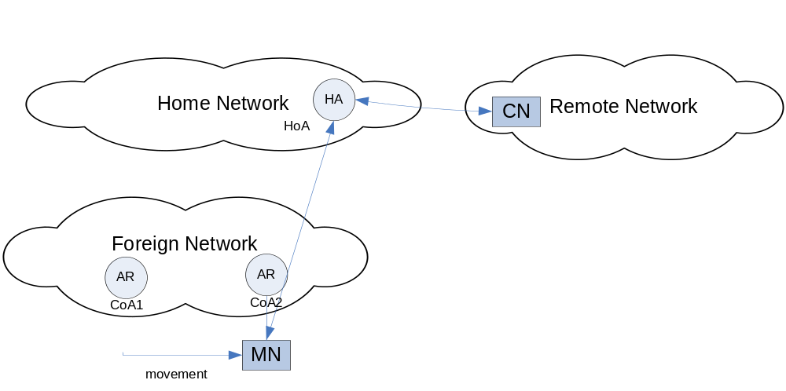
Figure 5.1-1: Mobile IP

5.1.1 MIPv6 Bidirectional Tunneling
In the reverse direction, the MN could simply send packets directly to the CN using normal IP routing. However, this results in triangular routing and depending on the relative location of the HA, there can be a situation where the path in one direction (e.g. CN to HA to MN) is significantly longer than the path in the reverse direction (e.g., MN to CN). A further consideration in this case occurs if the MN uses its home address as a source address. The problem here is that many networks perform ingress filtering of incoming packets and will not accept packets that are topologically incorrect. This would be the case with packets from the MN because they actually originate from the care-of-address but the source address in the IP packet is the home address. Because of these issues, MIPv6 allows the MN to follow the same path back to the CN via the HA using bidirectional tunneling whereby in addition to the HA tunneling packets to the MN, the MN reverse tunnels packets to the HA. The HA will decapsulate a tunneled IP packet and forward it to the CN. With bidirectional tunneling the CN is not required to support Mobile IP.

5.1.2 MIPv6 Route Optimization
Bidirectional tunneling solves the problems of triangular routing and ingress filtering; however, there still can be suboptimal routing since the path from the MN to the CN via the HA may be relatively long even when the MN and CN are in close proximity. With MIPv6 the situation where the path through the HA is longer than a direct path to the CN may be addressed using a technique called route optimization. With route optimization the MN sends binding updates to both the HA and the CN. In this case the MN and CN can communicate directly and adapt to changes in the MN’s CoA. RFC 3775 defines the procedures for route optimization. It requires that the MN initiate the return routability procedure. This procedure provides the CN with some reasonable assurance that the MN is addressable at its claimed care-of address and its home address.

It is generally acknowledged that there are drawbacks to route optimization. RFC 4651 presents a taxonomy and analysis of enhancements to MIPv6 route optimization. This document notes that the two reachability tests of the return routability procedure can lead to a handoff delay unacceptable for many real-time or interactive applications, that the security and that the return-routability procedure guarantees might not be sufficient for security-sensitive applications, and periodically refreshing a registration at a correspondent node implies a hidden signaling overhead. Because of the overhead and delay associated with the return routability procedure and because at least for ATSC it is expected that the CN and HN will be in relative close proximity, this manual requires that IPS CNs that implement Mobile IPv6 route optimization allow route optimization to be administratively enabled or disabled with the default being disabled. New solutions to route optimization are expected as a result of IETF chartered work in the Mobility Extensions for IPv6 (MEXT) working group which includes aviation-specific requirements.

5.2 Enhancements to MIPv6

When a mobile node (MN) changes its point of attachment to the network, the changes may cause delay, packet loss, and generally result in overhead traffic on the network.

5.2.1 Heirarchical Mobile IPv6 (HMIPv6)
One technology developed to address these issues is “Heirarchical Mobile IPv6 (HMIPv6)” [RFC 4140]. RFC 4140 introduces extensions to Mobile IPv6 and IPv6 Neighbor Discovery to allow for local mobility handling. HMIPv6 reduces the amount of signaling between a MN, its CNs, and its HA. HMIPv6 introduces the concept of the Mobility Anchor Point (MAP). A MAP is essentially a local home agent for a mobile node. A mobile node entering a MAP domain (i.e., a visited access network) will receive Router Advertisements containing information about one or more local MAPs. The MN can bind its current location, i.e., its On-link Care-of Address (LCoA), with an address on the MAP's subnet, called a Regional Care-of Address (RCoA). Acting as a local HA, the MAP will receive all packets on behalf of the mobile node it is serving and will encapsulate and forward them directly to the mobile node's current address. If the mobile node changes its current address within a local MAP domain (LCoA), it only needs to register the new address with the MAP. The RCoA does not change as long as the MN moves within a MAP domain. RFC 4140 notes that the use of the MAP does not assume that a permanent HA is present, that is, a MN need not have a permanent HoA or HA in order to be HMIPv6-aware or use the features of HMIPv6. HMIPv6-aware mobile nodes can use their RCoA as the source address without using a Home Address option. In this way, the RCoA can be used as an identifier address for upper layers. Using this feature, the mobile node will be seen by the correspondent node as a fixed node while moving within a MAP domain. This usage of the RCoA does not have the cost of Mobile IPv6 (i.e., no bindings or home address options are sent back to the HA), but still provides local mobility management to the mobile nodes with near-optimal routing. Although such use of RCoA does not provide global mobility.

5.2.2 Fast Handovers for Mobile IPv6 (FMIPv6)
A further enhancement to MIPv6 is “Fast Handovers for Mobile IPv6 (FMIPv6)” [RFC 4068]. FMIPv6 attempts to reduce the chance of packet loss through low latency handoffs. FMIPv6 attempts to optimize handovers by obtaining information for a new access router before disconnecting from the previous access router. Access routers request information from other access routers to acquire neighborhood information that will facilitate handover. Once the new access router is selected a tunnel is established between the old and new router. The previous Care-of Address (pCoA) is bound to a new Care-of Address (nCoA) so that data may be tunneled from the previous Access Router to the new Access Router during handover. Combining HMIPv6 and FMIPv6 would contribute to improved MIPv6 performance but this comes at the cost of increased complexity.

5.2.3 Proxy Mobile IPv6 (PMIPv6)
In MIPv6 as described above the MN updates the HA with binding updates messages. This mode of operation is called node-based mobility management. A complimentary approach is for access network service providers to provide network-based mobility management using Proxy Mobile IPv6 (PMIPv6) on access links that support or emulate a point-to-point delivery. This approach to supporting mobility does not require the mobile node to be involved in the exchange of signaling messages between itself and the home agent to potentially optimize the access network service provision. A proxy mobility agent in the network performs the signaling with the home agent and does the mobility management on behalf of the mobile node attached to the network. The core functional entities for PMIPv6 are the Local Mobility Anchor (LMA) and the Mobile Access Gateway (MAG). The local mobility anchor is responsible for maintaining the mobile node's reachability state and is the topological anchor point for the mobile node's home network prefix(es). The mobile access gateway is the entity that performs the mobility management on behalf of a mobile node and it resides on the access link where the mobile node is anchored. The mobile access gateway is responsible for detecting the mobile node's movements to and from the access link and for initiating binding registrations to the mobile node's local mobility anchor. An access network which supports network-based mobility would be agnostic to the capability in the IPv6 stack of the nodes which it serves. IP mobility for nodes which have mobile IP client functionality in the IPv6 stack as well as those nodes which do not, would be supported by enabling Proxy Mobile IPv6 protocol functionality in the network. The advantages of PMIPv6 are reuse of home agent functionality and the messages/format used in mobility signaling and common home agent would serve as the mobility agent for all types of IPv6 nodes. PMIPv6 like HMIPv6 is a local mobility management approach which further reduces the air-ground signaling overhead.

5.2.4 Network Mobility (NEMO)
Mobile IPv6 supports movement of an individual network node. However, there are scenarios in which it would be necessary to support movement of an entire network in the ATN/IPS. One case is for APC where is would be wasteful of bandwidth to have mobility signaling for every individual passenger. Another case may when there is a common airborne router supporting multiple traffic types provided proper security issues can be addressed. The extension to Mobile IPv6 which supports these scenarios is called Network Mobility (NEMO). This manual lists NEMO in accordance with RFC 3963 as an option for implementation. The NEMO operational model introduces a new entity called a Mobile Network Node (MNN) which is any node in the network that moves as a unit. It can be a host moving with other MNNs or a Mobile Router. The Mobile Router operates like any Mobile IP host on the egress interface (to a fixed access router). The Mobile Router also negotiates a prefix list with the home agent. The home agent uses this list to forward packets arriving for the MNNs that share the common prefix to the Mobile Router. On the ingress interface (to the mobile network) the Mobile Router advertises will advertise one or more prefixes to the MNNs. Although on the surface NEMO appears to be a straight-forward extension to Mobile IP there are several considerations that are still being investigated in IETF working groups. These issues include how to do NEMO route optimization and several considerations with prefix delegation and management.

One possible implementation of NEMO mimics Proxy Mobile IPv6 in that it is the network access points that implement the mobility support. When a mobile node attaches to the access link, the ground access point will set up a virtual Mobile Router that registers the relevant network prefixes with the Home Agent. All traffic received by this virtual Mobile Router for the registered mobile network prefixes will be forwarded across the air-ground link to the connected mobile node. The mobile node need not support any Mobile IPv6 or Network Mobility signalling and can also auto-configure the IPv6 address if the virtual Mobile Router sends Router Advertisements for the mobile network prefixes across the air-ground link. When the mobile node connects to another ground access point, the virtual router is moved by the ground access network to the new access point with updates to the Home Agent as if the router was physically present on the mobile node.

This implementation model allows for mobile nodes with IPv6 stacks that are agnostic of the fact that they reside on a mobile link and also reduces the protocol overhead for each message that is sent across the air-ground link.

6.0 SECURITY GUIDANCE

This section of the Manual for the ATN using IPS Standards and Protocols contains a description of the rational for the requirements in section 2.5 of Part I of the manual with background information when additional clarification is warranted and general guidance for implementation of security.

6.1 Requirments for Implementation

This ATN/IPS Manual contains certain security provisions that are required to implement. The requirement to implement security is intended to be consistent with the Security Architecture for IPv6, which requires that all IPv6 implementations comply with the requirements of RFC 4301. Although all ATN/IPS nodes are required to implement Internet Protocol security (IPsec) and the Internet Key Exchange (IKEv2) protocol, the actual use of these provisions is to be based on a system threat and vulnerability analysis.

6.2 Ground-Ground Security

6.2.1 Ground-Ground IPsec
The baseline for ground-ground security is to require network layer security in the ATN/IPS internetwork implemented using IPsec. IPsec creates a boundary between unprotected and protected interfaces. IPsec is typically used to form a Virtual Private Network (VPN) among gateways (NIST 800-77). A gateway may be a router or another security device such as a firewall. In this context other security devices are considered to be ATN/IPS nodes. The gateway-to-gateway model protects communications among ATN/IPS networks between regions or between states or organizations in a particular region. IPsec may also be used in a host-to-gateway environment, typically to allow hosts on an unsecure network to gain access to protected resources. IPsec may also be used in a host-to-host environment where end-to-end protection of applications is provided.

To achieve interoperability across the ATN/IPS internetwork, this manual specifies support for the IPsec security architecture, the Encapsulating Security Payload (ESP) protocol and a common set of cryptographic algorithms. The architecture is as specified in RFC 4301. ESP is as specified in RFC 4303 and the cryptographic algorithms which may be used are specified in RFC 4835. This ATN/IPS manual further specifies that ESP encryption is optional but authentication is always performed.

This manual specifies that ATN/IPS nodes in the ground-ground environment may implement the IP Authentication Header (AH) protocol as specified in RFC-4302. This is in recognition that while AH may exist in certain products, it’s use in IPsec has been downgraded. RFC 4301 states, “Support for AH has been downgraded to MAY because experience has shown that there are very few contexts in which ESP cannot provide the requisite security services. Note that ESP can be used to provide only integrity, without confidentiality, making it comparable to AH in most contexts”.

6.2.2 Ground-Ground IKEv2
The IPsec architecture [RFC 4301] specifies support for both manual and automated key management. As the ATN/IPS evolves use of manual key management will not scale well. Therefore this manual specifies that nodes in the ground-ground environment shall implement the Internet Key Exchange (IKEv2) Protocol as specified in RFC 4306 for automated key management. IKEv2 is the latest version of this protocol. The IKEv2 specification is less complicated than the first version of the protocol which should contribute to better interoperability among different implementations.

As is the case for ESP, the IKEv2 protocol requires a set of mandatory-to-implement algorithms for interoperability. This manual requires that nodes in the ground-ground environment implement the Cryptographic Algorithms specified in RFC 4307.

6.2.3 Alternatives to IPsec/IKEv2 for Ground-Ground Security
Alternatives to network security may be appropriate in certain operating environments. Alternatives to IPsec may be applied at the Data Link, Transport, or Applicaiton Layer. NIST SP 800-77 describes the main alternatives, characterizes the alternatives in terms or strengths and weaknesses, and identifies potential cases where they may be used as alternatives to IPsec.

6.3 Air-Ground Security

6.3.1 Air-Ground IPsec
Similar to the ground-ground environment, to achieve interoperability in the air-ground environment this manual specifies that ATN/IPS nodes support the IPsec security architecture and the Encapsulating Security Payload (ESP) protocol. As in the ground case, the architecture is as specified in RFC 4301 and ESP is as specified in RFC 4835. However rather than implement all of the the cryptographic algorithms which are identified in RFC 4835, specific default algorithms are identified for authentication and for encryption and authentication together. This is in consideration of bandwidth-limited air-ground links and so as not to have unused code in the avionics platform.

The authentication algorithm selected for use when confidentiality is not also selected is AUTH_HMAC_SHA2_256-128 as specified in RFC 4868. This algorithm uses a 256-bit key to compute a HMAC tag using the SHA-256 hash function. The tag is truncated to 128 bits. The same algorithm is used for integrity in IKEv2 as described below.

If ESP encryption is used, this manual specifies that the Advanced Encryption Standard (AES) be used in Galois/Counter Mode (GCM). AES-GCM is used with an 8 octet Integrity Check Value (ICV) and with a key length attribute of 128 as specified in RFC 4106. AES-GCM is a “combined mode” algorithm which offers both confidentiality and authentication in a single operation. Combined mode algorithms offer efficiency gains when compared with sequentially applying encryption and then authentication. When AES-GCM is used the ICV consists solely of the AES-GCM Authentication Tag and a separate HMAC tag is not applied.

6.3.2 Air-Ground IKEv2
Because manual key management is not practical in the air-ground environment, this manual requires that ATN/IPS nodes implement the Internet Key Exchange (IKEv2) Protocol as specified in RFC 4306. As is the case of ESP in consideration of bandwidth limitations and so that there will not be unused code in the avionics platform, this manual specifies a set of default algorithms for use in IKEv2. The selection of transforms is intended to be compatible with the selections of the ATA DSWG and AEEC DSEC working groups to the extent possible; however, this manual only uses transforms that have been registered with IANA. Five transforms are used by IKEv2.

- There is a pseudo-random function (PRF) which is used in IKEv2 for generation of keying material and for authentication of the IKE security association. This manual requires the use of PRF_HMAC_SHA_256 as specified in RFC 4868 as the PRF.

- IKEv2 uses the Diffie-Hellman key exchange protocol to derive a shared secret value used by the communicating peers. The Diffie-Hellman calculation involves computing a discrete logarithm using either finite field or elliptic curve arithmetic. When elliptic curve cryptography is used, the conventional choices are to use either prime characteristic or binary curves. This manual selects a prime characteristic curve and requires the use of the 233-bit random ECP group as specified in RFC 4753.

- When public key certificates are used in IKEv2 for entity authentication certain data must be signed in the IKEv2 exchange. This manual requires that signing be performed using the Elliptic Curve Digital Signature Algorithm (ECDSA) using SHA-256 as the hash algorithm on the 256-bit prime characteristic curve as specified in RFC 4754.

- The authentication exchange of IKEv2 has a payload that is encrypted and integrity protected. This manual specifies that AES CBC with 128-bit keys as specified in RFC 3602 be used as the IKEv2 encryption transform.

- This manual specifies that the encrypted payload be integrity protected using HMAC-SHA-256-128 as specified in RFC 4868.

The above suite of algorithms together with the use of AES-GCM for ESP encryption is the “Suite-B-GCM-128” set specified in RFC 4869. This suite is expected to be available as a Commercial-Off-The-Shelf implementation and should provide adequate cryptographic strength beyond 2030. See NIST SP 800-57 for additional guidance on cryptographic algorithm and key size selection.

The use of IKEv2, while offering the advantage of COTS availability and flexibility in signaling algorithms, authentication mechanisms, and other parameters, will result in more overhead than might otherwise be incurred in a custom aviation-specific solution. IKEv2 requires at least 4 messages to be exchanged to establish a session key for air-ground communications. In addition, the encryption algorithms in IKEv2 and ESP result in message expansion. While this expansion may be negligible for large messages, it will represent a more significant percentage for small messages. While this is a significant consideration for bandwidth-constrained data links, it is expected to be less of an issue when there is a high-speed data link approved for safety services.

6.3.3 Securing Air-Ground End-to-End Communications
Figure 6.3.3-1 depicts the options for securing end-to-end communications in the ATN/IPS air-ground environment. IKEv2 and ESP of IPsec are required to be implemented. This manual also defines options for TLS and for IKEv2 with Application-level security. In all cases this manual defines a default set of cryptographic algorithms.

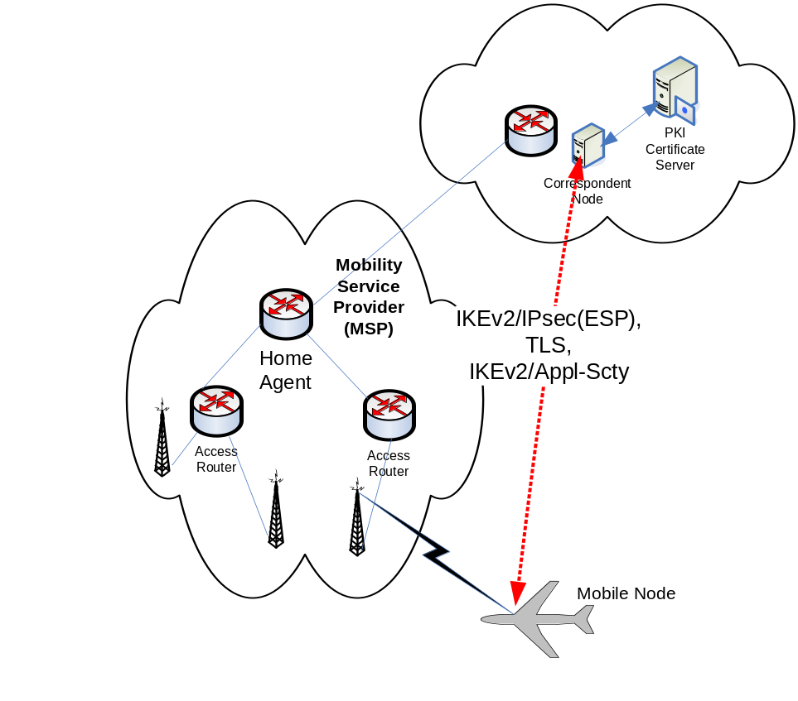

Figure 6.3.3-1 – Options for Air-Ground End-to-End Security

6.3.3.1 Air-Ground End-to-End Network Layer Security

As described in sections 6.3.1 and 6.3.2, for air-ground end-to-end network layer security this manual requires that ESP be implemented along with IKEv2 for key establishment. Figure 6.3.3-1 depicts the CN interfacing to a PKI Certificate Server. The interface method is considered a local matter. This may be an LDAP interface to a database of X.509 Certificates and Certificate Revocation Lists (CRLs) or another certificate management protocol. As noted above a “Suite-B” set of algorithms as specified in RFC 4869 is being used for ESP and IKEv2. The US National Security Agency Suite B Certificate and CRL Profile identifies the Certificate Management Messages over CMS protocol as specified in RFC 2797 as the preferred protocol. The actual authentication method used in an Administrative Domain is a local matter and will depend on the application. IKEv2 permits pre-shared keys or Digital Certificates to be used with Digital Certificates considered to be a stronger method. It would be possible to use pre-shared keys in the downlink direction and to use Digital Certificates in the uplink direction. Since there is no practical way for the MN to independently check a CRL, short-lived certificates could be used in the uplink direction. In the downlink direction if Digital Certificates are used it is recommended that rather than the MN sending an actual certificate, the MN should use the IKEv2 “Hash and URL” method. With method the MN sends the URL of a PKI certificate server where the CN can retrieve its certificate. Section 6.3.5 contains more guidance on PKI profiles and certificate policy. This section has described using certificates for authentication when strong authentication is required. This is the preferred approach in the end-to-end environment even though it would be possible to use IKEv2 and the Extensible Authentication Protocol (ESP) with an authentication, authorization, and accounting (AAA) infrastructure as will be described for access networks and mobility service providers. It is expected that PKI bridge concept being developed by the Air Transport Association (ATA) Digital Security Working Group (DSWG) will facilitate operating a PKI on a global basis. Under the PKI Bridge each Administrative Domain may certify to a central bridge rather than each Administrative Domain cross-certifying with every other Administrative Domain.

6.3.3.2 Air-Ground End-to-End Transport Layer Security

This manual permits ATN/IPS mobile nodes and correspondent nodes to implement the Transport Layer Security (TLS) protocol as specified in RFC 5246. This will permit applications that already use TLS to operate in the ATN/IPS air-ground environment. If TLS is used, then the following cipher suite as defined in RFC 4492 is required:

TLS_ECDH_ECDSA_WITH_AES_128_CBC_SHA

This cipher suite is for:

- The Transport Layer Security (TLS) protocol. Version 1.0 or 1.1 may be used

- Elliptic Curve Diffie Hellman (ECDH) key agreement

- Elliptic Curve Digital Signature Algorithm (ECDSA) for client authentication

- The Advanced Encryption Standard (AES) with 128 block size in Cipher Block Chaining (CBC) mode for confidentiality

- The Secure Hash Algorithm (SHA) version 1 for integrity (i.e., for HMAC)

This cipher suite is selected because it has algorithms in common with those identified for air-ground IPsec and IKEv2. Note that this cipher suite a required implementation for servers and one of the suites that clients may implement to be compliant with RFC 4492.

6.3.3.3 Air-Ground End-to-End Application Layer Security

This manual permits ATN/IPS mobile nodes and correspondent nodes to implement application layer security at the IPS Dialogue Service Boundary. This alternative is intended to be for legacy ATN applications which may already implement application layer security in the ATN/OSI environment. In this case mobile nodes and correspondent nodes shall append an HMAC-SHA-256 keyed message authentication code to application messages. HMAC-SHA-256 is already required for ESP and IKEv2 so there is essentially no additional cryptography for this option. The HMAC tag truncated to 32 bits is computed over the User Data concatenated with a send sequence number for replay protection. Since IKEv2 is required in any case, if application layer security is used for air-ground security, IKEv2 is again used for key establishment.

6.3.4 Securing Access Network and Mobile IP Signaling
Figure 6.3.4-1 depicts options for securing Access Service Provider (ASP) or Mobility Service Provider (MSP) signaling. The distinction between an ASP and MSP has become useful in IETF working groups examining the use of AAA back end infrastructures for mobility security. According to RFC 4640 an ASP is a network operator that provides direct IP packet forwarding to and from the end host. An MSP is a service provider that provides Mobile IPv6 service. In the figure the AAA-NA service is used for network access and the AAA-MIP server is used for access to Mobile IP service.

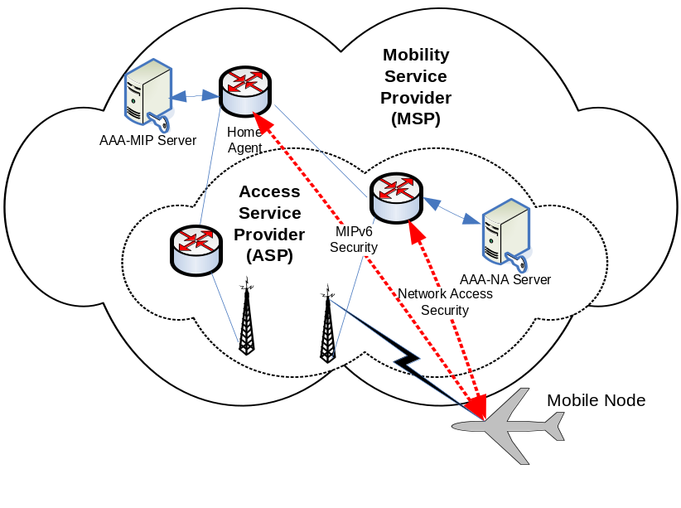
Figure 6.3.4-1 – ASP or MSP Security

6.3.4.1 Securing Mobile IP Signaling

Consistent with RFC 3775 this manual requires that IPsec be used specifically for protection of Mobile IP signaling in conformance to RFC 4877. RFC 4877 is an update to RFC 3776 and describes how IKEv2 is to be used for automated key management. RFC 4877 in particular describes how IKEv2 with EAP as the authentication method may be used. When extensible authentication is used in IKEv2 there is an additional exchange after the IKE_SA_INIT and IKE_SA_AUTH exchanges. In this case the MN will not include an authentication payload in the IKE_SA_AUTH exchange but rather will include an EAP payload in the next message. The HA then interacts with the AAA-MIP server to complete the authentication exchange and if successful completes the IKEv2 exchange.

6.3.4.2 Air-Ground Access Network Security

This ATN/IPS Manual requires that mobile nodes implement the security provisions of the access network. The security provisions of an access network are those associated with access control to the network itself and are typically implemented using an AAA infrastructure.

The IETF mobility working groups and other standards development organizations have recognized that although Mobile IPv6 and Proxy Mobile IPv6 were originally designed without integration with an AAA infrastructure, it may be more efficient to authenticate users using credentials stored at the AAA server. Furthermore, use of an AAA infrastructure may facilitate other bootstrapping functions such as dynamic configuration of other parameters such as the home address and home agent address in order to accomplish mobility registration. EAP between the MN and Authenticator may operate over the access network link level protocol or in conjunction with IKEv2 as described for securing Mobile IP signaling. EAP between the Authenticator and AAA server operates over RADIUS [RFC 2865] or DIAMETER [RFC 3588].

6.3.5 Public Key Infrastructure Profile and Certificate Policy
This manual requires that ATN/IPS nodes use the Internet X.509 Public Key Infrastructure Certificate and Certificate Revocation List (CRL) Profile as specified in RFC 5280 and the Internet X.509 Public Key Infrastructure Certificate Policy and Certificate Practices Framework as specified in RFC 3647. This manual notes that the Air Transport Association (ATA) Digital Security Working Group (DSWG) has developed a Certificate Policy (ATA Specification 42) for use in the Aviation community. ATA Specification 42 includes certificate and CRL profiles that are suitable for aeronautical applications. These profiles provide greater specificity than, but do not conflict with, RFC 5280. The ATA Specification 42 profiles are interoperable with an aerospace industry PKI bridge. Interoperability with an operational aerospace and defense PKI bridge will provide the opportunity to leverage existing infrastructure rather than develop an infrastructure unique to the ATN/IPS and will more readily achieve interoperability and policy uniformity in a multi-national, multi-organizational aerospace and defense environment.

6.3.6 General Guidance for Implementation of Security
Many government agencies have developed additional guidance and profiles for implementing security. In the US the NIST 800 series of recommendations is an example of general security implementation guidance covering a broad range of topics.
In the IETF there have been many Internet Drafts dealing with security. Two informational RFCs of particular interest are RFC 4942 AND RFC 4864. RFC 4942 gives an overview of security issues associated with IPv6. The issues are grouped into three general categories: issues due to the IPv6 protocol itself; issues due to transition mechanisms; and issues due to IPv6 deployment. RFC 4864 notes that Network Address Translation (NAT) is not required in IPv6 and describes how Local Network Protection (LNP) mechanisms can provide the security benefits associated with NAT. In particular, RFC 4864 describes how the IPv6 tools for Privacy Addresses, Unique Local Addresses, DHCPv6 Prefix Delegation, and Untraceable IPv6 Addresses may be used to provide the perceived security benefits of NAT including the following: Gateway between the Internet and an Internal Network; Simple Security (derived from stateful packet inspection); User/Application Tracking; Privacy and Topology Hiding; Independent Control of Addressing in a Private Network; Global Address Pool Conservation; and Multihoming and Renumbering. RFC 4864 describes the addition benefits of native IPv6 and universal unique addressing including the following: Universal Any-to-Any Connectivity, Auto-Configuration, Native Multicast Services, Increased Security Protection, Mobility and Merging Networks.

7.0 Voice over Internet Protocol (VoIP)

7.1 EUROCAE SPECIFICATION

EUROCAE published a series of documents which define the Voice over Internet Protocol specification as related to the foreseen implementation of VoIP ATM services in Europe.
These documents are numbered ED 136, ED 137A, ED 138 and consist of:

•ED-136 - VoIP ATM System Operational and Technical Requirements, edition February 2009

•ED-137B - Interoperability Standards for VoIP ATM Components with the following volumes:

ED137/1B -

VOL1 – Radio, edition January 2012
ED137/2B - VOL 2 – Telephone, edition January 2012
ED137/3B - VOL 3 – European Legacy Telephone Interworking, edition January 2012
ED137/4B - VOL 4 – Recording, edition January 2012
ED137/5B - VOL 5 – Supervision, edition January 2012

•ED-138 - Network Requirements and Performances for VoIP ATM Systems with the following parts:

ED-138 Part1 – Network Specification, edition February 2009

ED-138 Part 2 – Network Design Guideline, edition February 2009

They are available on the EUROCAE website at:

http://www.eurocae.net/

8.0 IPS Implementations

8.1 OLDI
On-Line Data Interchange (OLDI) combined with the Flight Message Transfer Protocol (FMTP) is a means to enable AIDC operational requirements for the co-ordination and transfer of aircraft between adjacent air traffic control units. The relationship between AIDC and OLDI messages is described in the Appendix of ICAO Document 9694, Part VI, Chapter 1. The OLDI specification does not mandate the implementation of OLDI messages but specifies the requirements that need to be met when implementing such facilities. If OLDI messages are implemented as the result of regulatory provisions, or based on bilateral agreement between Air Traffic Control Units, then the requirements outlined as mandatory in this specification for those messages become mandatory for implementation. This is required in order to meet the purpose of the messages and to ensure interoperability between systems. The co-ordination procedure requires that systems identify whether or not transfers are in accordance with Letters of Agreements (LoAs). The process which checks such compliance is referred to in the OLDI Specification as "the filter". The database used for the filter will include the following, if required:
- agreed co-ordination points;
- eligible (or ineligible) flight levels which may also be associated with the co-ordination points;
- aerodromes of departure;
- destinations;
- agreed direct routes ;
- time and/or distance limits prior to the COP, after which any co-ordination message is considered non-standard;
- any other conditions, as bilaterally agreed.

All items in this list may be combined to define more complex conditions. The format of the messages (ICAO PANS/RAC 4444 or EUROCONTROL ADEXP) to be transmitted and received has to be agreed bilaterally. The address of the ATS units providing the services has to be agreed and has to be different from the addresses of the other units to which the ATS units are already connected or planned to be connected. The ATS unit addresses are part of the OLDI message.

8.2 Flight Management Trasfer Protocol (FMTP)

The Flight Message Transfer Protocol (FMTP) is a communications stack based on TCP/IPv6 to support the transmission of OLDI messages. FMTP is a state machine that handles connection establishment and session management. Each FMTP system requires to be assigned with an identification value that is to be exchanged during connection establishment. The identification values have to be bilaterally agreed and must be different from the values of the other units to which the ATS units are already connected or planned to be connected.

The FMTP specification assumes the transfer of ASCII characters, but implementations of the protocol may wish to extend this support to other character sets or binary transfers. Further guidance material on FMTP is available from EUROCONTROL at the following website. http://www.eurocontrol.int/communications/public/standard_page/com_network.html

8.2.1 Testing OLDI/FMTP
EUROCONTROL has developed a test tool named ETIC to validate OLDI/FMTP implementations and build test scenarios. The tool can be made available to FMTP implementation projects upon request. Request for further information on ETIC can be addressed to etic@eurocontrol.int.

8.3 AMHS
AMHS has already achieved operational status over TCP/IP in the European region and North American regions. It is to be noted that the European deployments make use of IPv6 for network interconnections in line with Part II of this document.

APPENDIX A – REFERENCE DOCUMENTS

IETF STANDARDS AND PROTOCOLS
The following documents are available publicly at http://www.ietf.org and form part of this manual to the extent specified herein. In the event of conflict between the documents referenced herein and the contents of this manual, the provisions of this manual shall take precedence.

Request for Comments (RFCs)

netlmm-mn-ar-if
Network-based Localized Mobility Management Interface between Mobile Node and Mobility Access Gateway, May 2007

RFC 768 User Datagram Protocol, August 1980
RFC 793 Transmission Control Protocol (TCP), September 1981
RFC 1006 ISO Transport Service on top of TCP, May 1987
RFC 1122 Requirements for Internet Hosts – Communication Layers
RFC 1123 Requirements for Internet Hosts – Application and Support
RFC 1323 TCP Extensions for High Performance May 1992
RFC 1981 Path Maximum Transmission Unit (MTU) Discovery for IP Version 6, August 1996
RFC 2126 ISO Transport Service on top of TCP, March 1997
RFC 2385 Protection of BGP Sessions via the TCP MD5 Signature Option
RFC 2460 Internet Protocol, Version 6 (IPv6) Specification, December 1998
RFC 2474 Differential Services Field, December 1998
RFC 2475 An Architecture for Differentiated Services
RFC 2488 Enhancing TCP over Satellite Channels, January 1999
RFC 2597 Assured Forwarding PHB Group
RFC 2858 Border Gateway Protocol (BGP4) Multiprotocol Extensions June 2000
RFC 3095 Robust Header Compression (ROHC): Framework and four profiles; RTP, UDP, ESP, and uncompressed
RFC 3241 Robust Header Compresion (ROHC) over PPP
RFC 3246 An Expedited Forwarding Per-Hop Behavior (PHB)
RFC 3602 the AES-CBC Cipher Algorithm and Its Use with IPsec
RFC 3647 Internet X.509 Public Key Infrastructure Certificate Policy and Certification Practices Framwork
RFC 3775 Mobility Support in IPv6, June 2004
RFC 3963 Network Mobility (NEMO) Basic Support Protocol
RFC 4106 The use of Galois/Counter Mode (GCM) in IPsec Encapsulating Security Payload (ESP)
RFC 4213 Basic Transition Mechanisms for IPv6 Hosts and Routers
RFC 4271 A Border Gateway Protocol 4 (BGP-4), January 2006
RFC 4291 IP Version 6 Addressing Architecture, February 2006
RFC 4301 Security Architecture for the Internet Protocol, December, 2005
RFC 4302 Internet Protocol (IP) Authentication Header, December 2005
RFC 4303 IP Encapsulating Security Payload (ESP), December 2005
RFC 4306 Internet Key Exchange (IKEv2) Protocol, December 2005
RFC 4307 Cryptographic Algorithms for Use in the Internet Key Exchange Version 2 (IKEv2), December 2005
RFC 4443 Internet Control Message Protocol (ICMPv6) for the Internet Protocol Version 6 (IPv6) Specification, March 2006
RFC 4492 Elliptic Curve Cryptography (ECC) Cipher Suites for Transport Layer Security, May 2006
RFC 4555 IKEv2 Mobility and Multihoming Protocol (MOBIKE), June 2006
RFC 4753 Encription Control Protocol (ECP) Groups for IKE and IKEv2
RFC 4754 IKE and IKEv2 Authentication Using the Elliptic Curve Digital Signature Algorithm (ECDSA)
RFC 4830 Problem Statement for Network-Based Localized Mobility Management (NETLMM), April 2007
RFC 4831 Goals for Network-Based Localized Mobility Management (NETLMM), April 2007
RFC 4835 Cryptographic Algorithm Implementation Requirements for Encapsulating Security Payload (ESP) and Authentication Header (AH) ,April 2007
RFC 4843 An IPv6 Prefix for Overlay Routable Crytographic Hash Identifiers (ORCHID)
RFC 4868 Using HMAC-SHA-256, HMAC-SHA-384 and HMAC-SHA-512 with IPsec
RFC 4877 Mobile IPv6 Operation with IKEv2 and the Revised IPsec Architecture
RFC 4996 Robust Header Compression (ROHC): A Profile for TCP/IP (ROHC-TP)
RFC 5246 The Transport Layer Security (TSL) Protocol Version 1.2
RFC 5280 Internet X.509 Public Key Infrastructure Certificate and Certificate Revocation List (CRL) Profile

RELEVANT ICAO PUBLICATIONS
In the event of a conflict between the manual and the provisions in Annex 10, the provisions of Annex 10 shall take precedence.

ICAO Annex 2 Rules of the Air
ICAO Annex 3 Meteorological Service for International Air Navigation
ICAO Annex 10 Aeronautical Telecommunications – Volume III, Part I – Digital Data Communication Systems
ICAO Annex 11 Air Traffic Services
ICAO Doc. 9705-AN/956 Edition 3, Manual of Technical Provisions for the ATN, 2002
ICAO Doc. 9739 Edition 1, Comprehensive ATN Manual (CAMAL), 2000

ICAO Doc. 4444 Procedures for Air Navigation Services – Air Traffic Management 14th Edition, 2001
ICAO Doc. 9694 Manual of Air Traffic Services Data Link Applications

ICAO Doc. 9880 Detailed Technical Specifications for the Aeronautical Telecommunication Network (ATN) using ISO/OSI protocols

EUROCONTROL SPECIFICATIONS
The following documents are available publicly at http://www.eurocontrol.int/ses and form part of this manual to the extent specified herein. In the event of conflict between the documents referenced herein and the contents of this manual, the provisions of this manual shall take precedence.

EUROCONTROL-SPEC-0100 EUROCONTROL Specifications of Interoperability and Performance Requirements for the Flight Message Transfer Protocol (FMTP), Edition 2.0, June 2007
EUROCONTROL-SPEC-0106 EUROCONTROL Specifications for On-Line Data Interchange (OLDI), Edition 4.0, October 2007

ICAO Manuals

ICAO Document 9705 Manual of Technical Provisions for the ATN
ICAO Document 9880 Manual of Technical Provisions for the ATN
ICAO Document 9694 Manual of Air Traffic Services Data Link Applications

APPENDIX B – ABBREVIATIONS/DEFINITIONS

The acronyms used in this manual are defined as follows:

AAC Aeronautical Administrative Communications
AF Assured Forwarding
AOC Aeronautical Operational Communications
AS Autonomous System
AH Authentication Header
AIDC ATS Interfacility Data Communications
AINSC Aeronautical Industry Service Communication
AN Access Network
ANSP Air Navigation Service Provider
ATM Air Traffic Management
ATSMHS ATS Message Handling Services
ATN Aeronautical Telecommunication Network
ATC Air Traffic Control
ATS Air Traffic Services
ATSU ATS Unit
ATSC Air Traffic Services Communication
BGP Border Gateway Protocol
CL Connection-less
CN Correspondent Node
CO Connection-oriented
CRL Certificate Revocation List
DiffServ Differential Services
ECC Elliptic Curve Cryptography (ECC)ECP Encryption Control Protocol
EF Expedited Forwarding
ESP Encapsulating Security Protocol
FIR Flight Information Region
FMTP Flight Message Transfer Protocol
G-G Ground- to- Ground
HA Home Agent
HC Handover Control
HMAC Hash Message Authentication Code
H-MM Host-based Mobility Management
IANA Internet Assigned Numbers Authority
ICAO International Civil Aviation Organization
ICMP Internet Control Message Protocol
IETF Internet Engineering Task Force
IKEv2 Internet Key Exchange (version2)
IP Internet Protocol
IPS Internet Protocol Suite
IPsec IP Security
IPv4 Internet Protocol version 4
IPv6 Internet Protocol version 6
ISO International Organization for Standardization
LAN Local Area Network
LIR Local Internet Registry
LM Location Management
MM Mobility Management
MN Mobile Node
MOA Memorandum of Agreement
MSP Mobile Service Provider
MTU Maximum Transmission Unit
N-MM Network-based Mobility Management
OLDI On-Line Data Interchange
OSI Open System Interconnection
PHB Per-Hop-Behavior
PPP Point-to-Point Protocol
QoS Quality of Service
RIR Regional Internet Registry
RFC Request for Comments
ROHC Robust Header Compression
RTP Real-time Transport Protocol
TCP Transmission Control Protocol
TLS Transport Layer Security
SARPs Standards and Recommended Practices
SPI Security Parameter Index
UDP User Datagram Protocol
WAN Wide Area Network

DEFINITIONS
Definitions are consistent with IETF terminology.

Access Network
A network that is characterized by a specific access technology.

Administrative Domain

An administrative entity in the ATN/IPS. An Administrative Domain can be an individual State, a group of States, an Aeronautical Industry Organization (e.g., an Air-Ground Service Provider), or an Air Navigation Service Provider (ANSP) that manages ATN/IPS network resources and services. From a routing perspective, an Administrative Domain includes one or more Autonomous Systems.

ATN/IPS Internetwork

The ATN/IPS internetwork consists of IPS nodes and networks operating in a multinational environment.

Autonomous System
A connected group of one or more IP prefixes, run by one or more network operators, which has a single, clearly defined routing policy.

Global Mobility
Global Mobility is mobility across access networks.

Handover Control
The handover control (HC) function is used to provide the ‘session continuity’ for the ‘on-going’ session of the mobile node.

Host A host is a node that is not a router. A host is a computer connected to the ATN/IPS that provides end users with services.

Host-based Mobility Management
A mobility management scheme in which MM signaling is performed by the mobile node.

IPS Mobile node
an IPS node that uses the services of one or more MSPs.

Local Mobility
Local Mobility is network layer mobility within an access network.

Location Management
The location management (LM) function is used to keep track of the movement of a mobile node and to locate the mobile node for data delivery.

Mobility Service Provider (MSP)
is a service provider that provides Mobile IPv6 service (i.e. Home Agents), within the ATN/IPS. A MSP is an instance of an AD which may be an ACSP, ANSP, airline, airport authority, government organization, etc.

Network-based Mobility Management
A mobility management scheme in which the MM signaling is performed by the network entities on behalf of the mobile node.

Node A device that implements IPv6

Router A router is an node that forwards Internet Protocol (IP) packets not explicitly addressed to itself. A router manages the relaying and routing of data while in transit from an originating end system to a destination end system.

Inter-Domain Routing (Exterior Routing Protocol)
Protocols for exchanging routing information between Autonomous Systems. They may in some cases be used between routers within an AS, but they primarily deal with exchanging information between Autonomous Systems.

Intra-Domain Routing (Interior Routing Protocol)
Protocols for exchanging routing information between routers within an AS.

This is applicable when OLDI/FMTP is used as a means to enable AIDC services.

