WGF9/WP29

Measurements Dealing With Impact Of VDL Mode 4 Transmissions In The NAV-Band On Commercial FM Broadcast Receivers

Authors: Jürgen Mielke, Institut für Rundfunktechnick; Reinhard Gorol, Institut für Rundfunktechnik;
Helmut Günzel, DFS Deutsche Flugsicherung GmbH; Dr. Armin Schlereth, DFS Deutsche Flugsicherung GmbH
Date: 16.10.2002

- Introduction

In the time period 16th to 19th of September 2002 measurements related to interference impact of VDL Mode 4 transmissions (NAV-band: 108 – 118 MHz) on commercial FM broadcast receivers have been conducted by the Institute For Broadcast Technologies (IRT = Institut für Rundfunktechnik) together with DFS Deutsche Flugsicherung GmbH at IRT facilities in Munich. This report outlines the test conditions and results.

The following set of FM receivers have been investigated:

Receiver type | Device under test
Reference receiver | Rohde & Schwarz EU200 + MSDC2
home receiver | Grundig T303
home receiver | Sony (IRT Code: DE 30/139)
home receiver | Pioneer SX 305
car receiver | Blaupunkt London
car receiver | Grundig WKC 3870
car receiver | Pioneer KEH P600

Table 1: FM receivers under test

- Test Description

The test configuration used during the measurement exercise was set up according ITU Recommendation ITU-R BS.641 as shown in Figure 1. The FM broadcast desired signal settings were selected as described in ITU-R BS.450 with a power value of 40 dB(pW). As an interference criteria the signal-to-noise ratio (S/N) at the stereo decoder (R&S MSDC 2) output has been used. For a signal-to-noise value of 45 dB with a reference FM peak deviation of ± 40 kHz the related interference RF power value was measured.

Due to the fact that the VDL Mode 4 transceivers (2 units under test) could only be tuned down to a minimum frequency of 112 MHz it was necessary to use a mixer configuration. As input signals to the mixer a VDL Mode 4 test signal at 136 MHz channel frequency and a sinusoidal signal with 28 MHz + ∆f have been chosen to provide a mixer output signal component at 136 MHz – 28 MHz - ∆f = 108 MHz - ∆f. The consecutive band pass filter could attenuate sufficiently the mixer product at 136 MHz + 28 MHz + Δf with a rejection of more than 70 dB. It has been verified that the spectrum shape of the desired VDL Mode 4 signal at the output of this filter has not been changed significantly compared to the mixer input version. Spectra of the VDL Mode 4 signal at the input of the mixer and at the output of the band pass filter are outlined in Attachment A. The frequency response of the band pass filter is shown in Attachment B.
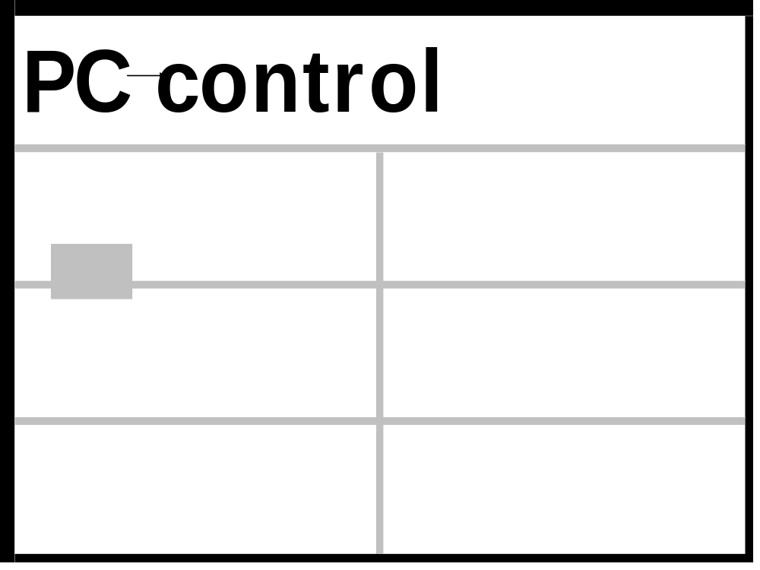

Figure 1: Test setup VDL 4 Mode 4 vers. VHF/FM Broadcast
As a worst case scenario VDL Mode 4 transmission took place every second in one slot transmissions.
For completion Table 2 gives an overview on VDL Mode 4 system characteristics.

Parameter | System characteristics
frequency band | 118,0 – 137,0 MHz (ICAO Recommendation for 108,0 – 117,975 MHz)
Range | more than 200 nmi
Bandwidth | 25 kHz each channel
Bitrate | 19,200 bits/sec
Modulation | Binary GFSK:  modulation index = 0,25;  BT product = 0,28 ± 0,03;  19,2 kbps ± 50 ppm;
channel selection time | < 10 ms
transmitter power stabilisation (90 % of steady state power level) | < 834 μs (≡ 16 symbol periods)
synchronisation and ambiguity resolution | 24 bit binary sequence (0101 0101 0101 0101 0101 0101) + burst flag (NRZI encoded)
receiver to transmitter turn around time | < 16 μs
transmitter to receiver turn around time | < 1 ms
UTC primary time synchronisation | < 400 ns (2 σ)
secondary time synchronisation | < 15000 ns (2 σ)
frequency capture range | signal with maximum frequency offset of ± 965 Hz
channel access | self-organising TDMA
slot length | 60/4500 sec = 13,3 msec
output power (at the antenna) | ground station: 44 dBm +0,5 bis -1 dB;  airborne radio: 37 oder 40 dBm +0,5 bis -1 dB
receiver sensitivity | - 98 dBm (BER 10E-4)
Polarisation | vertical
transmission rate | 1, 2, 5 or 10 seconds (range of 1 to 60 per minute possible; depends on airspace: e.g. En Route 10 seconds, Approach 5 seconds, on the ground 1 second)
Channels | 2 x 25 kHz Global Signalling Channels (Broadcast) + regional or local channels if required

Table 2: Overview on VDL Mode 4 system characteristics

- Test Results

Figures 2 to 4 show measured protection ratios. It should be mentioned that measurement points are linearly interpolated, which does not mean that the graphical values between these measurement points are representative.

Due to the fact that protection ratios refer to a signal-to-noise ratio of 45 dB, first the signal-to-noise ratio without interference has been determined. These values were always well above the required ones (Table 6), which guaranteed a sufficient accuracy for determination of the reference value of 45 dB.

In order to be able to figure out the difference of interference impact of a bursted transmission coming from VDL Mode 4 and a FM broadcast interferer, protection ratios for both scenarios have been determined. Beginning with a co-channel interferer (0 kHz frequency offset) protection rations have been evaluated in 50 kHz steps up to a frequency difference of 500 kHz. These results are outlined in Figure 2 for the FM broadcast interferer case and in Figure 3 for the VDL Mode 4 interferer case. For car receivers, which showed a significant low protection ratio, additional measurements have been done for frequency separation of 1 MHz and 2 MHz. These values are outlined in Table 6 and Table 7 as well.

In addition measurements of the image frequency rejection capability according DIN EN 60315-4 §3.3.2.4 with coloured noise for the following FM receivers have been made.

Receiver | Image frequency rejection
Rohde & Schwarz EU200 + MSDC2 | 61 dB
Blaupunkt London (car-receiver) | 40 dB
Pioneer KEH P600 (car-receiver) | 32 dB

Table 3: Image frequency rejection values

- Conclusion

Difference in protection ratios for the VDL Mode 4 interferer case and the FM broadcast interferer case are outlined in Figure 6. Important are values for 100 kHz frequency offset and above, because 100 kHz is the minimum distance between a FM broadcast frequency (107,9 MHz) and a VDL Mode 4 candidate frequency (108,0 MHz). One could easily see that in most cases VDL Mode 4 is less harmful than the reference FM broadcast interferer. Only one car receiver was more sensitive against VDL Mode 4 transmissions on adjacent channels equal or above 150 kHz frequency offset. But it should be mentioned, that results are not reflecting the subjective listener perception.

Due to the bursted characteristics of the VDL Mode 4 interference an increase of 10 dB in signal-to-noise ratio is recommended compared to the FM broadcast interference scenario. This outcome of the measurements should be verified if needed in more comprehensive listener tests.

For the co-channel case and for frequency offset of more than 300 kHz a reduction of 10 dB interferer RF power value leads also to an increase of about 10 dB in signal-to-noise ratio. Taking this into account and assuming a minimum field strength for the desired signal of 54 dB(μV/m) according ITU-R BS.412 and considering frequency offsets of ≥ 300 kHz the worst performing FM receiver would require a spatial separation of 24,5 km to the VDL Mode 4 transmitter. In that context it has been assumed that the VDL Mode 4 transmits with 10 W output power and is connected to an antenna with 3 dB gain. The feeder loss is assumed to be 3 dB as well, so that both effects are compensating each other. For the FM receiver with the best protection ratio a minimum distance of 550 m can be calculated. The mean value for the protection distance for car receivers turned out to be 6,6 km and for home receivers 900 m. On the image frequency interference is as a worst case acceptable at a distance of 2,7 km, whereas for the R&S reference receiver a value of only 97 m can be derived.

Except for the case of the worst performing car receiver perceivable interference from VDL Mode 4 transmissions might only be expected in the final approach phase of aircrafts near airports. Taking into account that for car receivers signal-to-noise ratios of less than 45 dB are realistic and that the minimum field strength for the desired signal in large cities of 74 dB(μV/m) (ITU-R BS.412) have to be considered, protection distances of less than a tenth of the above mentioned values would be acceptable.

The following tables summarise the protection distances derived from the measurement results and the discussion above. For the calculation the following formula for free space propagation has been used:

d [km] = 10^[(74,8 + 10 – E_undesired)/20] with

E_undesired = E_desired – protection ratio

E_desired = 54 dB(μV/m)
signal-to-noise ratio = 55 dB
frequency offset = 300 kHz
FM receiver | Protection ratio [dB] | Protection distance [km]
R&S EU200 + MSDC2 | -36 | 0,55
Grundig T303 | -32 | 0,87
Sony (IRT Code: DE 30/139) | -36 | 0,55
Pioneer SX 305 | -27 | 1,5
Blaupunkt London | -26 | 1,7
Grundig WKC 3870 | -3 | 24,5
Pioneer KEH P600 | -14 | 6,9

Table 4: Overview on protection distances for rural areas according ITU-R BS.412.

E_desired = 74 dB(μV/m)
signal-to-noise ratio = 55 dB
frequency offset = 300 kHz
FM receiver | Protection ratio [dB] | Protection distance [km]
R&S EU200 + MSDC2 | -56 | 0,055
Grundig T303 | -52 | 0,087
Sony (IRT Code: DE 30/139) | -56 | 0,055
Pioneer SX 305 | -47 | 0,15
Blaupunkt London | -46 | 0,17
Grundig WKC 3870 | -23 | 2,45
Pioneer KEH P600 | -34 | 0,69

Table 5: Overview on protection distances for large cities according ITU-R BS.412.

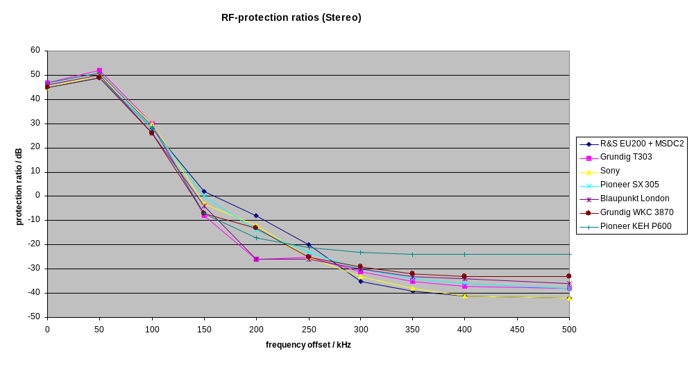
Figure 2: Protection ratios for FM receivers under test and FM-mono signal as interferer
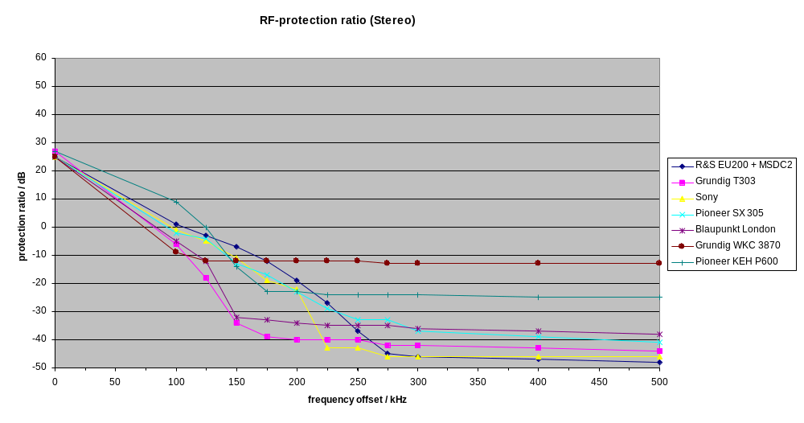
Figure 3: Protection ratios of FM receivers under test andVDL-Mode-4-signal as interferer
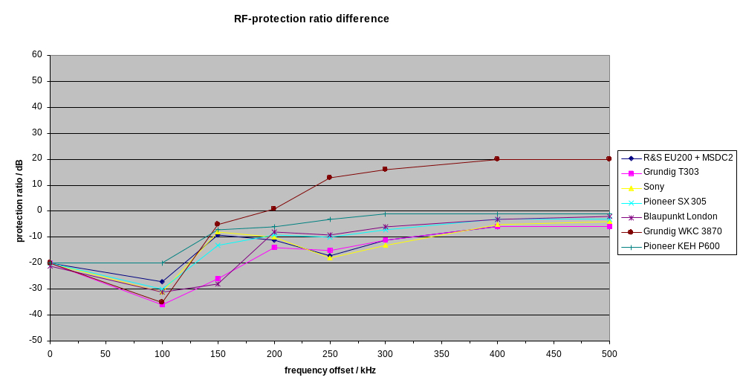
Figure 4: Protection ratio difference for FM receivers under test (VDL Mode 4 compared to FM-mono signal)

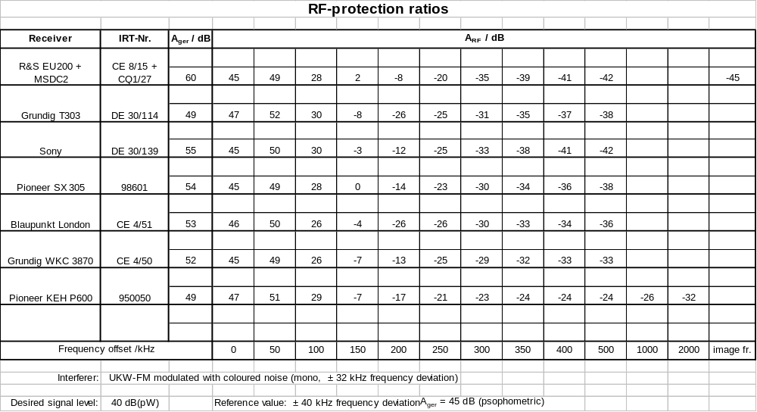Table 6: Measurement values for FM receivers under test with FM mono signal as interferer

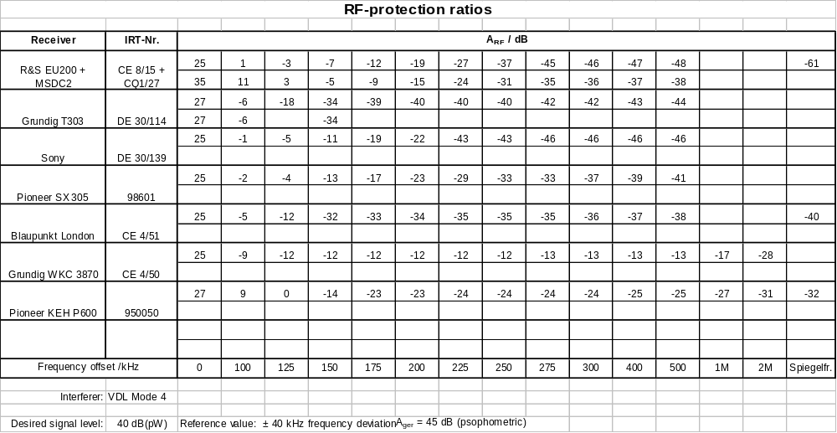
Table 7: Measurement values for FM receivers under test with VDL Mode 4 as interferer

Attachment A: VDL Mode 4 Spectrum

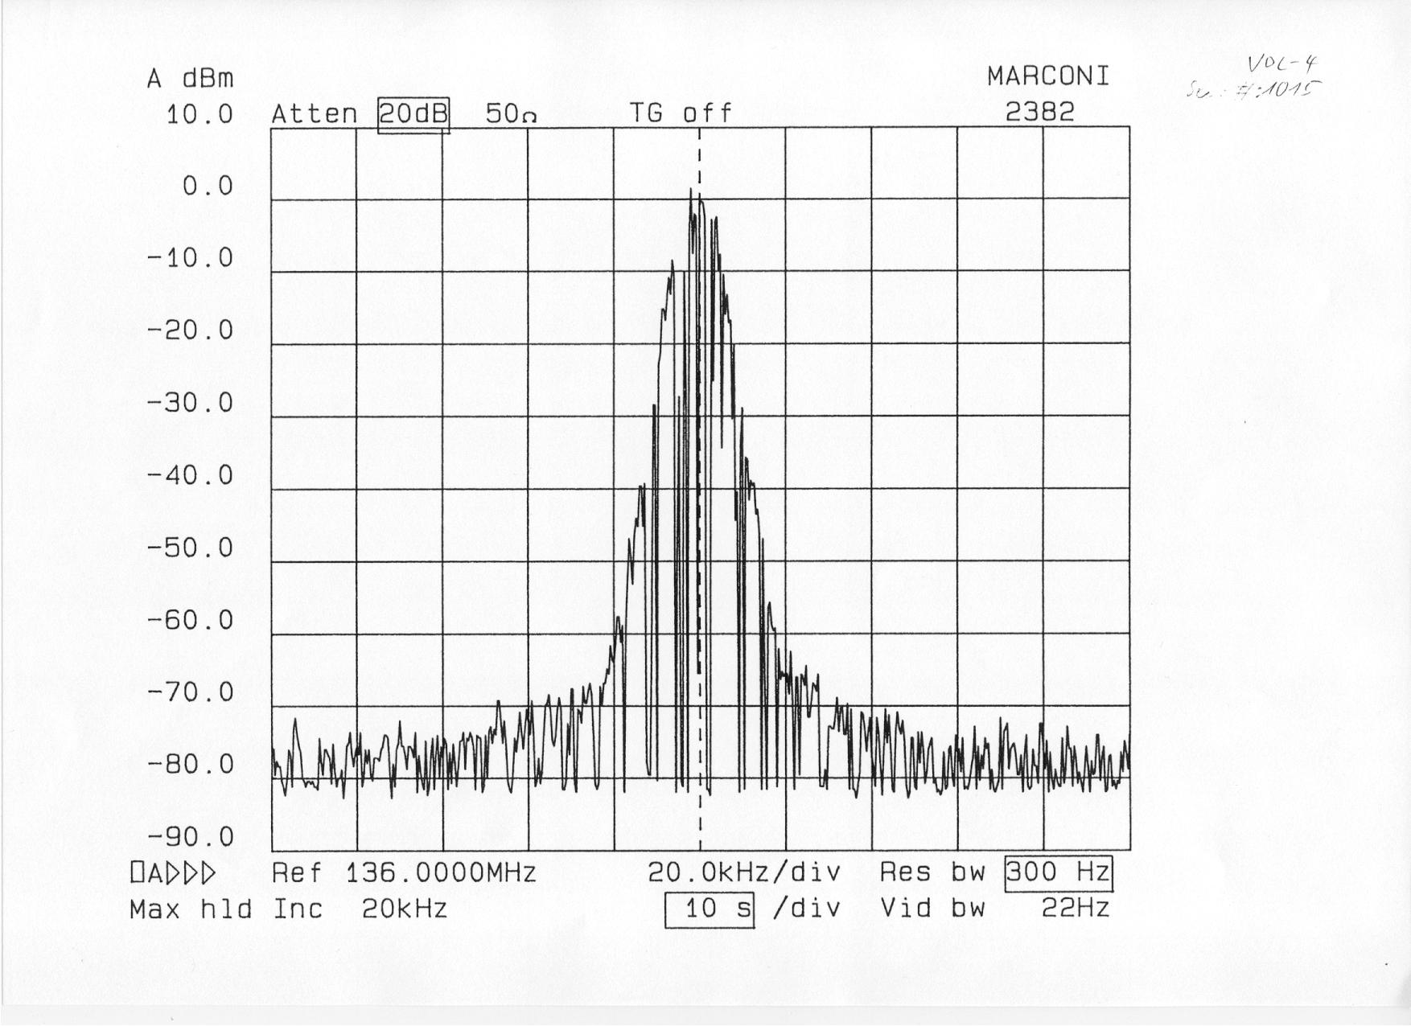
Figure A-1: Original VDL Mode 4 signal
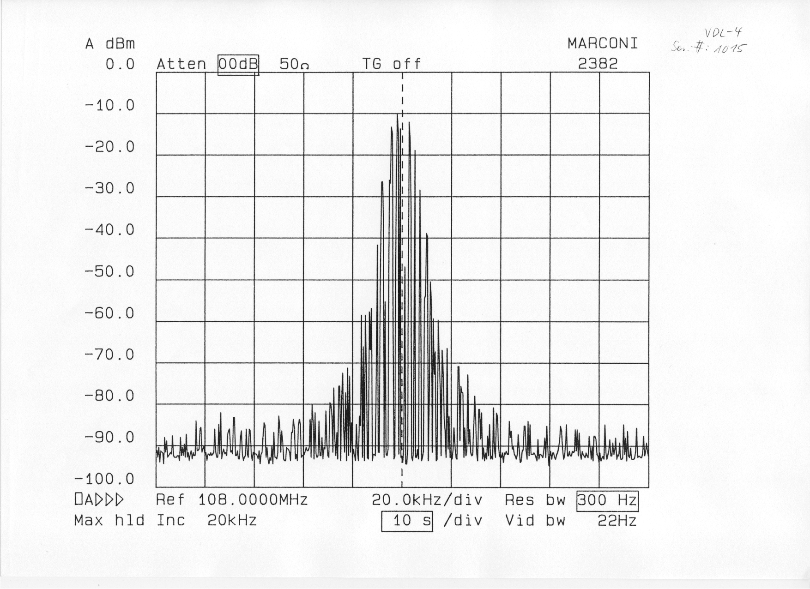
Figure A-2: VDL Mode 4 signal at the output of the band pass filter
Attachment B: Band pass filter frequency response

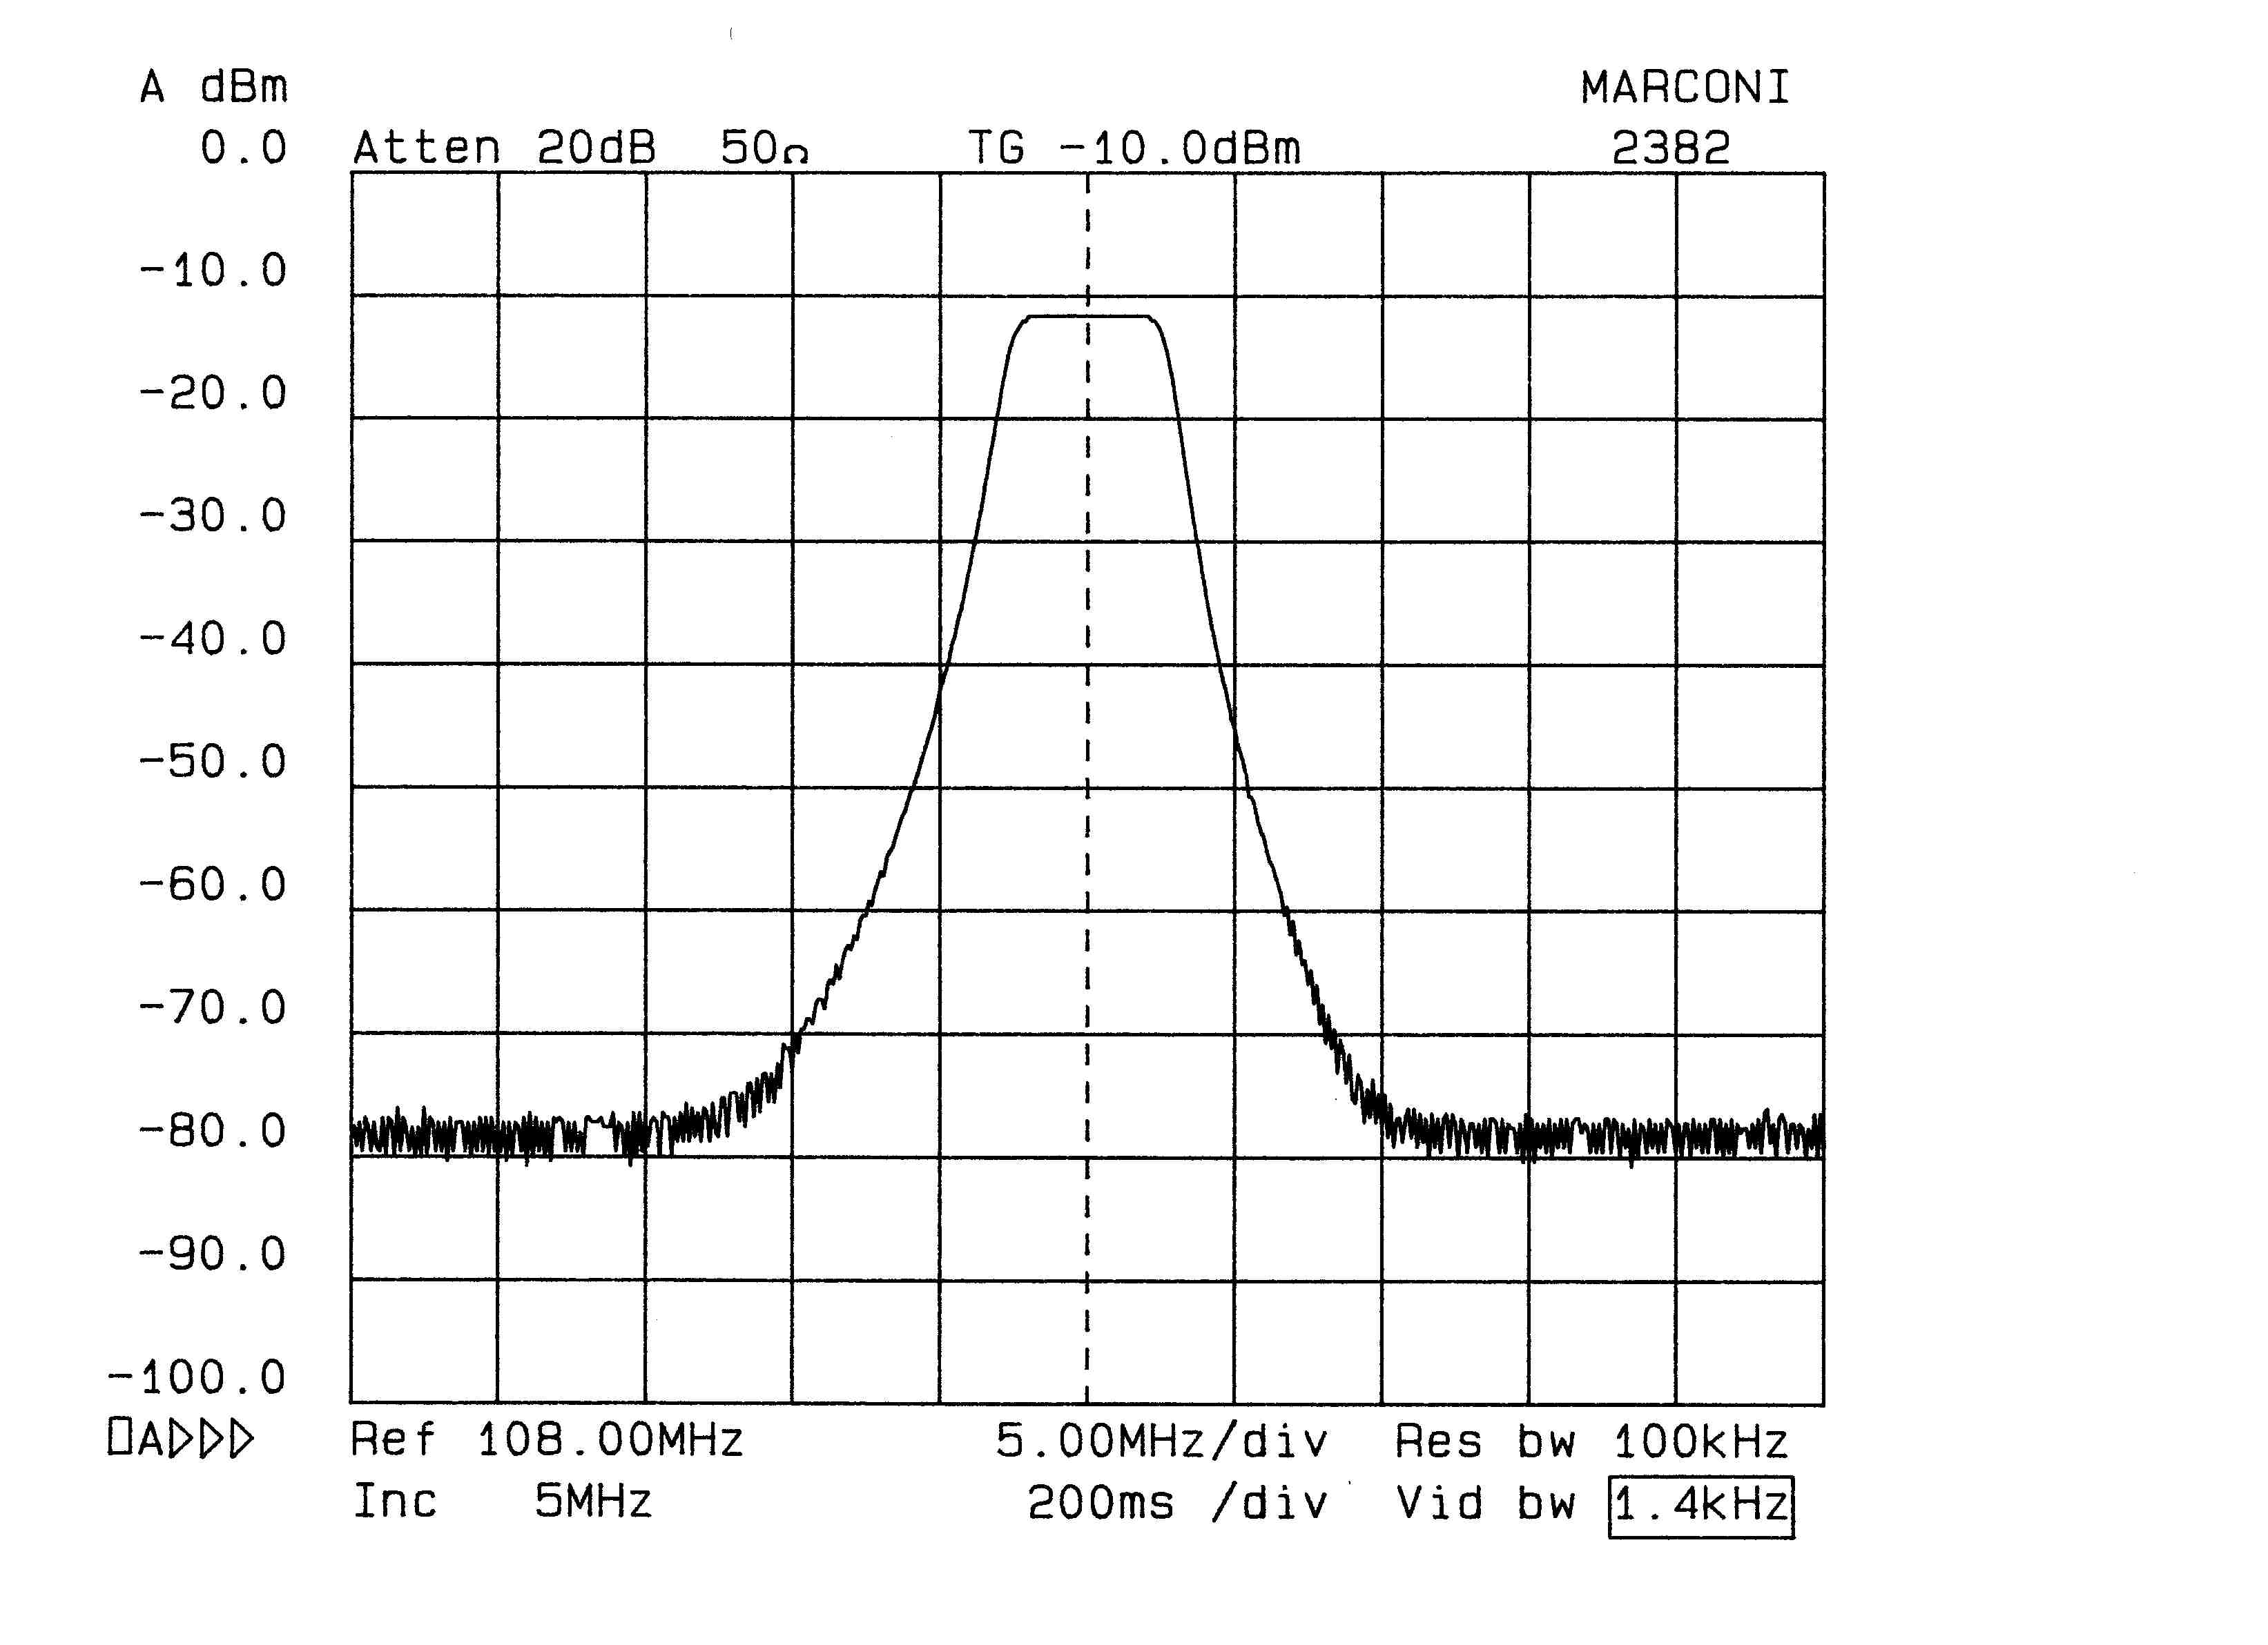

Figure B-1: Freuency response of band pass filter

