 | INTERNATIONAL TELECOMMUNICATION UNION | AMCP WF7/WP13
 | RADIOCOMMUNICATION  STUDY GROUPS | Document 8D/TEMP/143-E  31 October 2001  English only
Source: Documents 8D/189, 8D/190, 8D/207, INF/1, INF/2
Working Party 8D
(SWG 8D5)
PRELIMINARY DRAFT NEW RECOMMENDATION ITU-R M.
Methodology for assessing the impact of the radionavigation-satellite
service (space-to-Earth) on the aeronautical radionavigation service (DME/TACAN) in the band 1 164-1 215 MHz

Summary
TBD.
The ITU Radiocommunication Assembly,
considering
a) that in accordance with the Radio Regulations, the band 960-1 215 MHz is allocated on a primary basis to the aeronautical-radionavigation service in all the ITU Regions;
b) that WRC-2000 introduced a co-primary allocation for the radionavigation-satellite service (space-to-Earth) in the frequency band 1 164-1 215 MHz (subject to the conditions specified under S5.328A), with a provisional limit on the aggregate power flux-density produced by all the space stations within all radionavigation-satellite systems at the Earth's surface of −115 dB(W/m²) in any 1 MHz band for all angles of arrival;
c) that analyses show that RNSS signals in the 1 164-1 215 MHz band can be designed to not cause interference to the DME/TACAN ARNS receivers operating in this band;
d) that the aeronautical radionavigation service is a safety service in accordance with provision S1.59 and special measures need to be taken by administrations to protect these services in accordance with provision S4.10,
recommends
1 that the methodology in Annex 1 should be used to determine pfd levels that protect DME aircraft receivers from aggregate RNSS (space-to-Earth) emissions in the band 1 164-1 215 MHz;
2 that the methodology in Annex 2 should be used to assess whether the aggregate pfd level from recommends 1 is met.
ANNEX 1
Methodology to determine pfd levels that protect DMES from
aggregate RNSS emissions in the band 1 164-1 215 MHz

1 Aggregate protection criterion determination
[replace by the definition of epfd if the epfd concept is accepted]
This annex addresses aggregate pfd levels at the Earth's surface of all space-based RNSS emissions in the band 1 164-1 215 MHz, whether space-to-Earth or space-to-space RNSS. While Resolution 605 requests study of RNSS (space-to Earth), the provisional aggregate pfd limit in footnote S5.328A is not limited to any specific direction.
Received signal powers are typically calculated by link analysis equations, considering the average power (other cases - maximum power) that is emitted by the transmitter to the received signal power that is received at the antenna and is dependant on the received antenna characteristics. However, the power flux-density is independent of carrier frequency and is a function of spreading loss over the slant range d. This is sometimes called path loss. For single RNSS system the pfd equation is:
pfd = (e.i.r.p.)/(4πd²) (W/m²) (1)
Translating equation (1) into dB's (where distance, d, is in metres):
pfd = 10log (e.i.r.p.) − 10log (4πd²) dB(W/m²) (2)
No. S5.328A indicates that the provisional pfd limit is −115 dBW/m² in a 1 MHz bandwidth, and is to represent an aggregate of all RNSS systems operating between 1 164-1 215 MHz.
The aggregate pfd power from all satellites visible to the ARNS station(s) is determined using the following equation:
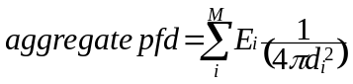 (3)
where:
i: 1 of M satellites being considered in the interference calculation for the kth ARNS receiver
E_{i}: maximum e.i.r.p. density per reference bandwidth input to the antenna for the ith RNSS downlink beam
d_{i}: slant range in metres.
The parameters in Table 1 identify the aggregate pfd levels at which DME ARNS equipment will be protected from RNSS (space-to-Earth) emissions in the 1 164-1 215 MHz band.
TABLE 1
Aggregate interference pfd limit to protect DME interrogator/receiver from RNSS
 |  | Parameter |  | Value |  | Reference
1 |  | DME RNSS interference threshold (at antenna port) in the DME receiver bandwidth (650 kHz) |  | −130.9 dBW |  | Note 1  Reference bandwidth 650 kHz
2 |  | Effective DME/TACAN antenna gain towards RNSS constellations including polarization mismatch |  | –1.5 dBi |  | Note 2:  (0.5 dBi antenna gain –2 dB polarization mismatch)
3 |  | Effective area of 0 dBi antenna at 1 176 MHz |  | −22.9 dB/m²
4 |  | Aggregate interference in DME BW |  | −106.5 dB(W/m²/  650 kHz) |  | Combine 1, 2 and 3  (1 minus 2 minus 3)
5 |  | 10 log (1 MHz/DME BW) |  | 1.9 dB |  | Conversion of 650 kHz to  1 MHz
6 |  | Aggregate interference in 1 MHz |  | −104.6 dB(W/m²/MHz) |  | Combine, 4 and 5  (4 plus 5)
7 |  | Safety margin |  | 6 dB |  | ITU
8 | Apportionment of RNSS interference to all the interference sources |  | 6 dB |  | Apportion 25 % of total permissible interference to RNSS
9 | Aggregate RNSS (s-E) interference limit at antenna surface |  | −116.6 dB(W/m²/MHz) |  | [Note 3]  Combine 6, 7 and 8  (6 minus 7 minus 8)
NOTE 1 - This value is based on a –129 dBW CW interference threshold limit specified in RTCA MOPS – DO 189 2.2.16 modified by minus 1.9 dB representing the difference of the impact of CW and RNSS signals on DME performance (see section 1.1 below).
NOTE 2 – DME antenna gain is 0.5 dBi; polarization mismatch is minus 2 dB (see section 1.2 below).
[NOTE 3 (guidance for the next 8D meeting): If accepted, the proposal for an epfd or (isotropic) epfd limit instead of pfd will implies slight modifications:
− modification of the first page of Annex 1 (definition of epfd or (isotropic) epfd see section 1 of Annex 1B first proposal);
− modification of Table 1: rows 2(maximum Beech Baron antenna gain taking into account the polarization mismatch) and 9 (epfd limit necessary to protect ARNS);
− deletion of sections 1.2 and 1.4;
− new section in Annex 1A with the worst DME/TACAN antenna pattern (Beech Baron) to be used when calculating epfd or (isotropic) epfd (see Appendix 1 of Annex 2 first proposal which correspond to the antenna in section 1.2.3);
− combination between the three proposed Annexes 2.]

1.1 Comparison between the impact of CW interference type of signal and RNSS type of interference signal on DME/TACAN on-board receivers

1.1.1 Susceptibility of DME receivers from interference by RNSS signals (spread spectrum signals)
Ground DME transponder signals of peak value –83 dBm were set as the wanted signal at the different DME interrogator/receivers.
The total power of the narrow (Figure 1) or wideband (Figure 2) interference source was measured within a bandwidth of 650 kHz, and the variation in performance of a DME between CW signals and the RNSS signals was determined for a number of different DME designs and a number of DMEs of the same type. These DMEs were of type designed for large commercial airline and smaller commercial aviation aircraft.
The shape of the interference signals used in the tests is given in Figure 1 and Figure 2.
For Figure 1, the interference source was generated from a RNSS signal simulator that produced the exact signal structure and frequency signal of an existing RNSS system. This 1.023 Mega chip per second (Mcps) pseudo-random CDMA transmission was translated in frequency to the relevant DME receive frequency under test. The range of interfering RNSS narrow-band signals (measured in 650 KHz) applied to DMEs was –83 to -94 dBm.
For Figure 2, the interference source was generated from digital signal generator, that produced a 10.023 Mcps pseudo-random CDMA emission similar to that proposed by the RNSS in the band 1 164-1 215 MHz. The signal was applied directly to the relevant receive DME under test. The range of interfering RNSS wideband signals (measured in 650 KHz) applied to DMEs was –81 to −93 dBm.
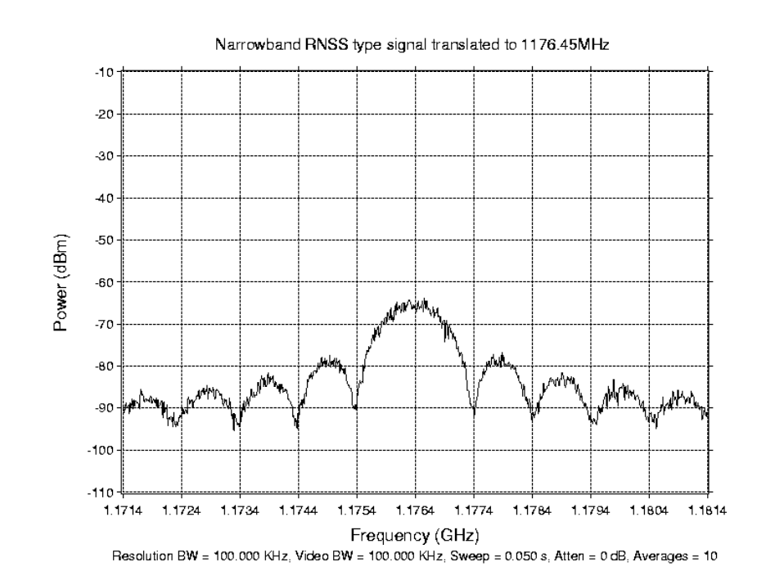
FIGURE 1
Example of RNSS narrow-band signal
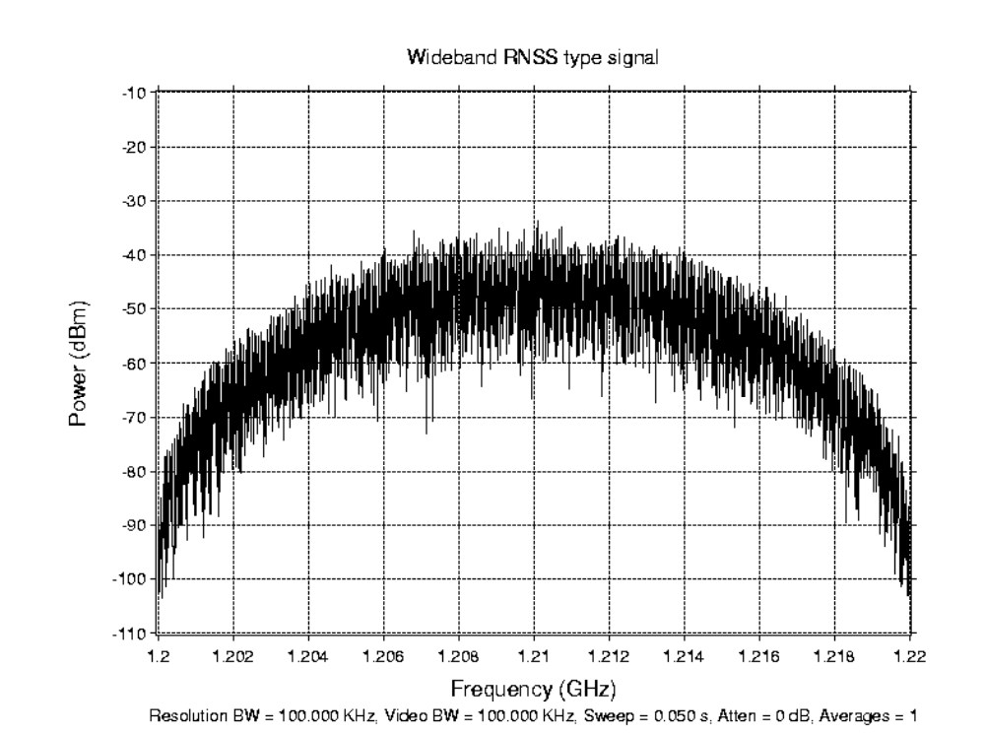
FIGURE 2
Example of RNSS wideband signal

1.1.2 CW RNSS measurement results
DME showed 1.9 dB (in 650 kHz) more susceptibility to RNSS emissions than to CW interferences emissions. Measurement variation of about ±1 dB was noted, as was a performance variation of about ±3 dB between the different DMEs.

1.2 Effective DME/TACAN antenna gain towards RNSS constellations

[This section will be modified in the case that the epfd concept is accepted]

1.2.1 Determination of the effective DME/TACAN antenna gain towards RNSS constellations
When an antenna receives power, within its reference bandwidth, simultaneously from transmitters at various distances, in various directions and at various levels of incident power flux-density, the (isotropic) epfd is that power flux-density which, if received from a single transmitter in the far field of the antenna in the direction of 0 dBi gain, would produce the same power at the input of the receiver as is actually received from the aggregate of the various transmitters.
The instantaneous (isotropic) equivalent power flux density is calculated using the following formula:
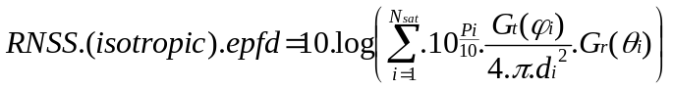 (4)
with:
N_{sat}: is the number of satellites that are visible from a DME interrogator
i: is the index of the satellite considered
P_{i}: is the RF power at the antenna input of the transmitting satellite considered in dB(W/MHz) in the DME receiver bandwidth
Gt(ϕi): is the transmit antenna gain of the satellite considered in the direction of the DME interrogator receiver
Gr(θi): is the receive antenna gain of the DME interrogator receiver in the direction of the satellite considered
d_{i}: is the distance in metres between the satellite considered and the DME interrogator receiver
In a first approximation, the RNSS pfd level 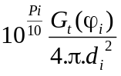 is assumed constant therefore
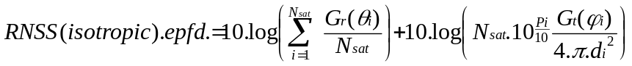
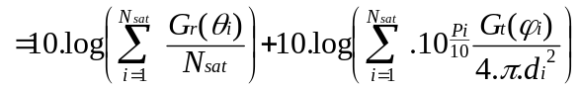
and
= Effective _{DME/TACAN} antenna gain towards RNSS constellations + pfd (aggregate RNSS interference limit at antenna surface)
The Effective DME/TACAN antenna gain towards RNSS constellations is therefore:
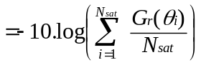
For a RNSS signal with circular polarization, a polarization mismatch must be taken into account (see section 2.2.2).

1.2.2 Circular polarization isolation towards DME antenna

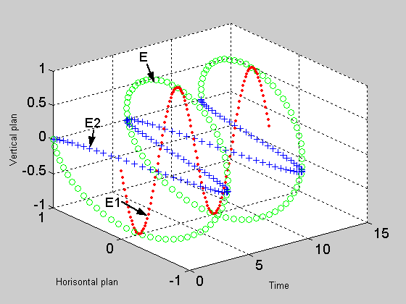
Figure 3
Circular polarization representation with E₁=E₂=1
Taking E1 in the Vertical Plan of the DME interrogator and E2 in the Horizontal Plan, then the RNSS power after the DME antenna is:
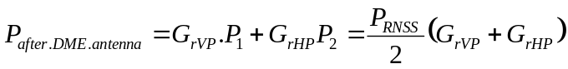
The Effective DME/TACAN antenna gain towards RNSS constellations including polarization mismatch is now therefore:
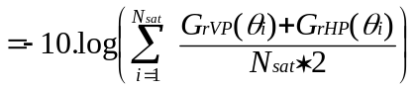 (5)
where:
G_{rVP} is the absolute gain in the Vertical Polarization
G_{rHP} is the absolute gain in the Horizontal Polarization
Therefore a linear vertically polarized DME antenna should receive −3 dB of the total circularly polarized RNSS signal. However, RNSS emissions are observed in the side lobes, not the main beam of a DME antenna, where polarization mismatch is less certain. As an example, Appendix S8 section 2.2.3 of the ITU Radio Regulations gives factors that are to be used in the consideration of polarization mismatch for GSO versus FSS. The isolation of right or left handed circularly polarized signal towards linearly polarized antenna is given −1.46 dB. Some recent measurements on aircraft DME have indicated a value of -2.5 dB, while other experience of aircraft polarization mismatch has observed factors of 0 dB. It was therefore considered practical to assume a polarization mismatch of –2 dB, for RNSS circularly polarized signals to a DME antenna. This value should therefore be added to the effective antenna gain determined by modelling RNSS constellation against DME antenna patterns.

1.2.3 DME radiated antenna patterns characteristics
DME antenna characteristics based on available antenna elevation patterns in the nose to tail and wing to wing direction were combined for use in the determination of the effective antenna gain. The following method was used to determine the antenna gain in other than the nose to tail and wing to wing directions, for the simulation of RNSS satellite movement versus DME antenna.

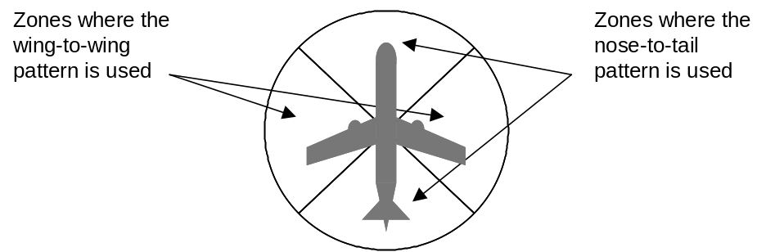
The following figures represent models of DME antennas patterns used in the simulation, [those radiated patterns will be kept in case of epfd concept].

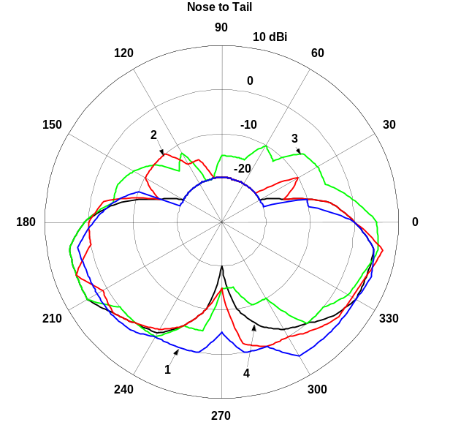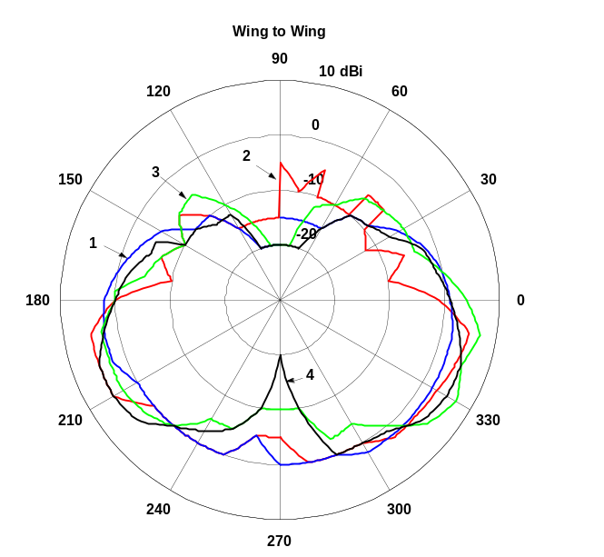

Antenna 1 corresponds to Grumman gulfstream
Antenna 2 corresponds to Beech B-99
Antenna 3 corresponds to Beech Baron
Antenna 4 corresponds to Lear jet

1.2.4 Simulation
The following RNSS constellation parameters were used in the analysis of effective antenna gain.
RNSS constellation characteristics
RNSS constellation
Number of satellites: 30
Number of orbit planes: 3
Inclination: 56°
Altitude: 23 595 km
RNSS constellation
Number of satellites: 24
Number of orbit planes: 6
Inclination: 55°
Altitude: 20 200 km
The simulation has the following steps:
– The DME on-board receiver is placed virtually at 40 000 ft (worst case) (except small propeller aircraft DME antenna pattern 20 000 ft) with a longitude of 0° and a latitude 0°.
– The RNSS constellation is simulated during 10 days with a step of 5 minutes. At each steps Y is calculated.
– The previous steps are repeated changing only the latitude (+10°) of the DME interrogator until the latitude equals 90°.
– The previous steps are repeated changing only the longitude (+20°) of the DME interrogator until the longitude equals 360°.
− The result is a plot giving the statistic of Effective DME/TACAN antenna gain towards RNSS constellations including polarization mismatch.

1.2.5 Simulation results
The results of simulations of RNSS constellations against a variety of aircraft, ranging from small commercial aircraft to larger aircraft are shown below. All aircraft were analysed at an altitude of 40 000 ft, except the small propeller based commercial which was limited in its performance to 20 000 ft.

Large jet A |  |  | Turbo prop Aircraft |  |  | Small Propeller |  |  | Large jet B
w2w | N2t | avg | w2w | n2t | avg | w2w | n2t | avg | w2w | n2t | avg
−0.65 | −2.81 | 1.66 dBi | 1.84 | 2.26 | 2.07  dBi | 0.26 | 0.77 | 0.5  dBi | 1.54 | 1.86 | 1.74  dBi
w2w=wing to wing n2T=Nose to Tail
The worst-case effective antenna gain chosen was 0.5 dBi that of the smaller aircraft, placed at 20 000 ft.
With a polarization mismatch of 2 dB factor, the resultant effective DME/TACAN antenna gain towards RNSS constellations including polarization mismatch factor is –1.5 dBi.

1.3 Apportionment of the DME aggregate interference limit to RNSS
The chosen factor of 6 dB for the apportionment of the aggregate interference limit, from all other interference sources to the RNSS aggregate interference limit, recognizes that there exists the possibility of interference from the spurious and out-of-band emissions of other airborne ARNS and AMSS systems and also from the bands adjacent to the ARNS. The onboard ARNS systems include multiple Secondary Surveillance Radar transponders (SSR), multiple Airborne Traffic Collision Alert transponders (ACAS) and other DME interrogator/receivers, onboard Satellite terminals in the AMSS also operate. Adjacent band sources of interference are high-powered Radiolocation Service radar operating just above 1 215 MHz and Broadcast service transmitters operating below 960 MHz. State systems working under non-interference and no protection basis exist and do operate in this band and need to be taken account of.

1.4 Comparison of the permissible interferences calculated by using simulation results of epfd vs. pfd [will be deleted in case of epfd concept]
Figure 4 shows the epfd and pfd results of simulations with the small propeller aircraft DME antenna pattern (taken from the Beech Baron which gives the worse case). The calculation is from a Galileo-like RNSS satellite system down to the airplane that is located above the equator at 20 000 feet. A typical constellation of 27 satellites and its parameters were assumed for these calculations. The maximum pfd per satellite was assumed to be –129.7 dB(W/m²/MHz) and both the satellite and aircraft antenna pattern that were used can be found in input Document 8D/189. The results show that the maximum epfd is reached at 0.3% of the time.

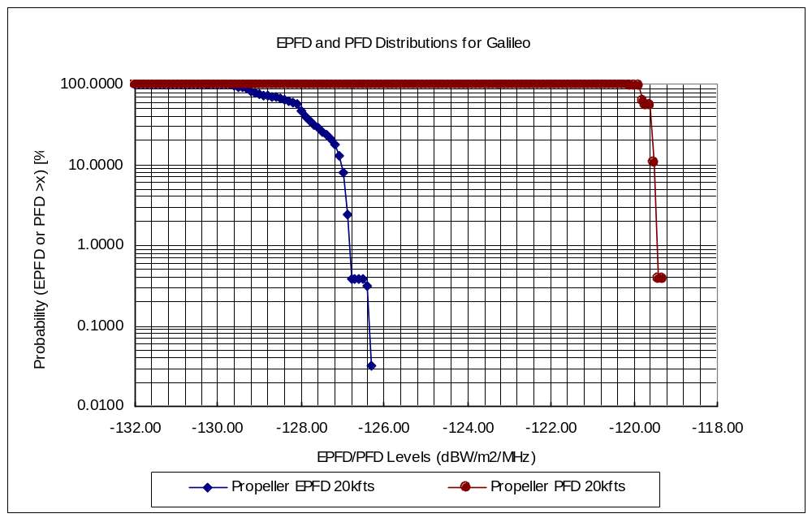
Figure 4
epfd and pfd probability distributions
Tables 2 and 3 show the permissible interference calculated by using epfd and pfd respectively. The small difference between the margins of 0.27 dB shows that the above pfd methodology is quite accurate and therefore verifies this methodology. The parameters for the effective antenna gain; safety factor and the interference apportionment values were taken from the reference below. It should be noted that verifying the accuracy of the methodology is independent of the safety factor and the interference apportionment used in Tables 1 and 2. The permissible pfd in this case was found to be −116.47 dB(W/m²/MHz).
Table 2
Permissible interference allowance using epfd
DME/RNSS interference threshold in 650 kHz receiver bandwidth |  |  | −129 - T | dBW/650 kHz
For T = 1.9 dB* |  |  | −130.9 | dBW/650 kHz
Conversion to 1 MHz |  |  | 1.9 | dB
For safety factor, 6 dB* |  |  | −6.0 | dB
Apportionment of total interference sources X = −6 dB* |  |  | −6.0 | dB
Interference limit at receiver input |  |  | −141.0 | dBW/MHz
Polarization mismatch, −2 dB* |  |  | 2.0 | dB
10 × log (Area of Omni antenna (λ²/4π)) at 1 200 MHz | −23.0 | dBm²
Peak gain of aircraft antenna | 7.0 | dBi
10 × log (Area of aircraft antenna) | −16.0 | dBm² | 16.0 | dB/m²
epfd limit at antenna input |  |  | −123.0 | dBW/m²/MHz
Achieved epfd (from simulation) |  |  | −126.1 | dBW/m²/MHz
Margin |  |  | 3.1 | dB
TABLE 3
Permissible interference allowance using pfd
DME/RNSS interference threshold in 650 kHz receiver bandwidth |  |  | −130.90 | dBW/650 kHz
Effective antenna gain ("Y" without pol. mismatch),+0.5 dB* |  |  | −0.5 | dBi
Polarization mismatch, −2 dB* |  |  | 2 | dB
Effective area of 0 dBi antenna at 1 200 MHz (−23.03 dBm²) |  |  | 23.03 | dB/m²
Aggregate interference in DME bandwidth |  |  | −106.37 | dBW/m²/650 kHz
Conversion to 1 MHz |  |  | 1.90 | dB
Aggregate interference in 1 MHz |  |  | −104.47 | dBW/m²/MHz
For safety margin (+6 dB)* |  |  | −6.00 | dB
Apportionment of RNSS interference to all interference sources* |  |  | −6.00 | dB
Interference flux limit at antenna input |  |  | −116.47 | dBW/m²/MHz
Achieved pfd |  |  | −119.30 | dBW/m²/MHz
Margin |  |  | 2.83 | dB
ANNEX 2
[NOTE - This Annex 2 will be a combination of Annexes 2-1, 2-2, 2-3 with the following structure:
− A main part which explains the method to derive aggregate epfd or pfd for all RNSS co-sharing RNSS systems from the aggregate epfd or pfd for each co-sharing RNSS systems.
− In appendix the possible methods to derive the aggregate epfd or pfd for each co-sharing RNSS systems.]
[NOTE - For the second and third proposal (Annexes 2-2 and 2-3) some concerns were raised for the next meeting:
− if epfd concept is retained to adapt the methodology to the epfd concept;
− to take into account the maximum number of satellite in visibility instead of average;
− the visible area needs to be from an elevation angle of–3.5° instead of 0°;
− propose a method to determine the value of K (third proposal);
− verify the assumption: all satellites are independent (second proposal);
− verify the assumption: "For uniformly random constellation positions, we have, based on the law of large numbers, a normal distribution for the aggregate gain GA" (third proposal).]
ANNEX 2-1 [first proposal]
Method for calculating the aggregate epfd from all RNSS satellites of
all RNSS systems operating in the same frequency band, which
are visible from a given point at a certain altitude
The method consists in two steps:
− The epfd distribution function determination for each co-sharing RNSS systems.
− The aggregate epfd for all co-sharing RNSS systems determination based on the previous epfd distribution functions.

1 Method for calculating the aggregate epfd from satellites of one RNSS system, which are visible from a given point at a certain altitude
The method set out below is for determining the epfd from satellites in a non-geostationary system and geostationary system operating in the same frequency band that are visible from a given point at a certain altitude.

1.1 Definition of epfd: equivalent power flux-density
The definition is based upon Article S22.5C as adopted at WRC-2000.
When an antenna receives power, within its reference bandwidth, simultaneously from transmitters at various distances, in various directions and at various levels of incident power flux-density, the epfd is that power flux-density which, if received from a single transmitter in the far field of the antenna in the direction of maximum gain, would produce the same power at the input of the receiver as is actually received from the aggregate of the various transmitters.
The instantaneous equivalent power flux-density is calculated using the following formula:
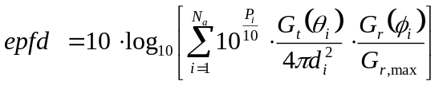
where:
N_{a}: is the number of non-GSO space stations that are visible from the receiver
i: is the index of the non-GSO space station considered
P_{i}: is the RF power of the unwanted emission at the input of the antenna (or RF radiated power in the case of an active antenna) of the transmitting space station considered in the non-GSO system in dBW per MHz
θ _{i} : is the off-axis angle between the boresight of the transmitting space station considered in the non-GSO system and the direction of the receiver
G_{t}(θ_{i}): is the transmit antenna gain (as a ratio) of the space station considered in the non-GSO system in the direction of the receiver
d_{i}: is the distance in metres between the transmitting station considered in the non-GSO system and the receiver
φ_{i}: is the off-axis angle between the pointing direction of the receiver and the direction of the transmitting space station considered in the non-GSO system
G_{r}(φ_{i}): is the receive antenna gain (as a ratio) of the receiver, in the direction of the transmitting space station considered in the non-GSO system (see Annex 2)
G_{r,max}: is the maximum gain (as a ratio) of the receiver
epfd: is the instantaneous equivalent power flux-density in dB(W/m²/MHz) in the 1 MHz at the receiver
NOTE 1 - It is assumed that each transmitter is located in the far field of the receiver (that is, at a distance greater than 2D²/λ, where D is the effective diameter of the receiver antenna and λ is the observing wavelength). In the case under consideration this will always be satisfied.

1.2 epfd distribution function for non-GSO satellites constellation using a circular orbit
The method for calculating the epfd from satellites in a non geostationary system using circular orbit consist in determining the position of each satellite in its orbit as a time variation as well as the position of the visible arc in each orbit as a time variation. Having those two elements, it is possible to determine the number of satellites which are visible with an elevation angle above a certain value, and therefore the number N(el) of satellites in view for each 1° of elevation of the visible area. If we suppose that the satellite pfd(el) level is dependant to the elevation as well as the ARNS antenna gain Gr(el), the epfd produced by all satellite of one non-GSO system can be derived from N(el),Gr(el) and pfd(el).
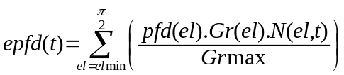 (1)
From this equation, the epfd distribution function can be determined using the method in Appendix 1 to annex 1B or by a constellation simulation.

1.3 epfd distribution function for GSO satellites systems
In this case the epfd will not be dependent on the time variable. The distribution will be therefore a dirac function. However the dirac value will depend on the observer latitude and longitude. In order to have only a latitude function as in the non-GSO case, the worst longitude for each latitude will be retained to compute the epfd.
(2)
where:
Long: Observer longitude
The following equation will be useful to determine, for a latitude the worst-longitude case.
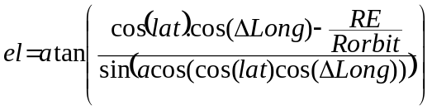 (3)
where:
Rorbit: RE+36 000 km
ΔLong: the difference of longitude between the GSO satellite longitude and the observer longitude

1.4 For other cases: elliptical orbit …
Constellation simulations could be used in these cases to determine the epfd distribution for each observer latitude.

2 Method for calculating the aggregate epfd from satellites of all RNSS systems operating in the same frequency band, which are visible from a given point at a certain altitude (at a given observer latitude)
If we accept the assumption that satellite RNSS systems are independent to each other, the aggregate epfd for all RNSS systems distribution function is determined as the convolution of each RNSS systems epfd distribution functions:
(4)
From those distribution functions (one to each latitude from 0 to 90°), cumulative distribution functions can be derived CDF(lat). Those cumulative functions are not above the limit of
–116.6-1.5-1.69 = −119.8 dB(W/m²/MHz) for more than 1% of time at the worst-case location.

APPENDIX 1
(to Annex 2)
Model of ARNS antenna pattern to be used on epfd calculations
(Beech Baron aircraft)
The following table provides the antenna gain for each elevation between –3 ° and 90°. –3.5° corresponds to the minimum elevation for an aircraft at 40 000 feet. For value between two values of the table a linear interpolation should be used. Only Gr in dB is needed for epfd calculation.

Elevation angle in ° | Antenna gain including polarization mismatch |  | Elevation angle in ° | Antenna gain including polarization mismatch |  | Elevation angle in ° | Antenna gain including polarization mismatch
 | In dBi | Gr/Grmax in dB |  | In dBi | Gr/Grmax in dB |  | In dBi | Gr/Grmax in dB
−3 (Grmax) | 1.69 | 0 | 37 | –8.37 | –10.06 | 77 | –19.37 | –21.06
−2 | 1.45 | –0.24 | 38 | –8.39 | –10.08 | 78 | –19.65 | –21.34
−1 | 1.21 | –0.48 | 39 | –8.39 | –10.08 | 79 | –19.90 | –21.59
0 | 0.97 | –0.72 | 40 | –8.38 | –10.07 | 80 | –20.12 | –21.81
1 | 0.55 | –1.14 | 41 | –8.6 | –10.29 | 81 | –20.03 | –21.72
2 | 0.14 | –1.55 | 42 | –8.8 | –10.49 | 82 | –19.94 | –21.63
3 | –0.25 | –1.94 | 43 | –8.98 | –10.67 | 83 | –19.84 | –21.53
4 | –0.77 | –2.46 | 44 | –9.14 | –10.83 | 84 | –19.72 | –21.41
5 | –1.28 | –2.97 | 45 | –9.29 | –10.98 | 85 | –19.60 | –21.29
6 | –1.79 | –3.48 | 46 | –9.42 | –11.11 | 86 | –19.47 | –21.16
7 | –2.3 | –3.99 | 47 | –9.54 | –11.23 | 87 | –19.32 | –21.01
8 | –2.81 | –4.5 | 48 | –9.64 | –11.33 | 88 | –19.17 | –20.86
9 | –3.31 | –5 | 49 | –9.73 | –11.42 | 89 | –19 | –20.69
10 | –3.81 | –5.5 | 50 | –9.81 | –11.5 | 90 | –18.81 | –20.5
11 | –4.18 | –5.87 | 51 | –10.16 | –11.85
12 | –4.53 | –6.22 | 52 | –10.49 | –12.18
13 | –4.88 | –6.57 | 53 | –10.81 | –12.5
14 | –5.22 | –6.91 | 54 | –11.11 | –12.8
15 | –5.56 | –7.25 | 55 | –11.38 | –13.07
16 | –5.89 | –7.58 | 56 | –11.64 | –13.33
17 | –6.21 | –7.9 | 57 | –11.87 | –13.56
18 | –6.52 | –8.21 | 58 | –12.08 | –13.77
19 | –6.82 | –8.51 | 59 | –12.26 | –13.95
20 | –7.12 | –8.81 | 60 | –12.42 | –14.11
21 | –7.21 | –8.9 | 61 | –12.88 | –14.57
22 | –7.31 | –9 | 62 | –13.34 | –15.03
23 | –7.40 | –9.09 | 63 | –13.78 | –15.47
24 | –7.49 | –9.18 | 64 | –14.22 | –15.91
25 | –7.58 | –9.27 | 65 | –14.65 | –16.34
26 | –7.66 | –9.35 | 66 | –15.07 | –16.76
27 | –7.74 | –9.43 | 67 | –15.48 | –17.17
28 | –7.81 | –9.5 | 68 | –15.89 | –17.58
29 | –7.90 | –9.59 | 69 | –16.28 | –17.97
30 | –7.96 | –9.65 | 70 | –16.67 | –18.36
31 | –8.04 | –9.73 | 71 | –17.14 | –18.83
32 | –8.12 | –9.81 | 72 | –17.59 | –19.28
33 | –8.19 | –9.88 | 73 | –18 | –19.69
34 | –8.25 | –9.94 | 74 | –18.39 | –20.08
35 | –8.3 | –9.99 | 75 | –18.75 | –20.44
36 | –8.34 | –10.03 | 76 | –19.07 | –20.76
The following figure represents the antenna pattern:

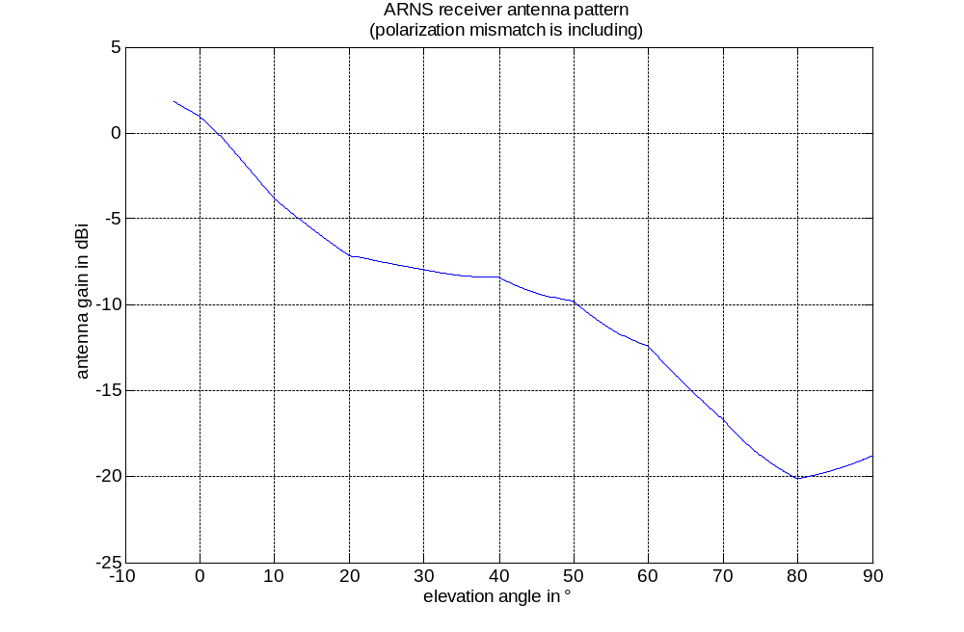
Appendix 2
(to Annex 2)
Example method for calculating the epfd distribution
function of a non-GSO RNSS constellation
For sections 1 to 2.5 a constellation composed of M orbits planes with N satellites by orbit and uniformly distributed is considered.

1 Required non-GSO constellation parameters
To compute the distribution of epfd(t) of one RNSS satellites constellation, the administration must provide the following characteristics:
Pfd(el): pfd of one satellite function of the elevation angle
M: the number of orbit planes
N: the number of satellites by orbit planes
Hsat: satellites altitude
i : orbit inclination

2 Time dependent visible arc location
The aim of this section is to derive an equation, which will permit to calculate during a certain time, the visible arc location in the orbit number m of M orbits. The visible arc is defined by a minimum elevation angle elmin.
The orbit portion, which is visible from a given point with an elevation angle above a certain value elmin can be fully characterized by equations 2 and 3 derived from equation 5. Equation 5 provides the relation between the minimum elevation angle, the visible arc and the angle between the orbital plane and the "Earth centre-observer" direction.
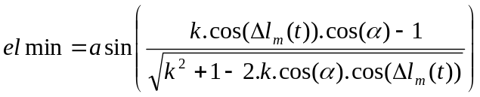 (5)
where:
elmin: minimum elevation, which defines the visible arc
α: half of the visible arc
k: orbit radius/(Earth + observer altitude)
Δl_{m}(t): angle between the orbital plane m and the "Earth centre-observer" direction. Due to the Earth rotation with a temporal period Ep, Δl is a time dependent function as follow:
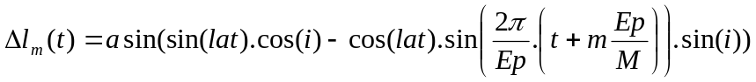
with:
lat: observer latitude
t: time
Ep: Earth rotation period (23 h, 56 min and 4.09 s)
M: number of orbits
m: satellite orbit number m among M orbit (1 to M)
i: orbit inclination

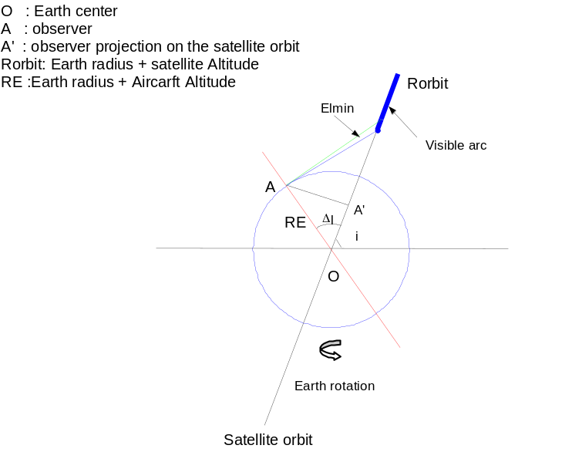
Figure 1
Taking, (x,y) the coordinates of A’: the projection in the orbital plane m of the observer point A (see Figure 2),
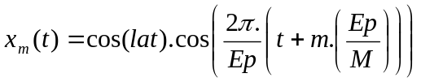
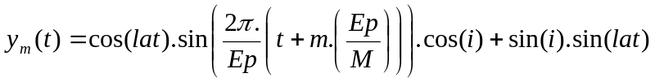
the angle θ_{m}, which is the angle between the ascending node and A’ can be determined by means of the expression:
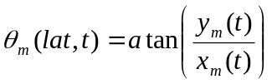 when x_{m}(t)>=0 and y_{m}(t)>=0
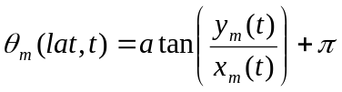 when x_{m}(t)<0 (6)
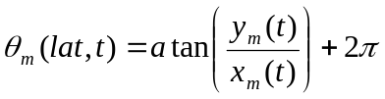 when x_{m}(t) >=0 and y_{m}(t) <0

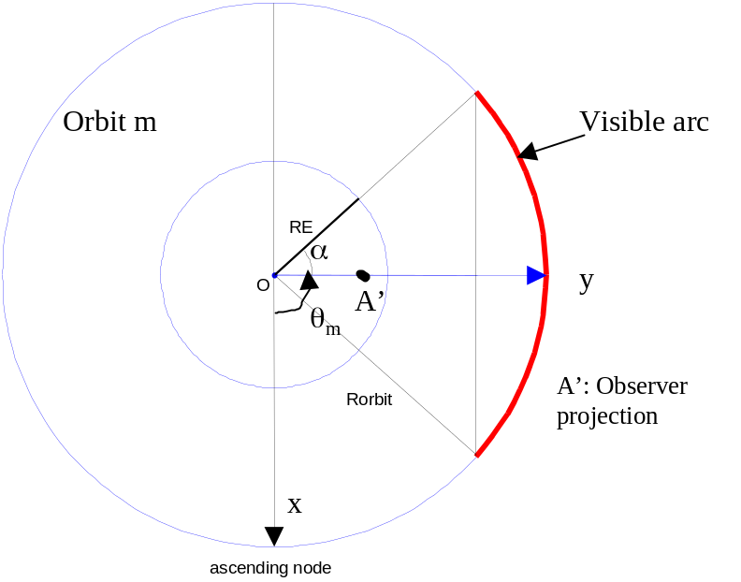
Figure 2
From equation 5, α (half visible arc) can be determined by means of expression:
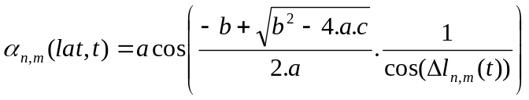 when elmin>=0
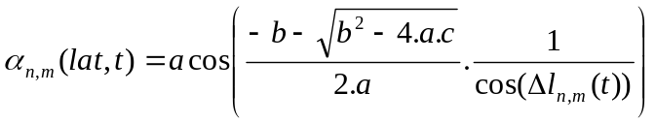 when elmin<0 (7)
where:
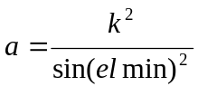, 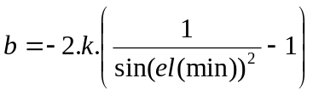 and 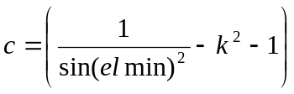

3 Satellite location on the orbit as a time variation function
The aim of this section is to determine the location of satellite number n of orbit m during a time period.
The satellite location on the orbit is determined by means of the expression:
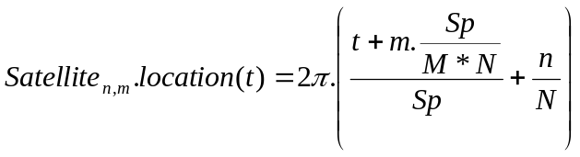 in rad (8)
where:
N: number of satellites by orbits
n: satellite number n among N satellites (1 to N) of the orbit m among M orbits
Sp: the satellite rotation period (9.952004586e-3*(6378.14+satellite altitude)^1.5)

4 Number of satellites with an elevation between el-0.5° and el +0.5° (at a given observer latitude)
The condition cond_{n,m} to have a satellite in view with an elevation between el-0.5 and el+0.5 can be determined using equations 6, 7 and 8 by the expression:
Cond_{n,m}(t)=1 when or
(9)
Cond_{n,m}(t)=0 otherwise
where:
α_{n,m}1(t): time variation of the half visible arc corresponding to a minimum elevation el-0.5
α_{n,m}2(t): time variation of the half visible arc corresponding to a minimum elevation el+0.5
Applying equation 9 to each satellite (n,m) of a RNSS satellites constellation it is possible to determine the number (N(el,t)) of satellites visible between two elevations (el1=el-0.5 and el2=el+0.5 with low differences here 1°) in function of the time:
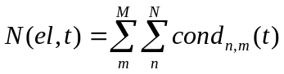 (10)

5 epfd from satellites in visibility (at a given observer latitude)
It is therefore possible from equation 10 to derive the power received by an ARNS receiver from satellites of a constellation as follows:
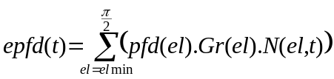 (11)
where:
pfd(el): the pfd from a RNSS satellite seen with an elevation angle el
Gr(el): the ARNS antenna gain for an elevation el
epfd(t) is a random variable which has a distribution function. To each observer latitude corresponds a different distribution function dist(lat).
APPENDIX 3
(to Annex 1)
Example of the calculation of the aggregate epfd produced
by two non-GSO and one GSO RNSS systems
In this example, three RNSS systems are planned to use the frequency range 1 164-1 215 MHz co-frequency. The main characteristics of the systems are shown in Tables 1 and 2. Only, one latitude (47°) will be considered here. The same computation has to be performed for latitude from 0 to 90°.
Table 1
Non-GSO Parameters
Non-GSO Parameters | Conventional symbol | Value system  1 | Value system  2
Altitude of orbit (km) | Hsat | 23 595 | 20 200
Number of satellites by orbit plane | N | 10 | 4
Number of orbit plane | M | 3 | 6
Inclination (in °) | I | 56 | 55
Pfd (el) | Pfd (el) | See Table 3 | See Table 3
Table 2
GSO Parameters
GSO Parameters | Conventional symbol | Value GSO satellite 1 | Value GSO satellite 2
Satellite Longitude (in°) | Long | 0 E | 20 E
Pfd (el) |  | See Table 3 | See Table 3
Table 3
Levels of pfd produced by a single satellite at the Earth's surface
θ, degrees | d, km  non-GSO system 1 | d, km  non-GSO system 2 | D, km  GSO system | G(δ), dB | pfd, dBW/m² in any 1 MHz band, per satellite  non-GSO: system 1 | pfd, dBW/m² in any 1 MHz band, per satellite  non-GSO: system 2 | pfd, dBW/m² in any 1 MHz band, per satellite  GSO system: one satellite
–3.5 | 29 679 | 26 194 | 42 287 | 10.0 | –129.53 | –136.35 | –135.49
0 | 29 287 | 25 801 | 41 895 | 10.0 | – 129.41 | –136.22 | –135.41
5 | 28 736 | 25 252 | 41 343 | 10.0 | –129.25 | –136.03 | –135.30
10 | 28 200 | 24 718 | 40 803 | 10.0 | –129.08 | –135.85 | –135.18
15 | 27 682 | 24 203 | 40 277 | 10.0 | –128.92 | –135.67 | –135.07
20 | 27 186 | 23 712 | 39 771 | 10.0 | –128.77 | –135.49 | –134.96
25 | 26 715 | 23 246 | 39 287 | 9.9 | –128.71 | –135.42 | –134.95
30 | 26 271 | 22 809 | 38 828 | 9.9 | –128.57 | –135.25 | –134.85
35 | 25 856 | 22 401 | 38 396 | 9.8 | –128.53 | –135.19 | –134.85
40 | 25 472 | 22 025 | 37 996 | 9.6 | –128.60 | –135.25 | –134.96
45 | 25 122 | 21 683 | 37 627 | 9.4 | –128.68 | –135.31 | –135.08
50 | 24 805 | 21 374 | 37 293 | 9.1 | –128.87 | –135.49 | –135.30
55 | 24 524 | 21 100 | 36 995 | 8.8 | –129.07 | –135.67 | –135.53
60 | 24 279 | 20 862 | 36 734 | 8.5 | –129.28 | –135.88 | –135.77
65 | 24 071 | 20 661 | 36 512 | 8.1 | –129.61 | –136.19 | –136.12
70 | 23 900 | 20 495 | 36 328 | 7.8 | –129.85 | –136.42 | –136.37
75 | 2.3 767 | 20 366 | 36 185 | 7.5 | –130.10 | –136.67 | –136.64
80 | 23 671 | 20 274 | 36 082 | 7.2 | –130.36 | –136.93 | –136.91
85 | 23 614 | 20 218 | 36 021 | 7.1 | –130.44 | –137.00 | –137.00
90 | 23 595 | 20 200 | 36 000 | 7.0 | –130.54 | –137.10 | –137.10

1 Visible arc position on the orbit m as a time dependent function
Only an example of one orbit of system 1 is presented below.

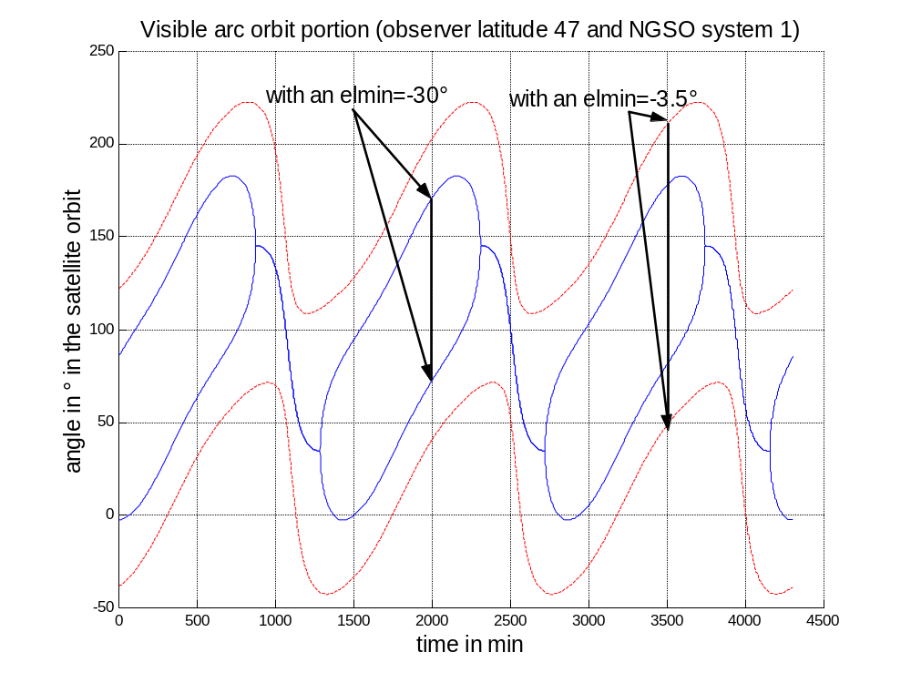

2 Satellite location on the orbit as a time variation function
The following figure gives an example of when a satellite is visible with an elevation between –3.5 and 30 ° when the observer is at latitude 47° (with non-GSO system 1). This can be performed with two elevations difference of 1°.

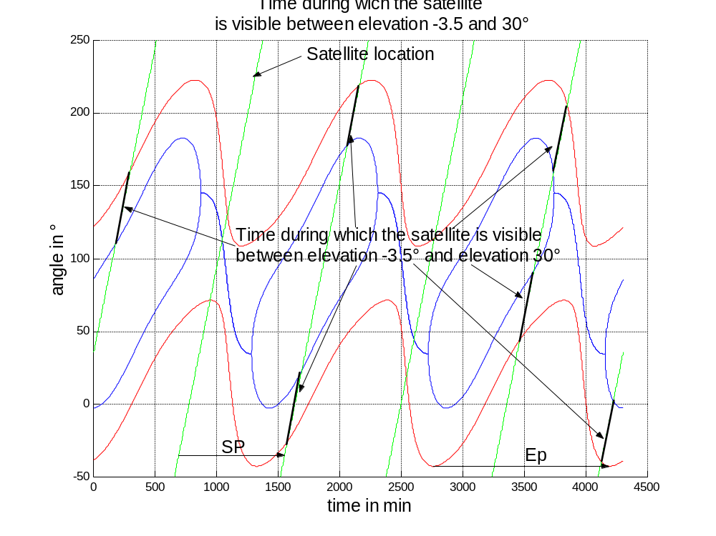

3 Number of satellites visible above –3.5°, 30° for non-GSO system 1
The following figures present on one hand, the number of satellites visible above an elevation angle of –3.5° and on the other hand the number of satellites visible above an elevation angle of 30°.

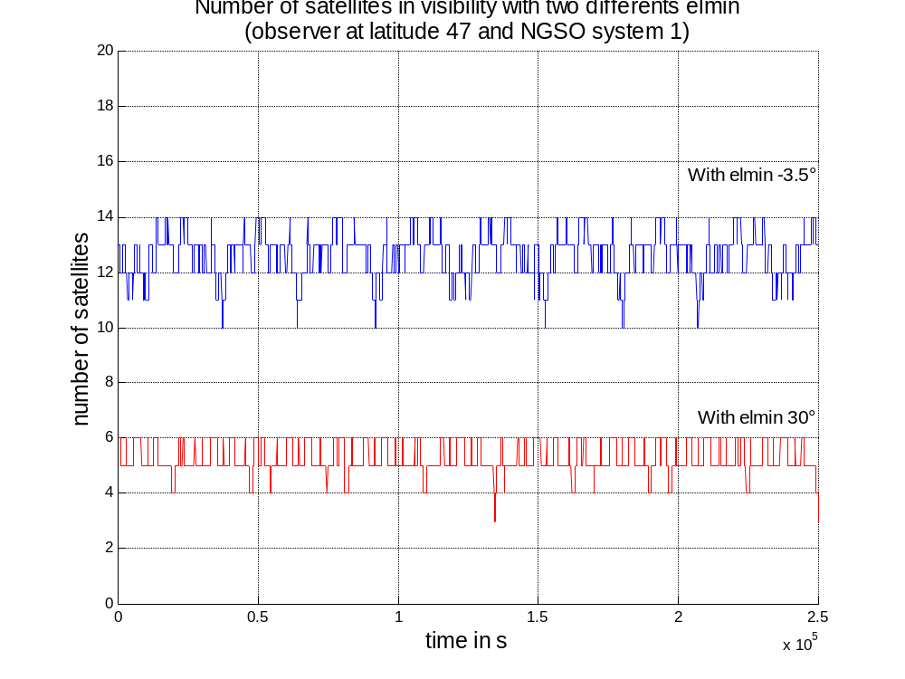

4 epfd distribution for system 1 (observer at latitude 47°)
Time representation result

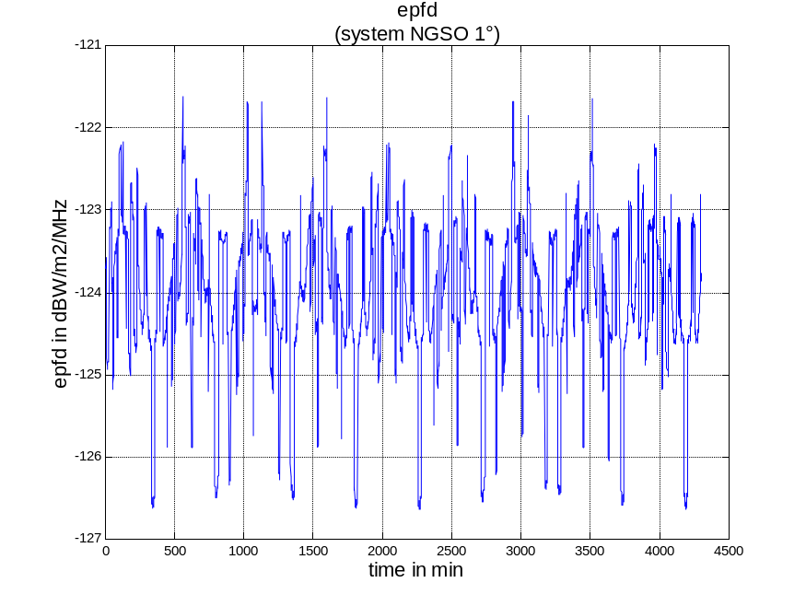
Distribution function
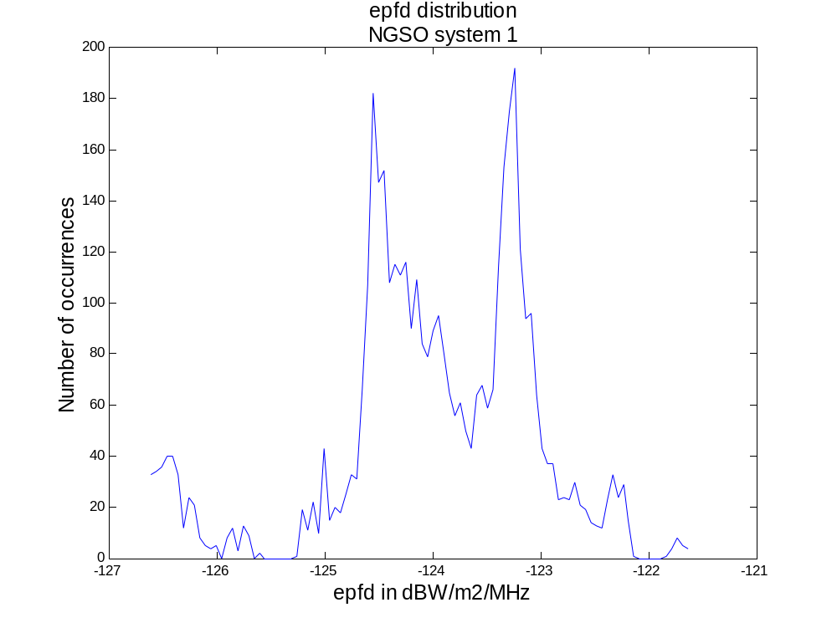

5 epfd distribution for system 2 (observer at latitude 47°)
Distribution function

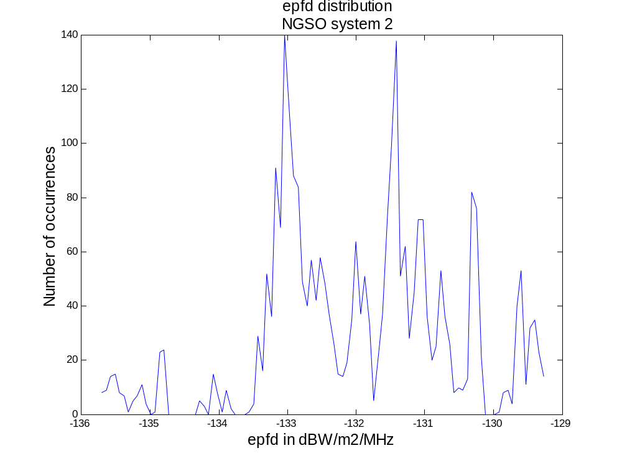

6 epfd distribution for the GSO system
Using equation 1 the elevation can be determined as a function of the observer longitude when the latitude is 47°:

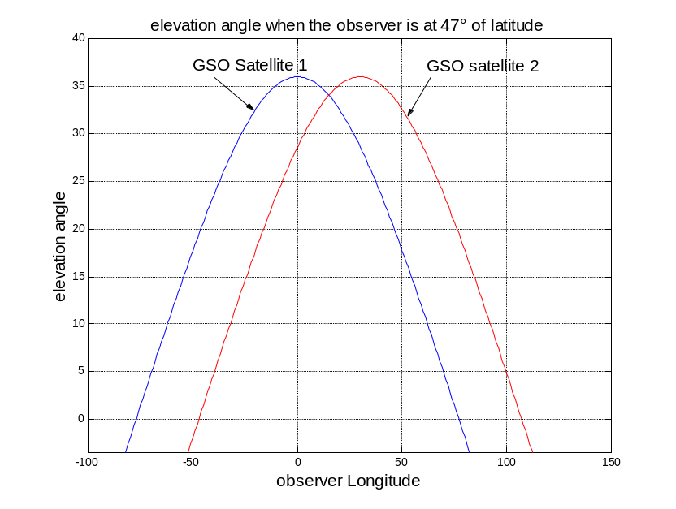
this provides directly the epfd as follow:
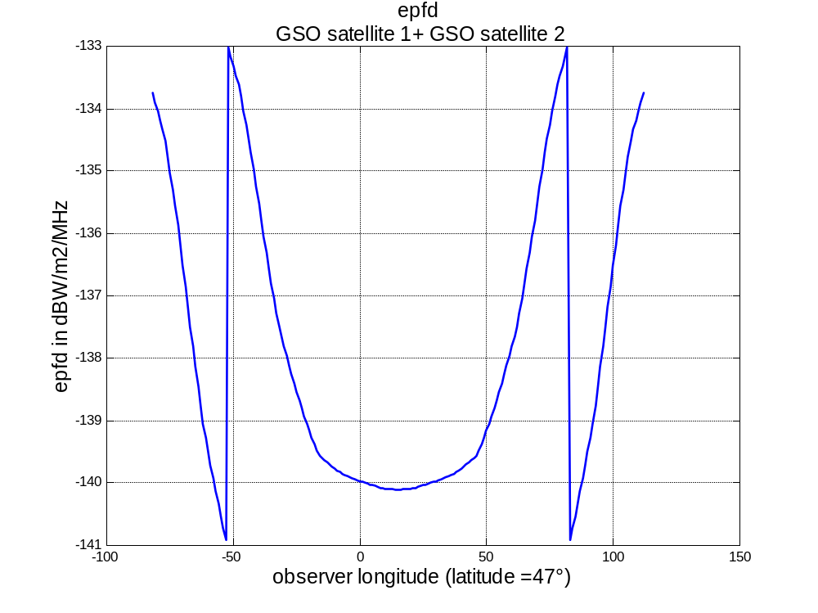
Distribution function
The worst epfd is –133 dB(W/m²/MHz).

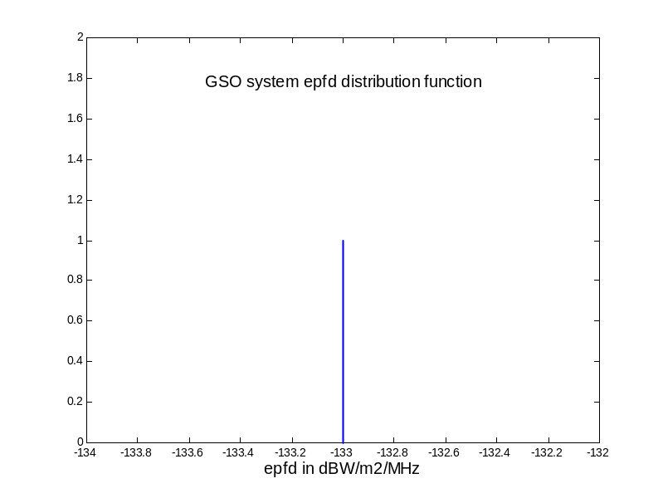

7 aggregate of all RNSS systems epfd distribution
The aggregate epfd for all RNSS systems distribution to be compared to the limit of –119.8 dB(W/m²/MHz) is obtained by the convolution of the 3 previous distributions (see sections 4, 5 and 7).
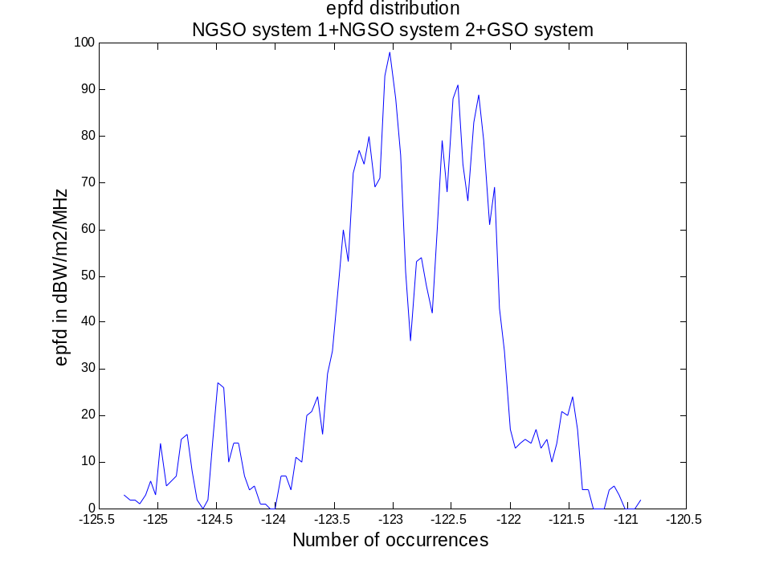
The cumulative distribution function is presented below and the aggregate epfd level corresponds to 1% of CDF is –121.45 dB(W/m²/MHz). This value has to be compared to the limit of –119.8 dB(W/m²/MHz).

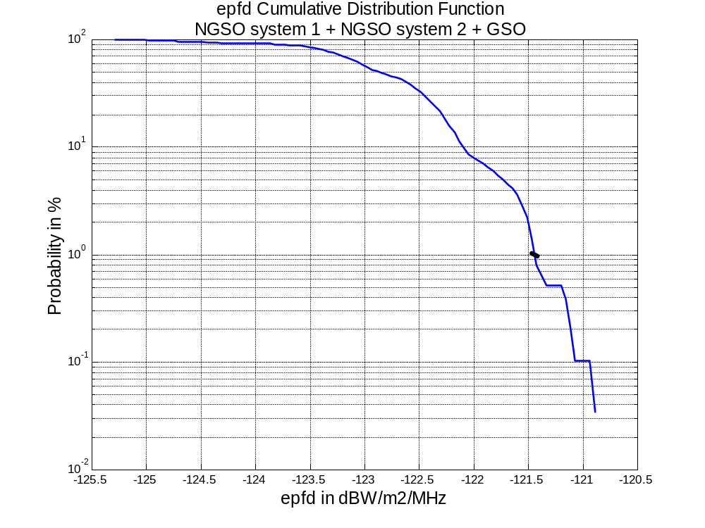

8 Conclusion of the computation example
The aggregate epfd for this example is below the aggregate epfd limit of –119.8 dB(W/m²/MHz). All those previous steps have to be computed for each latitude (0 to 90°) to determine the worst latitude case which will provide the result which should be below –119.8 dB(W/m²/MHz) for a CDF at 1% of the time.
ANNEX 2-2 [Second proposal]
Method for assessing the aggregate pfd from all RNSS
system space stations having circular orbits
The method set forth below for assessing the aggregate pfd from the space stations of all RNSS systems could be used for assessing the sharing between the radionavigation-satellite service and the aeronautical radionavigation service (DME/TACAN) in the band 1 164-1 215 MHz.
Shown below is a method for calculating the aggregate pfd from RNSS system space stations at a given point on the Earth's surface. The method is based on the assumption that the orbital constellation of satellites in RNSS systems involves circular orbits. Furthermore, the shape of the radiation pattern of the satellite antennas gives a more or less identical pfd level at the Earth's surface from the signal radiated by the different satellites, as well as an even coverage of the service area.
The pfd from a single signal (with a specific class of emission) from a satellite in an RNSS system in control band Δf is determined by means of the expression:
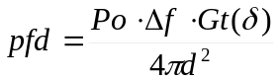 (W/m² in control band Δf Hz) (1)
where:
Po: maximum spectral power density supplied to the RNSS system satellite antenna (W/Hz)
Gt(δ): RNSS system satellite transmitting antenna gain in direction δ from the nadir
d: inclined distance from the satellite to a given point on the Earth's surface
For circular orbits, the inclined distance d is determined by the expression:
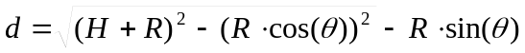 (m) (2)
where:
R: the Earth's radius (m)
H: altitude of the RNSS satellite orbit (m)
θ: angle of arrival of emission with respect to a horizontal plane (degrees). That angle is associated with the angle of deviation from the nadir δ by the following expression:
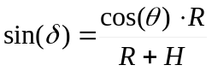 (3)
Using expressions (1-3), it is possible to determine the pfd produced by a single signal emitted by one satellite in an RNSS system for different angles of arrival θ with respect to a horizontal plane, and to determine the worst angle θ₁ and the corresponding angle δ₁ at which the pfd values will be greatest, i.e.:
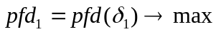
Taking into account the accepted assumption that existing RNSS systems produce a more or less identical level of signal power at the Earth's surface, the maximum aggregate pfd from all visible satellites may be determined by means of the following expression:
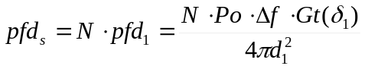 (4)
where:
N: maximum number of RNSS system satellites visible from a specific point on the Earth's surface and operating simultaneously in the same frequency band with the same class of emission (this parameter may be provided by RNSS system operators or be determined in accordance with the methodology set forth in Appendix 1).
It should be noted that expression (4) is true for cases of RNSS system satellites emitting signals on one carrier with a single class of emission. In the event of each satellite simultaneously emitting several radionavigation signals on a single carrier frequency with different classes of emission, the maximum aggregate pfd produced by all the emissions from all the visible RNSS system satellites may be determined by the expression:
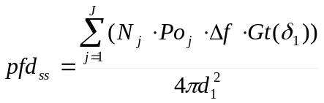 (5)
where:
J: number of signals with different classes of emission emitted simultaneously from one satellite on a single carrier.
Where several RNSS systems are operating simultaneously in the same frequency band, the aggregate pfd from all of the satellites in those systems may be determined by the expression:
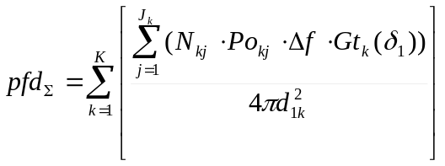 (6)
where:
K: number of RNSS systems operating simultaneously in the same frequency band.
It should be noted that the values of the parameter K must be determined on the basis of the possibility of sharing by different RNSS systems in the same frequency band.
An example of the use of this method, together with the results of an assessment of the degree of conformity with the data obtained by means of simulation modelling, are shown in Appendix 2.
Conclusion
The results obtained by means of the proposed method have shown that the calculated levels of aggregate pfd (Appendix 2) exceed by an insignificant amount the levels of aggregate pfd obtained by means of simulation modelling. The calculation error does not exceed one dB, which is comparable with the errors encountered in actual practice and may be acceptable.
appendix 1
(to Annex 2-2)
Method for calculating the number of satellites that are visible from a given point on the Earth's surface and operating in the same frequency band
The method set out below is for determining the number of satellites in a non-geostationary system that are visible from a given point on the Earth's surface and operating in the same frequency band. It may be used in compatibility calculations between RNSS system space stations and ARNS stations.
The probability of an elementary event - the finding of a subsatellite point of a space station in a non-geostationary RNSS system in elementary area A on the Earth's surface - is determined by means of the expression (Recommendation ITU-R S.1257):
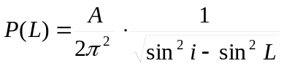 (7)
where:
i: inclination of satellite orbit (rad)
L: latitude of area A (rad).
Area A may be represented as an element in the area of visibility which, in spherical coordinates, is expressed as dA = dBdL, where dB and dL are elementary increments in longitude and latitude.
In the light of the foregoing, the probability of finding a subsatellite point of a space station in a non-geostationary RNSS system in the area of visibility may be determined by means of the expression:
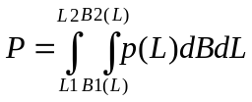 (8)
where:
L1 and L2: latitudinal boundaries of the area of visibility where the centre of the area of visibility is located at latitude Lo (rad):
L1 = –I where Lo–Q<–I, otherwise L1 = –Q + Lo, (9)

L2 = I where Lo + Q>I, otherwise L1 = Q + Lo, (10)
I = π –i where i >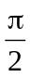, otherwise I = i; (11)
Q: arc of the great circle between the centre of the area of visibility and its edge:
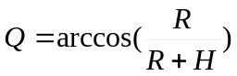 (12)
B1(L) and B2(L): longitudinal boundaries of the area of visibility at latitude L where the centre of the area of visibility is located at latitude Lo:
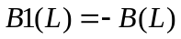 (13)
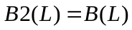 (14)
B(L): longitudinal difference modulus of the centre of the area of visibility and of the boundary of the area of visibility at latitude L:
B(L) = arccos(1 – v) where v < 2, otherwise B(L) = π, (15.1)
where: 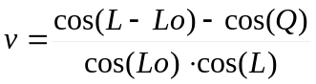 (15.2)
p(L): probability density:
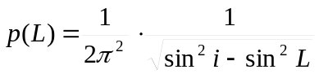 (16)
Given that p(L) is not dependent on B, but that 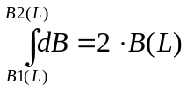, expression (8) may take the form:
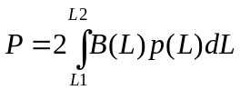 (17)
It is thus possible, using expressions (9-12 and 15-17) to determine the probability of finding a non-geostationary satellite in the area of visibility of an observer located at latitude Lo.
If we accept the assumption that satellite appearances in the area of visibility are independent events, the mathematical expectation of the number of visible satellites will be:
M = n ·P, (18)
where:
n: number of satellites in the system.
The orbital layout of RNSS systems is decided on the basis of the need to provide even coverage to the service area. Every effort is made to ensure that satellites within such a constellation are located evenly with respect to each other, such that their mutual positions are sufficiently stable. Proceeding on this basis, the assumption that was accepted above results in the obtaining of excessively high data by comparison with the actual data (see Appendix II). Having regard to the foregoing, we may use the following expression to calculate the maximum number of visible satellites in an RNSS system:
m = integer(M + 1). (19)
In order to determine the maximum number of visible satellites in an RNSS system that are operating in the same frequency band, it is necessary to take additional account of the multiple access method that is used by the RNSS system and of the necessary bandwidth for transmitting a single radionavigation signal.
The number of satellites operating in the area of visibility on a single frequency band with a specific class of emission may be determined from the following expressions:
– for systems using CDMA:
N = m; (20)
– for systems using FDMA/CDMA:
N = l integer(F/ΔF + 1) where m > l integer(F/ΔF + 1), otherwise N = m (21)
where:
F: necessary bandwidth for the specified class of emission
ΔF: frequency grid pitch
l: maximum possible number of RNSS system satellites using the same carrier frequencies in the area of visibility.
appendix 2
(to Annex 2-2)
Example of the calculation of the aggregate pfd produced by an RNSS system
By way of an example, an RNSS system is considered for which it is planned to use the frequency range 1 164-1 215 MHz. The main characteristics of the system are shown in Table 1.
table 1
Parameter | Conventional symbol | Value
Altitude of orbit (km) | H | 19 100
Inclination of orbit (degrees) | I | 64.8
Number of satellites in constellation | N | 24
Multiple access method |  | CDMA
Number of signals transmitted on a single carrier | J | 1
Necessary bandwidth (MHz) | F | 1.02
Maximum power density of satellite (dBW/Hz) | Po | −42.3
Radiation pattern of satellite transmitting antenna | G(δ) | See Figure 1.
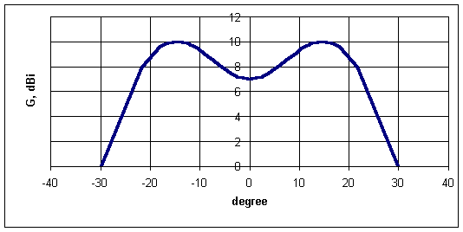
figure 1
Radiation pattern of the space station transmitting antenna
Equations (1-3) are used to determine the pfd produced by a single signal from one satellite at the Earth's surface in a 1 MHz band for different angles of arrival. The results of the calculations are shown in Table 2.
table 2
Levels of pfd produced by a single signal at the Earth's surface
θ, degrees | d, km | δ, degrees | G(δ), dB | pfd, dBW/m² in any 1 MHz band
0 | 24 661 | 14.49 | 10.0 | −131.13
5 | 24 112 | 14.43 | 10.0 | −130.94
10 | 23 580 | 14.26 | 10.0 | −130.74
15 | 23 067 | 13.98 | 10.0 | −130.56
20 | 22 578 | 13.59 | 10.0 | −130.39
25 | 22 115 | 13.10 | 9.9 | −130.25
30 | 21 681 | 12.51 | 9.9 | −130.15
35 | 21 276 | 11.82 | 9.8 | −130.10
40 | 20 904 | 11.05 | 9.6 | −130.10
45 | 20 564 | 10.19 | 9.4 | −130.16
50 | 20 259 | 9.25 | 9.1 | −130.29
55 | 19 989 | 8.25 | 8.8 | −130.49
60 | 19 754 | 7.18 | 8.5 | −130.73
65 | 19 554 | 6.07 | 8.1 | −131.00
70 | 19 391 | 4.91 | 7.8 | −131.27
75 | 19 264 | 3.71 | 7.5 | −131.53
80 | 19 173 | 2.49 | 7.2 | −131.73
85 | 19 118 | 1.25 | 7.1 | −131.87
90 | 19 100 | 0.00 | 7.0 | −131.91
It can be seen from Table 2 that where angle δ₁ = 11.82 degrees, the pfd values will be greatest.
Expressions (9-12 and 15-19) are used to determine the probability of finding an RNSS system satellite in the area of visibility of an observer located at different latitudes, as well as the corresponding mathematical expectation and maximum value in respect of the number of visible satellites (Table 3).
table 3
Probability data for the number of visible RNSS system satellites
Lo, degrees | P | M | m
0 | 0.539 | 12.936 | 13
20 | 0.493 | 11.832 | 12
40 | 0.56 | 13.44 | 14
60 | 0.625 | 15 | 16
80 | 0.641 | 15.384 | 16
In accordance with expression (20), all the satellites in the RNSS system in question that are located within the area of visibility are operating on the same frequency band.
Expression (6) is used to determine the maximum aggregate pfd produced by the emissions of all of the visible RNSS system satellites.
The results of the calculations are shown in Table 4. In addition, Table 4 and Figures 2 and 3 show the calculation results obtained by means of simulation modelling of the RNSS system in question.
table 4
Maximum aggregate pfd resulting from the emissions of all of the
visible RNSS system satellites, dBW/m² in any 1 MHz band
Lo, degrees | 0 | 20 | 40 | 60 | 80
Calculations | −118.91 | −119.26 | −118.59 | −118.01 | −118.01
Modelling | −121.42 | −120.87 | −120.92 | −120.62 | −120.62

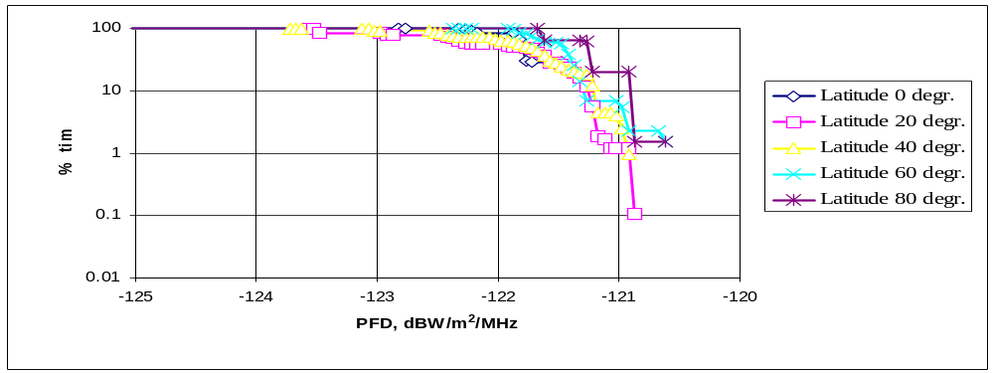
figure 2
Aggregate pfd produced by all of the RNSS system satellites visible to
an observer at different latitudes (simulation modelling)

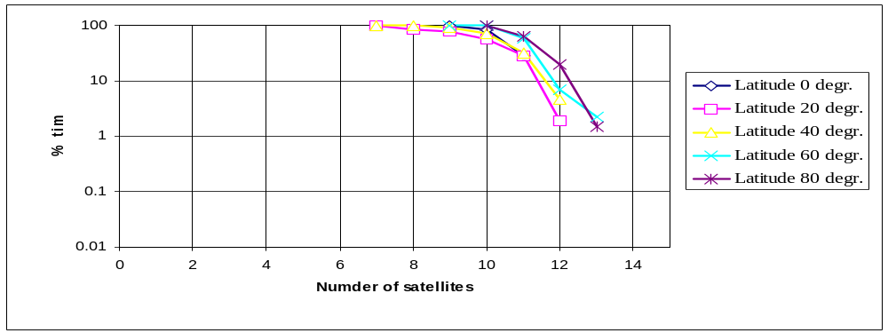
figure 3
Number of RNSS system satellites visible to an observer
at different latitudes (simulation modelling)
As can be seen from the above data, the aggregate pfd levels calculated by means of the above-mentioned method are slightly higher than the pfd levels obtained by means of the simulation model.
The above calculations show that the aggregate pfd level from an RNSS system operating in the frequency range 1 164-1 215 MHz does not exceed –118 dBW/m²/MHz, which corresponds to the pfd limit of –115 dBW/m² in any 1 MHz band laid down in No. S5.328A of the Radio Regulations.
ANNEX 2-3 [third proposal]
Methodology for assessing the aggregate epfd of RNSS operating in the
band 1 164-1 215 MHz to distance measuring equipment and tactical
air navigation system (DME/TACAN) receivers in determining the relation
of aggregate epfd to aggregate pfd

1 Introduction
To determine need for a pfd limit on RNSS for protection of DME/TACAN receivers, it is first desirable to determine the level of epfd caused by RNSS to DME/TACAN. When the level of RNSS epfd is known, one can then determine a level of pfd needed to support a maximum level of RFI. After such a pfd value is obtained, the restrictions on the RNSS itself can then be determined. If those restrictions are excessive, then a pfd limit may be deemed inappropriate.
The intent here is to show how the aggregate epfd of an RNSS can be evaluated and related to the aggregate pfd of that RNSS.

2 Formulation for aggregates of epfd, pfd and antenna gain
This section gives a formulation for the aggregates of epfd, power flux-density (pfd), and antenna gain.

2.1 Single-entry epfd
The epfd is, for a single transmitter, given by:
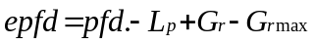 (1)
where:
L_{p} is the polarization loss (dB) associated with the polarization mismatch between the transmitted signal and the receiver antenna
G_{r} is the receiver-antenna's gain (dBi) in the direction of the transmitter
Grmax is the maximum receiver-antenna’s gain (dBi)
pfd received power flux density in dBW/m²/MHz

2.2 Aggregate epfd
Equation 1 is for a single transmitter. The total power is the sum over all the transmitters and is given as:
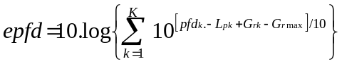 (2)
where:
K is the number of transmitters
k uniquely denotes a transmitter
The other notation is defined as for equation 1, except that the "k" subscript means the term is defined relative to the k-th transmitter. Note that the receiver gain, G_{r,k}, varies by k; i.e., the transmitter, only because the direction from the receiver antenna to transmitters varies by transmitter, but the receiver antenna is the same.
To simplify this analysis, we now make some assumptions:
1) The pfd_{k} is taken to be the maximum expected from the RNSS for all k
2) L_{p,k} is assumed to be the same constant for all k
Using these assumptions, Equation 2 simplifies to:
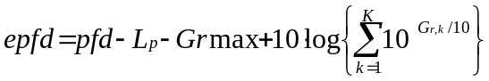 (3)
where the dependency on the transmitter now only appears in the gain, G_{r,k}.
Note that the only factor that is varies with time is the last term; viz., 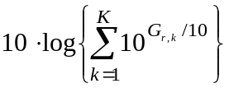.

2.3 Comparison of _{epfd}, aggregate power flux-density, pfd_{A}, and aggregate gain, G_{A}
We can write the pfd due to a single transmitter as:
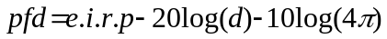 (4)
where:
pfd is the pfd (dBW/m²/MHz)
d is the distance between the transmitter and receiver antennas (m)
The aggregate pfd, as in equation 3 of Annex 1A, is just the sum individual pfds:
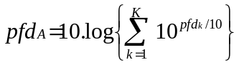 (5)
Now using the same assumptions as in section 2.2, the aggregate pfd simplifies to:
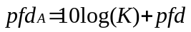 (6)
The only pfd term that varies with time is K, the number of satellites in view. This is in contrast to the interference power's aggregate-gain term:
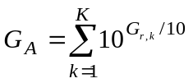
The numerical difference between I_{A} and G_{A}, in decibels, is:
where:
Gr is assumed to be the average G_{r,k}
Since the errors introduced by the assumptions used are small, for current RNSS systems, it is now necessary to examine how K and G_{A} term are related.

2.4 Comparison of epfd and pfd_{A}
For successful application of a pfd limit, there must be a simple relationship between the aggregate interference power, epfd , and the aggregate pfd, pfd_{A}. If these terms are directly proportional to one another, then it is indeed appropriate to set a pfd limit.
In the following sections, there are simplified approximations of epfd and pfd_{A}. Then an example based on GPS is provided.

2.5 A statistical approximation for epfd
For a uniformly random elevation, we can now calculate the statistics of epfd. The mean gain towards a single transmitter is simply:
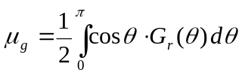 (7)
The variance towards a single transmitter is:
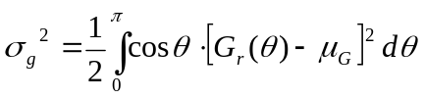 (8)
For uniformly random constellation positions, we have, based on the law of large numbers, a normal distribution for the aggregate gain, G_{A}, with a mean of 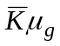 and standard deviation 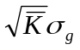. The mean value of the number of visible satellites,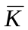, is 8.977. By direct calculation, the value of μ_{g} is 0.36 and σ_{g} is 0.827 so one can estimate that G_{A} has a normal distribution with mean 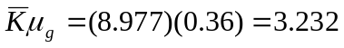 and standard deviation 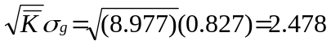.

2.6 The DME receiver antenna pattern
The gain of DME receiver antennas usually falls between –1 and 5 dBi. Since pfd limits are better suited to systems that have significant interference from a wide field of view, the gain of the DME antenna will be taken as 3 dBi for the purposes of this example. Higher gains will tend to accentuate differences between K and G_{r}.
For a DME receiver antenna pattern, the one given in Annex 2, Figure 2, is used. In particular, the heavier line is used. Table 1 lists the gain values. This is a broader pattern than the measured pattern, and it will tend to attenuate the differences between K and G_{r}.
Table 1
Gain vs. elevation angle
Elevation | dB-peak | DBi
0°-10° | 0 | 3
10°-20° | –10 | –7
20°-50° | –12.5 | –9.5
50°-65° | –15 | –12
65°-180° | –20 | –17
For the azimuth, it is assumed that the elevation and gain pattern is the same for all azimuth angles. (In operation the DME antenna may simply rotate.)

2.7 A GPS example
By direct calculation, the value of μ_{g} is 0.36, from equation 9, and σ_{g} is 0.827, from Equation 10, so one can estimate that G_{A} has a normal distribution with mean ; i.e., 5.09 dB, and standard deviation 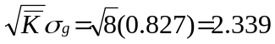. Note that the normal distribution has 97.7% of its sample values below two standard deviations plus the mean, and assuming a normal approximation, 97.7% of the time G_{A} is less than 7.91; i.e. 8.98 dB.
For transmitted power, it was assumed that all the GPS satellites transmitted on a MHz bandwidth centered on 1 176.45 MHz with a r.i.p. of –154 dBW at 0º elevation. Assuming isotropic radiators on the satellites, this translates to an equivalent isotropically radiated power (e.i.r.p.) of 31 dBW on each satellite.
The assumed noise figure (NF) for the DME receiver was 2 dB, and the assumed receiver bandwidth was 650 kHz centred on the L5 centre frequency of 1 176.45 MHz. This gives an OTR factor of 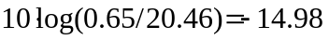dB. No polarization loss, L_{p}, was also assumed. Then by Equation 3, (isotropic) epfd; i.e. Grmax=0 dBi,
(dBW/m²/MHz)
and epfd is less than –160.18 + 8.98 = –151.2 dB 97.7% of the time. By Equation 6, we have
(dBW/m²/MHz)
or less for 97.7% of the time.

3 Conclusion
A method to simplify the calculation of aggregate epfd or pfd has been presented. This method has the benefit of avoiding simulation of non-GSO RNSS operations, but it remains to be validated by measurements, simulations, or other appropriate methods.

_________________

* Values from Report of the Global Navigation Satellite Systems Panel WGB Spectrum Subgroup Meeting, 10-14 September 2001, ICAO, Montreal, Canada.
This proposed 1%, needs to be coordinated with ICAO.

