 | INTERNATIONAL TELECOMMUNICATION UNION | AMCP WF7/WP11
 | RADIOCOMMUNICATION  STUDY GROUPS | Document 8D/TEMP/136-E  30 October 2001  English only
Source: Document 8D/174
Working Party 8D
(DG 8D2B)
draft working document
Contribution towards identification of scenarios where real-time pre-emption would be required

1 Introduction
A work plan to study feasibility and practicability of prioritization and real-time pre-emptive access between different networks of MSS in the bands 1 545-1 555 MHz and 1 646.5-1 656.5 MHz, based on Resolution 222 (WRC-2000) was established at the eleventh meeting of WP 8D.
This document provides characteristics of AMS(R)S communications that may be useful for identifying scenarios where real-time pre-emption between networks would be required.

2 Characteristics of AMS(R)S communications

2.1 AMSS communications
According to ICAO definitions (Annex 10, Vol. III, Chapter 3), AMSS communications consist of the following communications:
a) ATSC (air traffic service communication):
Communication related to air traffic services including air traffic control, aeronautical and meteorological information, position reporting and service related to safety and regularity of flight.
b) AOC (aeronautical operational control):
Communication required for the exercise of authority over the initiation, continuation, diversion or termination of flight for safety, regularity and efficiency reasons.
c) AAC (aeronautical administrative communication).
d) APC (aeronautical passenger communication).
As a safety service, AMS(R)S communications include ATSC and AOC above.

2.2 Types of AMS(R)S communications and FIR organization
There are two kinds of AMS(R)S communications: data and voice. It is necessary to handle them separately because their natures are different.
Data communication is mainly used for routine communications such as air traffic control and aeronautical operational control. There are two different natures of channel requirements, such as indispensable channels to be assigned to each beam for communication control, channels to be assigned to each airspace for air traffic control and flight information service, and other AOC communication channels proportional to the number of operating aircraft.
As for voice communication, it is mainly used for transmission of non-routine information that data communication would have some difficulties with. Accordingly it is necessary to reserve at least one channel per designated operational coverage area (sector) in the flight information region (FIR) for the need of unexpected communication such as in the case of sudden meteorological deterioration, situations causing a risk to the aircraft and revision of flight plan. For AOC communications, their traffic will be proportional to the number of operating aircraft as usual, except in non-routine situations.
Figure 1 illustrates the concept of the flight information region (FIR) divided into sectors.

2.3 Required performance of AMS(R)S communications
a) Transmission quality and reliability (availability)
The most important issue for aeronautical safety communications is that communication channels shall be surely established when required.
It is observed that characteristics of general telecommunication channels other than AMS(R)S, such as public telephone or entertainment broadband data transmission, are primarily concerned with transmission quality such as frequency response and distortion.
For the reliable communication for ATSC related services, AMS(R)S requires, for both data and voice communications, higher channel availability, integrity and continuity of service compared to that for general communication channels and higher response of channel access such as within a few seconds' delay even in the busy hour.
b) Service area and beams
From an operational and economical point of view, it is generally desired that normal traffic in a wide area will be handled by the global beam, and high traffic in congested airspace will be handled by spot beams.

3 Estimation of peak instantaneous aircraft count (PIAC)
For identifying scenarios where real-time pre-emption would be required, it may be useful to estimate characteristics of peak instantaneous aircraft count (PIAC) using satellite communications.
a) Conditions of estimation
To estimate PIAC, it is necessary to identify the following, inter alia:
− applicable airspace: North Pacific, South East Asia, etc.;
− season or time slot: both in the busiest hour and off-peak hour, etc.;
− category of aircraft operation: scheduled, non-scheduled, etc.;
− types of avionics.
b) Target year's PIAC
Generally, the number of operating aircraft widely varies and needs to be investigated on an hourly, daily and seasonal basis. Peak value in the most busy hour in the year shall be obtained, or estimated by taking into account the growth rate for the year. The reference PIAC for the scheduled flight in some specific (reference) year may be obtained by investigating an airlines timetable database for the year, such as OAG (official airlines guide). An example of daily PIAC variation in Asia and the Pacific area is shown in Figure 2.
The basic PIAC for scheduled flights of the target year, which is N years later than the reference year, may be obtained by reference PIAC applying growth factor obtained by statistical data or yearly growth rate based on the economical growth.
The PIAC of non-scheduled flights may be estimated by applying the ratio of scheduled and non-scheduled flights. The PIAC of general aviation (GA) may be estimated by applying the ratio of scheduled and GA flights based on the statistical data of GA flight hours.
The target year's PIAC is then obtained by summing up the above PIACs, for scheduled flights, for non-scheduled flights and for general aviation.
c) PIAC using satellite communications
The PIAC using satellite communications in the specified airspace may be obtained as the product of target year's PIAC and the ratio of aircraft using satellite communication.
It is considered that communication traffic is nearly proportional to the number of the aircraft operating aircraft.

4 Conclusion
For the study of feasibility and practicability of prioritization and real-time pre-emptive access between different networks of MSS, it may be useful to consider requirements for the AMS(R)S communications and their characteristics as presented above.
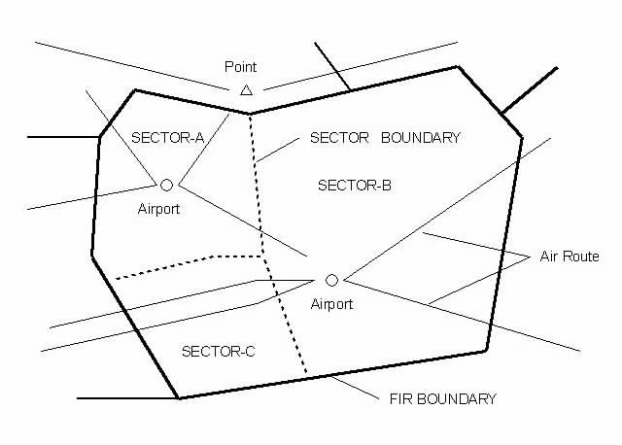
Figure 1
Concept of FIR and sector
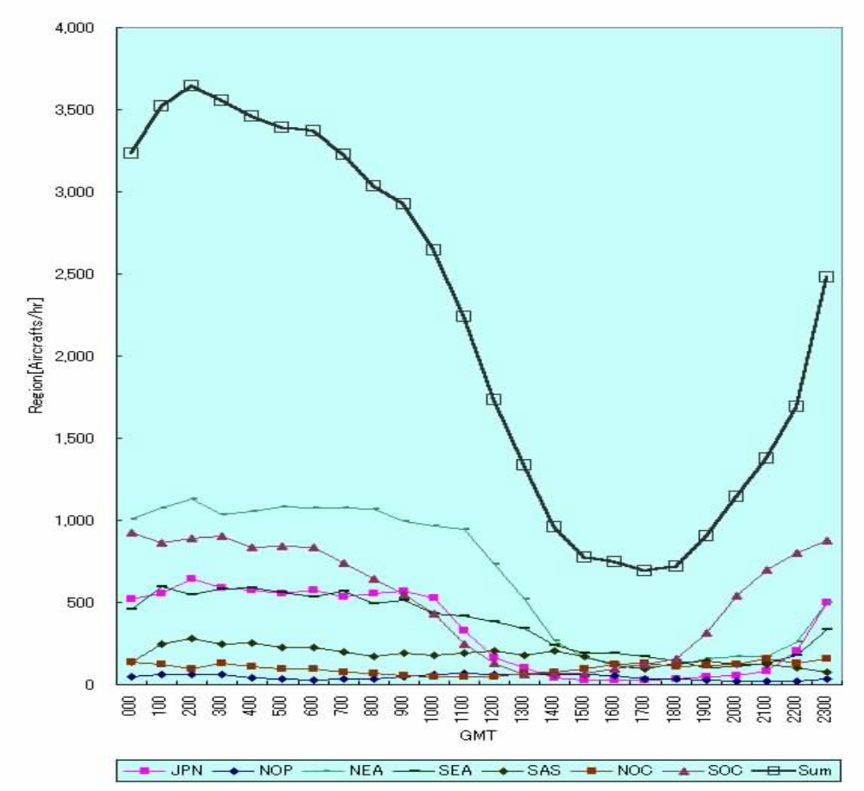
NOTES: | JPN: Japan  SEA: South East Asia  SOC: South Oceania | NOP: Northern Pacific  SAS: South Asia | NEA: North East Asia  NOC: North Oceania  Sum: Summation
Figure 2
Example of PIAC (Asia and Pacific zone )

______________

