|  |  |  |  |  |
| --- | --- | --- | --- | --- |
| C:\Program Files\Default Company Name\ICAOMainMenuSetup\Icons\icaologo.jpg | International Civil Aviation Organization  **WORKING PAPER** | |  | | --- | | ACP-WGF30/WP27 -  2014-03-17 | |  | |

**AERONAUTICAL COMMUNICATIONS PANEL (ACP)**

**30TH MEETING OF THE WORKING GROUP F**

**Pattaya, Thailand 13 – 19 March 2014**

|  |  |
| --- | --- |
| **Agenda Item 10:** | **Any other business** |

UK radar remediation programme

(Presented by *John Mettrop*)

|  |
| --- |
| **SUMMARY** |
| The UK has identified a potential vulnerability of aeronautical radars that operate in the band 2 700-3 100 MHz with respect to transmissions in the frequency bands 2 500-2 690 MHz and 3 400-3 600 MHz. The issue has been attributed to a number of issues including inadequate radar receiver selectivity to adjacent band transmissions, inter-modulation products produced in the radar receiver and spurious emissions from LTE equipment falling in the pass-band of the radar receiver. This paper provides information on the quantification of the issue, the modifications required in the radar and the regulatory requirements placed on the LTE equipment. |
| **ACTION** |
| The ACP WGF is invited to:   * Note the content of the paper |

1. INTRODUCTION
   1. This paper sets out information on the receiver performance of some aeronautical radars operating within the frequency band 2 700-3 100 MHz and the potential susceptibility to transmissions in adjacent bands, which can include those of wireless base-stations operating within the frequency bands 2 500-2 690 MHz. This paper highlights the key UK findings on the potential shortfall in selectivity performance of aeronautical radars, the mitigation required and the regulatory measures taken to ensure that spurious emissions from LTE equipment deployed below 2 690 MHz does not cause interference to aeronautical radars operating above 2 700 MHz.
2. background
   1. Agenda item 1.6 of the 2000 World Radiocommunications Conference sought to identify additional global frequency bands for the terrestrial component of IMT-2000. As a result of this agenda item footnote **5.384A**[1] was added to identify that the mobile allocations in the frequency range 2 500‑2 690 MHz could be used by IMT-2000 by those administrations wishing to implement such applications. This footnote was later amended to include the frequency band 2 300-2 400 MHz and remove the 2000 designation after IMT.
   2. In Europe the Commission has harmonised the use of the frequency band 2 500-2 690 MHz for terrestrial systems capable of providing electronic communications services (Commission Decision 2008/477/EC). The use shall be on a technology and service neutral basis. Member States are required to designate and subsequently make available, on a non-exclusive basis, the frequency band 2 500-2 690 MHz for terrestrial systems capable of providing electronic communications services in compliance with certain RF parameters including maximum in-band EIRP level. World-wide the frequency band 2 500-2 690 MHz has been made available for wide-area mobile services.
   3. The frequency band 2 700-2 900 MHz is separated from the frequency band 2 500-2 690 MHz by 10 MHz. The assumption at the time the allocation below 2 690 MHz was made to the mobile service was that there was not a problem due to the frequency separation.
3. Studies Carried out in The UK
   1. **Initial study (2008)**
      1. As a part of the on-going preparations to make the frequency band 2 500-2 690 MHz available for new applications in the UK, Ofcom commissioned a study from ERA Technology Ltd (now called Cobham Technical Services) to conduct a study to assess the potential out of band emissions from radar operating above 2 700 MHz that would be experienced by mobile systems operating below 2 690 MHz. Whilst undertaking these studies ERA Technology, having some spare time and with Ofcom’s consent, carried out a number of trials to assess the susceptibility of m operating above 2 700 MHz to transmissions in the frequency band 2 500-2 690 MHz to confirm the resilience of radar to LTE signals below 2 690 MHz. The objective of the trials were to assess the maximum LTE signal level that could be tolerated by a radar in terms of out-of-band interference into the Radar IF; blocking performance due to the effects of amplifier saturation within the Radar receiver and radar adjacent channel selectivity.
      2. For this study, ERA conducted trials using a test Radar into which they injected four types of adjacent band signal (CW, AWGN, and test WiMAX /UMTS signals) and measured the impact on the radar performance for both co-frequency as well as at various frequency offsets from the radar centre frequency. A report was produced by those conducting the studies in October 2008 the main findings of which are given below:-
         1. **Co-channel interference** 
            1. The results for continuous interference (i.e. interference continuously present on all azimuths) show that there is good correlation between the modelled radar performance and the measured results for the injected tests. The theoretical noise floor of the radar was calculated at -110 dBm and the values below show the measured interference level required to reduce the probability of detection (Pd) from an initial level that is varied relative to a Reference Signal Level (RSL) to 50% allowing for measurement tolerances. The wanted return signal level was then adjusted in order to simulate various probabilities of detection in the absence of interference, noting that the RSL + 0.2 dB case equates to a radar suffering interference at an I/N level of -10 dB. Comparing theory, which would predict for the case of RSL + 0.2 dB an interference level of -120 dBm, with the results given below shows good correlation

|  |  |  |  |  |
| --- | --- | --- | --- | --- |
| **Interference type** | **Interference level (dBm/3 MHz)** | | | |
| **RSL + 0.2 dB  (90 to 88%; 70% to 66%; 60 to 55%)** | **RSL + 1 dB**  **(70% to 50%)** | **RSL + 2 dB**  **(90% to 50%)** | **RSL + 3 dB**  **(100% to 50%)** |
| **AWGN 2.5 MHz** | -120 | -115 | -111 | -108 |
| **UMTS downlink** | -118 | -111.5 | -108 | -106.5 |
| **WiMAX (5 bursts)** | -117.5 | -113 | -108.5 | -104.5 |

**Table 1: Summary of Co-Frequency Results for Continuous Interference in IF Filter**

* + - * 1. It was noted that continuous interference received in all azimuths represented a worst case scenario. The continuous interference case was simulated at the start of the measurements programme to simplify the test setup and ensure that worst-case scenarios were properly understood. Momentary interference generation was later adopted within the tests, which better reflects the case of a radar beam sweeping past an adjacent channel transmission. For momentary interference, the level of interference required to produce the same loss of Pd was 7 to 10 dB higher than the results indicated in Table 1 above (i.e., allowing for more interference power to cause the same degradation in Pd)**.**
      1. **Adjacent Channel Interference**
         1. A theoretical study was conducted as a part of the ERA study into a first approximation of how the radar receiver response to CW signals varies with frequency, considering the impact of the various components of the system. The result of this study are shown below, however it should be noted that this study assumes that the lowest tuneable frequency is 2 700 MHz which is incorrect and should have been taken as 2 750 MHz for the radar type under consideration and hence the results should be shifted by 50 MHz (i.e. with radar carrier at 2 750 MHz instead 2 700 MHz).



**Figure 1: Theoretical modelling (first approximation) of CW Interference effects   
for test radar (assuming an assigned carrier at 2 700 MHz)**

* + - * 1. Injected testing were then carried out to measure how the radar receiver responded as the interfering signal varied with frequency for various levels of probability of detection in the absence of interference. A summary of those results is given below:-

|  |  |  |  |  |
| --- | --- | --- | --- | --- |
| **Frequency offset** | **Interference level (dBm)** | | | |
| **RSL + 0.2 dB  (90 to 88%; 70% to 66%; 60 to 55%)** | **RSL + 1 dB**  **(70% to 50%)** | **RSL + 2 dB**  **(90% to 50%)** | **RSL + 3 dB**  **(100% to 50%)** |
| **12.5 MHz** | -85.5 | -79.5 | -74.5 | -76 |
| **25 MHz** | -51 | -46.5 | -45 | -43.5 |
| **50 MHz** | -48 | -45 | -44 | -41 |
| **100 MHz** | -48 | -45 | -44 | -41 |

Table 2: Summary of results for CW with continuous injected interference

* + - * 1. Superimposing the results for RSL + 0.2 dB on the approximate theoretical response results in the following diagram. Comparison of the modelled and measured results for (RSL + 1 dB) and (RSL + 3 dB) are contained in the referenced study report:-

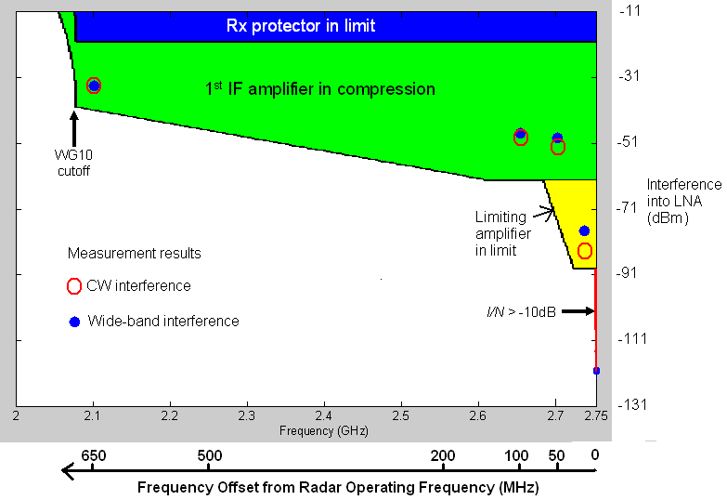

**Figure 2: Comparison of first approximation modelling of the test radar with   
injected measurements using RSL + 0.2 dB**

* + - * 1. The results indicated that the proposed signal levels within the frequency band 2 500‑2 690 MHz from LTE transmissions would impact on the performance of the radar type tested operating above 2 700 MHz. The opinions of the Civil Aviation Authority and the Ministry of Defence were sought in May 2009. Both confirmed that they regarded these results as significant and that they warranted further investigation and that unless action was taken to address the impact of LTE signals below 2 690 MHz on the performance of this radar type operation of this type of radar would have to be restricted or banned. The result of which would be the reduction in traffic an airport using such radar would be able to handle as it would have to use procedural approaches (estimate for Heathrow 48 landings per hour down to 15 per hour).
        2. As a result of discussions between Ofcom, Civil Aviation Authority and the Ministry of Defence it was agreed that further studies were required. Firstly the results of the injected testing needed to be validated through radiated trials. Secondly work would be needed to investigate, if necessary, how the radar receivers could be modified such that their adjacent band rejection would be improved without impacting the operational performance of the radars. Finally work was needed to investigate whether these results were an indication of a generic issue relevant to all radar types or specific to the test radar type under consideration. Further work was therefore commissioned.
  1. **Flight Trials, Phase 1 (2009)**
     1. The initial study focused on conducted tests and provided estimates of adjacent band transmission levels into the radar low noise amplifier that would cause a certain level of degradation to non fluctuating targets and therefore represented the worst case scenario. These flight trials used radiated measurements with the interference source being located in the main beam of the radar under test at a range of 350 metres. The target aircraft was a King Air B200 with a radar cross section (nose on) of 3.5 square metres that was provided by Cobham Flight Precision.
     2. A total of 18 runs were performed using various interference waveforms and at various signal levels. Each run was initiated at 54 nm (within the instrumented range of the radar) and terminated at 28 nm with the aircraft maintaining a velocity of between 220-230 kts. The probability of detection was assessed from 50 nm to 30 nm to ensure that the aircraft was in stable flight along the predetermined flight path. Attenuation was applied in the radar receiver font end to emulate an aircraft with a cross sectional area of 1 square metre.
     3. The test radar has three processing channels: Normal Radar (NR), Ground Clutter Filter (GCF) and Moving Clutter Filter (MCF).They will yield different results for signal and interference depending on the correlation of these signal inputs and Constant False Alarm Rate (CFAR). The output of these three channels are combined using an “OR” function, but they can be separately switched On/Off.  The NR channel has the lowest Signal to Noise Ratio (SNR) for a given Pd.  The effective detection thresholds for GCF and MCF are higher due to the processing required to remove clutter etc. During the testing, the NR and GCF outputs were used and the results obtained are shown below:-

|  |  |  |  |  |  |
| --- | --- | --- | --- | --- | --- |
| **Run** | **Radar channel** | **Interference type** | **Interference frequency** | **Interference level, EIRP (dBm) at 350 m** | **Probability of detection  (Average over 50 nm to 30 nm)** |
| 1 | NR | CW | 2 690 MHz | OFF | 95% |
| 2 | NR | CW | 2 690 MHz | Level 1 = 50 dBm | 0% |
| 3 | NR | CW | 2 690 MHz | Level 2 = 35 dBm | 91% |
| 4 | NR | CW | 2 690 MHz | Level 3 = 20 dBm | 92% |
| 5 | GCF | CW | 2 690 MHz | OFF | 90% |
| 6 | GCF | CW | 2 690 MHz | Level 1 = 50 dBm | 19% |
| 7 | GCF | CW | 2 690 MHz | Level 2 = 35 dBm | 82% |
| 8 | GCF | CW | 2 690 MHz | Level 3 = 20 dBm | 76% |
| 9 | NR | AWGN 10 MHz | 2 690 MHz | Level 1 = 50 dBm | 0% |
| 10 | NR | AWGN 10 MHz | 2 690 MHz | Level 2 = 35 dBm | 69% |
| 11 | NR | AWGN 10 MHz | 2 690 MHz | Level 3 = 20 dBm | 92% |
| 12 | GCF | AWGN 10 MHz | 2 690 MHz | Level 2 = 50 dBm | 65% |
| 13 | NR | WiMAX 80% | 2 690 MHz | Level 1 = 35 dBm | 0% |
| 14 | NR | WiMAX 80% | 2 690 MHz | Level 2 = 50 dBm | 88% |
| 15 | NR | WiMAX 80% | 2 690 MHz | Level 3 = 35 dBm | 95.5% |
| 16 | NR | CW | 2 600 MHz | Level 1 = 50 dBm | 53% |
| 17 | NR | CW | 2 600 MHz | Level 2 = 35 dBm | 95.5% |
| 18 | NR | CW | 3 400 MHz | Level 2 = 35 dBm | 18% |

**Table 3:Log of interference tests for each flight run and the average Pd for that run**

* + 1. As would be expected, the probability of detection varied for each run with distance and the graph below illustrates the case for runs conducted when the Normal Radar channel was selected:



**Figure 3: Aircraft runs 1, 3, 17, 18, radar NR channel CW and AWGN interference – Test radar**

* + 1. The results of these trials correlated within measurement accuracy with those obtained during the initial study.
  1. **Design authority study (2009)**
     1. A study was commissioned from the radar design authority, which was divided into two parts. The initial work was to develop a theoretical model of the test radar and use it to predict the impact that adjacent band signals would have on the radar. The subsequent work was to investigate the feasibility of modifying the radar receiver in a way that would be performance neutral with respect to its primary function but increase its ability to reject adjacent band signals.
     2. The study contractor produced a mathematical model of the test radar receiver front end which took into account various gains, losses and filtering effects of the radar receiver stages. The results of this model were then compared to the measured results from the initial ERA injected tests (see paragraph 4.1 above), both for modelled and measured performance, with the result as shown below with the yellow dots indicating the measured points.

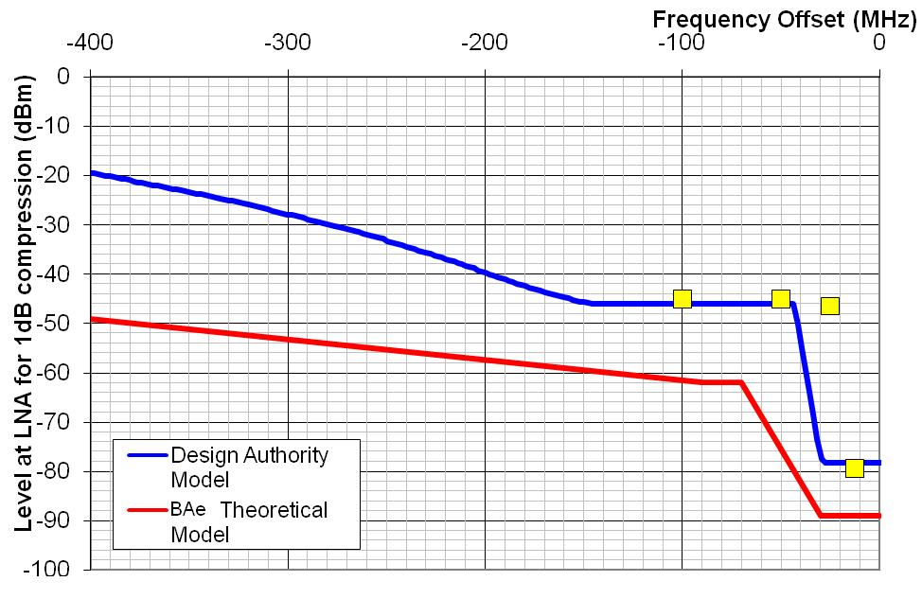

**Figure 4: Modelled susceptibility of a test Radar to adjacent use**

* + 1. This revised modelling reduced the discrepancy that was present in the initial study between the theory and practical measurement with the exception of one point. However on further investigation it was found that the radar used for the initial testing had been modified to operate with a narrower IF bandwidth filter and, once this was taken into account, the one obvious marked difference was explained.
    2. Having confirmed the results obtained in the initial testing the study contractor investigated how the radar adjacent band rejection could be improved. It was noted that, as was common design practice when the relevant test radar was designed, all of the filtering stages were after the amplification stages in order to minimise the noise figure. However since the low noise amplifier has a gain of around 34 dB, the impact on the noise figure of the radar of any filter fitted after this stage would be insignificant with the impact decreasing for filters installed further down the receiver chain. Therefore the order of the 1st IF Amplifier and filter could effectively be switched without degrading the noise figure of the receiver in order to improve the adjacent band rejection performance of the radar.
    3. Running this configuration through the mathematical model indicated that, whilst the adjacent band performance of the radar was significantly improved as a result of the configuration change, it did not resolve the whole issue. The manufacturer estimated that additional mitigation would be required in the main radar beam, but not the auxiliary or high beam due to the additional antenna discrimination that was provided by this beam to the horizon. Replacing the current low noise amplifier with one that had a lower noise figure allowed an additional filter to be incorporated without theoretical affecting the operational performance. The modification, combined with the switch in order of the 1st IF amplifier and filter and an upgrade to the main beam radar transmit‑receive (TR) protection switch, provided a solution that theoretically met the adjacent band performance requirement without compromising the operational performance of the radar.
  1. **Flight Trials, Phase 2 (2009)**
     1. Phase 1 of the trials confirmed that the test radar would experience problems from signals below 2 690 MHz without suitable mitigation measures being put in place. Phase 2 of the trials took place in August 2009 with the intention of testing the effectiveness of the proposed mitigation modification designed by the study contractor. These trials consisted of 19 runs with both, the main beam and high beam as well as low and high radar frequencies being tested, and hence these trials were regarded as more comprehensive than the Phase 1 trials. A summary of the trial results is given below:-

|  |  |  |  |  |  |  |  |  |
| --- | --- | --- | --- | --- | --- | --- | --- | --- |
| **Run** | **Radar channel** | **Interference source** | | | **Radar frequency** | **Test range (nm)** | **Pd** | |
| **Modulation** | **Frequency (MHz)** | **EIRP (dBm)** | **Video%** | **Plot %** |
| 1 | NR attenuated | Reference | | | F2 | 50-24 | MB 92.9  AB 100 |  |
| 2 | NR attenuated | CW | 2 690 | 50 | F2 | 50-24 | MB 88.1  AB 100 |  |
| 3 | NR Attenuated | CW | 2 690 | 50 | F1 | 50-24 | MB 80.2  AB 100 |  |
| 4 | NR | CW | 2 690 | 53 | F2 | 50-OH | MB 56.6  AB 99.2 |  |
| 5 | NR | CW | 2 690 | 53 | F1 | 50-OH | MB 93.1  AB 99.3 |  |
| 6 | NR | Reference | | | F2 | 50-OH | MB 100  AB 100 |  |
| 7 | GCF | Reference | | | F2 | 50-24 | MB 85.9  AB 100 | MB 72.7  AB 90.0 |
| 8 | GCF attenuated | CW | 2 690 | 50 | F2 | 50-24 | MB 53.8  AB 100 | MB 40.0  AB 100 |
| 9 | GCF Attenuated | CW | 2 690 | 50 | F2 | 50-24 | MB 85.7  AB 100 | MB 70.9  AB 87.1 |
| 10 | GCF Attenuated | CW | 2 690 | 50 | F1 | 50-24 | MB 80.4  AB 100 | MB 65.3  AB 93.3 |
| 11 | NR | CW | 2 600 | 53 | F2 | 50-24 | MB 95.1  AB 96.6 | MB 85.0  AB 86.7 |
| 12 | NR | CW | 2 600 | 53 | F1 | 50-24 | MB 96.0  AB 100 | MB 86.9  AB 93.3 |
| 13 | NR | AWGN | 2 685 | 50 | F2 | 50-24 | MB 8.1  AB 92.9 | MB 1.0  AB 58.6 |
| 14 | NR | AWGN | 2 685 | 50 | F1 | 50-24 | MB 99.0  AB 100 | MB 83.0  AB 89.7 |
| 15 | NR | WiMAX  10 MHz | 2 685 | 50 | F1 | 50-24 | MB 36.6  AB 96.4 | MB 20.6  AB 83.3 |
| 16 | NR | WiMAX 10 MHz | 2 685 | 50 | F1 | 50-24 | MB 96.0  AB 100 | MB 84.7  AB 86.4 |
| 17 | NR Attenuated | Reference | | |  | 50-24 | MB 83.2  AB 100 | MB 77.8  AB 86.2 |
| 18 | NR | CW | 3 400 | 53 | F2 | 50-24 | MB 100  AB 100 | MB 88.8  AB 93.3 |
| 19 | NR | CW | 3 400 | 53 | F1 | 50-24 | MB 87.6  AB 100 | MB 69.4  AB 96.6 |

**Table 4: Probability of detection (MB averaged over 50-30 nm,   
AB averaged over 30-24 nm or to the O/H)**

* + 1. The results of this trial were not conclusive. Blocking was clearly evident in some of the runs in the January trials and the equivalent runs in the August trials show no signs of blocking, under the higher adjacent channel input powers to the radar receiver. Whilst the results for CW would suggest that the proposed modifications achieved their objective of improving the radar receiver capability to reject adjacent band signals, those for AWGN and WiMAX were less conclusive and would not be sufficient to provide evidence for a safety case. It is believed that the reason for the inconclusive results was the radar receiver in-band noise produced by the interference source; however other mechanisms were not ruled out. The reason for the inconclusive results was investigated and discovered to be a result of intermodulation products generated in the front end of the radar receiver.
  1. **Trial 2 (2010)**
     1. The purpose of the Site 2 trial was to confirm whether the tested modifications affected the performance of the radar, especially the Moving Target Indicator (MTI), in the absence of 2.6 GHz transmissions. Site 2 was selected for the trial as there is significant ground clutter along the coast near the site. The results of the trials were that the MTI performance was not affected as a result of the modification and that equipment parameters such as noise figure and the minimum discernable signal were either the same or slightly improved. It was therefore concluded that the tested modifications did not adversely affect the performance of the radar.
  2. **Predicted impact on other aeronautical radars**
     1. In parallel with the practical work described above, discussions have been held with the various radar manufacturers who are the design authorities for radars currently operated in the UK. As a result of these discussions and the information supplied, the UK has been able to derive estimates for the potential separation distances between existing radar and transmissions within the frequency band 2 500-2 690 MHz from a mobile network base station. The estimates below are based on assumptions such as the estimated adjacent band radar receiver performance, various assumed margin and link allowances and the application of free space path loss conditions. They were taken as indicative rather than absolute.

|  |  |  |  |  |  |  |
| --- | --- | --- | --- | --- | --- | --- |
|  | Test radar measured blocking performance | Radar Type 2 assumed blocking performance | Radar Type 3 assumed blocking performance | Radar Type 4 assumed blocking performance |  |  |
| Maximum receive power at radar receiver input | -41 | -41 | -27 | -27 |  | dBm |
| Feeder loss | 2 | 2 | 4 | 2 |  | dB |
| Pre LNA filter loss@2690MHz | 0 | 0 | 1 | 0 |  | dB |
| Antenna gain to horizon (wrt Omni) | 28 | 28 | 30 | 28 |  | dB |
| Antenna cross-polarisation factor (circular polarisation radars) | 3 | 3 | 3 | 3 |  | dB |
| Multiple interference allowance | 3 | 3 | 3 | 3 |  | dB |
| antenna pattern and sitting variation | 2 | 2 | 2 | 2 |  | dB |
| apportionment of interference  (e.g. 25% of Interference margin) | 6 | 6 | 6 | 6 |  | dB |
| Anomalous propagation allowance | 8 | 8 | 8 | 8 |  | dB |
| **Maximum power incident to equivalent omni antenna (T&D Applications)** | **-83** | **-83** | **-68** | **-69** |  | **dBm** |
|  |  |  |  |  |  |  |
| Assumed adjacent channel transmitter power | 61 | 61 | 61 | 61 |  | dBm |
| **Minimum coupling loss separation** | **141** | **141** | **25** | **28.1** |  | **km** |
| **(based on free space path loss)** | **77.4** | **77.4** | **13.8** | **15.5** |  | **nmi** |

**Table 5: Initial estimates of minimum coupling loss separation distances (based on free-space path loss) to avoid the potential for blocking to different ATC radar operating above   
2 700 MHz by transmissions in the frequency band 2 500-2 690 MHz**

* 1. **Conclusions of the Studies**
* That the interference threat from LTE operating below 2 690 MHz into radar operating above 2 700 MHz was real
* That all radars types would be affected
* That in order to mitigate this interference threat the following action would have to be taken:-
* Improve the radar receiver adjacent band rejection
* Limit the aggregate field strength of both the LTE’s fundamental signal and the spurious emissions that would be experienced at a radar site to a level that would protect the revised radar receiver
  1. **Additional Radar Filter Design Scenario**
     1. Having concluded that the front ends of the currently deployed radars would need to modified the following scenario was adopted against which the modified radar receiver would have to operate normally. This scenario was given to the radar manufacturers against which they were asked to modify the designs of their receivers.
* Power radiated by the LTE base station 61dBm
* Number of simultaneous downlink channels 23
* Minimum separation from radar 1km[2]
* Multipath enhancement 6dB
* Maximum additional insertion loss 0.4 dB
  + 1. On the basis of above assumptions the following power at the front end of the radar receiver could be calculated for the main and auxiliary beam

|  |  |  |  |
| --- | --- | --- | --- |
|  | **Main Beam** | **Aux Beam** | **Units** |
| 5 MHz Base station downlink EIRP | 61 | 61 | dBm |
| Number of downlink channels =23 | 13.6 | 13.6 | dB |
| Free space path loss | 100.7 | 100.7 | dB |
| Multipath enhancement | 6 | 6 | dB |
| Antenna gain | 30 | 17 | dBi |
| Linear pol feed | 0 | 0 | dB |
| Transmission line loss | 2.1 | 2.1 | dB |
| Total average power at front end receiver | 7.8 | -5.2 | dBm |
| Peak/average power ratio of signal | 25 | 25 | dB |
| Peak power at front end receiver | 32.8 | 19.8 | dBm |
| **Table 6: Assumed power at the radar receiver** | | | |

* + 1. It is worth noting that the modifications requested required in some instances more than 60 dB of additional adjacent band suppression.
  1. **Results of the Radar Modifications**
     1. Without the modifications the susceptibility of the radar to either compression or 3rd order intermodulation products is shown below

|  |  |  |
| --- | --- | --- |
| Parameter |  | Variation (dBm) |
| 1 dB compression point (pre LNA reference point) | Radar 1 | -20 |
| Radar 2 | -30 |
| Signal level for 3rd order IMPs threshold pre filter modification (pre LNA reference point) | Radar 1 | -50 |
| Radar 2 | -60 |

**Table 7: Input levels to the LNA to cause 1 dB compression or 3rd order product effects**

* + 1. And the minimum coupling loss calculation carried out as part of the JTG studies

|  |  |  |  |  |  |  |  |
| --- | --- | --- | --- | --- | --- | --- | --- |
|  | Units | Radar 1 ITU 1 dB compression point | Radar 1DB1 | Radar 1DB2 | Radar IMP1 | | Radar IMP2 |
| Mobile base station transmit power | dBm/MHz | 36.0 | | | | | |
| Mobile base station feeder loss | dB | 3.0 | | | | | |
| Mobile base station antenna gain | dB | 18.0 | | | | | |
| Free space path loss for 1km | dB | 101.0 | | | | | |
| Radar maximum antenna gain | dBi | 33.5 | | | | | |
| Radar feeder loss | dB | 2.0 | | | | | |
| Power at the receiver front-end | dBm/MHz | -18.5 | | | | | |
| Radar compression point | dBm | -10.0 | -20 | -30 | -50 | -60 | |
| Safety factor | dBm | 6.0 | | | | | |
| Interference point | dBm | -16.0 | -26 | -36 | -56 | -66 | |
| **Interference margin** negative number indicates the amount of additional attenuation required | dB | 2.5/4.5 | -7.5 | -17.5 | -37.5 | -47.5 | |

**Table 8: Mobile base station fundamental signal on the 1 dB compression point and IMP thresholds  
of a radar receiver - without additional filtering**

* + 1. The values indicate that for one base station at 1 km the shortfall for the:

• 1 dB compression point at -20 dBm is 7.5 dB

• 1 dB compression point at -30 dBm is 17.5 dB

• IMP1 generation level requirement at -50 dBm the shortfall is 37.5 dB

• IMP2 generation level requirement at -60 dBm the shortfall is 47.5 dB

* + 1. By introducing the additional 60dB of adjacent band rejection then the summary results are as follows:-

|  |  |  |  |  |  |  |
| --- | --- | --- | --- | --- | --- | --- |
|  | Units | Radar 1 ITU 1 dB compression point | Radar 1DB1 | Radar 1DB2 | Radar IMP1 | Radar IMP2 |
| Radar compression point | dBm | -10.0 | -20 | -30 | -50 | -60 |
| Interference margin from table 12 (no filtering) | dB | 2.5 | -7.5 | -17.5 | -37.5 | -47.5 |
| With 60 dB additional filtering | dB | 57.5 | 52.5 | 42.5 | 22.5 | 12.5 |

**Table 9: Mobile base station fundamental signal on the 1 dB compression point and IMP thresholds  
of a radar receiver - with additional filtering**

* + 1. The values indicate that for a mobile base station at 1 km, the margin for:

• 1 dB compression point at -20 dBm is 52.5 dB

• 1 dB compression point at -30 dBm is 42.5 dB

• IMP generation level requirement at -50 dBm is 22.5 dB, thus

• IMP generation level requirement at -60 dBm is 12.5 dB

* + 1. This suggests that filtering in the region of 60 dB or more should be considered to avoid IMP issues with typical ATC radar so that adjacent band operation is achievable.
  1. **Constraints on the Mobile Base Station**
  2. The UK studies concluded that modifications to the radar receiver alone would not protect the radar from adjacent band LTE interference and hence the following limits were imposed on the LTE operators

|  |  |  |
| --- | --- | --- |
|  | Power flux density threshold for mobile broadband signals in the adjacent band  (dBm/m2) | Spectral power flux density threshold for mobile broadband signals in radar band  (dBm/MHz/m2) |
| Radar protection thresholds | 5 + 10*log10(BW/120) | -131 + 10*log10(BW/120) |
| Where: BW is the total bandwidth (MHz) assigned to the base station transmissions in the adjacent band.  For the case of this example (based on the UK 2.6 GHz coordination requirements), the total bandwidth assigned is 120 MHz. | | |

**Table 10: UK 2.6 GHz coordination requirements**

1. ACTION BY THE MEETING
   1. The ACP WG-F is invited to:

* Note the content of the paper
* Take action in your own State if needed

1. 5.384AThe bands, or portions of the bands, 1 710-1 885 MHz and 2 500-2 690 MHz, are identified for use by administrations wishing to implement International Mobile Telecommunications-2000 (IMT-2000) in accordance with Resolution **223 (WRC‑2000)**. This identification does not preclude the use of these bands by any application of the services to which they are allocated and does not establish priority in the Radio Regulations.
2. This separation distance was assumed on the basis that any lesser distance was liable to fall within an airport boundary and hence location and power could be specified by the airport