
International Civil Aviation Organization

Regional Preparatory Group (RPG) Meeting for ITU Worldradiocommunication Conference 2015
(WRC-2015)

Pattaya, Thailand, 11 – 12 March 2014

Agenda Item 3: The reality of frequency management in APAC; current practices and new challenges

FREQUENCY FINDER
A program for managing, assessing compatibility and presenting frequency assignments
for aeronautical communication and navigation systems on a map

(Presented by the Secretariat)

SUMMARY

This paper presents the Frequency Finder software, which was developed as a tool to assist ICAO Regional Offices and States to manage and coordinate aeronautical frequency assignments.

- Introduction

1.1 ICAO is developing the program Frequency Finder that offers a tool to assist ICAO Regional Offices and States to manage and coordinate aeronautical frequency assignments. This program combines the data base management functions for updating the ICAO COM lists, calculation of interference areas and a geographical interface for plotting of the frequency assignments, including any interference area, on a map (currently with Google Earth only). The graphical interface can be used to overlay frequency assignments on certain geographical areas such as ACC or FIR sectors, with air-routes and combined with other ICAO databases that are being developed.

1.2 The program has initially been developed to provide support to Regional offices that have a central role in the coordination of frequency assignment with focus on ICAO Regions outside Europe (and in North America: USA and Canada). The program is currently being modified to accommodate frequency assignment planning in Europe as well (in particular the use of 8.33 kHz frequency assignments).

1.3 Frequency Finder is built along different modules:
- VHF air/ground communications (DSB-AM, VDL Mode 2 and VDL Mode 4)
- VHF navigation (ILS, VOR, GBAS, VDL Mode 4)
- NDB
- HF air/ground communication
- SSR Mode S II code assignments
In addition, Frequency Finder has included applications that will allow for the plotting of FIR sectors and air-routes as well as for ACC sectors as used in Europe.

1.4 The program is using FileMaker Pro (version 12) for data base management, calculation of interference contours, assessing compatibility between frequency assignments and for generating the files necessary to plot the frequency use and interference areas on a map (with Google Earth). The program is available in a full version (that requires the user to have FileMaker Pro installed on the local computer) and in a runtime version (which does not require FileMaker Pro).

1.5 The modules for NDB and HF frequency assignment planning are still to be developed. The module for the coordination of SSR Mode S Interrogator Identifier codes (only for using the codes 0 – 15) is being implemented. The planning criteria for the coordination of these Mode S II codes have been reviewed by the Aeronautical Surveillance Panel this module will be incorporated in Frequency Finder shortly. The module for VHF navigation systems (ILS, VOR and DME has been completed using the [limited] frequency assignment planning criteria for these systems that are applied in the ICAO Regions outside Europe. This module is being modified to incorporate the planning criteria for ILS, VOR and DME as per Annex 10. The module for VHF air/ground communication planning has been completed. This module implements the planning criteria for VHF air/ground communication systems as described in detail in the ICAO Handbook on radio frequency spectrum requirements for civil aviation, Volume II (Doc. 9718).

1.5 Frequency Finder has been used to generate the ICAO global frequency assignment plans which is to be published on the ICAO website and has concatenated and harmonized the different ICAO Regional COM lists into a single data base, including a single format for the frequency assignments. This global frequency assignment plan is intended to facilitate interregional coordination of frequency assignment as well as to be used as part of the global eANP. The global frequency assignment plan will also be used to seek registration of frequency assignments that have been coordinated through ICAO with the International Telecommunication Union (ITU) in the ITU Master International Frequency Register (MIFR). The global frequency assignment plan can be accessed with the URL http://gis.icao.int/ff1/ff1.php .

2. Using Frequency Finder.

2.1 The module for VHF air/ground communications in a standalone configuration is completed. Frequency Finder includes the global database of frequency assignments for VHF air/ground communications and VHF Navaids (including DME).

Note: Frequency Finder currently includes for the VHF Navaids the frequency assignment planning criteria that are applied in Regions outside Europe. Working Group F of the Aeronautical Communications Panel is involved in developing harmonized criteria that should be applied on a global basis.

Frequency Finder is linked to the Global database which facilitates the updating (by States) of their local version of the Global (or Regional) database. For use by Regional Offcies, a method has been implemented to upload modifications to the Global database.

2.2 Management of the database in Frequency Finder is provided by typical data base functions such as:
- Querying the database – the database can be queried using specific parameters (Region, Country, Location, Frequency, Service or FIR (ACC) sector. The user can also manually select frequency assignments.
- Entering new frequency assignments – entering new frequency assignments can be done through a special window in the program
- Modifying existing frequency assignment - modifying an existing frequency can be done through a special window in the program
Note: new frequency assignments or modifications to an existing frequency assignment can immediately be tested for compatibility with other frequency assignments; these frequency assignments can be saved as a “draft” or “temporary” assignment
- Exporting the data base (as FileMaker Pro, Excel or PDF file) in the format of the ICAO COM list

A screenshot of the (global) database is in Figure 1

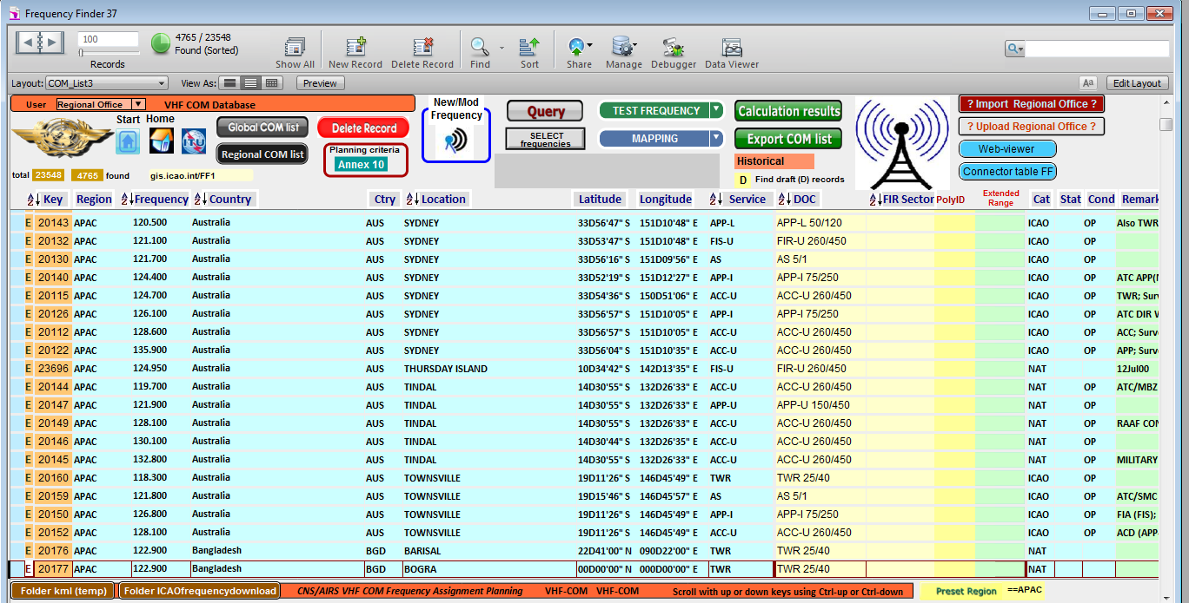

Figure 1 – Screenshot of the (global) data base.

2.3 Mapping of frequency assignments.

2.3.1 The Designated Operational Coverage of frequency assignments can be plotted on a map, using Google Earth. The user can plot the DOC of a single frequency assignment or a selection (as result of a query) of frequency assignments. In case the frequency is linked to either an FIR sector (or for Europe an ACC sector) the plotted coverage is limited to the boundaries of the relevant sector.
Examples for plotting the coverage on a map are in Figures 2 and 3.
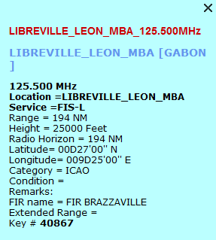

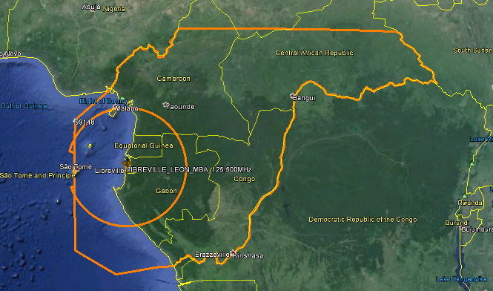

Figure 2 – Designated operational coverage limited to the boundaries of the FIR Brazzaville in Gabon; (FIR-L on 125.500 MHz MHz)

2.3.2 In Figure 2, the boundaries of the FIR Brazzaville are shown since (for testing purposes) the frequency 125.500 MHz has been associated in Frequency Finder with FIR Brazzaville. When calculating compatibility with other frequency assignments, protection throughout the FIR is secured. This means that Extended range stations can be added without further coordination being required. Also is shown in Figure 2 (in a circle segment) the actual coverage (to the radio horizon) that can be achieved by the station in Gabon.
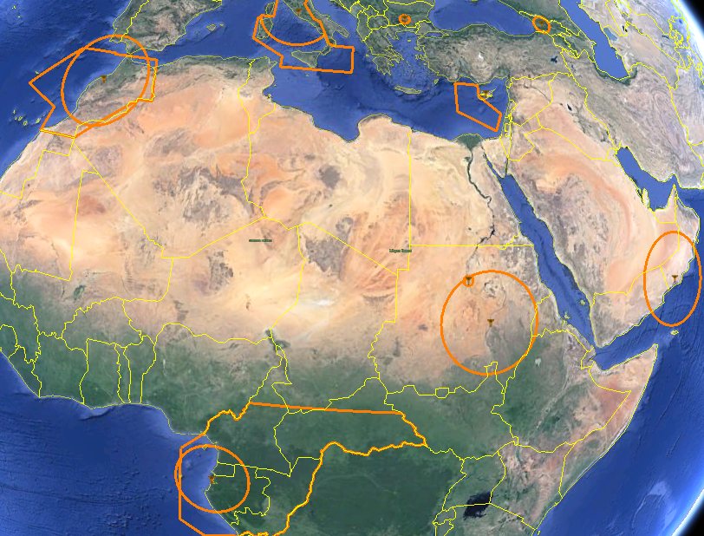

Figure 3 – Overview of all frequency assignments on the frequency 125.500 MHz in the AFI, EUR and MID Regions

2.3.3 Figure 3 shows all frequency assignment in the AFI, MID and EUR Region as per the Regional frequency assignment plans (COM Lists). Please note that for the frequency assignments in Algeria two coverage areas are shown. This is caused because of inconsistencies between the EUR and AFI COM lists.

2.4 Testing existing frequency assignments

2.4.1 Frequency Finder can test existing frequency assignments as well as (proposed) modifications or new frequency assignments on compatibility with the Global database.. Frequency Finder tests compatibility of the selected frequency with all co-frequency and adjacent frequency assignments in a circle with a radius of 1020 NM. Frequency Finder calculates the minimum distance required between the stations as well as the actual distance and identifies if the frequency assignment planning criteria (minimum separation distances) are met.

2.4.2 The results of each of the co- and adjacent channel calculations can be examined. Figure 4 shows the co-frequency calculation details that are presented when the frequency 119.700 MHz at Jomo Kenyatta international airport in Nairobi, Kenya was tested.
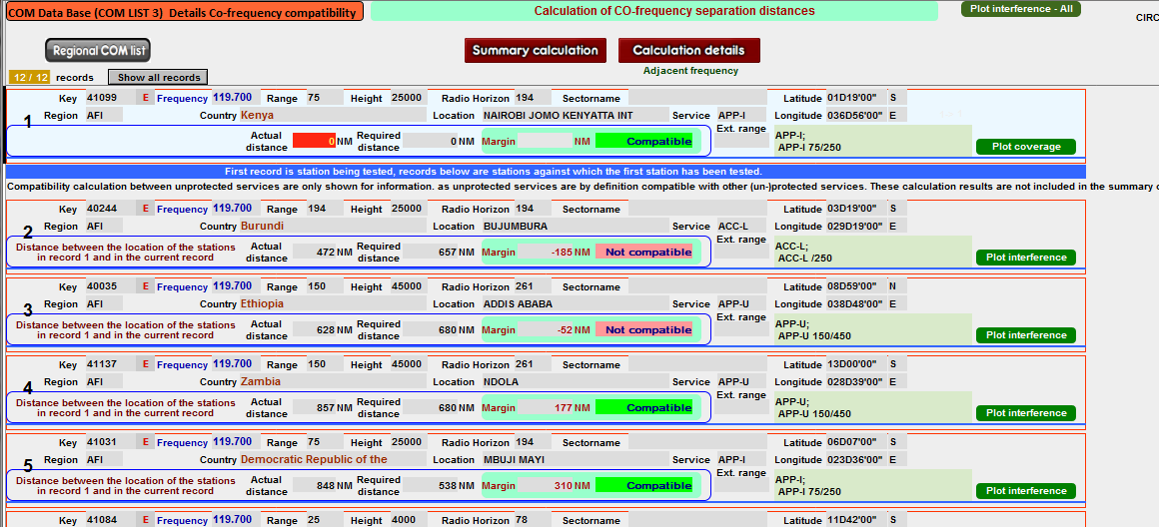

Figure 4 – Screenshot co-frequency calculation details

2.4.3 The calculation details shown in Figure 4 include all potential incompatibilities when testing the frequency 119.700 MHz in use at Jomo Keyatta international airport in Nairobi, Kenya. The frequency assignments in the ICAO COM list for which the (ICAO, administrative) frequency assignment planning criteria are not met are identified as “not compatible” and can be plotted on a map with Google Earth.

2.4.4 Figure 5 shows these test result as Frequency Finder presents these on a map with Google Earth.

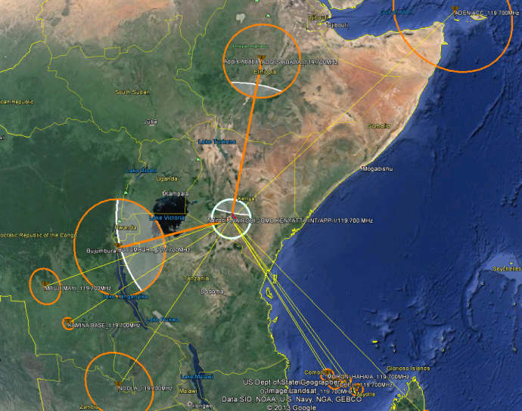

Figure 5 – Interference contours between Jomo Kenyatta international on 119.700 MHz in Nairobi, Kenya and potentially interfering stations in the ICAO Global COM list.

2.4.5 Figure 5 shows the compatibilities and incompatibilities with the frequency assignment that is being tested (119.700 MHz in Nairobi Kenya) and other frequency 7 assignments in the ICAO Global COM list. When the stations are connected with a thin yellow line, the frequency assignments are compatible. When the frequency assignments are connected with a thick orange line the frequency assignments are not compatible. The white circle or circle segments show the geographical area where the frequency assignment planning criteria are not met. Not in all cases tis means that actually interference is experienced. The ICAO frequency assignment planning criteria are pretty conservative (and on the safe side).

2.4.6 The parameters for the tests are saved in the window “Summary Calculations” as shown in Figure 6. Tests can be re-evaluated later with the button “Redo calculations”, taking into account any changes that have been made to the data base of frequency assignments at a later point in time.

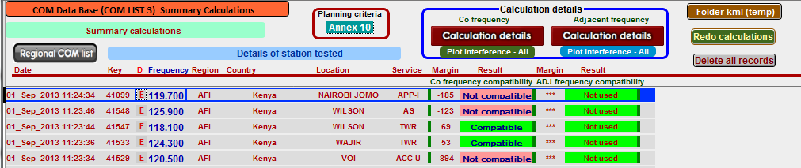

Figure 6 – Summary of compatibility calculations.

Note: The currently available data from in particular the EUR frequency table, as imported from the Eurocontrol managed SAFIRE database contains numerous inconsistencies which cause Frequency Finder to stop with error messages. This data needs to be further reviewed. This may in particular affect compatibility calculations with AFI States which are peripheral to the EUR Region.

2.5 New frequency or modified frequency assignments.

2.5.1 In a special window “New/mod frequency”, the user can modify an existing frequency assignment or introduce a new frequency assignment

2.5.2 Figure 7 shows the box used to enter modifications to an existing frequency assignment (in case a new frequency assignment is to be entered, this box is empty). After the parameters to be modified (or, for a new frequency assignment, the necessary details) are entered, the modified frequency assignment can be tested with regard to compatibility with the frequency assignment plan. The user will be informed if the modifications are compatible.

2.5.3 This box allows for insertion of the uniform designated operational coverage (DOC) of services as well as for tailoring the DOC to specific requirements.

2.5.4 After all details for a new or modified frequency assignment have been entered and tested the user can decide to keep the modified (or new) frequency assignment in the data base as a draft entry and start coordination with ICAO and/or States. Keeping the draft entry in the data base is necessary to secure that later modifications to the frequency assignment plan take into account the modified (or new) frequency assignment. Alternatively, the user can turn the “draft” frequency assignment into a permanent frequency assignment in the data base.
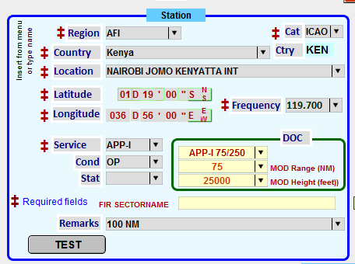

Figure 7 – Box for entering modifications to an existing frequency assignment.

2.6 Search for a new (or alternative) frequency.

2.6.1 Frequency Finder offers the user the option to search for either an alternative frequency (in case the frequency of an existing frequency assignment should be changed) or for a new frequency in case a new frequency assignment is to be added to the data base. Figure 8 shows the box that is to be used in this case.

2.6.1.1 In this box the user can select the frequency range within which the search for an alternative (or new) frequency assignment should take place or select from the allotment table which has been established by each Region.

2.6.2.2 The user can select the number (from 1 – 10) of alternative frequencies that Frequency Finder should attempt to find. After the search is completed, Frequency Finder shows the number of compatible frequencies from which the user can select. The margin (distance) to the nearest co-frequency (or adjacent frequency) assignment is also shown. For efficient frequency assignment planning, the user should select the frequency with the smallest margin (*** indicates that within the circle with a radius of 1020 NM around the station that is being tested no co-frequency (or adjacent frequency) assignments are recorded in the frequency assignment plan).

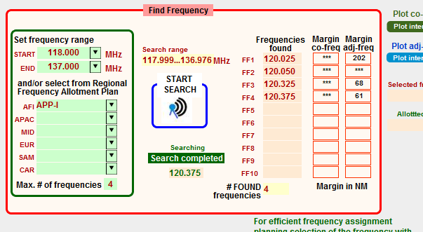
Figure 8 – Box in Frequency Finder to search for a new frequency assignment
2.7 Extended range stations

2.7.1 Station operating in an extended range configuration can be identified by entering in the database a name for the “family” of extended range stations as shown (simulated) in Figure 9.

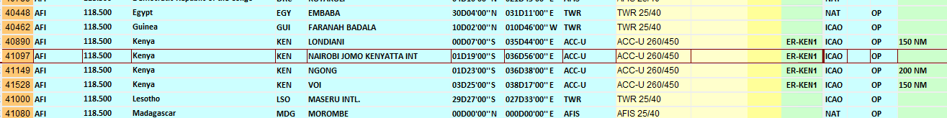

Figure 9 – Identification of stations operating in an extended range configuration

These stations are not being tested for interference between each other. An example of the presentation of interference calculations involving extended range facilities is shown in Figure 10.

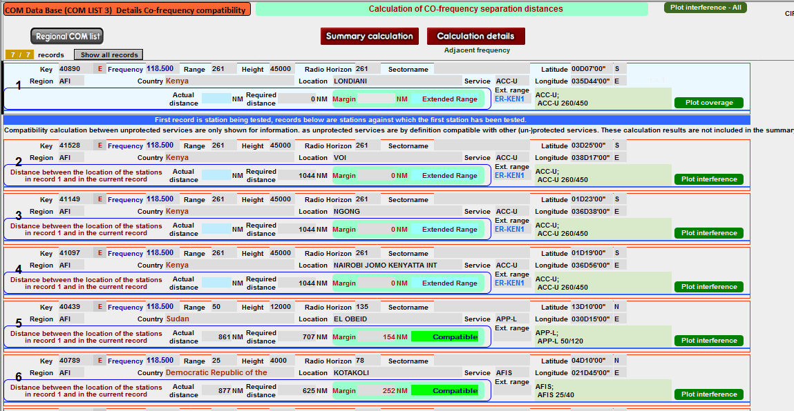

Figure 10 – Calculation results involving Extended range facilities.

Note that for stations that belong to the same extended range facility the field margin is set to 0 (zero), meaning that these frequency assignments are compatible.

2.7.2 In Figure 10 test results of the station Londiani on 119.700 MHz in Kenya are shown. Stations that are operating in an extended range configuration as identified in Figure 9 and 10 are not interfering with the station Londiani and are plotted on the map without a connected line. Other stations that operate on the same frequency but are not part of the extended range network are plotted and linked to the station Londiani as shown in Figure 10a. The yellow lines in figure 10a indicate that no interference with the station Londiani is foreseen (but these stations may in turn interfere with other stations in the extended range network).

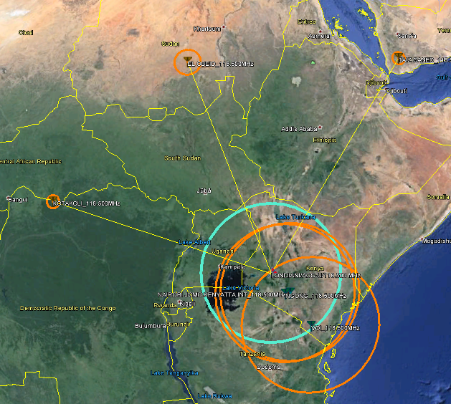

Figure 10a – Interference calculations involving extended range facilities.

2.8 Area services

2.8.1 Frequency Finder offers the option to plot the coverage of area services (ACC, FIR). In figure 11 the frequency 125.500 MHz, in use at Libreville in Gabon has been linked (for test purposes) to the FIR Brazzaville (Figure 11a).

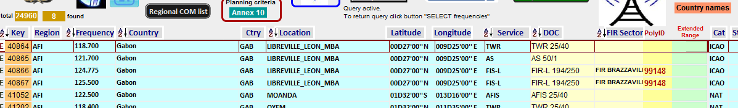

Figure 11a – Frequency assignments are linked to FIR areas.

When the coverage for this frequency assignment is plotted on a map (with the button Mapping/Single), the map shows the coverage of the station as well as the whole of the FIR (Figure 11b). In this case the coverage is assumed to the radio horizon of the station in Libreville.

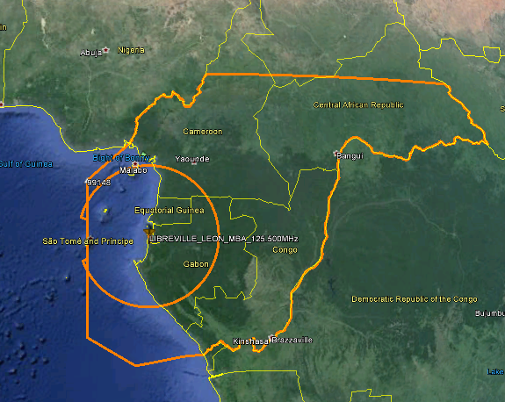

Figure 11b Coverage of the station in Libreville at 125.500 MHz (FIR-L) and the FIR to which this station has been associated.

2.8.2 Calculation of interference considers the protection of the whole area. Figure 11c shows the actual coverage of the in Libreville, the coverage within the boundary of the FIR and the (co-frequency) interference that can be caused by the station Khartoum ACC in Sudan.

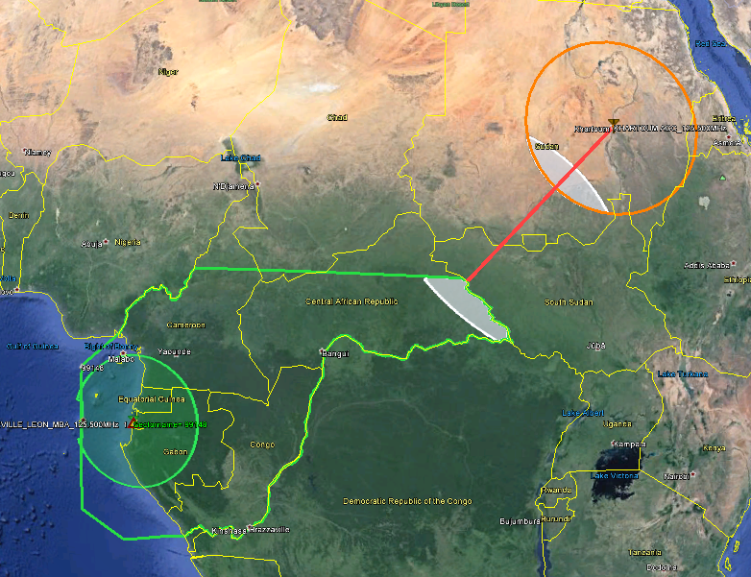

Figure 11c – Calculated interference into FIR Brazzaville.
2.8.3 One (or more) frequency assignments can be affiliated to an FIR sector. For this purpose, the Coordinates of all FIR sectors have been incorporated in Frequency Finder. These coordinates are from the ICAO program ICAOFIR13 and need to be updated from time to time. A mechanism to easily import this data is available.

2.8.4 For the EUR Region, the protection of area services also includes ACC sectors. These have also been incorporated in Frequency Finder.

2.8.5 Figure 12 shows the coverage of 5 stations that are operating in the Democratic Republic of the Congo on the frequency 130.100 MHz. These stations have been, for test purposes, associated with FIR Kinshasa. The coverage of these stations as presented with Frequency Finder is in Figure 12.

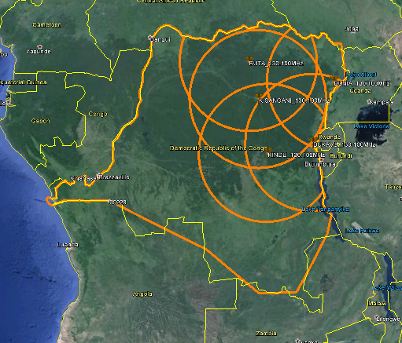

Figure 12 coverage of the frequency 130.100 MHz for FIR Kinshasa in the Democratic Republic of the Congo.

3. Use of Frequency Finder

3.1 In its final format, Frequency Finder is intended to provide a tool for use by ICAO Regional Offices and ICAO Contracting States for the management and coordination of frequency assignments and to generate the ICAO global frequency assignment plan. The configuration that has been developed is as follows and summarized in Figure 13:

- The program resides on the local computer used by States and Regional offices
- The global data base of frequency assignments resides on the ICAO website (HQ)
- The global database can be downloaded from the ICAO website and imported in the local version of Frequency Finder to enable the user access to the most current version of the global database.
- States and Regional Offices can use the global database to assess compatibility between current frequency assignments and with new or modified frequency assignments. With Frequency Finder, interregional coordination of frequency assignments is assured.
- The local data base can be updated (either manually or automatically) with the current version of the global database.
- Only Regional Offices can update the global database with modification to the database.

Note 1: the European database of frequency assignments, which is developed using different programs, will be imported in the ICAO global data base (and in the format of the global ICAO database) at regular intervals. Such updates can be inserted automatically or through manual intervention.
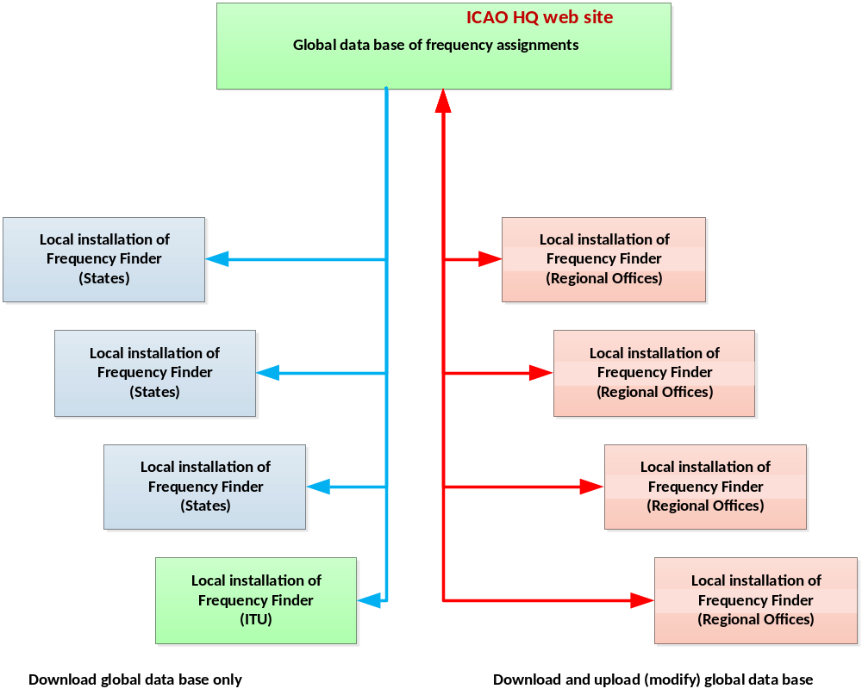
Figure 13 – Configuration for using Frequency Finder

Note 2: The above configuration is currently being developed.

4. Further developments
4.1 VHF Air/Ground communication

4.1.1 Apart from modifications that may improving the user friendliness of Frequency Finder or removing bugs, further work will concentrate on the identification of errors in current data base (all Regions).

4.1.2 Further work on the calculation of buffer zones for areas services (and for VOR/DME keyhole coverage areas) as well as introducing the use of terrain data to better visualize on the map the coverage of the VHF stations is necessary but cannot be completed with additional resources being available.

4.2 VHF Navigation systems

4.2.1 Frequency Finder currently includes the global data base of frequency assignments for VHF navigation systems (ILS, VOR, DME, GBAS). Frequency assignment planning is based on the planning criteria that are being used in the Regional Offices outside Europe. This database is outdated and Frequency Finder is being modified to accommodate more up-to-date frequency assignment planning criteria for NAV systems.

4.2.2 In conjunction with developing for the ICAO Handbook on radio frequency spectrum requirements for civil aviation (Volume II) frequency assignment planning criteria for ILS, VOR, GBAS and VDL Mode 4 (in the frequency band 108 – 117.975 MHz), Frequency Finder is being updated to include these planning criteria. The use of Frequency Finder for frequency planning for VHF navigation systems will be aligned with the functions that have been introduced for the module for VHF air/ground communication systems.

4.3 LF/MF beacons and aeronautical HF bands

4.3.1 Initially, only the global data base for both LF/MF beacons (NDB and locator) as well as for HF air/ground communication frequencies will be introduced. At a later stage Frequency Finder will be updated with material that would enable using Frequency Finder for frequency assignment planning.

4.4 SSR Mode S Interrogator Identifier codes (SSR Mode S II codes)

4.4.1 Subject to agreement in the Aeronautical Surveillance Panel on planning criteria for SSR Mode S II codes, the module for that would enable Regions to coordinate and assign SSR Mode S II codes will be introduced in Frequency Finder.

4.5 eANP (electronic ANP) GIS Web Server mapping solution

4.5.1 Data from the frequency assignment plans that can be presented on maps is planned to be integrated in the development of the eANP GIS web server mapping solutions which are currently being developed in ICAO. Examples are the presentation of air routes (currently a provisional application for plotting on a map air routes has been inserted in Frequency Finder) and other data from the ICAO Regional Plans.

5. Coordination with the ITU (updating the Master International Frequency List)
5.1 ICAO is considering, at the request of the ITU, to align the ITU Master International Frequency Register (MIFR) with the ICAO global data base of frequency assignments. The Program Frequency Finder has been modified with the cooperation of the ITU and now includes a method to generate the necessary T12 and T13 notices that can be submitted to the ITU by States.

6. Implementation and use of Frequency Finder.

6.1 Implementation and the use of Frequency Finder by the ICAO Regional Offices is planned during the spring of 2014. This is in conjunction with implementing the mechanism provided in Frequency Finder to update the Global database base (by the ICAO Regional Offices) which resides on the ICAO web-site (http://gis.icao.int/ff1 ).

6.2 For the use of Frequency Finder by States workshops were planned. A workshop for this purpose is essential since the frequency assignment planning criteria were updated (and now presented in the ICAO Handbook on radio frequency spectrum requirements for civil aviation) and Frequency Finder offers specific techniques for efficient frequency assignment planning that need to be clarified. However, currently, due to budgetary reasons, these workshops are not foreseen in the near future.

--------------------------------

