 | International Civil Aviation Organization  INFORMATION PAPER
  ACP-WG-F/29
  IP-01

AERONAUTICAL COMMUNICATIONS PANEL (ACP)
29th MEETING OF WORKING GROUP F

Nairobi, Kenya 3 – 12 September 2013

Agenda Item xx: | Xxx

Millimeter wave broadband wireless direct communication between air and ground

National Institute of Information and Communications Technology, Japan

SUMMARY
This paper provides information of experiment of broadband communication systems for airplanes in which over-40 GHz band serves to facilitate broadband wireless communications between air and ground.

- INTRODUCTION
Currently, air traffic control (ATC), air operator certificate (AOC), and Aeronautical Administrative Communication (AAC) are used for aeronautical communication system which mainly has data link and voice channels. Sharing various kinds of information, such as traffic control information, weather information, video and/or images about airport surface, surveillance of airport surface, and detailed aircraft condition, video around aircraft, etc., among ground and aircraft will be essential in the future.
In recent years, new technologies such as Aeronautical Mobile Airport Communications (AeroMACS) and L-band digital aeronautical communication system (LDACS) have been developed for higher transfer speed communication for ATC, AOC, and AAC. AeroMACS is a broadband wireless communications system at speeds from a few Mbps upto about 75Mbps for local area networks on the airport surface. LDACS is a ground-based system at speeds upto about 700 kbps, which uses line-of-sight communications to support air-to-ground communication in particular for en-route in continental airspace. In the future, higher data transfer rate in en-route airspace than that of supposed communication system may be necessary for enabling broadband communication for sharing traffic control information, weather information, detailed aircraft condition, video and/or images about airport surface and around aircraft, etc., such as AeroMACS. Meanwhile, Broadband direct wireless connection system between air and ground using over-40 GHz band for en-route in continental airspace has been developed in Japan. This system has some benefits of low-cost communication, light weight, high antenna gain, etc. Over-40 GHz band is not used heavily in commercial applications and is expected to facilitate the broadband communication system at speed upto 500Mbps.
This broadband system can be useful not only for air traffic control but also transmitting images and video of disaster area from aircraft to ground station without landing and high accurate and reliable unmanned aircraft system (UAS) control by transmitting video around the unmanned aircraft (UA) and sensor information of the UA to the ground station.
Operation of this system is supposed to be that airplanes fly over ground tracking antennas arranged at regular intervals and as the aircraft passes overhead, the antennas hand over service one after another to the aircraft. Figure 1 shows the example case study operated in Japan.

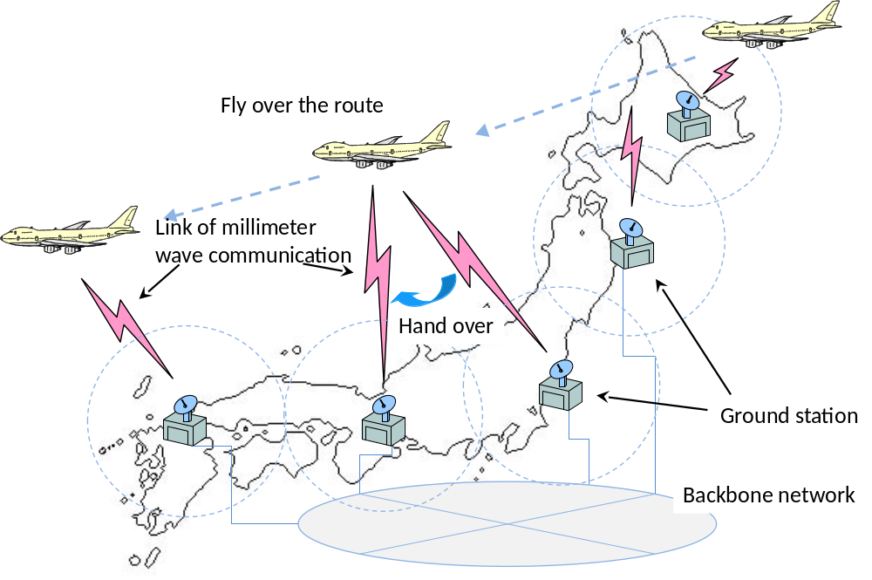
Figure 1 Example case study: over-40 GHz wave broadband wireless direct communication system between air and ground operated in Japan.

This document provides a report of experiments of broadband communication systems for airplanes in which the over-40 GHz band (Millimeter wave band) serves to facilitate broadband wireless communications between air and ground as feasibility study.
- Experiment

  - Experiment summary
The verification test using aircraft was conducted on the island of Oahu, Hawaii, USA, for the purpose of verifying high-speed transmission and mass volume downloading by bidirectional communication between air and the ground. A small airplane was used as the airborne station. Table 1 presents an overview of the airborne verification test, and Figure 2 illustrates a diagram of the airborne verification test. One of the key technologies of the system is to track the target terminal antennas. To track each antenna position, the antenna system needs to consider the characteristics of the over-40 GHz wave and the geographical dimensions. The ground-based stations with tracking antenna must continuously track the aircraft with a high degree of accuracy. The onboard antenna must track the ground-based antenna by considering aircraft attitude and location. With a reflector controlling the antenna beam in the system, the mechanism provides a cost-effective, power-efficient tracking antenna. The ground station has a mechanically controlled reflector to direct the antenna beam in a specific direction by tilting the reflection disk mechanically. Furthermore, a radio wave was separately transmitted at 44.55 GHz, in addition to the communication signal wave so that the system could execute the mono-pulse tracking technique by monitoring the reception level of the radio wave signal. The system uses the frequency division multiplex (FDD) method for communication. The transmission and reception frequencies are allocated as 46.8 GHz and 44.45 GHz, respectively, for simultaneous transmission. The data transfer rate is 141.7 Mbps when QPSK modulation with a symbol rate of 78 Msps is applied. The 106.3 Mbps transfer rate is realized when 8PSK modulation with a symbol rate of 39 Msps is applied. The antenna control information, such as the reception level and antenna directional data, is stored in the control sections. The modem signal and the error information of Bit Error Rate (BER) or Packet Error Rate (PER) (circuit quality) are also stored in the modem sections at both the airborne and ground stations. The flight data, which consists of airplane location/attitude information, is stored only on the aircraft. The ground station treats the transmitting and receiving data through over-40 GHz waves.

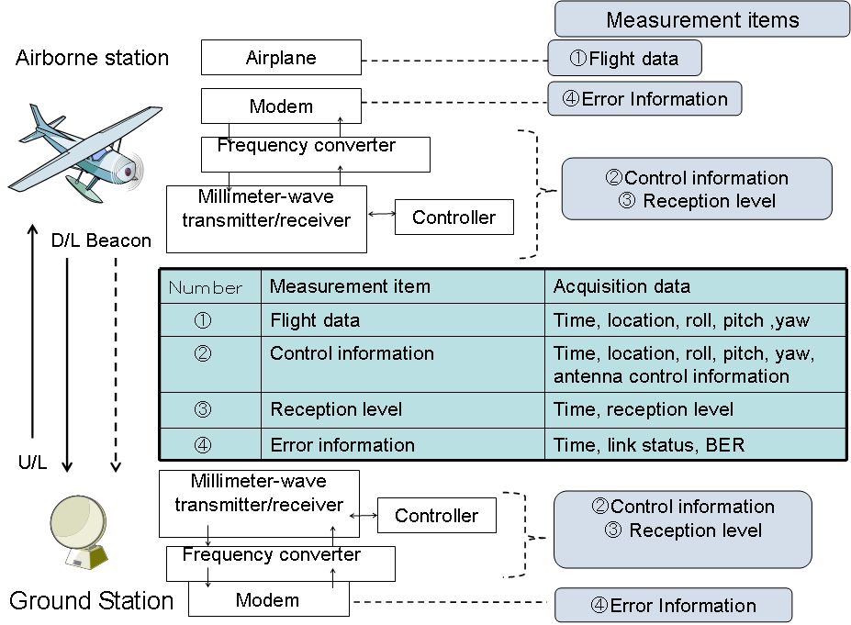
Figure 2 Airborne verification test system

Table 1 Airborne verification test overview
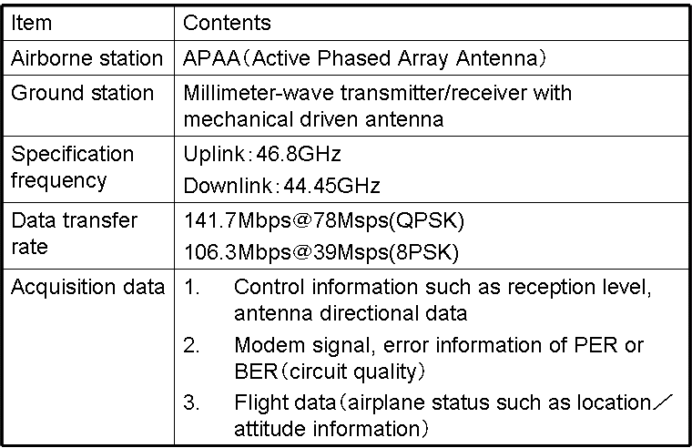

  - Aircraft Configuration
Figure 3 shows the connection diagram on the aircraft. The aircraft system consists of antennas for transmitting/receiving radio waves, a controller for directional control of the antennas, a modem for modulating/demodulating data, and a power supply from the aircraft to each device.
The onboard antenna consists of transmission and a reception components using active phased array antenna (APAA) technology, which realizes a low profile feature size and is capable of two-dimensional electronic antenna scanning. The APAA is composed of 64 elements in an eight-by-eight array. Each element of the APAA is connected to the transmitting/receiving module to control the antenna beam direction by changing the phase component with 4-bit resolution. In addition, the directional control of the antenna is limited to +/- 45 degrees as a device specification.
The configuration of the control section allows the connection of the GPS and the gyro sensor modules to acquire the location and attitude of the aircraft. The system computes the direction to which the antenna should be directed in the very near future to command and control the antenna for direction to a point from the past track of the flight path based on information from the GPS and the gyro sensor. The modem is configured to allow switching modulation between QPSK and 8PSK using a PC. The PC is also used as a file server.

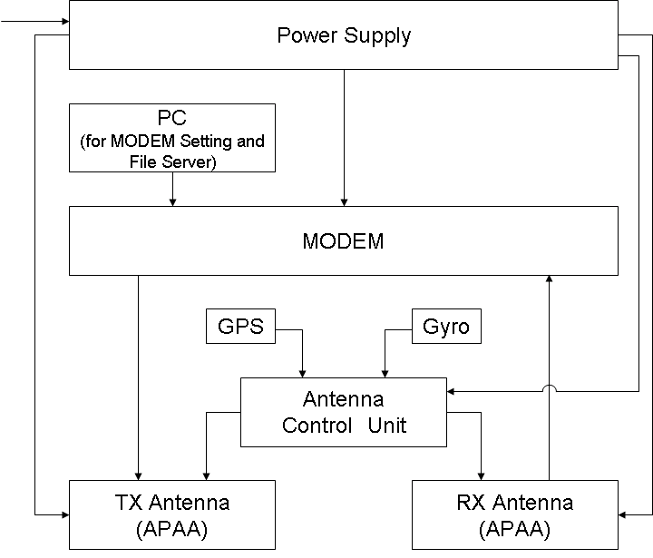
Figure 3 Experimental configuration at the airplane side

- evaluation Results
Table 2 shows the items to be evaluated in the airborne verification test. Each item was conducted using the test procedures shown in Figure 4. The following figures show the results.

Table 2 Airborne verification test evaluation items
Number | Evaluation item | Remarks
(A) | Antenna pattern measuremnt | Figure 4(1) shows testing procefure
(B) | Tracking ability test | Figure 4(1) shows testing procefure
(C) | Communication capability test and mass volume data transfer test | Figure 4(2) and (3) show testing procefure
(D) | Communication distance test | Figure 4(2) and (3) show testing procefure

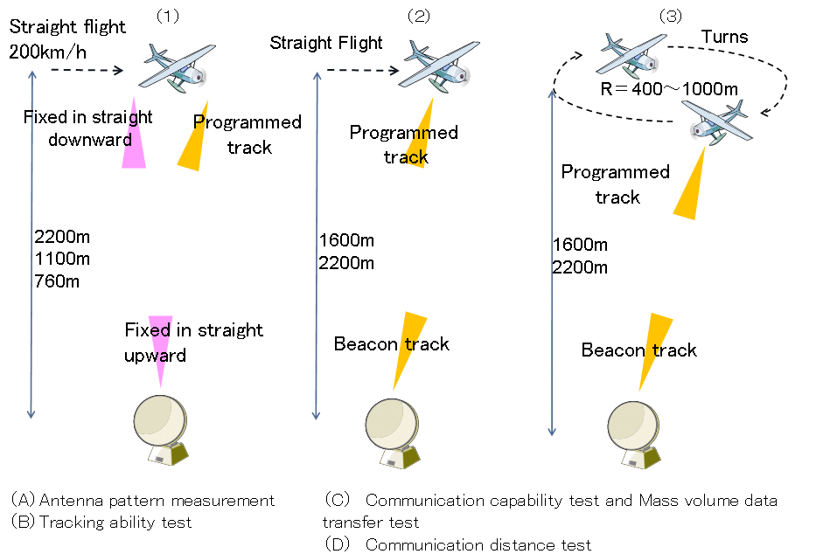
Figure 4 Testing procedures

  - Antenna pattern measurement
As shown in Figure 4, the antenna pattern was measured on the basis of the reception level during several passages of the airborne station exactly over the ground station. The antenna directivity of the ground station was fixed straight upward and that of the airborne station was selected as either fixed straight downward or in the programmed tracking mode during the passage by selecting patterns of flight altitudes. The sampling interval for data acquisition was 0.1 seconds.
Figure 5 shows the results of antenna pattern measurements of the altitude of the aircraft, which was approximately 900 m. The result of the measurement obtained in an anechoic chamber is also depicted. As a result, the beam width of the antenna is observed at about 8 degrees in the airborne test, while it is observed at 10 degrees in an anechoic chamber. Although the width becomes approximately 2 degrees narrower than that of the designed value, the characteristics of the antenna beam are almost identical. The difference in the peak values of the antenna beams is attributed to the effect of the mounting error of the device or the influence of the fuselage.
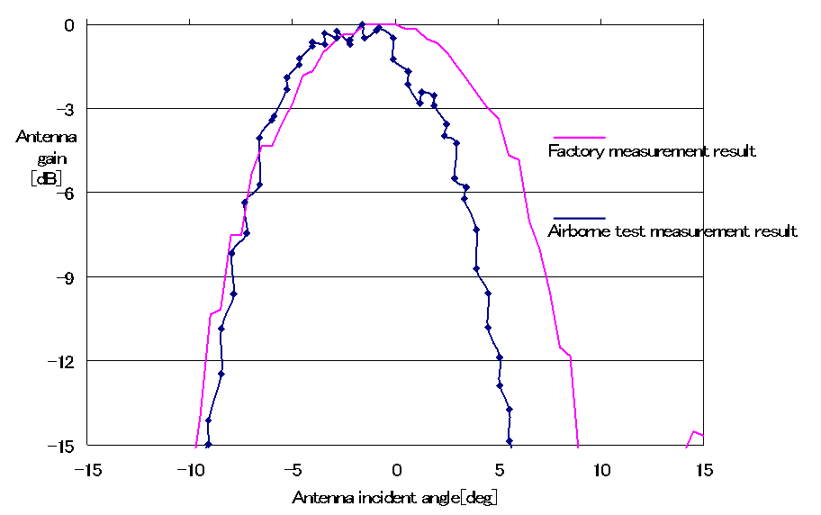
Figure 5 Antenna pattern measurement result

  - Tracking ability test
As shown in Figure 4, tracking ability was measured based on reception level during several round trip passages of the airborne station over the ground station. The antenna directionality of the ground station was fixed straight upward and that of the airborne station was selected as either fixed straight downward or in a programmed tracking mode during the passage by selecting three flight altitudes (2,500 m, 1,500 m, and 900 m). The sampling interval for data acquisition was 0.1 seconds, and the airspeed was about 200 km/h. Figure 6 shows the reception level of the airborne station antenna when fixed straight downward. Also, Figure 7 shows the reception level of the airborne station antenna in programmed tracking mode. The duration of the communicating segment, which is specified as a segment from a point about 5 dB below the peak until that of 5 dB from the peak of electrical power from this result, is approximately 1.0 second when fixed straight downward and approximately 3.5 seconds in programmed tracking mode. Programmed tracking mode was longer and can be confirmed as tracking correctly. The maximum angular ground speed was 229.65 km/h at an altitude of 785.47 m tracked at 4.7 degrees per second in calculation, which was confirmed as the desired data to be obtained. Although restrictions on the flight altitude limit the value, a higher tracking capability is ensured since APAA is performed during the electronic scan.
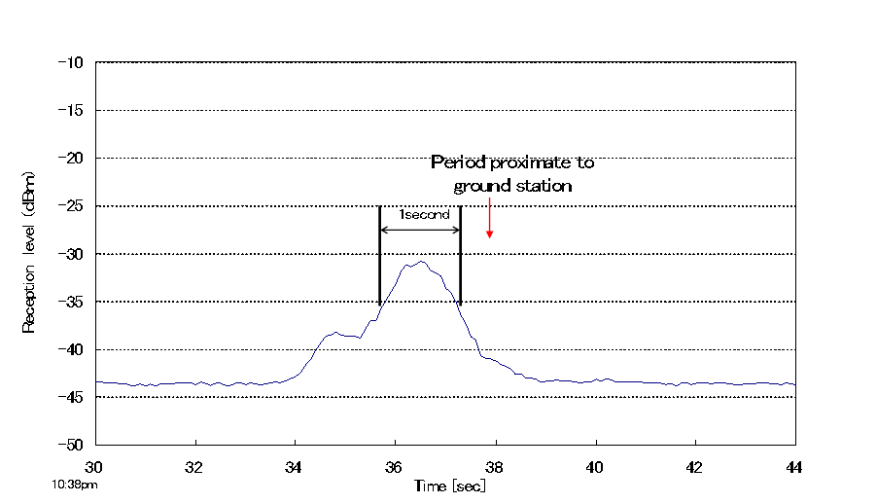
Figure 6 Reception level of airborne station with antenna fixed in straight downward

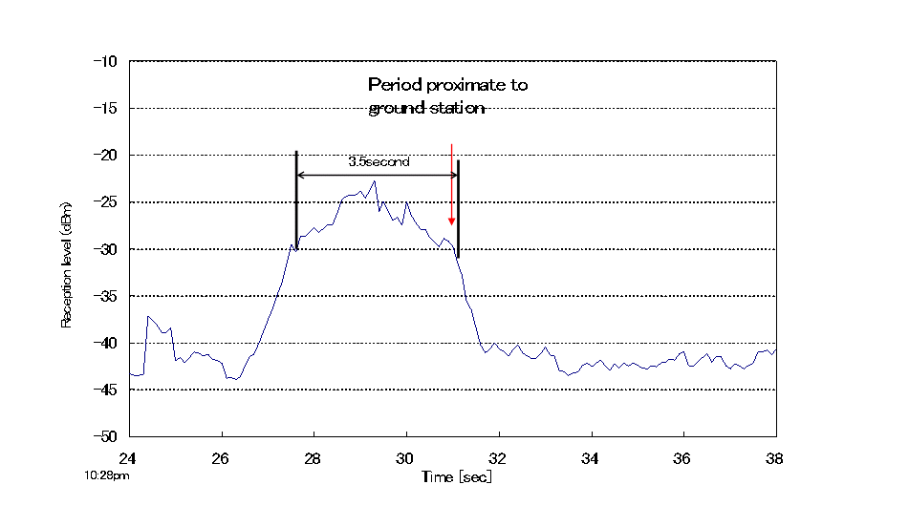
Figure 7 Reception level of airborne station with antenna in programmed tracking mode

  - Communication capability test and mass volume data transfer test
Reception level and BER characteristics were obtained as shown in Figure 4 (2). The modulation type during this acquisition was QPSK, and the flight altitude was approximately 2,000 m. Figure 8 shows the reception level and BER for the uplink. Similar results were obtained for the downlink as well. Although the uplink and downlink have slightly different frequencies, the characteristics were confirmed as almost identical. Indications of higher reception levels than the designed value during uplink can be inferred as caused by the transmission signal of the downlink, which was reflected by the dome and diffracted to the reception side. The BER of the uplink ensured a sufficient value even under such conditions. The BER shown here is a BER before correcting errors so that it can be improved by this correction. It succeeded in establishing communication for approximately 2 minutes as well as in downloading a 500 Mbyte file in approximately one minute during this communication establishment segment even in this environment.
In addition, a similar result was confirmed during the turning flight as shown in Figure 4 (3). During the turns, a test was conducted with modulation type QSPK, as well as switched to 8PSK. As a result, characteristics identical to those during straight flight were obtained without dependence on the modulation type. The system succeeded in establishing communication for approximately 20 minutes in the combination of QPSK and 8PSK type, as well as in downloading a 500 Mbyte file for both the QPSK and 8PSK during this communication establishment segment of the flight. These results can be considered verification of mass volume downloading with bidirectional IP communication.

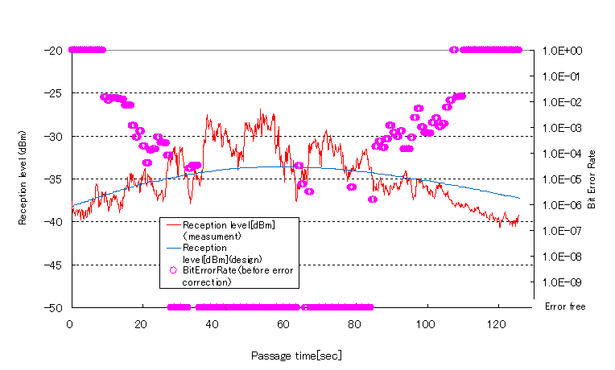
Figure 8 Reception level during uplink and BER

  - Communication distance test
We calculated the communication distance from the result obtained in the test in 3.3. Figure 9 shows the results of the communication distance obtained during straight flight. The results indicated that communication was established for a horizontal distance of 2,380 m and a flight altitude of 1,816 m, thus the communication distance was approximately 3 km. At this time, the angle of elevation sighting the airborne station from the ground station is 38 degrees, which was confirmed as a minor difference compared to the device specification of 45 degrees for the beam scan range of the APAA used on the airborne station. This scan range influences the restriction of communication distance. This result confirms that the communication distance corresponding to the beam scan range of the antenna for an airborne station is ensured.

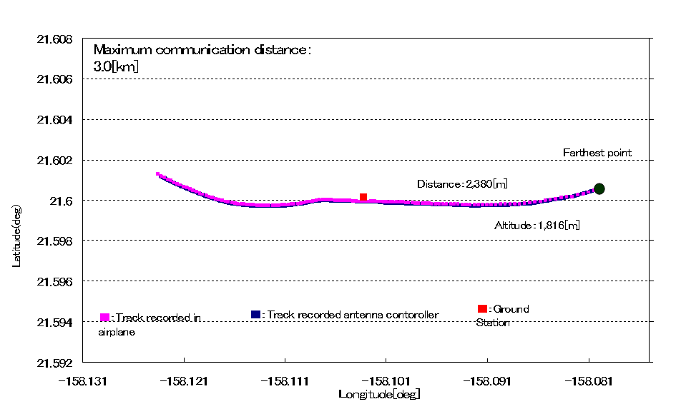
Figure 9 Communication distance calculation result (during straight flight)

- Conclusion
This document provides a report of experiments as feasibility study of a broadband direct communication system between air and ground using 40 GHz band, and proved the effectiveness of the broadband wireless communications in airplanes and on the ground. The results confirm the success of the airborne verification test using a small airplane. Application of this result to various aircraft shall establish an environment that enables mass volume data transmission between air and ground.
The range of application of this system for air traffic control can be sharing various kinds of traffic control information, such as accurate aircraft surveillance, air traffic information, weather information, surveillance of destination airport surface, etc., among flight control and aircraft. This information enables flight control to order an optimal and safety flight route, which has potential for reduction of carbon dioxide emissions by reducing fuel consumption, reduction of flight time, and economic effectiveness by the reduction of aircraft waiting time in the air and on the ground. Moreover, this broadband system can be useful for transmitting images and video of disaster area from aircraft to ground station without landing and high accurate and reliable UAS control by transmitting video around the UAV and sensor information of the UAV to the ground station.
This work will be continued for practical use in the future.
- ACTION BY THE MEETING
To note the information provided.

