 | International Civil Aviation Organization  WORKING PAPER
  ACP-WGF22/WP12

AERONAUTICAL COMMUNICATIONS PANEL (ACP)

22nd MEETING OF WORKING GROUP (WG F)

Mexico City, Mexico 23 – 30 April 2010

Agenda item | 3): Development of material for ITU-R meetings

NSP Spectrum Subgroup review of ITU WP5B output entitled:
"Sharing in the band 5 030-5 091 MHz between the international standard microwave landing system (MLS) and a satellite system of the aeronautical mobile-satellite (route) service (AMS(R)S)"
(Annex 18 of December 2009 WP5B report)

(Prepared by: ICAO NSP SSG Rapporteur, Felix Butsch)
(Presented by ICAO secretariat)

SUMMARY
An attached study of the "Sharing in the band 5 030-5 091 MHz between the international standard microwave landing system (MLS) and a satellite system of the aeronautical mobile-satellite (route) service (AMS(R)S)" had been presented to the recent ITU WP5B meeting in Dec. 2009.
ITU WP 5B requested in a Liaison Statement the view of ICAO on this issue for its next meeting planned in May 2010. The recent ICAO ACP WG/F meeting in Dec. 2009 started to review the document and recommended a further review by the ICAO NSP SSG.
Since there was no SSG meeting between ACP-WGF21 and ACP-WGF22 SSG reviewed the document by correspondence.
The attached document contains proposed revisions and remarks by ICAO NSP SSG members, which are mostly related to the characteristics of MLS.

Radiocommunication Study Groups | 
Source: Document 5B/TEMP/169 | Annex 18 to  Document 5B/417-E
Source: Document 5B/TEMP/169 | 11 December 2009
Source: Document 5B/TEMP/169 | English only
Annex 18 to Working Party 5B Chairman’s Report
Working document towards a preliminary draft
new report ITU-R M.[MLS-AMSRS]
Sharing in the band 5 030-5 091 MHz between the international standard microwave landing system (MLS) and a satellite system of the
aeronautical mobile-satellite (route) service (AMS(R)S)
TABLE OF CONTENTS
Page
1 List of acronyms 4
2 Reference documents 4
3 Introduction 4
4 Definition 5
5 Microwave landing system 5
5.1 General architecture 5
5.2 MLS transmitter 8
5.3 MLS receiver 10
5.4 Protection criteria 12
6 Possible AMS(R)S system 12
6.1 General architecture 12
6.2 Space segment 13
6.3 UA terminal segment 15
6.4 Carrier bandwidth and frequency plan 17
6.5 Link budgets 17
7 Coexistence studies 19
7.1 Introduction 19
7.2 General methodology 20
7.3 Single interferer analysis 21
7.3.1 Satellite to MLS (satellite to UA link, forward) 21
7.3.2 MLS to UA (satellite to UA link, forward) 23
7.3.3 UA to MLS (UA to satellite link, return) 25
7.3.4 MLS to satellite (UA to satellite link, return) 28
7.4 Aggregation analysis 30
7.4.1 Satellite to MLS (satellite to UA link, forward) 30
7.4.2 MLS to UA (satellite to UA link, forward) 31
7.4.3 UA to MLS study (UA to satellite link, return) 33
7.4.4 MLS to satellite (UA to satellite link, return) 35
7.5 Frequency planning constraints determination 37
7.6 Frequency planning 39
8 Conclusion 41

List of figures
Fehler! Es konnten keine Einträge für ein Abbildungsverzeichnis gefunden werden.
List of tables
Page
Table 1: MLS receiver sensitivity 12
Table 2: Carrier bandwidth 17
Table 3: Interferences from satellite to MLS receiver – Single interferer – Results 23
Table 4: Interferences from MLS transmitter to UA receiver – Single interferer – Results 25
Table 5: Interferences from UA transmitter to MLS receiver – Single interferer – Results 28
Table 6: Interferences from MLS transmitter to satellite – Single interferer – Results 29
Table 7: Interferences from satellite to MLS receiver – Aggregation – Results 31
Table 8: Interferences from MLS transmitter to UA receiver – Aggregation – Results 33
Table 9: Interferences from UA transmitter to MLS receiver – Aggregation – Results 35
Table 10: Interferences from MLS transmitter to satellite – Aggregation – Results 37

1 List of acronyms
ACI | Adjacent Channel Interference
AZ | Azimuth
BAZ | Back Azimuth
DPSK | Differential Phase Shift Keying
EL | Elevation
FDD | Frequency Duplex Division
GCS | Ground Control Station
GES | Ground Earth Station
LHCP | Left Hand Circular Polarization
MLS | Microwave Landing System
NF | Noise Figure
NPR | Noise Power Ratio
RHCP | Right Hand Circular Polarization
SNR | Signal to Noise Ratio
SSPA | Solid State Power Amplifier
UA | Unmanned Aircraft (= UAV)
UAS | Unmanned Aerial System
UAV | Unmanned Aerial Vehicle (= UA)

2 Reference documents
[Annex 10] International Standards and Recommended Practices (SARPs), Annex 10, Volume 1 (Radio Navigation Aids), ICAO, 6th edition, July 2006.

3 Introduction
The band 5 030-5 091 MHz is proposed, under WRC-12 Agenda item 1.3, as a candidate band for satellite systems providing UAS with safety communications as required for their integration in non segregated airspaces.
However, due to MLS precedence in that band, this could be achieved only if AMS(R)S systems are appropriately designed in order to ensure compatibility with foreseen MLS deployment.
The aim of this document is to provide material for analysis of the sharing situation between AMS(R)S systems and MLS in the band 5 030-5 091 MHz.

4 Definition
Figure 1
Definition – Forward link and return link
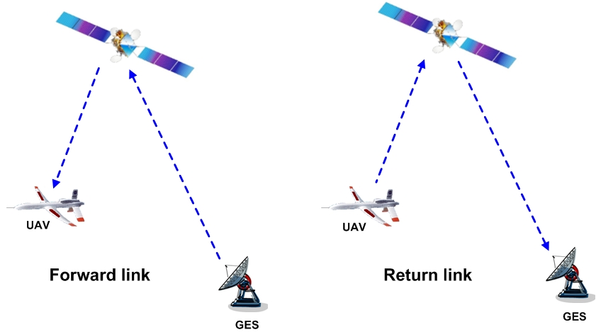

5 Microwave landing system

5.1 General architecture
The microwave landing system (“MLS”) is a precision approach and landing guidance system, which provides position information and various ground-to-air data. It was originally designed to replace or supplement the instrument landing system (“ILS”). Following figures present the general architecture. Azimuth and elevation signals are transmitted preceded by a DPSK modulated preamble. MLS transmitters are installed on runways while MLS receivers are on board aircrafts.
Figure 2
MLS principle (1/2)
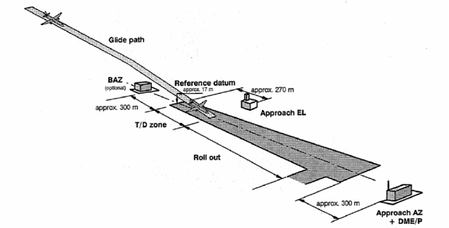
Figure 3
MLS principle (2/2)
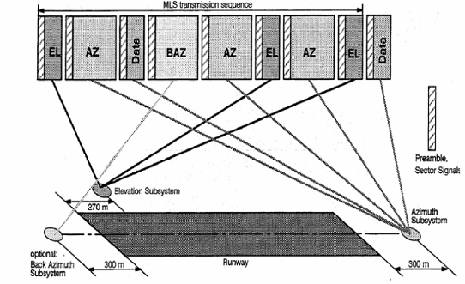

MLS system provides coverage within an azimuth [+40°, −40°, possible extension to +60°,-60°] and an elevation [0.9°, 15°]. Moreover, the MLS AZ coverage area is limited longitudinally to 22.5 nm (41.7 km) and vertically to 20 000 ft (6 000 m). The Back Azimuth coverage is limited longitudinally to 10 nm (18.5 km) from the opposite threshold and vertically to 10000 ft (3000 m).This is illustrated on following figures, which give a horizontal view and a vertical view of the MLS coverage area.
Figure 4
MLS coverage area (horizontal view)
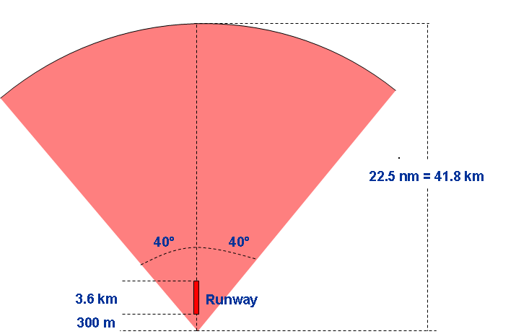

Figure 5
MLS coverage area (vertical view)
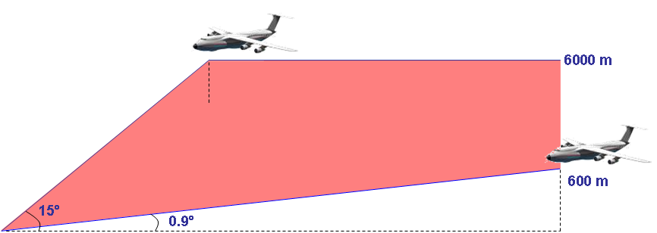

As of today, MLS system is operational on one airport in one European country. Four runways are equipped, two being used simultaneously.
The COM3 database gives a frequency plan for about 800 MLS assignments over Europe. It should be noted that NSP SSG indicated that the consideration of these 800 assignments may pose an overly restrictive assumption in MLS sharing studies, since the latest responses to a state-letter by the ICAO Paris office indicates that there is a lower need for MLS stations in Europe (around 400).
However, as no frequency plan is available for these requirements, for the time being sharing studies are based on this worst-case scenario. Let us note finally that, each MLS channel is paired with a DME channel and for a limited amount of channels with an ILS/VOR VHF frequency.
Figure 6
MLS transmitters (COM3 database)
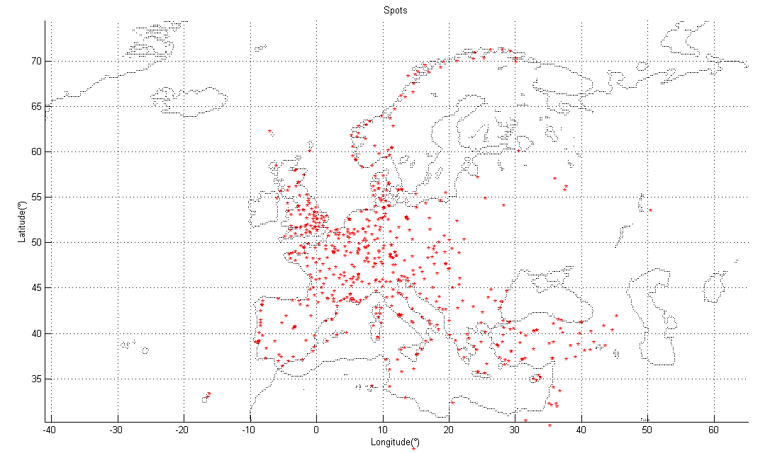

5.2 MLS transmitter
As in ICAO SARPs Annex 10 (reference [Annex 10]), MLS transmitter output power is considered to be 43 dBm (20W). The elevation antenna is depicted below. The maximum gain is 14 dBi and gets down to 8 dBi for a 15° elevation. Let us note finally that a vertical polarization is used.
Figure 7
MLS Tx antenna pattern
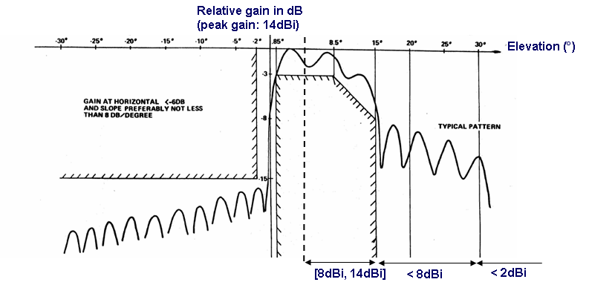

MLS transmitters generate out-of-band emissions. This is illustrated on Fig. 8, which presents the measurements carried out on a typical MLS transmitter by a European civil aviation authority (300 Hz resolution bandwidth).
Figure 8
MLS emission spectrum
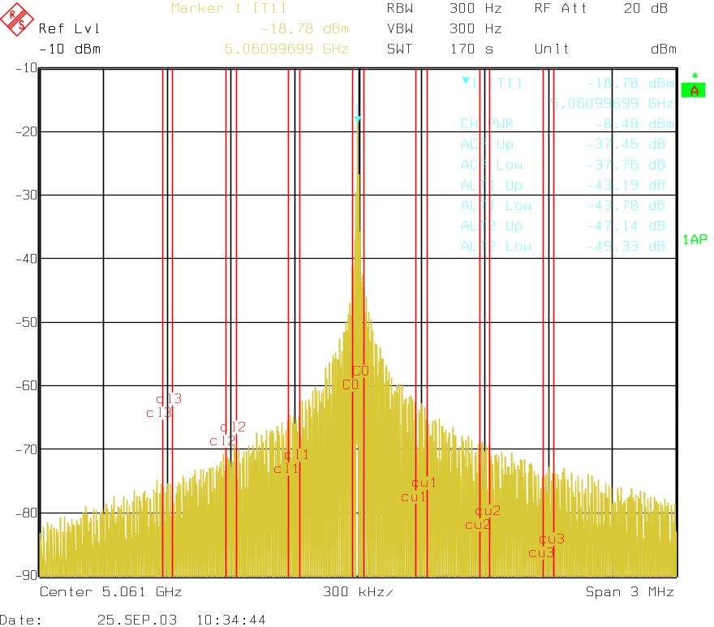

From recent NSP documentation, the MLS out-of-band power at f_{Δ} kHz from the MLS centre frequency and measured over a bandwidth BW can be analytically modelled as follows:
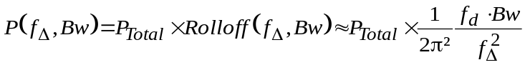
with:
P_{Total}: total MLS power, typically 43 dBm;
Bw: bandwidth of interest;
f_{d}: MLS DPSK carrier bandwidth, i.e. modulation rate (15.625 kHz);
f_{Δ}: frequency offset from the MLS centre frequency.

5.3 MLS receiver
The following figure represents the MLS antennas installed on board an actual aircraft. Let us note that, several MLS antennas may be embarked. This has to be considered when assessing interactions between a UA and a MLS receiver.
Figure 9
MLS antenna positions
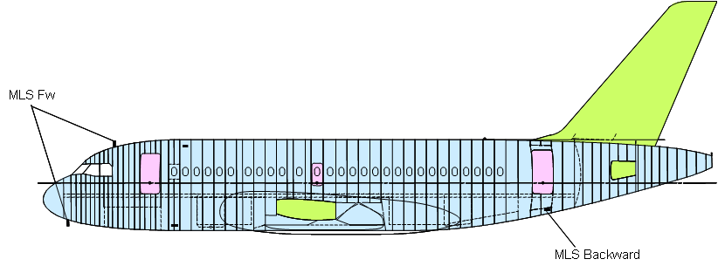

The azimuth antenna pattern of the MLS receiver is supposed to be omni, which is a worst case approach. The elevation antenna pattern that is considered is depicted below. It is based on generic Recommendation ITU-R F.1336-2 and on typical MLS Rx antennas characteristics (e.g. a 40° elevation beamwidth is considered). Let us note as well that a vertical polarization is used.
Figure 10
MLS Rx antenna pattern
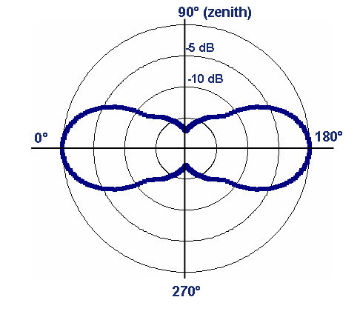

As specified in reference [Annex 10], MLS receiver minimum required sensitivity is –100 dBm for DPSK signals (at receiver input). Actual MLS receiver designs achieve a sensitivity of –107 dBm. This sensitivity is computed as follows:
Table 1
MLS receiver sensitivity
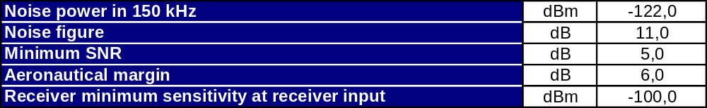

5.4 Protection criteria
In order not to cause harmful interference to the MLS operating in the band 5 030-5 091 MHz, the aggregate power flux-density received over 150 kHz by a MLS receiver in a MLS coverage area at its antenna input and at its centre frequency shall not exceed –124.5 dBW/m².
This requirement translates into −130 dBm/150 kHz, using the conversion rule given in reference [Annex 10] (Attachment G, § 2.6.2.1): Power into isotropic antenna (dBm) = Power density (dW/m²) – 5.5 dB. This power level is afterwards referenced as the in-band power level.

6 Possible AMS(R)S system

6.1 General architecture
The following figure presents the high-level architecture of a possible AMS(R)S system. Ground control station (GCS) can be collocated with a dedicated ground earth station (GES) or connected to a centralized GES through a terrestrial network. As a baseline, the link between the GES and the satellite, i.e. the feeder link, uses as well the 5 030-5 091 GHz band.
Figure 11
AMS(R)S architecture
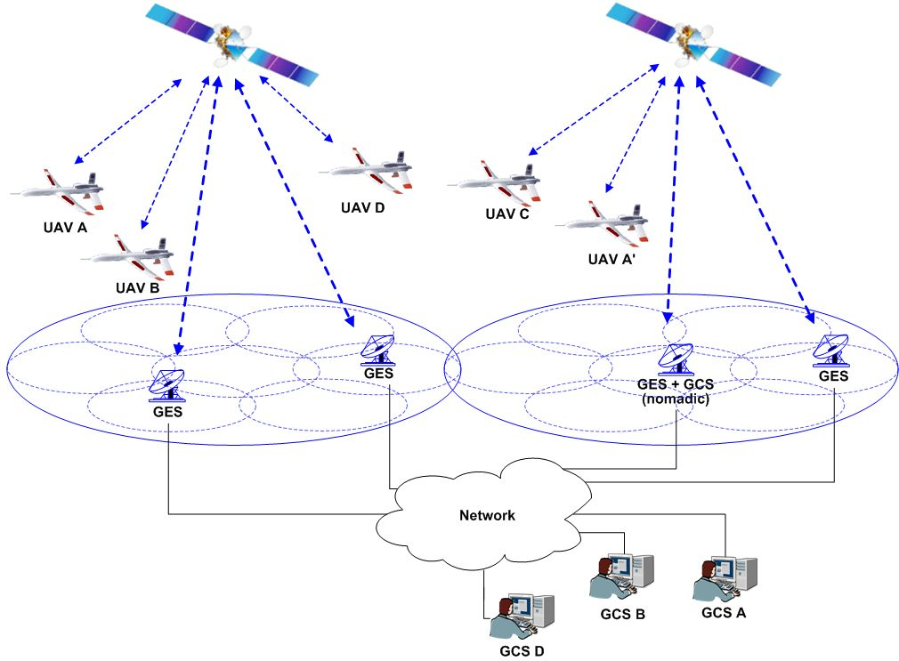

6.2 Space segment
The satellite segment is made of a constellation of several geostationary satellites in order to offer a global coverage of the part of the Earth visible from the geostationary orbit. As an example, the satellite serving the European area is located at a distance between 37 000 km and 40 000 km depending on the latitude that is considered (e.g. 38 000 km in Toulouse). The corresponding elevation is between 15° and 50° (e.g. 39° in Toulouse). Assuming a coverage of Europe only
Each satellite will create several narrow spot beams. For each satellite, spot beams can be activated dynamically within the satellite coverage. As a baseline, a frequency reuse 4 is considered. Such a pattern is illustrated on the following figure for a 6 metre satellite antenna, which is the required size to close the link budget with sufficient margins.
Figure 12
Illustrative state-of-the-art spot beam satellite antenna and frequency re-use pattern
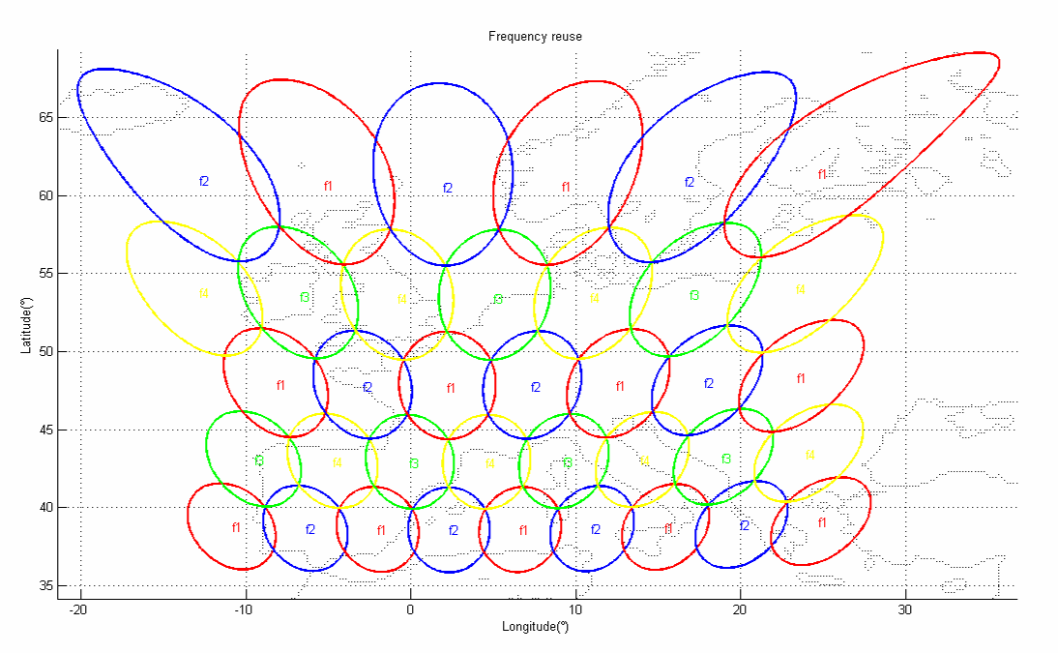

Satellite out-of-band emissions are driven by its NPR (noise power ratio) performance. As depicted below, the NPR is the ratio between the carrier signal power and the noise level brought by multi carrier amplifier non-linearities. A NPR equal to 17 dB is considered for the analysis. Such a value is a typical value for a state-of-the-art satellite and a 3-4 dB output back-off (OBO), which is the difference between the effective amplifier output power and the maximum amplifier output power.
Figure 13
Satellite noise power ratio (NPR)
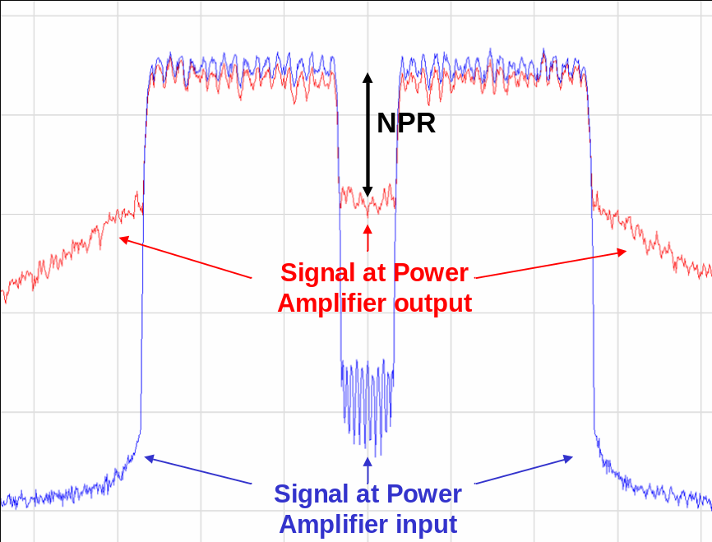

6.3 UA terminal segment
As far as the UA terminal segment is concerned, a low-gain omni terminal is considered. Possibly, several antennas may be used to ensure the availability of the link whatever the attitude of the UA is.
A 3 dBi antenna gain is assumed. The antenna pattern is supposed to be omni for the azimuth and partially omni above the horizon for the elevation. For information, an example of an L-band airborne antenna pattern is presented below (higher gains can be reached at 5 GHz). Let us note that the antenna gain decreases when reaching the zenith.
Figure 14
Example of L-band airborne antenna pattern
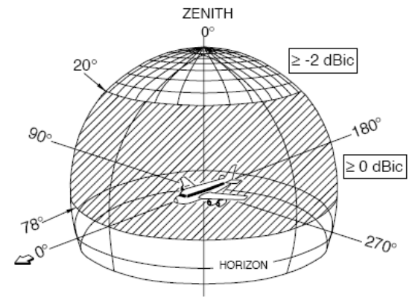

A circular polarization is used, either RHCP (Right hand circular polarization) or LHCP (Left hand circular polarization).
Figure 15
LHCP and RHCP


A power amplifier providing at maximum a 20W radio output power is considered. The emission spectrum has been modelled though simulations and is depicted on the following figure. The blue curve represents the ideal amplifier while the red curve represents the real amplifier.
Figure 16
UA emission spectrum
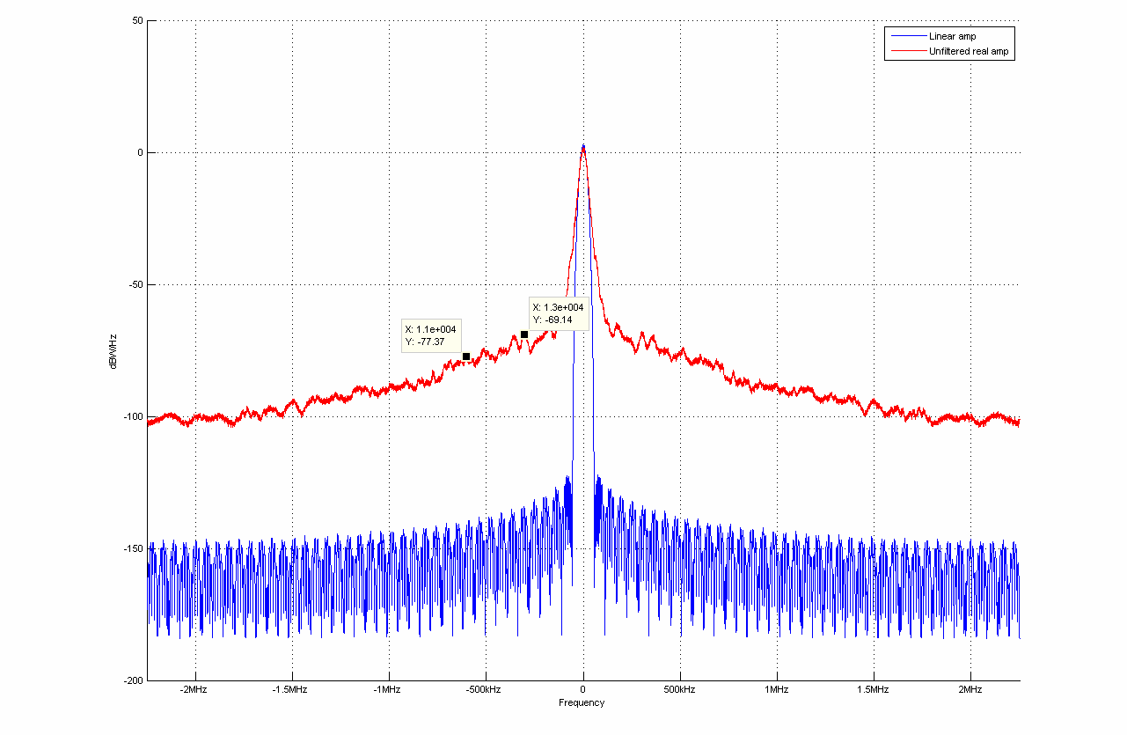

Finally, in order to ease the feasibility of the UA terminal diplexer, a half duplex FDD (frequency duplex division) design is considered, meaning that the UA terminal doesn’t transmit and receive at the same time. It must thus transmit or receive twice as faster, that’s why the required bandwidth is twice as wider. Let us note that such a design doesn’t impact the overall system capacity given that two users can be multiplexed in time on a single carrier.

6.4 Carrier bandwidth and frequency plan
The following table presents the computation leading to the carrier bandwidth. In the return link, 2 carriers, i.e. 4 UA, are multiplexed on a 300 kHz channel. In the forward link, 8 carriers, i.e. 16 UA, are multiplexed on a 300 kHz channel.
Table 2
Carrier bandwidth
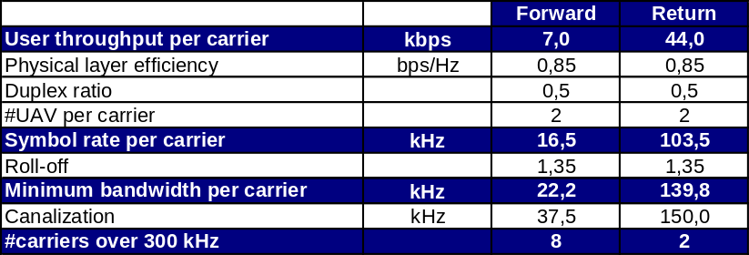

The AMS(R)S system will operate in the 5 030-5 091 MHz band. This frequency band is split into three separate parts:
– 5 030-5 050 MHz: satellite to UA (forward) and satellite to GES (return) paths;
– 5 050-5 071 MHz: frequency separation to ensure a sufficient isolation between both paths (20 MHz is the foreseen separation so that the satellite diplexer can provide a sufficient isolation). This section of the band is thus not used and a part of it could be reserved for tactical MLS stations (provided that the corresponding MLS frequency allocation is validated at ICAO level). Indeed, tactical MLS stations can be used anywhere and, as a consequence, require MLS channels that are never used by the AMS(R)S system. As a baseline, it is assumed that 10% of the overall band, i.e. 6 MHz, is reserved in the section 5 050-5 071 MHz for tactical MLS stations (knowing that around 30 tactical MLS stations are included in the COM3 database, which contained around 800 MLS stations).
– 5 071-5 091 MHz: UA to satellite (return) and GES to satellite (forward) paths.

6.5 Link budgets
Link budgets for the return link and the forward link are presented hereafter. The feeder link is assumed to be in 5 030-5 091 MHz band, this case being the most restrictive one. A QPSK 1/2 DVB-RCS type waveform is considered. Parameters that are of prime interest for sharing studies are highlighted in red:
– Max EIRP
– Used bandwidth (i.e. symbol rate)
– Tolerated degradation caused by MLS stations.
Figure 17
AMS(R)S return link budget
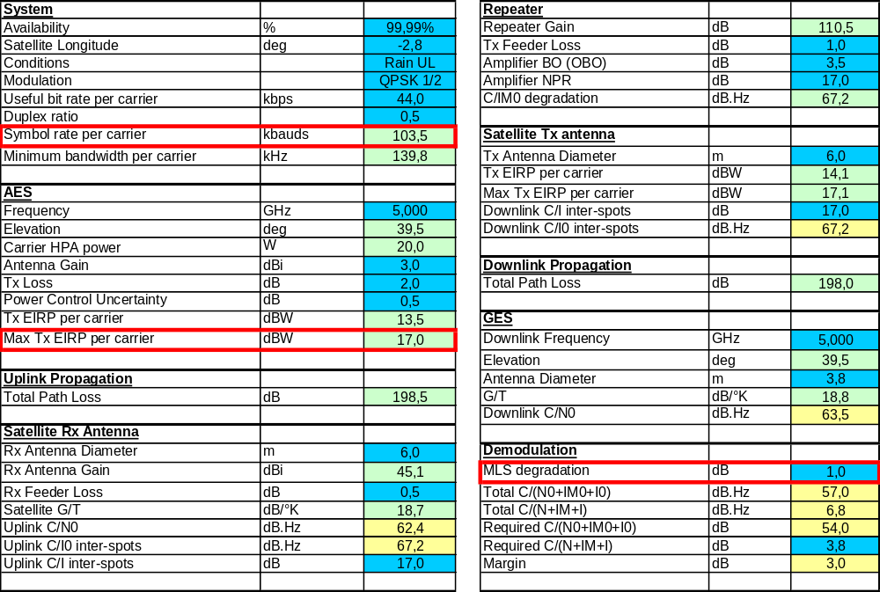

Figure 18
AMS(R)S forward link budget
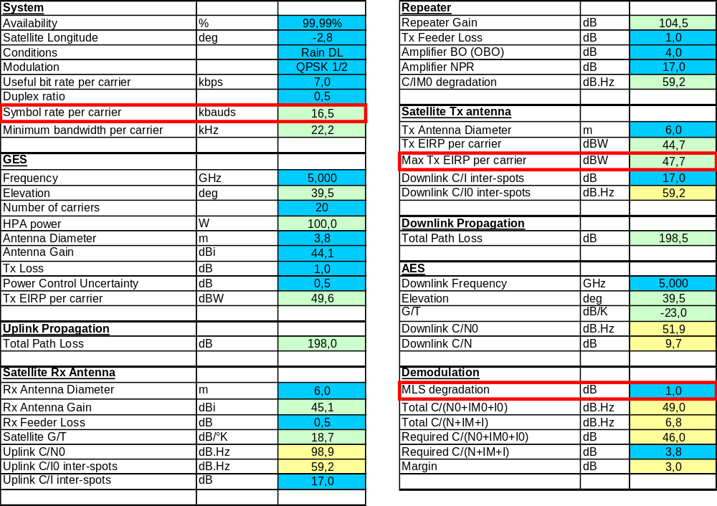

7 Coexistence studies

7.1 Introduction
The coexistence study aims at assessing whether:
1) The sharing of the band between MLS and the AMS(R)S system is feasible (considering the criteria defined in § 5.4).
2) The AMS(R)S system can provide the required capacity, as defined in the preliminary draft new Report ITU-R M.[UAS-SPEC] of which assumptions in terms of UA density and bit rate per UA have been retained. It is to be noted that spot beams considered here are smaller than those in the preliminary draft new Report ITU-R M.[UAS-SPEC]. This leads to 16 UA per spot and to satellite spectrum requirement smaller than the 49 MHz concluded in this Report.
For the sake of illustration of interactions between MLS and the AMS(R)S system, MLS transmitters (red signs) and AMS(R)S spots are represented on the following figure, along with the number of MLS transmitters in each AMS(R)S spot.
Figure 19
Satellite spots and MLS transmitters in satellite coverage
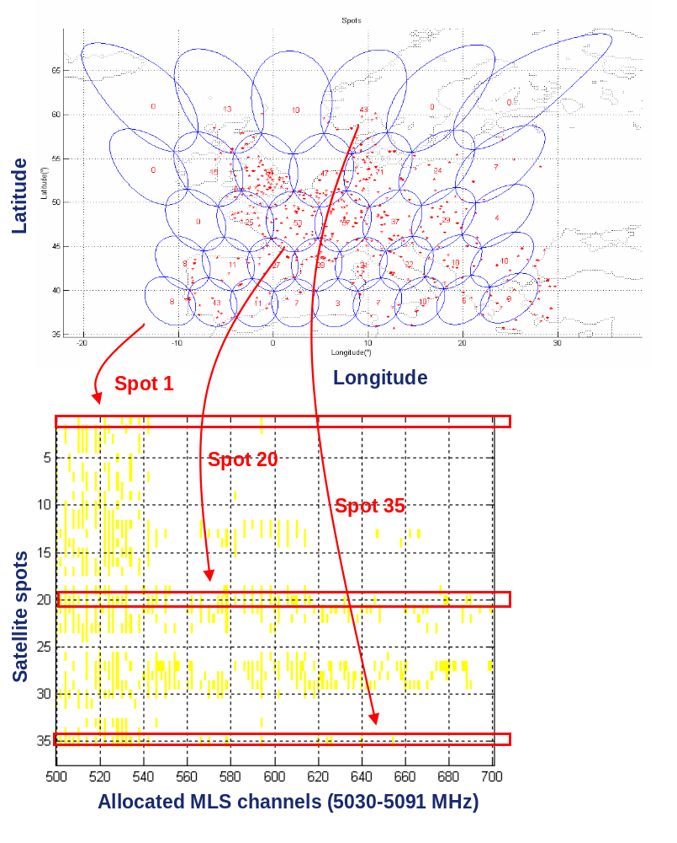

7.2 General methodology
The general methodology, which is presented on Fig. 20, is organized in 4 steps:
1) Single interferer analysis: for each case (e.g. UA creating potential interferences towards MLS), all possible scenarios, i.e. all possible locations of the interferer, are studied to determine what the interference level is as a function of the frequency isolation.
2) Frequency planning constraints determination: based on the single interferer analysis, an initial set of constraints, i.e. required frequency isolation as a function of the spatial isolation, is derived. These constraints can be refined after the aggregation analysis.
3) Aggregation analysis: all potential AMS(R)S interferers are considered to compute the aggregated interference level. A worst case scenario is considered.

4) Effective frequency planning: the exact locations of MLS transmitters and their corresponding channel number (based on COM3 database) are taken into account to derive an effective frequency planning over Europe. Question: does this approach restrict planning activities for MLS other then the current frequency plan in COM3 database? What is meant with exact locations of MLS transmitters?

Figure 20
General methodology
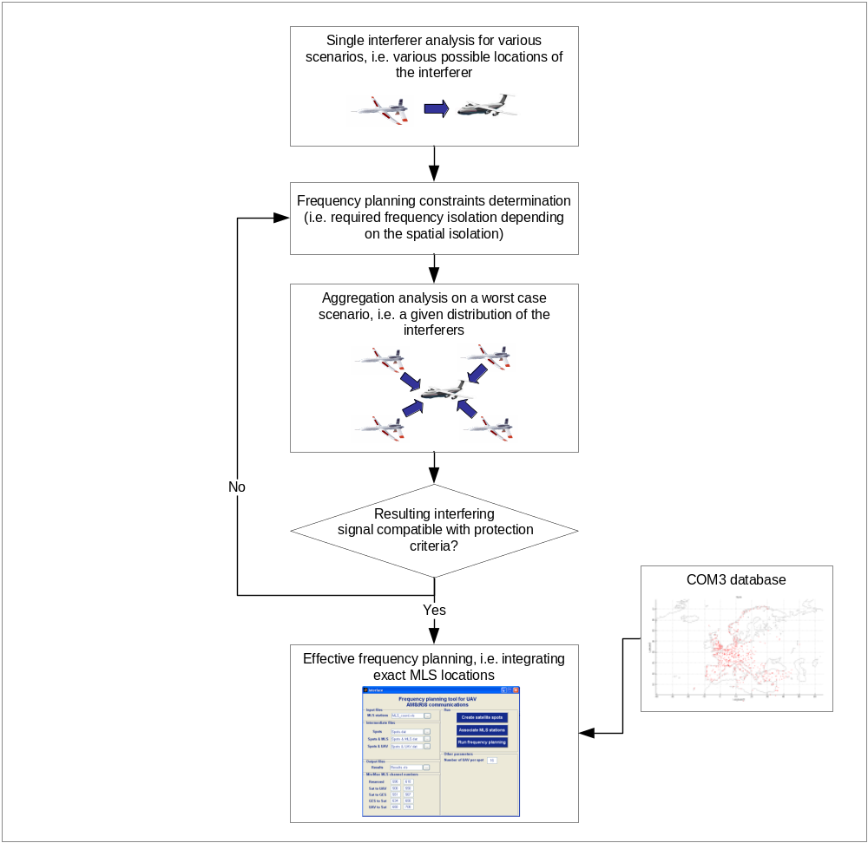

7.3 Single interferer analysis

7.3.1 Satellite to MLS (satellite to UA link, forward)
The general scenario for the potential interferences created by the satellite towards the MLS receiver is described hereafter. In this example, the UA is served by the satellite spot in which is located the MLS receiver. Scenarios in which the UA is served by other satellite spots are as well considered. These other spots are represented on Fig. 22.
Figure 21
Interferences from satellite to MLS receiver – Single interferer scenario
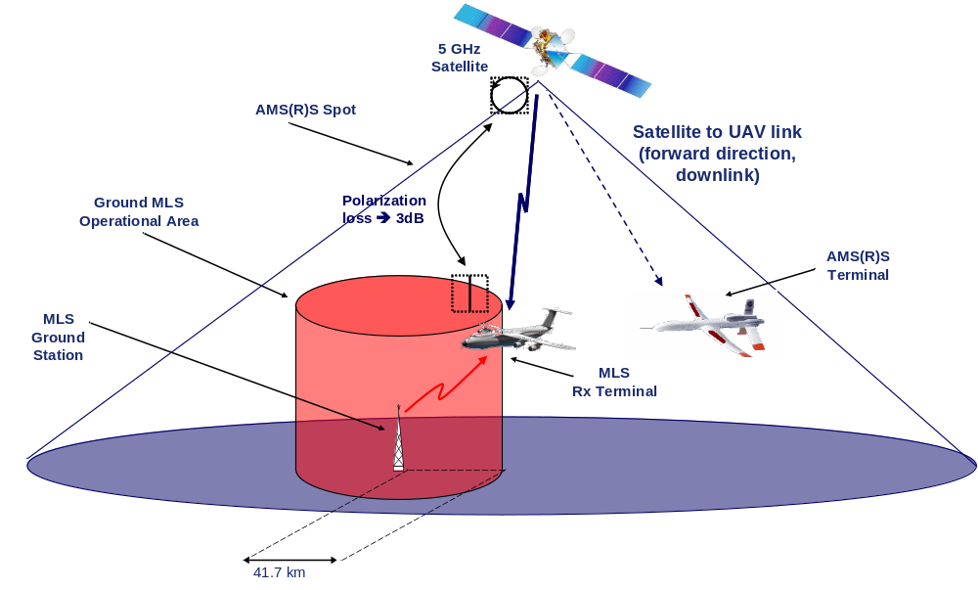
Figure 22
Satellite spots creating potential interferences towards the MLS receiver
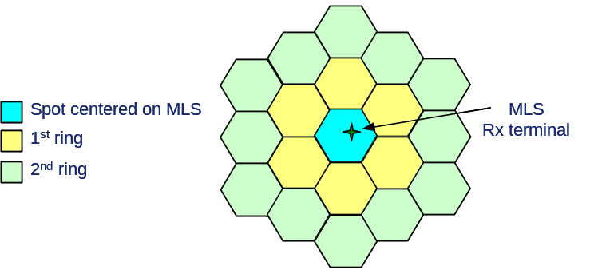

Results are presented in the following table, each combination of spatial and frequency isolations being studied. Combinations that are flagged “NOK” do not meet criteria defined in § 5.4, meaning that they cannot be used. As an example, the same 300 kHz channel as the one used by a MLS station cannot be used neither in the spot covering the MLS coverage area corresponding to this MLS station or in the spots surrounding this spot (1st ring spots).
Table 3
Interferences from satellite to MLS receiver – Single interferer – Results
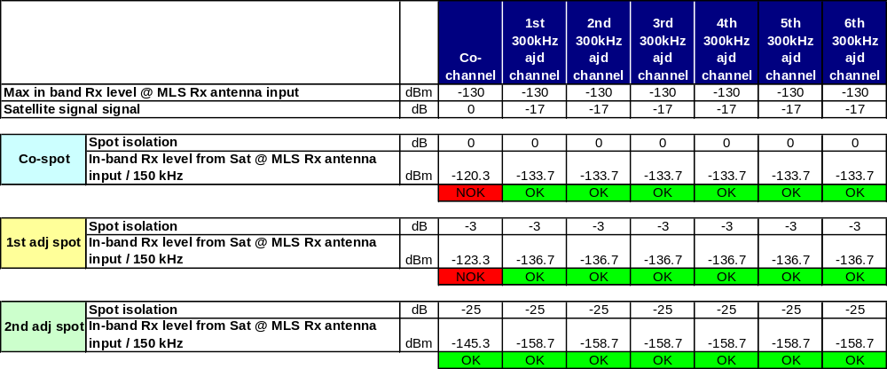

7.3.2 MLS to UA (satellite to UA link, forward)
The general scenario for the potential interferences created by a MLS transmitter towards the satellite is described hereafter.

Figure 23
Interferences from MLS transmitter to UA receiver – Single interferer scenario
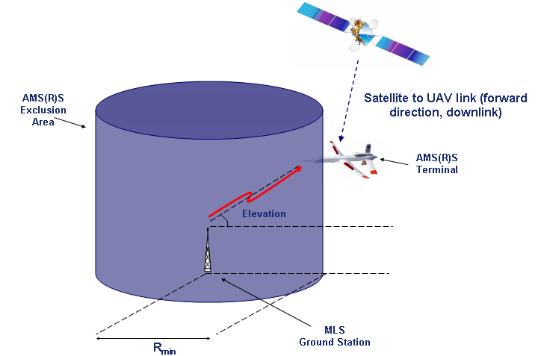

The following figure presents the path loss variation between the MLS transmitter and the UA depending on the elevation for a given UA altitude (10 km). Indeed, due to variation of the MLS Tx antenna pattern, the path loss varies as the UA is approaching the MLS transmitter. Thus, the minimum path loss, i.e. the worst case for the interferences towards the UA, is reached when the MLS transmitter sees the UA with a 13° elevation, corresponding then to a distance equal to 44.5 km (respectively 4.4 km) for a UA flying with a 10 km (respectively 1 km) altitude. This worst case is considered for the analysis. Remark: The MLS AZ antenna pattern is designed to meet the minimum fieldstrength at the edge of the coverage limits. This means that everywhere inside the coverage area the fieldstrength is higher than that at the coverage limits. Does the “worst case” really represent the worst case?
Figure 24
MLS to UA path loss variation depending on the elevation
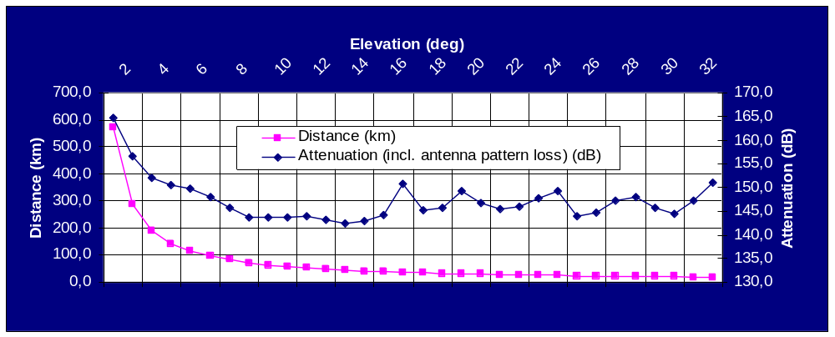

Results are presented in the following table, each combination of spatial and frequency isolations being studied. Combinations that are coloured red do not make it possible to sufficiently protect the AMS(R)S system, meaning that they cannot be used.
Table 4
Interferences from MLS transmitter to UA receiver – Single interferer – Results
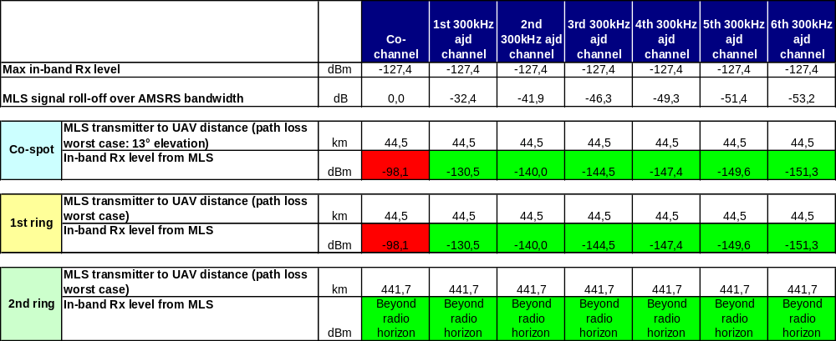

7.3.3 UA to MLS (UA to satellite link, return)
The general scenario for the potential interferences created by the UA towards the MLS receiver is described hereafter.
Figure 25
Interferences from UA transmitter to MLS receiver – Single interferer scenario
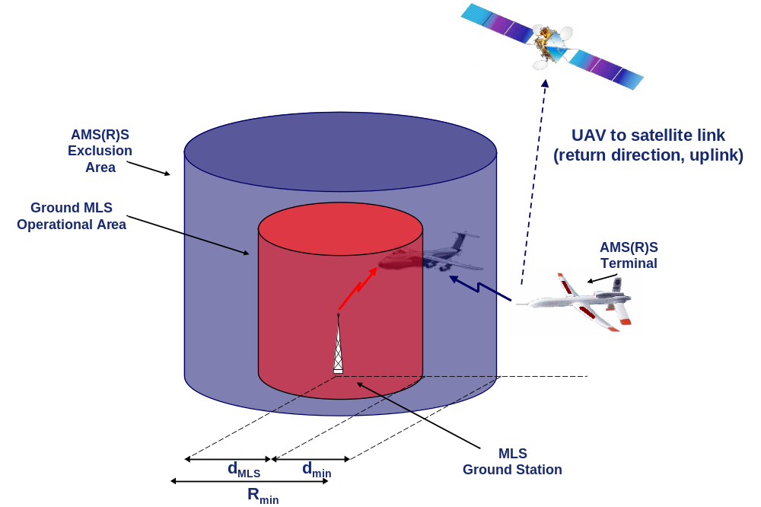

This scenario can be divided into 3 sub scenarios:
– Scenario A: the UA is in the MLS operational area and is at the minimum vertical separation from MLS receiver, as per ICAO regulation that gives the minimum vertical separation between two aircrafts in controlled airspace (i.e. [1 000 ft = 300 m]). A minimum frequency isolation is required.
Figure 26
Interferences from UA transmitter to MLS receiver – Scenario A
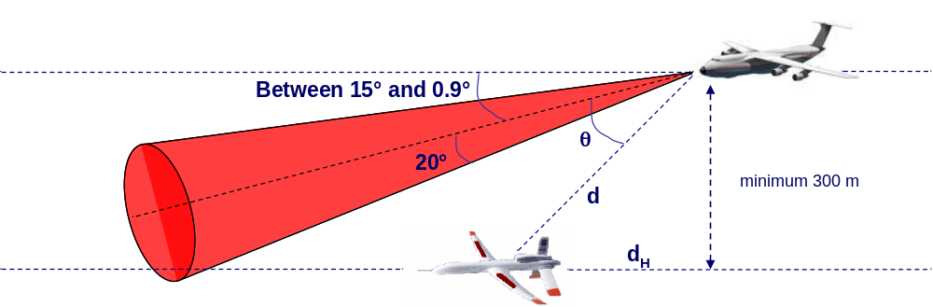

– Scenario B: the UA is in the MLS operational area and is at the minimum horizontal separation from MLS receiver, as per ICAO regulation that gives the minimum horizontal separation between two aircrafts in controlled airspace (i.e. [2 NM = 3.7 km]). A minimum frequency isolation is required.
Figure 27
Interferences from UA transmitter to MLS receiver – Scenario B
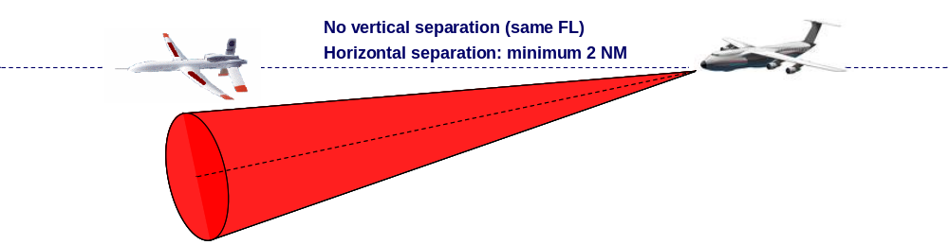

– Scenario C: the UA is outside the MLS operational area and possibly beyond the radio horizon. The required spatial isolation depends on the frequency offset.
Figure 28
Interferences from UA transmitter to MLS receiver – Scenario C
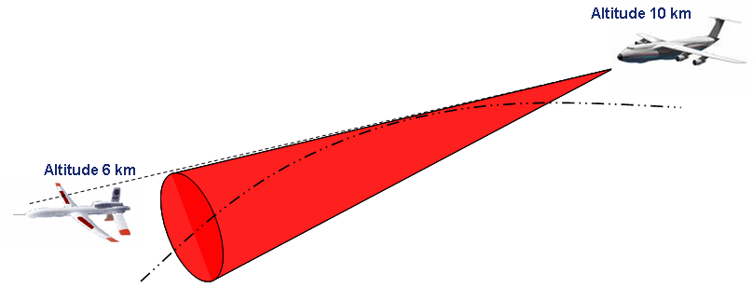

Results are presented in the following table, each combination of spatial and frequency isolations being studied. Combinations that are flagged “NOK” do not meet criteria defined in § 5.4, meaning that they cannot be used. Assuming that the MLS receiver is at the edge of two spots of the 1st ring, two cases are studied for 1st ring spots: firstly, a 1st ring spot being close to the MLS Rx (adjacent spot) and, secondly, a 1st ring spot being on the other side (non adjacent spots). This illustrated on Fig. 32, which presents the aggregation scenario.
Table 5
Interferences from UA transmitter to MLS receiver – Single interferer – Results
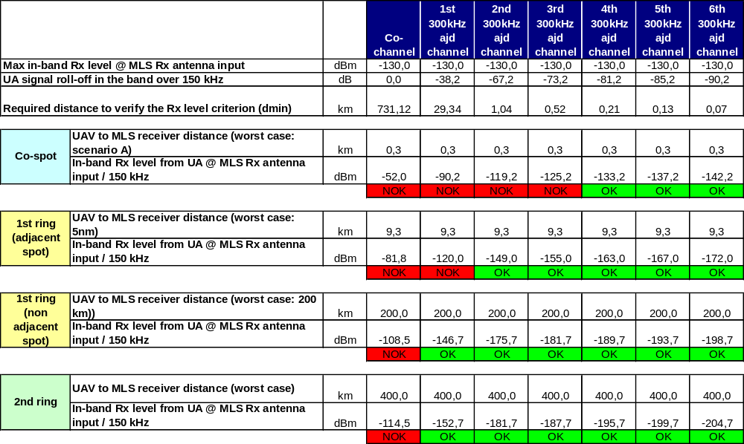

7.3.4 MLS to satellite (UA to satellite link, return)
The general scenario for the potential interferences created by a MLS transmitter towards a UA receiver is described hereafter.
Figure 29
Interferences from MLS transmitter to satellite – Single interferer scenario
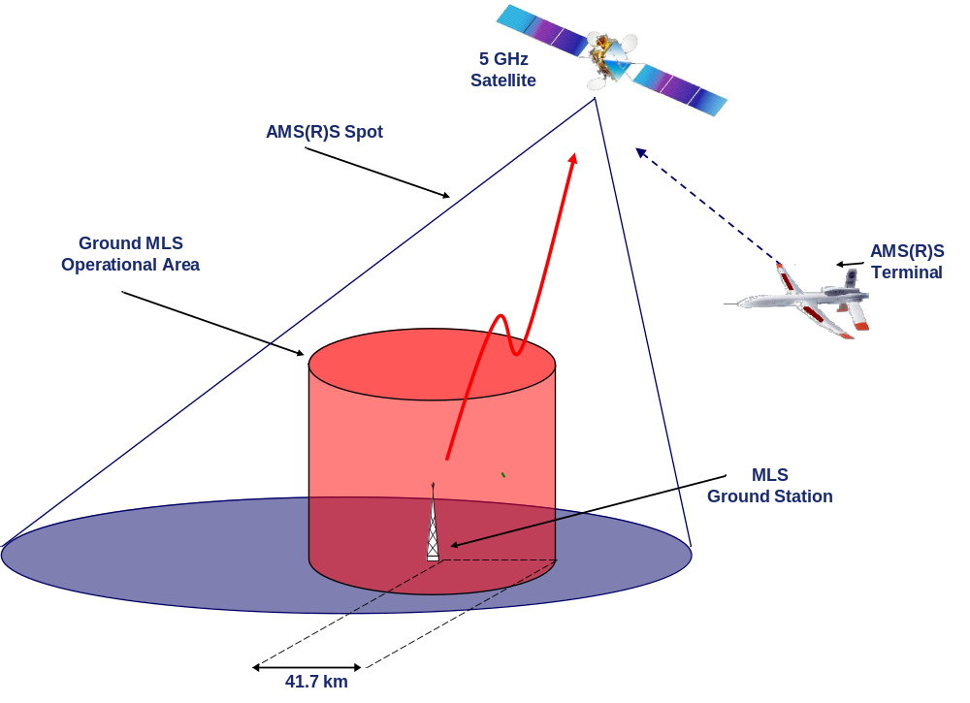

Results are presented in the following table, each combination of spatial and frequency isolations being studied. Combinations that are coloured red do not make it possible to sufficiently protect the AMS(R)S system, meaning that they cannot be used.
Table 6
Interferences from MLS transmitter to satellite – Single interferer – Results
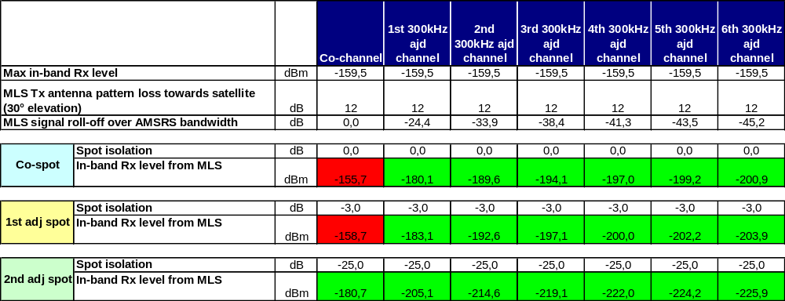

7.4 Aggregation analysis

7.4.1 Satellite to MLS (satellite to UA link, forward)
The aggregation scenario is described hereafter. It integrates frequency planning constraints that stems from the sharing with MLS as well as frequency reuse constraints. The MLS receiver is assumed to be at the edge of 3 spots, which is a worst case.
Figure 30
Interferences from satellite to MLS receiver – Aggregation scenario
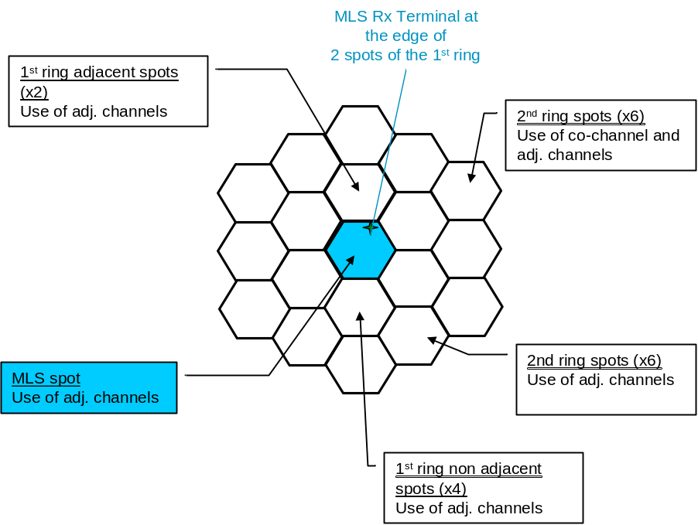

Results of the aggregation analysis are presented in the following table, presenting the intermediate aggregated levels as well as the total aggregated level, which is below the maximum level received at MLS receiver antenna input.
Table 7
Interferences from satellite to MLS receiver – Aggregation – Results
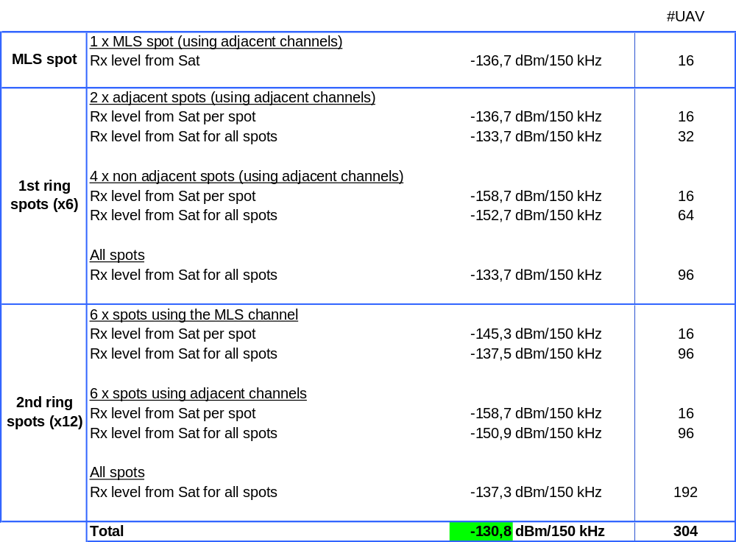

7.4.2 MLS to UA (satellite to UA link, forward)
The aggregation scenario for the MLS to UA case is presented hereafter. In order to sufficiently protect the UA, frequency planning constraints that are considered are more stringent than the ones resulting from the single interferer analysis. Moreover, the fact that MLS transmitters cannot all use the same channel is integrated in the analysis.
Figure 31
Interferences from MLS transmitter to UA receiver – Aggregation scenario
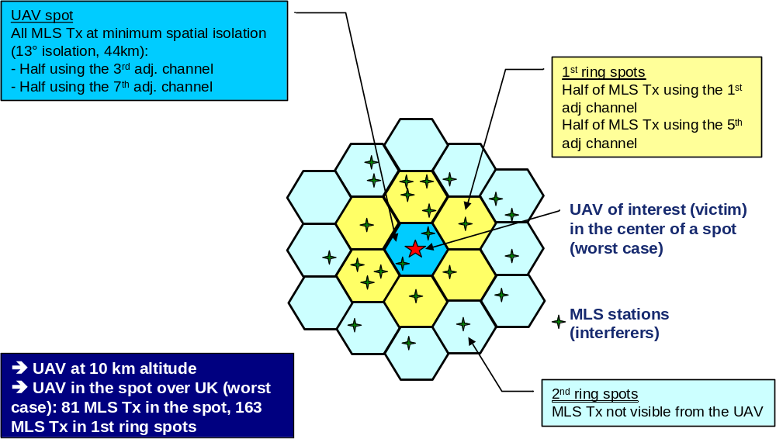

Results of the aggregation analysis are presented in the following table, presenting the intermediate aggregated levels as well as the total aggregated level, which is below the maximum level received at UA antenna input.

Table 8
Interferences from MLS transmitter to UA receiver – Aggregation – Results
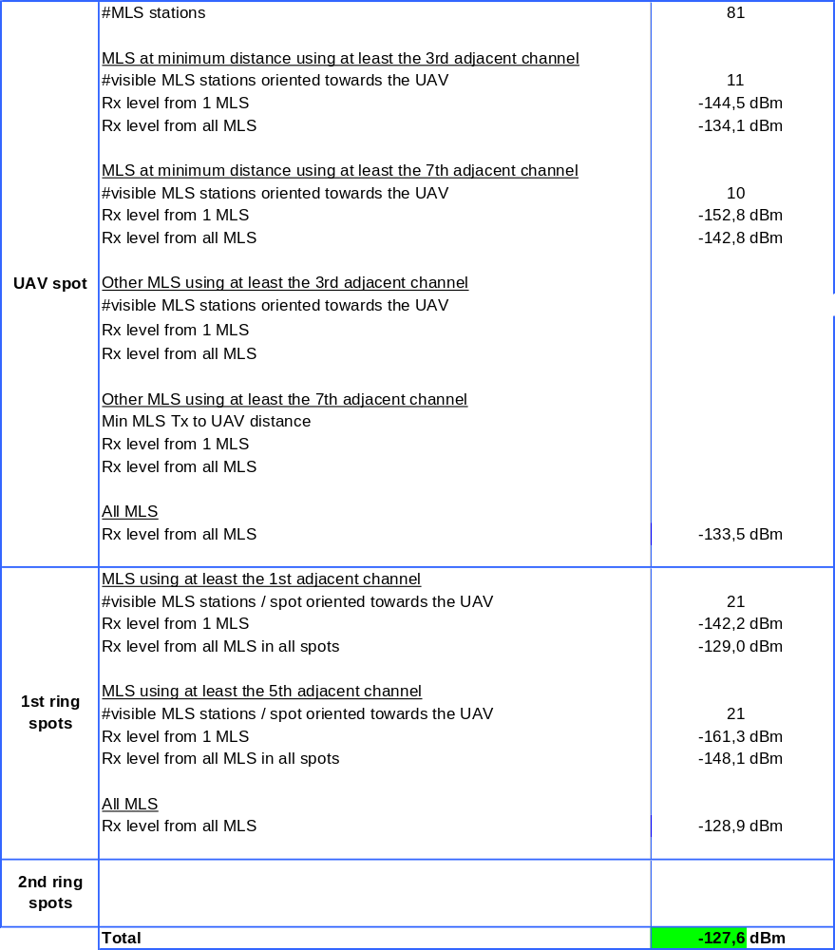

7.4.3 UA to MLS study (UA to satellite link, return)
The aggregation scenario is described hereafter. Similarly to the aggregation scenario for interferences from satellite to MLS receiver, it integrates frequency planning constraints that stems from the sharing with MLS as well as frequency reuse constraints. Moreover, 16 UA per spot are considered, meaning that the interference created by 19 * 16 = 304 UA is aggregated at the MLS receiver (UA at a higher distance are beyond radio line-of-sight).
Figure 32
Interferences from UA transmitter to MLS receiver – Aggregation scenario
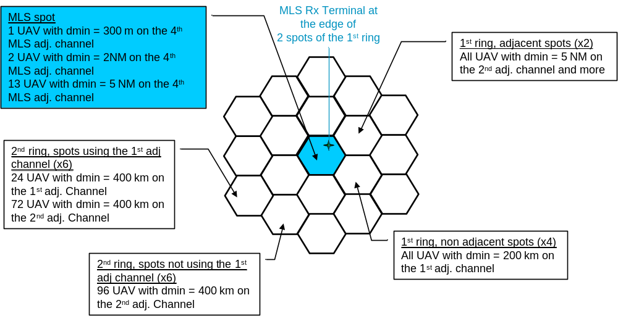

Results of the aggregation analysis are presented in the following table, presenting the intermediate aggregated levels as well as the total aggregated level, which is below the maximum level received at MLS receiver antenna input. Let us note that, for the sake of clarity, not all frequency planning constraints have been integrated, overestimating then slightly the resulting aggregated level. Nevertheless, it is worth highlighting anyway that this aggregated level is mainly driven by the interference created by the closest UA, i.e. the one located at 300 m (minimum vertical separation) from the MLS receiver.

Table 9
Interferences from UA transmitter to MLS receiver – Aggregation – Results
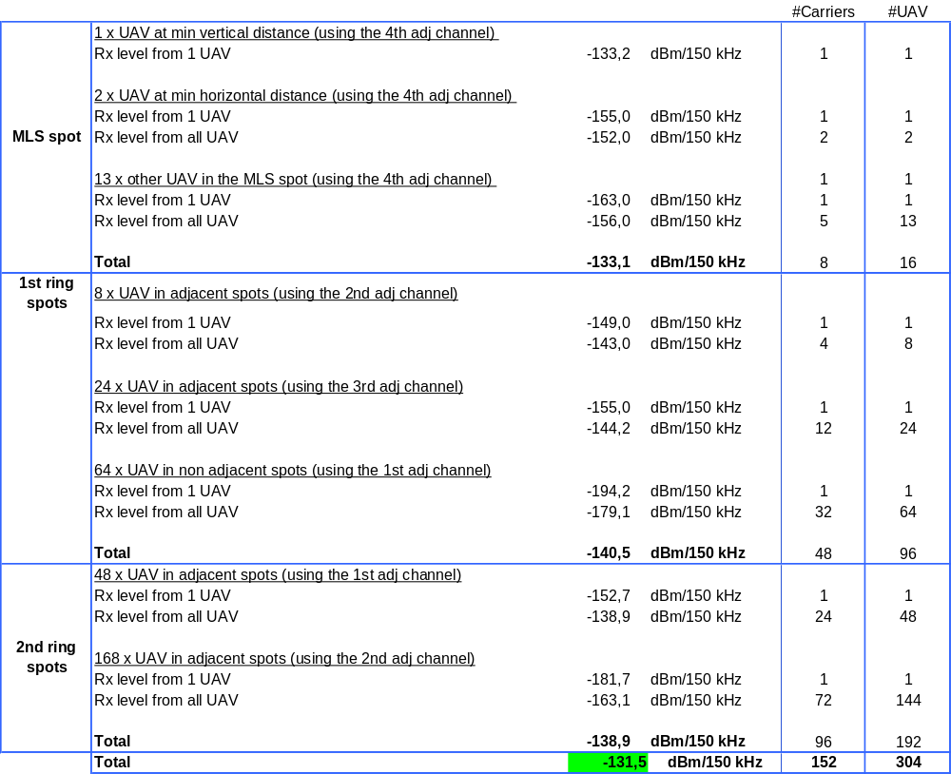

7.4.4 MLS to satellite (UA to satellite link, return)
The aggregation scenario for the MLS to satellite case is presented hereafter.
Figure 33
Interferences from MLS transmitter to satellite – Aggregation scenario
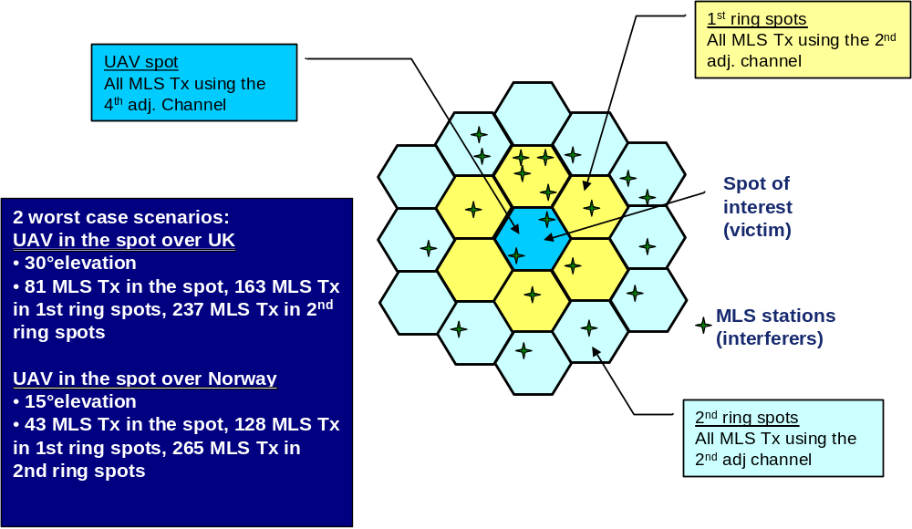

Results of the aggregation analysis are presented in the following table, presenting the intermediate aggregated levels as well as the total aggregated level, which is below the maximum level received at satellite antenna input.
Table 10
Interferences from MLS transmitter to satellite – Aggregation – Results
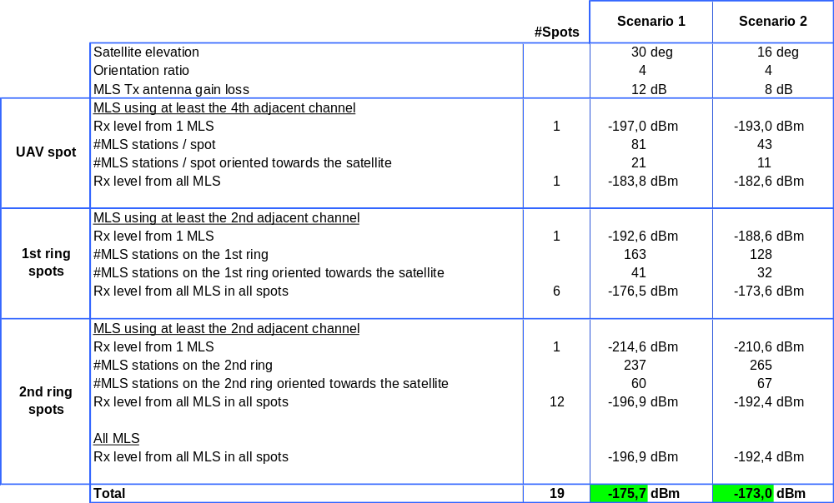

7.5 Frequency planning constraints determination
Following graphs present the frequency planning constraints resulting from the single interferer analysis and the aggregation analysis. These constraints are used as inputs for the frequency planning process. Let us note that, although the frequency planning constraints for the return link are given in terms of distance, from an operational point of view, the frequency won’t be changed when approaching a MLS coverage area but when entering a satellite spot in which the UA may interfere with a MLS coverage area.
Figure 34
Frequency planning constraints for the forward link (satellite to UA)
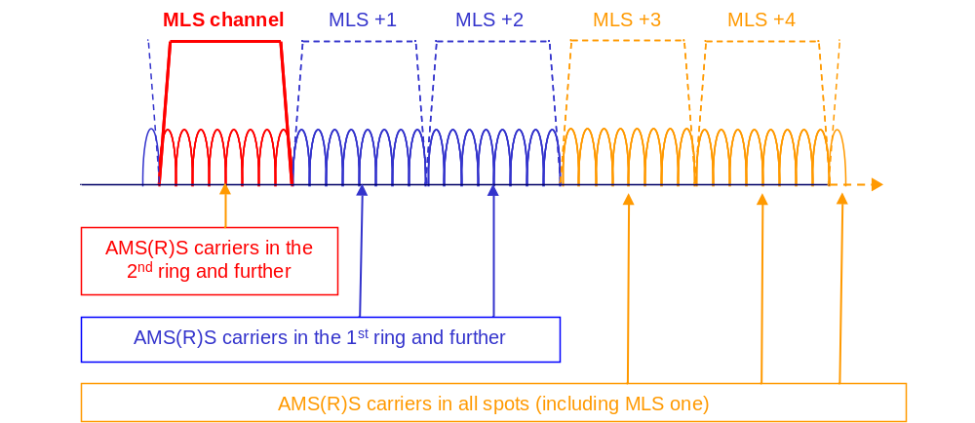
Figure 35
Frequency planning constraints for the return link (UA to satellite)
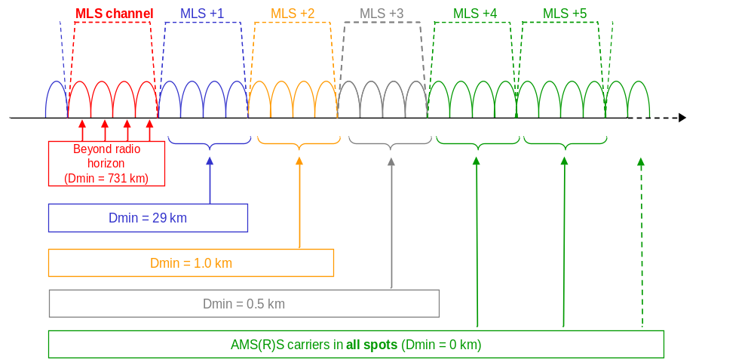

A similar study can be performed for the feeder link, if operated as well the 5 030-5 090 MHz band. Resulting frequency planning constraints are significantly relaxed due to:
– the much lower satellite EIRP for the satellite to GES link;
– the high directivity of the GES antenna.
Moreover, contrarily to UA, GES can be located so that interferences with MLS receivers are minimized.

7.6 Frequency planning
The following graph depicts the resulting frequency plan for the complete band and all links (the colour code is explained hereafter):
– Satellite to UA (forward): channels 500 to 550;
– Satellite to GES (return): channels 551 to 567;
– GES to satellite (forward): channels 634 to 650;
– UA to satellite (return): channels 651 to 700;
– Tactical MLS: channels 590 to 610 (see §6.4).
Several GES, distributed over several spots, are considered. This is illustrated on Fig. 37.
This frequency plan makes it possible to serve the required number of UA, as derived from preliminary draft new Report ITU-R M.[UAS-SPEC].
Figure 36
Resulting frequency plan
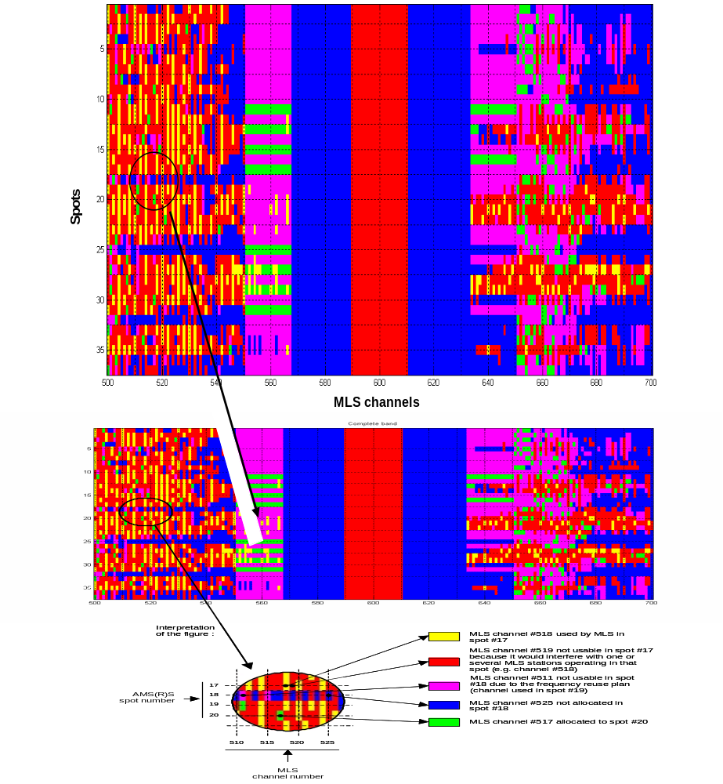
Figure 37
GES allocation
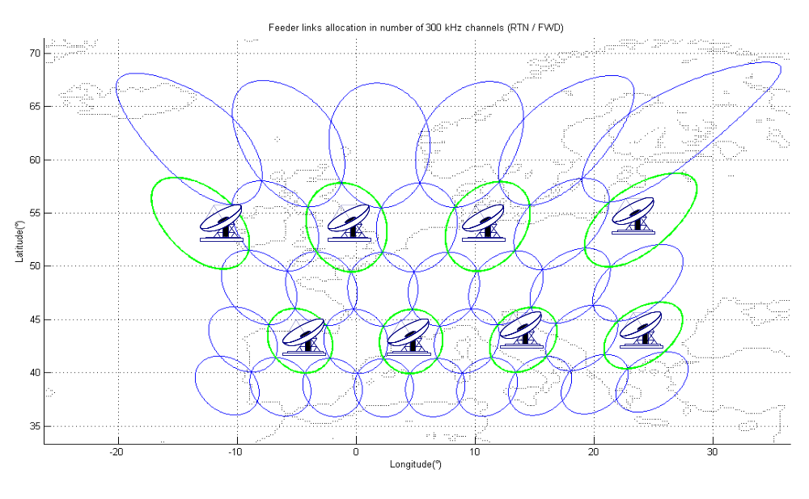

8 Conclusion
The above studies show that it is possible to design an AMS(R)S system sharing the 5 030-5 091 MHz band with the MLS, even when considering worst-case assumptions.
Indeed, in particular, studies assume a massive MLS deployment in Europe (i.e. approximately 800 MLS stations), which, as considered by ICAO, is a very conservative approach considering latest MLS requirements expressed by ICAO State Members, which are much below 800 stations.
However, even when using these worst case assumptions, studies show that i) the protection criteria for MLS (in-band level below –130 dBm/150 kHz) is met for all interference scenarios and ii) UA spectrum requirements as derived from preliminary draft new Report ITU-R M.[UAS-SPEC] can be accommodated in the band 5 030-5 091 MHz.
Hence, carefully designed AMS(R)S system in the band 5 030-5 091 MHz safeguards the long-term access to the band for MLS, while enabling additional aeronautical use of the band, which is particularly spectrum efficient.

See NSP/WGW March 2009 meeting report, Att. F, section 6a6, which deals with Flimsy 3 (Mar 09_NSP/wgw_Flimsy 3 AD MLS Spectrum rev 2.doc) to the NSP/SSG meeting, and which concludes: “The SSG agreed, that the model for the emission characteristics of MLS presented in Flimsy 3 was suitable to determine the requested out-of-band emissions of MLS in the band 5 010 to 5 030 MHz requested by ITU-R WP 4C”.
Antenna used as a reference: Sensor Systems S65-5366-4M.
Final Report of the ICAO NSP Spectrum Sub-Group meeting, 31 March – 2 April 2008, ICAO Headquarters, Montreal (“ICAO_NSP_March_2008_SSG_report_final”).

