 | International Civil Aviation Organization  DRAFT WORKING PAPER
  ACP-WGF20/WP-11
  19 March 2009
AERONAUTICAL COMMUNICATIONS PANEL (ACP)

TWENTIETH MEETING OF WORKING GROUP F

Montreal, Canada 24 March - 3 April 2009

Agenda Item 5 Development of material for ITU-R meetings

PROPOSED MODIFICATION TO WORKING DOCUMENT TOWARDS THE PRELIMINARY DRAFT NEW RECOMMENDATION ITU-R M.[AMS(R)S SPECTRUM]
（Methodology for the Calculation of AMS(R)S Spectrum Requirements）

(Presented by K. INOGUCHI, Japan)
(Prepared by Y. SUZUKI)

SUMMARY
This document presents a preliminary draft contribution to the third meeting of the ITU-R WP 4C on proposed modifications to the working document towards the PDNR ITU-R M.[AMS(R)S SPECTRUM] under consideration in Japan.
ACTION
The WG-F members are asked to consider this working paper and provide a common methodology to estimate spectrum requirements for the AMS(R)S, as far as possible, responding to the WP 4C for the Res. 222 (Rev.WRC-07) relating to the WRC-11 Agenda Item 1.7.

WRC -07 adopted WRC -11 agenda item 1.7 in order to ensure long-term spectrum availability and access to spectrum necessary to meet requirements for the aeronautical mobile-satellite (R) service (AMS(R)S) in the 1.5/1.6 GHz bands, and to take appropriate action on this subject, and requested ITU-R to conduct the appropriate technical, operational and regulatory studies to ensure long-term spectrum availability for the AMS(R)S in accordance with Resolution 222 (Rev.WRC-07).
The WP 4C developed the working document towards PDNR "Methodology for the estimation of the AMS(R)S" at its second meeting, and it is expected to complete the PDNR at the third meeting.
This document presents a preliminary draft contribution to the third meeting of WP 4C as shown in Appendix 1 under consideration in Japan.
WG-F members are asked to consider this working document and provide a common methodology to estimate spectrum requirements for the AMS(R)S, as far as possible, responding to the WP 4C for the Res. 222 (Rev.WRC-07) relating to WRC-11 Agenda Item 1.7.

Appendix 1 Preliminary draft contribution to the third meeting of the ITU-R WP 4C meeting under consideration in Japan " Proposed Modification to Working Document Towards a Preliminary Draft New Recommendation ITU-R M.[AMS(R)S SPECTRUM]"

Appendix 1

Preliminary draft contribution to the third meeting of the ITU-R WP 4C meeting under consideration in Japan
"Proposed Modification to Working Document Towards a Preliminary Draft New Recommendation ITU-R M.[AMS(R)S SPECTRUM]"

1. Introduction
WRC -07 adopted WRC -11 agenda item 1.7 in order to ensure long-term spectrum availability and access to spectrum necessary to meet requirements for the aeronautical mobile-satellite (R) service (AMS(R)S) in the 1.5/1.6 GHz bands, and to take appropriate action on this subject, and requested ITU-R to conduct the appropriate technical, operational and regulatory studies to ensure long-term spectrum availability for the AMS(R)S in accordance with Resolution 222 (Rev.WRC-07).
The WP 4C adopted a work plan at its first meeting and developed a working document towards PDNR "Methodology for the estimation of the AMS(R)S", and it is expected to complete this PDNR at the third meeting.
This document proposes modifications of the working document to be considered at the third WP 4C meeting.

2．Discussions
The PDNR developed at the second WP 4C meeting is based on the contribution from the ICAO that was originally proposed by ESA and Japan.
The PDNR consists of six annexes as follows.
Annex 1: General Introduction to Methodology
Annex 2: Aviation communication needs
Annex 3: Detailed Methodology Approach
Annex 4: PIAC Methodology Approach
Annex 5: Examples on the use of the methodologies
Annex 6: Acronym definitions

The points of further consideration would include;
(1) Equations in two methods for the calculation of the spectrum requirements, the Annex 3 (Simulation approach) and the Annex 4 (PIAC approach) have many similarities and it is invited to check by the next meeting to see if the Annexes 3 and 4 can be merged.
(2) The elements for the Annex 5, Examples on the use of the methodologies, are needed to be provided.
(3) The calculation process should be simple and straightforward as far as possible. Therefore lengthy tutorial descriptions should be removed or shortened, and such contents could be included in the accompanied ITU-R Report, which will be discussed, on spectrum requirements for the AMS(R)S as appropriate.
(4) Some processes of the calculations are difficult to apply practicably or to apply for world wide. Therefore such processes should be more clearly explained.
(5) Terms and definitions are needed to be reconsidered and to be aligned throughout the text.

3．Proposal
It is proposed that the WP 4C considers Attachment 1 to complete the PDNR.
It is also proposed that, if appropriate, the PDNR should be re-examined to make it concise and clear as an ITU-R Recommendation.

Attachment 1 Preliminary Draft New Recommendation, ITU-R M.[AMS(R)S SPECTRUM]

Attachment 1

PRELIMINARY draft new Recommendation
ITU-R M.[AMS(R)S spectrum]
Methodology for estimating spectrum requirements of the aeronautical mobile-
satellite (R) service
[Summary]
TBD
[Scope]
TBD

The ITU Radiocommunication Assembly,
considering
a) that aeronautical mobile satellite (Route) service (AMS(R)S) is an essential element of ICAO Communication Navigation and Surveillance (CNS)/Air Traffic Management (ATM) to provide safety and regularity of flight in civil aviation;
b) that AMS(R)S communications for CNS/ATM services are today being provided in the bands 1 545-1 555 MHz and 1 646.5-1 656.5 MHz under footnote No. 5.357A;
c) that the International Civil Aviation Organization (ICAO) has adopted Standards and Recommended Practices (SARPs) addressing satellite communications with aircraft in accordance with the Convention on International Civil Aviation;
d) that ICAO and other aviation bodies have developed documentation describing the long-term AMS(R)S communication services;
e) that ICAO and other aviation bodies have developed studies and documents for the long-term flight forecast;
f) that existing satellite systems provide AMS(R)S communications and that new satellite systems around the world are being developed to support the long-term AMS(R)S communication requirements,
recognizing
a) that Resolution 222 (Rev.WRC-07) invited ITU-R to study the existing and future spectrum requirements of the AMS(R)S,
recommends
1 that the methodology described in Annex 1 should be used for the estimation of the spectrum requirements of the AMS(R)S communications.

Annex 1
General Introduction to Methodology
In order to estimate the required spectrum for AMS(R)S communications in the framework of Resolution 222 (Rev.WRC-07), the following steps (see figure A1) are envisaged:
(a) Estimation of the AMS(R)S communication needs, described in Annex 2;
(b) AMS(R)S satellite system characteristics (including techniques for efficient use of spectrum) necessary for meeting the needs identified in (a);
(c) Use of the methodology described in Annex 3 to derive the AMS(R)S spectrum requirements by combining the needs identified in (a) with the satellite communication characteristics identified in (b).
The following conditions should be determined prior to the estimation of the spectrum requirements, e.g.:
– Target year;
– Airspace considered;
– Type of satellite system to be considered.
It is noted that the methodology in this document deals only on a single satellite system basis covering a given area of the world.

AMS(R)S communication needs
AMS(R)S
Satellite System
characteristics
Methodology to derive spectrum requirements for AMS(R)S
Bandwidth Spectrum requirements for AMS(R)S system
Figure A1
Methodology to derive spectrum requirements for AMS(R)S

Annex 2
AMS(R)S Communication Needs
[Note: Figure and equation numbers are provisional and are to be renumbered.]
AMS(R)S communication needs will depend on the aggregate information volume (i.e. the total aggregate data and voice requirements) for all aircraft in a certain airspace region and over a given time. In order to estimate these communication needs, knowledge of the following is required:
• flight movements over the area of interest;
• communication needs on a per-aircraft basis.

A2.1 Flight movements
Information on flight movements is required to evaluate the number of aircraft located within a given area (e.g. airspace) at any given time. The information can be based on the actual air traffic statistics, or on forecasts of future traffic over a given airspace. Such statistics are normally compiled by the relevant aviation authorities, e.g. by ICAO, IATA for worldwide data and by Eurocontrol for the European region.

A2.2 Communication needs of a single aircraft
The AMS(R)S communication needs of a single aircraft will in general depend from several factors, such as the airspace scenario, operational concept, air traffic services provided over different aircraft flight phase and position.
Identification and quantitative characterization of these communication needs is a complex matter and has been considered by different aviation bodies. For example, the ICAO Aeronautical Communication Panel (ACP) has recommended as guidance for the assessment of future communication requirements the “Communications Operating Concept and Requirements for the Future Radio System, Version 2 (COCR V2)”, developed by Eurocontrol and FAA. COCR V2 describes in detail the aviation communication services required by a single aircraft in different air space domains and flight phases, and is a suitable basis for the purpose of the assessment described in this document.

A2.3 Communication needs of multiple aircrafts
The cumulative communication needs over a given airspace area and a given time frame can be obtained by combining the information on flight movements in that area and time frame (section A2.1) with the information on the communication needs of a single aircraft (section A2.2).
This Annex describes two methods of performing the combination of the above information. One method is based on a simulation approach (See section A2.3.1) and the other on a Peak Instantaneous Aircraft Count (PIAC) approach (See section A2.3.2). The difference between these occurs at the level of inputs, i.e. one considers a flight by flight and time iterated simulation, and the other relies on estimation of the maximum number of aircraft over a given airspace and the average communication rate per aircraft.

A2.3.1 Simulation method

[To be proposed by ESA]

A2.3.2 PIAC method
The information on flight movements can be captured in a single parameter, i.e. the PIAC (Peak Instantaneous Aircraft Count). It is defined as the maximum, over a specified period, of the instantaneous count of aircraft presented over a given airspace S, i.e.:
AC (S) = max_{(t)} N(t; S) (8)

where N(t;S) is the total number of aircraft flying over airspace S at time t

The information on the communication needs of the aircraft is also captured by a single parameter, i.e. the averaged unit information volume per aircraft in a specified duration.
From the knowledge of the communications in flight phases (section A2.1), it is possible to derive the averaged unit information volume per aircraft (R), in a specified duration. This is done as follows: if each of the communication profile per flight can be written generically as r(t), then its time average can be expressed as:
R = average_{(t)} r(t) (9)
This can be either derived by simulations, or by statistical approach.
Hence, given AC(S) and R, the Maximum Information Volume (MIV) is then simply calculated as:
MIV(S) = AC(S) · R (10)
[In general, if MIV_{SIM} is defined by the MIV derived with the simulation approach of section A2.3.1, then it is easy to show that MIV_{PIAC}(S) and MIV_{SIM}(S) are very similar to each other, to the extent that they might be almost equal.]

The above process may be carried out by following steps.

(1) Estimation of the PIAC
This is a basic parameter required for the estimation of the spectrum requirement for the AMS(R)S communications in the specified airspace (such as specified service area or beam cluster zone) and the specified period (i.e. year).
This number may be obtained by various methods, generally for the current time frame it is derived by using actual statistics and for future time frame derived by detailed investigation and forecasting.

(1a) Obtain Reference PIAC
The reference PIAC for scheduled flight in specified airspace S , in the most busy hour, in the reference year (Y_{r}), i.e. AC_{r}(S), can be obtained by investigating airlines timetable database of the year, such as OAG (Official Airlines Guide) and will be referred as
AC_{r}(S) = PIAC(Y_{r}, S).

(1b)

Calculate Target year’s PIAC
At the target year Yt, the PIAC for all scheduled flights in the airspace S, i.e. ACt(S), can be obtained by using the reference PIAC derived above for the year Y_{r}, the airflight yearly growth rate (g_{i}) of all flights and for the years between Y_{r} and Yt. This will give:
AC_{t}(S) = AC_{r}· (1 + g₁) · (1 + g₂) · ... · (1 + g_{k}) (13)
where k = Yt – Y_{r}. In case g₁= g₂=... =g_{k}= g, then:
AC_{t}(S) = AC_{r} · (1 + g)^{k} (14)

(1c) Obtain Target Year’s Total PIAC
If the total number of flights served in a given airspace S is the sum of scheduled flights (F), non-scheduled flights (NS) and general aviation (GA), the total target year’s PIAC in the airspace S, i.e. ACtt(S), becomes:
ACtt(S) = r_{x} · AC_{r}(S)
where,
r_{x} = (F + NS + GA)/F

(1d) PIAC for satellite communications
The PIAC relevant for a satellite covering airspace S is obtained from the total target year’s PIAC multiplying by ratio (r_{s}) of aircraft using satellite communication (r_{s}), i.e.: .
AC_{s}(S) = r_{s} · AC_{tt}(S) (15)
or using all parameters defined above, the PIAC for consideration in the calculation of the MIV_{PIAC} is then equal to:
AC_{s}(S) = r_{s} · r_{x} ·(1 + g)^{k}· AC_{r} (16)

(2) Estimete averaged unit information volume

Averaged unit information volume (R) to be handled by a satellite system can be obtained by aggregating the amount of data (kbits) or Erlangs over a given period of time T_{p} (e.g. 1 hour) [and at the peak period of the day and of the busiest day of the year].
This value may be obtained by actual communication statistics, or estimated by communication requirements such as from the COCR v2. We need to make also sure that this estimation is relevant for the given year Y.

A2.3.3 Inputs to the calculation of spectrum requirements
Either of the methods described in sections A2.3.1 and A2.3.2 lead to the calculation of the MIV and as such they will both adequately characterize aviation communication needs over a given area of airspace. As such they can be used as inputs for the calculation of AMS(R)S spectrum requirements in the airspace area S. It is thus a matter of choice by the interested aviation experts or satellite operator to choose one method versus another.
Specifically, given area S:
[(1) with the simulation method described in section A2.3.1, the AMS(R)S communication needs in S could be described as either:
MIV(S) = max_{(t)} RIV(t;S) (18)=(3)
or:
RIV(t; ΔS_{k}), ∀ ΔS_{k} ⊆ S (19)
where (18) represents a constant value directly expressing the maximum aggregate information throughput in area S, and (19) consists of a set of time functions expressing the required information throughput in each of the ΔS_{k} areas contained within S (see Figure A3), which can be used in conjunction with information on spot beam architecture to derive maximum information throughput MIV(σ_{S}) for each spot beam.]

(2) with the PIAC method described in section A2.3.2, communication needs in S_{i} would be described as:
MIV_{PIAC}(S_{i}) = PIAC(S_{i}) · R (20)
where S_{i} are all the airspaces for which a PIAC has been calculated.

[note: moved from below]
[As stated above, both methods lead to the same or very similar MIV values and thus, for the same airspace area and satellite system will also lead to the same spectrum estimation. It is thus a matter of preference to choose one method versus another, which may be driven by the tools available by who is making the calculations.]

Annex 3
Calculation of the Spectrum Requirements per Satellite System
(Merged with Detailed Methodology Approach and PIAC Methodology Approach)
[Note: Figure and equation numbers are provisional and are to be renumbered.]

[A part of Annex 4]

A3.1 General
This methodology [(see Figure A8)] estimates the spectrum requirements for AMS(R)S communications starting from the aviation communication needs as defined in Annex 2.

A3.1.1 Process of the Calculation
The details on the calculation of the spectrum requirement of a satellite system to operate over a given airspace S are presented in Figure [A5] below. As seen in Figure [A1], two sets of inputs will be required:
(1) Aviation inputs, formulated either as RIV(t; ΔS) or as MIV (S) and Quality of Service as allowable data delay or call loss;
(2) Satellite characteristics as described in section A3.2.
Figure [A5] below outlines a methodology to calculate the spectrum requirement per satellite systems. The methodology consists of the following three steps:
Step 1: Given the MIV(S) or RIV(t; ΔS) and antenna beam configuration, determine the MIV(σ) for each beam area σ.

Step 2: From the MIV(σ), calculate the spectrum requirement for each beam area σ, i.e. SR(σ), by considering the satellite system characteristics. This is explained in section A3.4 below.
Step 3: If a multi-beam system is being considered, then calculate the spectrum requirement for the whole type of the signal for the satellite system covering area S, i.e. SR(S), by considering possible frequency reuse scheme. This is explained in section A3.6.

A3.1.2 Forward and Return Links
It is noted that the estimation of AMS(R)S spectrum may need to be performed separately for the satellite forward link and for the satellite return link. These two components are in general different because of the different communication needs in both links. The methodology presented in this Recommendation may be applied separately to both components if such differnt is significant.

A3.2 AMS(R)S Satellite System Characteristics
A3.2.1 Satellite beam configuration and frequency reuse pattern
[a part of A3.4]
[Spectrum requirements of satellite network depend on the satellite beam configuration and frequency reuse scheme. For example if an airspace is covered by a global beam or by a cluster of beams where frequency reuse is not possible or not employed then this calculation can be shipped and the SR is assumed to be equal to the SR calculated in the section A3.5.

In general, spot beams can contribute to decrease the total spectrum needs of the system by employing frequency reuse. For example, Figure [A8] shows a region covered by 11 spot beams. With this spot beam pattern, if each of the 11 beams has the same spectrum requirement B=SR(σ), then the figure shows that, instead of requiring a bandwidth assignment of Ba = 11· B, when applying cluster size of 3 in the frequency reuse pattern given in the figure, a spectrum assignment of Bn = 3 B = (3/11) Ba would be sufficient. The bandwidth efficiency of this specific case would therefore be equal to 11/3, and the total BRSS would be smaller (by a factor μ = 3/11) than the sum of the individual SR(σ). Thus:
TSR = (3/11) Σ_{i} SR (σ_{i}) (32)
In reality, because the different beams may have a different traffic loading, resulting in different SR(σ), the overall re-use efficiency is reduced, i.e. less than 11/3. This means that for the spot beam example in Fig. A8 the satellite system bandwidth is larger than the theoretical, i.e. μ is larger than the case of best achievable efficiency (3/11). Hence in general:
TSR = μ Σ_{i} SR (σ_{i}) (32)
with: 0 < μ ≤ 1
The estimation of factor μ is complex and should be conducted by the satellite operator.
It is noted that the cluster size (N_{c}) will generally selected such as 3, 4, 7 and 11, and it depends on satellite antenna sidelobe characteristics and interference criteria.]

[Note: The case should be revised for Nc = 4 or 7]
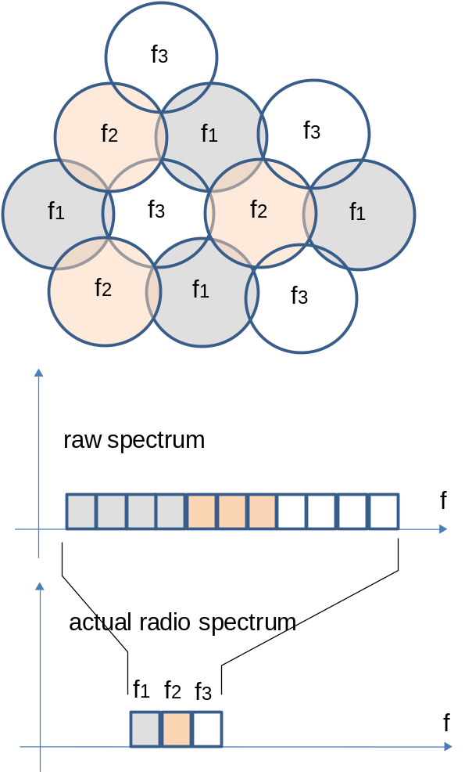
Figure A8
Spot beam frequency-reuse

A3.2.2 Satellite Transmission Characteristics
Satellite transmission characteristics, especially transmission capacity of the carrier (Cd) and its necessary carrier separation (Δ) are essential parameter for estimating spectrum requirements of each type of signal.
The following characteristics are also relevant for deriving above parameters.
(1) Overhead for the packet formatting, encapsulation, error correction and etc.
(2) Type of modulation and multiplexing
(3) Bearer rate
(4) Additional capacity to ensure data delay (D_{d}) and call loss (L_{c})

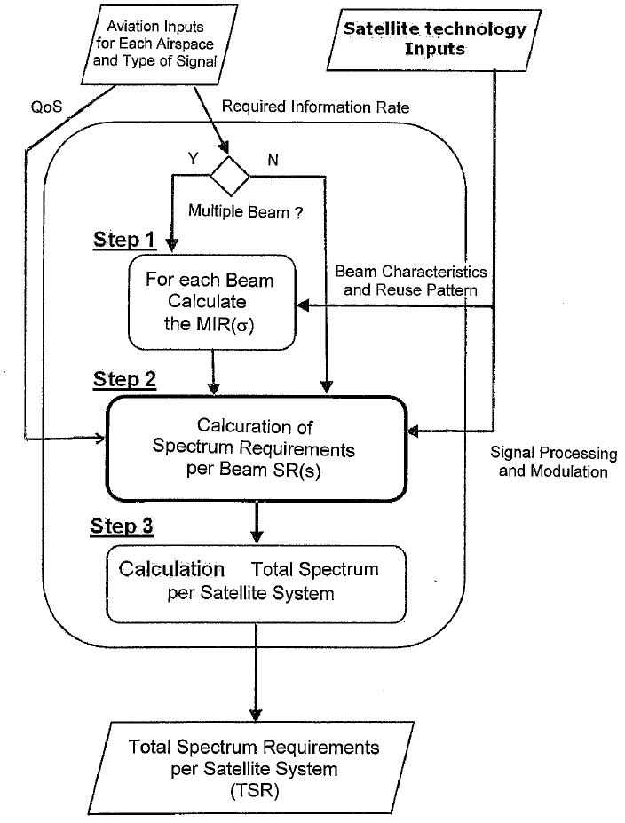

Figure A5
Calculation of spectrum requirement per satellite system - TBD
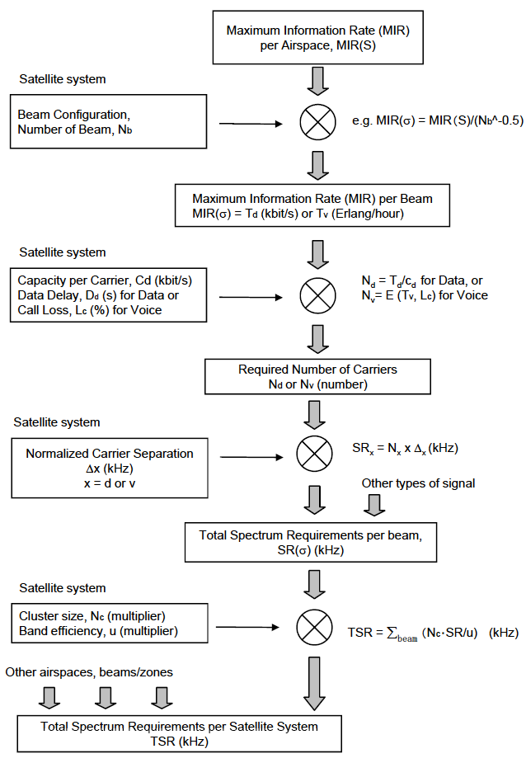
Figure A9
Estimation of required Spectrum for AMS(R)S

A3.3 Calculation of the Maximum Information Volume per Beam for each Type of Signal (Step 1)
Maximum Information Volume per beam (MIV(σ)) can be obtained based on the maximum information volume per given airspace provided by the aviation community.

A3.3.1 Case of the MIV(S) Input
(i) In the case of the global beam
MIV(σ) = MIV(S)
where,
MIV(S): Maximum information volume in the given airspace (kbit/Hr for data or Erlang for voice).
(ii) In the case of the multi beam system
MIV(σ) = MIV(S)/(N_{b}^-0.5)
where,
MIV(S): Maximum information volume in the given airspace (kbit/Hr for data or Erlang for voice),
N_{b}: Number of beam elements in the given airspace.

A3.3.2 Case of the RIV(t;ΔS) Input
[ If a set of the RIV(t;ΔS) is provided for the small cells (t;ΔS) in the airspace S, the following process can be used to obtain the maximum information volume for each satellite beam area (MIV(σ))].

[To be Provided by ESA]

A3.4 Calculation of the Spectrum Requirement (SR) per Beam for each Type of Signal
The methodology to derive the spectrum requirement per beam is based on the determination of certain multiplicative factors, which, when applied to the MIV (Mbit or Erlang in specified period e.g. one hour), determine the spectrum requirements SR (MHz) of the area for which the MIV applies. This could be either for:
(a) each of the beams of a multi-beam satellite system for which frequency reuse is possible, or
(b) for an area S covered by a single beam or a cluster of beams for which frequency reuse is not possible.
A3.4.1 For the Data Signal
(a) Detailed simulation approach
[To be proposed by ESA]

(b) Simplified and generic approach
If parameters as shown in the detailed simulation approach above are not practicably available, the following process would be more convenient and generally applicable to all cases.
(i) Estimate the overhead to the source information
The overhead to the source information to the modulator (α) can be estimated by considering characteristics of pre-coding for the normalized carrier as follows.
α = α₁･α₂
where, 
α_{1:} Overhead for the synchronizing and error correction bits
α_{2:} Overhead for the additional bits for packet and others

(ii) Calculate required number of normalized carriers
The required number of normalized carriers (N_{d}) can be calculated by the following formula
N_{d} = α･Roundup(T_{d}/C_{d})
where,
T_{d} Maximum data rate to be handled = MIV(σ)_{d} in kbit/s
C_{d} Transmission capacity of the normalized data carrier in kbit/s

(iii) Calculate required spectrum per beam
Required spectrum is obtained by multiplying normalized carrier separation for the respective types of carrier (Δ_{d}) and the required number of carriers as follows:
SR(σ)_{d} = N_{d} x Δ_{d} (kHz)
where Δ_{d} is the carrier separation between normalized carriers in kHz.

3.4.2 For the Voice Signal
In the case of the voice signal, different approach to estimate the required spectrum is needed.
Required number of voice circuit (N_{v}) to satisfy acceptable call loss (Lc) can be estimated based on the following formula.
N_{v} = E(T_{v,} Lc)
where,
E(T_{v,} Lc) is a function of satisfying following Erlangs C equation
N_{v}-1
Lc > (N_{v}xT_{v}^{Nv}/(N_{v}! (N_{v} - T_{v}))/(Σ(T_{v}^{x}/x!) + N_{v}xT_{v}^{Nv}/(N_{v} ! (N_{v} - T_{v})))
x = 0
T_{v}: total voice traffic volume (Erlang/Hr) = MIV(σ)_{v}
Then, required spectrum for voice signal per beam (RB_{v}(σ)) is obtained as,
RB_{v}(σ) = N_{v}･Δ_{v}
where,
Δ_{v}: carrier separation of the nomalized voice carrier in kHz

A3.5 Calculation of Total Spectrum Requirement per Beam
Required spectrum per beam (SR(σ)) can be obtained as,
SR(σ) = SR(σ)_{d} + SR(σ)_{v}
where,
SR(σ)_{d}: required spectrum for data signal per beam
SR(σ)_{v}: required spectrum for voice signal per beam

A3.6 Calculation of the Spectrum requirement per Satellite System
Total spectrum requirements for a satellite network (TSR) can be obtained by summing spectrum requirements per beam throughout all airspaces (all beams or service areas).
TSR = (SR(G) + ΣSR(M) + N_{c}･SR(F))/u
where,
SR(G): required spectrum SR(σ) for global beam
SR(M): required spectrum SR(σ) in the multi spot beam that frequency reuse is not possible
SR(F): maximum required spectrum of SR(σ) in the beam cluster
N_{c}: cluster size in the frequency reuse pattern, usually 7.
u: inefficiency due to carrier arrangements
It is noted that in the case of the beam cluster in the frequency reuse pattern, total spectrum requirement would be N_{c}･SR(F) regardless the number of beams.

A3.7 Additional Considerations
[This methodology can also be applied if different types of MIV and/or RIV are provided as input. For example in the cases below:
Broadcast mode of operation
For example the aviation communications needs can be divided between broadcast and non broadcast mode of operation and thus have as an input an MIV_{B} and MIV_{NB}. In such case the TRS for the Broadcast mode is derived separately from the TSR for the Non Broadcast mode and thus the total bandwidth will be equal to the sum of these two.
Satellite Systems Employing Different Data Rates
Another example is the MIV for systems employing different data rates for different types of AMS(R)S communication services, or even for different AESs, the same methodology would apply. Here the total MIV would have to be divided to the different data rates and this can happen at different levels in the methodology, i.e. it can happen at the factors of α, β or γ, as we described above. As this is an issue relevant to the satellite operator/manufacturer it is left to them to decide and provide such information and then apply the methodology above. In such case, spectrum requirements for each individual data rate or AES type can de derived separately then at the end aggregated, or the factors α, β or γ, can be derived such that it takes into account of this aspect.

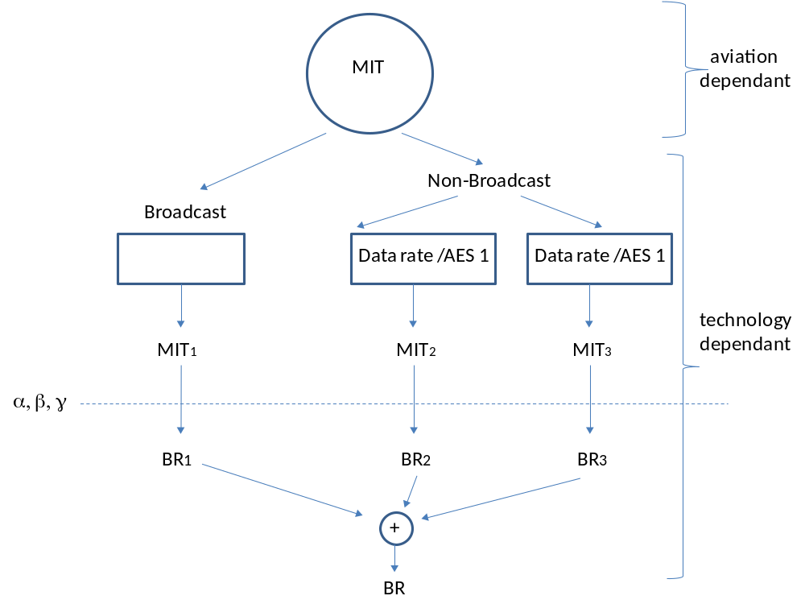
Figure A9: Possible ways to shape the MIV when applying technology dependant parameters
[Note: BR => SR, MIT => MIV]

]

[Note: Merged into Annex 3]
Annex 5
Examples on the use of the methodologies

This Annex provides an example on how to apply the methodologies described in Annex 3 and 4.

A5.1 Introduction
Examples of the application of the methodology are given in the following sections which show the input parameters and the intermediate stage of the calculation of the spectrum requirements for the AMS(R)S communications.

A5.2 Simplified and Generic Methodology
Table 1 gives the estimated traffic demands in years 2015, 2025 and 2035, and calculates the spectrum requirements in various conditions of the satellite networks.

A5.3 Detailed Simulation Methodology
[To be provided by ESA]

A5.4 Conclusion
Methodologies shown in the Annexes 2 and 3 are demonstrated as shown in the Tables.
It should be noted that values and results are only for example and should not be considered as a part of the recommendation.

Table 1
Estimation of the required spectrum based on the simplified and generic methodology approach

 | Case |  |  | 1a | 1b | 2 | 3 | 4 | 5
No. | Airspace Item |  | Unit | Global Beam | Beam Cluster | Global Beam | Beam Cluster | Beam Cluster | Beam Cluster | Formula/source
1 | Reference Year | Yr |  | 2008 | 2008 | 2008 | 2008 | 2008 | 2008 | Spec
2 | Target Year | Yt |  | 2015 | 2015 | 2025 | 2025 | 2035 | 2035 | Spec
3 | Reference Year's PIAC | ACr | count | 680 | 2720 | 3400 | 3400 | 3400 | 3400 | Estimate(OAG)
4 | Growth Rate | g | % | 5 | 5 | 5 | 5 | 4 | 6 | Estimate
5 | Basic PIAC in Target Year | ACt | count | 957 | 3827 | 7793 | 7793 | 9803 | 16,396 | ACr*(1+g)^(Yt-Yr)
6 | NS-GA Factor | rx | ratio | 1.5 | 1.5 | 1.5 | 1.5 | 1.5 | 1.5 | Estimate
7 | Satcom Ratio | rs | ratio | 0.2 | 0.2 | 0.7 | 0.7 | 0.7 | 0.7 | Estimate
8 | AMS(R)S PIAC | ACs | count | 287 | 1148 | 8183 | 8183 | 10294 | 17216 | ACt*rx*rs
1 | Unit Data Traffic | Tdo | kbit/AC.Hr | 50 | 50 | 50 | 50 | 50 | 50 | Est. Data in 2008
2 | Total Data Rate | Td | Mbit/Hr | 14.4 | 57.4 | 409.1 | 409.1 | 514.7 | 860.8 | ACs*Tdo/1000
3 | Unit Voice Traffics | Tvo | Erl/Hr | 0.01 | 0.01 | 0.01 | 0.01 | 0.01 | 0.01 | Est. Data in 2008
4 | Total Voice Traffics | Tv | Erl/Hr | 2.9 | 11.5 | 81.8 | 81.8 | 102.9 | 172.2 | ACs*Tvo
5 | Allowable call loss | Lc | ratio | 0.001 | 0.001 | 0.001 | 0.001 | 0.001 | 0.001 | COCR?
No. | Item |  | Unit | Global Beam | Beam Cluster | Global Beam | Beam Cluster | Beam Cluster | Beam Cluster | Formula/source
1 | Antenna Beamwidth | Ba | deg. | 18 | 1.5 | 18 | 1 | 1 | 1 | Design
2 | Number of beam | Nb | number | 1 | 187 | 1 | 250 | 250 | 250 | Design
3 | Cluster size | Nc | number | 1 | 7 | 1 | 7 | 7 | 7 | Design
4 | Beam Concentration Factor | rc | number | 1 | 13.7 | 1 | 15.8 | 15.8 | 15.8 | Nb^0.5
5 | AMS(R)S PIAC/beam | ACb | number | 287 | 84 | 8183 | 518 | 651 | 1,089 | ACs*rc/Nb
1 | Unit Data Traffic | Tdo | kbit/AC.Hr | 50 | 50 | 50 | 50 | 50 | 50 | Estimate
2 | Data Traffics/beam | Td | Mbit/Hr | 14.4 | 4.2 | 409.1 | 25.9 | 32.6 | 54.4 | ACb*Tdo
3 | Effective Transmission Rate | Cd | kbit/s | 0.14 | 0.14 | 0.14 | 0.14 | 4 | 4 | Spec.
4 | No.of Required Data Ch. | Nd | ch | 28 | 9 | 790 | 50 | 3 | 4 | Td*10^6/Cd*3600
5 | Additional Spectrum | SRa | kHz | 20 | 15 | 30 | 15 | 15 | 15 | Spec
6 | Carrier Separation | Dd | kHz | 5 | 5 | 5 | 5 | 10 | 10 | Spec
7 | SR for Data Ch. | SRd | kHz | 160 | 60 | 3980 | 265 | 45 | 55 | Nd*Dd+SRa
1 | Unit Voice Traffics | Tvo | Erl | 0.01 | 0.01 | 0.01 | 0.01 | 0.01 | 0.01 | Estimate
2 | Voice Traffics/beam | Tv | Erl | 2.87 | 0.84 | 81.83 | 5.18 | 6.51 | 10.89 | ACb*Tvo
3 | Call Loss | Lc | number | 0 | 0 | 0 | 0 | 0 | 0 | COCR?
5 | No. of Required Voice Ch. | Nv | ch | 10 | 6 | 51 | 15 | 17 | 23 | Earlang-C Formula
6 | Carrier Separation | Dv | kHz | 17.5 | 17.5 | 7.5 | 7.5 | 7.5 | 7.5 | Spec
7 | SR for Voice Ch. | SRv | kHz | 175 | 105 | 382.5 | 112.5 | 127.5 | 172.5 | Nv*Dv
1 | Spectrum Requirements | SR | kHz | 335 | 1155 | 4363 | 2643 | 1208 | 1593 | (SRd+SRv)*Nc
2 | Band Efficiency | u | number | 0.8 | 0.8 | 0.8 | 0.8 | 0.8 | 0.8 | Estimate
3 | Total Spectrum Requirements | TSR | kHz | 419 | 1444 | 5453 | 3303 | 1509 | 1991 | SR/u
Notes: The following factors have been considered in choosing values for input parameters shown in Table 1
(1) Reference year's PIAC is obtained for Asia Pacific area by investigating the OAG 2008 version.
(2) Unit data traffics and unit voice traffics are estimated based on the operational data in the MTSAT and Inmarsat in Japan.
(3) Yearly growth rate is an estimated value and need to be chosen by current forecast in actual application.
(4) TBD

Annex 6
Definitions and Acronyms
a) Definitions
Maximum Information Volume (MIV) | Maximum aggregate data or voice traffics for the AMS(R)S communications within specified airspace averaged throughout given time period. (Mbit or Erlang)
Maximum Information Rate (MIR) | Maximum rate of data or voice transmission for the AMS(R)S communications within specified airspace in given period (Mbit/s or Erlang/hour)
Required Information Volume (RIV) | Maximum [aeraged] data or voice traffics for the AMS(R)S communications per single aircraft within specified airspace averaged throughout given time period. (Mbit or Erlang)
Required Information Rate (RIV) | Maximum rate of data or voice traffics for the AMS(R)S communications per single aircraft within specified airspace in given period. (Mbit/s or Erlang/hour)
Peak Instantaneous Aircraft Count (PIAC) | The maximum number of aircrafts at the instance of specified period presented over a given airspace
b) Acronyms
AES | Aeronautical Earth Stations
COCR | Communications Operating Concept and Requirements for the Future Radio System
CNS | Communication Navigation and Surveillance
ATM | Air Traffic Management
ICAO | International Civil Aviation Organization
FAA | Federal Aviation Administration
_______________

