 | International Civil Aviation Organization  INFORMATION PAPER
  ACP-WGF17 / WP28
  September 2007

AERONAUTICAL COMMUNICATIONS PANEL (ACP)

FIFTEENTH MEETING OF WORKING GROUP F

Nairobi, Kenya 19 - 25 September 2007

Agenda Item 7: | Any Other Business

REPORT
OF THE
ICAO NSP SPECTRUM SUB-GROUP MEETING
9th to 11th May 2006, EUROCONTROL, Brussels

(Presented by the rapporteur of the ICAO NSP Spectrum Sub-group)

REPORT
OF THE
ICAO NSP SPECTRUM SUB-GROUP MEETING
6 – 9 March 2007, Radisson Hotel, New Delhi,

I. Introduction

The meeting of the GNSSP Spectrum Sub-group (SSG) was held at the Radisson Hotel, New Delhi, from 7 to 9 March 2007. Mr. Felix Butsch, the rapporteur of the sub-group, chaired the meeting. The spectrum sub-group expressed its appreciation to the Airports Authority of India (AAI) for hosting the meeting. Working and information papers are listed in attachment A. Attachment B contains a list of action items and actionees. Attachment C provides a list of participants. A proposal for the update of the work programme of the SSG is presented in appendix D. The proposed new guidance material for DME and VOR coverage volumes are contained in appendix E.

The agenda for the meeting was as follows:
Agenda Item 6: Spectrum (except WRC issues)
6 a): Update of guidance material for VOR and DME
6 b): Updating of SARPs for terrestrial radio navigation aids
6 c): Navigation data links in the band 108 to 117.975 MHz
6 d): Characterization of new GNSS signals
6 e): Other issues

II. Results of the Discussions

Agenda Item 6 a: Update of guidance material for VOR and DME

WP7, “Conventional Navigation Aids - Baseline Amendments to Annex 10, Attachment C, DME Guidance Material”,

6a1) At the previous NSP meeting the SSG was asked by the CN&TSG to review the section 7.1.7 “Geographical separation criteria” of the proposed amendments to DME guidance material in Attachment C, Section 7 of Annex 10. Such material had been presented as ICAO NSP Oct06 WGW/WP39. Since an update of that WP has been presented as WP7 of the current NSP meeting, the SSG reviewed the above-mentioned section in WP 7.

6a2) The meeting agreed in general with the proposed modifications of section 7.1.7, however deemed it necessary to review the whole section 7.1. During this review members of the group pointed out that the deletion of section 7.1.11, which contained special considerations for making pulse spectrum measurements, without any replacement is not appropriate. The group decided to ask CN&TSG, why this section has been removed and to point out that a adequate replacement of section 7.1.11 is desirable.

6a3) SSG agreed also that to make the CN&TSG also aware that section 7.1.9 is superseded by the proposed new guidance material on DME coverage, which is currently being developed by the SSG and is presented in WP22, rev.1 and Appendix E of this report.

6a4) One member of the group pointed out, that there is a need for SSG to dedicate further work to an update of Table C-4 in section 7.1. The reason for this is that the stipulated D/U values in the table are overly restrictive, since they were originally based on DME/P, which is not likely to be implemented. He volunteered to present further material on this issue at a future SSG meeting.

Action item SSG11/1: Germany to present a proposal for revision of Table C-4 in section 7.1 of ICAO Annex 10, Vol. 1 dealing with geographical separation of DME.

WP8, “Conventional Navigation Aids - Baseline Amendments to Annex 10, Attachment C, VOR Guidance Material”,

6a5) At the previous NSP meeting the SSG was asked by the CN&TSG to review the section 3.1 “Guidance relating to VOR effective radiated power (ERP) and coverage” of the proposed amendments to VOR guidance material in Attachment C, Section 3 of Annex 10. Such material had been presented as ICAO NSP Oct06 WGW/WP40. Since an update of that WP has been presented as WP8 of the current NSP meeting, the SSG reviewed the above-mentioned section in WP 8.

6a6) Members of the group pointed out that the value of –100 dBW mentioned in section 3.1.1 is wrong and should be replaced by –110 dBW. However, the SSG agreed that it is sufficient to make the CN&TSG aware, that section 3.1 is anyhow superseded by the proposed new guidance material on VOR coverage, which is currently developed by the SSG and is presented in rev. 1 of WP23.

WP22, rev.1, “Updating of Guidance Material for DME in Annex 10, Vol.1 for DME”,

6a7) WP22 contains a report of the ad-hoc Group on DME and VOR coverage dedicated to preparation of guidance material on VOR and DME service volumes, which had been established at the October meeting of the ICAO NSP SSG. This WP presents the results of the analysis of available documentation of today’s DMEs and TACANs in the form of a draft recommendation for change proposal to ICAO ANNEX 10, Volume 1

6a8) In a special session of the ad-hoc group during the current meeting of the SSG the proposal for updated guidance material for DME service volumes were further refined.
The changes took the following considerations into account:
- To keep the proposed changes very short, since there is anyhow an opportunity to publish detailed guidance on DME and VOR coverage design in an additional volume of the ICAO RF-handbook, ICAO DOC 9718.
- To not mention TACAN, but rather make a distinction between systems using an antenna, which have there first antenna lobe a 3° elevation (DME) and which have there first antenna lobe a 6° elevation (TACAN)
The results of this effort are contained in revision 1 of WP22, which is also contained in Appendix E of this report.

WP22, Appendix 1, rev.1, “Basic Document on Navigation systems - DME & TACAN systems and antennas”,
6a9) This WP provides the detailed documentation on the methodology and of the technical specification of DME and TACAN systems.

6a10) Various members of the group provided comments and change proposals, which were taken into account for the drafting of revision 1 of this document. The group agreed, that the ad-hoc group shall develop detailed guidance material for DME service volume design to be published as part of an additional volume of the ICAO RF-handbook, ICAO DOC 9718 dedicated to RF interference issues, based on WP22, Appendix 1, rev.1.
Action Item 11/x: “DME/VOR coverage ad-hoc group” to present a proposal of detailed guidance material on DME coverage volume to be included in a new volume of the ICAO RF-handbook, ICAO DOC 9718.

Flimsy 1, rev.1, “Estimation EIRP values for the curves presented in Figure 39 of WP22”

6a10) In this paper, EIRP values corresponding to the various DME coverage prediction curves have been derived. They are based on assumptions for the necessary minimum power density at the airborne receive antenna (-89 dBW/m²) and on the effective area of this antenna (-23 dB(m²). This material has been used by the ad-hoc-group to further refine the proposal for updated guidance material for DME service volumes.

WP23, rev.1, “Updating of Guidance Material for VOR in Annex 10, Vol.1,

6a12) WP23 contains a report of the “Ad Hoc Group on DME and VOR coverage”. It presents the results of the analysis of available documentation of today’s VORs and DVORs in the form of a draft recommendation for change proposal to ICAO ANNEX 10, Volume 1.

6a13) In a special session of the ad-hoc group during the current meeting of the SSG the proposal for updated guidance material for VOR service volumes has been further refined. The results are contained in revision 1 of WP23 and Appendix E of this report, which contains only the proposed new guidance material.

6a14) To keep the proposed changes very short the meeting took into consideration that there is an opportunity to publish detailed guidance on VOR coverage design in an additional volume of the ICAO RF-handbook ICAO DOC 9718 dedicated to RF interference issues.

WP23, Appendix 1, rev.1, “Basic Document on Navigation systems - VOR & DVOR systems and antennas”,
6a15) This paper provides the detailed documentation on the technical specification of currently utilized VOR and DVOR systems. Various members of the group provided comments and change proposals, which were taken into account for the drafting of revision 1 of this document. The group agreed that the ad-hoc group shall develop detailed guidance material for VOR and DVOR service volume design to be published as part of an additional volume of the ICAO RF-handbook ICAO DOC 9718 dedicated to RF interference issues based on WP23, Appendix 1.

Action Item SSG11/2: “DME/VOR coverage ad-hoc group” to present a proposal of detailed guidance material on VOR coverage volume to be included in a new volume of the ICAO RF-handbook, ICAO DOC 9718.

6aX) The SSG agreed that the material prepared by the “Ad Hoc Group on DME and VOR coverage”, which is contained in of WP22, WP 23 and its appendices shall be finally split into the following documents:
- Guidance material on DME and VOR coverage in Attachment C of Annex 10 (Attachment E of this report)
- Detailed material on DME and VOR coverage in an additional volume of the ICAO RF-handbook ICAO DOC 9718 dedicated to RF interference issues
- A separated “manual-like” ICAO document containing the information of system characteristics of the currently used DME, TACAN, VOR and DVOR systems

Action Item SSG11/3: SSG rapporteur to ask ICAO secretariat about appropriate way of publishing the information of system characteristics of the currently used DME, TACAN, VOR and DVOR systems

WP23, Appendix 2: “Basic Document on Navigation systems – Bibliography and Reference Documents”,
This paper provides a list of reference documents for WP22 and WP23.

WP23, Appendix 3: “Basic Document on Navigation systems – Abbreviations and Definitions,
This paper provides a list of abbreviations and definitions used in WP22 and WP23.

Flimsy 3, rev.1, ”Estimation EIRP values for the curves presented in Figure C-13 of WP23”,

6a16) In this paper, EIRP values corresponding to the various VOR coverage prediction curves have been derived. They are based on assumptions for the necessary minimum power density at the airborne receive antenna (-107 dBW/m²) and on the effective area of this antenna (-3 dB(m²). This material has been used by the ad-hoc-group to further refine the proposal for updated guidance material for VOR service volumes.

IP14, “IF-77 Radio Frequency Propagation Model”
6a17) IP5 presents the status of the United States effort to convert and update of the IF-77 propagation model to facilitate its use for the calculation of DME and VOR Field Strength Coverage. This effort is progressing along schedule and is expected to produce a complete windows version of the IF-77 model by October 2007. The SSG noted with interest that this software would be made available to the ICAO community.

Action item SSG11/4: US to present antenna diagrams of the antenna models being contained in the existing IF-77 propagation model.

Agenda Item 6 b): Updating of SARPs for terrestrial radio navigation aids

Note: No papers were presented and no discussion took place under this agenda item.

Agenda Item 6 c): Navigation data links in the band 108 to 117.975 MHz

Note: No papers were presented and no discussion took place under this agenda item.
Agenda Item 6 d) Characterization of new GNSS signals

Note: No papers were presented and no discussion took place under this agenda item.

Agenda Item 6 e): Other issues

WP6 “Sustaining adequate protection of GNSS receivers from intermodulation interference caused by future INMARSAT onboard equipment”,
6e1) WP6 describes current potentially inappropriate situation with electromagnetic compatibility between GNSS (GLONASS) receivers and future INMARSAT (SBB/S64) equipment on-board the same aircraft. The SSG was made aware, that current modernization of INMARSAT avionics and subsequent revision of MOPS requirements without taking into account all GNSS components, namely GLONASS, could jeopardize normal operation of GLONASS and any other GNSS system on the frequencies above 1585 MHz.

6e2) The SSG agreed that there is a need to study compliance between SATCOM MOPS, AMSS SARPs and GNSS SARPs and elaborate appropriate measures to sustain adequate protection of GNSS. The meeting took the opportunity, that its work programme had to be reviewed at the current meeting anyhow, to add a task dedicated to this issue to its work programme.
Action Item SSG11/5: Russia, to present the results of analysis of available documents related to electromagnetic compatibility between GNSS (e.g. GLONASS) and AMSS (e.g. INMARSAT) on-board equipment.
Action Item SSG11/6: US to provide information on recent changes to the AMSS MOPS, RTCA-DO 210D, which affect the compatibility with GNSS.

IP5, “Measures to mitigate possible RF interference from CCTV to DME in Russia”,

6e3) This paper contains information on actions taken by the Russian Federal Air navigation Service to mitigate interference generated by wireless Closed Circuit (CC) TV cameras illegally operated in the ARNS L-band which can cause interference to DME facilities. The goal is to inform ATC service provider of a possible solution to this problem.

Update of the Spectrum Sub-group’s work programme (Appendix D of this report)

6e4) After a discussion with participation of a representative of the ICAO secretariat, the group agreed on a proposal of an updated work programme for the SSG (Appendix D). This update takes into account a request of the ICAO secretariat, that ITU and World Radio Conference related spectrum matters should only be discussed in ACP WG/F to avoid redundancy between the work of both groups.

An updated action item list can be found as Attachment B of this report.
For venue and time of the next meeting see chapter III of this report.

III Administrative maters

A representative of the ICAO secretariat told the SSG that the autumn meeting of the ICAO NSP will overlap the dates of the World Radio Conference 2007. Many SSG members pointed out that they will be attending the WRC meeting.. Therefore, the group agreed that the next meeting of the Spectrum Sub-group should take place in conjunction with the ICAO NSP meeting in spring 2008.

ATTACHEMENT A: LIST OF PAPERS

WP No. | Title | Presented to NSP by (Presented to SSG by)
Agenda Item 6 a): Update of guidance material for VOR and DME
WP7 | Conventional Navigation Aids - Baseline Amendments to Annex 10, Attachment C, DME Guidance Material | Ken Ashton  (Steve Mitchell)
WP8 | Conventional Navigation Aids - Baseline Amendments to Annex 10, Attachment C, VOR Guidance Material | Ken Ashton  (Steve Mitchell)
WP22, Rev. 1 | Updating of Guidance Material for DME in Annex 10, Vol.1 | Rapporteur of DME VOR coverage ad-hoc group  (Joachim Wollweber)
WP22, Appendix 1  Rev. 1 | Basic Document on Navigation systems - DME & TACAN systems and antennas | Stefan Naerlich  (Joachim Wollweber)
Flimsy 1, Rev. 1 | Estimation EIRP values for the curves presented in Figure 39 of WP22 | Vladimir Korchagin  (Mikhail Markelov)
WP23, Rev. 1 | Updating of Guidance Material for VOR in Annex 10, Vol.1 | Rapporteur of DME VOR coverage ad-hoc group  (Joachim Wollweber)
WP23,  Appendix I  Rev. 1 | Basic Document on Navigation systems - VOR & DVOR systems and antennas | Stefan Naerlich  (Joachim Wollweber)
WP23,  Appendix 2 | Basic Document on Navigation systems - Bibliography and Reference Documents | Stefan Naerlich  (Joachim Wollweber)
WP23  Appendix 3 | Basic Document on Navigation systems - - Abbreviations and Definitions | Stefan Naerlich  (Joachim Wollweber)
Flimsy 3,  Rev.1 | Estimation EIRP values for the curves presented in Figure C-13 of WP23 | Vladimir Korchagin  (Mikhail Markelov)
IP14 | IF-77 Radio Frequency Propagation Model | Bruce DeCleene  (Robert Frazier)
Agenda Item 6 b): Updating of SARPs for terrestrial radio navigation aids
 | Note: No papers were presented and no discussion took place under this agenda item.
Agenda Item 6 c): Navigation data links in the band 108 to 117.975 MHz
 | Note: No papers were presented and no discussion took place under this agenda item.
Agenda Item 6 d) Characterization of new GNSS signals
 | Note: No papers were presented and no discussion took place under this agenda item.
Agenda Item 6 e): Other issues
WP6 | Sustaining adequate protection of GNSS receivers from intermodulation interference caused by future INMARSAT onboard equipment | Vladimir Korchagin  (Mikhail Markelov)
IP5 | Measures to mitigate possible RF interference from CCTV to DME in Russia | Vladimir Korchagin  (Mikhail Markelov)

ATTACHMENT B: ACTION ITEM LIST
Action number |  | Action | Actionee | Status
SG5/3 |  | To review data used for VDL M3 to AM(R)S to establish if the results can be used for GBAS to AM(R)S. | Japan | Open
SG5/5 |  | Resolve test methods’ discrepancies (to ensure consistency of methodology in assessing ILS/VOR compatibility with VDL Mode 4). | Sweden | Ongoing
Actions from the Montreal meeting May 2004 (SSG6):
SG6/5 |  | To provide more information on systems under the responsibility of the NSP to be used for the development of a general methodology for compatibility analysis of different aeronautical radio systems | SSG | Ongoing,  WP 4 by US WP12 of the SSG in October 2004
Actions from the Montreal meeting October 2004 (SSG7):
SSG7/8 | Provide new material on the frequency bands proposed in the draft ICAO position on the allocation of AM(R)S in the aeronautical nav. Bands (ILS, VOR, DME, MLS). |  | SSG | Obsolete
SSG7/9 | Provide new material on impact of UWB on GLONASS. |  | Russia | Open
SSG7/10 | Monitor the process of development of the new ITU recommendation on FM broadcast compatibility of GBAS. |  | SSG | Ongoing
Actions from the Montreal meeting October 2005 (SSG8):
SSG8/2 | Present results of FMG on improved coordination criteria for conventional nav aids to SSG. |  | DFS | Ongoing  (see SSG/10, IP2)
SSG8/3 | Harmonization of general interference assessment models from ACP and NSP |  | Secretariat | Open
SSG8/5 | Prepare text for the RF handbook on potential interference to GNSS by commercial broadcast |  | Secretariat | Open
SSG8/7 | To provide information on typical VOR and DME facilities that help to define changes to Annex 10 on DME/VOR service volumes. |  | SSG | Ongoing,  Partly fulfilled by WP22, Appendix 1 and WP23, Appendix 2 of SSG11
SSG8/10 | To provide a definition of CAT I/II/III for the PDNR on FM immunity of GBAS. |  | UK | Obsolete
Actions from the Brussels meeting May 2006 (SSG9):
SSG9/2 | To make the “MLS Planning Criteria” as presented to the ICAO EANPG FMG MLS ad-hoc group meeting at its meeting in Paris at the 13th April 2006, as well as the report of this meeting available to SSG member. |  | ICAO | Closed
SSG9/5 | To check the input papers leading to current guidance material on VOR coverage, whether ERP in the Annex 10 is really referring to a dipole, or whether it is actually already standing for EIRP |  | ICAO | Superseded by SSG10/4
SSG9/6 | To check proposed update for guidance material on VOR coverage until next meeting, especially compare with characteristics with typical VOR installations in own countries and to contribute to a more detailed specification until next meeting. |  | SSG | Closed by WP22 and WP 23 of SSG11
SSG9/8 | To check the input papers leading to current guidance material on DME coverage, whether ERP in the Annex 10 is really referring to a dipole, or whether it is actually already standing for EIRP. |  | ICAO | Superseded by SSG10/4
SSG9/12 | To investigate the basis for the derivation of the interference threshold value of -130 dBm for noise-like interference to MLS. |  | SSG | Ongoing
SSG9/13 | To explain, why noise was not taken into account for the derivation of the values in the table in Appendix C of WP6. |  | US | Closed
SSG9/14 | SSG to investigate the basis for the derivation of the interference limit value of -94.5 dBW/m² as applicable to MLS-type interference. |  | SSG | Ongoing
SSG9/15 | To undertake measurements to investigate the impact of noise-like signals (AMT, FSS, RNSS) on the performance of MLS receiver. A test plan for the measurements shall be circulated among SSG members before undertaking the measurements. |  | France | Open  (SSG10/WP42 provides test-plan)
Actions from the Montreal meeting October 2006 (SSG10):
SSG10/1 | Robert Frazier (US) to further clarify the reason for “discontinuities” in the DME propagation curves. |  | US | Open
SSG10/3 | To provide consolidated guidance material change proposal to March 2007 meeting of the CN&TSG and CSG covering DME/VOR service volume and GBAS frequency coordination (based on the work of its ad-hoc group). |  | SSG | Open,  Partly fulfilled by WP22 and WP23 of SSG/11
SSG10/4 | To review every text passage and figure in ICAO Annex 10, Volume I to check all occurrences of the acronyms ERP, Peak ERP, EIRP, Peak EIRP, dBi, and the term ‘effective radiated power’ containing ERP, whether revision of the existing text is necessary to avoid misinterpretation. Summarize the results and propose changes in a WP. |  | ICAO secretariat | Open
SSG10/5 | To insert in chapter 1 “Definitions” of Annex 10, the definitions of EIRP, ERP, Peak ERP, Peak EIRP, dBi, effective radiated power. |  | ICAO secretariat | Open
SSG10/6 | To investigate, whether working papers from former ICAO meeting containing the derivation of the required effective radiated power to meet the desired power density for DME, figure C-20 of attachment C of ICAO Annex 10 are available. |  | ICAO secreatariat | Open
SSG10/7 | To provide suitable material from earlier WG/B meeting on frequency coordination criteria between VDL Modes 2, 3, 4 and VHF communication, e.g. test set-up specification. |  | ACP WG/B rapporteur  (R. Frazier) | Open
SSG10/8 | To provide results of GBAS vs. ILS bench tests carried out by STNA in 2004. |  | Christophe Dehaynain (France) | Open
SSG10/9 | To present bench test results to determine the interference threshold of VHF COM and ILS against GBAS signals. |  | SSG | Open
SSG10/10 | To develop more detailed frequency coordination criteria between GBAS and VHF-COM as well as GBAS and ILS for publication by ICAO. |  | SSG | Open
SSG10/11 | To explore impact of change of propagation model in the guidance material for the frequency co-ordination of GBAS (section 7.2.1.3.3 of Attachment D to Volume 1 of ICAO Annex 10, and Tables D3 and D4.) and to draft a proposed revised version. |  | Joachim Wollweber (Germany) | Open
SSG10/12 | To review the GBAS SARPS changes in WP23, in order to investigate the need of necessary changes of the guidance material, taking also in to account potential decisions of CSG on WP23. |  | SSG | Open
SSG10/13 | To bring WP30 to the attention of EUROCAE WG62. |  | Robert Frazier (US) | Open
SSG10/14 | To explore appropriate means to inform ICAO member states on the interference threat by wire-less TV cameras transmitting illegally in the DME/SSR band, (make aware campaign). |  | ICAO secretariat | Open
Actions from the Delhi meeting March 2007 (SSG11):

SSG11/1 | To present a proposal for revision of Table C-4 in section 7.1 of ICAO Annex 10, Vol. 1 dealing with geographical separation of DME |  | Joachim Wollweber (Germany) | Open
SSG11/x | To present a proposal of detailed guidance material on DME coverage volume to be included in a new volume of the ICAO RF-handbook, ICAO DOC 9718. |  | DME/VOR coverage ad-hoc group | Open
SSG11/2 | to present a proposal of detailed guidance material on VOR coverage volume to be included in a new volume of the ICAO RF-handbook, ICAO DOC 9718. |  | DME/VOR coverage ad-hoc group | Open
SSG11/3 | To ask ICAO secretariat about appropriate way of publishing the information of system characteristics of the currently used DME, TACAN, VOR and DVOR systems |  | SSG rapporteur | Open
SSG11/4 | To present antenna diagrams of the antenna models being contained in the existing IF-77 propagation model |  | Robert Frazier (US) | Open
SSG11/5 | To present the results of analysis of available documents related to electromagnetic compatibility between GNSS (e.g. GLONASS) and AMSS (e.g. INMARSAT) on-board equipment. |  | Russia, | Open
SSG11/6 | US to provide information on recent changes to the AMSS MOPS, RTCA-DO 210D, which affect the compatibility with GNSS. |  | Robert Frazier (US) | Open
SSG11/7 | To provide NTIA restrictions on the use of GPS re-radiators |  | Robert Frazier (US) | Open

ATTACHEMENT C: LIST OF PARTICIPANTS OF THE SSG
Name | Attendance | Organisation | Telephone | Email
Alessandro Capretti | P | ICAO Secretariat | +1-514-954-5847 | acapretti@icao.int
Felix Butsch | F | DFS, Germany | +49 6103-707-1533 | Felix.Butsch@dfs.de
Joachim Wollweber | F | DFS, Germany | +49 6103-707-1531 | Joachim.Wollweber@DFS.de
Stefan Naerlich | P | DFS, Germany | +49 6103-707-2250 | Stefan.Naerlich@DFS.de
Gondo Gulean | P | EUROCONTROL | +32-2-729-4578 | Gondo.gulean@EUROCONTROL.int
Mikhail Markelov | F | Airnavigation  State Scientific & Research Institute, Russia | +7(495)-490-95-84 | Markelov@atminst.ru
Nikolay Shienok | F | Geyser Scientific & Production Co. Russia | +7(495) 784-63-30 | Shienok@geyser.ru
Robert Frazier | F | FAA, USA | +1-202-267-9722 | Robert.Frazier@FAA.GOV
Steve Mitchell | F | NATS, UK | +44-1489-444646 | Steve.mitchell@nats.co.uk
John Taylor | F | Transport Canada | +1 (613) 993-4061 | TAYLORJ@tc.gc.ca
John Owen | F | NATS, UK | +44-1252-455546 | Jiro@DSTL.gov.uk
Note: P/F = Part time/Full time attendance

ATTACHEMENT D: Updated work programme of the ICAO NSP Spectrum Sub-group
as proposed by ICAO NSP Spectrum Sub-group, Delhi, 7th of March 2007
in collaboration with the ICAO secretariat

1. Future use of the band 5030 to 5150 MHz

- Preparing technical studies aiming at ensuring sufficient spectrum for the future use of MLS
(Status: ongoing, Target date: tbd)
- Technical assessment of vulnerability of MLS to other systems in the band.
(Status: ongoing, Target date: tbd)

2. Navigation data links in the band 108 to 117.975 MHz

- GBAS/GRAS compatibility with DSB-AM operating in the 118-137 MHz band
(Status: not yet started, Target date: end of 2008)
- GBAS/GRAS compatibility with ILS operating in the 108-112 MHz band
(Status: not yet started, Target date: tbd)
- Compatibility between VOR, GBAS/GRAS with AM(R)S in the band 112 to 117.95 MHz
- Preparing technical studies aiming at ensuring sufficient spectrum for VOR, GBAS/GRAS in the band 112 to 117.95 MHz in the light of an expected generic allocation for an AM(R)S in the band
(Status: ongoing, Target date: tbd)

3. GNSS in frequency bands used by RNSS

- Characterization of GPS L5, GLONASS L3, (GPS-L1, only pulsed), SBAS L5 and Galileo (L1, E5) receiver interference thresholds to be included in Annex 10.
(Status: ongoing, Target date: end 2008)
- Technical Studies aiming at protection of on-board GNSS receivers against other avionics equipment (e.g. AMSS) as well as harmonization of relevant ICAO and non-ICAO standards
(Status: ongoing, Target date: tbd)

4. Generation of guidelines for the safe use of GNSS re-radiators in aviation

Note: Such re-radiator are providing GNSS signals inside buildings, e.g. in hangars for check GPS receiver before the aircraft is leaving the hangar)
(Status: not yet started, Target date: mid 2008)

5. Future use of the band 960 to 1215 MHz

- Preparing technical studies aiming at ensuring sufficient spectrum for the future use of DME
(Status: ongoing, Target date: tbd)
- Technical assessment of vulnerability of DME and GNSS to AM(R)S in the band.
(Status: not yet started, Target date: tbd)

ATTACHEMENT E: Proposed new guidance material for DME and VOR coverage

Text to be deleted This test is to be deleted
Text to be inserted This text is to inserted

Proposed Update of Guidance Material for DME in Annex 10, Vol.1

7.1.6 Siting of DME associated with ILS or MLS

7.1.6.1 The DME should, where possible, provide to the pilot an indicated zero range at touchdown in order to satisfy current operational requirements.

7.1.6.2 The optimum site for a DME transponder is dependent upon a number of technical and operational factors. DME/N may be installed with ILS or MLS where operational requirements permit. DME/P, which provides higher accuracy and coverage throughout the entire runway region, is required to support the more flexible and advanced operations that are available with MLS.

7.1.6.3 In the case of DME/N, the provision of zero range indication may be achieved by siting the transponder as close as possible to the point at which zero range indication is required. Alternatively, the transponder time delay can be adjusted to permit aircraft interrogators to indicate zero range at a specified distance from the DME antenna. When the indicated DME zero range has a reference other than the DME antenna, consideration should be given to publishing this information.

7.1.6.4 In the case of DME/P, in order to meet accuracy and coverage requirements, particularly in the runway region, it is recommended that the DME/P be sited as closely as possible to the MLS azimuth facility, consistent with obstacle clearance criteria. For aircraft equipped with a full MLS capability, the desired zero range indication can then be obtained by utilizing MLS basic data. Note that the DME/P transponder time delay must not be adjusted for this purpose.

7.1.6.5 It is desirable that all users obtain indicated zero range at touchdown irrespective of the airborne equipment fitted. This would necessitate location of the DME/P abeam the runway at the touchdown point. In this case accuracy requirements for DME/P would not be met on the runway. It must be noted that MLS Basic Data Word 3 only permits the coding of DME/P coordinates within certain limits.

7.1.6.6 If an MLS/DME/P and an ILS/DME/N serve the same runway, an aircraft equipped with a minimum MLS capability can have a zero range indication at the MLS approach azimuth site when operating on MLS and a zero range indication at the touchdown point when operating on ILS. As this is considered to be operationally unacceptable, specifically from an ATC point of view, and if ILS/MLS/DME frequency tripling to prevent the relocation of the DME/N is not possible, the implementation of DME/P is to be postponed until the DME/N is withdrawn.

7.1.6.7 The nominal location of the zero range indication provided by a DME/N interrogator needs to be published.

7.1.6.8 In considering DME sites, it is also necessary to take into account technical factors such as runway length, profile, local terrain, required coverage volume (circular or sector) and transponder antenna height to assure adequate signal levels in the vicinity of threshold and along the runway. Care is also to be taken that where distance information is required in the runway region, the selected site is not likely to cause the interrogator to lose track due to excessive rate of change of velocity.

In order to allow consideration of actual antenna designs, equipment characteristics, and service volumes, the signal ratios needed to assure interference-free operation of the various facilities operating on DME channels are provided in 7.1.8, 7.1.9 and 7.1.10. Given these ratios, the geographical separations of facilities may be readily evaluated by accounting for power losses over the propagation paths.

7.1.7 Desired to undesired (D/U) signal ratios at the airborne receiver

7.1.8.1 Table C-4 indicates the necessary D/U signal ratios needed to protect the desired transponder reply signal at an airborne receiver from the various co-frequency/adjacent frequency, same code/different code, undesired transponder reply signal combinations that may exist. The prerequisite for any calculation using the provided ratios is that the required minimum power density of the desired DME is met throughout the operationally published coverage volume. For initial assignments, the D/U ratios necessary to protect airborne equipment with 6-microsecond decoder rejection should be used. In making an assignment, each facility must be treated as the desired source with the other acting as the undesired If both satisfy their unique D/U requirement, then the channel assignment may be made.

Table C-4. Protection ratio D/U (dB)

Type of assignment | A | B
Co-frequency:  Same pulse code  Different pulse code | 8  8 | 8  –42
First adjacent frequency:  Same pulse code  Different pulse code | –(P_{u} – 1)  –(P_{u} + 7) | –42  –75
Second adjacent frequency:  Same pulse code  Different pulse code | –(P_{u} + 19)  –(P_{u} + 27) | –75  –75
Note 1.— The D/U ratios in column A protect those DME/N interrogators operating on X or Y channels. Column A applies to decoder rejection of
6 microseconds.

Note 2.— The D/U ratios in column B protect those DME/N or DME/P interrogators utilizing discrimination in conformance with 3.5.5.3.4.2
and 3.5.5.3.4.3 of Chapter 3 and providing a decoder rejection conforming
to 3.5.5.3.5 of Chapter 3.

Note 3.— P_{u} is the peak effective radiated power of the undesired signal in dBW.

Note 4.— The frequency protection requirement is dependent upon the antenna patterns of the desired and undesired facility and the ERP of the undesired facility.

Note 5.— In assessing adjacent channel protection, the magnitude of D/U ratio in column A should not exceed the magnitude of the value in column B.

7.1.8.2 Accordingly, DME channel assignments depend upon the following:

a) For co-channel assignments: This condition occurs when both the desired and undesired signals operate on a channel (W, X, Y or Z) that is co-frequency, same code. The D/U signal ratio should be at least 8 dB throughout the service volume.

b) For co-frequency, different code assignments: This condition occurs when one facility operates on an X channel with the other on a W channel. A similar Y channel and a Z channel combination also applies.

c) For first adjacent frequency, same code assignments: This condition occurs when both the desired and undesired facilities are of W, X, Y or Z type.

d) For first adjacent frequency, different code assignments: This condition occurs when one facility operates on an X channel with the other on a W channel, but with a frequency offset of 1 MHz between transponder reply frequencies. A similar Y channel and a Z channel combination also applies.

e) For second adjacent frequency, same or different code assignments: The second adjacent frequency combinations generally need not be frequency protected. However, special attention should be given to Note 4 of Table C-4, especially if the undesired facility is a DME/P transponder.

7.1.9 Special considerations for DME Y and Z channel assignments

Assignment of a Y or Z channel whose reply frequency is 63 MHz removed from the reply frequency of another channel (either a W, X, Y or Z channel) or vice versa requires a distance separation of at least the radio horizon. The radio horizon distance is calculated taking into account both antenna elevations.

7.1.10 Special considerations for DME W or Z channel assignments

Assignment of a W or Z channel whose reply frequency is 63 MHz removed from the reply frequency of a Y channel or vice versa requires a distance separation of at least equal to the service volume range of the Y channel facility plus 28 km (15 NM).

7.1.11 Special considerations for making pulse spectrum measurements

The effective radiated power contained in the 0.5 MHz measurement frequency band specified in 3.5.4.1.3 e) can be calculated by integrating the power spectral density in the frequency domain or equivalently by integrating the instantaneous power per unit time in the time domain using the appropriate analogue or digital signal processing techniques. If the integration is performed in the frequency domain then the resolution bandwidth of the spectrum analyser must be commensurate with the 5 per cent duration interval of the DME pulse. If the integration is performed in the time domain at the output of a 0.5 MHz five pole (or more) filter then the time sample rate must be commensurate with the pulse spectrum width.

7.1.12 Special considerations for DME/P associated with ILS

7.1.12.1 For those runways where it is intended to install DME associated with ILS and where early MLS/RNAV operations are planned, installation of DME/P is preferred.

      - When it is intended to use the DME/P ranging information throughout the terminal area, interrogation pulse pairs with the correct spacing and nominal frequency must trigger the transponder if the peak power density at the trans-ponder antenna is at least minus 93 dBW/m². This sensitivity level is based on the values contained in Chapter 3, 3.5.4.2.3.1 and it is applied to DME/P IA mode, where at this level DME/P IA mode is intended to comply with DME/N reply efficiency and at least DME/N accuracy.

7.2 Guidance material concerning DME/N only

7.2.1 Geographical separation criteria
Whether a particular installation can provide the required frequency protected coverage volume can be determined by using Fig. C-20. The propagation loss for paths without obstructions uses the IF-77 propagation model.

Whenever a DME that provides coverage using either directional or bi-directional DME antenna, the antenna pattern in azimuth and elevation has to be taken into account to achieve full benefit of the reduced separation requirements outside the antennas main lobe. The actual radiation patterns of the antennas depend on a number of factors, including height of the antenna phase centre, height of the DME counterpoise above ground level (AGL), terrain-roughness, site elevation above mean sea level (MSL), and conductivity of ground and counterpoise. For coverage under difficult terrain and siting conditions, it may be necessary to make appropriate increases in the effective radiated power. Conversely, practical experience has shown that under favourable siting conditions, and under the less pessimistic conditions often found in actual service, satisfactory system operation is achieved with a lower EIRP. However to account for lowest EIRP in notches between the lobes of the real elevation antenna pattern the values in Figure C-20 are recommended. Note.— Further guidance may be found in, e.g., ICAO RF Handbook, Document 9718.

7.2.2 Effective isotropic radiated power (EIRP) of DME/N facilities

7.2.1.1 The power density figure prescribed in 3.5.4.1.5.1 of Chapter 3 is on the following assumptions:

Airborne receiver sensitivity –dBW

Airborne transmission line loss +3 dB

Airborne polar pattern loss
relative to an isotopic antenna +4 dB

Necessary power at antenna –dBW

Minus dBW at the antenna corresponds to minus dBW/m² at the mid-band frequency.

Note.— The power density for the case of an isotropic antenna may be computed in the following manner:

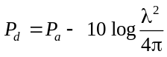

where P_{d} = power density in dBW/m²;

P_{a} = power at receiving point in dBW;

λ = wavelength in metres.

7.2.1.2 Nominal values of the necessary EIRP to achieve a power density of minus 89 3 dBW/m² are given in Figure C-20. For coverage under difficult terrain and siting conditions it may be necessary to make appropriate increases in the EIRP. Conversely, under favourable siting conditions, the stated power density may be achieved with a lower EIRP.

7.2.1.3 The use of Figure C-20 is illustrated by the following examples. In order to achieve the necessary nominal power density at slant range/levels of 342 km (185 NM)/12 000 m (40 000 ft), 263 km (142 NM)/12 000 m (40 000 ft) and 135 km (73 NM)/6 000 m (20 000 ft), ERPs of the order of plus 42 dBW, plus 36 dBW and plus 30 dBW respectively would be required.

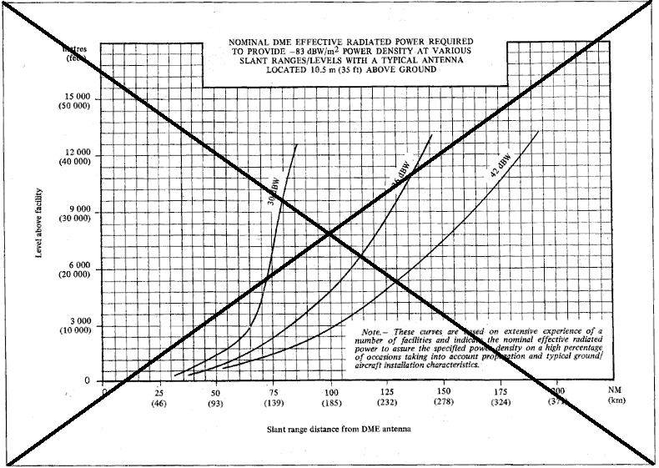

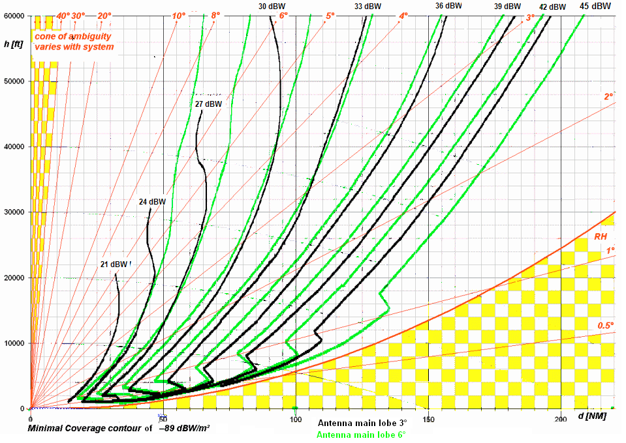Figure C-20. DME Coverage Volume for Various EIRPs.

Note 1. The curves are based on the IF-77 propagation model, which has been confirmed by measurements.
Note 2. Whenever the installation is located significantly higher than the assumed reference antenna, the power density will increase.
Note 3. The cone of ambiguity in which the performance requirements cannot be met may begin as low as 40 deg elevation for older systems, but may begin closer to 70 deg for newer systems.
Note 4. DME ground antenna elevation is assumed to be 17 ft AGL in this figure.
Note 5. Due to antenna design, placement and location above MSL, the achievable range can be larger than identified, while terrain shielding can lessen it significantly.

Proposed Update of Guidance Material for VOR in Annex 10, Vol.1

3. Material concerning VOR/DVOR

  - Guidance relating to VOR/DVOR effective isotropic radiated power (EIRP) and coverage
Unless specifically mentioned, all guidance material provided below applies to VOR and DVOR signals.

3.1.1 The field strength specified at Chapter 3, 3.3.4.2, is based on the following consideration:

Airborne receiver sensitivity |  | –117 dBW
Transmission line loss, mismatch loss,  antenna polar pattern variation with  respect to an isotropic antenna |  | +7 dBW
Power required at antenna |  | –110 dBW

The power required of minus 1100 dBW is obtained at 118 MHz with a power density of minus 107 dBW/m²; minus 107 dBW/m² is equivalent to 90 microvolts per metre, i.e. plus 39 dB referenced to 1 microvolt per metre.

Note.— The power density for the case of an isotropic antenna may be computed in the following manner:

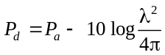

where

P_{d} = power density in dBW/m²;

P_{a} = power at receiving point in dBW;

λ = wavelength in metres.

3.1.2 Nominal values of t The necessary EIRP to achieve a field strength of 90 microvolts per metre (minus 107 dBW/m²) are is given at in Figure C-13. The signal strength is directly proportional to the antenna elevation pattern. The actual radiation patterns of the antennas depend on a number of factors such as height of the antenna phase centre above ground level (AGL), terrain-roughness, -form and height above mean sea level (MSL), conductivity of ground and counterpoise. However to account for lowest EIRP in notches between the lobes of the real elevation antenna pattern a conservative value has been provided. Whenever more precise system data is available a more precise estimation of range is permissible. Further guidance may be found in e.g. ICAO-DOC 9718 ICAO RF-Handbook. For coverage under difficult terrain and siting conditions, it may be necessary to make appropriate increases in the effective radiated power. Conversely, practical experience has shown that under favorable siting conditions, and under the less pessimistic conditions often found in actual service, satisfactory system operation is achieved with a lower EIRP.

Note.— The nominal effectiveradiated powers, expressed as a function of level and range, are based upon consideration of basic theoretical data from various sources (such as ITU-R and NBS) modified empirically to reflect typical operational experience.

3.1.3 The use of Figure C-13 is illustrated by the following examples. In order to achieve the necessary field strength at a slant 342 km (185 NM)/12 000 m (40 000 ft), 300 km (162 NM)/12 000 m (40 000 ft), and 166.5 km (90 NM)/6 000 m (20 000 ft), nominal effective radiated powers of plus 23 dBW, plus 17 dBW and plus 11 dBW respectively are required.

3.1.34 In order to facilitate frequency and equipment planning, wherever practicable, EIRP categories corresponding to plus 23 dBW, plus 17 dBW and plus 11. should be employed. These ERP values should be indicated during regional planning activities.
3.1.3 Fig C-13 gives the curves of coverage volume for various EIRP values for VOR/DVOR. As an example a VOR having an EIRP of plus 25 dBW is equivalent to a VOR with an output power of 100 W, a cable loss of 1 dB and an antenna gain of 6 dBi.
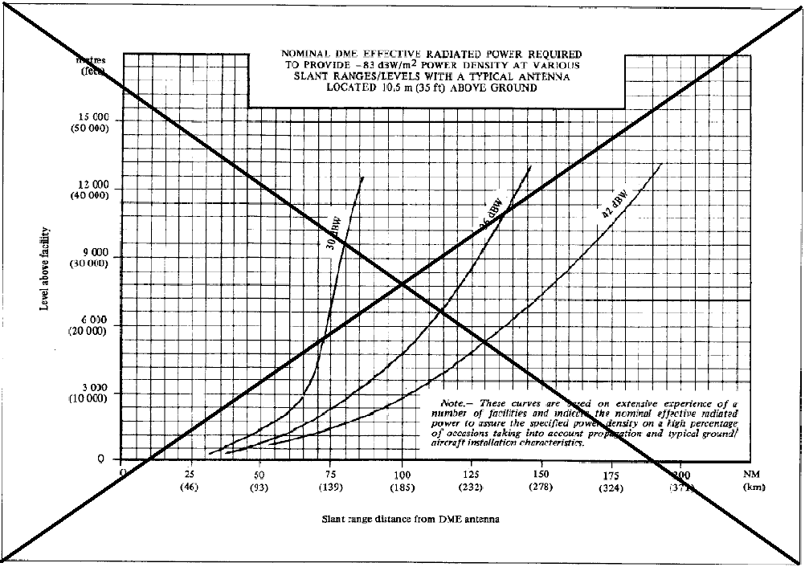
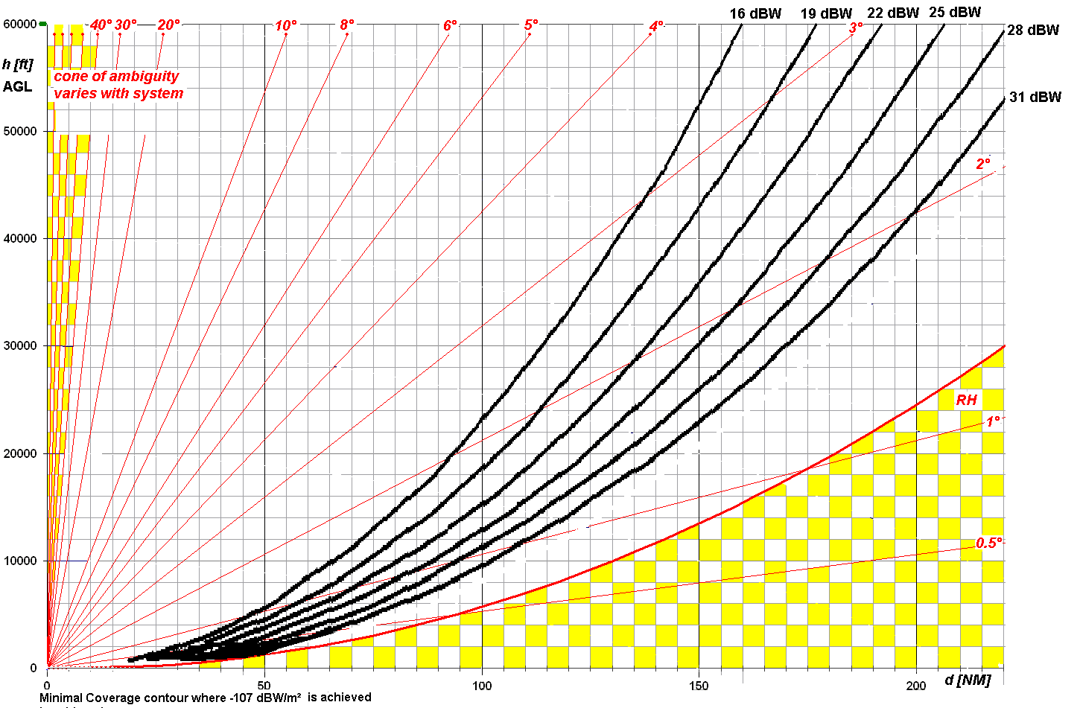
VOR/DVOR coverage volume for various EIRP values
Figure C-13

Note 1 The airborne antenna receives the combined variable and reference signal generated by the VOR/DVOR ground facility. The signal strength provided in this figure is the composite signal.
Note 2 The curves are based on the IF-77 propagation model which has been confirmed by measurements.

Note 3 The cone of ambiguity, in which the performance requirements cannot be met, is assumed to be at 40° as specified under 3.3.3.2. In cases where the VOR/DVOR manufacturer provided proof that the cone of ambiguity starts at higher elevation angles the start of the cone of ambiguity can be increased accordingly.
Note 4 The guidance provided assumes that the VOR/DVOR Counterpoise height Above Ground Level (AGL) that defines the antenna pattern is at [10 ft] AGL.
Note 5 Due to antenna design and height above MSL, the achievable range can be larger then identified while terrain shading can decrease it significantly.
3.1.5 VOR having an EIRP of plus 23 dBW approximates to a VOR with an output power of 100 W, a cable loss of 1 dB and an antenna gain of 6 dBi. previously referred to in Annex 10 as Category A (transmitter power 200 W). Possible relationships between EIRP, cable loss and transmitter output powers are illustrated by the following examples:
Whenever one or both VOR are located much higher then the assumed reference antenna assumed to be 30 ft above MSL then the Radio Horizon will increase.
 |  | Example I |  | Example II
Transmitter power |  | +23 dBW |  | +18 dBW
Ground transmission line loss |  | –2dB |  | –1 dB
Antenna gain relative to an isotropic antenna |  | +2 dBi |  | +6 dB
ERP |  | +23 dBW |  | +23 dBW

Similarly, a VOR having an ERP of plus 17 dBW approximates to a VOR previously referred to in Annex 10 as Category B (transmitter power 50 W). Possible relationships between ERP and transmitter output powers are illustrated by the following examples:

 |  | Example I |  | Example II
Transmitter power |  | +17 dBW |  | +10 dBW
Ground transmission line loss |  | –2 dB |  | –1 dB
Antenna gain relative to an isotropic antenna |  | +2 dB |  | +8 dB
ERP |  | +17 dBW |  | +17 dBW

3.1.56 It is recognized that under the above ERIP categories may achieve a greater coverage. Due to antenna lobing the achievable range can be significantly larger then identified. Values are conservative worst case assumptions. Therefore the signals of unwanted VOR/DVOR facility can be assumed to be up 6 dB stronger. than is necessary for some operational requirements. A suitable lesser coverage might be achieved by a VOR facility having an ERIP of approximately plus 11 dBW as follows:

 |  | Example I |  | Example II
Transmitter power |  | +11 dBW |  | +7 dBW
Ground transmission line loss |  | –2 dB |  | –1 dB
Antenna gain relative to an isotropic antenna |  | +2 dB |  | +5 dB
ERP |  | +11 dBW |  | +11 dBW

