 | INTERNATIONAL CIVIL AVIATION ORGANIZATION  MIDDLE EAST OFFICE  Seminar on aeronautical spectrum management  (Cairo, 7 – 17 June 2006)

Agenda item 10: Available spectrum for the implementation of ICAO systems

Aviation Spectrum Resource Map for Europe
(presented by EUROCONTROL)

Summary:
This paper presents the progress in the formulation of an aviation spectrum roadmap tool for Europe. It will be further refined through consultation with States and aviation interests.

Introduction
Each of the communication, navigation and surveillance domains has a strategic plan detailing the future evolution of its services and the methodology to implement the objectives in line with the ATM Strategy 2000+. In consideration of the WRC 07 agenda items there is a need to extract the spectrum issues from each of the CNS domains and identify where there are overlapping areas of interest and consequently any interdependencies. This paper presents an expansion on the concept of a process that can map the spectrum resource derived from CNS strategies and presents a draft map of the current analysis.

Approach
The approach detailed previously is summarized as follows:-

Step 1: To produce a dependency diagram for a scenario from each of the CNS domains.

Step 2: To combine the CNS domain dependency drawings into one spectrum dependency diagram such that all links between the domains can be represented. (Ref: Figure 1).

Step 3: To produce a radio spectrum allocation chart taking into account time constraints.

Step 4: To produce the radio spectrum map, based on a timescale, detailing the spectrum resource requirements at a high level, which in turn can be applied as inputs to the Aeronautical Spectrum Model.

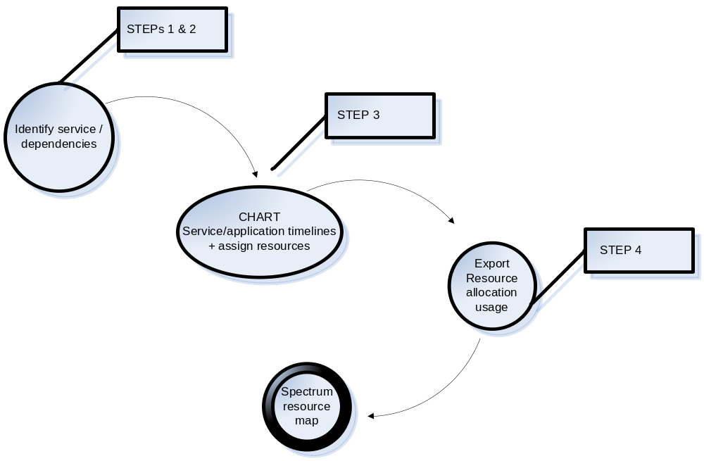
Fig. 1 Spectrum resource mapping process

The diagrams given in the Annex represent the output of the steps above. The services and applications identified in the spectrum and dependency diagram are grouped with their operational associations and time scales applied. The source of the times has been derived where available from the respective domain strategic scenarios. Where there are identified key decisions as prerequisites these have been nominated a time that is consistent with any required rule making or subsequent dependency needed to achieve the implementation that has been indicated in the relevant strategic plan. A glossary of the terminology used is provided in annex 4.

STEPs 1 and 2 – DEpendencY DIAGRAM

Diagram Overview
The diagram provided in Annex 1 shows the identified spectrum related service application dependencies derived from the first two steps noted above. The diagram is intended to be viewed from the current systems listed on the left through the operational function that is supported by the service/s to the future systems identified from the domain strategies and the identified spectrum allocation required. AND / OR symbols are used on the connectors defining the relationships supporting the associated text boxes.

  - Mandate Text Boxes

The purpose of these text boxes is to indicate that there are prerequisite decisions needed before agreements are made on the introduction or cessation of services. Such agreements may also be supported by associated mandates. Note that for each agreement there are prerequisites that include the interests of General Aviation and the Military. Additionally any consideration for withdrawal of services will require the assessment of the operational impact for service providers and airlines as provided by safety cases and cost benefit analyses.

STEP 3 – CHART OF AVIATION SERVICE TIMESCALES
  - Chart Overview

The plan provided in Annex 2 provides a Gantt chart representation of the timescale relationships for step 3 noted above. The beginning of year 2000 has been taken as the baseline for the chart. Each service has a number of key tasks listed either indicating the current service requirement or the prerequisite elements needed leading to a proposed implementation. The associated radio spectrum band allocation is indicated as a resource label printed at the right of the respective task bar. The approach to the planning utility has been to define the resources as each of the aviation band broken down into further detail of sub bands and a usage allocation for the time period listed as a percentage.

  - Mandate/Decision Prerequisites

Certain prerequisite decisions that are necessary before agreements are made on the introduction or cessation of services have been included. These have been indicated as milestones and linked to the associated elements such that any impact of variation may be indicated. Where there is a mandate required for the introduction of a service then the subsequent rule making period is also indicated on the plan. Where a potential withdrawal of services is projected this has been indicated in a lighter shading task bar along with the continuing service requirement up to the expected final application. It must be noted that the timescales for stated safety, business case and certification requirements are subject to the individual formal process requirements.

STEP 4 SPECTRUM RESOURCE USAGE MAP

Map Overview
The map (Annex 3) is derived from the export of the resource allocation information entered in the planning tool used to create the chart in step 3. A three colour key highlights the extent of the usage allocation based on the percentage data computed from the grouping of the associated service applications in each spectrum band. The formatting of the colour thresholds is via user selectable conditions. The objective of this map is to identify those spectrum bands and the time periods where the resource demand exceeds a specified limit.

CONCLUSIONS
The spectrum resource mapping tool will be useful in providing a coordinated approach to the aviation requirements from each of the CNS domains. This approach provides an audit trail back to the operational requirement though each of the steps. The time periods and allocation usage are dependent on information from each of the service areas in the domains. The tool must be further developed through consultation with State and aviation interests including the aeronautical Spectrum Frequency Consultation Group.

RecommendationS

The meeting is invited to note the progress and provide continued support for the spectrum roadmap methodology.
ANNEX 1 Spectrum Dependencies

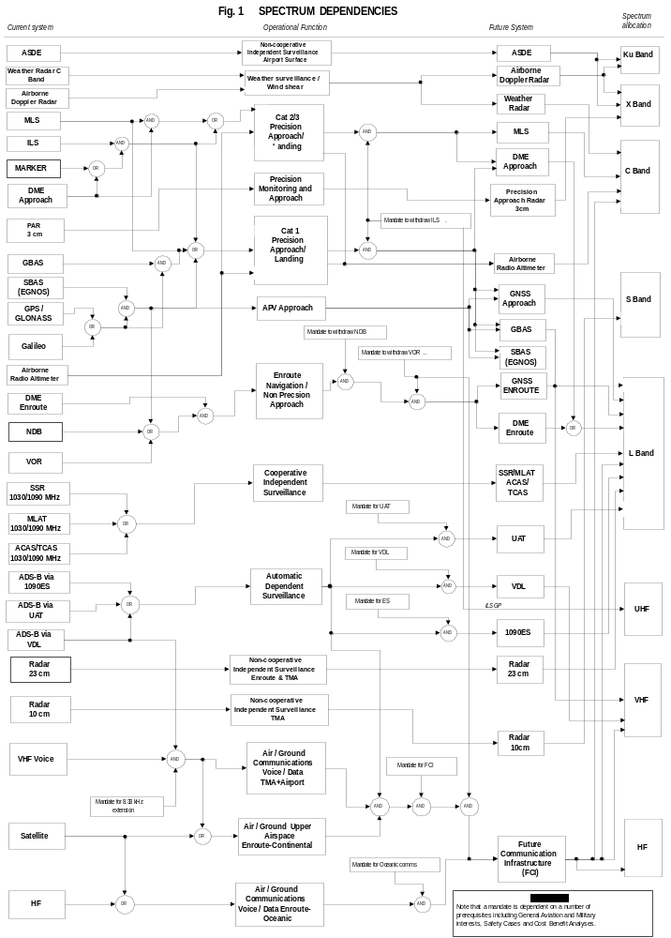

ANNEX 2 Aviation Spectrum Service / Application Timescales

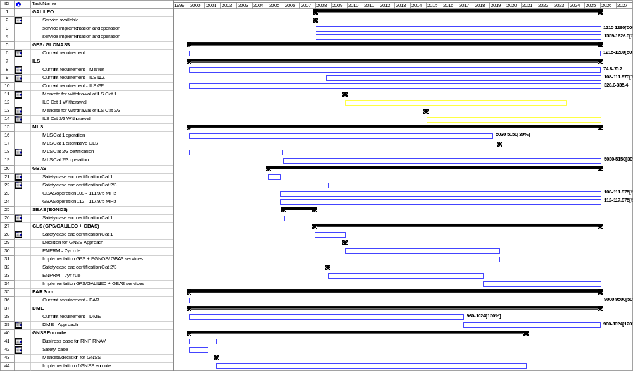

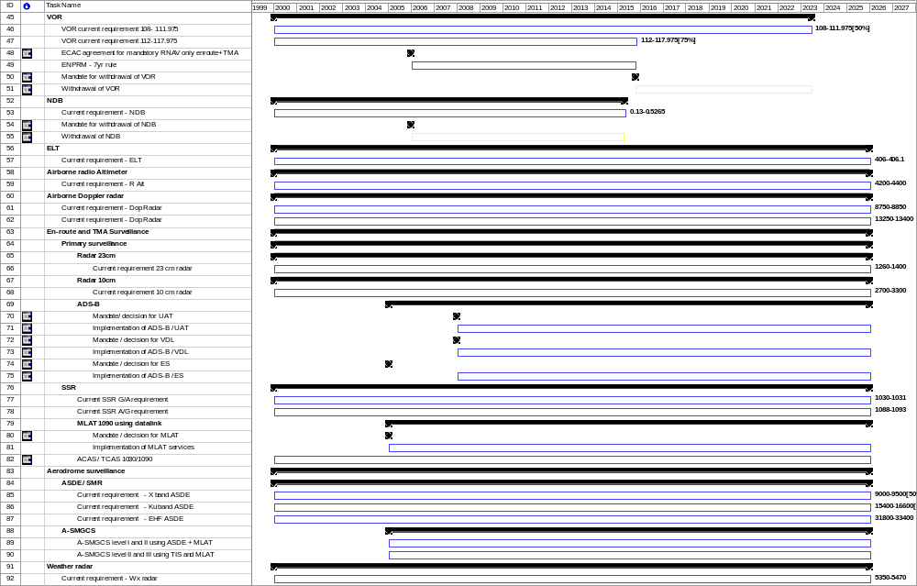

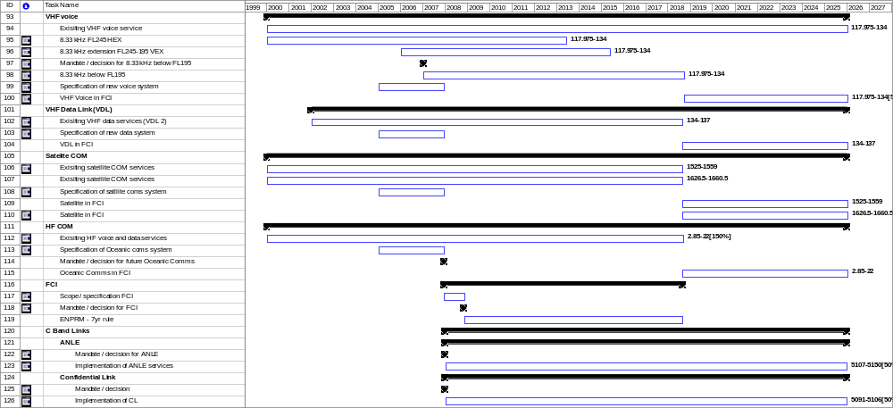
ANNEX 3 – Spectrum Resource Map

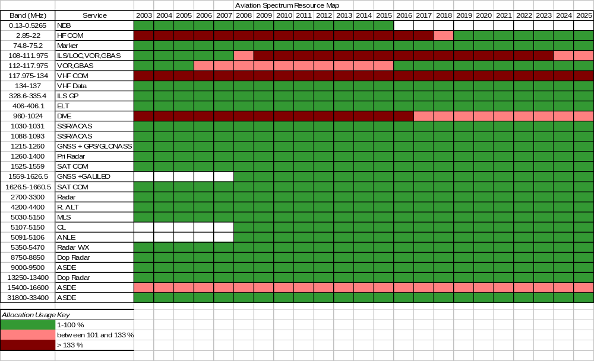

Annex 4: Glossary of terms
ACAS Airborne Collision Avoidance System

ADS Automatic Dependent Surveillance

ASDE Airport Surface detection Equipment

APV Approach with Vertical guidance

Cat 1/2/3 Category of precision approach

DME Distance Measuring Equipment

EGNOS European Geostationary Overlay Service

ES Extended Squitter

FCS Future Communications System

GBAS Ground Based Augmentation System

GLONASS Global Navigation Satellite System

GNSS Global Navigation Satellite System

GPS Global Positioning System

ILS Instrument Landing System

MLAT Multilateration

MLS Microwave Landing System

NDB Non- Directional Radio Beacon

PAR Precision Approach Radar

SBAS Satellite Based Augmentation System

SSR Secondary Surveillance Radar

TCAS Traffic Alert and Collision Avoidance System

TMA Terminal Management Area

UAT Universal Access Transceiver

VDL VHF Data Link

Note: OR in this context is the logical OR (i.e. is not exclusive).

