MLS Protection Criteria For 3rd and Subsequent Adjacent Channels

Interpretation of the Proposed Changes To Annex 10

Prepared by John Mettrop

1.0 Introduction
A problem has been found with the specification of a transmitted MLS signal. The correction of this error has resulted in the need to change the planning criteria in order to maintain the intended protection levels for an MLS receiver. This paper looks at the practical implications of these changes with respect to a simplified 2 dimensional planning model, noting that adding a third dimension would have an effect on the results.

2.0 Assumptions
- That the desired transmitter is operating at the minimum power that ensures the required signal in space criteria within the required service volume will be met.
- That the undesired signal is radiated at such a level that it only just meets the required 3rd Adjacent channel criteria
- That free space path loss applies
- The back azimuth protection will not have varied and hence is not considered in this paper

3.0 Proposed Requirement
The following summarises the proposed minimum required signal in space criteria and the associated protection criteria:-

3.1 Minimum Desired Power Density

Function | DPSK Signal (dBW/m²) | Angle Signals (dBW/m²) |  |  | Clearance Signals  (dBW/m²)
Function | DPSK Signal (dBW/m²) | 1º | 2º | 3º | Clearance Signals  (dBW/m²)
Approach azimuth guidance | -89.5 | -85.7 | -79.7 | -76.2 | -88.0
High rate approach azimuth guidance | -89.5 | -88.0 | -84.5 | -81.0 | -88.0
Back azimuth guidance | -89.5 | -88.0 | -84.5 | -79.2 | -88.0
Approach elevation guidance | -89.5 | -88.0 | -82.7 | N/A | N/A

3.2 Signal to Noise Ratio Protection Criteria

Table Y
Function | Angle Signals (dBW/m²)
Function | 1º | 2º | 3º
Approach azimuth guidance | -69.8 | -63.8 | -60.2
High rate approach azimuth guidance | -74.6 | -68.5 | -65.0
Back azimuth guidance | N/A | N/A | N/A
Approach elevation guidance | -71.0 | -65.0 | N/A
Where the desired signal power density is greater than the levels given in Table Y then the signal to noise ratio protection criteria to be applied are:-

Function | DPSK Signal | Angle Signals |  |  | Clearance Signals
Function | DPSK Signal | 1º | 2º | 3º | Clearance Signals
Approach azimuth guidance | 5 dB | 24.7 dB | 30.7 dB | 34.3 dB | 5 dB
High rate approach azimuth guidance | 5 dB | 19.9 dB | 26 dB | 29.5 dB | 5 dB
Back azimuth guidance | 5 dB | 5.2 dB | 11.2 dB | 14.8 dB | 5 dB
Approach elevation guidance | 5 dB | 23.5 dB | 29.5 dB | N/A | 5 dB
Where the signal power density is less than that given in Table Y then the signal to noise ratio protection criteria to be applied are:-

Function | DPSK Signal | Angle Signals |  |  | Clearance Signals
Function | DPSK Signal | 1º | 2º | 3º | Clearance Signals
Approach azimuth guidance | 5 dB | 8.2 dB | 14.3 dB | 17.8 dB | 5 dB
High rate approach azimuth guidance | 5 dB | 3.5 dB | 9.5 dB | 13 dB | 5 dB
Back azimuth guidance | 5 dB | 5.2 dB | 11.2 dB | 14.8 dB | 5 dB
Approach elevation guidance | 5 dB | 3.5 dB | 9.5 dB | N/A | 5 dB

3.3 Undesired Emission on the 3rd and Subsequent Adjacent Channels
- Mean power density above a height of 600 m < -94.5 dBW/m²
- Mean power density at a distance greater than 4.8 km <-94.5 dBW/m²

4.0 Interpretation
The following interpretation is conducted on the basis of the 3 degree value for the approach azimuth guidance and using ITU-R Recommendation P.525-2.

4.1 Minimum Desired Signal Power
ITU-R Recommendation P.525-2 provides the following two formulae:-
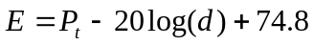 (1)
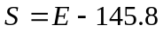 (2)
Where:-  = Electrical field strength (dB(µv/m))
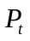 = Isotropically transmitted power (dB(W))
= Radio path length (km)
= Power Flux-density (dBW/m²))
From these two formulae we can derive the following formulae:-
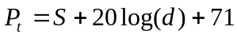dBW (3)
Assuming that the isotropically radiated power is set at a level such that the minimum desired signal level (-76.2 dBW/m²) is just met at maximum range (41.7 km). Substituting these values into equation (1) gives the following result:-
Minimum desired isotropically radiated power = 27.2dBW

4.2 Range at Which the Power Density In Table Y is Reached
Re-arranging equation (3) to make the radio path length the subject of the formula:-
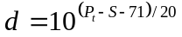km (4)
Knowing the minimum desired isotropically radiated power (27.2 dBW) the the range at which the power density quoted in table Y (-60.2 dBW/m²)is reached can be calculated which gives the following result:-
Range = 6.6 km

4.3 Maximum Undesired Signal Power
The maximum undesired signal power can also be calculated using equation (3)
dBW (3)
Assuming that the signal from the undesired transmitter is such that it only just meets the mean power density requirements (-94.5 dBW/m²) at the minimum range (4.8 km) then:-
Maximum undesired radiated power = -9.9 dBW

4.4 Exclusion Zone Around the Centre Line
Knowing the minimum desired and the maximum undesired isotropically radiated powers as well as the required protection criteria then the separation distance of the undesired signal source from the desired service volume can be calculated using equation (4)
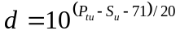km (4)
Where: 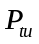 = undesired isotropically radiated power = 9.9 dBW
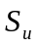 = undesired power flux density
= desired power flux density – required SNR dBW/m²
= minimum separation distance km
Given that the service volume for an MLS station for a straight approach will be ±3º then the exclusion zone around the centre line of an MLS approach path can be calculated by adding the relevant 3º offset to the value of d calculated above.
If we could assume that the power flux density of the desired signal conformed to free-space path loss within the desired service volume then the desired power flux density could be calculated using a re-arranged version of equation (3) as follows:-
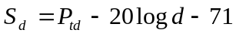 (3)
Where: 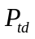 = desired isotropically radiated power = 27.2 dBW
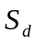 = desired power flux density dBW/m²
= separation distance km
Applying these formula and allowing for a 3 degree offset from the centre line the following exclusion zone can be calculated:-

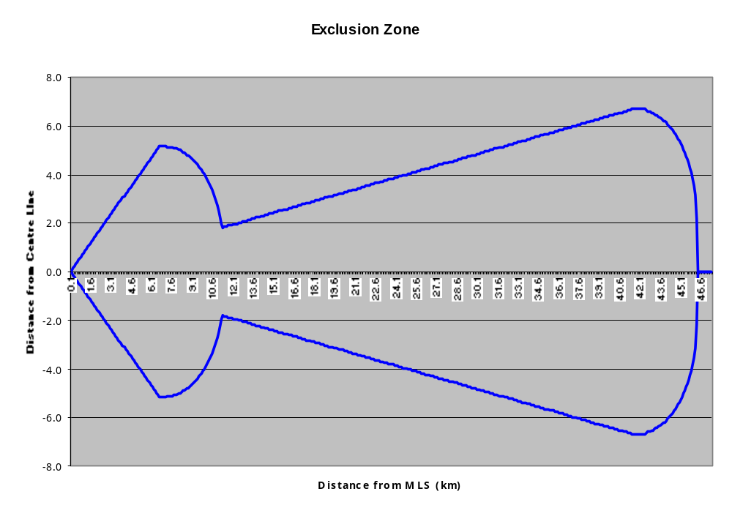
Note:- The exclusion zone given above does not take into account the vertical undesired signal requirements. Were this to be taken into account then the lateral extent of the exclusion zone would depend on the difference in altitude of the two MLS installations as well as the minimum angle of the glide slope. For two MLS which are at the same height and assuming a minimum glide slope angle of 2 degrees then the maximum lateral distance the exclusion zone would have to extend is 17km.
However given the proximity to the ground multipath and other propagation anomalies will cause unpredictable variations in the desired power flux density ( this has been confirmed by flight test data). Since these anomalies cannot be predicted, the separation distance calculation should be based on the assumption that the desired power flux density is at a minimum which simplifies the equation and gives the following exclusion zone:-
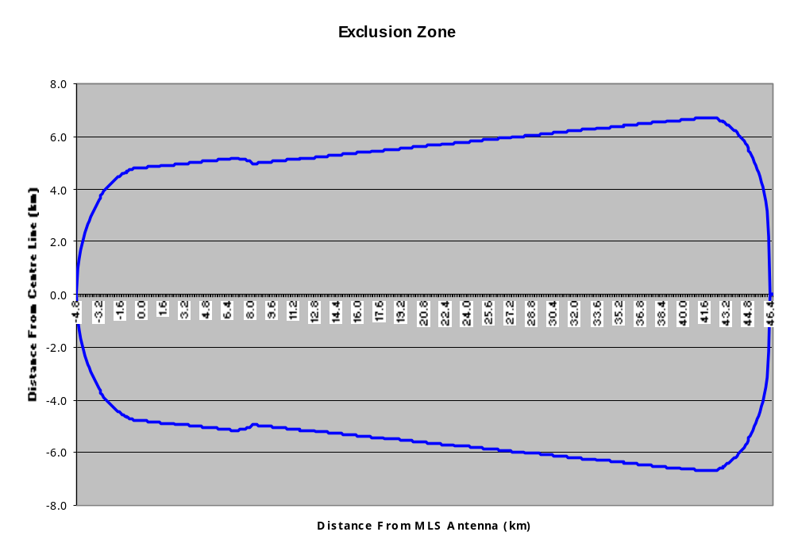Since there is no definition of any improvement in the transmission mask beyond the 3rd adjacent channel, then this diagram becomes an exclusion zone within which no other MLS can be placed. It should be noted that a working paper, presented in a working group of the whole meeting of the Navigation Systems Panel, suggested that it might be possible to allow for an additional role of 2dB per channel in the transmitter radiated power mask. If it were possible to take this into account then an incremental reduction in the exclusion zone for successive adjacent channels could be implemented.

5.0 Conclusion
That the exclusion zone given below should, for adjacent channels beyond the 2nd, be incorporated into the planning rules within the European region for MLS until such time as any improvements in the transmitter mask can be taken into account.

