 | International Civil Aviation Organization  WORKING PAPER
  ACP-WGF14/WP-21
  22/08/05

AERONAUTICAL COMMUNICATIONS PANEL (ACP)

FOURTEENTH MEETING OF WORKING GROUP F

Malmo, Sweden 22 – 26 August 2005

Agenda Item 3 | : WRC’07 Agenda Item 1.6

Feasibility of VOR/DME replanning in Europe to free the sub-band 116 –118 MHz for AM(R)S usage

(Presented by Alain DELRIEU)

SUMMARY
In the frame of the WRC-07 Agenda Item 1.6, besides the identification of new spectrum allocation for AM(R)S in view of introducing a future ground cellular mobile communication system, one potential way forward is to try to expand the current VHF AM(R)S band within the ARNS band below 118 MHz (VOR band). Such potential solution could provide within the European region several hundreds of 8.33 kHz DSB AM channels that could bridge the time gap between 2010 and the actual deployment of the new mobile radio communication component, under study by ICAO/ACP/WGC that is now foreseen by 2020 at the earliest. This paper summarizes a simulation conducted by France to assess the feasibility of this scenario from a strict spectrum management point of view. It indicates that it could possible to free between 1 and 2 MHz below 118 MHz to be allocated to AM(R)S while keeping all the current VOR and VOR/DME assignments through a direct frequency change of all the existing assignments within the VOR upper frequency band (116 MHz – 118 MHz).

ACTION
It is recommended to use this material to ensure that proper decision are taken at ITU WRC 07 to allocate a part of the ARNS band (108 –118 MHz) to AM(R)S to extend the frequency band dedicated to VHF DSB AM communication assignments

1.Introduction

One potential way forward identified in Europe to cope with the current and foreseeable frequency congestion within 118 – 137 MHz VHF band, despite the wide introduction of the new 8.33 kHz channel spacing, is to try to reassign the VOR frequencies above 116 MHz within the frequency band below 116 MHz without withdrawing any of those assignments.
A simulation has been conducted by France in order to study the feasibility of this scenario from a point of view strictly limited to spectrum management
The document in annex provides the complete description of the simulations with the various scenario implemented. The scenario implemented based upon the European Air Navigation Plan COM 3 table, are the following:
- Freeing part of the VOR sub-band
With four sub scenario:
  - 1 MHz vacated
  - 1.5 MHz vacated
  - 2 MHz vacated
  - 2 MHz vacated with a special condition (removing of all MLS associated DME existing assignments)
- Identification of the impact of the 2 MHz reduction of the ARNS band on the GBAS deployment capability in Europe through a comparison between :
  - 1775 GBAS requirements assigned within the whole existing ARNS band
  - 1775 GBAS requirements assigned within the reduced ARNS band (108 – 116 MHz)
- Quantification of the gain for AM(R)S after the release of 2 MHz within the ARNS band

2. Synthesis of results

2.1 VOR reassignment simulation

The following table provides the results of the first set of scenario dealing with existing VOR re-assignments:

Width of sub-band vacated | 1 MHz | 1.5 MHz | 2 MHz | 2 MHz without MLS-DME
Nr of VOR and VOR-DME in the sub-band having to be replanned | 133 | 201 | 264 | 264
Successfully replanned VORs | 120 | 178 | 232 | 244
Replanning failures, including: | 13 | 23 | 32 | 20
- Failures (All Land VOR-DME) | 3 | 6 | 10 | 10
- Failures (other VOR-DME) | 8 | 16 | 21 | 9
- Failures (All Land VOR) | 1 | 1 | 1 | 1
- Failures (other VOR) | 0 | 0 | 0 | 0

Those tables show that if we consider separately the All Land assignments (that are usually associated with implementation of mobile station during existing VOR renewing) that could probably be reduced in number in the foreseeable future, only 8 assignments were not reassignable in the scenario 1a and only 21 in the scenario 1b. If the MLS/DME constraint is removed the number of blocking assignments is reduced to 9 for the 2 MHz vacation scenario.

Those results shows that depending on specific technical and institutional arrangements the release of up to 2MHz in the ARNS band is feasible

2.3. GBAS assignments

The following table provides the result of two comparative exercises of assignments of 1775 GBAS stations within the region within the nominal ARNS band and within the reduced ARNS band (minus 2 MHz). The 1775 GBAS needs are indeed generated by using the existing ILS assignment and generating 50% increase by random duplication of existing ILS assignments.

Scenario | Destination band | moved  VORs | New  GBASs | Re-planned  GBASs | Failures
2A | 108.000 - 116.000 MHz | 178 | 1,775 | 1,668 | 107
2B | 108.000 - 118.000 MHz | 0 | 1,775 | 1,702 | 73

This table shows that the impact of reducing the ARNS band on the flexibility of GBAS deployment in Europe is very limited even in a very demanding scenario in terms of GBAS needs. This second scenario confirms that the reduction of the ARNS band is not a serious issue for the GBAS deployment in Europe.

Spectrum gain for the AM(R)S VHF assignments

The last part of the simulation concerns the quantification of the gain for the VHF AM(R)S assignments. The freeing of 2 MHz below 118 MHz provides 240 new 8.33 kHz channels that could be used to provide communication services in the upper airspace. The simulation was not really assessing this scenario but the usage of this extra spectrum allocation to satisfy both 25 kHz and 8.33 kHz needs without any discrimination between the nature of the services and including also ATIS and VOLMET services. It shows that the gain was significant even the proposed segregation (usage only for en route upper airspace and for 8.33 kHz assignments). In conclusion it shows that if completely feasible (that is to say that all the other aspects need to be analysed) the spectrum gain will be very significant and will certainly facilitate the filling of the current gap between now and the implementation of the future components of the air/ground mobile communication system.

3. Conclusion

The study conducted by France indicates that it could be feasible from a pure spectrum management point of view to release part of the current ARNS band between 108 – 118 MHz to provide extra spectrum for the VHF AM(R)S in conjunction with the use of 8.33 kHz channels, within this new extension of the AM(R)S VHF band, in order to release pressure on the congested VHF 118-137 MHz usage
PT3 is invited to:
    - take note of the study and of its encouraging results
    - take the appropriate measure to ensure that the allocation of the 116 - 118 MHz part of the ARNS band is also given to AM(R)S on a co-primary basis at the next ITU WRC07, in addition to the existing allocation (since WRC’03, ref. 5.197A) limited for use by VDL Mode 4
    - encourage the investigation of the other aspects of the use of this part of the ARNS band to cope with the VHF frequency congestion in Europe (e.g. aircraft radio retrofit issue, including flight deck frequency selector, economical aspect of the VOR frequency changes, timescale of implementation, FM broadcasting compatibility, etc..…)

Version 1.0 - 15 March 2005

PARTIAL REPLANNING

OF THE VOR BAND

 DSNA/DTI/SO3 SYSTEX 2

TABLE OF CONTENTS

1. INTRODUCTION 3
2. CONTENT OF THE STUDY 3
3. SCENARIOS STUDIED 4
4. DATABASES 5
4.1 COM3 database 5
4.2 COM2 database 5
5. SCENARIO 1: Vacation of the VOR sub-band 6
5.1 Scenario 1A: 1MHz vacated between 117.000 and 118.000 6
5.1.1 Assignments processed 6
5.1.2 Location of the VORs processed 6
5.1.3 List of failures 7
5.2 Scenario 1B: 1.5 MHz vacated between 116.500 and 118.000 8
5.2.1 Assignments processed 8
5.2.2 Location of the VORs processed 8
5.2.3 List of failures 9
5.3 Scenario 1C : 2 MHz vacated between 116.000 and 118.000 10
5.3.1 Assignments processed 10
5.3.2 Location of the VORs processed 10
5.3.3 List of failures 11
5.4 Scenario 1D: 2MHz vacated between 116.000 and 118.000, with MLS-DMEs deleted 12
5.4.1 Assignments deleted 12
5.4.2 Assignments processed 12
5.4.3 Location of the VORs processed 12
5.4.4 List of failures 13
5.5 Scenario 1A, 1B, 1C and 1D: consolidated results 14
6. SCENARIO 2: Verification of GBAS 15
6.1 Scenario 2A: Planning of 1,775 GBASs between 108.000 and 116.000 15
6.1.1 Assignments processed 15
6.1.2 Location of the failed GBASs 15
6.1.3 List of failures 16
6.2 Scenario 2B: Planning of 1,775 GBASs between 108.000 and 118.000 18
6.2.1 Assignments processed 18
6.2.2 Location of the failed GBASs 18
6.2.3 List of failures 19
6.3 Scenario 2A, 2B: consolidated results 20
7. SCENARIO 3: Spectrum gains for voice communication 21
7.1 Scenario 3A: Gains associated with the use of a supplementary 2 MHz band 21
7.1.1 Assignments processed 21
7.1.2 Successful assignments 22
7.1.3 Percentage of assignments satisfied 23
7.1.4 List of successful assignments 24

INTRODUCTION
As part of the preparations for the forthcoming World Radiocommunications Conference (WRC) of the International Telecommuncation Union (ITU) scheduled for 2007, Civil Aviation is studying the possibilities of using the frequency bands allocated to other civil aviation services (mainly the radio navigation service) for the mobile aeronautical communication service in order to find an answer to the current congestion of the VHF band.
One of the options studied involves reassigning the VORs in the higher range (116 – 118 MHz) in the VHF radio navigation band (108 – 118 MHz) to be able to use the higher range for the mobile communication service.

CONTENT OF THE STUDY
The study involves simulating, on the basis of COM2 and COM3 data from the European Air Navigation Plan, three scenarios for the re-planning of VOR services. These services, whose frequencies are in the band to be vacated (e.g. between 116 and 118 MHz) will be transferred to frequencies elsewhere in the band (e.g. between 108 and 116 MHz).

The objective of the scenarios examined is to make it possible to:
- evaluate the feasibility of reassigning the VHF OmniRange (VOR) from the 116-118 MHz band to elsewhere in the radio navigation band,
- to assess the capacity gained in this way with a view to assigning to it the mobile radio communication services using 8.33 kHz channel spacing,
- to evaluate the capacity for assigning to the lower part of the radio navigation band (108 - 116 MHz) VHF Data Broadcast stations (VDB: system for broadcasting GPS differentials via VHF) associated with the Ground Based Augmentation System (GBAS).

The COM2 and COM3 tables and the planning criteria will conform to those used by EUROCONTROL for the compatibility and re-planning studies in the radio navigation frequency (VOR, ILS, GBAS and DME) and mobile radio communication bands.

SCENARIOS STUDIED
Three scenarios will be studied:

The first scenario involves evaluating the possibility of reallocating a frequency to the VOR and VOR/DME services currently in the band to be vacated and identifying the services for which it is impossible to find directly (without using “shift” techniques) a new frequency elsewhere in the band.
This scenario will be examined for three bandwidths to be vacated: 1 MHz, 1.5 MHz and 2 MHz.
The objective of this scenario is to evaluate, for each bandwidth examined, the outstanding difficulties which might require specific action (of the “shift” type).

The second scenario involves verifying that the allocation of new GBAS services is still possible elsewhere in the band. The GBAS services are obtained by copying and “transforming into GBAS” a certain percentage (between 100 and 200%) of existing ILS.

NB: STNA’s wish to use a percentage of 100% for category I ILS and a percentage of category II/III cannot be fulfilled because no category is indicated in the COM3 table supplied by EUROCONTROL.

The third scenario involves determining the voice communication services (ACC, APP, etc.) which could be accommodated in the higher part of the band, once it has been vacated in this way (1 MHz, 1.5 MHZ et 2 MHz respectively). The services planned will be defined by duplicating the existing services for which it is currently impossible to find a new frequency in the 118 - 137 MHz band. In this scenario, an attempt will be made to assess the actual capacity freed up in the radio navigation bands in order to be able to assess the usefulness of such an initiative.

DATABASES
The databases were provided by EUROCONTROL on the basis of ICAO’s COM tables, with a number of amendments which make it possible to process assignments with incorrect or missing data for a planning exercise.

COM3 database
The table below presents a breakdown by service of the assignments of the COM3 table used.

Code | ILS | ID | VOR | VD | DME | MLS | IDM | NPM | Total
Services matched | ILS | ILS  DME  MLS | VOR | VOR  DME | DME | MLS  DME | ILS  DME  MLS | MLS
 | 649 | 525 | 178 | 910 | 523 | 896 | 74 | 17 | 3 772

COM2 database
This is the COM2 database used for block planning.

SCENARIO 1: Vacation of the VOR sub-band

Scenario 1A: 1MHz vacated between 117.000 and 118.000

Assignments processed

Width of sub-band vacated | 1MHz
VOR and VOR-DME in the sub-band | 133
Re-planned VORs | 120
Failures, including: | 13
- Failures (All Land VOR-DME) | 3
- Failures (other VOR-DME) | 8
- Failures (All Land VOR) | 1
- Failures (other VOR) | 0

Location of the VORs processed

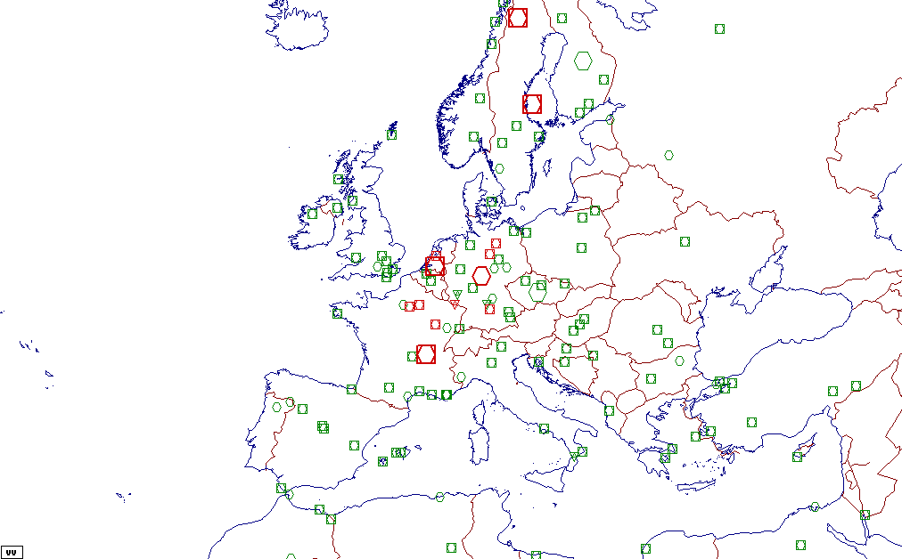
The failures are shown in red. The VORs, VORTACs and VOR-DMEs which it was possible to re-plan are shown in green.
The icons indicate type of service, as set out below:
 | : VOR |  | : VOR-TAC |  | : VOR-DME
The large icons identify the “ALL LAND” mobile services.

List of failures

Cty | Location | Poly | Type | VHF  freq | DOC | VHF  pwr | DME  pwr
ED | ALL GERMANY | LAND | VOR | 117.950 | 25/100 | 80L
ED | BRUNKENDORF |  | VD | 117.700 | 80/500 | 200L | 39
ED | HEHLINGEN |  | VD | 117.300 | 80/500 | 200L | 39
ED | NOERDLINGEN |  | VD | 117.550 | 60/500 | 50 | 37
ED | SAARBRUCKEN |  | VD | 117.000 | 60/500 | 400L | 42
EH | ALL NETHERLANDS | LAND | VD | 117.650 | 100/500 | 50L | 37
EH | PAMPUS |  | VD | 117.800 | 120NT,150TC,80/500 | 50L | 37
EN | ALL NORWAY | LAND | VD | 117.200 | 100/500 | 50L | 37
ES | ALL SWEDEN | LAND | VD | 117.900 | 80/400 | 50L | 29
LF | ALL FRANCE | LAND | VD | 117.200 | 40/250 | 50L | 37
LF | CHATILLON-SUR-MARNE |  | VD | 117.600 | 70VE,100/500 | 50L | 37
LF | PARIS/CH.DE GAULLE |  | VD | 117.050 | 110/500 | 50L | 37
LF | ROLAMPONT |  | VD | 117.300 | 120HL,60/500 | 50L | 36

Scenario 1B: 1.5 MHz vacated between 116.500 and 118.000

Assignments processed

Width of sub-band vacated | 1.5 MHz
VOR and VOR-DME in the sub-band | 201
Re-planned VORs | 178
Failures, including: | 23
- Failures (All Land VOR-DME) | 6
- Failures (other VOR-DME) | 16
- Failures (All Land VOR) | 1
- Failures (other VOR) | 0

Location of the VORs processed

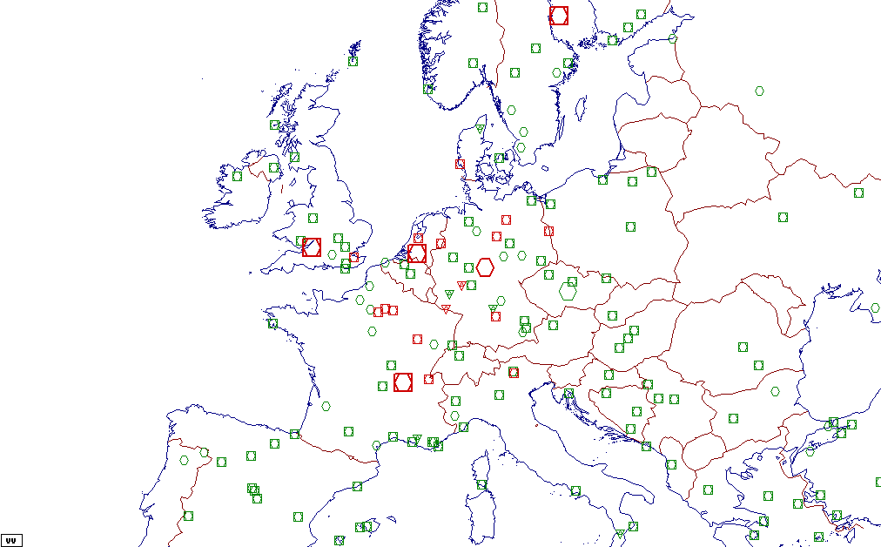
The failures are shown in red. The VORs, VORTACs and VOR-DMEs which it was possible to re-plan are shown in green.
The icons indicate type of service, as set out below:
 | : VOR |  | : VOR-TAC |  | : VOR-DME
The large icons identify the “ALL LAND” mobile services.

List of failures

Cty | Location | Poly | Type | VHF  freq | DOC | VHF  pwr | DME  pwr
ED | ALL GERMANY | LAND | VOR | 117.950 | 25/100 | 80L
ED | BRUNKENDORF |  | VD | 117.700 | 80/500 | 200L | 39
ED | HEHLINGEN |  | VD | 117.300 | 80/500 | 200L | 39
ED | NOERDLINGEN |  | VD | 117.550 | 60/500 | 50 | 37
ED | SAARBRUCKEN |  | VD | 117.000 | 60/500 | 400L | 42
ED | TAUNUS |  | VD | 116.700 | 60SA,40/250 | 400L | 42
EG | ALL UK | LAND | VD | 116.900 | 100/500 | 50L | 37
EG | ALL UK | LAND | VD | 116.950 | 100/500 | 50L | 37
EG | DETLING |  | VD | 117.300 | 60/500 | 50L | 39
EH | ALL NETHERLANDS | LAND | VD | 117.650 | 100/500 | 50L | 37
EH | PAMPUS |  | VD | 117.800 | 120NT,150TC,80/500 | 50L | 37
EH | REKKEN |  | VD | 116.800 | 80/500 | 25L | 37
EK | VESTA |  | VD | 116.600 | 200PX,160XE,100/500 | 50L | 36
EN | ALL NORWAY | LAND | VD | 117.200 | 100/500 | 50L | 37
EP | SUBI/SLUBICE |  | VD | 116.700 | 150/500 | 100L | 39
ES | ALL SWEDEN | LAND | VD | 117.900 | 80/400 | 50L | 29
LF | ALL FRANCE | LAND | VD | 117.200 | 40/250 | 50L | 37
LF | BOURSONNE |  | VD | 116.750 | 60/500 | 50L | 37
LF | CHATILLON-SUR-MARNE |  | VD | 117.600 | 70VE,100/500 | 50L | 37
LF | PARIS/CH.DE GAULLE |  | VD | 117.050 | 110/500 | 50L | 37
LF | ROLAMPONT |  | VD | 117.300 | 120HL,60/500 | 50L | 36
LI | BOLZANO |  | VD | 116.800 | 100/500 | 50L | 39
LS | PASSEIRY |  | VD | 116.600 | 120GS,80/500 | 50L | 37

Scenario 1C : 2 MHz vacated between 116.000 and 118.000

Assignments processed

Width of sub-band vacated | 2 MHz
VOR and VOR-DME in the sub-band | 264
Replanned VORs | 232
Failures, including: | 32
- Failures (All Land VOR-DME) | 10
- Failures (other VOR-DME) | 21
- Failures (All Land VOR) | 1
- Failures (other VOR) | 0

Location of the VORs processed

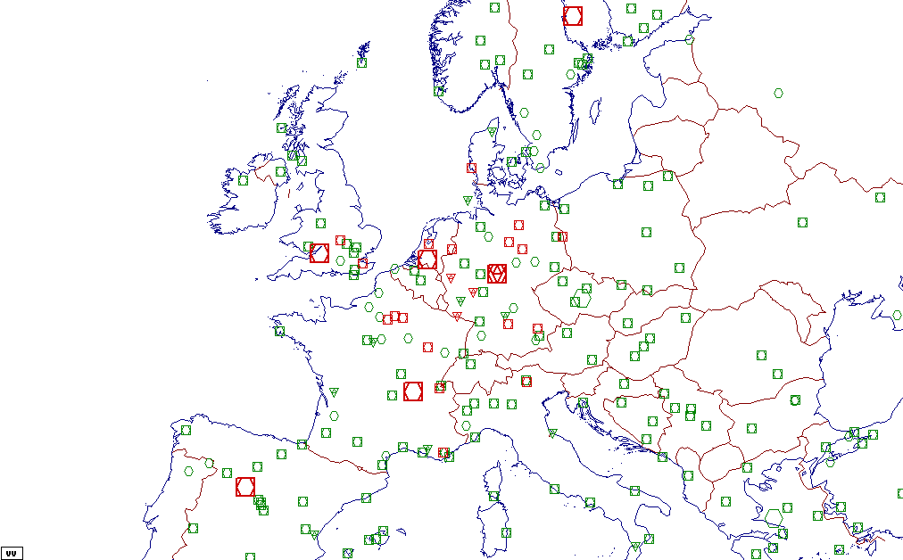
The failures are shown in red. The VORs, VORTACs and VOR-DMEs which it was possible to re-plan are shown in green.
The icons indicate type of service, as set out below:
 | : VOR |  | : VOR-TAC |  | : VOR-DME
The large icons identify the “ALL LAND” mobile services.

List of failures

Cty | Location | Poly | Type | VHF  freq | DOC | VHF  pwr | DME  pwr
ED | ALL GERMANY | LAND | VOR | 117.950 | 25/100 | 80L
ED | ALL GERMANY | LAND | VD | 116.050 | 100/500 | 200L | 40
ED | ALL GERMANY | LAND | VD | 116.350 | 100/500 | 200L | 40
ED | ALL GERMANY | LAND | VD | 116.150 | 40/250 | 200L | 39
ED | BRUNKENDORF |  | VD | 117.700 | 80/500 | 200L | 39
ED | HEHLINGEN |  | VD | 117.300 | 80/500 | 200L | 39
ED | MAGDEBURG |  | VD | 117.350 | 80/500 | 400L | 37
ED | MOOSBURG |  | VD | 117.150 | 60/500 | 200L | 37
ED | NOERDLINGEN |  | VD | 117.550 | 60/500 | 50 | 37
ED | NORVENICH |  | VD | 116.200 | 60/500 | 200L | 40
ED | SAARBRUCKEN |  | VD | 117.000 | 60/500 | 400L | 42
ED | TAUNUS |  | VD | 116.700 | 60SA,40/250 | 400L | 42
EG | ALL UK | LAND | VD | 116.900 | 100/500 | 50L | 37
EG | ALL UK | LAND | VD | 116.950 | 100/500 | 50L | 37
EG | DAVENTRY |  | VD | 116.400 | 75TX,60/500 | 50L | 39
EG | DETLING |  | VD | 117.300 | 60/500 | 50L | 39
EH | ALL NETHERLANDS | LAND | VD | 117.650 | 100/500 | 50L | 37
EH | PAMPUS |  | VD | 117.800 | 120NT,150TC,80/500 | 50L | 37
EH | REKKEN |  | VD | 116.800 | 80/500 | 25L | 37
EK | VESTA |  | VD | 116.600 | 200PX,160XE,100/500 | 50L | 36
EN | ALL NORWAY | LAND | VD | 117.200 | 100/500 | 50L | 37
EP | SUBI/SLUBICE |  | VD | 116.700 | 150/500 | 100L | 39
ES | ALL SWEDEN | LAND | VD | 117.900 | 80/400 | 50L | 29
GE | ALL SPAIN | LAND | VD | 116.100 | 60/250 | 50L | 37
LF | ALL FRANCE | LAND | VD | 117.200 | 40/250 | 50L | 37
LF | BOURSONNE |  | VD | 116.750 | 60/500 | 50L | 37
LF | CHATILLON-SUR-MARNE |  | VD | 117.600 | 70VE,100/500 | 50L | 37
LF | LE LUC/LE CANNET |  | VD | 117.600 | 100/250 | 50L | 37
LF | PARIS/CH.DE GAULLE |  | VD | 117.050 | 110/500 | 50L | 37
LF | ROLAMPONT |  | VD | 117.300 | 120HL,60/500 | 50L | 36
LI | BOLZANO |  | VD | 116.800 | 100/500 | 50L | 39
LS | PASSEIRY |  | VD | 116.600 | 120GS,80/500 | 50L | 37

Scenario 1D: 2MHz vacated between 116.000 and 118.000, with MLS-DMEs deleted

Assignments deleted
MLS-DMEs deleted | 870

Assignments processed
Width of sub-band vacated | 2 MHz
VOR and VOR-DME in the sub-band | 264
Replanned VORs | 244
Failures, including: | 20
- Failures (All Land VOR-DME) | 10
- Failures (other VOR-DME) | 9
- Failures (All Land VOR) | 1
- Failures (other VOR) | 0

Location of the VORs processed
The failures are shown in red. The VORs, VORTACs and VOR-DMEs which it was possible to re-plan are shown in green.
The icons indicate type of service, as set out below:
 | : VOR |  | : VOR-TAC |  | : VOR-DME
The large icons identify the “ALL LAND” mobile services.

List of failures

Cty | Location | Poly | Type | VHF  freq | DOC | VHF  pwr | DME  pwr
ED | ALL GERMANY | LAND | VD | 116.150 | 40/250 | 200L | 39
ED | ALL GERMANY | LAND | VOR | 117.950 | 25/100 | 80L
ED | ALL GERMANY | LAND | VD | 116.050 | 100/500 | 200L | 40
ED | ALL GERMANY | LAND | VD | 116.350 | 100/500 | 200L | 40
ED | HELGOLAND |  | VD | 116.300 | 200MD,60/500 | 400L | 42
EG | ALL UK | LAND | VD | 116.900 | 100/500 | 50L | 37
EG | ALL UK | LAND | VD | 116.950 | 100/500 | 50L | 37
EH | ALL NETHERLANDS | LAND | VD | 117.650 | 100/500 | 50L | 37
EH | PAMPUS |  | VD | 117.800 | 120NT,150TC,80/500 | 50L | 37
EH | REKKEN |  | VD | 116.800 | 80/500 | 25L | 37
EK | VESTA |  | VD | 116.600 | 200PX,160XE,100/500 | 50L | 36
EN | ALL NORWAY | LAND | VD | 117.200 | 100/500 | 50L | 37
EP | SUBI/SLUBICE |  | VD | 116.700 | 150/500 | 100L | 39
ES | ALL SWEDEN | LAND | VD | 117.900 | 80/400 | 50L | 29
GE | ALL SPAIN | LAND | VD | 116.100 | 60/250 | 50L | 37
LF | ALL FRANCE | LAND | VD | 117.200 | 40/250 | 50L | 37
LF | BOURSONNE |  | VD | 116.750 | 60/500 | 50L | 37
LF | CHATILLON-SUR-MARNE |  | VD | 117.600 | 70VE,100/500 | 50L | 37
LF | PARIS/CH.DE GAULLE |  | VD | 117.050 | 110/500 | 50L | 37
LS | PASSEIRY |  | VD | 116.600 | 120GS,80/500 | 50L | 37

Scenario 1A, 1B, 1C and 1D: consolidated results

Width of sub-band vacated | 1 MHz | 1.5 MHz | 1.5 MHz | 2 MHz | 2 MHz without MLS-DME
VOR and VOR-DME in the sub-band | 133 | 201 | 202 | 264 | 264
Replanned VORs | 120 | 178 | 182 | 232 | 244
Failures, including: | 13 | 23 | 20 | 32 | 20
- Failures (All Land VOR-DME) | 3 | 6 | 5 | 10 | 10
- Failures (other VOR-DME) | 8 | 16 | 14 | 21 | 9
- Failures (All Land VOR) | 1 | 1 | 1 | 1 | 1
- Failures (other VOR) | 0 | 0 | 0 | 0 | 0

List of countries where failures are located:

Code | Country | Number of failures
 |  | Minimum | Maximum
ED | GERMANY | 5 | 12
EG | UNITED KINGDOM | 0 | 4
EH | NETHERLANDS | 2 | 3
EK | DENMARK | 0 | 1
EN | NORWAY | 1 | 1
EP | POLAND | 0 | 1
ES | SWEDEN | 1 | 1
GE | SPAIN | 0 | 1
LF | FRANCE | 4 | 6
LI | ITALY | 0 | 1
LS | SWITZERLAND | 0 | 1

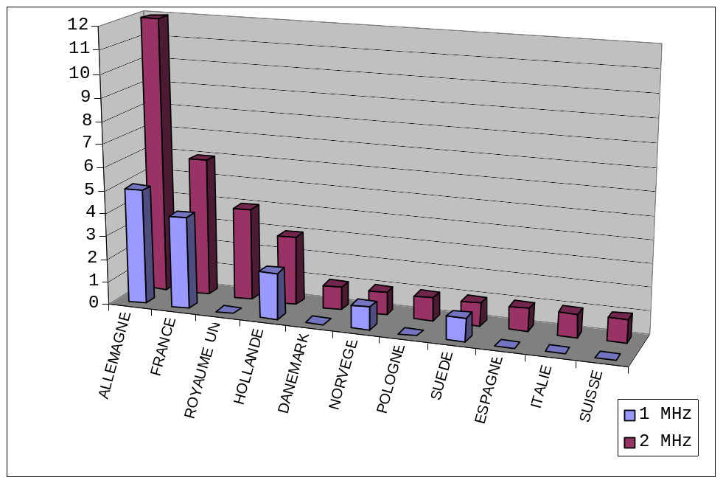

SCENARIO 2: Verification of GBAS

Scenario 2A: Planning of 1,775 GBASs between 108.000 and 116.000
The “new” GBASs are planned in the COM3 band which was reorganised following the migration of the VORs from the 116-118 MHz band to the 108-116MHz band. These “new” GBASs (considered to be future requirements) are created by copying all the ILSs and ILS-DMEs existing in EUROPE, applying a factor of 150%.
The coverage defined for the GBASs corresponds to a circular coverage with a radius:
- of 25NM, in the case of a copied ILS,
- equivalent to the DOC of the DME, for copies of ILS-DME.
The height of the airspace is equal to :
- FL100, for the ILSs,
- maximum FL of the DME service for copies of ILS-DME.
It was assumed that each GBAS service would use all the frequency slots allocated to it.
Prior to re-planning, the spectrum corresponds to that obtained from scenario 2C, i.e. following transfer between 108.000 and 116.000 MHz of 239 VOR and VOR/DME assignments whose frequency was between 116.000 and 118.000 MHz.

Assignments processed
Destination band | New GBASs | Re-planned GBASs | Failures
108.000 – 116.000 Mhz | 1,775 | 1,668 | 107

Location of the failed GBASs
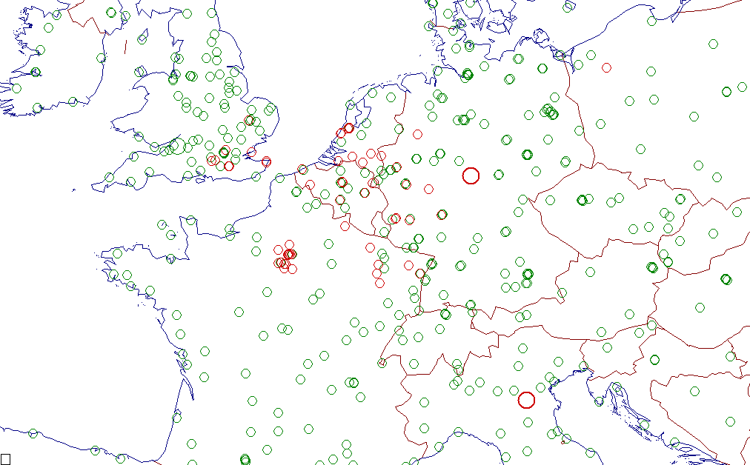
The failures are shown in red. The successfully re-planned GBASs are shown in green.

List of failures
Cty | Location | DOC |  | Cty | Location | DOC
EB | BRUXELLES/NATIONAL | 25/100 |  | EP | MIROSLAWIEC | 200/250
 | BRUXELLES/NATIONAL | 25/250 |  | LF | BRETIGNY | 25/100
 | BRUXELLES/NATIONAL | 25/100 |  |  | BRETIGNY | 25/100
 | CHARLEROI/BRUSSELS | 25/250 |  |  | CHARLEVILLE/MEZIER | 25/100
 | CHARLEROI/BRUSSELS | 25/250 |  |  | CREIL | 25/100
 | KORTRIJK/WEVELGEM | 25/250 |  |  | EPINAL/MIRECOURT | 25/100
 | KORTRIJK/WEVELGEM | 25/250 |  |  | EPINAL/MIRECOURT | 25/100
 | LIEGE/LIEGE | 25/250 |  |  | ETAIN/ROUVRES | 25/250
 | LIEGE/LIEGE | 25/250 |  |  | ETAIN/ROUVRES | 25/250
 | LIEGE/LIEGE | 25/250 |  |  | MELUN/VILLAROCHE | 25/250
 | LIEGE/LIEGE | 25/250 |  |  | NANCY/OCHEY | 25/100
 | OOSTENDE/OOSTENDE | 25/250 |  |  | NANCY/OCHEY | 25/100
ED | ALL GERMANY | 25/100 |  |  | PARIS/CH.DE GAULLE | 25/100
 | DUSSELDORF/DUSSELD | 25/100 |  |  | PARIS/CH.DE GAULLE | 25/250
 | FRANKFURT/MAIN | 25/100 |  |  | PARIS/CH.DE GAULLE | 25/250
 | FRANKFURT/MAIN | 25/100 |  |  | PARIS/CH.DE GAULLE | 25/250
 | FRANKFURT/MAIN | 25/100 |  |  | PARIS/CH.DE GAULLE | 25/100
 | FRANKFURT/MAIN | 25/100 |  |  | PARIS/CH.DE GAULLE | 25/100
 | FRANKFURT/MAIN | 25/100 |  |  | PARIS/CH.DE GAULLE | 25/250
 | FRANKFURT/MAIN | 25/100 |  |  | PARIS/CH.DE GAULLE | 25/100
 | FRANKFURT/MAIN | 25/100 |  |  | PARIS/LE BOURGET | 25/250
 | FRANKFURT/MAIN | 25/100 |  |  | PARIS/LE BOURGET | 25/100
 | FRANKFURT/MAIN | 25/100 |  |  | PARIS/LE BOURGET | 25/100
 | FRANKFURT/MAIN | 25/100 |  |  | PARIS/LE BOURGET | 25/100
 | HAHN | 25/100 |  |  | PARIS/LE BOURGET | 25/250
 | HAHN | 25/100 |  |  | PARIS/LE BOURGET | 25/100
 | KOLN/KOLN-BONN | 25/100 |  |  | PARIS/LE BOURGET | 25/100
 | MUNSTER/OSNABRUCK | 25/100 |  |  | PARIS/ORLY | 25/250
 | NIEDERRHEIN | 25/100 |  |  | PARIS/ORLY | 25/100
 | SIEGERLAND | 25/100 |  |  | PHALSBOURG | 25/250
 | SPANGDAHLEM | 25/100 |  |  | PONTOISE | 25/100
 | SPANGDAHLEM | 25/100 |  |  | STRASBOURG/ENTZHEIN | 25/100
EG | FARNBOROUGH | 25/250 |  |  | TOUL | 25/100
 | GATWICK (TEE) | 25/100 |  |  | TOUSSUS-LE-NOBLE | 25/250
 | LONDON/GATWICK | 25/250 |  |  | TOUSSUS-LE-NOBLE | 25/100
 | LONDON/GATWICK | 25/250 |  |  | TOUSSUS-LE-NOBLE | 25/250
 | MANSTON | 25/750 |  |  | TOUSSUS-LE-NOBLE | 25/100
 | MANSTON | 25/750 |  |  | VILLACOUBLAY | 25/250
 | MANSTON | 25/750 |  | LI | ALL ITALY | 25/100
 | MILDENHALL | 25/100
 | MILDENHALL | 25/100
 | NORTHOLT | 25/250
 | ODIHAM | 25/100
 | ODIHAM | 25/100
 | SOUTHEND | 25/250
EH | AMSTERDAM/SCHIPHOL | 25/250
 | AMSTERDAM/SCHIPHOL | 25/250
 | AMSTERDAM/SCHIPHOL | 25/100
 | AMSTERDAM/SCHIPHOL | 25/100
 | AMSTERDAM/SCHIPHOL | 25/100
 | EINDHOVEN | 25/250
 | EINDHOVEN | 25/250
 | EINDHOVEN | 25/100
 | GILZE-RIJEN | 25/250
 | GILZE-RIJEN | 25/250
 | GILZE-RIJEN | 25/250
 | MAASTRICHT | 25/250
 | MAASTRICHT/ZUID-LI | 25/100
 | MAASTRICHT/ZUID-LI | 25/100
 | VALKENBURG | 25/250
 | VALKENBURG | 25/250
 | VALKENBURG | 25/250
 | VALKENBURG | 25/250
 | VOLKEL | 25/250
 | VOLKEL | 25/250
 | VOLKEL | 25/250
 | WOENSDRECHT | 25/250
 | WOENSDRECHT | 25/250

A large part of these failures correspond to multiple GBAS requests at a single airport. These requests are based on initial hypotheses determining requirements. GBASs by copy/transformation of 1.5 times the ILS and ILS-DMEs at that airport are set out in the COM3 table.
For example, at FRANKFURT/MAIN, the GBAS requirement determined on the basis of these hypotheses was 18 services. Of these 18 services, there were 10 failures, yet 8 GBAS requirements were satisfactory for this airport alone.
Similarly, at PARIS/CDG, 8 requirements were considered, with 6 failures and 2 successes.

Scenario 2B: Planning of 1,775 GBASs between 108.000 and 118.000
The "new" GBASs are planned in the current COM3 band between 108 and 118Hz, with no migration of the VORs located between 116 and 118 MHz.
The objective of this scenario is to provide a basis of comparison reflecting a measure of current GBAS capacity. A comparison of the results of this scenario 2B with the preceding scenario 2A makes it possible to evaluate the deterioration caused by scenario 2A to the GBAS capacity of the spectrum. The deterioration observed results both from the use of a reduced 2MHz band and from the migration of the VOR services to a reduced band.

Assignments processed

Destination band | New GBASs | Re-planned GBASs | Failures
108.000 - 118.000 Mhz | 1,775 | 1,702 | 73

Location of the failed GBASs

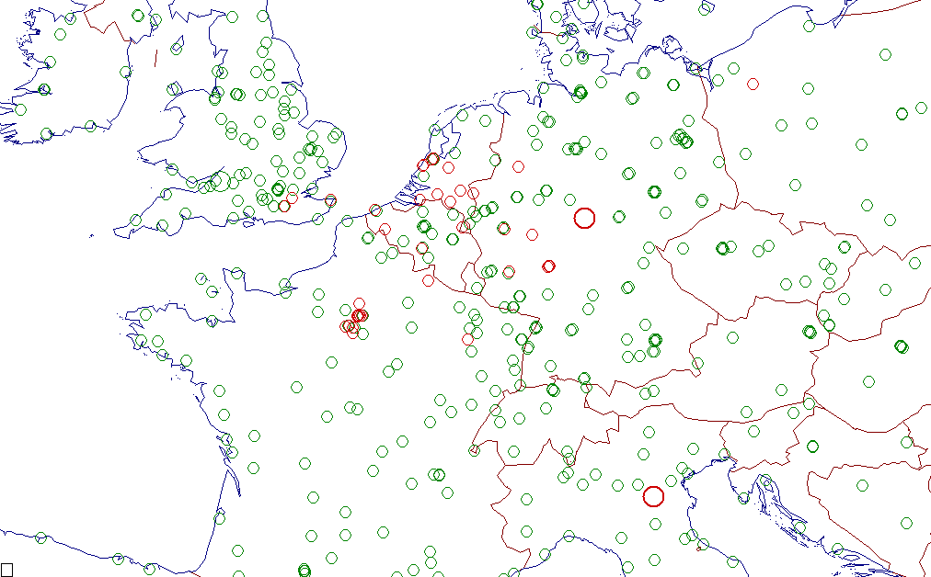
The failures are shown in red. The successfully re-planned GBASs are shown in green.

List of failures
Cty | Location | DOC |  | Cty | Location | DOC
EB | CHARLEROI/BRUSSELS | 25/250 |  | EP | MIROSLAWIEC | 200/250
 | CHARLEROI/BRUSSELS | 25/250 |  | LF | BRETIGNY | 25/100
 | KORTRIJK/WEVELGEM | 25/250 |  | LF | BRETIGNY | 25/100
 | OOSTENDE/OOSTENDE | 25/250 |  | LF | CHARLEVILLE/MEZIER | 25/100
 |  |  |  | LF | CREIL | 25/100
 |  |  |  | LF | NANCY/OCHEY | 25/100
 |  |  |  | LF | PARIS/CH.DE GAULLE | 25/100
 |  |  |  | LF | PARIS/CH.DE GAULLE | 25/250
 |  |  |  | LF | PARIS/CH.DE GAULLE | 25/250
 |  |  |  | LF | PARIS/CH.DE GAULLE | 25/250
 |  |  |  | LF | PARIS/CH.DE GAULLE | 25/100
 |  |  |  | LF | PARIS/CH.DE GAULLE | 25/100
ED | ALL GERMANY | 25/100 |  | LF | PARIS/CH.DE GAULLE | 25/250
 | FRANKFURT/MAIN | 25/100 |  | LF | PARIS/CH.DE GAULLE | 25/100
 | FRANKFURT/MAIN | 25/100 |  | LF | PARIS/LE BOURGET | 25/250
 | FRANKFURT/MAIN | 25/100 |  | LF | PARIS/LE BOURGET | 25/100
 | FRANKFURT/MAIN | 25/100 |  | LF | PARIS/LE BOURGET | 25/100
 | FRANKFURT/MAIN | 25/100 |  | LF | PARIS/LE BOURGET | 25/100
 | FRANKFURT/MAIN | 25/100 |  | LF | PARIS/LE BOURGET | 25/100
 | FRANKFURT/MAIN | 25/100 |  | LF | PARIS/ORLY | 25/250
 | FRANKFURT/MAIN | 25/100 |  | LF | TOUSSUS-LE-NOBLE | 25/250
 | FRANKFURT/MAIN | 25/100 |  | LF | TOUSSUS-LE-NOBLE | 25/100
 | FRANKFURT/MAIN | 25/100 |  | LF | TOUSSUS-LE-NOBLE | 25/250
 | FRANKFURT/MAIN | 25/100 |  | LF | TOUSSUS-LE-NOBLE | 25/100
 | FRANKFURT/MAIN | 25/100 |  | LF | VILLACOUBLAY | 25/250
 | HAHN | 25/100
 | KOLN/KOLN-BONN | 25/100
 | MUNSTER/OSNABRUCK | 25/100
 | MUNSTER/OSNABRUCK | 25/100
 | NIEDERRHEIN | 25/100
 | SIEGERLAND | 25/100
EG | BIGGIN HILL | 25/250
 | LONDON/GATWICK | 25/250
 | LONDON/GATWICK | 25/250
 | MANSTON | 25/750
 | MANSTON | 25/750
 |  |  |  | LI | ALL ITALY | 25/100
EH | AMSTERDAM/SCHIPHOL | 25/250
 | AMSTERDAM/SCHIPHOL | 25/100
 | AMSTERDAM/SCHIPHOL | 25/100
 | AMSTERDAM/SCHIPHOL | 25/100
 | EINDHOVEN | 25/250
 | EINDHOVEN | 25/100
 | GILZE-RIJEN | 25/250
 | GILZE-RIJEN | 25/250
 | MAASTRICHT | 25/250
 | MAASTRICHT/ZUID-LI | 25/100
 | SOESTERBERG | 25/250
 | SOESTERBERG | 25/250
 | VALKENBURG | 25/250
 | VALKENBURG | 25/250
 | VALKENBURG | 25/250
 | VOLKEL | 25/250
 | VOLKEL | 25/250
 | VOLKEL | 25/250
 | WOENSDRECHT | 25/250

Scenario 2A, 2B: consolidated results

Scenario | Destination band | moved  VORs | New  GBASs | Re-planned  GBASs | Failures
2A | 108.000 - 116.000 MHz | 178 | 1,775 | 1,668 | 107
2B | 108.000 - 118.000 MHz | 0 | 1,775 | 1,702 | 73

The reduction in GBAS capacity caused by the migration of the VORs to the 108-116 band would appear to be marginal: 34 extra GBAS failures on the basis of a scenario of introducing 1,775 GBASs.

SCENARIO 3: Spectrum gains for voice communication

Scenario 3A: Gains associated with the use of a supplementary 2 MHz band

Assignments processed
The requirements processed correspond to the COM2 assignments for which it is impossible to find an additional frequency without having to use a permutation mechanism. Assignments of the type “NATIONAL AERODROMES” were removed from the list of assignments processed.
The assignments were classified by country, based on the type of channel spacing (8.33 or 25 MHz) and type of service (AV corresponds to the ATIS and Volmet “Broadcast” services”).

Channel type |  |  |  | 25 |  |  |  |  |  |  |  |  |  | 8.33 | 8.33  & 25
FL |  | <150 |  |  |  | >=150 | and | <300 |  | >=300 |  |  |  | >=300
Country | A/G | TWR  AFIS | APP | ACC  F | A/G | AV | APP | ACC  F | A/G | AV | APP | ACC  F | Total | ACC | Total
AUT |  |  |  |  |  | 5 | 11 | 2 |  | 1 |  | 10 | 29 | 5 | 34
BEL |  | 3 | 4 |  | 1 | 3 | 3 | 15 | 1 | 1 |  |  | 31 | 9 | 40
CZE |  |  |  |  | 4 |  | 7 | 4 | 1 | 1 |  | 3 | 20 | 4 | 24
D |  | 3 | 4 | 8 | 11 | 9 | 14 | 81 |  | 4 |  | 18 | 152 | 32 | 184
DNK |  |  |  |  |  |  |  | 5 |  | 1 |  | 4 | 10 |  | 10
F | 7 | 7 | 19 | 1 | 17 | 18 | 23 | 49 | 14 | 7 |  | 47 | 209 | 42 | 251
G | 13 | 11 | 28 | 6 |  | 14 | 26 | 49 | 4 | 5 | 2 | 86 | 244 | 6 | 250
HNG |  |  |  | 1 | 1 |  |  | 2 |  | 1 |  | 5 | 10 | 1 | 11
HOL | 3 |  |  | 1 |  | 3 | 8 | 9 |  | 1 |  | 11 | 36 | 4 | 40
HRV |  |  |  |  |  |  | 5 | 7 | 1 | 1 |  | 9 | 23 |  | 23
I |  |  |  | 3 | 3 |  | 5 | 21 | 2 | 3 |  | 22 | 59 | 4 | 63
IRL |  |  |  |  |  |  |  |  | 2 |  |  | 9 | 11 |  | 11
LUX |  | 2 | 1 |  |  |  | 1 |  |  |  |  |  | 4 |  | 4
POL |  |  |  |  |  |  |  | 3 | 1 | 1 |  | 12 | 17 |  | 17
S |  |  |  |  |  |  |  |  | 1 | 1 |  | 7 | 9 |  | 9
SUI |  |  |  |  |  | 6 |  | 9 |  | 2 |  | 8 | 25 | 5 | 30
SVK |  |  | 1 |  | 1 |  |  | 4 |  | 1 |  | 6 | 13 |  | 13
SVN |  |  |  |  |  |  | 1 | 4 | 1 |  |  | 1 | 7 |  | 7
UKR |  |  |  |  |  |  |  |  |  |  |  | 4 | 4 |  | 4
YUG |  |  |  |  |  |  |  | 7 |  |  |  | 10 | 17 |  | 17
Total | 23 | 26 | 57 | 20 | 38 | 58 | 104 | 271 | 28 | 31 | 2 | 272 | 930 | 112 | 1042
Country | A/G | TWR  AFIS | APP | ACC  F | A/G | AV | APP | ACC  F | A/G | AV | APP | ACC  F | Total | ACC | Total
FL |  | <150 |  |  |  | >=150 | and | <300 |  | >=300 |  |  |  | >=300
Channel type |  |  |  | 25 |  |  |  |  |  |  |  |  |  | 8.33 | 8.33  & 25

Successful assignments
The table shows the successful assignments, classified in the same way as in the table of assignments processed.
AV corresponds to the ATIS and Volmet “Broadcast” services
Channel  type |  |  |  | 25 |  |  |  |  |  |  |  |  |  | 8.33 | 8.33  & 25
FL |  | <150 |  |  |  | >=150 | and | <300 |  | >=300 |  |  |  | >=300
Country | A/G | TWR  AFIS | APP | ACC  F | A/G | AV | APP | ACC  F | A/G | AV | APP | ACC  F | Total | ACC | Total
AUT |  |  |  |  |  | 2 | 2 | 1 |  | 1 |  | 1 | 7 | 2 | 9
BEL |  | 2 | 0 |  | 1 | 2 | 2 | 2 | 0 | 1 |  |  | 10 | 2 | 12
CZE |  |  |  |  | 2 |  | 3 | 0 | 0 | 0 |  | 1 | 6 | 1 | 7
D |  | 2 | 1 | 1 | 2 | 0 | 2 | 17 |  | 2 |  | 2 | 29 | 3 | 32
DNK |  |  |  |  |  |  |  | 0 |  | 1 |  | 0 | 1 |  | 1
F | 1 | 2 | 2 | 0 | 2 | 0 | 3 | 11 | 2 | 3 |  | 7 | 33 | 5 | 38
G | 4 | 1 | 9 | 1 |  | 3 | 7 | 7 | 0 | 0 | 0 | 12 | 44 | 0 | 44
HNG |  |  |  | 1 | 1 |  |  | 2 |  | 1 |  | 0 | 5 | 1 | 6
HOL | 1 |  |  | 1 |  | 0 | 2 | 1 |  | 1 |  | 1 | 7 | 2 | 9
HRV |  |  |  |  |  |  | 3 | 3 | 0 | 1 |  | 1 | 8 |  | 8
I |  |  |  | 3 | 2 |  | 1 | 4 | 0 | 1 |  | 8 | 19 | 0 | 19
IRL |  |  |  |  |  |  |  |  | 1 |  |  | 2 | 3 |  | 3
LUX |  | 0 | 0 |  |  |  | 1 |  |  |  |  |  | 1 |  | 1
POL |  |  |  |  |  |  |  | 0 | 1 | 1 |  | 6 | 8 |  | 8
S |  |  |  |  |  |  |  |  | 1 | 1 |  | 4 | 6 |  | 6
SUI |  |  |  |  |  | 1 |  | 2 |  | 0 |  | 1 | 4 | 1 | 5
SVK |  |  | 1 |  | 0 |  |  | 3 |  | 1 |  | 0 | 5 |  | 5
SVN |  |  |  |  |  |  | 0 | 0 | 0 |  |  | 0 | 0 |  | 0
UKR |  |  |  |  |  |  |  |  |  |  |  | 4 | 4 |  | 4
YUG |  |  |  |  |  |  |  | 6 |  |  |  | 5 | 11 |  | 11
Total | 6 | 7 | 13 | 7 | 10 | 8 | 26 | 59 | 5 | 15 | 0 | 55 | 211 | 17 | 228
Country | A/G | TWR  AFIS | APP | ACC  F | A/G | AV | APP | ACC  F | A/G | AV | APP | ACC  F | Total | ACC | Total
FL |  | <150 |  |  |  | >=150 | and | <300 |  | >=300 |  |  |  | >=300
Channel type |  |  |  | 25 |  |  |  |  |  |  |  |  |  | 8.33 | 8.33  & 25

The result shows that with one frequency (25 MHz) it will be possible to satisfy around 3 requirements for which it is currently impossible to find a frequency.

Percentage of assignments satisfied
AV corresponds to the ATIS and Volmet “Broadcast” services
Channel  type |  |  |  | 25 |  |  |  |  |  |  |  |  |  |  | 8.33 | 8.33  & 25
FL |  | <150 |  |  |  | >=150 | and | <300 |  |  | >=300 |  |  |  | >=300
Country | A/G | TWR  AFIS | APP | ACC  F | A/G | AV | APP | ACC  F | A/G |  | AV | APP | ACC  F | Total | ACC | Total
AUT |  |  |  |  |  | 40% | 18% | 50% |  | 100% |  |  | 10% | 24% | 40% | 26%
BEL |  | 66% | 0% |  | 100% | 66% | 66% | 13% | 0% | 100% |  |  |  | 32% | 22% | 30%
CZE |  |  |  |  | 50% |  | 42% | 0% | 0% | 0% |  |  | 33% | 30% | 25% | 29%
D |  | 66% | 25% | 12% | 18% | 0% | 14% | 20% |  | 50% |  |  | 11% | 19% | 9% | 17%
DNK |  |  |  |  |  |  |  | 0% |  | 100% |  |  | 0% | 10% |  | 10%
F | 14% | 28% | 10% | 0% | 11% | 0% | 13% | 22% | 14% | 42% |  |  | 14% | 15% | 11% | 15%
G | 30% | 9% | 32% | 16% |  | 21% | 26% | 14% | 0% | 0% |  | 0% | 13% | 18% | 0% | 17%
HNG |  |  |  | 100% | 100% |  |  | 100% |  | 100% |  |  | 0% | 50% | 100% | 54%
HOL | 33% |  |  | 100% |  | 0% | 25% | 11% |  | 100% |  |  | 9% | 19% | 50% | 22%
HRV |  |  |  |  |  |  | 60% | 42% | 0% | 100% |  |  | 11% | 34% |  | 34%
I |  |  |  | 100% | 66% |  | 20% | 19% | 0% | 33% |  |  | 36% | 32% | 0% | 30%
IRL |  |  |  |  |  |  |  |  | 50% |  |  |  | 22% | 27% |  | 27%
LUX |  | 0% | 0% |  |  |  | 100% |  |  |  |  |  |  | 25% |  | 25%
POL |  |  |  |  |  |  |  | 0% | 100% | 100% |  |  | 50% | 47% |  | 47%
S |  |  |  |  |  |  |  |  | 100% | 100% |  |  | 57% | 66% |  | 66%
SUI |  |  |  |  |  | 16% |  | 22% |  | 0% |  |  | 12% | 16% | 20% | 16%
SVK |  |  | 100% |  | 0% |  |  | 75% |  | 100% |  |  | 0% | 38% |  | 38%
SVN |  |  |  |  |  |  | 0% | 0% | 0% |  |  |  | 0% | 0% |  | 0%
UKR |  |  |  |  |  |  |  |  |  |  |  |  | 100% | 100% |  | 100%
YUG |  |  |  |  |  |  |  | 85% |  |  |  |  | 50% | 64% |  | 64%
Total | 26% | 26% | 22% | 35% | 26% | 13% | 25% | 21% | 17% | 48% |  | 0% | 20% | 22% | 15% | 21%
Country | A/G | TWR  AFIS | APP | ACC  F | A/G | AV | APP | ACC  F | A/G |  | AV | APP | ACC  F | Total | ACC | Total
FL |  | <150 |  |  |  | >=150 | and | <300 |  |  | >=300 |  |  |  | >=300
Channel type |  |  |  | 25 |  |  |  |  |  |  |  |  |  |  | 8.33 | 8.33  & 25

List of successful assignments

Country | Site | 8/25 | Service | DOC  in NM | FL | POLY
AUT | WIEN ACC | 8 | ACC/U |  | 450 | POLY
AUT | WIEN ACC | 8 | ACC/U |  | 450 | POLY
AUT | WIEN ACC | 25 | VOLMET | 261 | 450
AUT | WIEN ACC | 25 | ACC/U |  | 450 | POLY
AUT | LINZ/LINZ | 25 | ATIS | 60 | 200
AUT | WIEN ACC | 25 | ACC/L |  | 200 | POLY
AUT | WIEN/SCHWECHAT | 25 | VOLMET | 100 | 200
AUT | WIEN/SCHWECHAT | 25 | APP/I | 40 | 200
AUT | SALZBURG/SALZBURG | 25 | APP/I | 40 | 150
BEL | BRUXELLES ACC | 8 | ACC/U |  | 450 | POLY
BEL | BRUXELLES ACC | 8 | ACC/U |  | 450 | POLY
BEL | BRUXELLES ACC | 25 | VOLMET | 261 | 450
BEL | BRUXELLES ACC | 25 | ACC/L |  | 250 | POLY
BEL | BRUXELLES ACC | 25 | ACC/L |  | 250 | POLY
BEL | SEMMERZAKE | 25 | A/G | 50 | 250
BEL | LIEGE/LIEGE | 25 | ATIS | 60 | 200
BEL | BRUXELLES/NATIONAL | 25 | ATIS | 60 | 200
BEL | BRUXELLES/NATIONAL | 25 | APP/I | 40 | 150
BEL | BRUXELLES/NATIONAL | 25 | APP/I | 40 | 150
BEL | CHARLEROI/BRUSSELS S | 25 | TWR | 25 | 40
BEL | NAMUR/SUARLEE | 25 | AFIS | 15 | 30
CZE | PRAHA ACC | 8 | ACC/U |  | 450 | POLY
CZE | PRAHA ACC | 25 | ACC/U |  | 450 | POLY
CZE | BRNO/TURANY | 25 | A/G | 50 | 250
CZE | KUNOVICE | 25 | APP/H | 50 | 250
CZE | PLZEN | 25 | APP/I | 40 | 150
CZE | ZATEC | 25 | A/G | 40 | 150
CZE | PRAHA/RUZYNE | 25 | APP/I | 40 | 150
D | RHEIN UAC | 8 | ACC/U |  | 450 | POLY
D | RHEIN UAC | 8 | ACC |  | 450 | POLY
D | RHEIN UAC | 8 | ACC/U |  | 450 | POLY
D | FRANKFURT ACC | 25 | VOLMET | 261 | 450
D | RHEIN UAC | 25 | ACC/U |  | 450 | POLY
D | BERLIN ACC | 25 | VOLMET | 261 | 450
D | HANNOVER ACC | 25 | ACC/U |  | 450 | POLY
D | BERLIN ACC | 25 | ACC/L |  | 295 | POLY
D | BERLIN ACC | 25 | ACC/L |  | 295 | POLY
D | BERLIN ACC | 25 | ACC |  | 295 | POLY
D | DUSSELDORF ACC | 25 | ACC/L |  | 285 | POLY
D | MUNCHEN ACC | 25 | ACC/L |  | 280 | POLY
D | MUNCHEN ACC | 25 | ACC |  | 280 | POLY
D | MUNCHEN ACC | 25 | ACC |  | 275 | POLY
D | FRANKFURT ACC | 25 | ACC/L |  | 250 | POLY
D | FRANKFURT ACC | 25 | ACC/L |  | 250 | POLY
D | MUNCHEN ACC | 25 | F |  | 250 | POLY
D | BREMEN ACC | 25 | ACC/L |  | 250 | POLY
D | BREMEN ACC | 25 | ACC |  | 250 | POLY
D | FRANKFURT ACC | 25 | ACC/L |  | 250 | POLY
D | FRANKFURT ACC | 25 | ACC/L |  | 250 | POLY
D | FRANKFURT ACC | 25 | ACC/L |  | 250 | POLY
D | LEIPZIG/LEIPZIG | 25 | A/G | 50 | 250
D | BERLIN ACC | 25 | ACC/L |  | 250 | POLY
D | BERLIN/BERLIN | 25 | APP/H | 60 | 200
D | DRESDEN | 25 | APP/H | 50 | 200
D | DUSSELDORF ACC | 25 | ACC |  | 155 | POLY
D | DRESDEN | 25 | A/G | 40 | 150
D | FRANKFURT ACC | 25 | F |  | 100 | POLY
D | NURNBERG/NURNBERG | 25 | APP/L | 60 | 100
D | MANNHEIM/NEUOSTHEIM | 25 | ATIS | 50 | 100
D | FRANKFURT/FRANKFURT | 25 | AS | 25 | 0
DNK | KOBENHAVN ACC | 25 | VOLMET | 261 | 450
F | BREST ACC | 8 | ACC/U |  | 450 | POLY
F | BREST ACC | 8 | ACC/U |  | 450 | POLY
F | PARIS/REIMS ACC | 8 | ACC/U |  | 450 | POLY
F | BREST ACC | 8 | ACC |  | 430 | POLY
F | BREST ACC | 8 | ACC |  | 380 | POLY
F | PARIS/REIMS ACC | 25 | ACC/U |  | 450 | POLY
F | PARIS/REIMS ACC | 25 | VOLMET | 261 | 450
F | BORDEAUX ACC | 25 | ACC/U |  | 450 | POLY
F | BREST ACC | 25 | ACC/U |  | 450 | POLY
F | BREST/LOPERHET | 25 | A/G |  | 450 | POLY
F | MARSEILLE ACC | 25 | VOLMET | 261 | 450
F | MARSEILLE ACC | 25 | VOLMET | 261 | 450
F | MARSEILLE ACC | 25 | ACC/I |  | 350 | POLY
F | MARSEILLE ACC | 25 | ACC/I |  | 350 | POLY
F | MARSEILLE ACC | 25 | ACC/I |  | 350 | POLY
F | MARSEILLE ACC | 25 | ACC/I |  | 350 | POLY
F | TOURS/ST-SYMPHORIEN | 25 | A/G |  | 300 | POLY
F | PARIS ACC | 25 | ACC/L |  | 250 | POLY
F | PARIS ACC | 25 | ACC/L |  | 250 | POLY
F | PARIS ACC | 25 | F |  | 250 | POLY
F | PARIS/REIMS ACC | 25 | ACC/L |  | 250 | POLY
F | PARIS/REIMS ACC | 25 | ACC/L |  | 250 | POLY
F | PARIS/REIMS ACC | 25 | ACC/L |  | 250 | POLY
F | PARIS/REIMS ACC | 25 | F |  | 250 | POLY
F | VILLACOUBLAY | 25 | A/G | 50 | 250
F | NICE/COTE D'AZUR | 25 | APP/H | 50 | 250
F | ISTRES | 25 | ACC |  | 250 | POLY
F | BORDEAUX ACC | 25 | F |  | 250 | POLY
F | MARSEILLE ACC | 25 | ACC/L |  | 250 | POLY
F | MARSEILLE ACC | 25 | F |  | 250 | POLY
F | NICE/COTE D'AZUR | 25 | APP/H | 50 | 250
F | TOULOUSE/BLAGNAC | 25 | A/G |  | 250 | POLY
F | METZ/NANCY-LORRAINE | 25 | APP | 50 | 195
F | LILLE/LESQUIN | 25 | APP |  | 115 | POLY
F | BEAUVAIS/TILLE | 25 | APP/L | 25 | 100
F | LE TOUQUET/PARIS-PLA | 25 | TWR | 25 | 40
F | MERVILLE/CALONNE | 25 | TWR | 25 | 40
F | TOULOUSE | 25 | A/G |  | 40 | POLY
G | SCOTTISH ACC | 25 | ACC/U |  | 460 | POLY
G | SCOTTISH ACC | 25 | ACC/U |  | 460 | POLY
G | LONDON ACC | 25 | ACC/U |  | 450 | POLY
G | LONDON MIL ACC | 25 | ACC/U |  | 450 | POLY
G | LONDON ACC | 25 | ACC/U |  | 450 | POLY
G | LONDON ACC | 25 | ACC/U |  | 450 | POLY
G | SCOTTISH ACC | 25 | ACC/U |  | 450 | POLY
G | LONDON ACC | 25 | ACC/U |  | 430 | POLY
G | MANCHESTER ACC | 25 | ACC/I |  | 310 | POLY
G | MANCHESTER ACC | 25 | ACC/L |  | 300 | POLY
G | SCOTTISH ACC | 25 | ACC/I |  | 300 | POLY
G | MANCHESTER ACC | 25 | ACC/I |  | 300 | POLY
G | MANCHESTER ACC | 25 | ACC/I |  | 290 | POLY
G | MANCHESTER ACC | 25 | ACC/I |  | 270 | POLY
G | LONDON ACC | 25 | ACC/L |  | 250 | POLY
G | LONDON ACC | 25 | F |  | 250 | POLY
G | HUMBERSIDE/HUMBERSID | 25 | APP/H | 50 | 250
G | LONDON ACC | 25 | ACC/L |  | 245 | POLY
G | MANCHESTER/MANCHESTE | 25 | APP/H | 40 | 240
G | MANCHESTER/MANCHESTE | 25 | APP/H | 40 | 240
G | EAST MIDLANDS/EAST M | 25 | ATIS | 60 | 200
G | HUMBERSIDE/HUMBERSID | 25 | ATIS | 60 | 200
G | LONDON ACC | 25 | ACC/L |  | 200 | POLY
G | COVENTRY | 25 | ATIS | 60 | 200
G | CARDIFF/CARDIFF | 25 | APP/L |  | 190 | POLY
G | CARDIFF/CARDIFF | 25 | APP | 40 | 190
G | BRISTOL/LULSGATE | 25 | APP/L | 60 | 150
G | MANCHESTER/MANCHESTE | 25 | APP/I | 40 | 150
G | MANCHESTER FIR | 25 | ACC |  | 150 | POLY
G | SHOREHAM | 25 | APP/L | 25 | 100
G | NORTHOLT | 25 | ATIS | 100 | 100
G | MANSTON | 25 | APP/I | 40 | 100
G | WATTISHAM | 25 | APP/L | 30 | 100
G | BOSCOMBE DOWN | 25 | APP/I | 40 | 100
G | COLTISHALL | 25 | APP/I | 40 | 80
G | PORTLAND | 25 | APP/I | 40 | 80
G | NORWICH | 25 | APP/L | 40 | 70
G | FARNBOROUGH | 25 | APP/L | 25 | 60
G | SOUTHAMPTON/SOUTHAMP | 25 | APP/L | 50 | 55
G | FARNBOROUGH | 25 | A/G | 50 | 50
G | NORTH SEA | 25 | A/G |  | 50 | POLY
G | CHALGROVE | 25 | A/G | 25 | 40
G | NORTH SEA | 25 | ACC |  | 30 | POLY
G | NORTH SEA | 25 | A/G |  | 0 | POLY
HNG | BUDAPEST ACC | 8 | ACC/U |  | 450 | POLY
HNG | BUDAPEST ACC | 25 | VOLMET | 261 | 450
HNG | VESZPREM | 25 | A/G | 50 | 250
HNG | BUDAPEST ACC | 25 | ACC |  | 250 | POLY
HNG | BUDAPEST ACC | 25 | ACC |  | 250 | POLY
HNG | BUDAPEST ACC | 25 | F |  | 95 | POLY
HOL | MAASTRICHT UAC | 8 | ACC/U |  | 450 | POLY
HOL | MAASTRICHT UAC | 8 | ACC/U |  | 450 | POLY
HOL | NIEUW MILLIGEN ACC | 25 | ACC/U |  | 450 | POLY
HOL | AMSTERDAM ACC | 25 | VOLMET | 261 | 450
HOL | AMSTERDAM ACC | 25 | ACC/L |  | 250 | POLY
HOL | AMSTERDAM/SCHIPHOL | 25 | APP/I | 40 | 150
HOL | GILZE-RIJEN | 25 | APP/I | 40 | 150
HOL | NIEUW MILLIGEN ACC | 25 | F |  | 120 | POLY
HOL | NORTH SEA | 25 | A/G |  | 40 | POLY
HRV | ZAGREB ACC | 25 | ACC |  | 450 | POLY
HRV | ZAGREB ACC | 25 | VOLMET | 261 | 450
HRV | PULA/PULA | 25 | APP/H | 50 | 250
HRV | SPLIT TMA | 25 | APP/H | 50 | 250 | POLY
HRV | PULA TMA | 25 | F |  | 250 | POLY
HRV | ZAGREB ACC | 25 | ACC/L |  | 250 | POLY
HRV | ZAGREB TMA | 25 | F |  | 250 | POLY
HRV | SPLIT TMA | 25 | APP/H | 50 | 200 | POLY
I | BRINDISI ACC | 25 | ACC/U |  | 450 | POLY
I | PADOVA ACC | 25 | ACC/U |  | 450 | POLY
I | ITALIA UAC | 25 | ACC/U |  | 450 | POLY
I | BRINDISI ACC | 25 | ACC/U |  | 450 | POLY
I | ITALIA UAC | 25 | ACC/U |  | 450 | POLY
I | ITALIA UAC | 25 | ACC/U |  | 450 | POLY
I | ROMA ACC | 25 | VOLMET | 261 | 450
I | ITALIA UAC | 25 | ACC/U |  | 450 | POLY
I | BRINDISI ACC | 25 | ACC/U |  | 365 | POLY
I | GENOVA/SESTRI | 25 | A/G | 50 | 250
I | ROMA ACC | 25 | F |  | 250 | POLY
I | MILANO ACC | 25 | ACC/L |  | 250 | POLY
I | MILANO ACC | 25 | F |  | 250 | POLY
I | ROMA ACC | 25 | F |  | 250 | POLY
I | ROMA/CIAMPINO | 25 | A/G |  | 250 | POLY
I | VERONA/VILLAFRANCA | 25 | APP/I | 40 | 150
I | MILANO ACC | 25 | ACC/L |  | 100 | POLY
I | MILANO ACC | 25 | ACC/L |  | 100 | POLY
I | MILANO ACC | 25 | ACC/L |  | 95 | POLY
IRL | SHANNON ACC | 25 | ACC/U |  | 450 | POLY
IRL | SHANNON ACC | 25 | ACC/U |  | 450 | POLY
IRL | CASEMENT | 25 | A/G |  | 450 | POLY
LUX | LUXEMBOURG/LUXEMBOUR | 25 | APP/I | 40 | 150
POL | WARSZAWA ACC | 25 | ACC/U |  | 460 | POLY
POL | WARSZAWA ACC | 25 | ACC/U |  | 450 | POLY
POL | SZCZECIN | 25 | A/G | 80 | 450
POL | POZNAN | 25 | ACC/U |  | 450 | POLY
POL | WARSZAWA ACC | 25 | ACC/U |  | 450 | POLY
POL | WARSZAWA ACC | 25 | VOLMET | 261 | 450
POL | WARSZAWA ACC | 25 | ACC/U |  | 450 | POLY
POL | WARSZAWA ACC | 25 | ACC |  | 410 | POLY
S | MALMO ACC | 25 | ACC/U |  | 450 | POLY
S | MALMO ACC | 25 | ACC/U |  | 450 | POLY
S | MALMO ACC | 25 | A/G |  | 450 | POLY
S | MALMO ACC | 25 | ACC/U |  | 450 | POLY
S | JONKOPING | 25 | VOLMET | 261 | 450
S | MALMO ACC | 25 | ACC/U |  | 350 | POLY
SUI | ZURICH ACC | 8 | ACC |  | 330 | POLY
SUI | ZURICH ACC | 25 | ACC/U |  | 450 | POLY
SUI | GENEVE ACC | 25 | ACC/L |  | 260 | POLY
SUI | ZURICH ACC | 25 | ACC/L |  | 250 | POLY
SUI | SAMEDAN | 25 | ATIS | 60 | 200
SVK | BRATISLAVA ACC | 25 | VOLMET | 261 | 450
SVK | BRATISLAVA ACC | 25 | ACC/L |  | 250 | POLY
SVK | BRATISLAVA ACC | 25 | F |  | 250 | POLY
SVK | BRATISLAVA ACC | 25 | ACC |  | 150 | POLY
SVK | BRATISLAVA | 25 | APP/I | 45 | 125
UKR | IZMAIL ACC | 25 | ACC/U |  | 450 | POLY
UKR | VINNYTSIA ACC | 25 | ACC/U |  | 450 | POLY
UKR | DNIPROPETROVS'K ACC | 25 | ACC/U |  | 450 | POLY
UKR | KYIV/BORYSPIL' ACC | 25 | ACC/U |  | 450 | POLY
YUG | BEOGRAD ACC | 25 | ACC |  | 450 | POLY
YUG | BEOGRAD ACC | 25 | ACC |  | 450 | POLY
YUG | BEOGRAD ACC | 25 | ACC/U |  | 450 | POLY
YUG | PODGORICA/GOLUBOVCI | 25 | ACC/U |  | 450 | POLY
YUG | BEOGRAD ACC | 25 | ACC |  | 315 | POLY
YUG | BEOGRAD ACC | 25 | ACC |  | 285 | POLY
YUG | BEOGRAD ACC | 25 | ACC |  | 285 | POLY
YUG | BEOGRAD ACC | 25 | ACC/L |  | 250 | POLY
YUG | BEOGRAD ACC | 25 | F |  | 250 | POLY
YUG | BEOGRAD ACC | 25 | ACC/L |  | 245 | POLY
YUG | BEOGRAD ACC | 25 | ACC |  | 245 | POLY

