5 GHz Wireless Channel Characterization for the MLS Extension Band: Measurement and Modeling Update

27 July 2005

David W. Matolak, Ph.D.
School of Electrical Engineering and Computer Science
Avionics Engineering Center
Ohio University
Athens, OH 45701
phone: 740.593.1241
fax: 740.593.0007
email: matolak@ohiou.edu

Summary

This document is a brief description of the recent progress made in wireless channel characterization for the MLS extension band (5.091-5.15 GHz), under NASA Glenn’s ACAST project. We summarize the project activities to date, provide a short discussion of the major findings and channel characteristics, then provide some example measurement and modeling results.
The aim of the channel characterization project is to develop models for the wireless channel in this band, around airport surface areas. This includes the development of time-varying tapped delay line models, and empirical path loss models. An overview of the importance of the project, methods, and work plan is provided in [1]. Interim results have been published in [2]-[5], and journal papers, and the project final report, are in preparation.

Project Activities

The primary project activities have been a detailed literature review, planning and conduct of measurements, data processing to obtain channel statistics, and development of the channel models from the measured data and statistics.
We have made mobile measurements at two large airports to date: Cleveland and Miami. We have also made mobile measurements at three small airports: Ohio University airport, Burke Lakefront (in Cleveland), and Tamiami (in Miami). For these mobile measurements, the transmitter (Tx) is set up at the air traffic control tower (ATCT), and the receiver (Rx) is moved around the airport surface areas in a van to emulate the channel seen by an aircraft or airport ground vehicle. In addition to the mobile measurements, at the large airports we have also taken point-to-point measurements, with the Tx again at the ATCT, and the Rx located at a sensor or radio location on the airport surface. The point-to-point measurements employ directional antennas, and the mobile measurements employ omni-directional antennas. We have also taken some mobile measurements with the Tx located on the airport surface, to emulate a relay type of communication link.
Measurements at an additional large airport (JFK in New York) are planned for late August, and if time and budget permit, measurements at an additional airport (likely Detroit) will also be made. The project is to conclude at the end of the calendar year 2005. Worth noting is that coordination with local airport and FAA personnel at the sites—essential for the measurement campaign success—has been efficient and effective.
At each airport, thousands of power delay profiles (PDPs) were taken, along with received signal strength information (RSSI). From these measurements, we have obtained statistics on delay spread, coherence bandwidths, path loss, and channel tap amplitude and correlation statistics, all of which will be used to develop the detailed channel models.

Characterization Results

After collecting the measurements, planning for future measurements, and analyzing the data, we have developed a simple airport classification scheme, based upon airport size:
- Small airports: general aviation airports
- Medium airports: for example, Cleveland Hopkins
- Large airports: for example, Miami International, JFK
The channel models developed will be specific to airport size, but there will of course be some commonality when appropriate, i.e., when similar physical environment characteristics obtain.
For the large and medium-sized airports, we have divided the airport surface into three distinct regions:
- Line of sight-open (LOS-O): for example, nearly all runways, and some taxiways fit this;
- Non-line of sight-specular (NLOS-S): mostly NLOS conditions, but with a dominant (specular) component at minimal delay, and some low-energy multipath components, e.g., some taxiways and near airport terminal buildings;
- NLOS: completely obstructed LOS, with significant and relatively high-energy multipath components, e.g., very near airport gates.
The small airports also have these three regions, but generally they have less area in the NLOS categories. The regions have distinct ranges of delay spreads, with LOS-O the smallest, and NLOS the largest.
Naturally, aircraft will typically inhabit all three regions after landing or prior to takeoff. This results in a statistically non-stationary channel, in contrast to most terrestrial models. In addition, for the large airports, the large buildings on and around the airport surface present persistent, long-delay multipath, also in contrast to most terrestrial models. Also in contrast to other models (both for terrestrial, e.g., cellular radio, and analytical airport surface channel models), scattering around the mobile is almost never isotropic, and the channel taps are frequently correlated. Finally, in some areas, at all the airports, some of the channel taps exhibit very severe fading (so-called “worse than Rayleigh” fading).
For the point to point measurements, as with the majority of the mobile measurements, we have found that link closure is easy with typical components. As expected, the point to point channels exhibit a smaller channel dispersion and much larger coherence bandwidth than the mobile settings. With the directional antennas, we have made measurements of received power and delay spread as a function of azimuth angle, and have obtained data that can be used to evaluate the potential for angular (spatial) diversity for improved security and performance in an airport surface network. These measurements are also valuable for airport surface station siting.
Example Measurements and Modeling Results

Figure 1 shows a photograph taken of the Miami International Airport. In the lower right foreground is the edge of the wall along the “catwalk” near the top of the ATCT. Large buildings both on the airport surface, and beyond the runway in the distance can be clearly seen.

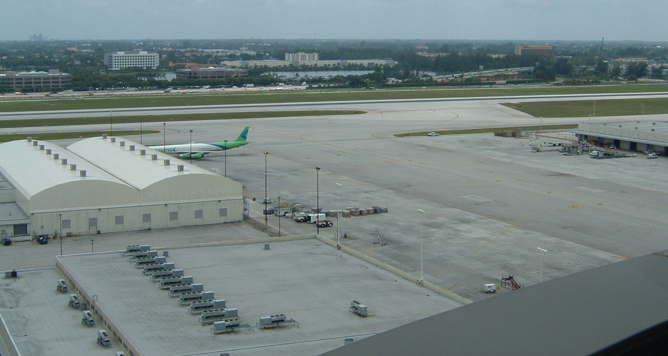
Fig. 1. View of part of Miami airport surface, from ATCT.

An example PDP from the Miami measurements is shown in Figure 2. The plot is received power in dBm versus delay in microseconds. This plot is for an NLOS case, and significant multipath components within a few dB of the main (first-arriving) impulse are evident within 1 microsecond. The root mean square (RMS) delay spread σ_{τ} for this PDP is 1.43 microseconds. To connect this with the modeling, a tapped delay line channel model based upon this PDP would have approximately 15 taps, with the taps spaced at 20 nanosecond intervals. For all PDPs we have also employed a noise thresholding technique, such that the probability of mistaking a noise impulse for an actual multipath echo is 10⁻³ or smaller.
To illustrate the non-stationarity in the airport surface environment, Figure 3 shows a plot of σ_{τ} versus PDP index (time), for mobile measurements in Miami. The approximately 100 PDPs taken for this figure show σ_{τ} values ranging from as low as 200 nanoseconds to as large as 2 microseconds as the mobile van moved from NLOS to LOS and back to NLOS conditions.
Figure 4 shows explicitly the time variation of the PDPs, also for Miami, in NLOS conditions. The rightward axis is delay in microseconds, and the leftward axis is time in seconds. Over the course of a few seconds, channel fading can be observed for all the significant received impulses. Fades of several dB are present on the main tap, and subsequent taps incur fades of 10-20 dB.

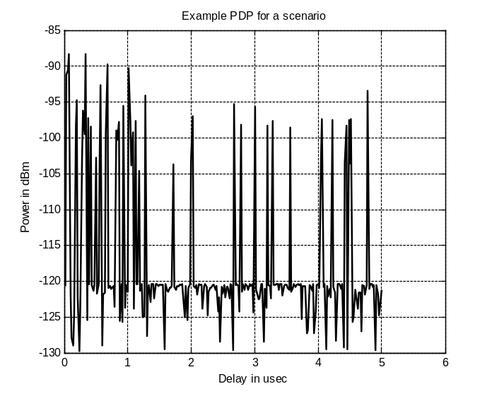
Fig. 2. Example PDP (received power vs. delay) for NLOS region in Miami.
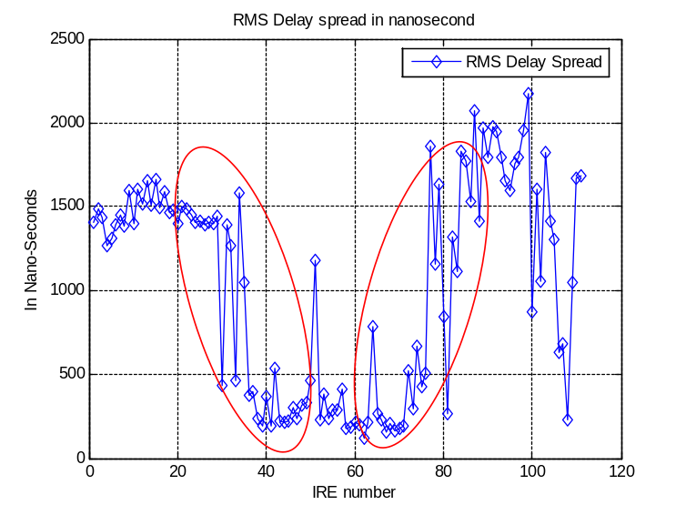
Fig. 3. Example RMS delay spread vs. time, Miami, showing transitions (circled) from NLOS to LOS to NLOS conditions.

Table 1 provides some example statistics for Miami. Similar results were collected for Cleveland, and the small airports, and will also be collected from future measurements.
In addition to time and delay domain characterization, by Fourier transforming PDPs we can obtain frequency domain information. Figure 5 shows an example frequency correlation estimate (FCE) from Cleveland. The FCE can be thought of as the spaced frequency correlation function of the channel, whose width is approximately the channel coherence bandwidth. For the example in Figure 5, which is for a NLOS case, the correlation is approximately 0.3 at 1.5 MHz away from the mid-band frequency. This means that for frequency separations greater than 3 MHz, the channel affects the frequency components in an approximately uncorrelated manner.
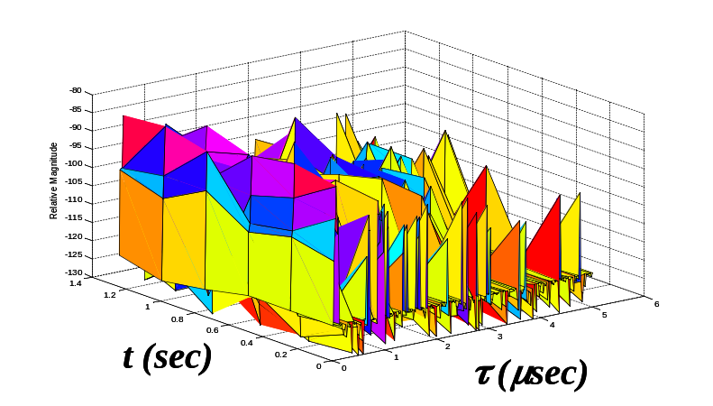

Fig. 4. Example PDPs vs. time, Miami, NLOS case.

Table 1. RMS delay spread statistics for Miami, two regions.
σ_{τ} Statistic | NLOS-S  (nsec) | NLOS  (nsec)
Max | 1000 | 2394
Min | 32.8 | 1001
Mean | 380 | 1382

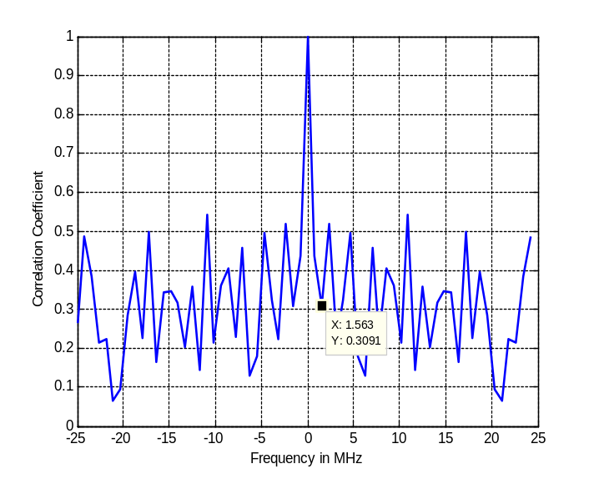
Fig. 5. Example FCE, Cleveland, NLOS case.

Some example modeling results obtained from these measurement are now described. First, Figure 6 shows the probability of occurrence of a given tap in the tapped delay line model, versus the tap index. This is an outcome of the non-stationarity of the channel—some of the multipath echoes (taps) exist, or “persist,” for only some fraction of time as the mobile receiver moves through the environment. For our 50 MHz measurement bandwidth, the tap spacing is 20 nanoseconds. This figure pertains to Miami, for both NLOS-S and NLOS regions. Closely related to this figure is Figure 7, which shows the average relative tap power or energy vs. tap index, for the same regions as in Figure 6. For both these figures, a threshold of 20 dB below the main tap was employed.
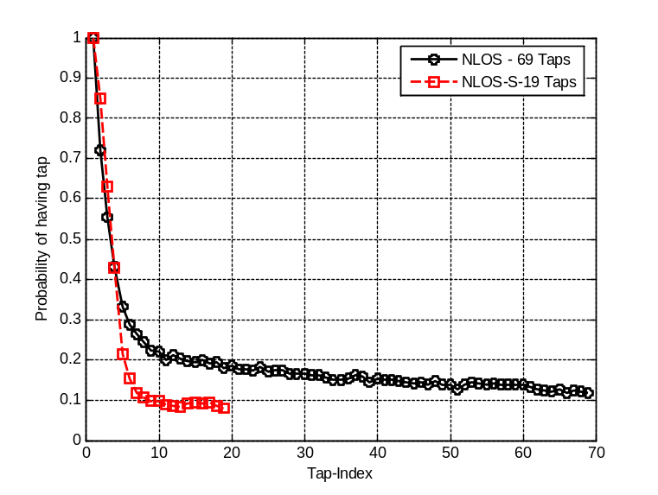
Fig. 6. Probability of tap occurrence vs. tap index, Miami, NLOS and NLOS-S cases.

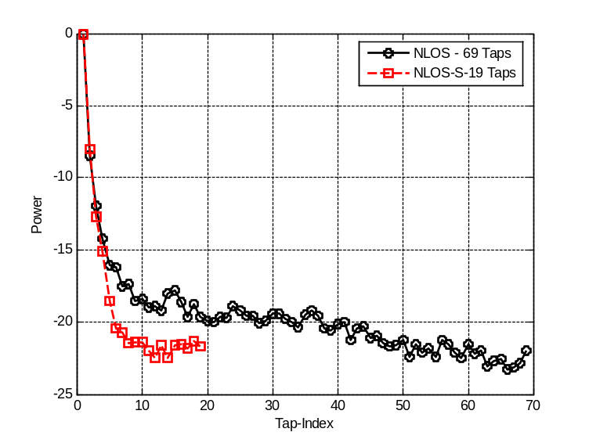
Fig. 7. Relative tap power vs. tap index, Miami, NLOS and NLOS-S cases

By collecting statistics for each tap amplitude versus time, we can estimate appropriate fading tap amplitude models. These models are random processes, often with the well-known Rician or Rayleigh statistics. Example amplitude histograms and fits for the NLOS-S case in Miami are shown in Figure 8 for the first two (of 5) channel taps. The first tap is well modeled as Rician, with a K-factor of nearly 6 dB, whereas the second tap is worse than Rayleigh, modeled via the Nakagami process, with parameter m~0.75. We have also found that the Weibull and lognormal distributions are often applicable for obtaining good fits.

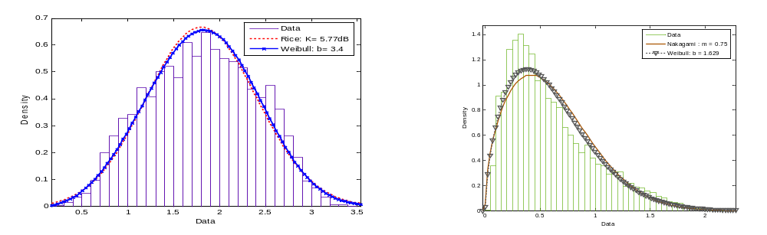
Fig. 8. Example tap amplitude statistics for Miami NLOS-S case; main (specular) tap (left) is Rician, second tap (right) is worse than Rayleigh.

For the point to point measurements, we show here only one figure, that of RMS delay spread versus azimuth angle, for Miami, at two locations. Figure 9 illustrates the range of delay spreads seen in this type of environment.

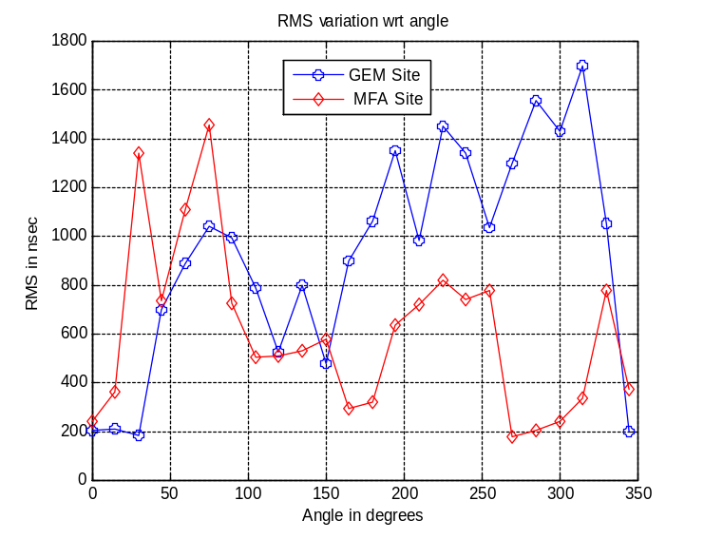
Fig. 9. RMS delay spread vs. azimuth angle for Miami, two sites.

Conclusion

The channel models to be developed will be tapped delay line, statistical models. In addition to these models will be propagation path loss models. Most commonly in both analysis and simulations, the effects of path loss and channel fading can be treated separately. The tapped delay line structures are the most typical form of dispersive, fading channel model employed [6]. An illustration of such a model is shown in Figure 10. In this figure, the k^{th} input symbol is x_{k}, the k^{th} output symbol is y_{k}. The τ’s denote delays, and the h’s are the randomly time-varying channel tap weights. Our measurements provide us with estimates of the number of taps (L), the delays (τ’s), and the random tap weights (h’s). For each airport region and type of airport, we are developing models for the average energies of the tap weights, the random process models that best describe their (amplitude and phase) time variation and persistence, and the inter-tap correlations.
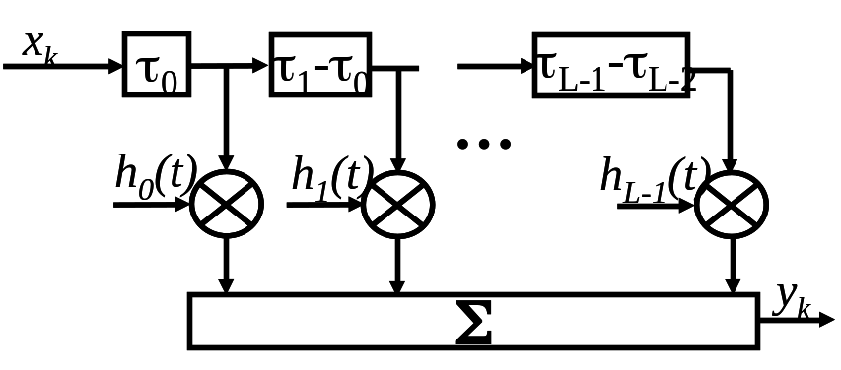
Fig. 10. Canonical tapped delay-line model of time varying channel.

These channel models can be used by any researchers or engineers who evaluate the performance of waveforms or systems on this channel. Thus, the models provide a common framework for comparison of different systems. Different candidate systems can be compared over models that are realistic, yielding more realistic estimates of system performance than if only analytical models were used.
Knowledge of channel statistics can be used in system design in many specific ways. Here we provide just a few examples of how the channel model can be used.
1. For multicarrier OFDM systems (such as the IEEE 802.11/16), a guard time or “cyclic prefix” is employed to specifically avoid intersymbol interference caused by multipath. The length of this guard time should be as long as (or longer than) the channel impulse response, and this length is directly quantified by the channel delay spread we measure.
2. When the channel taps are highly correlated (which we have found in many cases), the amount of attainable time diversity, or multipath diversity, is greatly reduced over that which is available with uncorrelated taps. Thus, simpler combining or equalization schemes should be used, as more complex ones offer little benefit other than an often very small gain in received signal energy. This offers design guidance for both narrowband (equalizer) and spread spectrum (RAKE) single carrier schemes.
3. For multicarrier OFDM, direct sequence (MC-DS) spread spectrum systems, or frequency-hopped (FH) spread spectrum systems, the channel coherence bandwidth should be used in design. For FH schemes, the average hop frequency difference should be larger than the coherence bandwidth to attain frequency diversity. In the MC-DS case, depending upon complexity and performance requirements, the coherence bandwidth is used to select both the number of subcarriers and their bandwidths (~chip rates). The coherence bandwidth is also of use in OFDM systems, as it can provide guidance for how the input data bits are distributed across subcarriers, and the data rate of each subcarrier.
4. For specifying link parameters such as transmit power levels, antenna gains, and receiver amplifier quality (e.g., noise figure), the path loss models provide invaluable information.
5. For interference estimation analyses. This band is allocated on a co-primary basis to non-geostationary mobile-satellite-service Earth-to-space feeder uplinks. Therefore, proper interference characterization with respect to empirical data can be performed.

References

[1] D. W. Matolak, “Wireless Channel Characterization: Overview and Application to 5 GHz Band Airport Surface/Terminal Environments,” Ohio University Report for NASA Glenn Research Center, May 2004.

[2] D. W. Matolak, L. Foore, R. Apaza, “Channel Characterization in the 5 GHz Microwave Landing System Extension Band for Future Airport Surface Communications,” Proc. 5th NASA Integrated Communications, Navigation and Surveillance (ICNS) Conf. & Workshop, Fairfax, VA, 2-5 May 2005.

[3] I. Sen, D. W. Matolak, W. Xiong, N. T. Yaskoff,” 5 GHz Wireless Channel Characterization for Airport Surface Areas,” Proc. 15th Virginia Tech Symp. on Wireless Pers. Comm., Blacksburg, VA, June 8-10, 2005.

[4] R. D. Apaza, D. W. Matolak, “Wireless Communications for Airport Surface: 5 GHz Measurement Procedures and Results,” Proc. 11th Ka and Broadband Communications Conf., Rome, IT, September 25-28, 2005.

[5] D. W. Matolak, N. T. Yaskoff, I. Sen, W. Xiong, “Characterization of the 5 GHz Wireless Channel for Small Airport Surface Areas,” Proc. 24th Digital Avionics Systems Conference, Washington, DC, Oct. 30-Nov. 3, 2005.

[6] J. G. Proakis, Digital Communications, 4th ed., New York: McGraw-Hill, 2000.

