 | International Civil Aviation Organization  Working PAPER
  ACP-WGF14/WP-6
  22/06/2005

AERONAUTICAL COMMUNICATIONS PANEL (ACP)

FOURTEENTH MEETING OF WORKING GROUP F

Malmo, Sweden 22 – 26 August 2005

Agenda Item 5: ITU-R Working Parties 8B and 8D

Comments on and PROPOSED CRITERIA
TO PROTECT GLONASS
FROM INTOLERABLE INTERFERENCE
CAUSED BY AERONAUTICAL MOBILE SATELLITE SERVICE (AMSS)

-Result of discussions by the Spectrum Subgroup (SSG) of the Navigation Systems Panel NSP
by correspondence in June 2005

Prepared by Felix Butsch,
Rapporteur of the Spectrum Subgroup

SUMMARY

The NSP Spectrum Subgroup was asked by the ICAO Secretariat to comment a section for the AMSS SARPs that was proposed by ACP/WG-M at its meeting in Montreal in May 2005 to protect GLONASS from intolerable interference caused by Aeronautical Mobile Satellite Service (AMSS).

This document contains the outcome of the relevant discussion by correspondence between members of SSG as summarized by its Rapporteur. SSG does not deem the earlier proposed emission limit for AMSS as adequate and therefore proposes a new emission limit specification derived from the broadband interference threshold for GLONASS as was stipulated by Annex 10.

- Introduction
The SSG was asked by the ICAO secretariat to comment section for the AMSS SARPs that was proposed by ACP/WG-M at its meeting in Montreal in May 2005 to protect the GLONASS system from intolerable interference caused by AMSS.
- Discussion
RD 1 proposed the following section for the AMSS SARPs to protect GLONASS from intolerable interference caused by AMSS:
12.3.2.3.2 Recommendation. — The average output spectral density of the composite of harmonics, discrete spurious and noise emissions created by the AES when transmitting at its maximum total output power should not be greater than -115 dBW/MHz in radio-navigation satellite service band 1 559 - 1 605 MHz, when measured at the input to the AES antenna over a period of 20 milliseconds.
Note 1.— This recommendation assumes an isolation between the input to the AMS(R)S antenna subsystem and the output of the satellite navigation antenna subsystem of 40 dB and assumes an additional margin of 6 dB relative to the satellite navigation receiver susceptibility requirements established for by the GNSS Panel .
Note 2.— Additional protection of radio-navigation satellite services in the band 1 605 - 1 609.36 MHz from the composite of harmonics, discrete spurious, noise and intermodulation products may be necessary for AES installations made prior to January 1, 2005.]

The interference thresholds for GLONASS receiver used on Satcom euipped aircraft and operaiting in steady state navigation (tracking) mode can be read from Figure B-18 of Annex 10, vol. 1. They are as follows:
-140 dBW for noise-like interference with bandwidth 1 MHz;
-149 dBW for CW interference.

In flight GNSS receiver from time to time switch from tracking to acquisition mode to reacquire lost satellite signal (as a result of aircraft maneuver) or to acquire a new satellite. It is a normal way of receiver operation. For acquisition mode the interference threshold is 6 dB less than that for tracking mode and is the same as for terminal area and enroute navigation, i.e. -146 dBW/MHz for broadband noise-like interference and - 155 dBW for CW interference (see upper curve at Figure B-18). Because of the need to protect acquisition mode and tracking into account that most pilots will also use GLONASS receivers for en-route navigation, the latter, more stringent values have to be applied.

If we assume an isolation of 40 dB between the antenna port of the AMSS transmitter and the antenna port of the GLONASS receiver, we arrive at an emission limit for AMSS of (-146 + 40 = -106) dBW/MHz for broadband noise-like interference and (-155+40 = -115) dBW for CW interference. If we include 6 dB safety margin, we arrive at emission limmits of –112 dBW/MHz for noise-like interference and – 121 dBW for CW interference.

To derive an adequate emission limit for a wider range of bandwidth values, the lower curve of the GLONASS broadband interference threshold (curve for acquisition mode, terminal area and en-route navigation from Figure B-18 of Volume I of Annex 10) should be shifted by (40 - 6 = 34) dB upwards (+40 dB isolation, -6 dB safety margin). Calculated values are presented in Table 1.

Table 1. Interference threshold for AES
Interference Bandwidth | Interference Threshold
0 Hz < Bw_{i} ≤ 1 kHz | -121 dBW
1 kHz < Bw_{i} ≤ 10 kHz | Linearly increasing from -121 to -115 dBW
10 kHz < Bw_{i} ≤ 0.5 MHz | -115 dBW
0.5 Mhz < Bw_{i} ≤ 10 MHz | Linearly increasing from -115 to -102 dBW
10 MHz < Bw_{i} | -102 dBW

For comparison: Table B-85 “Interference threshold for GLONASS receivers” and Figure B-18 “Interference threshold versus bandwidth for GLONASS” of Volume I of Annex 10 (RD 2).

The value of -115 dBW/MHz proposed in the draft AMSS SARPs (paragraph 12.3.2.3.2 Recommmendation) is sufficient to protect GLONASS receiver from noise-like interference. However, an emission limit of at least -121 dBW needs to be imposed on AMSS and included into AMSS SARPs to protect GLONASS receiver from harmonics and discrete spurious emissions.
Assuming AES antenna gain is equal to +12 dBic (paragraph 2.2.3.2.1 of RTCA DO-210C [RD 4]) and IERP equal to 34.8 dBW (AMSS SARPs paragraph 4.2.3.5.1.1 bis) we arrive to maximum AES harmonics and spurious emission level at the AES antenna port is equal to:
34.8 dBW −117 dBc − 12 dBic = −94.2 dBW.
AES harmonics and spurious emission level at the GLONASS antenna port is 34 dB lower and equal to (−94.2 dBW − 34 dB) = − 128.2 dBW. This value exeeds GLONASS CW interference threshold which is equal to − 155 dBW.
Therefore allowable AES emissions level in frequency band 1605 – 1610 MHz sould not exeed (−117 dBc − (− 155 dBW − 128.2 dBW)) = − 143.2 dBW ≈ − 143 dBW.

To provide adequate protection for GLONASS receivers equipped with narrow correlators (most common type of aviation receivers today), allowable AMSS emissions in the band 1605-1610 MHz and below shall not exceed the GLONASS mask (Table B-83 and Fig.B-18 of GNSS SARPs).

The upper protected frequency of the GNSS band should be at least 1609.4 MHz because Table B-83 of GNSS SARPs is based on the final version of GLONASS L1 frequency plan. It should be noted that this upper frequency bound is also compliant with PNDR ITU-R M.[1477_NEW] and GLONASS-related comments provided in Attachment F to NSP WG1 Meeting Report (Bangkok, May 2005).

Figure 1 presents main portion of the CW intrference mask applied for GLONASS recever operated in acquisition mode and intended to use on Satcom equipped aircraft (solid (black) line). The initial curve was taken from GNSS SARPs Figure B-16 and then converted with account of isolation between AES and GLONASS antennas (40 dB), safety margin (6 dB) and maximum AES EIRP (≈35 dB). The dotted (red) line presents proposed thresolds for AES harmonics and discrete spurious emissions.
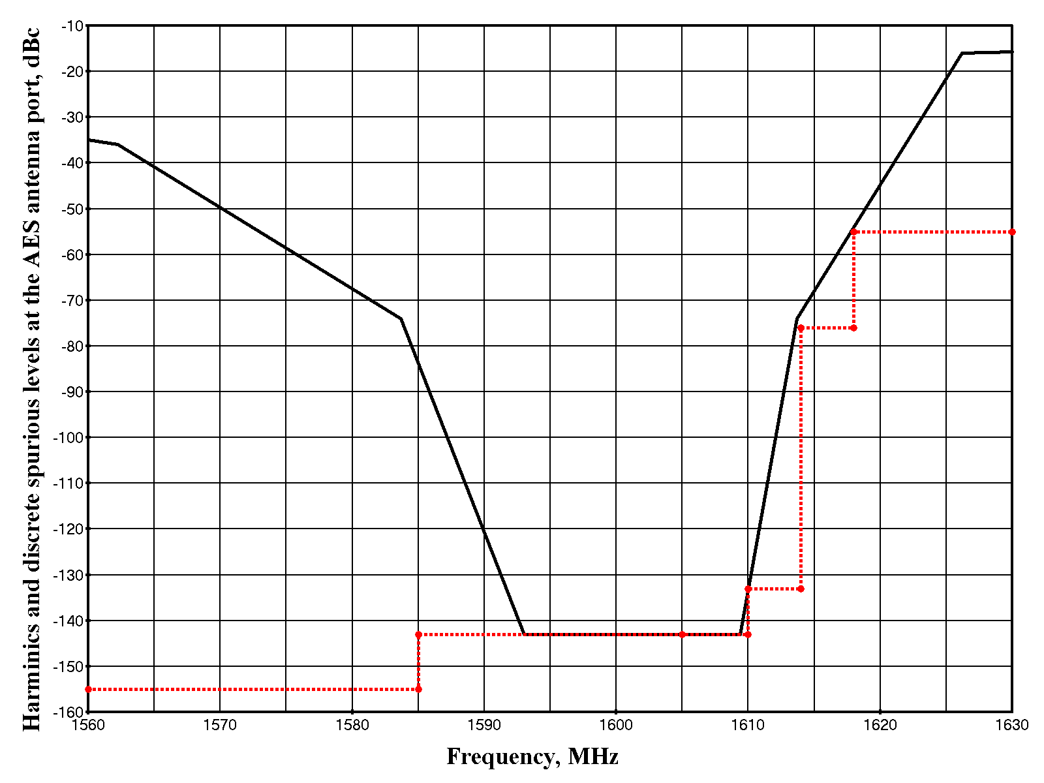
Figure 1. Harmonics and discrete spurious interference threshold versus frequency for GLONASS receiver (solid black line) and proposed AES emission levels (dotted red line)

After analysis and discussion of the issue by correspondence, the SSG concluded that instead of modification of the draft AMSS SARPs paragraph 12.3.2.3.2 two different requirements for AMSS emissions should be established: one for the aircraft equipped with GLONASS receiver (or combined GPS/GLONASS receiver) and another for aircraft equipped with basic GNSS receiver (namely GPS receiver). The proposed new Table 4-3 of the AMSS SARPs (Annex 10, Vol. III, Part 1, Chapter 4, page 74) is presented below. Also it is necessary to delete current paragraph 4.2.3.5.8.1 Recommendation (Annex 10, Vol. III, Part 1, Chapter 4, page 11). Note 2 of draft paragraph 12.3.2.3.2 could be included in paragraph 4.2.3.5.8. Paragraphs 2.5.3 and 2.5.3.2 of AMSS guidance material should be amended as appropriate.

Table 2: Proposed new Table 4-3: Maximum harmonic, discrete spurious and noise density levels
Frequency (MHz) | EIRP (density) for AES collocated with  Basic GNSS receiver  (GPS receiver) | EIRP (density) for AES collocated with GLONASS receiver  (combined GPS/GLONASS receiver)
below 1 525 | -135 dBc/4 kHz | -135 dBc/4 kHz
1 525 to 1 559 | -203 dBc/ 4kHz | -203 dBc/ 4kHz
1 559 to 1 585 | -155 dBc/MHz | -155 dBc/MHz
1 585 to 1 605 | -143 dBc/MHz | -143 dBc/MHz
1 605 to 1 610 | -117 dBc/MHz | -143 dBc/MHz
1 610 to 1 614 | -95 dBc/MHz | -133 dBc/MHz
1 614 to 1 618 | -55 dBc/4 kHz | -76 dBc/4/kHz
1 614 1 618 to 1 660 | -55 dBc/4 kHz | -55 dBc/4kHz
1 660 to 1 670 | -55 dBW/20 kHz¹ | -55 dBW/20 kHz¹
1 670 to 1 735 | -55 dBc/4 kHz | -55 dBc/4 kHz
1 735 to 12 000 | -105 dBc/4 kHz | -105 dBc/4 kHz
12 000 to 18 000 | -70 dBc/4 kHz | -70 dBc/4 kHz
1. Within the transmit band, excluding the frequency band within ±35 kHz of the carrier.

- Conclusion
The group is invited to:
- consider proposed approach to ensure compliance between GNSS SARPs and AMSS SARPs regarding provision of adequate protection for GLONASS receivers from AMSS interference aboard aircraft and
- to adopt additional AES EIRP density requirements included in amended Table 4-3 of the AMSS SARPs presented in this document and make necessary changes in AMSS guidance material as appropriate.
- Reference documents
RD 1: “Outstanding discussions from ACP/WG-M/9”, Montreal, Canada, 23 to 26 May 2005, ACP/WG-M/10 - WP/xx
RD 2: GNSS SARPS, Section B.3.7 “Resistance to interference” of Appendix B to Vol. I of ICAO Annex 10, Amendment 77, 28/11/2002
RD 3: AMSS SARPs, Vol. III of ICAO Annex 10, Part 1, page 10
RD 4: RTCA/DO-210C, Minimum Operational Performance Standards (MOPS) for
Geosynchronous Orbit Aeronautical Mobile Satellite Services (AMSS) Avionics

Appendix I: Sections taken from GNSS SARPs
(Appendix B to Vol. I of ICAO Annex 10, (RD 2))

3.7 Resistance to interference

3.7.2.2 GLONASS RECEIVERS

3.7.2.2.1 GLONASS receivers used for the precision approach phase of flight or used on aircraft with on-board satellite communications shall meet the performance objectives with CW interfering signals present with a power level at the antenna port equal to the interference thresholds specified in Table B-83 and shown in Figure B-16 and with a desired signal level of –165.5 dBW at the antenna port.

3.7.2.2.2 GLONASS receivers used for non-precision approach shall meet the performance objectives with interference thresholds 3 dB less than specified in Table B-83. For terminal area and en-route steady-state navigation operations and for initial acquisition of the GLONASS signals prior to steady-state navigation, the interference thresholds shall be 6 dB less than those specified in Table B-83.

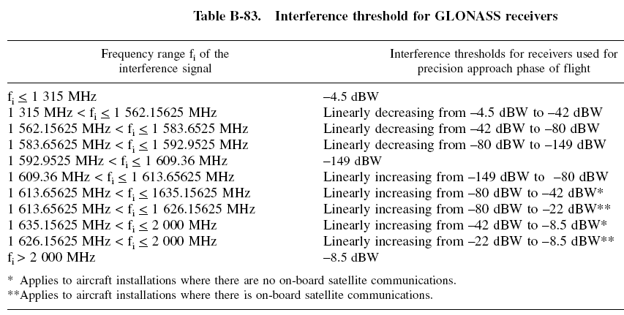
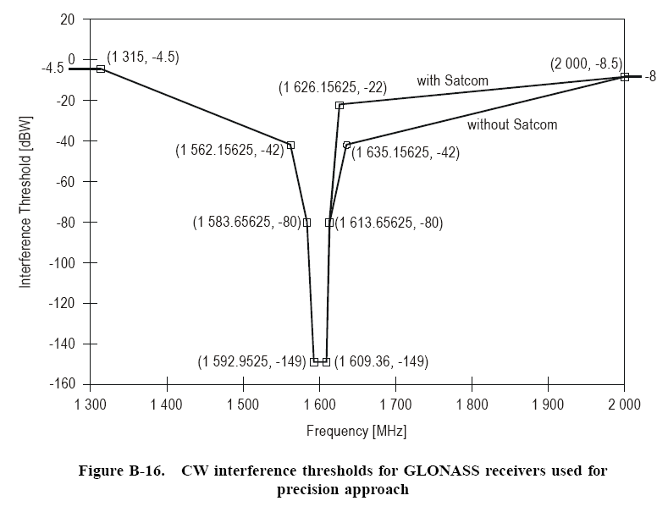

3.7.3 Band limited noise- like interference
3.7.3.2 GLONASS receivers

3.7.3.2.1 After steady state navigation has been established, GLONASS receivers used for the precision approach phase of flight or used on aircraft with on-board satellite communications shall meet the performance objectives with noise like interfering signals present in the frequency range of f_{k}± Bw_{i}/2 and with power levels at the antenna port equal to the interference thresholds specified in Table B-85 with the desired signal level of –165.5 dBW at the antenna port.
Note. -f_{k} ist the centre frequency of a GLONASS channel with f_{k} = 1602 MHz + k × 0.6525 MHz and k = -7 to +13 as defined in Table B-16 and Bw_{i} is the equivalent noise bandwidth of the interference signal..

3.7.3.2.1 GLONASS receivers used for non precision approach shall meet their performance objectives with interference thresholds for band limited noise-like signals 3 dB less than specified in Table B-85. For terminal area and en route steady-state navigation operations and for initial acquisition of the GLONASS signals prior to steady-state navigation, the interference thresholds for band limited noise-like signals shall be 6 dB less than those specified in Table B-85.

Table B-85. Interference threshold for band-limited noise like interference to GLONASS receivers used for precision approach
Interference Bandwidth | Interference Threshold
0 Hz < Bw_{i} ≤ 1 kHz | -149 dBW
1 kHz < Bw_{i} ≤ 10 kHz | Linearly increasing from -149 to -143 dBW
10 kHz < Bw_{i} ≤ 0.5 MHz | -143 dBW
0.5 MHz < Bw_{i} ≤ 10 MHz | Linearly increasing from -143 to -130 dBW
10 MHz < Bw_{i} | -130 dBW
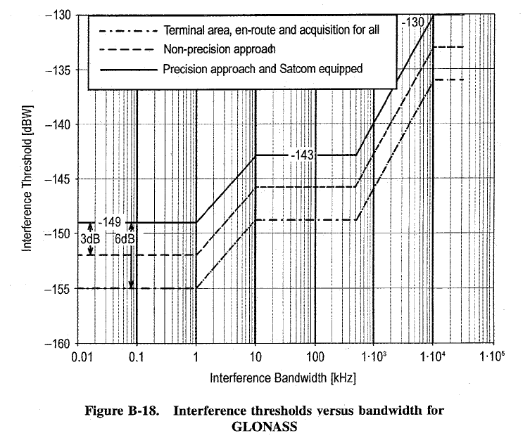
Appendix II: Sections taken from AMSS SARPs

(Annex 10, Vol.III, Part 1, page 10, RD 3)
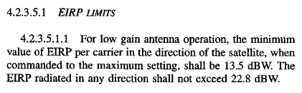
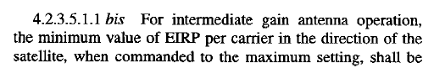
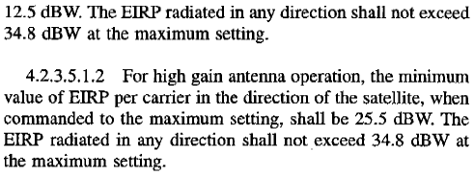

Annex 10, Vol.III, Part 1, page 11
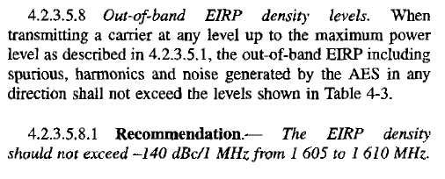
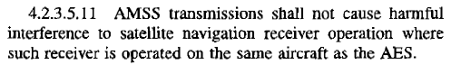
Annex 10, Vol.III, Part 1, page 74 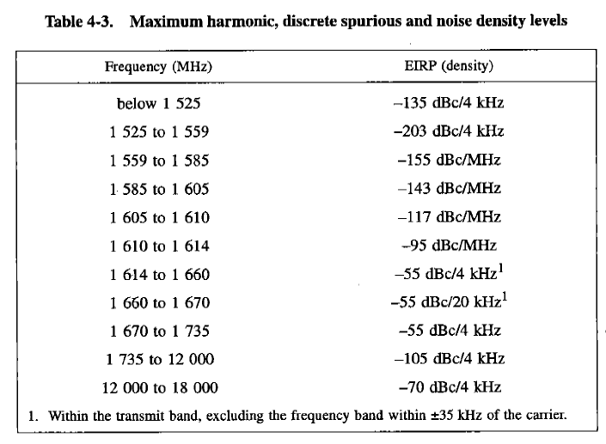

Annex 10, Vol.III, Attachment A to Part 1, Guidance Material for Aeronautical Satellite Service, page 360
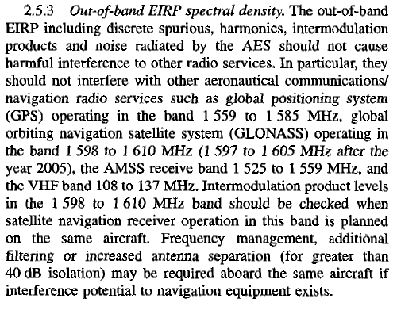

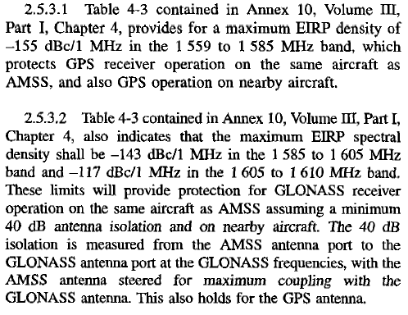

-- THE END --

