

International Civil Aviation Organization

Regional Preparatory Group (RPG) Meeting for World Radiocommunication Conference 2007 (WRC-2007), ACP Working Group B and F and NSP SSG Meetings.

Bangkok, Thailand, 21-25 February 2005.

RPG/ACP/NSP WP-31

.

Agenda item 4: Interference from ultra wideband systems

Elements of CEPT draft report 64
(Presented by the Secretary)

ANNEX 2-10: Radio Navigation Satellite Service (RNSS)

1 Introduction
Radionavigation satellite systems (RNSS) are particular systems to which very careful consideration is afforded in the development of appropriate protection criteria to preclude interference from UWB-based unlicensed services.
Two overriding issues encountered in developing UWB protection requirements applicable to RNSS receivers were:
1) The low signal levels available to terrestrial-based RNSS receivers,
2) Uncertainties associated with potential mobile UWB-to-mobile RNSS interference interactions.
As a result of the RNSS signals, the signal power at the surface of the earth is very low. In addition, RNSS receivers, particularly those for use in mobile applications, employ small antenna sub-systems with characteristics inferior to the relatively large directional antennas typically used to receive satellite downlink signals.
Since UWB technology is proposed to be developed, interference interactions involving mobile applications of both UWB and RNSS technologies must be considered.
This paper summarizes the link budget analyses and those special circumstances considered in the development of UWB-specific criteria to ensure protection to existing and future RNSS receivers.
Regarding RNSS receivers, several recommendations ITU-R-M have already been suggested as the basis to be used in the studies, but do not cover the RNSS systems evolutions, neither Galileo system current design and characteristics, nor foreseen GPS modernization program (new signals and characteristics).
There is a clear need for reviewing several ITU recommendations dealing with RNSS systems. The information provided in these recommendations will be used for compatibility studies between RNSS and other services and systems.
These Recommendations are the following ones:
– ITU-R M.1088 “Considerations for sharing with systems of other services operating in the bands allocated to the radionavigation-satellite service” dated 1994
– ITU-R M.1317 “Considerations for sharing between systems of other services operating in bands allocated to the radionavigation-satellite and aeronautical radionavigation services and the Global Navigation Satellite System (GLONASS-M)” dated 1997
– ITU-R M.1477 “Technical and performance characteristics of current and planned radionavigation-satellite service (space-to-Earth) and aeronautical radionavigation service receivers to be considered in interference studies in the band 1 559-1 610 MHz” dated 2000
– ITU-R M.1479 “Technical characteristics and performance requirements of current and planned radionavigation-satellite service (space-to-space) receivers to be considered in interference studies in the frequency bands 1 215-1 260 MHz and 1 559-1 610 MHz” dated 2000
– ITU-R M.1318 “Interference protection evaluation model for the radio navigation-satellite service in the 1 559-1 610 MHz band”
Looking at UWB interferences, depending on UWB type of applications (imaging, vehicular radars, communications, positioning) the impact on RNSS receiver might be different.
The interference effects upon RNSS receivers are classified as noise-like, pulse-like and CW like transmissions and the RNSS receivers are not equally tolerant to each effect. GPS measurement campaigns done during the FCC rulemaking process actually shown these different effects. The same classification is forecast for the Galileo receivers.
In addition, the class and the degree of UWB RFI impact is observed to depend on UWB signal characteristics such as pulse repetition frequency (PRF), waveform and modulation in relation to the RNSS receiver bandwidth, not only RF bandwidth (1 MHz magnitude) but also after correlation process bandwidth (less than 1 kHz magnitude).
Depending on the periodicity of the PRF, on the type of modulation (Pulse Amplitude Modulation, Pulse Position Modulation, On-Off Keying, Bi-phase modulation …), the UWB spectrum shape will be different. In some cases, it will produce many spectral lines where in other cases it could be considered as a continuous spectrum. The impact on the RNSS receiver will be very different.
For RNSS concerns, the two main types of UWB applications, namely those requiring high data rate and the others requiring low data rate, would then have mainly two different expected effects:
– a noise floor increasing effect from the communications devices, degrading continuously RNSS receivers performance if they are sharing the RNSS band,
– an intermittent CW like interference (loss of lock on satellites signal during tracking or interminable acquisition time), from the others devices (positioning, or radar/imaging). These latter effects need to be carefully studied.
Noise like effect
For the Noise like effect, there are materials available. Classical link budget analysis is sufficient to propose new regulations based on the Galileo system which seems to offer sufficient protection to RNSS receivers.
It is to be noted that the current study is based on the effect of noise like effect single entry primeraly.
CW like effect
RNSS receivers can also experience CW-like interference effects due to power concentrations in UWB frequency spectrums when periodical signals are used. Indeed, some UWB devices, foreseen for localisation or Radar applications, could transmit periodic signal. The impact of the CW like effect is under study and has to be assessed taking into account the PRF, its periodicity but also the UWB modulation.
When the receiver loses lock onto the RNSS signal, it experiences a large phase and code error, resulting in the loss of the entire power of the navigation signal component, creating a positioning discontinuity. In the worst conditions, it can give Hazardous Misleading Information on the user positioning. In these conditions, the power measured in the lock detection block is thus only due to the interferer, and is similar to the power that would have the useful signal without interferer. Consequently, the lock detection block is not able to detect that the receiver is tracking the interferer, rather than the useful signal.
This effect explains why commercial low cost receivers are very susceptible to CW interference: the loss of lock is not detected and the ranging measurement of jammed satellites is used to compute the position (in absence of RAIM algorithm or when only a few satellites are available). Indeed, receivers generally experience a large positioning error, as reported in lot of interference tests. As an example, it has been reported positioning errors in the order of several kilometres before the loss of lock detection.
For those reasons, CW interference can compromise the positioning integrity or the navigation service continuity, and must be considered as a critical event.
The signal loss of lock, the interferer tracking, and the large position error are rather known effects of CW interferers on RNSS receivers. However, all the parameters which enter in conjunction to cause one effect or the other have not, up to now, been clearly characterized.
It is needed to characterize the UWB (PRF, periodicity, modulation …) and to assess the impact of each type of UWB on RNSS receivers.
In addition, depending on the GNSS application, the acquisition and tracking thresholds may be different and may lead to different protection levels.
Looking at the CW like effect interference on RNSS receivers, FCC defined an additional limit in any 1 kHz bandwidth. This limit is 10 dB below the one proposed in 1 MHz: such a limit has been retained in the FCC rules, without any rationale.

The purpose of the first appendix is to explain the technical background of this specific issue, keeping in mind that it is an on-going issue that needs further practical (simulations between UWB signals and GALILEO waveforms) and theoretical developments.

2 Galileo

2.1 Introduction
The effect of ultra-wideband (UWB) systems versus the radio navigation satellite service (RNSS) Galileo system, is studied in this chapter. The objective is to theoretically determine the degradations caused by UWB systems to Galileo receivers.

2.2 Galileo Services

2.2.1 Safety of life Applications
Galileo will provide a specific service for critical applications such as Aviation application from en route navigation operations up to Precision approaches
This service will be used also for critical applications such as Rail and Maritime applications

2.2.2 Commercial Applications
Galileo will provide a commercial service facilitating the development of professional applications and offering enhanced performance compared with the basic service, particularly in terms of service guarantee.

2.2.3 Mass market Applications
Galileo will provide an open, free basic service, mainly involving applications for the general public and services of general interest. This service is comparable to that provided by civil GPS SPS, which is free of cost for these applications, but with improved quality and reliability.
This service will be used for Emergency service E112, which will be developed in the future in Europe.

2.2.4 Governmental Applications
Galileo will provide a public regulated service (PRS), encrypted and resistant to jamming and interference, reserved principally for the public authorities responsible for civil protection, national security and law enforcement which demand a high level of continuity. It will enable secured applications to be developed in the European Union, and could prove in particular to be an important tool in improving the instruments used by the European Union.

2.3 Galileo Signal Characteristics:
The following provides a brief description of the future Galileo signals available for use in Galileo applications The following sections provide a brief description of the future Galileo signals available for use in Galileo applications. These characteristics have been used for the studies.
Some ITU recommendations such as ITU-R M 1477, includes the technical characteristics and protection criteria for Galileo: this specific ITU-R Recommendation is the basis of the following compatibility analysis.

2.3.1 Galileo L1
The Galileo L1 signal is centered on a frequency of 1 575.42 MHz with a bandwidth of 32 MHz (1 575.42 ± 16 MHz). As such, the L1 signal is completely contained within the 1 559-1 610 MHz frequency band allocated on a co-primary basis to the Aeronautical Radio Navigation Service (ARNS) and the Radio Navigation Satellite Service (RNSS).
The Galileo L1 signal provides an Open Service (OS), a Public Regulated Service (PRS), which both include a navigation message. Moreover an integrity message for Safety Application Service (SAS) is included in the OS signal. The L1 carrier is modulated with a BOC(1,1) code to provide the OS. The L1 carrier is also modulated with a BOCcos(15;2,5) code, to provide the PRS.
The minimum signal level at the surface of the earth is specified as -127 dBm.

2.3.2 Galileo E6
The Galileo E6 signal is transmitted on a center frequency of 1 278 MHz with a bandwidth of 40 MHz (1 278,75 ± 20 MHz).
The Galileo E6 signal provides a Commercial Service (CS), a Public Regulated Service (PRS), which both include a navigation message. The L1 carrier is modulated with a BPSK(5) code to provide the CS. The E6 carrier is also modulated with a BOC(10,5) code, to provide the PRS. The minimum signal level at the surface of the earth is specified as -125 dBm.

2.3.3 Galileo E5
The Galileo E5a signal is centered on a frequency of 1 176 MHz with a registered bandwidth of 24 MHz (1 176,45 ± 12 MHz). The E5a signal is contained within the 1 164-1 215 MHz frequency band allocated on a co-primary basis to the Aeronautical Radio Navigation Service (ARNS) and the Radio Navigation Satellite Service (RNSS).
The Galileo E5a signal provides an Open Service (OS), a Safety Application Service (SAS), which includes a navigation message. The E5a carrier is modulated with a BPSK(10) code to provide both OS and SAS.
The Galileo E5b signal is centered on a frequency of 1 207 MHz with a registered bandwidth of 24 MHz (1207,14 ± 12 MHz). The E5b signal is completely contained within the 1 164-1 300 MHz frequency band allocated to the Radio Navigation Satellite Service (RNSS).
The Galileo E5b signal provides a Safety Application Service (SAS), which includes a navigation message and an integrity message. The E5ab carrier is modulated with a BPSK(10) code to provide SAS.
The minimum signal level at the surface of the earth is specified as -125 dBm.

Carrier channel | Frequency (MHz) | transmitted bandwith (MHz) |  | Ranging code rate (Mchip/s) | symbol rates (symbs/s) |  | multiplex type | signal type |  | Primary code length  (chips) | Secondary code length  (chips)
E5a-I | 1 176,45 |  | 24,00 | 10,23 | 50 | QPSK |  | BPSK(10) | data | 10230 | 20
E5a-Q |  |  |  | 10,23 | N/A |  |  | BPSK(10) | pilot | 10230 | 100
E5b-I | 1 207,14 |  | 24,00 | 10,23 | 250 | QPSK |  | BPSK(10) | data | 10230 | 4
E5b-Q |  |  |  | 10,23 | N/A |  |  | BPSK(10) | pilot | 10230 | 100
E6-A | 1 278,75 |  | 40,00 | 5,115 | tbc | CASM |  | BOC (10,5) | data | classified | classified
E6-B |  |  |  | 5,115 | 1000 |  |  | BPSK(5) | data | 5115 | -
E6-C |  |  |  | 5,115 | N/A |  |  | BPSK(5) | pilot | 10230 | 50
L1-A | 1 575,42 |  | 32,74 | 7,672 | tbc | CASM |  | BOC (15;2,5) | data | classified | classified
L1-B |  |  |  | 1,023 | 250 |  |  | BOC(1,1) | data | 4092 | -
L1-C |  |  |  | 1,023 | N/A |  |  | BOC(1,1) | pilot | 4092 | 25

Galileo Signal Characteristics

2.4 Operational scenarios
Operational scenarios need to be developed for each of the Galileo services.
Link budget analyses have to be performed under the assumptions implied by each of the proposed Galileo application-based operational scenarios. Where applicable, these link budget analyses are performed utilizing technical characteristics and practices consistent with those specified in several ITU-R Recommendation and in particular in Recommendation ITU-R M.1477.

2.5 UWB transmitter-to-Galileo receiver link budget analyses
The following analyses have been made taking into account a single UWB emitter. Protection levels have been defined in 1 MHz band to take into account the noise like effect.

The protection in 1 KHz band to take into account the CW like effect and the impact of spectral lines has to be clearly assessed: a technical background about this issue is presented in the Appendix.

2.5.1 Galileo antenna gain in direction of UWB source
The antenna subsystem utilized in almost all mobile applications is often implemented as a silicone patch. The antenna typically produces an upper hemispherical pattern, with the gain maximized in the direction of the satellites in space. Table 2 defines the model used to determine the Galileo antenna gain in the direction of an assumed UWB source.

Emissions from UWB transmitters were assumed incident in the side lobe (-10 to 10 degrees) region of the Galileo receive antenna in this scenario. Therefore, the assumed antenna gain is 0 dBi.

For safety of life aeronautical applications, as a worst case analysis, the antenna gain in the direction of the interferer is 5 dBi.

- Table 1
Galileo Receive Antenna Model
OFF-AXIS ANGLE  (degrees relative to horizon) | Galileo ANTENNA GAIN  (dBi)
10 to 90 | 3
-10 to 10 | 0
-90 to –10 | -4.5

2.5.2 Propagation path loss
Free space path loss is determined from an unobstructed propagation path:
L_{p} = 20 Log₁₀ (F) + 20 Log₁₀ (D) – 27.55
where;

L_{p =} free space propagation path loss, in dB;
F = frequency, in MHz;
D = propagation path length, in meters.

Depending on the UWB type of applications, we have taken the following assumptions for the separation distance between an UWB device and a RNSS receiver:
TABLE 2
Separation distance scenario
TABLE 2
Separation distance scenario
UWB application | Separation distance (m)
Ground penetrating/wall imaging radar | 6
Through wall imaging | 6
Surveillance systems | 25
Medical imaging | 6
Indoor communications | 2
Handheld Communications | 1

In the case of safety of life applications, the path loss is usually calculated with a separation distance of 30m. This distance can be found in the corresponding literature, for example the RTCA paper quoted in §2.5.1.

2.6 Single UWB transmitter-to-Galileo receiver link budget analyses: noise-like effect only
The following analyses have been made taking into account a single UWB emitter. Protection levels have been defined in 1 MHz band to take into account the noise like effect.

2.6.1 Galileo protection requirement
The requirement for GALILEO protection is -141.3 dBW in any 1 MHz, therefore -111.3 dBm/MHz (Acquisition mode: receiver aggregate wideband interference threshold).

Concerning aeronautical applications named “Safety of life”, two additional parameters are specifically mentioned.
⇨An aeronautical safety margin of 5.6 dB is included as explained in ITU-R M.1477.
⇨A I/N of -20 dB. This value actually represents an error performance degradation of 1 % for all sources of interference. It has to be noted that this degradation has been proposed by ITU-R WP8D in September 2004 and sent to the next ITU-R TG1/8. However, it is proposed to use such an I/N value to the “Safety of life” applications only.

For non “Safety of life” applications, there is no aeronautical safety margin, and the I/N equals -6 dB.

2.6.2 Safety of life application
TABLE 3
Protection requirement for safety of life service (separation distance of 30 m)
GALILEO frequency band |  | E5a |  | E5b | L1 | Unit
GALILEO protection requirement |  | -111,3 |  | -111,3 | -111,3 | dBm/MHz
Aeronautical margin |  |  | -5,6 | -5,6 | -5,6 | dB
I/N |  |  | -20 | -20 | -20 | dB
GALILEO antenna gain |  |  | 5 | 5 | 5 | dBi
Propagation path loss |  |  | 63,40 | 63,63 | 65,94 | dB
GALILEO protection requirement |  | -78,50 |  | -78,27 | -78,96 | dBm/MHz

2.6.3 Non safety of life applications
TABLE 4
Protection requirement for a protection distance of 25 m
GALILEO frequency band |  | E5a |  | E5b | L1 | Unit
GALILEO protection requirement |  | -111,3 |  | -111,3 | -111,3 | dBm/MHz
I/N |  |  | -6 | -6 | -6 | dB
GALILEO antenna gain |  |  | 0 | 0 | 0 | dBi
Propagation path loss |  |  | 61,82 | 62,04 | 64,36 | dB
GALILEO protection requirement |  | -55,48 |  | -55,26 | -52,94 | dBm/MHz

TABLE 5
Protection requirement for a protection distance of 6 m

GALILEO frequency band |  | E5a |  | E5b | L1 | Unit
GALILEO protection requirement |  | -111,3 |  | -111,3 | -111,3 | dBm/MHz
Aeronautical margin |  |  | 0 | 0 | 0 | dB
I/N |  |  | -6 | -6 | -6 | dB
GALILEO antenna gain |  |  | 0 | 0 | 0 | dBi
Propagation path loss |  |  | 49,42 | 49,65 | 51,96 | dB
GALILEO protection requirement |  | -67,88 |  | -67,65 | -65,34 | dBm/MHz

TABLE 6
Protection requirement for a protection distance of 2 m

GALILEO frequency band |  | E5a |  | E5b | L1 | Unit
GALILEO protection requirement |  | -111,3 |  | -111,3 | -111,3 | dBm/MHz
Aeronautical margin |  |  | 0 | 0 | 0 | dB
I/N |  |  | -6 | -6 | -6 | dB
GALILEO antenna gain |  |  | 0 | 0 | 0 | dBi
Propagation path loss |  |  | 39,88 | 40,11 | 42,42 | dB
GALILEO protection requirement |  | -77,42 |  | -77,19 | -74,88 | dBm/MHz

TABLE 7
Protection requirement for a protection distance of 1 m
GALILEO frequency band |  | E5a |  | E5b | L1 | Unit
GALILEO protection requirement |  | -111,3 |  | -111,3 | -111,3 | dBm/MHz
Aeronautical margin |  |  | 0 | 0 | 0 | dB
I/N |  |  | -6 | -6 | -6 | dB
GALILEO antenna gain |  |  | 0 | 0 | 0 | dBi
Propagation path loss |  |  | 33,86 | 34,09 | 36,40 | dB
GALILEO protection requirement |  | -83,44 |  | -83,21 | -80,90 | dBm/MHz

3. GLONASS

3.1. Introduction

The GLONASS system is designed to solve radionavigation problems of different users. Radiation from mission oriented spaceborne transmitters is used as a source of signals employed for navigation solutions. On that basis the GLONASS receivers have been, from the outset, developed to operate using signals of low power spectral density (PSD). Therefore radiation produced by UWB systems of different applications could cause harmful interference to operation of the GLONASS receivers.
The below section discusses effects of UWB signals on the GLONASS receivers under different interference scenarios to define operation features of UWB systems to ensure compatibility .
3.2. Employment of the GLONASS System
The GLONASS Global Navigation Satellite System is designed to provide position-fixing, motion velocity and time measurements for maritime, aeronautical, terrestrial and other users.
The GLONASS system ensures operation of super important applications such as aeronautical navigation of aircraft on-route flight, approach and landing.

3.3. Characteristics of Signals in the GLONASS System

BPSK signals of four types are used in the GLONASS system. They are 16M4G7X, 4M01G7X, 1M02G7X, 10M2G7X. Table 1 shows characteristics of those signals.
PSD of any such signal is defined by the following analytical expression:
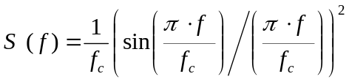, (1)
where f – frequency at which PSD is estimated;
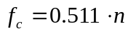 – signal chipping rate, MHz..

TABLE 1
GLONASS signal characteristics
Signal | Frequency (MHz) | Bandwidth (MHz) | Code rate (Mchip/s | Symbol rare (sym/s) | Signal type
16M4G7X | 1 201.5 | 16.4 | 8.191 | 200 | BPSK(16) | data
4M10G7X | 1 201.5 | 4.1 | 2.047 | 200 | BPSK(8) | data
10M2G7X | 1246.00 | 10.2 | 5.11 | 50 | BPSK(10) | data
1M02G7X | 1246.00 | 1.02 | 0.511 | 50 | BPSK(1) | data
10M2G7X | 1602.00 | 10.2 | 5.11 | 50 | BPSK(10) | data
1M02G7X | 1602.00 | 1.02 | 0.511 | 50 | BPSK(1) | data

3.4. Scenarios of Interference Effect on the GLONASS RNSS Receivers

The level of UWB signals effect on operation of GLONASS navigation receivers is defined by EIRP of an UWB device and a distance between that UWB device and a navigation receiver antenna. Minimum distance between an UWB system and a navigation receiver depends on application mission of appropriate assets.
This document considers navigation receivers of two main types:
- an airborne GLONASS navigation receiver designed for aircraft navigation (an airborne receiver);
- a low-cost commercial general-purpose GLONASS receiver.

Two scenarios of interference effect are analyzed in relation to operation of the airborne navigation receivers. They are:
- a single UWB device causing interference to a navigation receiver at the stage of aircraft landing (Fig. 1).
- multiple UWB devices causing interference to a navigation receiver installed in an aircraft approaching a runway (Fig. 2).
Aircraft altitude is 30 m (subject to RTCA No. 297-96/SC 159-710 (formerly DO-194) ).

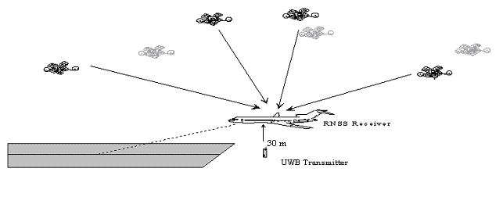
Fig. 1. Scenario 1

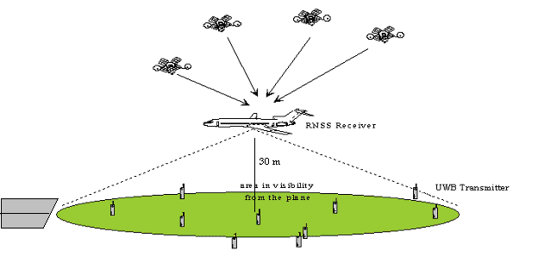
Fig. 2. Scenario 2

Scenarios of interference to a commercial (low-cost) GLONASS receiver from a single UWB device were analyzed for different applications of that device. Seven different scenarios were defined. Table 2 shows protection distances for different scenarios in relation to different types of UWB device applications.
TABLE 2
Protection distances for different applications of UWB devices
Types of UWB devices | Protection distance, m
Ground penetrating radar (GPR) systems | 6
Through-wall imaging radars | 6
Safety-of-life systems | 25
Medical applications | 6
Indoor communications | 2
Hand-held computer intercommunications | 1
Automotive radars | 2

Moreover two additional cases of interference effect on navigation receivers were analyzed for each of the above scenarios:
- The first case assumes that interference of constant spectral density affects a navigation receiver front end in the receiver operational frequency band (wide-band interference).
- The first case assumes that a navigation receiver is affected by a periodic pulse sequence therefore a single or several spectral lines of a transmitted signal affect the receiver front end (a narrow-band interference).

3.5. Protection Criteria for the GLONASS System

Irrespective to different forms of operational signals, selection of protection criteria should be based on a nature of interference affecting a RNSS receiver front end and it should not be a function of operational signal waveform or pulse repetition rate. Therefore it is assumed that limits on power spectral density may be used as protection criteria.
In case of a wide-band interference at a receiver front end its effect on the receiver is identical to increasing its noise temperature by several degrees. Therefore it may be assumed that limitation of receiver noise temperature could be used as a protection criterion.
The ITU has not yet defined a criterion of a fixed increase in noise temperature. That criterion has been proposed by analogy with protection of other services such as the fixed service. This section assumes that occurrence of interference at an airborne GLONASS receiver input would be equivalent to increasing its noise temperature by 1%. Since a nominal value of GLONASS receiver noise temperature is 400°К then interference could increase it by at least 4°К. Such an increase in the noise temperature is identical to interference of -162 dBW/MHz at a GLONAAS navigation receiver front end.
To protect an airborne GLONASS receiver from a narrow-band interference its power spectral density shall not exceed –177 dBW/kHz.
Criteria of a commercial GLONASS receiver protection from wide-band interference are defined by the requirement that interference-to-noise ratio (I/N) at that receiver front end shall not exceed –6 dB to be identical to increasing the receiver noise temperature by 25%. Such increasing in noise temperature is similar to interference of –148 dBW/kHz in power spectral density at the receiver front end.
Power spectral density at the front end of a commercial GLONASS receiver shall not exceed –163 dBW/kHz to provide its protection from narrow-band interference.

3.6. Analysis of UWB Systems Interfering with a GLONASS Receiver

3.6.1. GLONASS Receiver Antenna Gain
Estimation of airborne receiver protection requirements assumed its antenna gain of 5 dB.
Antenna gain of 3 dB was assumed for a commercial receiver in the direction to an interfering source.

3.6.2. UWB Signal Propagation Loss
Estimation of UWB signal loss for propagation between a transmitting source and a GLONASS receiver antenna used a free-space propagation model. Based on that model, losses in a radio link could be calculated using the following equation:
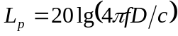, (2)
where 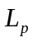 - propagation loss, dB;
f – central frequency of the GLONASS receiver operational band (размерность?);
D – protection distance from a navigation receiver to an UWB device, m;
с=3⋅10⁸ m/s, - velocity of light.

3.6.3. Estimation of Acceptable EIRP from an UWB Device for a Single UWB Signal
Objective of this analysis consists in defining an acceptable equivalent isotropic radiated power (EIRP) for signals transmitted from different UWB devices. The level of that EIRP is a function of GLONASS receiver antenna gain, signal frequency, distance from an UWB device to a GLONASS receiver and an acceptable power spectral density at the navigation receiver front end. For a specified set of the above parameters the EIRP from an UWB device is defined by the following equation:
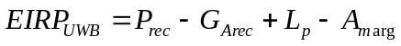, (3)
where  - EIRP of an UWB device, dBm/MHz;
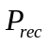 - maximum acceptable power spectral density of interference at a receiver front end, dBm/MHz;
 - navigation receiver antenna gain in the direction of an UWB device, dB;
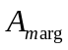 – an additional margin of 5.6 dB for a safety-of-life system (referred to an airborne receiver).

3.6.4. Estimation of Acceptable EIRP of an UWB Device for Aggregate UWB Interference.
Such analysis is required to define an acceptable EIRP from an UWB device for aggregate interference to a navigation receiver from multiple UWB devices operating at the Earth surface. The case is common for an airborne GLONASS receiver. It is obvious that EIRP of UWB devices would be a function of aircraft altitude, density of UWB devices located along the aircraft route and operation intensity of those devices. Estimation of power produced by multiple UWB devices at a navigation receiver front end used a model developed by NTIA such as:
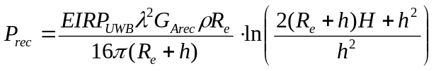, (4)
where - maximum acceptable power spectral density of interference at a receiver front end, dBm/MHz;
- EIRP of an UWB device, dBm/MHz;
λ=с/f – operational wave length, m;
- navigation receiver antenna gain in the direction of an UWB device, dB;
ρ - averaged location density for UWB devices, devices/m²;
h – navigation receiver antenna altitude above the earth surface, m;
R – distance from navigation receiver antenna projection on the earth surface to a radio horizon, m;
R_{e} – effective Earth radius, m;
H=R_{e}(1-cos(R/R_{e}).

Transformation of the above expression yields the following equation for a maximum acceptable EIRP from a single UWB device. It would be as:
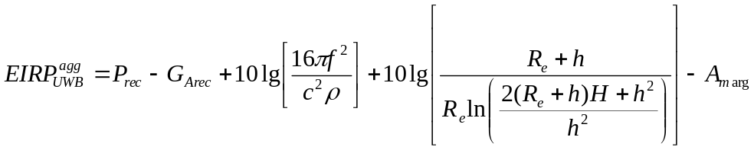, (5)
where - EIRP of an UWB device, dBm/MHz;
- maximum acceptable power spectral density of interference at a receiver front end, dBm/MHz;
- navigation receiver antenna gain in the direction of an UWB device, dB;
h – navigation receiver antenna altitude above the earth surface, m;
ρ - averaged location density for UWB devices, devices/m²;
R – distance from navigation receiver antenna projection on the earth surface to a radio horizon, m;
R_{e} – effective Earth radius, m;
H=R_{e}(1-cos(R/R_{e}).
- an additional margin of 5.6 dB for a safety-of-life system (referred to an airborne receiver).

3.7. Protection Requirements of Airborne GLONASS Receivers

3.7.1. Requirements of Protecting the Airborne GLONASS Receivers from Wide-Band Interference Caused by a Single UWB Device
Wide-band interference power spectral density at an airborne GLONASS navigation receiver shall not exceed –132 dBm/MHz. Using the equation for a maximum acceptable EIRP from an UWB device (see section 3.6.3) could provide obtaining the maximum acceptable EIRP emitted from a single UWB device. The EIRP values are shown in Table 3.
TABLE 3

Maximum EIRP from an UWB device with a single-source wide-band interference
Signal | Frequency,  (MHz) | Transmission band, (MHz) | EIRP_{UWB},  dBm/MHz
16M4G7X | 1 201.5 | 16.4 | -79.0
4M10G7X | 1 201.5 | 4.1 | -79.0
10M2G7X | 1246.00 | 10.2 | -78.7
1M02G7X | 1246.00 | 1.02 | -78.7
10M2G7X | 1602.00 | 10.2 | -76.5
1M02G7X | 1602.00 | 1.02 | -76.5
Protection distance 30 m |  |  | I/N=-20 dB
Antenna gain 5 dB

The estimation assumed that navigation receiver antenna gain would be G_{A rec} = 5 dB in the direction of an interference source with an additional margin for system safety being = -5.6 dB. Analysis of the estimation results shown in Table 4 suggests that a limit of –79 dBm/MHz imposed on an UWB device EIRP may be used as protection requirements of airborne GLONASS navigation receivers
Data shown in Table 3 were obtained for an airborne navigation receiver for which interference caused by an UWB device shall meet the criterion of I/N = -20 dB.

3.7.2. Requirements of Protecting the Airborne GLONASS Receivers from Wide-Band Interference Caused by Multiple UWB Devices
The protection criteria for a discussed case is a function of UWB devices density (ρ) per a square meter. Therefore two different scenarios of aggregate interference effect on a GLONASS navigation receiver from multiple UWB devices were analyzed including one for a suburban case of ρ=10⁻³ device/m² and the other one for an urban case of ρ=10⁻² device/m². It was assumed that the aircraft undertakes maneuvers in a standard atmosphere with a refraction factor of 4/3. Definition of protection requirements of such navigation receivers used the NTIA model which assumes the effective Earth radius of 8493 km and a distance to radio horizon of 22.1 km. Table 4 shows the estimation results for a navigation receiver affected with wide-band interference.

TABLE 4
Maximum EIRP of an UWB device under aggregate wide-band interference
Signal | Frequency,  (MHz) | Transmission band, (MHz) | ρ=10⁻³ dev./м² | ρ=10⁻² dev./м²
Signal | Frequency,  (MHz) | Transmission band, (MHz) | EIRP_{UWB} dBm/MHz | EIRP_{UWB} dBm/MHz
16M4G7X | 1 201.5 | 16.4 | -64.7 | -84.7
4M10G7X | 1 201.5 | 4.1 | -64.7 | -84.7
10M2G7X | 1246.00 | 10.2 | -64.4 | -84.4
1M02G7X | 1246.00 | 1.02 | -64.4 | -84.4
10M2G7X | 1602.00 | 10.2 | -64.2 | -82.2
1M02G7X | 1602.00 | 1.02 | -64.2 | -82.2
Protection distance 30 m |  |  | I/N=-20 dB
Antenna gain 5 dB

Analysis of the obtained results shows that the model proposed by NTIA for aggregate interference caused by multiple UWB devices would provide for realistic estimates of maximum EIRP from UWB devices but only for an urban case, because the EIRP limits for UWB devices obtained under a suburban scenario are less stringent compared with those obtained for a single-source interference.
Analysis of results presented in Table 4 shows that maximum EIRP of –84.7 dBm/MHz from an UWB device may be used as a protection requirement of an airborne GLONASS navigation receiver for an urban case. The said value is 5.7 dB less than the requirements for a single-source interference.

3.7.3. Requirements of Protecting the GLONASS Receivers from Narrow-Band Interference Caused by a Single UWB Device
Power spectral density of narrow-band interference at the front end of an airborne GLONASS navigation receiver shall not exceed –147 dBm/kHz. Using the equation for a maximum acceptable EIRP from an UWB device (see section 3.6.3) could provide obtaining the maximum acceptable EIRP emitted from a single UWB device. The EIRP values are shown in Table 5.
The estimation assumed that airborne navigation receiver antenna gain would be 5 dB with an additional margin for system safety being -5.6 dB. Analysis of the estimation results shown in Table 5 suggests that a maximum acceptable EIRP of –94 dBm/kHz may be used as protection requirements of airborne GLONASS navigation receivers.

TABLE 5
Maximum EIRP from an UWB device for a single-source CW-like interference
Signal | Frequency,  (MHz) | Transmission band, (MHz) | EIRP_{UWB},  dBm/kHz
16M4G7X | 1 201.5 | 16.4 | -94.0
4M10G7X | 1 201.5 | 4.1 | -94.0
10M2G7X | 1246.00 | 10.2 | -93.7
1M02G7X | 1246.00 | 1.02 | -93.7
10M2G7X | 1602.00 | 10.2 | -91.5
1M02G7X | 1602.00 | 1.02 | -91.5
Protection distance 30 m |  |  | I/N=-20 dB
Antenna gain 5 dB
Data shown in Table 5 were obtained for an airborne navigation receiver for which interference caused by an UWB device shall meet the criterion of I/N = -20 dB.

3.7.4. Requirements of Protecting the Airborne GLONASS Receivers from Narrow-Band Interference Caused by Multiple UWB Devices
The estimation was based on the parameters shown in section 3.7.1. Table 6 presents the estimates for interference power spectral density equal to –147 dBm/kHz.

TABLE 6
Maximum EIRP of an UWB device under aggregate CW-like interference
Signal | Frequency,  (MHz) | Transmission band, (MHz) | ρ=10⁻³ dev./м² | ρ=10⁻² dev./м²
Signal | Frequency,  (MHz) | Transmission band, (MHz) | EIRP_{UWB} dBm/kHz | EIRP_{UWB} dBm/kHz
16M4G7X | 1 201.5 | 16.4 | -79.7 | -99.7
4M10G7X | 1 201.5 | 4.1 | -79.7 | -99.7
10M2G7X | 1246.00 | 10.2 | -79.4 | -99.4
1M02G7X | 1246.00 | 1.02 | -79.4 | -99.4
10M2G7X | 1602.00 | 10.2 | -77.2 | -97.2
1M02G7X | 1602.00 | 1.02 | -77.2 | -97.2
Protection distance 30 m |  |  | I/N=-20 dB
Antenna gain 5 dB

Analysis of the results presented in Tables 5 and 6 shows that if location density for UWB devices is equal to 10⁻² dev./m² then the limits on EIRP from an UWB device would be more stringent by 5.7 dB as compared with those for single-source interference.
Maximum EIRP of –99.7 dBm/kHz from an UWB device may be used as protection requirements of an aeronautical navigation receiver installed in an aircraft when it is at stages of take-off or landing.

3.8. Requirements of Protecting the Commercial GLONASS Receivers from Interference Caused by a Single UWB Device

3.8.1. Requirements of Protecting the Commercial GLONASS Receivers from Wide-Band Interference
Interference-to-noise ratio for a commercial GLONAS receiver shall not exceed I/N = -6 dB. Appropriate maximum interference power spectral density would be –118 dBm/MHz. Using the above data for estimating the protection requirements of the commercial GLONASS receivers yields the results shown in Table 7.
TABLE 7
Maximum EIRP of an UWB device
UWB applications | Protection distance, m | Signal | Frequency,  MHz | EIRP_{UWB},  dBm/MHz
Ground penetrating radar systems.  In-wall imaging radars | 6 | 16M4G7X | 1 201.5 | -71.4
Ground penetrating radar systems.  In-wall imaging radars | 6 | 4M10G7X | 1 201.5 | -71.4
Ground penetrating radar systems.  In-wall imaging radars | 6 | 10M2G7X | 1246.00 | -71.1
Ground penetrating radar systems.  In-wall imaging radars | 6 | 1M02G7X | 1246.00 | -71.1
Ground penetrating radar systems.  In-wall imaging radars | 6 | 10M2G7X | 1602.00 | -68.9
Ground penetrating radar systems.  In-wall imaging radars | 6 | 1M02G7X | 1602.00 | -68.9
Safety-of-life systems | 25 | 16M4G7X | 1 201.5 | -59.0
Safety-of-life systems | 25 | 4M10G7X | 1 201.5 | -59.0
Safety-of-life systems | 25 | 10M2G7X | 1246.00 | -58.7
Safety-of-life systems | 25 | 1M02G7X | 1246.00 | -58.7
Safety-of-life systems | 25 | 10M2G7X | 1602.00 | -56.5
Safety-of-life systems | 25 | 1M02G7X | 1602.00 | -56.5
Medical applications | 6 | 16M4G7X | 1 201.5 | -71.4
Medical applications | 6 | 4M10G7X | 1 201.5 | -71.4
Medical applications | 6 | 10M2G7X | 1246.00 | -71.1
Medical applications | 6 | 1M02G7X | 1246.00 | -71.1
Medical applications | 6 | 10M2G7X | 1602.00 | -68.9
Medical applications | 6 | 1M02G7X | 1602.00 | -68.9
Indoor communications | 2 | 16M4G7X | 1 201.5 | -81.0
Indoor communications | 2 | 4M10G7X | 1 201.5 | -81.0
Indoor communications | 2 | 10M2G7X | 1246.00 | -80.7
Indoor communications | 2 | 1M02G7X | 1246.00 | -80.7
Indoor communications | 2 | 10M2G7X | 1602.00 | -78.4
Indoor communications | 2 | 1M02G7X | 1602.00 | -78.4
Communication between hand-held computers | 1 | 16M4G7X | 1 201.5 | -87.0
Communication between hand-held computers | 1 | 4M10G7X | 1 201.5 | -87.0
Communication between hand-held computers | 1 | 10M2G7X | 1246.00 | -86.7
Communication between hand-held computers | 1 | 1M02G7X | 1246.00 | -86.7
Communication between hand-held computers | 1 | 10M2G7X | 1602.00 | -84.5
Communication between hand-held computers | 1 | 1M02G7X | 1602.00 | -84.5
Automotive applications | 2 | 16M4G7X | 1201.5 | -73.0
Automotive applications | 2 | 4M10G7X | 1201.5 | -73.0
Automotive applications | 2 | 10M2G7X | 1246.00 | -72.7
Automotive applications | 2 | 1M02G7X | 1246.00 | -72.7
Automotive applications | 2 | 10M2G7X | 1602.00 | -70.5
Automotive applications | 2 | 1M02G7X | 1602.00 | -70.5
Antenna gain 3 dB |  | I/N = -6 dB
The estimations assumed that commercial navigation receiver antenna gain was 3 dB with no system safety margin (A_{marg} = 0 dB). Analysis of data in Table 7 shows that the UWB device EIRP obtained for protection distance of 1 m and equal to –87.0 dBm/MHz may be used as protection requirements of commercial GLONASS navigation receivers.

3.8.2. Requirements of Protecting the Commercial GLONASS Receivers from Narrow-Band Interference
Interference-to-noise ratio for commercial GLONAS receivers shall not exceed I/N = -6 dB. Corresponding maximum interference power spectral density would be –133 dBm/kHz. Using the above data for estimating the protection requirements of the commercial GLONASS receivers yields the results shown in Table 8.

TABLE 8
Maximum EIRP of an UWB device
UWB applications | Protection distance, m | Signal | Frequency,  MHz | EIRP_{UWB},  dBm/kHz
Ground penetrating radar systems.  In-wall imaging radars | 6 | 16M4G7X | 1 201.5 | -86.4
Ground penetrating radar systems.  In-wall imaging radars | 6 | 4M10G7X | 1 201.5 | -86.4
Ground penetrating radar systems.  In-wall imaging radars | 6 | 10M2G7X | 1246.00 | -86.1
Ground penetrating radar systems.  In-wall imaging radars | 6 | 1M02G7X | 1246.00 | -86.1
Ground penetrating radar systems.  In-wall imaging radars | 6 | 10M2G7X | 1602.00 | -83.9
Ground penetrating radar systems.  In-wall imaging radars | 6 | 1M02G7X | 1602.00 | -83.9
Safety-of-life systems | 25 | 16M4G7X | 1 201.5 | -74.0
Safety-of-life systems | 25 | 4M10G7X | 1 201.5 | -74.0
Safety-of-life systems | 25 | 10M2G7X | 1246.00 | -73.7
Safety-of-life systems | 25 | 1M02G7X | 1246.00 | -73.7
Safety-of-life systems | 25 | 10M2G7X | 1602.00 | -71.5
Safety-of-life systems | 25 | 1M02G7X | 1602.00 | -71.5
Medical applications | 6 | 16M4G7X | 1 201.5 | -86.4
Medical applications | 6 | 4M10G7X | 1 201.5 | -86.4
Medical applications | 6 | 10M2G7X | 1246.00 | -86.1
Medical applications | 6 | 1M02G7X | 1246.00 | -86.1
Medical applications | 6 | 10M2G7X | 1602.00 | -83.9
Medical applications | 6 | 1M02G7X | 1602.00 | -83.9
Indoor communications | 2 | 16M4G7X | 1 201.5 | -95.9
Indoor communications | 2 | 4M10G7X | 1 201.5 | -95.9
Indoor communications | 2 | 10M2G7X | 1246.00 | -95.6
Indoor communications | 2 | 1M02G7X | 1246.00 | -95.6
Indoor communications | 2 | 10M2G7X | 1602.00 | -93.4
Indoor communications | 2 | 1M02G7X | 1602.00 | -93.4
Communication between hand-held computers | 1 | 16M4G7X | 1 201.5 | -102.0
Communication between hand-held computers | 1 | 4M10G7X | 1 201.5 | -102.0
Communication between hand-held computers | 1 | 10M2G7X | 1246.00 | -101.7
Communication between hand-held computers | 1 | 1M02G7X | 1246.00 | -101.7
Communication between hand-held computers | 1 | 10M2G7X | 1602.00 | -99.5
Communication between hand-held computers | 1 | 1M02G7X | 1602.00 | -99.5
Automotive applications | 2 | 16M4G7X | 1 201.5 | -95.9
Automotive applications | 2 | 4M10G7X | 1 201.5 | -95.9
Automotive applications | 2 | 10M2G7X | 1246.00 | -95.6
Automotive applications | 2 | 1M02G7X | 1246.00 | -95.6
Automotive applications | 2 | 10M2G7X | 1602.00 | -93.4
Automotive applications | 2 | 1M02G7X | 1602.00 | -93.4
Antenna gain 3 dB |  | I/N=-6 dB
The estimations assumed that commercial navigation receiver antenna gain was 3 dB with no system safety margin (A_{marg} = 0 dB). Analysis of data in Table 9 shows that the UWB device EIRP obtained for protection distance of 1 m and equal to –102.0 dBm/kHz may be used as protection requirements of commercial GLONASS navigation receivers.

3.10. Conclusions of Chapter 3

Analysis of the obtained results shows that the acceptable EIRP from UWB devices should be of –79 dBm/MHz to provide protection of airborne GLONASS navigation receivers in case of a single-source wide-band interference. The acceptable EIRP from UWB devices should be of
–94 dBm/kHz in case of single-source narrow-band interference.
Employment of the NTIA model to consider aggregate interfering effect of multiple UWB devices distributed over a certain area provides for obtaining realistic results only for an urban scenario of operating the UWB devices. Estimates based on that model for UWB devices operating in suburban areas are significantly less stringent as compared with those for a single-source UWB signal.
Consideration of aggregate effect from interfering devices on GLONASS navigation receivers would result in 5.7 dB increase in requirements for maximum EIRP from UWB devices. In that case an acceptable EIRP from UWB devices would be of –84.7 dBm/MHz to provide protection of airborne GLONASS navigation receivers under aggregate wide-band interference. The acceptable EIRP from UWB devices would be –99.7 dBm/kHz for aggregate narrow-band interference affecting an airborne navigation receiver.
Protection of commercial GLONASS navigation receivers requires that the acceptable EIRP from UWB devices shall not exceed –87.0 dBm/MHz for a single-source wide-band interference and –102.0 dBm/kHz for narrow-band interference.

4 Conclusion
For the protection of the GALILEO stations, safety of life and non-safety of life services have been considered in different scenarios. The worst case limit is obtained for the Galileo non safety of life applications with a maximum e.i.r.p. limit of -83.50 dBm/MHz, assuming a 1 m protection distance.

For safety of life, a maximum e.i.r.p. limit of -79 dBm/MHz is obtained, assuming a 30 m protection distance.

Analysis of the obtained results shows that the acceptable EIRP from UWB devices should be of –79 dBm/MHz to provide protection of airborne GLONASS navigation receivers in case of a single-source wide-band interference. The acceptable EIRP from UWB devices should be of
–94 dBm/kHz in case of single-source narrow-band interference.
Acceptable EIRP from UWB devices would be of –84.7 dBm/MHz to provide protection of airborne GLONASS navigation receivers under aggregate wide-band interference. The acceptable EIRP from UWB devices would be –99.7 dBm/kHz for aggregate narrow-band interference affecting an airborne navigation receiver.

Protection of commercial GLONASS navigation receivers requires that the acceptable EIRP from UWB devices shall not exceed –87.0 dBm/MHz for a single-source wide-band interference and –102.0 dBm/kHz for narrow-band interference.

APPENDIX : THEORETICAL STUDY ABOUT NOISE LIKE AND CW EFFECTS ON GALILEO

This appendix explains the theoretical background about effects of noise like and CW like signals on GALILEO receivers. It is to be noted that this specific issue is still on-going and needs further development.

For UWB radar signals, the pulses are sent regularly in time with rate referred to as PRF, which results in a PSD composed of equally spaced spectral lines. The spacing between two spectral lines is equal to PRF.
Communication signals can have PPM, PAM or combined PPM/PAM formats. For the PPM, the modulation is achieved by shifting (or dithering) the pulse in time according to the symbol value. For the PAM, the symbol value directly modulates pulse amplitude. The pulses can be sent equally spaced in time or can follow a so-called “Time Hopping Codes” which gives a pseudo-random shift around the periodic position.

1. UWB signal modelling
The FCC part 15 document gives a specific limit for the GPS band resulting in two constraints that can be stated as follow:
– C1 (general limits): the power measured within 1 MHz bandwidth should not exceed the limit noted 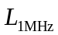,
– C2: the power of the spectral lines should not exceed the limits –10 dB when measured in a filter of bandwidth no less than 1 KHz.
The number of spectral lines present in 1 MHz, 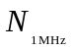, depends on the PRF:

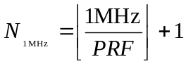,

where 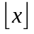 is the integer floor value of x. The power measured within 1 MHz bandwidth is equal to  where  is the power of one spectral line. Thus the two constraints can be written as follow:
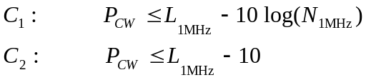

and the maximum transmitted power of one spectral line is given by:

.
The two constraints are equal when 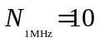 which corresponds to 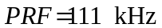. When 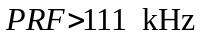 the constraint C2 is active and when 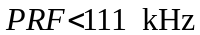 the constraint C1 is active.
The following table gives the figures for CW power limits (constraints C2) versus the application:
Table 8
Limit power for one spectral line in the GPS bands in dBm/MHz
Frequency Band (MHz) | Imaging below  960 MHz | Imaging, Mid-Frequency | Imaging, High frequency | Indoor applications | Hand held, including outdoor | Vehicular radar
1 164-1 240  1 559-1 610 | –75.3 | –63.3 | –75.3 | –85.3 | –85.3 | –85.3

Concerning GALILEO, the above limits need to be carefully assessed.

2. Signal model for Galileo
The GALILEO system consists in four types of channels E5a, E5b L1 and E6.
Each channel carries two types of signal: pilot and data.
The pilot signal spectrum consists of a sequence of lines, which are typical for a given periodic signal. The spacing between the lines depends on the code length multiplied by the chip duration. The spacing is very small, it is equal to 5 or 10 Hz. Hence, the spectrum of pilot channels can be considered as continuous.
The data signal spectrum is continuous due to the pseudo random characteristics of the data.
The power spectral density of base-band signal with QPSK modulation having spreading code rate 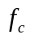 is given by [HOL]:

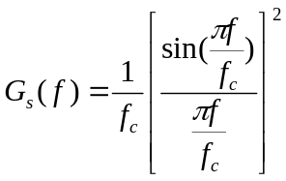 (13)

The normalised power spectral density of base-band signal with BOC modulation having sub-carrier frequency f_{s} and spreading code rate is given by [BET]:

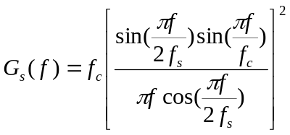 (14)

In the case of a BOC (m,n), 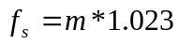 MHz and 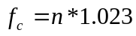 MHz.
In the case of the pilot channels the power spectral densities given by the preceding equations are discreet, with 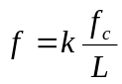, where L is the period of spreading code and k is integer.

2.1. Interference spreading by correlation
In the acquisition and tracking process of a spreading system, it is necessary to take into account that the interference with UWB is spectrally spread when correlated with the local replica of the PN code PN(t) [HOL].

Consider the model of the figure 1 of the spreading process, following an input band pass filter, centred at the intermediate frequency IF. This filter isolated the useful part of the received signal. It has one band for the BPSK channels and 2 bands for the BOC channels.
The interference only input is modelled as:

where 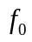 is the IF frequency.

Figure 1: Model for estimating interference spreading
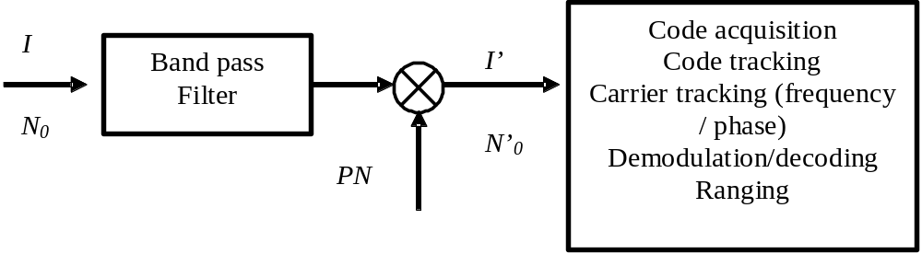
Let 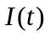 be the interference signal of UWB. The multiplier output interference is expressed as:

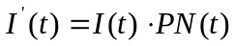

The autocorrelation of the output is given by:

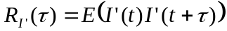
or:

The power spectral density at the frequency f is given by:

Since 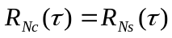, we have:

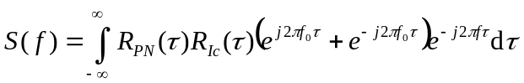

Assuming that the spectral density at f₀ due to the spectra at - f₀ is negligible, we have:

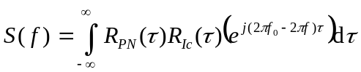

The effect of de-spreading an interference not correlated with the spreading sequence is to flatten the power density: this is a basic hypothesis. Thus, in a first approximation we can assume that the spectral density is flat in the input filter bandwidth. Accordingly:

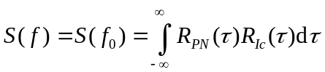

Since the integration of the product of two autocorrelation functions is equal to integration of the product of their respective power spectral densities, we have:

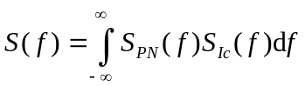 (15)

The autocorrelation of a long PN code modulated in M-PSK is given by equation (13). This is the case of the channels E5A, E5B, E6-B and E6-C. In the case of a BOC modulation, the autocorrelation is given by equation (14). This is the case of the channels E6A and L1.
The interference due to UWB may be noise or CW.

2.1.1. Noise like interference

In this case, the autocorrelation is given by:

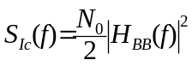

where 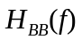is the equivalent baseband of the input filter .We assume that this filter is ideal having bandwidth B. Thus:

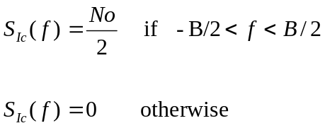 .
Table 9 gives 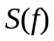 for both characteristics for Galileo channels: BPSK and BOC modulation, respectively 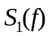 and 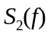.
Table 9
Equations giving for noise like interference
 | M-PSK modulation | BOC (m,n) modulation
Noise like  Interference | 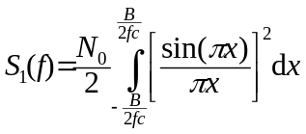 | 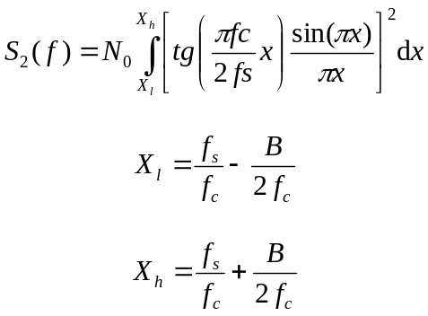

The equations of and 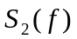 are of the form:

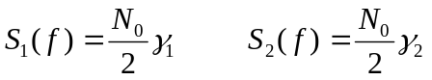

The preceding table shows that the effect on the despreading is to lower the DSP of the noise by a factor 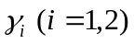. [HOL] gives the gain γ₁ in 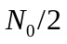 for the equation for several values of 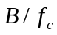 (see Table 10).
Table 10
Gain 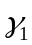 in noise spectral density (from [HOL]) Table 8.1, page 367)
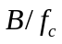 | Gain in in dB
6 | -0.22
4 | -0.27
3 | -0.39
2 | -0.51
1 | -1.02

By solving the equations giving with the help of Mathematica, for 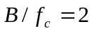 the reduction of gain is 0.44 dB. The difference is probably due to numerical approximations. In Table 11, the reduction γ is given for an ideal input filter, whose bandwidth is 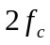 for BPSK channels, and 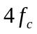 (2 times ) for BOC channels. Figure schematise the transformation of a noise like signal by despreading by a non-coherent sequence.
Table 11
Gain γ of a noise like signal
Carrier-channel | Reduction γ in noise in dB
E5a-I | -0,44
E5a-Q | -0,44
E5b-I | -0,44
E5b-Q | -0,44
E6-A | -1,19
E6-B | -0,44
E6-C | -0,44
L1-A BOC (15;2,5) | -1,19
L1-B | -0,67
L1-C | -0,67
Figure 2: Noise DSP before and after the despreading
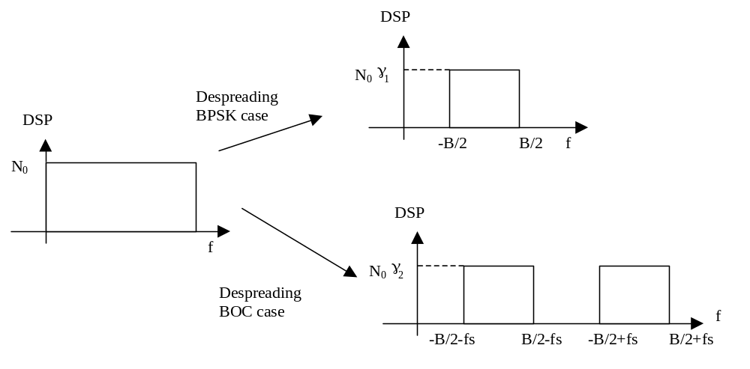

2.1.2. CW like interference

Figure 3 shows the transformation of a CW like signal by despreading by a non-coherent sequence into a spread signal.
Figure 3: Transformation of the CW like interference by despreading
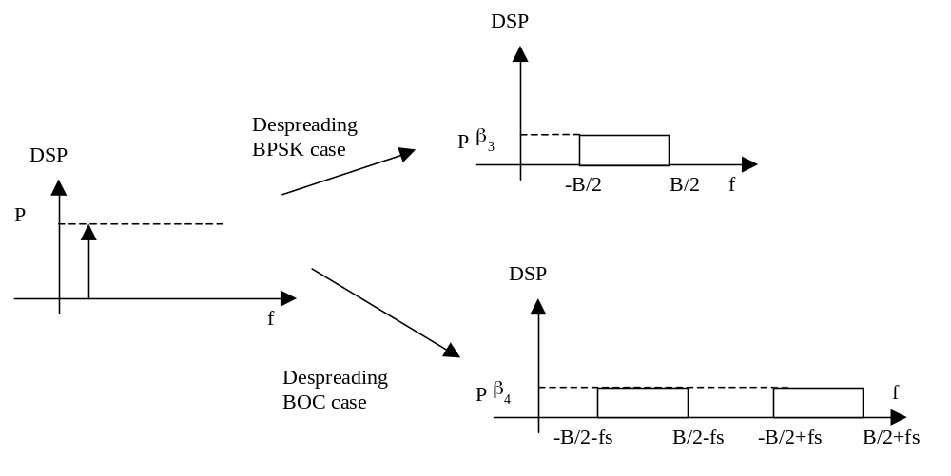

If the interference is a peak at the frequency F of value P: the autocorrelation is:

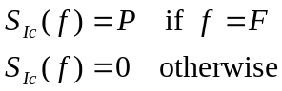.

Table 12 gives for both characteristics for Galileo channels: BPSK and BOC modulation, respectively 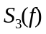 and 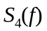.
Table 12
Equations giving for the CW-like case
 | M-PSK modulation | BOC (m,n) modulation
CW-like Interference | 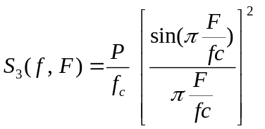 | 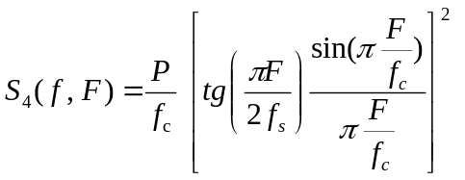

The equation of 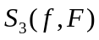 and 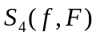 are of the form:

When the interference is the combination of a noise like interference and a CW like interference, 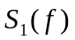 and 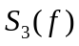 are summed when a PSK modulation is used and and 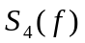 are summed when the considered channel is BOC modulated.
When the interference is composed of a number of lines, greater than one, two cases arise depending upon the PRF value versus the bandwidth of the receive filter B_{p}:
-1) the PRF is greater than 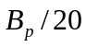. In this case, the time between two impulses is less than the length of the filter impulse response and the spectral lines can be assumed to be non-coherent (or independent). The effect induced by whose lines is thus the summation of the CW-like interference of each component. If the spectral lines have frequencies 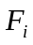 and power 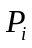, the functions 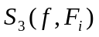 are summed for the channels with PSK modulation and the function 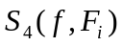 are summed with their relative power , for the frequency being in the band pass B_{p} of the filter. The total PSD of the despreaded interference can be written as follows:

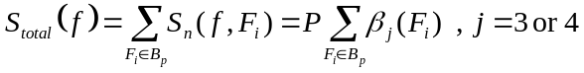 (16)

In first approximation, equation (16) can be evaluated as:

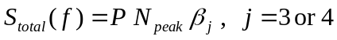

where β_{j} is the average PSD and where N_{peak} is the number of peaks inside the band pass B_{p} of the filter. We have:

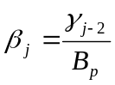 (17)
Table 13
Value of mean spectrum
Carrier channel | Signal type | β in dB
E5a | QPSK(10) | -73,55
E5b | QPSK(10) | -70,54
E6-A | BOC (10,5) | -74,30
E6-B E6-C | QPSK(5) | -70,54
L1-A | BOC(15;2,5) | -74,30

The following table gives for the different Galileo bands, the minimum value for which the interference can be considered as CW-like:
Table 14
Lowest PRF for which the UWB is considered as CW-like versus the
Galileo bandwidth receivers
Carrier channel | Bandwidth (MHz) |  | PRF (MHz)
E5a-I |  | 20,46 |  | 1,023
E5a-Q |  | 20,46 |  | 1,023
E5b-I |  | 20,46 |  | 1,023
E5b-Q |  | 20,46 |  | 1,023
E6-A |  | 20,46 |  | 1,023
E6-B |  | 10,23 |  | 0,5115
E6-C |  | 10,23 |  | 0,5115
L1-A (BOC(15;2,5)) |  | 20,46 |  | 1,023

-2) the PRF is less than 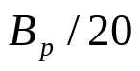. In this case, the time between two impulses is greater than the length of the filter impulse response. Then the coherence between the spectral lines cannot be longer ignored and the output of the receive filter, in time, is impulse-like. In other words, the receive filter “sees” the UWB impulses. Thus, the receiver sees a peak of energy for a short time (a few times the pulse length) and then almost no interference. The impact of this impulse-like noise on the Galileo receiver is not easy to assess since it is really dependent on the receiver implementation and will not be studied in this report. However, this kind of interference is usually mitigated using a blanking process and is less harmful than the CW-like case (see NTIA comments in [FCC]).
In the case of a pilot channel, two cases are possible: either the interference falls between two lines of the spectrum of the useful signal, or it falls onto a line. In the first case, there is no interference whereas in the second case the interference effect is equivalent to the continuous case (PSD channel). Thus the worst case is the same in the case of a pilot channel and in the case of data channel when only one line is present in the Galileo receiver. When more than one line is present in the Galileo receiver, it is unlikely that all the spectral lines frequency would match the frequencies of the pilot channel, and we can assess that the pilot channel is more robust than the data channel.

When the interference is composed of a number of lines, greater than one, two cases arise depending upon the PRF value versus the bandwidth of the receive filter B_{p}:
1) the PRF is greater than . In this case, the time between two impulses is less than the length of the filter impulse response and the spectral lines can be assumed to be non-coherent (or independent). The effect induced by whose lines is thus the summation of the CW-like interference of each component.

The following table gives for the different Galileo bands, the minimum value for which the interference can be considered as CW-like:
Table 15
Lowest PRF for which the UWB is considered as CW-like versus the
Galileo bandwidth receivers
Carrier channel | Bandwidth (MHz) |  | PRF (MHz)
E5a-I |  | 20,46 |  | 1,023
E5a-Q |  | 20,46 |  | 1,023
E5b-I |  | 20,46 |  | 1,023
E5b-Q |  | 20,46 |  | 1,023
E6-A |  | 20,46 |  | 1,023
E6-B |  | 10,23 |  | 0,5115
E6-C |  | 10,23 |  | 0,5115
L1-A : BOC(15;2,5) |  | 20,46 |  | 1,023

2) the PRF is less than . In this case, the time between two impulses is greater than the length of the filter impulse response. Then the coherence between the spectral lines cannot be longer ignored and the output of the receive filter, in time, is impulse-like. In other words, the receive filter “sees” the UWB impulses. Thus, the receiver sees a peak of energy for a short time (a few times the pulse length) and then almost no interference. The impact of this impulse-like noise on the Galileo receiver is not easy to assess since it is really dependent on the receiver implementation and will not be studied in this report. However, this kind of interference is usually mitigated using a blanking process and is less harmful than the CW-like case.
In the case of a pilot channel, two cases are possible: either the interference falls between two lines of the spectrum of the useful signal, or it falls onto a line. In the first case, there is no interference whereas in the second case the interference effect is equivalent to the continuous case (PSD channel). Thus the worst case is the same in the case of a pilot channel and in the case of data channel when only one line is present in the Galileo receiver. When more than one line is present in the Galileo receiver, it is unlikely that all the spectral lines frequency would match the frequencies of the pilot channel, and we can assess that the pilot channel is more robust than the data channel. But more investigation has to be done to verify this assertion.

2.2. Maximum interference levels for GALILEO

In this section, we investigate the maximum UWB interference possible at the input of the Galileo receiver.
The carrier to noise ratio can be expressed as:

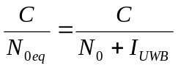

Where C is the received power of the useful signal,  is the interference due to the UWB system and 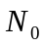 is the power spectral density of the thermal noise:

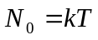

where 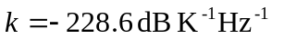 is the Boltzmann constant, T is the system temperature in Kelvin. For 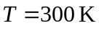 (typical value), we have:

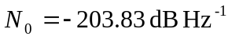.

The case where only the thermal noise is taken account in the budget link is the worst case for the UWB interference, but it is not realistic because one Galileo channel is not alone in the nature, and we have to consider the whole Galileo system and also systems like GPS.
The value of admissible interference is given by the allowed difference between 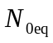 and . In many papers about interference between GPS and Galileo a value that is usually taken is 0.25 dB of inter system degradation (D) whereas FCC considers 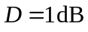 [FCC]. The maximum interference PSD 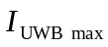 is given by the following relation:

where and D are given in dB.
The following tables give the value of in dB according to several values of D (0.25, 0.5, 0.75 and 1 dB) and several values of (-203.8, -199.1 dB/Hz) at the input of the Galileo receiver.
Table 16
Maximal admissible interference for 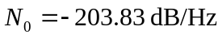
at the input of the Galileo receiver
in dB | -203.83 | -203.83 | -203.83 | -203.83
D: degradation in dB | 0.25 | 0.50 | 0.75 | 1.00
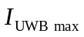 in dB | -216.10 | -212.96 | -211.07 | -209.70
Difference between and I in dB | 12.27 | 9.14 | 7.25 | 5.87
Table 17
Maximal admissible interference for = -199.1 dB/Hz
at the input of the Galileo receiver
in dB | -199.10 | -199.10 | -199.10 | -199.10
D: degradation in dB | 0.25 | 0.50 | 0.75 | 1.00
in dB | -211.37 | -208.24 | -206.35 | -204.97
Difference between and I in dB | 12.27 | 9.14 | 7.25 | 5.87

When the interference due to UWB is CW like the comparison between and has to be made after the interference spectrum has be flattened. That is after the correlation of the received signal with the spreading code. In this case, the comparison in done between 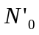 and 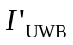. Thus it depends of the considered channel. The PSD of the thermal noise is modified by the functions or given in Table , in .
In the following, for the numerical applications, we make the following hypothesis:
• 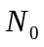 = –199.1 dB/Hz,
• the allowed degradation in 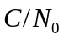 is 1 dB,
• the filter before the correlation is ideal and its bandwidth is equal to 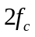 for BPSK modulation and 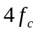 for BOC modulation
Of course, these impact only the numerical values, but the reasoning is always true.

In the following table, for each channel, the noise level N’_{o} is given after despreading, as well as the maximum of allowed interference: I’_{max}.
Table 18
Noise level and maximum of interference after despreading
Carrier channel | Signal type | N’_{o} | I’_{max}
E5a | QPSK(10) | -199.54 | -205.41
E5b | QPSK(10) | -199.54 | -205.41
E6-B E6-C | QPSK(5) | -199.54 | -205.41
E6-A | BOC (15;2,5) | -200.29 | -206.16
L1-A | BOC (15;2,5) | -200.29 | -206.16
L1-C | BOC (15;2,5) | -200.29 | -206.16

3. UWB interference model

3.1. Link budget
In this section, we compute the interference levels caused by UWB signals according to the FCC rules in the worst case. Those levels depend on the distance between the UWB transmitter(s) and the Galileo receiver.
Two cases have to be considered whether an aggregate assumption is taken or not.
In the case where only one UWB device is transmitting, the setting we consider to compute the interference levels is based on the following scheme:
Figure 4: Transmission link model from one UWB device to Galileo receiver
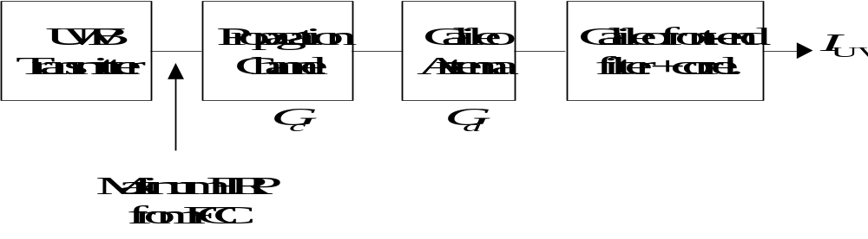

with:
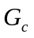: the attenuation due to the propagation channel,
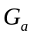: the gain of the Galileo receiver.
The propagation channel we include the free-space propagation  and possibly the attenuation from indoor to outdoor . The free-space attenuation in dB is given by:

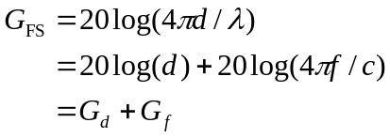 (18)

where d is the distance (in meters) between the UWB transmitter and the Galileo receiver, f is the frequency which will be considered as the Galileo carrier frequency (the frequency variation between the low and the high part of the receive filter results in a variation less than 0.1 dB), 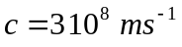 is the celerity, 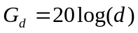 and 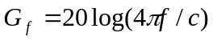. Thus for the different carrier frequency of the Galileo system we have:
Table 19
Free-space attenuation constant versus Galileo carrier frequencies
Carrier Frequency (MHz) | 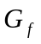 (in dB)
1 176.45 | 33.9
1 207.14 | 34.1
1 278.75 | 34.6
1 575.42 | 36.4

The indoor-outdoor attenuation is usually chosen equal to  and the Galileo antenna gain to 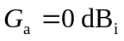
The aggregation case accounts for the presence of numerous UWB transmitters around the victim receiver. The aggregation is equivalent to a gain (>1) 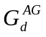 amplifying the transmitters EIRP, assumed here to be constant. This gain plays the same role as 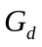 in eq. (16). According to the Fantasma model, applicable for terrestrial environment, this gain is equal to:

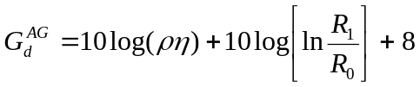
where:
 is the average density of transmitters per m²,
is the activity factor,
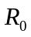 is the minimum radius of the observed zone,
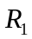 is the maximum radius of the observed zone.
It is worth noting that this model is very pessimistic in the sense that it is based on hypotheses that are unlikely to be encountered: flat earth model, free space propagation. In a urban environment, for which it is likely to have a lot of transmitters, the signal will be attenuated by many obstacles (buildings, foliage, …), the density of the obstacle increasing with the distance from the victim receiver. One clue that this model is not reliable is that goes to infinity with which is unrealistic. The FCC discarded the use of aggregation models justifying that according to some studies, this is the closest UWB transmitter that will be predominant over the other and cause interference.
Thus, the interference level seen at the entrance of a Galileo front-end receiver corresponds to the transmitted EIRP of an UWB device attenuated by a factor G that, according to the figures previously introduced will be (in dB):
• One UWB transmitter assumption

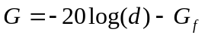 (19)

• Aggregate assumption (Fantasma model)

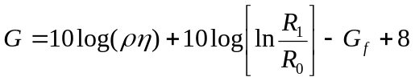 (20)

3.2. CW-like interference computation

In this section we compute the interference levels caused by UWB signals after the Galileo despreading in the CW-like case (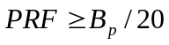) based on the UWB signal modelling and on the budget link.

3.2.1. “Pure” CW-like case

A spectral line transmitted from an UWB device with power , is received at the Galileo receiver with power (in dB) 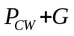. Noting 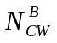 the number of spectral lines hitting the Galileo receive filter (which is constituted of one band for BPSK modulations or two bands for BOC modulations), the value of the interference caused by those spectral lines will be equal in decibel to
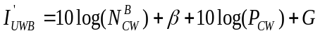

3.2.2. CW-like case with PSD

In this section we prove that when the transmitted signal is modulated with PPM, the corresponding effect is less than the “pure” CW-like case.
In the “pure” CW-like case, the resulting interference is given by:
 (21)
When continuous PSD is present, the resulting interference is the summation of the interference coming form the spectral lines and the interference coming from the continuous PSD. Therefore, we have:

(22)

The proof consists in demonstrating that 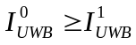, or equivalently 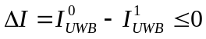. Using (21) and (22), 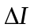 can be rewritten as 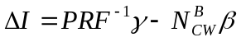. Using the equality (17) we have:

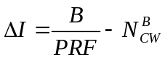.

The number of spectral lines falling within a filter of bandwidth  is equal to 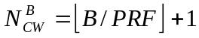. Thus can be expressed as:

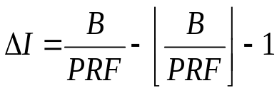.

Because we have 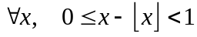, it implies that 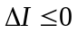.

4. Interference assessment
In this section we estimate the effect of UWB devices in the CW-like case (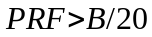) on GALILEO signals. In the one transmitter case we assume no obstacle and so 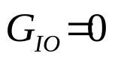dB and for the aggregate case we take 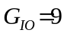dB.
We estimate the effect by computing the minimum distance for which 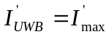. In the aggregate case, we fix the maximum radius 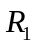 and compute the minimum radius . The minimum distance is given by:
– One transmitter case
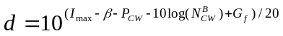 (23)
– Aggregate case
(24)

Let’s compute, for each Galileo band, the distance (23) and (24) for PRF ranging from the minimum value corresponding to the CW-like case to 100 MHz. For each PRF, we compute the number of spectral lines hitting the Galileo receiver and deduce the minimal distance. The blue curves are for the one transmitter case and the red curves for the aggregate one. Two cases have been studied depending on the application. For both cases, we have taken 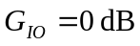 (non obstacle) for the one transmitter case and  for the aggregate case.
1) Indoor, hand held, including outdoor applications and vehicle radar
For those applications, the corresponding FCC e.i.r.p. limit is equal to 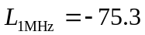 dBm/MHz. For the aggregate model we have chosen 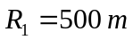, 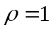 and 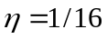 which corresponds to an environment of 1 user/m², using a TDMA based transmission mode with 16 users per piconet.
The curves show that the aggregate case induces no interference to the Galileo system. For the one transmitter case, the maximum of the minimum distance is obtained for the lowest PRF and is given in the following table for the different Galileo bands:
Table 20
Maximum of minimum protection distance (in m) vs. Galileo bands in the one
transmitter case for the communication applications
Band | E5a  E5b | E6-A | E6-B  E6-C | L1-A  BOC(14,2) | L1-A  BOC(10,5) | L1-B
Distance (m) | 0.6 | 0.55 | 0.8 | 0.45 | 0.7 | 0.7

2) Mid-frequency imaging applications
This application corresponds to the highest e.i.r.p. limit 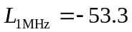 dBm/MHz. For the aggregate model we have chosen , 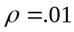 and 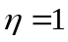 which corresponds to an environment of 1 user/100 m² (10 m x10 m) and 100 % activity.
Table 21
Maximum of minimum protection distance (in m) vs. Galileo bands
in the one transmitter case for the mid-frequency imaging applications
Band | E5a | E5b | E6-A | E6-B E6-C | L1-A  BOC(14,2) | L1-A  BOC(10,5) | L1-B
Distance in m for one transmitter | 7.5 | 7.5 | 7 | 10 | 9 | 5.8 | 9
Distance in m for aggregate | 58 | 53 | 40 | 141 | 11 | 108 | 100

Results of the compatibility analysis using existing eirp
In this chapter, we presented the effects of UWB interference on Galileo receivers.
We first gave a PSD model for the UWB signals that can be constituted by spectral lines only or continuous PSD or both at the same time. We then presented signal modelling of Galileo system for the different frequency bands and the calculation of the effect of interferers at the output of the dispreading process. We determined the maximum interference level causing a 1 dB increase of the equivalent thermal noise. We considered the CW-like case, with corresponds to PRF values that allow assuming that the dispreading process renders the spectral lines as white noise.

We assessed by simulation the minimum distance between an UWB transmitter (or an aggregation of UWB transmitters) and a Galileo receiver, for which the maximum interference level is achieved. The main results are the following using eirp mainly provided by UWB manufacturers and that can be found in the existing literature.
– For communication applications using an eirp of -75.3 dBm/MHz, the “one transmitter” case reveals minimum distance ranging form 45 cm to 80 cm, whereas the aggregate case does not jam the Galileo receiver.
– For the mid-frequency imaging applications, which corresponds to the highest e.i.r.p. limits of -53.3 dBm/MHz, the minimal distance ranges from 5.8 m to 9 m, while for the aggregate one, it ranges from 11 m to 141 m.
These above results show the evidence that, though not being harmful on a wide range, aggregated UWB devices would have potentially significant effects on a Galileo receiver located near an emitter. In any case, collocating RNSS and UWB seems to raise a severe challenge, which is quite impossible to solve in most cases.

For instance, the following figure provides the minimum protection distance for the GALILEO signal E5a.

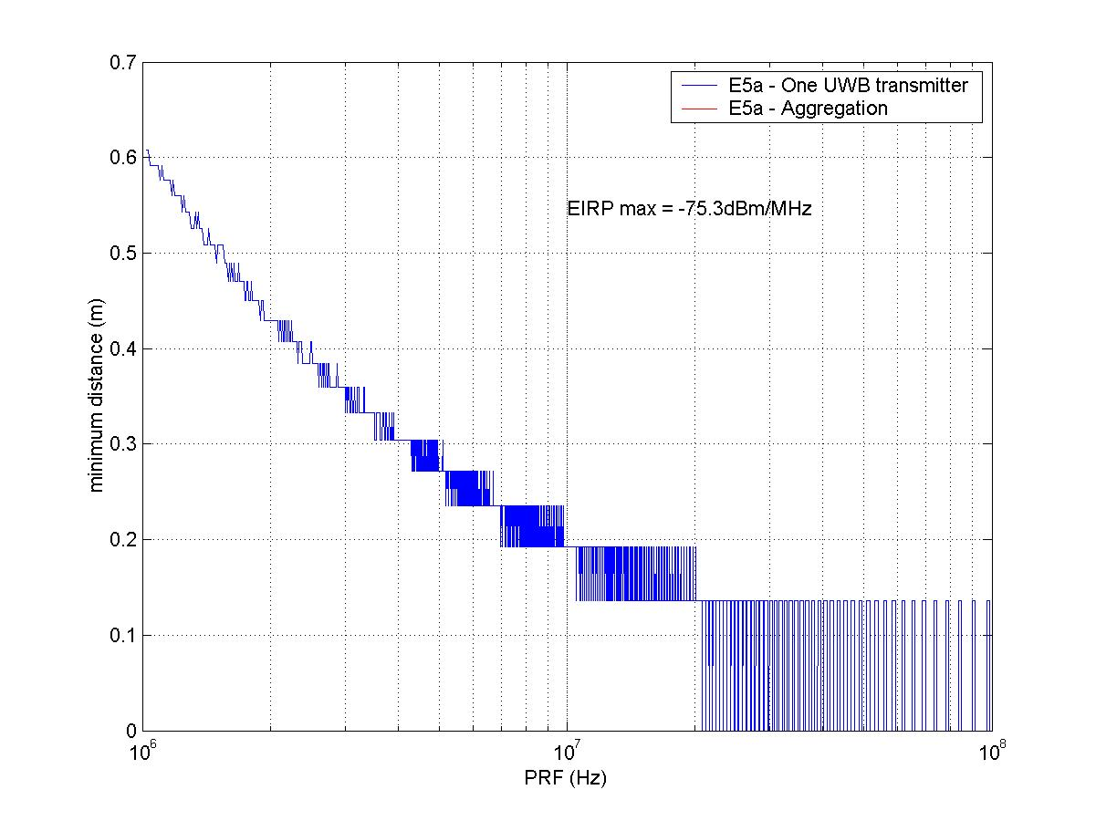
Figure 5: Minimal admissible distance vs. PRF for E5a channels for general limit EIRP=-75.3 dbM/MHz

Future work for Galileo
The conclusions drawn from those simulations need to be carefully considered since the maximum distance is obtained for the lowest PRF and the minimum distance varies dramatically around a limit corresponding to the B/20 criterion that was computed using a heuristic procedure. This criterion would need to be further validated through simulations. However, these conclusions already give some clear guidance and order of magnitude for the protection of the GALILEO earth station receivers.

2.9 References
[BET] J. W. BETZ, “ Design and performance of code tracking for the GPS M Code Signal”, Proceedings of ION GPS 2000, 19-22 sept. 2000, Salt Lake City, UT.
[FCC] “Revision of Part 15 of the Commission’s Rules Regarding UWB Transmission System”, Federal Communications Commission, ET Docket 98-153, FCC 02-48, adopted February 14, 2002.
[GST] Galileo System Team, “Signal in Space ICD”, ID/GAL/0258/GLI.
[HEI-al] G. W. HEIN and all, “Galileo Frequency and Signal Design”, GPS World 2003.
[HOL] J. K. HOLMES “Coherent Spread Spectrum systems”, Wiley Intersciences,1982.

RAIM : Receiver Autonomous Integrity Monitoring
Recommendation ITU-R M.1477, “Technical and Performance Characteristics of Current and Planned Radionavigation-Satellite Service (Space-to-Earth) and Aeronautical Radionavigation Service Receivers to be Considered in Interference Studies in the Band 1559-1610 MHz”, pertaining to Questions ITU-R 91/8 and ITU-R 217/8, 2000.
This limit is obtained for PRF for which the impulse response length of an ideal rectangular filter of bandwidth B_{p} drops below 20% of its maximum.
This limit is obtained for PRF for which the impulse response length of an ideal rectangular filter of bandwidth B_{p} drops below 20% of its maximum.

