ACP WG F11 - WP/14

AERONAUTICAL COMMUNICATIONS PANEL (ACP)

WORKING GROUP-F/11

Nairobi, 17–27 February 2004

Agenda Item : 11

DIGITAL BROADCASTING SYSTEMS IN THE 87-108 MHZ BAND

Presented by
Jim Weller, Australia

SUMMARY
Over many years the problem of interference from high powered FM broadcast stations into VHF aeronautical radiocommunications equipment has been studied, resulting in ITU-R Recommendation SM.1009-1. Some countries are evaluating digital sound broadcasting systems for possible introduction into the FM broadcasting band. At WRC-03 it was recognised that no studies had been performed into the compatibility between digital sound broadcasting systems and aeronautical systems, and Resolution [COM5/2] was approved to resolve that the ITU-R study these issues. This paper considers the three digital sound broadcast systems capable of operating in the FM band and their comparative suitability. The status of systems under test in various countries is considered. A summary of the spectrum characteristics of these systems is also provided.

BACKGROUND AND INTRODUCTION

Interference management process between FM broadcasting and aeronautical services
Frequency modulation (FM) broadcasting service interference to instrument landing systems (ILS) localiser, VHF omnidirectional radio range (VOR) and aeronautical VHF communications equipment has been a widely recognised problem for many years.
The problems of interference to aircraft receivers is usually due to the following factors:
- FM broadcasting stations operate with high-powers levels of up to 250kW erp, whereas aeronautical facilities in the adjacent band operate with power levels in the range 0.02-6kW erp;
- FM broadcasting stations due to their high power levels transmit significant spurious emissions;
- Some airborne ILS/VOR receivers have a high susceptibility to FM interference. ICAO has addressed this through new interference immunity standards in Annex 10 Vol I applicable from 1998. Some State regulation do not confirm to the new standard;
- There is no guard-band between the highest assignable frequency for FM broadcasting (107.9 MHz) and lowest assignable radionavigation frequency (108.0 MHz).
The decision of the World Administrative Radio Conference (Geneva, 1979) to extend the FM broadcasting band to 108 MHz put aeronautical and broadcasting services in adjacent bands. Recognising that this change might lead to interference problems, studies were carried out within the ITU Study Groups from 1982 to 1995 to determine the technical constraints to be used to achieve compatibility between the services.
At the Regional Administrative Conference for FM sound broadcasting in the VHF band (Region 1 and certain countries concerned in Region 3), Geneva 1984, compatibility criteria and assessment criteria assessment were agreed (called “Geneva Agreement, 1984” or GE84). However, compatibility between the FM broadcasting frequency plan and the aeronautical radionavigation service frequency plan was not fully studied. Also, no compatibility tests with the aeronautical mobile (R) service (117.975-137 MHz) were performed. Further studies were carried out by the ITU-R study groups resulting in the approval of Recommendation ITU-R SM.1009-1 in 1995.

Considerations at ITU Study groups and WRC-03
An agenda item for the WRC-03 (1.28) considered an allocation for data link applications such as Ground Based Augmentation System (GBAS) in the 108-117.975 MHz band. The agenda was also broadened to consider airborne data link systems transmitting navigation and surveillance signals such as VDL Mode 4.
The change to the allocation in the 108-117.975 MHz band especially for the airborne data link systems raised the concern of the broadcast community that these new systems might impose additional constraints on their systems in the adjacent 87-108 MHz band.
Australia submitted a preliminary draft new question (8B/265) at the ITU-R WP8B meeting in September 2002 to consider the compatibility between digital radio broadcasting systems and aeronautical radionavigation systems operating in the bands adjacent to 108 MHz. The new question did not get up but a liaison statement was sent to WP6E (6E/274) identifying that the compatibility between digital broadcasting systems and aeronautical systems had not been address, and requesting information related to implementation, schedules, relevant technologies and standards related to proposed digital radio broadcasting in the band.
The ITU-R WP6E meeting in March 2003 sent a reply to the WP8B liaison statement (8B/310). WP 6E indicated that it was aware that the US had operational systems at several locations, that India had a pilot project, and that Thales was coordinating a consortium of some 15 companies in the development of a new digital system that may be based upon DRM modulation. WP 6E invited WP 8B to review Recommendation ITU-R BS.1114-3 for technical data that would facilitate a compatibility analysis.
At WRC-03 a footnote 5.BA03 was introduced to allocate the new aeronautical systems as aeronautical mobile (R) services in the 108-117.975 MHz limited to ICAO systems supporting navigation and surveillance functions. These systems are not to interfere with existing ARNS. The new footnote references a new Resolution [COM5/2]. The new Resolution [COM5/2] resolves that:
- no additional constraints be placed on the broadcasting service in the adjacent band;
- that new aeronautical systems like VDL/4 shall be restricted to 112 MHz and above until compatibility issues with FM and digital broadcasting systems are resolved, and
- that ITU-R studies will occur into the compatibility between the aeronautical and broadcasting (FM and Digital) services.

Very High Frequency (VHF) broadcast bands
The VHF Band covers 30 – 300 MHz. Within the VHF Band there are three bands used for broadcasting as outlined below.
VHF Band I includes frequencies from 45 - 70 MHz and has, in part, been used to provide channel 0, 1 and 2 analog television services (amongst other non-broadcasting uses).
VHF Band II covers 87.5 - 108 MHz and is generally used for FM broadcasting although it has also been used for television broadcasting in some countries.
VHF Band III covers 174 - 230 MHz and is generally used for television broadcasting. The spectrum from 230 - 240 MHz is used for radiocommunication services, particularly by defence, but has been identified as being possibly suitable for digital radio services, particularly in Europe.

TERRESTRIAL DIGITAL SOUND BROADCASTING SYSTEMS
ITU-R WP6E is the broadcasting working party studying systems and the technical basis for planning for digital sound broadcasting in the range 30-3000 MHz. System details are available in the Recommendation ITU-R BS.1114-4.
BS.1114-4 describes three digital sound broadcast systems capable of being operated in the 30-3000 MHz band:

Digital System A
Digital System A also known as the Eureka 147 digital audio broadcasting (DAB) system, has been developed for both satellite and terrestrial broadcasting applications in order to allow a common low-cost receiver to be used. It has been actively supported by the European Broadcasting Union (EBU) for introduction of digital broadcasting into Europe. Since 1998, the system has been successfully demonstrated and extensively tested in various frequency bands between 200 MHz and 1500 MHz in Europe, Canada, the US and in other countries. The full system specification is European Telecommunications Standard ETS 300 401. Although Eureka 147 was designed to operate over a wide spectrum range from 30 - 3000 MHz, it has only been commercially implemented in two spectrum bands, VHF Band III and L-Band.

Digital System C
Digital System C, also known as the iBiquity In-Band On Channel (IBOC) Digital Sound Broadcast (DSB) system, is a fully developed system in the 88-108 MHz band with experimental operations in five major metropolitan areas in the US. The system is designed for terrestrial broadcasting applications. The system has the ability to offer simulcasting of analogue and digital signals and would allow transition for existing FM broadcasters from analogue to digital broadcasting. Regarding the operational United States systems, additional detail, including the results of extensive laboratory and field tests, is available from the United States’s National Radio Systems Committee’s (NRSC) website, under www.nrscstandards.org , Subcategory DAB Subcommittee. Consumer radios will be offered for sale beginning June 2003. The FCC is supporting the NRSC’s development of a standard based on Digital System “C” for digital broadcasting in this band. Protection ratios have been developed that cover the entire band from 88 to 108 MHz, including the guardband edge effects at the upper end.

Digital System F
Digital System F, also known as the Integrated Services Digital Broadcasting – for Terrestrial Sound Broadcasting (ISDB-T_{SB}) system, is designed to interface with multimedia broadcasting using terrestrial networks. The system has been field-tested and demonstrated in the 188-192 MHz and 2532-2655 MHz bands. This system has been adopted for digital terrestrial sound broadcasting by Japan.

In summary
Table 1 summarises the key aspects of the 3 digital systems considered.

Parameter | Eureka 147 | IBOC-FM | ISDB-T_{SB}
Bands | VHF Band-III  L-Band | VHF Band II  (FM Band) | VHF, UHF
Origin | Europe | US-proprietry | Japan
Terrestrial | Yes | Yes | Yes
Satellite | Possible | No | Possible
Hybrid | Possible | No | Possible
Wideband  Narrowband | Wideband  1.5 MHz | Narrowband  200 kHz | Wideband  0.4 or 1.3 MHz
Modulation System | COFDM  QPSK | COFDM | COFDM DQPSK, QPSK, 16-QAM, 64-QAM
Max data rates | 1.2 Mbit/s | 98 kbit/s | 0.3-5.3 Mbit/s
Infrastructure | FM/TV and infill sites | FM sites | FM/TV sites
Standardisation | Extensive | Developmental, limited | Some
Receiver availability | Yes | No | No
On-air | Yes | Tests | Tests
Table 1 – Summary of ITU-R approved Digital Sound Broadcasting Systems
Other than these three systems, there are a number of systems specifically designed for satellite broadcasting or have wide bandwidth requirements (eg. DVB-T, Worldspace and SDARS). Due to their transmission requirements including bandwidth and antenna size there is no plans for use of these systems in the VHF Band II and therefore these systems are not considered in this paper.
There are other systems designed specifically for the HF or MW bands which due to their lack of bandwidth provide no benefits over FM analogue systems and are therefore not considered in this paper (eg IBOC-AM and DRM).

DIGITAL SOUND BROADCASTING SYSTEMS SUITABILITY IN VHF BAND II
VHF Band II (87.5-108 MHz) is generally used world-wide for FM sound broadcasting although some countries also operate television in the band.

Eureka 147
To allow Eureka 147 into the VHF Band II, for many countries it would require significant reorganisation or closure of FM services to clear sufficient spectrum for the 1.5 MHz channel bandwidth. Therefore commercially it does not appear to be a viable candidate for the FM band in the short to medium term. In the long term, subject to receiver availability, the band may be suitable following the closure of FM radio services.

IBOC-FM
VHF-FM services in many countries operate with a 100 kHz channel spacing, using a channel bandwidth of 200 kHz. The IBOC-FM system has been designed for use with 100 kHz channel spacing and therefore can operate within the channel bandwidths of the existing VHF-FM band.

ISDB-T_{SB}
Japanese VHF bands are currently organised as follows:
VHF Band II, 76 - 90 MHz, for FM Radio broadcasting
VHF Band II, 90 - 108 MHz, for TV broadcasting
VHF Band III, 170 - 222 MHz, for TV broadcasting.
From available information on trials conducted to date, it appears there may be an intention for the ISDB-T_{SB} services to operate in Japan in the VHF bands below 222 MHz.

COUNTRY IMPLEMENTATION OF DIGITAL SOUND BROADCASTING SYSTEMS
Digital radio broadcasting has only been employed on a commercial scale since the mid 1990s. It is therefore at an early stage of development and no country has yet achieved significant commercial breakthrough of services.

Eureka 147
The UK, Germany and Canada, are reasonably advanced, through terrestrial application of the Eureka system for digital radio. A number of other European countries have also commenced Eureka services.
In the UK, digital services commenced in 1995 with the simulcast of a number of BBC services, while commercial services commenced in 1999 through the nation-wide commercial multiplex operator, Digital One. The UK currently employs VHF Band III (217.5 to 230 MHz) spectrum for Eureka but has plans to make L-Band spectrum (1452-1467.5 MHz) available in 2007.
Regular digital radio operations began in Germany in 1999, with Sachsen Anhalt being the first State to launch services. Around half of Germany’s digital radio services are provided by the commercial sector. Germany has commenced services in both the L-Band and VHF Band III (223-230 MHz). The Frequency Assignment Ordinance (2001) stipulates that all analog frequency allocations will be revoked by 2015 for FM radio.
In Canada, digital radio services have been operating in the L-Band since early 1999 in Toronto, Montreal and Vancouver, and since early 2000 in Ontario. Most digital radio services in Canada are simulcasts of existing analog services.
Other countries to have implemented the Eureka system include France, Sweden, Portugal, Italy, Spain, and Belgium.
Australia conducted a series of satellite trials of Eureka 147 in 1996 and terrestrial L-Band trials in 1997. Commercial trials for terrestrial Eureka 147 commenced on L-Band in Sydney in 1999 which are still operating. There is planning of further terrestrial trials of Eureka 147 in Sydney in the VHF band III.

IBOC-FM
In the US, the terrestrial digital radio solution is being pursued through the proprietary iBiquity IBOC system. Late in 2002, the US Federal Communications Commission (FCC) approved the use of the IBOC system for trials of terrestrial digital radio in the FM band. With the FCC’s decision, approximately 40 broadcast groups and stations in 26 US states indicated their intention to commence IBOC broadcasts in 2003. While a number of broadcasters have commenced trials, there are no consumer receivers currently available.
In February 2003, iBiquity announced an incentive program for US broadcasters wishing to convert to digital IBOC technology. The incentives include cheaper licence fees for use of its proprietary technology for commercial stations and a waiver of licence fees for not-for-profit stations. iBiquity has alliances with a number of receiver manufacturers including Alpine, Blaupunkt, Clarion, Delphi, Harman Kardon, JVC, Kenwood, Mitsubishi, and Panasonic. iBiquity has also formed an alliance with the Ford Motor Company for installation of IBOC receivers in new vehicles in return for an equity position in iBiquity.
Australia is holding discussions with Ibiquity to establish the first trial of HD radio outside of the US.

ISDB-T_{SB}
In Japan, digital radio via the ISDB-T_{SB} system will be trialed from late 2003 in Tokyo and Osaka.
Australia continues to monitor developments in ISDB-T_{SB}.

SPECTRUM CHARACTERISTICS OF DIGITAL SOUND BROADCASTING SYSTEMS
Most digital radio systems use an Orthogonal Frequency Division Multiplexing (OFDM) multi-carrier scheme. As all OFDM systems include a coding layer for improved error protection, the term Coded Orthogonal Frequency Division Multiplexing (COFDM) is usually applied. Before transmission the information is divided into a large number of bit-streams with low data rates each. These are then used to modulate individual orthogonal carriers using an appropriate modulation scheme. The spectrum of the signal is approximately rectangular and Gaussian noise-like as indicated in Fig. 1.

Spectrum characteristics for the three ITU-R approved system are provided in the Recommendation ITU-R Recommendation BS.1114-4. Relevant details are presented below.

Eureka 147
Eureka 147 has four alternative transmission modes (Modes I-IV) which allow the use of a wide range of transmitting frequencies up to 3 GHz. As an example of the transmission signal spectrum, Figure 1 shows the theoretical output spectrum for Mode II. This is typical of all three sound broadcasting systems since they all use COFDM digital radio transmissions.

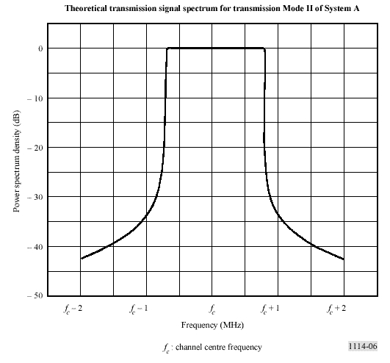
Figure 1: Eureka 147 Mode II Theoretical Output Spectrum
The out-of-band radiated signal spectrum in any 4 kHz band should be constrained by one of the masks defined in Fig. 2. The solid line mask should apply to VHF transmitters in critical areas for adjacent broadcast channel interference. The dotted line mask should apply to VHF transmitters in other circumstances and to UHF transmitters in critical cases for adjacent broadcast channel interference. The level of the signal at frequencies outside the normal 1.536 MHz bandwidth can be reduced by applying an appropriate filtering.
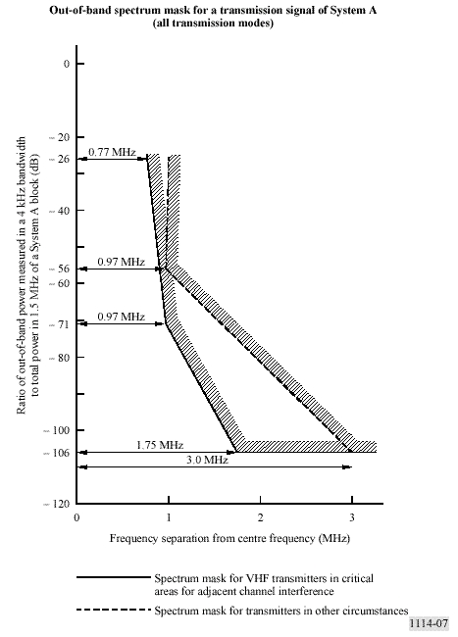
Figure 2 – Eureka 147 transmission signal (all modes) Out-of-band spectrum mask

IBOC-FM
IBOC-FM has three waveform types: hybrid, extended hybrid and all digital. The hybrid and extended hybrid types retain the analogue FM signal, while the all digital type does not. All three waveform operate well below allocated spectrum emissions mask as currently defined by the Federal Communications Commission (FCC).
The digital signal is modulated using orthogonal frequency division multiplexing (OFDM). OFDM is a parallel modulation scheme in which the data stream modulates a large number of orthogonal subcarriers, which are transmitted simultaneously.
The amplitude scaling of each OFDM subcarrier within each digital sideband is given in Table 1 for the hybrid, extended hybrid and all digital waveforms. The values for the hybrid waveforms are specified relative to the total power of the unmodulated analog FM carrier (assumed equal to 1). The values for the all digital waveform are specified relative to the total power of the unmodulated analog FM carrier (assumed equal to 1) that would have been transmitted in the hybrid and extended hybrid modes.
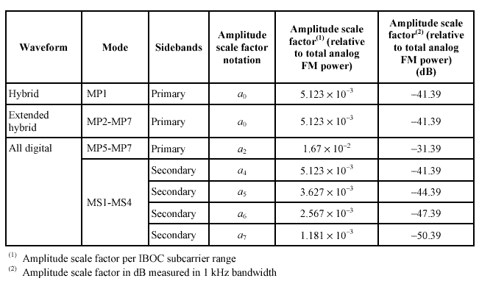
Table 1 – IBOC-FM OFDM subcarrier scaling
For the hybrid and extended hybrid waveforms, the values were chosen so that the total average power in a primary digital sideband (upper or lower) is 23 dB below the total power of unmodulated analog FM carrier. The spectrum of the hybrid waveform is shown in Fig. 3.
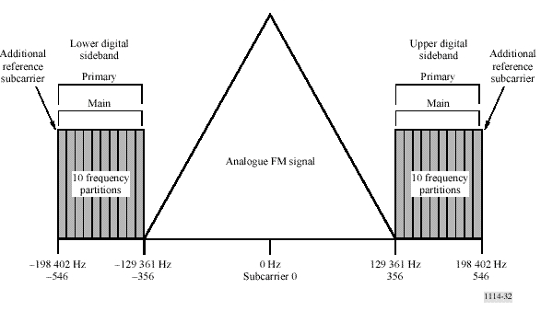
Figure 3 – IBOC-FM Spectrum of the hybrid waveform

For the all digital waveform, the values were chosen so that the total average power in a primary digital sideband (upper or lower) is at least 10 dB above the total power in the hybrid primary digital sidebands. In addition, the values were chosen so that the total average power in the secondary digital sidebands (upper and lower) is at least 20 dB below the total power in the all digital primary digital sidebands. The level of the digital subcarriers is such that the total power of these carriers is no more than 10dB below the nominal power of the FM analogue carrier that it replaces.
The all digital waveform is constructed by removing the analogue signal, fully expanding the bandwidth of the primary digital sidebands, and adding lower-power secondary sidebands in the spectrum vacated by the analogue signal. The spectrum of the all digital waveform is shown in Fig. 4.
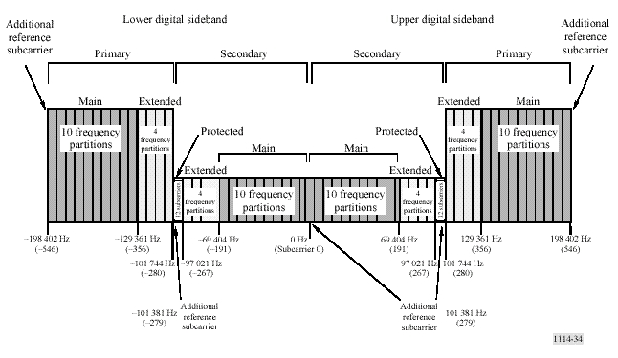
Figure 4 – IBOC-FM Spectrum of the all digital waveform
Hybrid and all digital carrier levels are operated well below the FM emissions mask. An example of one administration's mask, from the United States of America, Code of Federal Regulations (CFR), Title 47 § 73.317 is summarized in Table 2.
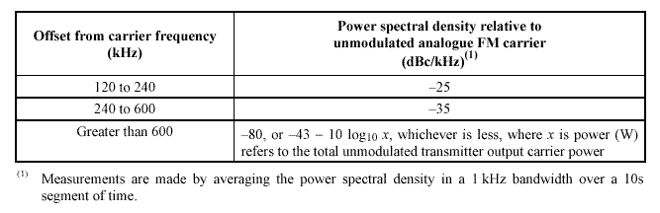
Table 2 – IBOC-FM Emission limits as a function of off-set from carrier frequency for FM channels in the US
In Table 3 the digital carrier power levels have been adjusted to depict the level below the 0 dBc emission mask.
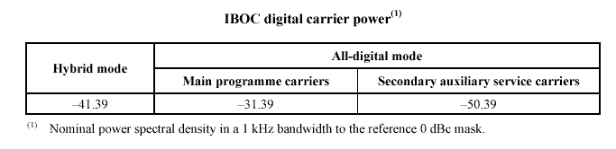
Table 3 – IBOC-FM digital carrier power
Figure 5 provides the noise level from all sources (phase noise and intermod products) in dB relative to the nominal power spectral density of the digital sidebands as measured in a 1 kHz bandwidth.
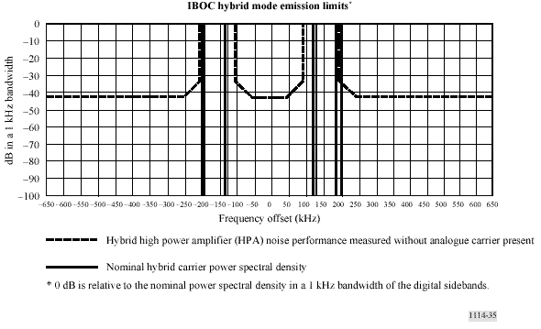
Figure 5 – IBOC-FM hybrid mode Emission limits
Note that since the nominal carrier power density for the hybrid mode is -41.39dB/kHz (Table 3), and the required emission limits for 0-50 kHz offset is -83.39 dB/kHz (Table 4), then the emission limit relative to the nominal carrier power density for 0-50 kHz offset is -42 dB/kHz (Figure 5).

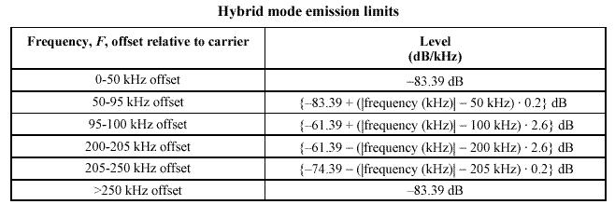
Table 4 – IBOC-FM hybrid mode Emission limits
Emission limits are also provided for all-digital mode operation in ITU-R Recommendation BS.1114-4 and are not repeated here.

ISDB-T_{SB}
ISDB-T_{SB} uses band segmented transmission (BST)-OFDM modulation. ISDB-T_{SB} has commonality with the ISDB-T system used for digital terrestrial television broadcasting in the physical layer. The bandwidth of an OFDM block called OFDM-segment is approximately 500 kHz.
ISDB-T_{SB} consists of one or three OFDM-segments - single-segment transmission and triple-segment transmission. Therefore the bandwidth of single-segment transmission and triple-segment transmission is approximately 500 kHz and 1.5 MHz. A bandwidth of OFDM-segment is defined in one of three ways depending on the reference channel raster of 6, 7 or 8 MHz. The bandwidth is a fourteenth of the reference channel bandwidth (6, 7 or 8 MHz), that is, 429 kHz (6/14 MHz), 500 kHz (7/14 MHz), or 571 kHz (8/14 MHz). The bandwidth of OFDM-segment should be selected in compliance with the frequency plans in each country. In addition, according to the broadcaster’s purpose, they can select the carrier modulation method DQPSK, QPSK, 16-QAM or 64-QAM.
ISDB-T_{SB} permits frequency reuse broadcasting networks to be extended using additional transmitters all operating on the same radiated frequency. In addition, the channels of independent broadcasters can be transmitted together without guardbands from the same transmitter as long as the frequency and bit synchronization are kept the same between the channels.
In considering only single-segment transmissions, the radiated signal for 6/14 MHz segment system should be constrained by the mask defined in Fig. 6 and Table 5. The level of the signal at frequencies outside the 429 kHz bandwidth (6/14 MHz) can be reduced by applying an appropriate filtering.
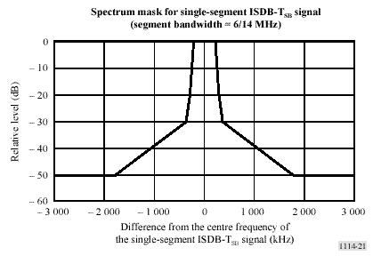
Figure 6 – ISDB-T_{SB} single –segment signal Spectrum mask

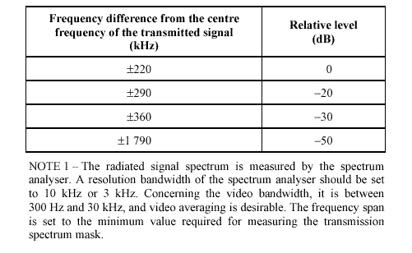
Table 5 – ISDB-T_{SB} single –segment signal Breakpoints of Spectrum mask
Emission limits are also provided for triple-segment transmission for 6/14 MHz operation in ITU-R Recommendation BS.1114-4 and are not repeated here

CONCLUSIONS
Of the three approved ITU-R digital sound broadcasting systems, the US IBOC-FM and Japanese ISDB-T_{SB} systems are the most likely to be introduced into VHF Band II (FM band) in the near to mid-term time frame. Both systems are undergoing live testing but commercial receivers are unavailable at this time. It may be that different countries/regions may adopt different systems and standards. Eureka 147 is likely to be implemented (at least in the short to medium term) in VHF Band III and the L-band.
Although the digital sound broadcasting systems conform to the current FM spectrum emission mask, there have been no theoretical or practical studies to determine their compatibility with aeronautical systems such as have been performed under ITU-R Recommendation SM.1009-1. Before serious roll-out of digital sound broadcasting systems, theoretical and practical studies will be required to assess compatibility wityh existing and proposed aeronautical systems in the VHF band. The aviation community needs to understand the digital sound broadcasting technology being introduced and establish links with the broadcasting community in order for them to understand the aviation communities concerns and be involved in studies carried out.

REFERENCES
Recommendation 591 (SG8), Report 929 (SG8), Report 1198 (SG10) and Decision 71 (SG8 and 10): Compatibility between the Broadcasting Service in the Band of about 87-108 MHz and the Aeronautical Services in the band 108-137 MHz
ITU-R Recommendation SM.1009-1: Compatibility between the Sound-Broadcasting Service in the Band of about 87-108 MHz and the Aeronautical Services in the band 108-137 MHz
ITU-R Recommendation B.1114-4 Systems for terrestrial digital sound broadcasting to vehicular, portable and fixed receivers in the frequency range 30-3 000 MHz
‘Digital Radio Technology Update’, Australian Digital Radio Study Group, Australian Broadcasting Authority, September 2003
‘Stocktake of Implementation Strategies for Digital Radio’, Australian Digital Radio Study Group, Australian Broadcasting Authority, Information Paper - September 2003
ANNEX 1 – Footnote 5.BA03 and Resolution [COM5/2] (WRC 03)

5.BA03 The band 108-117.975 MHz may also be used by the aeronautical mobile (R) service on a primary basis, limited to systems that transmit navigational information in support of air navigation and surveillance functions in accordance with recognized international aviation standards. Such use shall be in accordance with Resolution [COM5/2] (WRC-03) and shall not cause harmful interference to nor claim protection from stations operating in the aeronautical radionavigation service which operate in accordance with international aeronautical standards. (WRC-03)
RESOLUTION [COM5/2] (WRC-03)
Use of the band 108-117.975 MHz by aeronautical services
The World Radiocommunication Conference (Geneva, 2003),
considering
a) the current allocation of the frequency band 108-117.975 MHz to the aeronautical radionavigation service;
b) the current requirements of FM broadcasting systems operating in the frequency band 87-108 MHz;
c) that digital sound broadcasting systems are capable of operating in the frequency band at about 87-108 MHz as described in Recommendation ITU-R BS.1114;
d) the need for the aeronautical community to provide additional services by enhancing navigation and surveillance systems through a communication data link;
e) the need for the broadcasting community to provide digital terrestrial sound broadcasting services,
recognizing
a) that precedence must be given to the aeronautical radionavigation service operating in the frequency band 108-117.975 MHz;
b) that, in accordance with Annex 10 of the Convention of the International Civil Aviation Organization (ICAO) on international civil aviation, all aeronautical systems must meet standards and recommended practices (SARPs) requirements;
c) that within ITU-R, compatibility criteria between FM broadcasting systems operating in the frequency band 87-108 MHz and the aeronautical radionavigation service operating in the frequency band 108-117.975 MHz already exist, as indicated in the most recent version of Recommendation ITU-R SM.1009;
d) that all compatibility issues between FM broadcasting systems and ICAO standard ground-based systems for the transmission of radionavigation-satellite differential correction signals have been addressed,
noting
a) that aeronautical systems are converging towards a communication data link environment to support aeronautical navigation and surveillance functions, which need to be accommodated in existing radio spectrum;
b) that some administrations are planning to introduce digital sound broadcasting systems in the frequency band at about 87-108 MHz;
c) that no compatibility criteria currently exist between FM broadcasting systems operating in the frequency band 87-108 MHz and the planned additional aeronautical systems in the adjacent band 108-117.975 MHz using aircraft transmission;
d) that no compatibility criteria currently exist between digital sound broadcasting systems capable of operating in the frequency band at about 87-108 MHz and aeronautical services in the band 108-117.975 MHz;
e) that surveillance functions include the observation of aircraft location and velocity, and weather conditions for the purpose of air traffic control and situational awareness/collision avoidance between aircraft,
resolves
1 that the provisions of this Resolution and of No. 5.BA03 shall enter into force on 5 July 2003;
2 that any additional aeronautical systems1 planned to operate in the frequency band 108-117.975 MHz shall, as a minimum, meet the FM broadcasting immunity requirements contained in Annex 10 of the ICAO Convention on International Civil Aviation for existing aeronautical radionavigation systems operating in this frequency band;
3 that additional aeronautical systems operating in the band 108-117.975 MHz shall place no additional constraints on the broadcasting service or cause harmful interference to stations operating in the bands allocated to the broadcasting service in the frequency band 87-108 MHz and No. 5.43 does not apply to systems identified in recognizing d);
4 that frequencies below 112 MHz shall not be used for these additional aeronautical systems excluding the ICAO systems identified in recognizing d) until all potential compatibility issues with the lower adjacent frequency band 87-108 MHz have been resolved,
invites ITU-R
to study any compatibility issues between the broadcasting and aeronautical services that may arise from the introduction of these additional aeronautical systems as referenced in noting a), or appropriate digital sound broadcasting systems, as described in Recommendation ITU-R BS.1114 and to develop new or revised ITU-R Recommendations as appropriate,
instructs the Secretary-General
to bring this Resolution to the attention of ICAO.

Extract from Australian Digital Radio Study Group’s ‘Digital Radio Technology Update’ Australian Broadcasting Authority September 2003
ITU-R BS.1114-4, Figure 6
ITU-R BS.1114-4, Figure 7
ITU-R BS.1114-4, Table 15
ITU-R BS.1114-4, Figure 32
ITU-R BS.1114-4, Figure 34
ITU-R BS.1114-4, Table 19
ITU-R BS.1114-4, Table 20
ITU-R BS.1114-4, Figure 35
ITU-R BS.1114-4, Table 21
ITU-R BS.1114-4, Figure 21
ITU-R BS.1114-4, Table 9
1 In the context of this Resolution, the term “additional aeronautical systems” refers to systems that transmit navigational information in support of air navigation and surveillance functions in accordance with recognized international aviation standards.

