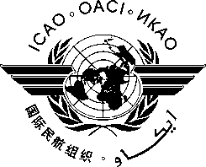
RASG-AFI-2

International Civil Aviation Organization

SECOND MEETING OF THE REGIONAL AVIATION SAFETY GROUP
FOR AFRICA-INDIAN OCEAN (RASG-AFI/2)
(Dakar, Senegal, 1-2 November 2013)

REGISTRATION FORM

- Please fill and forward the form in the same (MS Word) format. Do not fax, scan or change format to PDF.
- Insert information in the grey empty boxes
- Where appropriate, click to make the appropriate selection
- Surname

- Given Name (s)

- Job Title

- State/Organization

- Mailing Address

- Telephone

- Fax

- E-mail address

- Hotel

