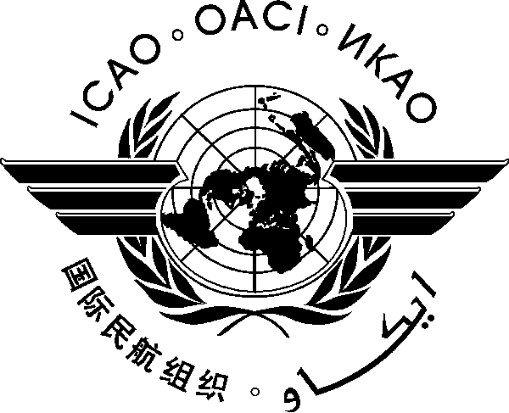
INTERNATIONAL CIVIL AVIATION ORGANIZATION
WESTERN AND CENTRAL AFRICAN OFFICE
Twenty-third Meeting of the AFI Satellite Network Management Committee (SNMC/23)
(Accra, Ghana, 15-19 February 2016)

Registration Form

(Kindly fill and return to icaowacaf@icao.int with copy to fsalambanga@icao.int)

First Name _____________________________________________________

Family Name _____________________________________________________

Title ______________________________________________________

State ______________________________________________________

Organization ______________________________________________________

Status (Member/Observer)________________________________________________

Address ______________________________________________________

Telephone/Fax ______________________________________________________

E-Mail _____________________________________________________

Hotel in Accra ______________________________________________________

