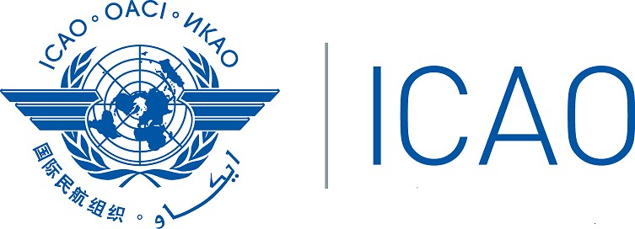

INTERNATIONAL CIVIL AVIATION ORGANIZATION

Twenty Fourth Meeting of the Africa-Indian Ocean Planning and Implementation Regional Group (APIRG/24) & Seventh Meeting of the Regional Aviation Safety Group for the AFI Region (RASG-AFI/7) – Joint sessions

(Virtual, 1 and 8 November 2021)

Agenda Item X: Title

(Presented by ….)

SUMMARY
This working paper presents …….

The action by the Meeting is in paragraph 3

Strategic Objectives | This working paper relates to the Strategic Objectives …..

- INTRODUCTION

  - …….

- DISCUSSION

  - …..

  - ……

3 ACTION BY THE MEETING

  - The meeting is invited to:
- Note the information contained in the WP;
- …..

