STATE ASBU Air Navigation Reporting Form (ANRF)
PIA | 4 | Block - Module | B0 - CDO | Date | August 18, 2015
Module Description
To use Performance-based airspace and arrival procedures allowing aircraft to fly their optimum profile using continuous descent operations (CDOs). This will optimize throughput, allow fuel efficient descent profiles, and increase capacity in terminal areas.
Element Implementation Status
1 | Element Description  (Derived from Element 1) Procedure changes to facilitate CDO. |  |  | Date Planned/Implemented  Dec 15, 2013 |  | Status  Implemented
Status Details
Optimized Profile Descent (OPD) is US equivalent to CDO. Most PBN STARs are either being developed or amended as OPD procedures.
There are 215 PBN STARs with OPD. These procedures serve 102 airports (as of June 2015)
2 | Element Description  (Derived from Element 1) Route changes to facilitate CDO. |  |  | Date Planned/Implemented  Dec 15, 2013 |  | Status  Implemented
Status Details
Route and associated airspace changes are routinely made as part of PBN procedure design and implementation processes.
3 | Element Description  Derived from Element 2) PBN STARs |  |  | Date Planned/Implemented  Dec 15, 2013 |  | Status  Implemented
Status Details
There are 367 total PBN STARs in the NAS with some of the procedures serving multiple airports (as of June 2015).
PBN STARs are implemented at 256 airports (as of June 2015).
Achieved Benefits
Access and Equity
Element 1: Only at locations where PBN STARs can be published to deconflict traffic flows with additional/different routing options. For example, RNAV STARs with OPDs implemented at Dulles and Regan National airports are now laterally separated.

Element 3: Only at locations where PBN STARs can be published to deconflict traffic flows with additional/different routing options.
Capacity
N/A
Efficiency
Element 1: Cost savings through reduced fuel burn due to improved vertical profiles.
Reduction in the number of required radio transmissions, and therefore controller and pilot workloads; however, we do not have empirical data to evaluate this particular benefit.
Operational benefits:
- Arrivals exhibited more efficient vertical profiles.
- Average time and distance within 250 nm of the airport did not change.
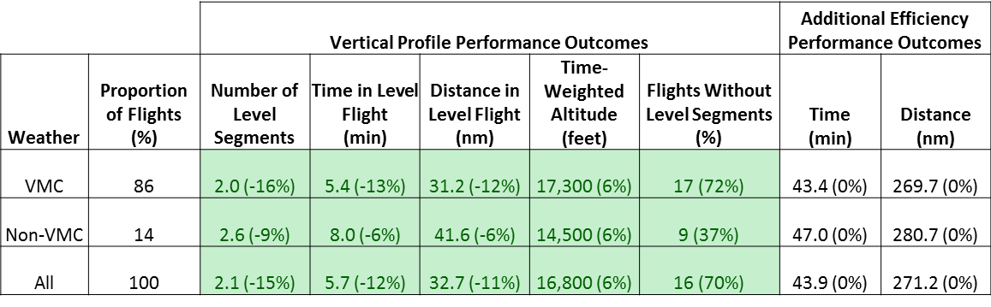
Element 3:
Only at locations where PBN STARs can be published to shorten typically flown terminal routing options, or to improve flow interaction, or improve vertical profiles.
Environment
Element 1: Reduced emissions as a result of reduced fuel burn (IFSET)
Element 3: Reduced emissions as a result of reduced fuel burn (IFSET)
Safety
Element 1: RNAV STARs facilitate executing stabilized approaches.
Element 3: More consistent flight paths and stabilized approach paths.
Implementation Challenges
Ground system Implementation
None
Avionics Implementation
None
Procedures Availability
None
Operational Approvals
None
Notes
None

