PA-RAST/8
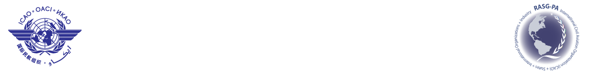
International Civil Aviation Organization
Eighth Meeting of the Regional Aviation Safety Team (PA-RAST/8)
Jamaica, Montego Bay, 12-13 March 2012

REGISTRATION FORM

1. | Name
2. | Position
3. | Organization
4. | Country
5. | Telephone
6. | Fax
7. | E-mail

Please return this form to

E-mail: icaonacc@icao.int
Fax: + 52 55 5203 2757

- - - - - - - - - -

