To participate as a sponsor at this event, please complete pages 1-5.

- Confirmation: Confirmation of the sponsorship agreement will be guaranteed by return of this duly completed and signed agreement and payment of the total fee.

Company Name
Contact Person | Salutation Mr. Mrs. Ms. Dr.
First Name
Last Name
Title
Address
City |  | Province
Postal / Zip Code |  | Country
Tel No. |  | Fax No.
Email Address

Company Information and Description
Please complete the table below, which will be used for the event directory. All the fields are mandatory and the company description, products or services cannot exceed more the 100 words.

Company Name
Salutation | Mr. Mrs. Ms. Dr.
First Name
Last Name
Email Address
Website Address
Company Description
Max 100 words

- Sponsorship, Delegate bag and Solutions workshop Fees – Hospitality Events
For Sponsorship Privileges, please see Appendix A and for Exhibition floor plan and booth spaces, please see Appendix B.

Event No. | Select your Number(s) | Sponsor  Category | Hospitality Event | Day | Approximate Time * | Fee in USD
1 |  | Platinum | Welcome Reception Sold out | Tuesday | 17:30 – 19:30 | $30,700
2 |  | Platinum | Welcome Reception Sold out | Wednesday | 17:30 – 19:30 | $30,700
3 |  | Platinum | Welcome Reception Sold out | Thursday | 17:30 – 19:30 | $30,700
4 |  | Gold | Lunch Sold out | Tuesday | 12:30 – 14:00 | $28,700
5 |  | Gold | Lunch Sold out | Wednesday | 12:30 – 14:00 | $28,700
6 |  | Gold | Lunch Sold out | Thursday | 12:30 – 14:00 | $28,700
7 |  | Silver | Continental Breakfast Available | Tuesday | 07:00 – 09:00 | $8,700
8 |  | Silver | Continental Breakfast Sold out | Wednesday | 07:00 – 09:00 | $8,700
9 |  | Silver | Continental Breakfast Available | Thursday | 07:00 – 09:00 | $8,700
10 |  | Bronze | Coffee/Refreshments Sold out | Tuesday | 10:45 – 11:15 | $4,500
11 |  | Bronze | Coffee/Refreshments Sold out | Tuesday | 15:15 – 15:45 | $4,500
12 |  | Bronze | Coffee/Refreshments Sold out | Wednesday | 10:45 – 11:15 | $4,500
13 |  | Bronze | Coffee/Refreshments Sold out | Wednesday | 15:15 – 15:45 | $4,500
14 |  | Bronze | Coffee/Refreshments Sold out | Thursday | 10:45 – 11:15 | $4,500

Delegate Bag | Fee
Confirmation has been received from ICAO to sponsor the delegate bag. Available | $7,700

Lanyards (ICAO and Customer logo) | Fee
Confirmation has been received from ICAO to sponsor lanyards. Available | $7,700

USB Key (ICAO and Customer logo) | Fee
Confirmation has been received from ICAO to sponsor the USB Key. Available | $8,900

Hospitality events will take place in the exhibition area. * Times are subject to change. ICAO will make arrangements to cater and pay for the hospitality events with recommended local caterers.

Solutions workshop*  Speaking Slot Number  (see section #4 below for more details) | Select your  Number(s) | Day/Approximate Time | Fee in USD
1 Sold out |  | Thursday, 09:00–09:20 | $5,600
2 Sold out |  | Thursday, 09:20–09:40 | $5,600
3 Sold out |  | Thursday, 09:40–10:00 | $5,600
4 Sold out |  | Thursday, 10:00–10:20 | $5,600
5 Sold out |  | Thursday, 10:20–10:40 | $5,600
6 Sold out |  | Thursday, 11:15–11:35 | $5,600
7 Sold out |  | Thursday, 11:35–11:55 | $5,600
8 Sold out |  | Thursday, 11:55–12:15 | $5,600
*Must be a sponsor or an exhibitor. Times are subject to change.

Total Cost (Sponsorship, Delegate Bag, Lanyards, USB Key & Solutions Workshop)

- Visibility Package
- One single sheet of printed promotional material (8” x 11.5” or A4) to be inserted into a pocket folder which will be distributed to each visitor during the event;
- A listing in the program directory displaying Company name, corporate logo, contact name, email, company url and a 100 word description of company, product or services;
- A directory listing in the TRIP partnership community website;
- Excerpts from up to three press releases issued by the exhibitor will be published in the corporate news section of the TRIP partnership community website, and;
- A free business card advertisement in the Fall symposium issue of the TRIP Report.

In addition to the Visibility Package outlined above, Platinum, Gold, Silver, Bronze and the Delegate Bag sponsors obtain exclusive privileges. (please see Appendix A below)

4. Solutions Workshop Speaking Slot*
Solutions-oriented 15-minute presentations, with five-minute question and answer periods if required, to be held prior to the opening of the Symposium.

The table above shows the current availability status of the speaking slots.

Fees - Solutions Workshop Speaking Slot*
The fee for this privilege is USD 5,600.

Making a Booking
Sponsorships and Solutions Workshop* speaking slots will be allocated on a first-come, first-served basis.

See the table above for the availability of a Solutions Workshop speaking slot and then complete the relevant section of this Sponsor Booking Form. (See Section 2 - Sponsorship, Delegate bag and Solutions workshop Fees – Hospitality Events)

5. Program Directory
A logo, description of your company’s products/services and contact information will be included in the Symposium Directory. Please complete this form and email to Mrs. Caroline Casabon, CCasabon@icao.int.

Corporate Logo
Please send us via email your company corporate logo. The resolution must be at least 300 dpi in one of the following formats:
(1) jpg;
(2) tif;
(3) bmp;
(4) eps.

6. Invoicing and Payment
Upon receipt of the duly completed Sponsorship Agreement, ICAO will remit an invoice for the symposium sponsorship fee; which will be sent by e-mail in a pdf format and the original will be mailed to the sponsor/exhibitor.

Please select one of the following payments below. We prefer payment by credit card.

 | Bank Transfer |  | Cheque
 | American Express |  | Master Card |  | Visa

For payment with major credit cards, please provide your credit card details below.

Card Number |  | Expiry Date
Card holder Number
Signature

Requirements for payment: payments must be made prior to the event and will be due upon receipt of the invoice. Methods of payment are: cheque, bank transfer or major credit card listed above. If payment is not received within fourteen (14) days, ICAO may not guarantee the customer’s first choice for the booth number or the sponsorship slot.

7. Promotional Material
Exhibitors are prohibited from placing flyers, pamphlets, brochures and other promotional items (i.e. Pens, USB sticks, mugs, memo pads, etc.) on tables or stands other than their own. These tables or stands are reserved for ICAO. Exhibitors may use their assigned tables to display their collateral materials.

Promotional materials must not promote military applications or make reference to the Republic of Taiwan.

8. Transportation and Customs clearance
ICAO will not be responsible for any transportation and customs clearance of the exhibition material.

Please, ensure that box 5 (Purchase’s name and address) of the Canada customs clearance form is completed by your company of shipping/transportation.

To view the Canada customs invoice form : http://www.cbsa-asfc.gc.ca/publications/forms-formulaires/ci1.pdf.

9. Cancellation Policy
This Sponsor Agreement may be cancelled by the Agreement signatory, with no penalty, within seven calendar days of receiving the confirmation receipt of the Agreement from ICAO. If the request for cancellation is received by ICAO later than seven, but within 15 calendar days of receiving the confirmation, the sponsor must pay, as a penalty charge, 25% of the applicable fee. Cancellations made after this 15-day period will be subject to a penalty charge of 50% of the fee. If the cancellation is, however, made during the 14 calendar days prior to the opening date of the event, the penalty will be 100% of the fee.

10. Acceptance
The undersigned hereby certifies that the terms and conditions set forth in this sponsorship agreement to sponsor at the 12th ICAO TRIP Symposium Headquarters.

Signature: _______________________________________________ Date:

11. Return the Agreement
Save the duly completed and signed Agreement in a pdf format and return it by e-mail to Mrs. Caroline Casabon, ccasabon@icao.int or by facsimile: +1 514-954-6769.

Appendix A – Sponsorship Privileges
In addition to the Visibility Package outlined above (section 3), Platinum, Gold, Silver, Bronze and the Delegate Bag sponsors obtain the following exclusive privileges:

Privileges | Sponsorship
 | Platinum | Gold | Silver | Bronze | Delegate Bag
Sponsor's corporate logo and hyper-link on the ICAO event Website | ✓ | ✓
Fifteen-minute non-commercial presentation to the delegates prior to the sponsored reception or lunch | ✓ | ✓
Complimentary prime location single exhibition space. Booth rental only. | ✓ | ✓
Up to three single sheets of printed promotional material  (8½×11 inch or A4) inserted into the delegate bags | ✓ | ✓ |  |  | ✓
Complimentary speaking slot at the Solutions Workshop | ✓
Recognition by the event moderator or master of ceremony during the opening and closing ceremonies | ✓ | ✓ | ✓ | ✓ | ✓
Prime visibility in the Program directory with the sponsor’s name, corporate logo, email, URL and company description of products/services | ✓ | ✓ | ✓ | ✓ | ✓
Display of sponsors' logos in the venue areas. (Overhead LED Screens) | ✓ | ✓ | ✓ | ✓ | ✓
Sponsors’ names and logos on the Symposium auditorium screen | ✓ | ✓ | ✓ | ✓ | ✓
Invitation to the hospitality event with sponsor name and logo on the Symposium auditorium screen | ✓ | ✓ | ✓ | ✓
Display of sponsor’s logo on the digital picture frame during the event being sponsored. Ie. On the coffee break table or lunch reception table. | ✓ | ✓ | ✓ | ✓
Free delegate or exhibitor passes and delegate bag or folder. | 8 | 6 | 2 | 1 | 1

Appendix B: Exhibition Floor Plan – 4th floor

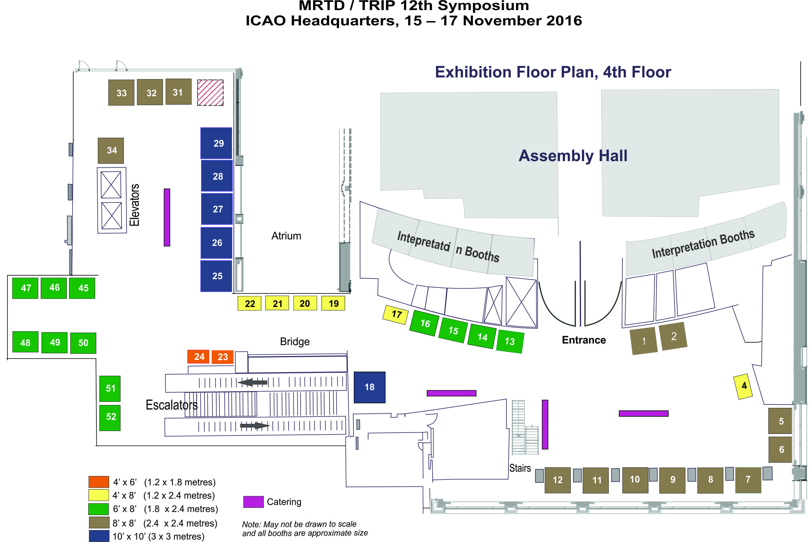

Appendix B: Exhibition Floor Plan – 3rd floor

