To participate as a Sponsor at this event, please complete pages 1-3

- Confirmation: Confirmation of the sponsorship agreement will be guaranteed by return of this duly completed and signed agreement and payment of the total fee.

Company Name
Contact Person | Salutation Mr. Mrs. Ms. Dr.
First Name
Last Name
Title
Address
City |  | Province/State
Postal / Zip Code |  | Country
Tel No. |  | Fax No.
Email Address

- Sponsorship Fees – Hospitality Events See Sponsorship Privileges Appendix A.

Event No. | Select Event No. | Sponsor Category | Hospitality Event | Day | Approximate Time * | Fee in $USD
1 |  | Platinum | Welcome Reception | Monday | 17:30 – 19:30 | $12,500
2 |  | Gold | Lunch | Monday | 13:00 – 14:30 | $9,500
3 |  | Gold | Lunch | Tuesday | 12:30 – 14:00 | $9,500
4 |  | Bronze | Coffee/Refreshments | Monday | 11:30 – 12:00 | $3,500
5 |  | Bronze | Coffee/Refreshments | Monday | 15:30 – 16:00 | $3,500
6 |  | Bronze | Coffee/Refreshments | Tuesday | 11:30 – 12:00 | $3,500
7 |  | Bronze | Coffee/Refreshments | Tuesday | 15:30 – 16:00 | $3,500

Note: * Time subject to change.

 | Other Promotions | Fee
 | ICAO Remote Tech Bag with Sponsorship’s corporate logo | $5,500
 | Lanyards – Sponsor to supply lanyards which is used to hold the photo ID badge | $2,500
 | USB Key – Sponsor to supply USB key | $1,500
 | One page (A4 or 8.5”x 11”) promotional material to be inserted in the event bag. | $1,500

Total Fee

- Exhibition Construction

A company renting a booth space may construct their own booth (ie. Pop-Up Banner, Table, Chairs, Bar Stools, Magazine Stand, Laptops, LED screen, etc) but must follow the rules as outlined by the City Conference Centre, Stockholm.
Please see link: http://www.stoccc.se/wp-content/uploads/2015/06/rules-for-exhibitions.pdf

If you wish for a contractor to build your booth, please contact Kostas Grintzos at kostas@cityexpo.se
Or visit: http://www.cityexpo.se/EN/Services.htm

- Program Directory
A logo, description of your company’s products/services and contact information will be included in the Symposium Directory. Please complete this form and email to Mr. Harvey Wong, hwong@icao.int

Corporate Logo
Please send us via email your company corporate logo. The resolution must be at least 300 dpi in one of the following formats:
(1) .jpg;
(2) .tif; or
(3) .bmp
(4) .eps

Contact Information and Description
Please complete the table below. All the fields are mandatory and the company description, products or services cannot exceed more the 100 words.

Company Name
Salutation | Mr. Mrs. Ms. Dr.
First Name
Last Name
Email Address
Website Address
Company Description
Max 100 words

- Invoicing and Payment
Following receipt of the duly completed Sponsorship Agreement, ICAO will prepare an invoice for the symposium sponsorship fee. A copy of the invoice will be sent by e-mail in a pdf format and the original will be posted to the sponsor/exhibitor.

Payment will be due within 14 days of receipt of the invoice and can be made by bank transfer, cheque or credit card as indicated below. Please select one of the following payments below. We prefer payment by credit card.

 | Bank Transfer |  | Cheque
 | Visa |  | Master Card

For payment with major credit cards, please provide your credit card details below.

Card Number |  | Expiry Date
Card holder Number
Signature

- Promotional Material
Exhibitors are prohibited from placing flyers, pamphlets, brochures and other promotional items on tables or stands other than their own. Promotional materials must not promote military applications or make reference to the Republic of Taiwan

- Cancellation Policy
This Sponsor Agreement may be cancelled by the Agreement signatory, with no penalty, within seven calendar days of receiving the confirmation receipt of the Agreement from ICAO. If the request for cancellation is received by ICAO later than seven, but within 15 calendar days of receiving the confirmation, the sponsor must pay, as a penalty charge, 25% of the applicable fee. Cancellations made after this 15-day period will be subject to a penalty charge of 50% of the fee. If the cancellation is, however, made during the 14 calendar days prior to the opening date of the event, the penalty will be 100% of the fee.

- Acceptance
The undersigned hereby certifies that the information set forth in this sponsorship agreement is accurate and agrees with the above payment and cancellation policy.

Signature: _______________________________________________ Date:

- Return the Agreement
Save the duly completed and signed Agreement and return it by e-mail in a pdf format to Mr. Harvey Wong hwong@icao.int or return it by facsimile: +1 514-954-6769

Appendix A – Sponsorship Privileges
The table below shows the privileges for each type of sponsorship

Privileges | Sponsorship
 | Platinum | Gold | Bronze | Delegate Bag
Sponsor's logo and hyper link on the ICAO event website | ✓
Fifteen-minute presentation prior to the sponsored reception | ✓
One complimentary booth size (4.5m X 2.6m) Platinum / (3.4m X 2.6m) Gold | ✓ | ✓
Number of printed promotional material  (8½×11 inch or A4) inserted into the delegate bags | 2 | 1 |  | 1
Prime visibility in the Symposium directory of the  sponsor’s name, logo and company’s products/services | ✓ | ✓ | ✓
Display of sponsor's name and corporate logos in auditorium screen and / or in the venue areas | ✓ | ✓ | ✓
Display of sponsor’s logo during the event being sponsored | ✓ | ✓ | ✓
Number of free Passes to the symposium | 3 | 2 | 1 | 2

Appendix B – Exhibition Floor Plan – Pillar Hall – First Floor
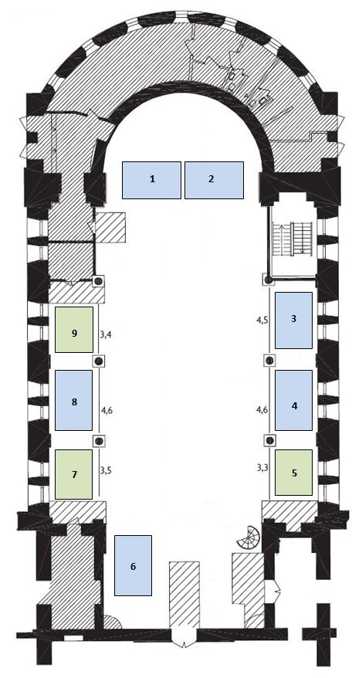
4.6m X 2.6m
3.4m X 2.6m
Note: May not be drawn to scale. All booths are approximate size

