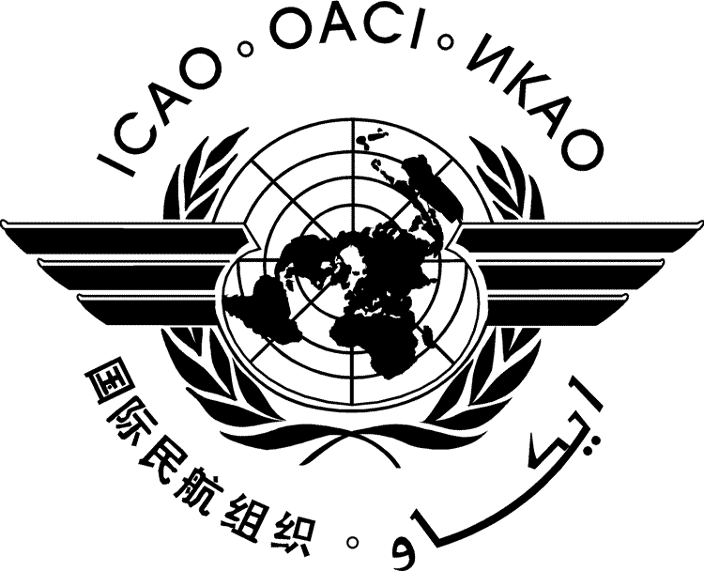 | International Civil Aviation Organization  WORKING PAPER | HLM-GMBM-WP/xxxx  ../../16
HIGH-LEVEL MEETING ON A GLOBAL MARKET-BASED
MEASURE SCHEME

Montréal, 11 to 13 May 2016

Agenda Item | xx:

[TITLE]

(Presented by xxx)

EXECUTIVE SUMMARY
[xxx]

Action by the HLM-GMBM is in paragraph xx.

