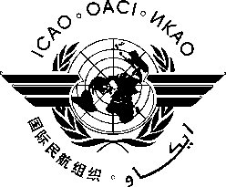

INTERNATIONAL CIVIL AVIATION ORGANIZATION

Tenth Meeting of the NAFISAT Supervisory Committee
((Sharm El-Sheikh, Egypt, 21-24 April 2015)

ATTENDANCE NOTIFICATION AND REGISTRATION FORM

- Please fill and forward the form in the same (MS Word) format. Do not fax, scan or change format to PDF.
- Insert information in the grey empty boxes
- Where appropriate, click to make the appropriate selection
- Surname

- Given Name (s)

- Job Title

- State/
Organization

- Mailing Address

- Telephone

- Fax

- E-mail address

- Hotel

